|  |  |
| --- | --- |
| **Name** | Ali Mostafa Almousa |
| **ID** | 1945427 |

**Exercise 1:**

**Changes made:**After removing the initial element, a new node was generated and designated as the head, leading to a memory leakage. To fix this bug, we can modify the head_ pointer to indicate the next marker, effectively eliminating the first element from the list.

Furthermore, replacing "delete temp;" with "delete marker;" ensures a more reliable deletion of the current marker node. Setting marker to 0 afterward prevents any possible misuse of the deleted memory.

**Output:**

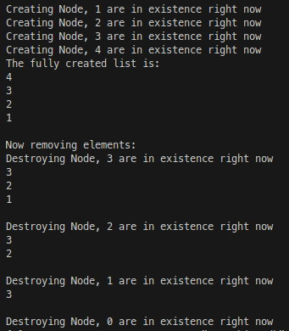

**Exercise 2:**

The bug in exercise 1 has been resolved, which in turn fixed this bug as well. The subsequent output demonstrates that the code is now free of any bugs, despite following the prescribed sequence of inserting 1, 2, 3, 4, and then removing 2 which previously should reproduce the bug as stated in the assignment document.

**Output:**

