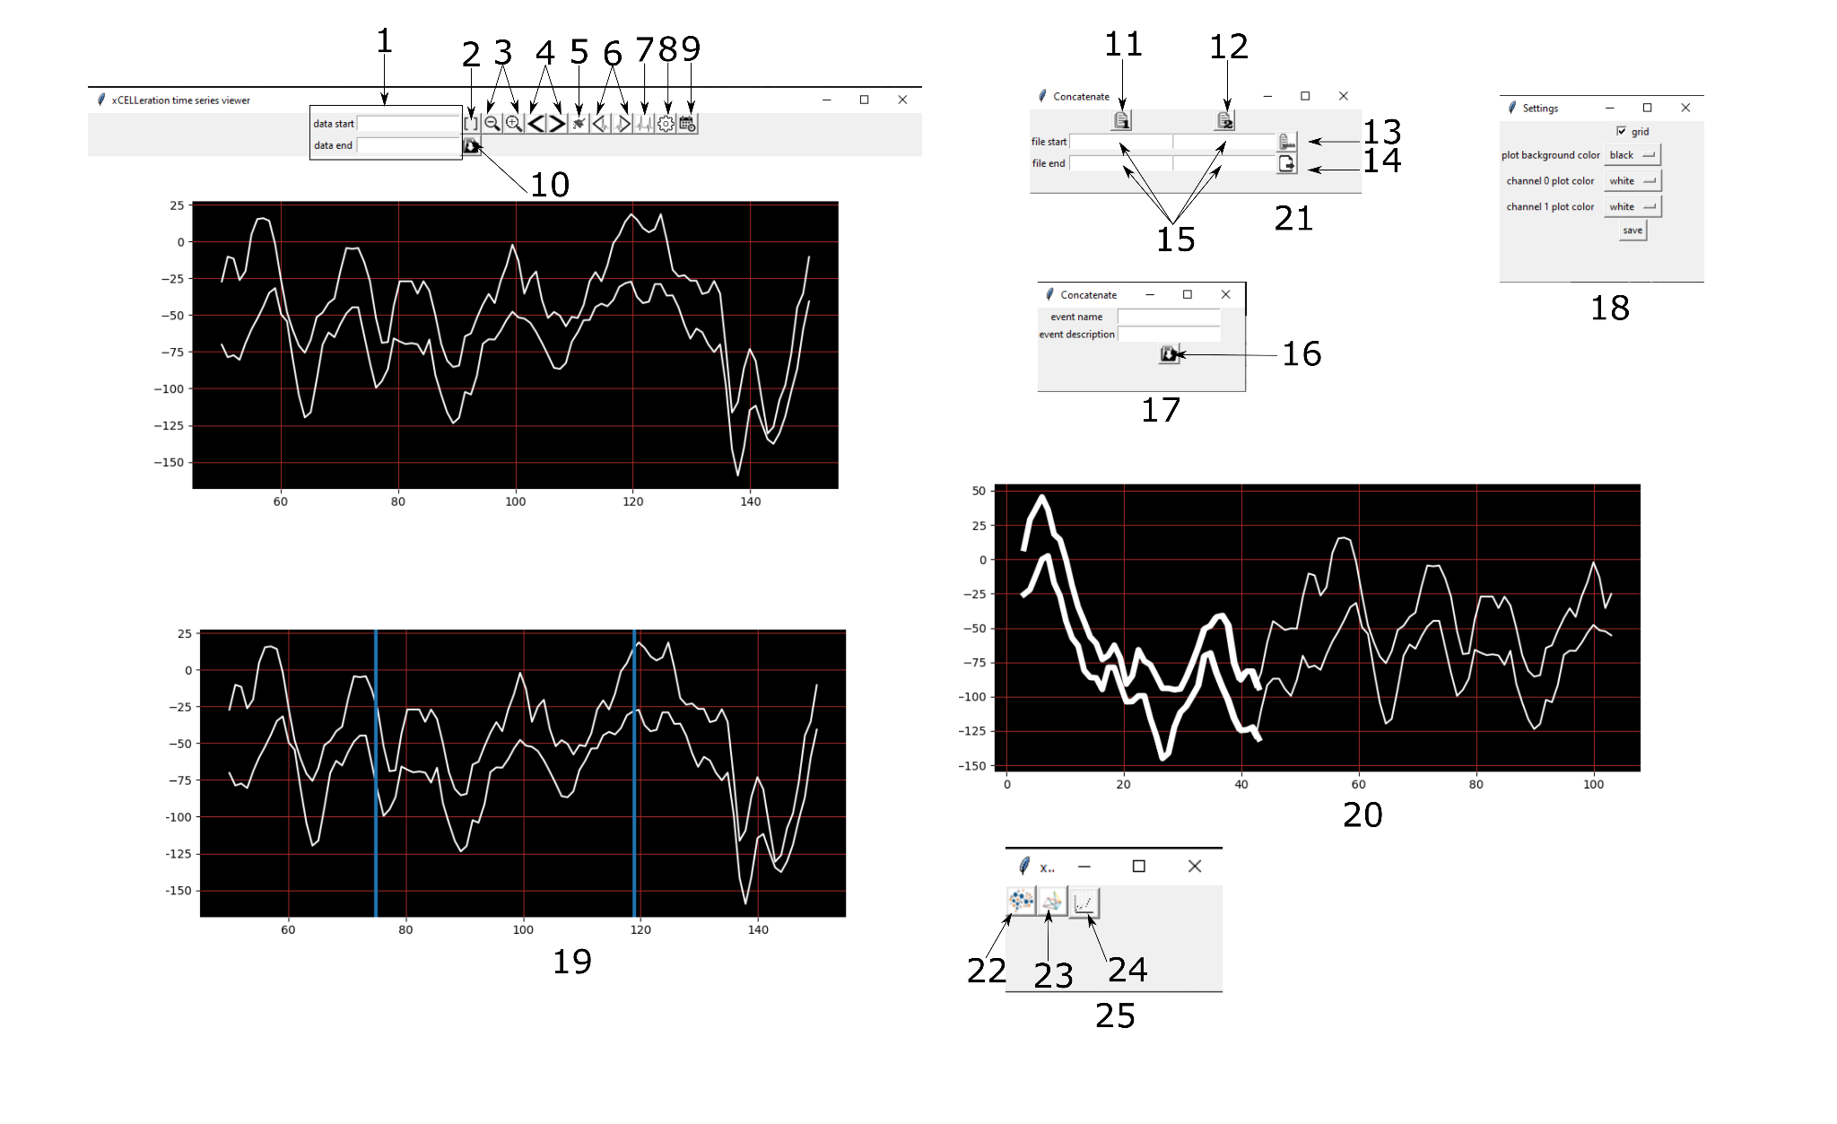

* **1:** set window for truncation.
* **2:** truncate data on display to bounds specified by 1.
* **3:** zoom in and out of data on display.
* **4:** pan through data on display.
* **5:** clear data.
* **6:** display next or previous spike on display.
* **7:** open window 21.
* **8:** open window 18.
* **9:** open window 19 on first clock, then after window selected, open window 17.
* **10:** save data to nwb file.
* **11:** select first .continuous file to concatenate.
* **12:** select second .continuous file to concatenate.
* **13:** select metadata file to attach to concatenated file.
* **14:** save concatenated file.
* **15:** window of data to concatenate for each selected file.
* **16:** save event to current file.
* **17:** add name and description and save event selected from window 19.
* **18:** select plot background color, plot line colors and gridlines.
* **19:** visually select event beginning and end timestamps.
* **20:** display event highlighted.
* **21:** concatenation window.
* **22:** select nwb file to open.
* **23:** select open ephys directory to open.
* **24:** plot selected file.
* **25:** file open window.

**Source Code Structure**

***Classes:***

Button_icons:

* Stores icons for buttons, images stored in images folder.

conc_files:

* Stores the data selected from 21, and the function triggered from selecting button 14

event_storage:

* Stores window selected by 19, flag selected by 9 and the data selected from 17
* Stores function triggered by 16

Channel_window:

* Stores all buttons for the main window,, data from selected file and information for the selected plot window and settings.
* Stores functions for zooming, panning, spike panning, truncate, add event, select files from 21 and plotting.

GUI:

* Stores window 25.
* Entry point of program