Phase 5 — Methodology Comparison with Recent Literature
Ali Aslam
University of the Punjab
April 21, 2026

1. Introduction
This project predicts whether professional developers agree that AI agents increased their productivity, using the 2025 Stack Overflow Developer Survey. It also helps to read our pipeline next to published work, because productivity is easy to oversell. Ziegler et al. [1] linked Copilot IDE usage to survey answers about perceived productivity, and Simaremare and Edison [2] surveyed how software practitioners adopt generative AI in industry. Weber et al. [3] ran a controlled within-subjects study of Copilot-style autocomplete versus conversational GPT-3 versus a non-AI baseline and reported substantial gains in programming efficiency when AI assistance is available. Our work asks which survey-measured attitudes and usage proxies associate with perceived agent productivity in a contemporary professional cohort.

2. Summary of Our Methodology
We used the public 2025 Stack Overflow Developer Survey (approximately 49,000 responses) and restricted analysis to a professional cohort (MainBranch = professional developer; employed or freelance; WorkExp > 0), yielding 9,513 rows after preprocessing.
The supervised target is binary: agreement (strongly or somewhat agree = 1) versus neutral or disagreement (= 0) with the statement that AI agents increased productivity, derived from the AIAgentImpact Likert-style matrix.
Phase 2 constructed numeric features via ordinal encodings, counts from multi-select fields, binary LLM and tooling flags, DevType bucketing, industry rare-category collapse, and one-hot encoding for nominal fields, producing phase2_preprocessed.csv.
Phase 3 combined five importance views (Random Forest, LightGBM, XGBoost, permutation importance, SHAP), engineered eight composite signals (for example ai_engagement_score, positive_disposition_score, ai_task_ratio, frustration_per_task), standardized continuous columns, and added a KMeans cluster feature, saving phase3_final.csv.
Phase 4 trained Logistic Regression, Random Forest, XGBoost, SVM (RBF), and KNN under five-fold stratified cross-validation, reporting ROC-AUC, F1-macro, accuracy, and macro precision/recall. SHAP and LIME provided complementary explanations. Subgroup analysis used DevType buckets. A three-feature minimal set (agent_change_ord, ai_engagement_score, agent_use_breadth) supported roughly an 84.7% reduction in survey burden while retaining strong discrimination. Best models achieved ROC-AUC near 0.84–0.85 on the full feature set.
Conceptually, the work separates AI trust and attitude signals from raw usage frequency where possible, then asks whether both jointly explain perceived productivity gains from agents. That separation responds to descriptive literatures that often juxtapose trust and adoption without a single supervised target. Methodologically, the emphasis on comparing gradient boosting to alternatives parallels the wide range of empirical setups and evaluation choices documented across LLM-for-software-engineering research [4].

Figures
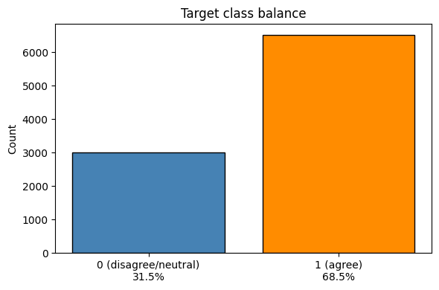
[Phase 2 — Target class balance bar chart (agree vs disagree %)]
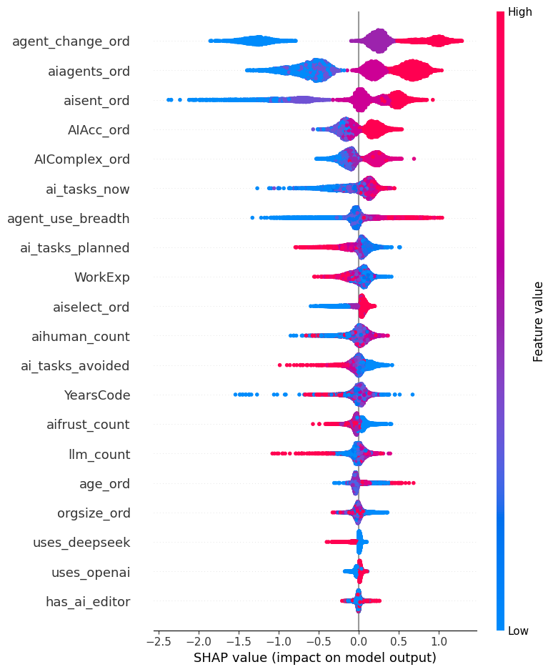
[Phase 3 — SHAP summary plot (top features by mean |SHAP value|)]
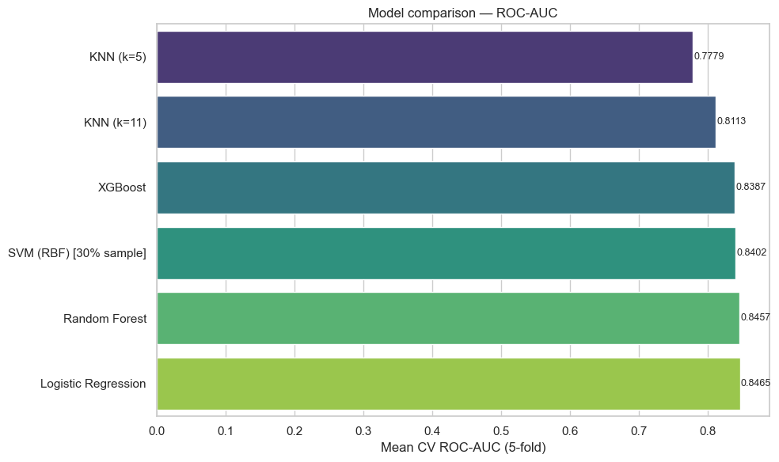
[Phase 4 — Model comparison ROC-AUC bar chart]
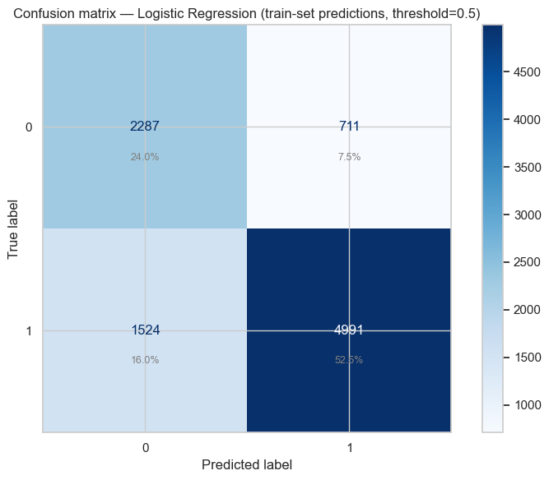
[Phase 4 — Confusion matrix of best model]

3. Literature Review — Five Recent Papers

3.1 Copilot usage data and what developers say about productivity
Ziegler, A., Kalliamvakou, E., Li, X. A., Rice, A., Rifkin, D., Simister, S., Sittampalam, G., & Aftandilian, E. (2024). Measuring GitHub Copilot's Impact on Productivity. Communications of the ACM, 67(3), 54–63. https://doi.org/10.1145/3633453
They emailed a survey to thousands of Copilot preview users and kept answers they could line up with IDE logs from a four-week window. They looked at acceptance of suggestions and other usage signals, then tied those to self-reported productivity and happiness style questions shaped by the SPACE idea. They found that acceptance rate of shown suggestions was a better signal than raw suggestion counts for perceived productivity.
Their setup is still about Copilot in the wild, not the Stack Overflow annual survey [1]. We do not get IDE logs at all; we only have public survey fields. On the other hand, we use a similar angle in that we mix “how people use AI” style features with how they feel about outcomes.

3.2 Practitioner survey on generative AI adoption in software work
Simaremare, M., & Edison, H. (2024). The State of Generative AI Adoption from Software Practitioners' Perspective: An Empirical Study. In Proceedings of the 50th Euromicro Conference on Software Engineering and Advanced Applications (SEAA), pp. 106–113. https://doi.org/10.1109/SEAA64295.2024.00024
They ran an exploratory survey with software practitioners about generative AI adoption. The paper lists many real use cases and discusses benefits and challenges from the respondents’ point of view. It is mostly descriptive and qualitative coding rather than training a classifier for one yes/no label.
Compared with our project [2], they paint a wide picture of how GenAI spreads in companies, but they do not build our exact binary target from Stack Overflow. We still liked this paper as a contrast because it shows how much of the literature stays at the “what people say in surveys” level without our kind of supervised learning pipeline.

3.3 Controlled study of Copilot, conversational GPT-3, and programming productivity
Weber, T., Brandmaier, M., Schmidt, A., & Mayer, S. (2024). Significant productivity gains through programming with large language models. Proceedings of the ACM on Human-Computer Interaction, 8(EICS), Article 256. https://doi.org/10.1145/3661145
They conducted a within-subjects user study with 24 programmers who completed Python tasks under three supports: GitHub Copilot-style autocomplete, a conversational GPT-3 interface, and a traditional workflow with only a web browser. They measured efficiency-related outcomes (among other usability measures) and analyzed how participants relied on each modality. They report that AI-supported conditions substantially improved productivity metrics relative to the baseline and that interaction design shaped strategies and reliance patterns.
Their evidence comes from timed lab tasks rather than a large annual developer questionnaire [3]. We instead model agreement that AI agents improved productivity on the 2025 Stack Overflow survey using engineered survey fields only. The paper is still directly relevant because it ties concrete LLM coding assistants to measurable productivity differences and shows that how AI is presented—not only whether it is on—matters, which motivates our separating engagement-style composites from raw attitude items.

3.4 Systematic literature review on large language models for software engineering
Hou, X., Zhao, Y., Liu, Y., Yang, Z., Wang, K., Li, L., Luo, X., Lo, D., Grundy, J., & Wang, H. (2024). Large language models for software engineering: A systematic literature review. ACM Transactions on Software Engineering and Methodology, 33(8), Article 220. https://doi.org/10.1145/3695988
They systematically analyzed hundreds of studies (through January 2024) on applying LLMs across software engineering, organizing evidence around models, data and preprocessing, optimization and evaluation strategies, and tasks where LLMs have been applied. The review synthesizes how the field measures success and where gaps remain rather than predicting a single survey item.
This work is broader than our binary Stack Overflow target and is not a predictive modeling paper [4]. It is relevant because it documents how heterogeneous methods and evaluation choices are when AI touches real development work, which supports our Phase 4–5 stance of benchmarking multiple classifiers, tuning decisions, and explanations instead of trusting one default pipeline. It also situates developer-facing AI impact as an active research theme that mostly lives in task-specific studies, not in survey-wide productivity-agreement models.

3.5 GitHub Copilot code quality versus human solutions
Moradi Dakhel, A., Majdinasab, V., Nikanjam, A., Khomh, F., Desmarais, M. C., & Jiang, Z. M. (2023). GitHub Copilot AI pair programmer: Asset or liability? Journal of Systems and Software, 203, Article 111734. https://doi.org/10.1016/j.jss.2023.111734
They empirically evaluated Copilot on fundamental algorithmic coding tasks and compared Copilot-generated solutions with human-written solutions on a large set of programming problems. They report that Copilot often produces efficient suggestions but also buggy or hard-to-reproduce code, that humans achieve a higher correct-solution rate overall, and that buggy Copilot output tends to be quicker to repair. They discuss when Copilot may help experts versus pose risks for novices who cannot vet suggestions.
We do not execute Copilot on benchmark tasks or score generated code [5]. We predict whether professionals agree that AI agents raised their productivity using self-reported survey fields. The paper is relevant because it grounds enthusiasm about AI pair programmers in measurable quality and repair-effort trade-offs: perceived productivity gains in the wild (our label) can coexist with nuanced evidence on correctness, which is why our features include frustration and trust-style signals rather than assuming usage always implies benefit.

4. Gap Analysis — What Makes Our Work Unique
- No published study we identified treats the 2025 Stack Overflow AIAgentImpact productivity-agreement item as a supervised classification endpoint with the same professional cohort filters.
- Many AI-adoption papers collapse sentiment, trust, and usage into descriptive cross-tabs or experimental arms; our feature design explicitly mixes ordinal attitude fields with breadth and task-composite usage signals, then evaluates incremental predictive value.
- The modeling stack is survey-native: it does not require Git telemetry, employer proprietary data, or fine-tuned language models, which improves replicability for student and open-data settings.
- Interpretability spans SHAP global summaries and LIME local explanations on a mixed one-hot and numeric space, mirroring practitioner needs when communicating model behavior to non-modelers.
- The minimal three-feature viable set and estimated survey-burden reduction go beyond typical importance-only discussions in survey ML papers and connect modeling to instrument design.
- Where Ziegler et al. [1] give detailed industry evidence linking Copilot telemetry to self-reported productivity, and Moradi Dakhel et al. [5] empirically contrast Copilot's suggestions with human code quality and repair effort, our project adds a Stack Overflow-based classifier and a short three-feature option for cutting survey length.

5. Methodology Improvements (Phase 5 Notebook)
Guided by the literature, Phase 5 implements: (1) structured hyperparameter search for XGBoost, motivated by evidence that details of how LLM tooling is configured and evaluated materially affect outcomes in controlled programming studies [3] and by the diversity of modeling setups surveyed across LLM-for-SE work [4]; (2) decision-threshold optimization on cross-validated probabilities to maximize F1-macro, addressing the default 0.5 cut point often left untuned in survey classifiers; (3) a stacking ensemble with a logistic meta-learner to test whether diversity gains appear, consistent with comparative multi-model designs emphasized for robust evaluation [3][4]; (4) optional future extension toward class-weight calibration or resampling if imbalance diagnostics warrant it beyond Phase 2 cohort filtering.

6. References
[1] Ziegler, A., Kalliamvakou, E., Li, X. A., Rice, A., Rifkin, D., Simister, S., Sittampalam, G., & Aftandilian, E. (2024). Measuring GitHub Copilot's Impact on Productivity. Communications of the ACM, 67(3), 54–63. https://doi.org/10.1145/3633453
[2] Simaremare, M., & Edison, H. (2024). The State of Generative AI Adoption from Software Practitioners' Perspective: An Empirical Study. In Proceedings of the 50th Euromicro Conference on Software Engineering and Advanced Applications (SEAA), 106–113. https://doi.org/10.1109/SEAA64295.2024.00024
[3] Weber, T., Brandmaier, M., Schmidt, A., & Mayer, S. (2024). Significant productivity gains through programming with large language models. Proceedings of the ACM on Human-Computer Interaction, 8(EICS), Article 256. https://doi.org/10.1145/3661145
[4] Hou, X., Zhao, Y., Liu, Y., Yang, Z., Wang, K., Li, L., Luo, X., Lo, D., Grundy, J., & Wang, H. (2024). Large language models for software engineering: A systematic literature review. ACM Transactions on Software Engineering and Methodology, 33(8), Article 220. https://doi.org/10.1145/3695988
[5] Moradi Dakhel, A., Majdinasab, V., Nikanjam, A., Khomh, F., Desmarais, M. C., & Jiang, Z. M. (2023). GitHub Copilot AI pair programmer: Asset or liability? Journal of Systems and Software, 203, Article 111734. https://doi.org/10.1016/j.jss.2023.111734

