Predicting Developer Agreement That AI Agents Increased Productivity: Stack Overflow Survey Analysis and Comparison with Recent Literature
Ali Aslam
University of the Punjab
May 03, 2026

Abstract
This study predicts whether professional developers agree that AI agents increased their productivity using the public 2025 Stack Overflow Developer Survey (professional cohort; 9,513 rows after preprocessing). The binary target comes from the AIAgentImpact Likert-style field. We engineer survey-native features through ordinal encoding, multi-select summaries, binary AI-tool flags, DevType and industry handling, composite scores from earlier preprocessing and composite-feature steps, and clustering, then train Logistic Regression, Random Forest, XGBoost, SVM (RBF), and KNN under five-fold stratified cross-validation with SHAP and LIME explanations. This study further adds structured XGBoost hyperparameter search, decision-threshold optimization for F1-macro, and a stacking ensemble with a logistic meta-learner, motivated by recent empirical literature on how LLM coding assistants are tuned and evaluated in software engineering. Best full models achieve ROC-AUC near 0.84–0.85; a three-feature minimal set (agent_change_ord, ai_engagement_score, agent_use_breadth) keeps strong discrimination while replacing most of the raw questionnaire width with three engineered inputs—about an 84.7% reduction in measured collection burden relative to 170 raw Stack Overflow columns. We situate the contribution alongside Copilot productivity telemetry studies (Ziegler et al.), practitioner generative-AI adoption surveys (Simaremare and Edison), controlled LLM programming experiments (Weber et al.), systematic reviews of LLMs for software engineering (Hou et al.), and empirical Copilot code-quality comparisons (Moradi Dakhel et al.).

1. Introduction
Developer-facing AI agents and coding assistants are now common, yet whether individuals believe these tools improve productivity varies within teams and roles. The 2025 Stack Overflow Developer Survey directly asks professionals whether AI agents increased their productivity, producing a concrete agreement label that can be linked to attitudes, usage patterns, and role context. Predicting that agreement matters because institutions adopt policies and tooling around AI partly on perceived benefit; understanding which survey signals carry predictive weight complements controlled lab studies and telemetry papers that estimate productivity under narrower experimental conditions.
Much published evidence on AI coding tools draws on IDE telemetry (e.g., suggestion acceptance) paired with self-reports [1], descriptive practitioner surveys about adoption [2], or controlled experiments that manipulate interface modality [3]. Those designs answer important questions, but they rarely treat the Stack Overflow productivity-agreement item as a supervised classification endpoint on a filtered professional cohort with engineered survey-only features. This leaves open whether compact combinations of attitudes, engagement-style composites, and usage proxies recover agreement as well as large raw questionnaires imply.
We therefore preprocess the public survey to a professional cohort (MainBranch, employment status, and positive work experience), construct numeric features from ordinal selections and multi-select fields, engineer composite scores from consensus importance views, and evaluate five model families under stratified five-fold cross-validation with SHAP and LIME explanations. Subgroup analyses examine experience and coarse developer-type buckets where counts remain stable.
The contribution is an open-data, survey-native classifier that benchmarks transparent linear and nonlinear estimators on the same folds, compares global and local explainers, and sketches a minimal three-feature instrument aligned with the full-model signal. This study further adds structured hyperparameter search, threshold tuning, and stacking so refinements align with contemporary emphasis on careful evaluation design in LLM tooling research [3], [4].

2. Related Work
Ziegler et al. [1] emailed a survey to thousands of Copilot preview users and kept answers they could line up with IDE logs from a four-week window. They looked at acceptance of suggestions and other usage signals, then tied those to self-reported productivity and happiness style questions shaped by the SPACE idea. They found that acceptance rate of shown suggestions was a better signal than raw suggestion counts for perceived productivity. Their setup is still about Copilot in the wild, not the Stack Overflow annual survey. We do not get IDE logs at all; we only have public survey fields. On the other hand, we use a similar angle in that we mix “how people use AI” style features with how they feel about outcomes.
Simaremare and Edison [2] ran an exploratory survey with software practitioners about generative AI adoption. The paper lists many real use cases and discusses benefits and challenges from the respondents’ point of view. It is mostly descriptive and qualitative coding rather than training a classifier for one yes/no label. Compared with our project, they paint a wide picture of how GenAI spreads in companies, but they do not build our exact binary target from Stack Overflow. This paper serves as a useful contrast because it shows how much of the literature stays at the “what people say in surveys” level without our kind of supervised learning pipeline.
Weber et al. [3] conducted a within-subjects user study with 24 programmers who completed Python tasks under three supports: GitHub Copilot-style autocomplete, a conversational GPT-3 interface, and a traditional workflow with only a web browser. They measured efficiency-related outcomes (among other usability measures) and analyzed how participants relied on each modality. They report that AI-supported conditions substantially improved productivity metrics relative to the baseline and that interaction design shaped strategies and reliance patterns. Their evidence comes from timed lab tasks rather than a large annual developer questionnaire. We instead model agreement that AI agents improved productivity on the 2025 Stack Overflow survey using engineered survey fields only. The paper is still directly relevant because it ties concrete LLM coding assistants to measurable productivity differences and shows that how AI is presented—not only whether it is on—matters, which motivates our separating engagement-style composites from raw attitude items.
Hou et al. [4] systematically analyzed hundreds of studies (through January 2024) on applying LLMs across software engineering, organizing evidence around models, data and preprocessing, optimization and evaluation strategies, and tasks where LLMs have been applied. The review synthesizes how the field measures success and where gaps remain rather than predicting a single survey item. This work is broader than our binary Stack Overflow target and is not a predictive modeling paper. It is relevant because it documents how heterogeneous methods and evaluation choices are when AI touches real development work, which supports benchmarking multiple classifiers, tuning decisions, and explanations during model training and evaluation (Section 3.4) and in the Phase 6 extensions (Section 3.5) instead of trusting one default pipeline. It also situates developer-facing AI impact as an active research theme that mostly lives in task-specific studies, not in survey-wide productivity-agreement models.
Moradi Dakhel et al. [5] empirically evaluated Copilot on fundamental algorithmic coding tasks and compared Copilot-generated solutions with human-written solutions on a large set of programming problems. They report that Copilot often produces efficient suggestions but also buggy or hard-to-reproduce code, that humans achieve a higher correct-solution rate overall, and that buggy Copilot output tends to be quicker to repair. They discuss when Copilot may help experts versus pose risks for novices who cannot vet suggestions. We do not execute Copilot on benchmark tasks or score generated code. We predict whether professionals agree that AI agents raised their productivity using self-reported survey fields. The paper is relevant because it grounds enthusiasm about AI pair programmers in measurable quality and repair-effort trade-offs: perceived productivity gains in the wild (our label) can coexist with nuanced evidence on correctness, which is why our features include frustration and trust-style signals rather than assuming usage always implies benefit.

3. Methodology
3.1 Dataset and Cohort
We used the public 2025 Stack Overflow Developer Survey (approximately 49,000 responses) and restricted analysis to a professional cohort: MainBranch indicating a developer by profession, employment as employed or independent contractor/freelancer, and non-null professional work experience greater than zero. That filter targets respondents for whom productivity questions are most interpretable and yields 9,513 rows for modeling after preprocessing, rather than the full survey pool that includes students and hobbyists.
The supervised target is binary: agreement (strongly or somewhat agree = 1) versus neutral or disagreement (= 0) with the statement that AI agents increased productivity, derived from the AIAgentImpact Likert-style matrix. Within this cohort the outcome is moderately imbalanced (about 68.5% agreement versus 31.5% neutral/disagreement), which motivates balanced class weights for linear and forest models and scale_pos_weight for XGBoost as implemented in the notebooks.
3.2 Feature Construction
Data preprocessing constructed numeric features via ordinal encodings, counts from multi-select fields, binary LLM and tooling flags, DevType bucketing, industry rare-category collapse, and one-hot encoding for nominal fields. Outputs were saved as phase2_preprocessed.csv for traceability.
3.3 Composite Feature Engineering
Composite feature design combined five importance views (Random Forest, LightGBM, XGBoost, permutation importance, SHAP), engineered eight composite signals (for example ai_engagement_score, positive_disposition_score, ai_task_ratio, frustration_per_task), standardized continuous columns, and added a KMeans cluster feature, saving phase3_final.csv.
3.4 Model Training and Evaluation
Model training and evaluation fit Logistic Regression, Random Forest, XGBoost, SVM (RBF), and KNN under stratified five-fold cross-validation, reporting ROC-AUC, F1-macro, accuracy, and macro precision/recall (means across folds). SHAP and LIME provided complementary explanations on the mixed one-hot and numeric space. Subgroup analysis used DevType buckets where counts support stable estimates. A three-feature minimal set (agent_change_ord, ai_engagement_score, agent_use_breadth) was derived by adding features in consensus importance order until at least 95% of the full consensus-model mean CV ROC-AUC was retained under XGBoost, substantially reducing the number of inputs compared with the full raw questionnaire width while preserving most of the discrimination observed on the full engineered matrix.
Conceptually, the work separates AI trust and attitude signals from raw usage frequency where possible, then asks whether both jointly explain perceived productivity gains from agents. That separation responds to descriptive literatures that often juxtapose trust and adoption without a single supervised target. Methodologically, the emphasis on comparing gradient boosting to alternatives parallels the wide range of empirical setups and evaluation choices documented across LLM-for-software-engineering research [4].
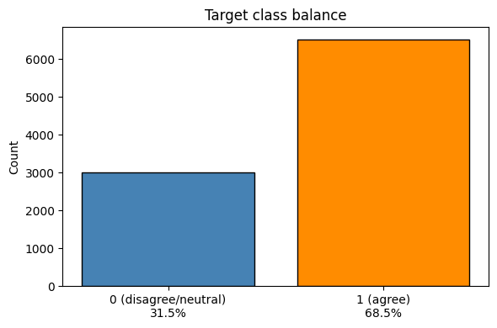
[Figure 1: Target class balance bar chart (agree vs disagree %)]
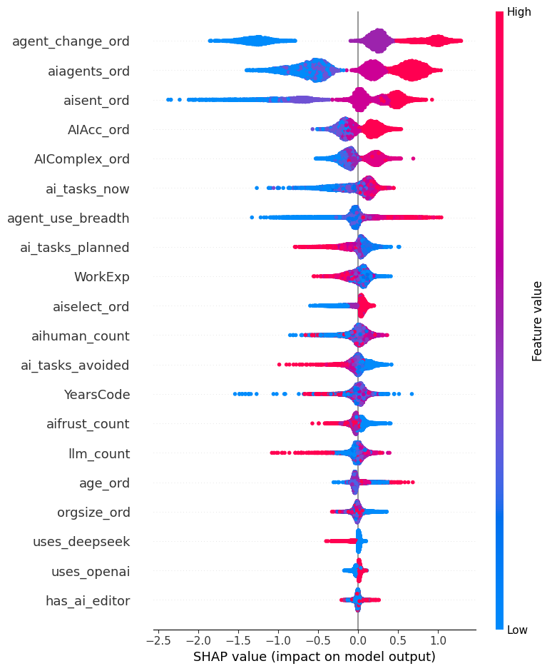
[Figure 2: SHAP summary plot (top features by mean |SHAP value|)]
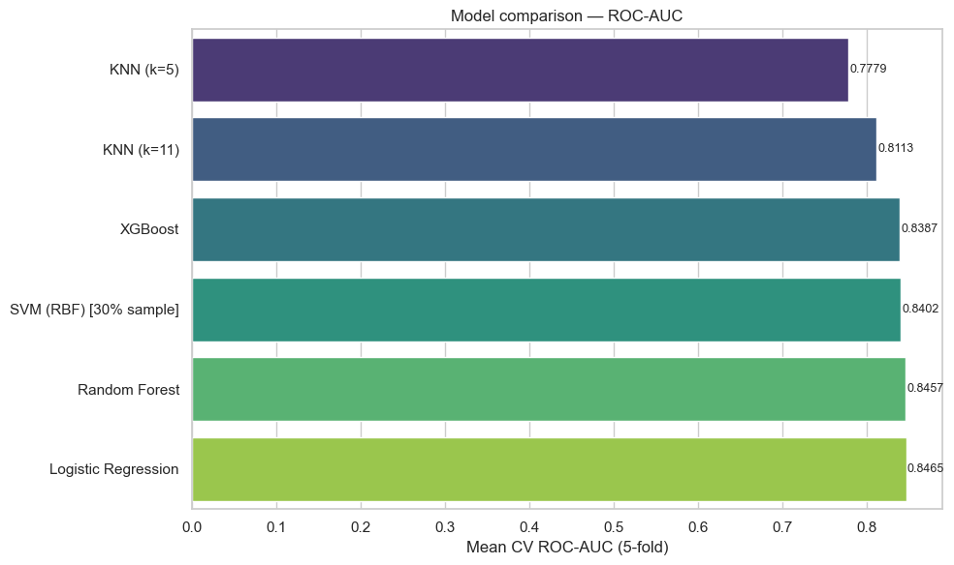
[Figure 3: Model comparison ROC-AUC bar chart]
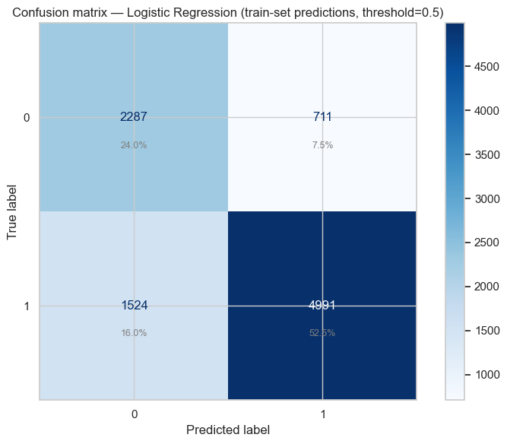
[Figure 4: Confusion matrix of best model]

3.5 Hyperparameter Search, Threshold Optimization, and Stacking Ensemble
This study further implements: (1) structured hyperparameter search for XGBoost, motivated by evidence that details of how LLM tooling is configured and evaluated materially affect outcomes in controlled programming studies [3] and by the diversity of modeling setups surveyed across LLM-for-SE work [4]; (2) decision-threshold optimization on cross-validated probabilities to maximize F1-macro, addressing the default 0.5 cut point often left untuned in survey classifiers; (3) a stacking ensemble with a logistic meta-learner to test whether diversity gains appear, consistent with comparative multi-model designs emphasized for robust evaluation [3], [4]; (4) optional future extension toward class-weight calibration or resampling if imbalance diagnostics warrant it beyond initial cohort filtering.

4. Results & Discussion
Model | ROC-AUC | F1-Macro | Accuracy | Precision (macro) | Recall (macro)
Logistic Regression * | 0.846487 | 0.741371 | 0.762746 | 0.734741 | 0.760428
Random Forest | 0.845679 | 0.746529 | 0.799747 | 0.783555 | 0.730268
XGBoost | 0.838749 | 0.744320 | 0.775360 | 0.741059 | 0.748927
SVM (RBF) [30% sample] | 0.840220 | 0.749350 | 0.803360 | 0.790979 | 0.732120
KNN (k=5) | 0.777892 | 0.703426 | 0.759486 | 0.722730 | 0.693672
KNN (k=11) | 0.811261 | 0.719919 | 0.778197 | 0.752105 | 0.706162

* Logistic regression is marked as the selected model because stratified five-fold ROC-AUC values at the top of the leaderboard differ only slightly and the notebook applies a simplicity tie-break in that situation.
The label is agreement (versus neutral or disagreement) that AI agents increased productivity on the engineered feature matrix described in Section 3.3; every metric in the table is a mean from stratified five-fold cross-validation on the professional cohort described in Section 3.1.
ROC-AUC values at the top of the leaderboard clustered in the mid-0.84s. Logistic regression reached the highest mean ROC-AUC (0.8465) with macro-averaged F1 about 0.741 and accuracy about 0.763. Random forest was essentially tied on AUC (0.8457) but pushed accuracy to about 0.800. XGBoost sat near 0.8387 AUC with accuracy about 0.775. The RBF SVM was fit on a 30% stratified subsample for runtime (n=2,853 in the notebook run) and logged about 0.8402 AUC with the highest accuracy in the comparison (about 0.803). KNN was weaker at k=5 (about 0.7779 AUC) and stronger at k=11 (about 0.8113 AUC). With such small AUC separations, logistic regression was taken forward as the primary model under the simplicity tie-break noted in the training notebook.
SHAP summaries and LIME cases were run on the same mixed one-hot and numeric space to show which survey-side signals push predictions toward agreement (Figure 2 is the global SHAP view; Figure 4 shows the confusion matrix for the selected model at the default threshold).
Subgroup checks refit XGBoost using the same protocol documented for the main evaluation. By experience, juniors under three years (n=677) had mean ROC-AUC about 0.772 (macro F1 about 0.687) versus seniors with seven or more years (n=6,924) at about 0.845 (macro F1 about 0.751), so the label is harder to recover for the junior slice. By coarse DevType bucket—keeping only roles with at least 200 respondents—mean CV AUC ran from about 0.847 for Infrastructure/Ops down to about 0.797 for Data/AI, with Web/Software and Other/Niche in between, which indicates that job context shifts how much explanatory power the survey fields carry.
For instrument-length considerations, features were added in consensus importance order until a prefix kept at least 95% of the full consensus model's mean CV ROC-AUC under XGBoost. That rule stopped at three features—agent_change_ord, ai_engagement_score, and agent_use_breadth—with mean CV ROC-AUC about 0.826 versus roughly 0.838 on the full consensus set (about 98.6% of full AUC retained). Compared with 170 raw Stack Overflow columns, using only those three engineered inputs corresponds to about an 84.7% reduction in measured collection burden while retaining nearly all of the cross-validated discrimination achieved with the full consensus feature set.
Turning from the table to interpretation: no published study we identified treats the 2025 Stack Overflow AIAgentImpact productivity-agreement item as a supervised classification endpoint with the same professional cohort filters. Many AI-adoption papers keep sentiment, trust, and usage in descriptive tables or experiments; here ordinal attitudes sit alongside breadth and task-style composites and we ask whether they contribute incremental predictive value. Everything runs on public survey rows—no employer telemetry and no fine-tuned LLMs—which keeps the setup reproducible for coursework or open data. Global SHAP plus local LIME on the mixed feature space supports explanations for readers who are not modelers. The three-feature construction ties modeling back to instrument design rather than stopping at importance plots only. Where Ziegler et al. [1] link Copilot telemetry to self-reported productivity and Moradi Dakhel et al. [5] contrast Copilot suggestions with human code quality and repair effort, this stack adds a Stack Overflow-side classifier and a concrete short-form option.
Limitations
The outcome is self-reported agreement about productivity, not objectively measured throughput or quality; associations should be read as perceptions aligned with survey fields rather than causal impacts of AI agents. Starting from roughly 49,000 responses, the professional cohort filter (developer by profession, employed or freelance, positive work experience) reduces the analytic sample to 9,513 rows to isolate a population for whom productivity questions are most meaningful, at the cost of excluding students, hobbyists, and others. The RBF SVM was trained on a 30% stratified subsample for computational reasons, so its metrics are best viewed as a scalability-adjusted estimate rather than a strict like-for-like comparison with models trained on every row. Class imbalance remains moderate and is handled with class weights rather than resampling in the reported runs. Many country subsamples within the cohort are too small for stable five-fold evaluation, so geography-based sensitivity analyses were not emphasized. Finally, Stack Overflow respondents are not a census of developers worldwide; voluntary response and questionnaire wording limit external validity.

5. Conclusion
Across five-fold stratified evaluation on 9,513 professional respondents, linear and nonlinear models achieved similar top-end ROC-AUC near 0.84–0.85, with logistic regression selected under a simplicity tie-break despite forest and boosting variants trading higher accuracy for negligible AUC differences. Explainable boosting on subsamples showed that perceived productivity agreement is harder to recover for junior developers than for seniors and varies materially across coarse developer-type buckets. A three-feature prefix retained roughly 98.6% of the consensus model’s mean CV AUC while collapsing most of the raw questionnaire burden into three engineered inputs. Together, these findings suggest that compact attitude-and-usage composites carry much of the signal for this label without requiring the full raw feature width.
Interpretation stays bounded by self-reported outcomes, cohort restrictions, subsampled SVM training, and moderate imbalance as summarized under Limitations above; perceived productivity should not be equated with measured engineering output.
Future work could extend class-weight calibration or resampling if imbalance diagnostics shift, broaden stacking or meta-learning comparisons when runtime allows, integrate additional survey waves if items remain comparable, and explore richer subgroup designs where subsample sizes support stable cross-validation—directions noted in Section 3.5.

References
[1] A. Ziegler et al., “Measuring GitHub Copilot's Impact on Productivity,” Commun. ACM, vol. 67, no. 3, pp. 54–63, 2024, doi: 10.1145/3633453.
[2] M. Simaremare and H. Edison, “The State of Generative AI Adoption from Software Practitioners' Perspective: An Empirical Study,” in Proc. 50th Euromicro Conf. Softw. Eng. Adv. Appl. (SEAA), 2024, pp. 106–113, doi: 10.1109/SEAA64295.2024.00024.
[3] T. Weber et al., “Significant productivity gains through programming with large language models,” Proc. ACM Hum.-Comput. Interact., vol. 8, no. EICS, Art. no. 256, Jun. 2024, doi: 10.1145/3661145.
[4] X. Hou et al., “Large language models for software engineering: A systematic literature review,” ACM Trans. Softw. Eng. Methodol., vol. 33, no. 8, Art. no. 220, 2024, doi: 10.1145/3695988.
[5] A. Moradi Dakhel et al., “GitHub Copilot AI pair programmer: Asset or liability?” J. Syst. Softw., vol. 203, Art. no. 111734, Sep. 2023, doi: 10.1016/j.jss.2023.111734.

