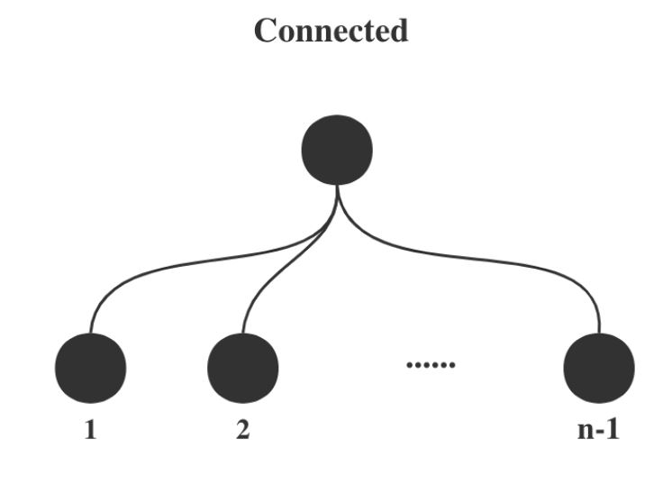

Runtime GD num_iters= 49.035340547561646

final cost with GD 54.82938035128265

final acc with 100 workers: 0.9347924528301886

**SVM model with 100 workers**: Star connection

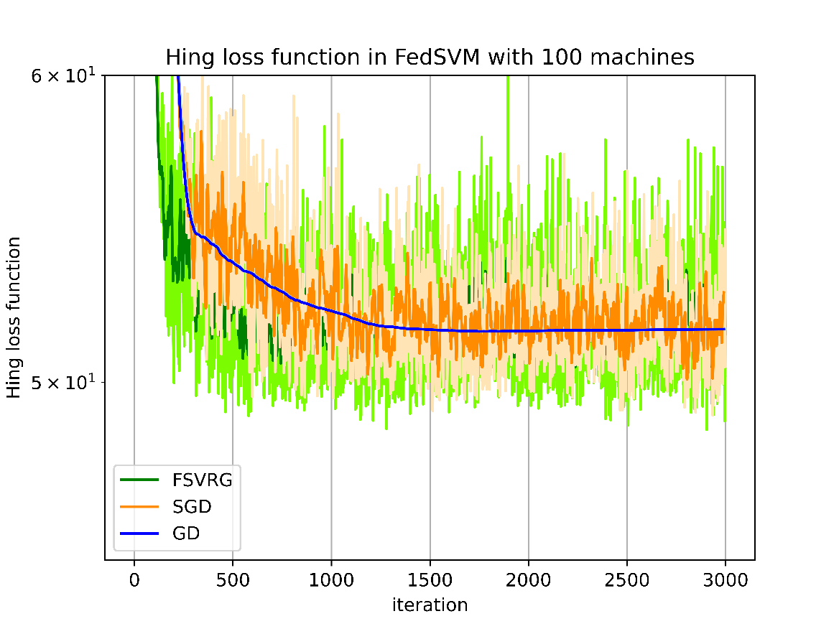

|  |  |
| --- | --- |
|  |  |
|  |  |
|  |  |
|  |  |
|  |  |

GD: Number of iterations: 3000 / 3000

GD: final norm: 0.448223126777565

-------------------------------------

Runtime GD num_iters= 38.90061640739441

final cost with GD 50.30420572155653

final acc with 100 workers FedSVM_GD: 0.946566037735849

SGD: Number of iterations: 3000 / 3000

SGD: final norm: 39.039097708279044

-------------------------------------

Runtime SGD num_iters= 30.64623188972473

final cost with SGD 62.64117391583893

final acc with 100 workers FedSVM_SGD: 0.9464150943396227

FSVRG: Number of iterations: 2999 / 3000

FSVRG: final norm: 10.428322710028127

-------------------------------------

Runtime FSVRG num_iters= 47.40384268760681

final cost with FSVRG 62.64117391583893

final acc with 100 workers FedSVM_FSVRG: 0.9427924528301886

**FedSVM model with 10 workers**: Star connection

GD: Number of iterations: 3000 / 3000

GD: final norm: 0.054761382437770206

-------------------------------------

Runtime GD num_iters= 49.41972279548645

final cost with GD 50.492480788488315

final acc with 10 workers FedSVM_GD: 0.9222641509433962

SGD: Number of iterations: 3000 / 3000

SGD: final norm: 36.5202034074581

-------------------------------------

Runtime SGD num_iters= 42.69002723693848

final cost with SGD 46.24369224031032

final acc with 10 workers FedSVM_SGD: 0.9029433962264151

FSVRG: Number of iterations: 2999 / 3000

FSVRG: final norm: 11.552635002692236

-------------------------------------

Runtime FSVRG num_iters= 57.00182890892029

final cost with FSVRG 46.24369224031032

final acc with 10 workers FedSVM_FSVRG: 0.9147169811320754

    
    
    
    
    
    