Revenue Increase by Price Discrimination of Retail Goods Based on RFM Weighting
https://github.com/ali-can-turan/Revenue_Increase_By_Price_Discrimination_Of_Retail_Goods_Based_On_RFM_Weighting

Purpose:
The purpose of this project is to implement price discrimination, determine updated prices for the items sold to increase, maximize revenue.



Description:
A recency, frequency and monetary value (RFM) analysis framework, enriched by consumer surplus calculation based on average prices of the items sold, is conducted which is in turn used to reveal WTP values and to segment customers based on their purchasing behavior.
At the end, revenue change is calculated after price discrimination (either above or below the actual price given in the raw data set) between aforementioned customer categories.
Assumption: RFM, average price and WTP modelling structured in this project assumes that they collectively predict the individual consumer surpluses so well that the demand quantity DOES NOT change.
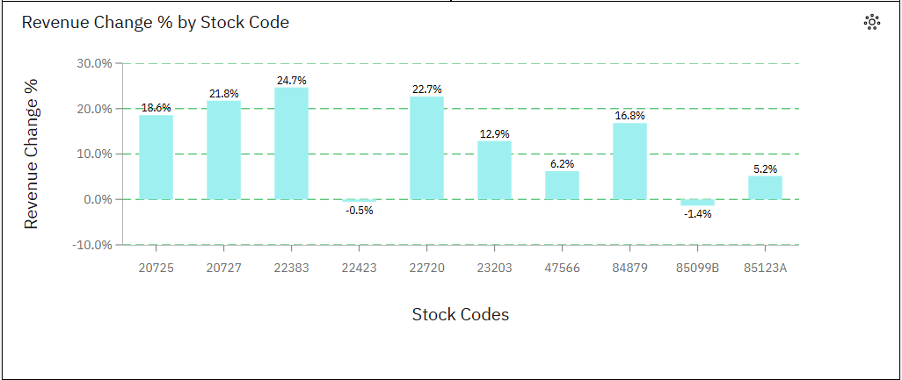

Administrative Points:
Raw / uncleaned parent data, “Online-Retailer-II by Bojan Tunguz”, is extracted from kaggle.com. URL to data is “kaggle.com/datasets/tunguz/online-retail-ii”.
Raw data consists of 541.911 rows to indicate retail purchases of 3958 distinct products, made by 4287 distinct customers, transacted through 25900 invoices within 38 countries in 2010 and 2011.
Raw data consists of 8 columns: invoice, stock code, description (of product), quantity, invoice date, price, customer ID, country.
Microsoft Excel is used for cleaning and preparation as well as populating RFM and WTP values; IBM Cognos is utilized for generating calculated fields, analyzing data, extracting insights and creating a dashboard.

Cleaning (Microsoft Excel):
1. Invoice column / field is removed as customer ID field is considered sufficient for analyses ahead.
2. Stock code and description field values are proved to equate each other. They are both kept though, to work on stock codes but to refer product descriptions at the same time.
3. Empty rows and meaningless entries in each field (negative or zero quantity and price values, invalid stock codes, product descriptions and customer IDs, values pertaining to the country “unspecified”) are removed.
4. Duplicate data rows are removed.
5. Number formatting is applied.
6. TRIM, CLEAN, SUBSTITUTE, FIND & REPLACE, FIND, LEFT, MID, RIGHT functions are employed for further cleaning.
7. Data is enriched by separating invoice date field into three columns: day, month, year.
(first 7 articles can be seen in the file: “Online_Retailer_II_Original_Cleaned.xlsx”)
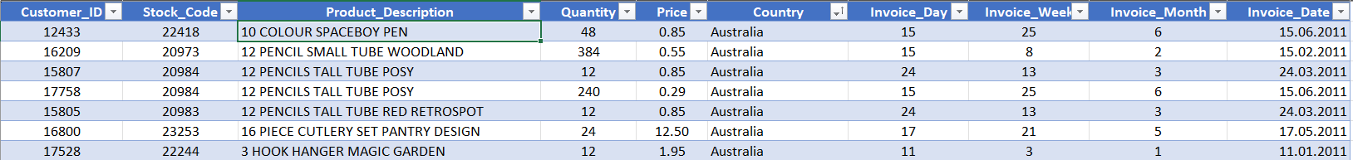
8. Outliers and normalization:
- 495.478 of all entries belongs to only one country United Kingdom (UK).
- It is revealed that total revenue obtained, customer and product count sold are drastically from UK.
- Therefore, it seems to be necessary to discard either United Kingdom or the rest except UK. If I ever to discard UK, too little data would be present to process. Hence, the rest is eliminated.
- RFM, average price and WTP analyses are too much to be handled for all 3958 distinct products; 10 most recurring products are chosen to analyze and the transactions pertaining to the other products are removed.
- Data consists of 2010 and 2011 entries. But only December values of 2010 are present in the data. Hence, 2010 values are discarded to catch a glimpse of 2011 values only in its entirety.
- January and December 2011 values are discarded as 3 weeks from January and 2 weeks from December are not present in the raw data.
9. Spell-check is only applied to country field as description column values are all in conformity with stock code field entries and between each other.
10. Further validation is not applied as the data would not be further populated in the ahead of time.
11. Data is made a table.
(End of cleaning, along with further enriched columns, can be seen in the file: “online_retail_II_Cleaned_and_Filtered.xlsx”)
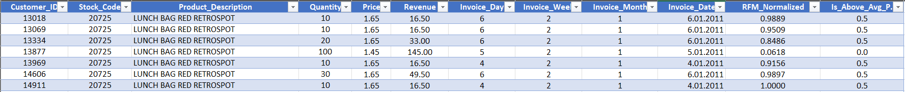

Analysis and Preparation (Microsoft Excel):
RFM Calculation:
1. RFM calculation is displayed in the “RFM calc” sheet. COUNTIFS, MAXIFS, SUM, SUMIFS functions are employed to extract data from the main table in “online_retail_II_UK” sheet, and determine RFM coefficients for each distinct customer ID. RFM formula utilized: R * 0.2 + F * 0.4 + M * 0.4.
2. RFM values are normalized by “RFM_Normalized = RFM value / MAX(RFM values)” within 0 and 1.
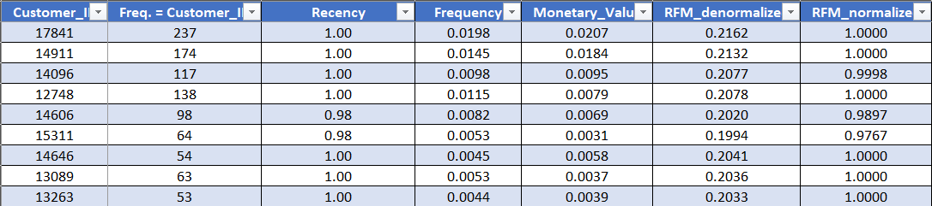
3. Main table is further enriched in “RFM_Normalized” field by customer specific RFM values.
Average price and customer posture against average price:
1. Average prices of the 10 most frequented products are calculated by: “Revenue / Quantity.”
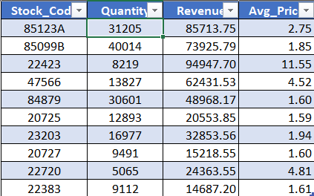
2. Main table is further enriched in “Is_Above_Avg.P.” field by setting the value 0.5 when the transaction price is over average and 0 otherwise.

Analysis (IBM Cognos – Data Module)
1. One calculated field is generated as (RFM + Is_Above_Avg.P.) = RFM_Normalized + Is_Above_Avg.P to assign each customer a value assessment over 1.5.
2. One calculated field is generated as WTP = (RFM + Is_Above_Avg.P.) * Price to see what would be the updated price when RFM and average price assessment are taken into consideration.
3. One calculated field is generated as “Updated_Revenue” by:
Case
when RFM + Is_Above_Avr_P >= 1.25 then WTP * Quantity
when RFM + Is_Above_Avr_P < 1.25 and RFM + Is_Above_Avr_P >= 1 then Revenue * 1.1
when RFM + Is_Above_Avr_P < 1 and RFM + Is_Above_Avr_P >= 0.75 then Revenue * 0.8
when RFM + Is_Above_Avr_P < 0.75 and RFM + Is_Above_Avr_P >= 0.5 then Revenue * 0.6
else Revenue * 0.4
end
which;
- increases the price to the WTP level for the customers of “RFM + Is_Above_Avg.P.” weighting 1.25 and above,
- increases the price / revenue 10% for the customers with “RFM + Is_Above_Avg.P.” weighting between 1.00 – 1.25,
- decreases the price / revenue 20% for the customers with “RFM + Is_Above_Avg.P.” weighting between 0.75 and 1.00,
- decreases the price / revenue 40% for the customers with “RFM + Is_Above_Avg.P.” weighting between 0.50 and 0.75,
- decreases the price / revenue 60% for the customers with “RFM + Is_Above_Avg.P.” weighting between 0.00 and 0.50.

Analysis and Insights (IBM Cognos – Dashboard)
Initials:
1. “Hibernating”, “At Risk”, “Potential Loyalist”, “Loyalist” and “Champion” customer categories are formed out of data in accordance with “RFM + Is_Above_Avg.P.” values.
2. “Revenue_Change” field is generated to calculated the difference between Updated_Revenue and Revenue.
3. “Revenue_Change %” field is generated to display the change in revenue in percentages.

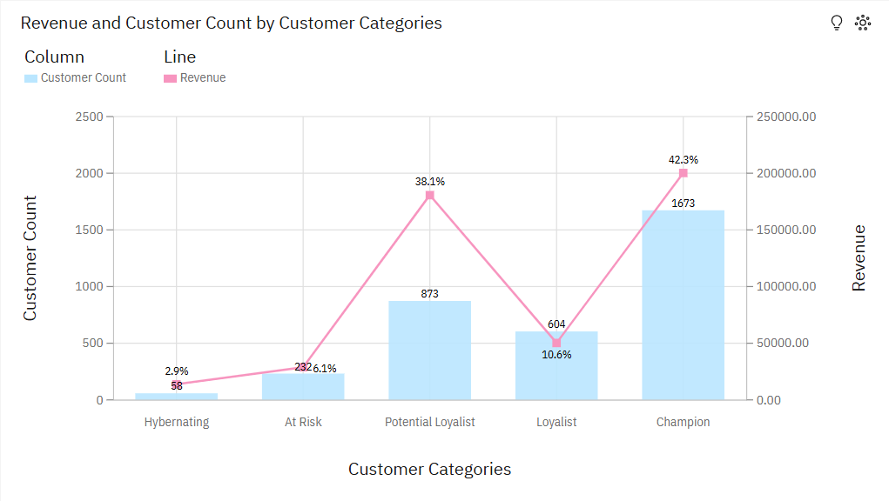

Dashboard:

1. 7 dashboard scenes are created in total.
2. 2 scenes are created to display current revenue for the selected 10 products by stock code, quantity sold, customer count and month.
3. 2 scenes are created to show customer count and stock code traded as well as “RFM + Is_Above_Avg.P.” by month.
4. 1 scene is created to present customer count and revenue relationship by customer categories.
5. 1 scene is created to show price and WTP relationship (projected price increase) by stock code.
6. Finally, 1 scene is created to set forth how much revenue is increased by price this price discrimination in general and by stock code.

Insights:
Scene 1 and 2:
1. Most revenue is elicited in November 2011 for all 10 products.
2. 85123A is the stock code with most customer count (distinct).
3. 22423 is the stock code with most revenue.
4. 85099A is the stock code with the most quantity sold.

Scene 3 and 4:
1. Customer count and stocks traded monthly are in conformity with “RFM + Is_Above_Avg_P. Weighting Sum” monthly, which verifies the approximation of RFM based model created in this project.
2. The stock code 85123A emerges as the one with the most “RFM + Is_Above_Avg_P. Weighting Sum”, which confirms the finding in scene 2.
3. Customer count in champion category emerges as the one that covers 48.6% of all customer counts.

Scene 5:
1. Revenue gained by potential loyalists race with that of champions though their customer count is way different. This means potential loyalists shop for respectively expensive products.

Scene 6 and 7:
1. 22423 is the stock code with the most revenue increase.
2. 22423 and 85099B are the stock codes whose WTP values increases even though their revenues decrease. This is because WTP is only used in updated revenue when “RFM + Is_Above_Avg.P.” weighting is above 1.25.
3. Revenue increase after price discrimination is 35,542.09, which translates into 7.5 percent. The revenue decrease in the stock codes 22423 and 85099B is quite low in comparison with the revenue increase in the other 8 products.

Recommendations:
- Different recency, frequency and monetary value coefficients could be employed to increase conformity between customer count, customer revenue and RFM values. Regression analysis could be conducted between individual customer RFM + Is_Above_Avg.P. values and their individual revenue contribution to further consolidate the reliability of the model.
- The same study could be repeated with a data set in which the price transitions are so observable that price elasticity could replace Is_Above_Avg.P. modelling used herein. That would be more valuable and reliable.

