clear all; close all; clc
load('Lab4.mat')
v_ss = 650; % found by inspection
t = linspace(0,length(vel)*0.005,length(vel)); % assuming each data point took 0.005 sec to add to buffer
vel_1_tau = (650*0.63); % velocity at one time constant, 63% of steady state
% find the index of the time constant
limit = 0.5;
for i = 1:length(vel)
if abs(vel(i)-vel_1_tau) < limit
index = i;
break
end
end
tau=t(index);
plot(t, vel)
hold on
yline(v_ss)
yline(vel_1_tau, '--')
plot(tau, vel_1_tau, 'o')
legend(["Data", "V_{ss} = 650 rpm", "0.63V_{ss}", "\tau = 1.12 sec"], location = "southeast")
title("Velocity Response")
xlabel("Time (sec)")
ylabel("RPM")
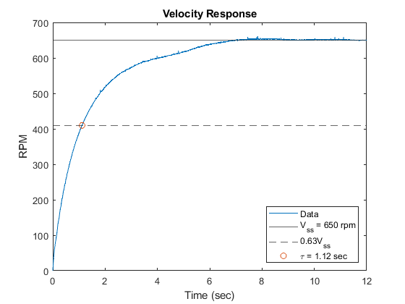
Published with MATLAB® R2021b

