Ali ElRogbany
Grant-Ivan Andalajao
Jihad Ballout
Harikrishna
Campus Pulse
Cloud Based Smart Campus Operations Platform for NorthBridge University

Table of Contents
Table of Contents 1
Table of Figures 4
Introduction 5
Problem Definition 5
Objectives 5
Selected Use Case 5
Team Organization 5
System Architecture 6
Overview 6
Write Path 6
Read Path 7
Components 7
Data Design 8
Design Choices and Justification 8
Technology Stack 9
Cloud Services 9
Programming Languages 9
Libraries and Frameworks 9
Deployment and Working Tools 9
Implementation Process 10
Preparation 10
Build in Four Slices 10
Deployment Workflow 16
Configuration Decisions 16
Technical Issues and Solutions 16
Security Design 16
Assets and Threats 17
IAM Strategy 17
Secure Networking 18
Encryption 18
API Protection 19
Secrets Management 25
Known Limitations 25
Scalability Strategy 26
Expected Behavior as the Workload Grows 26
Load Test Results 26
How the System Scales Further 27
Cost Analysis 27
Free Tier Assumptions 27
Estimated Costs 28
Billing Alert Evidence 29
Cost Optimization Decisions 30
Observability 31
Logs 31
Metrics 31
Dashboard 31
Alarms 31
Troubleshooting Mechanisms 32
Limits 33
Disaster Recovery Strategy 33
Threats and Protections in the Prototype 33
Backups 33
Designed Protection: Point in Time Recovery 34
Restore Procedure 34
Recovery Objectives 34
Continuity Decisions 35
Testing and Evaluation 35
Automated Tests 35
Functional and API Tests 36
Data Ingestion Tests 36
Monitoring Evidence 36
Performance Observations 36
Evaluation Against the Objectives 36
Lessons Learned 37
Technical Challenges 37
Trade-offs 37
Limitations 38
Future Improvements 38

Table of Figures
Figure I - CampusPulse 2026 architecture on AWS, region eu-west-3 6
Figure II - IAM user creation 10
Figure III - Terraform plan output for slice 1 11
Figure IV - Terraform apply output for slice 1 11
Figure V - Simulator output and GET /events response for slice 1 12
Figure VI - Terraform Cognito plan for slice 2 13
Figure VII - GET /stats output for slice 2 13
Figure VIII - GET /alerts output for slice 3 14
Figure IX - Terraform apply output for slice 3 15
Figure X - SNS subscription confirmation 15
Figure XI - IAM user permissions 18
Figure XII - GET /events with no token output 19
Figure XIII - GET /events with a false token output 20
Figure XIV - GET /stats as a student output 21
Figure XV - GET /alerts as a student output 22
Figure XVI - POST /events with no API key output 23
Figure XVII - POST /events with a valid key and an invalid body output 24
Figure XVIII - POST /events with a valid key and wrong event type output 25
Figure XIX - Load tests results 27
Figure XX - Cost estimate python script output 29
Figure XXI - Billing alert email 30
Figure XXII - campuspulse-access-denied-spike alert email 32
Figure XXIII - Pytest tests output 36

Introduction

Problem Definition
NorthBridge University operates buildings with sensors for room occupancy, temperature, humidity, energy use, door status and equipment faults. A reading has value only when staff see the reading in time. Without a shared platform, staff check each source separately and notice problems late. An overcrowded lecture room or a failed cooling unit comes to light after someone files a report.

The university needs one platform to collect these readings, store them and show them to the right people. Facilities staff need statistics and alerts. Students need a limited view of room conditions.

Objectives
- Receive sensor events through a public HTTPS API and store them in a managed database.
- Serve recent events, statistics and alerts to logged in users.
- Restrict each route by role. The two roles are ops_admin and student.
- Run the compute inside a private network with no route to the internet.
- Monitor the system with logs, a dashboard and alarms with email notification.
- Define every resource as code, so one command builds or removes the environment.
- Stay inside the AWS Free Tier and support the claim with a cost estimate.
- Measure behavior under load and document the limits.

Selected Use Case
We selected campus operations monitoring. The platform handles six event types: occupancy, temperature, humidity, energy, door_status and equipment_failure. Each event carries a building, a room, a value, a unit, a severity of normal, warning or critical, and a timestamp.

The simulator generates events for four buildings and nine rooms: Library-A (three rooms), Lab-B (two), Engineering-C (two) and Student-Center-D (two). A configurable share of readings is abnormal. Examples are a room filled to 110 to 150 percent of capacity and a temperature above 32 degrees Celsius.

Two roles use the platform. The ops_admin role reads events, statistics and alerts. The student role reads events and statistics only.

Team Organization
[TODO]

The team works from one GitHub repository. A contracts document fixes the event format, the API routes, the status codes, the DynamoDB key design and the role rules. Every component follows the contracts, so each part of the code connects to the others without rework.

System Architecture

Overview
CampusPulse is a serverless platform in the AWS region eu-west-3 (Paris). Sensors send events to Amazon API Gateway. AWS Lambda functions validate and store the events in Amazon DynamoDB. Amazon Cognito handles login and roles. Amazon CloudWatch collects logs and metrics, draws a dashboard and raises alarms. Amazon SNS sends alarm emails. Terraform builds everything.

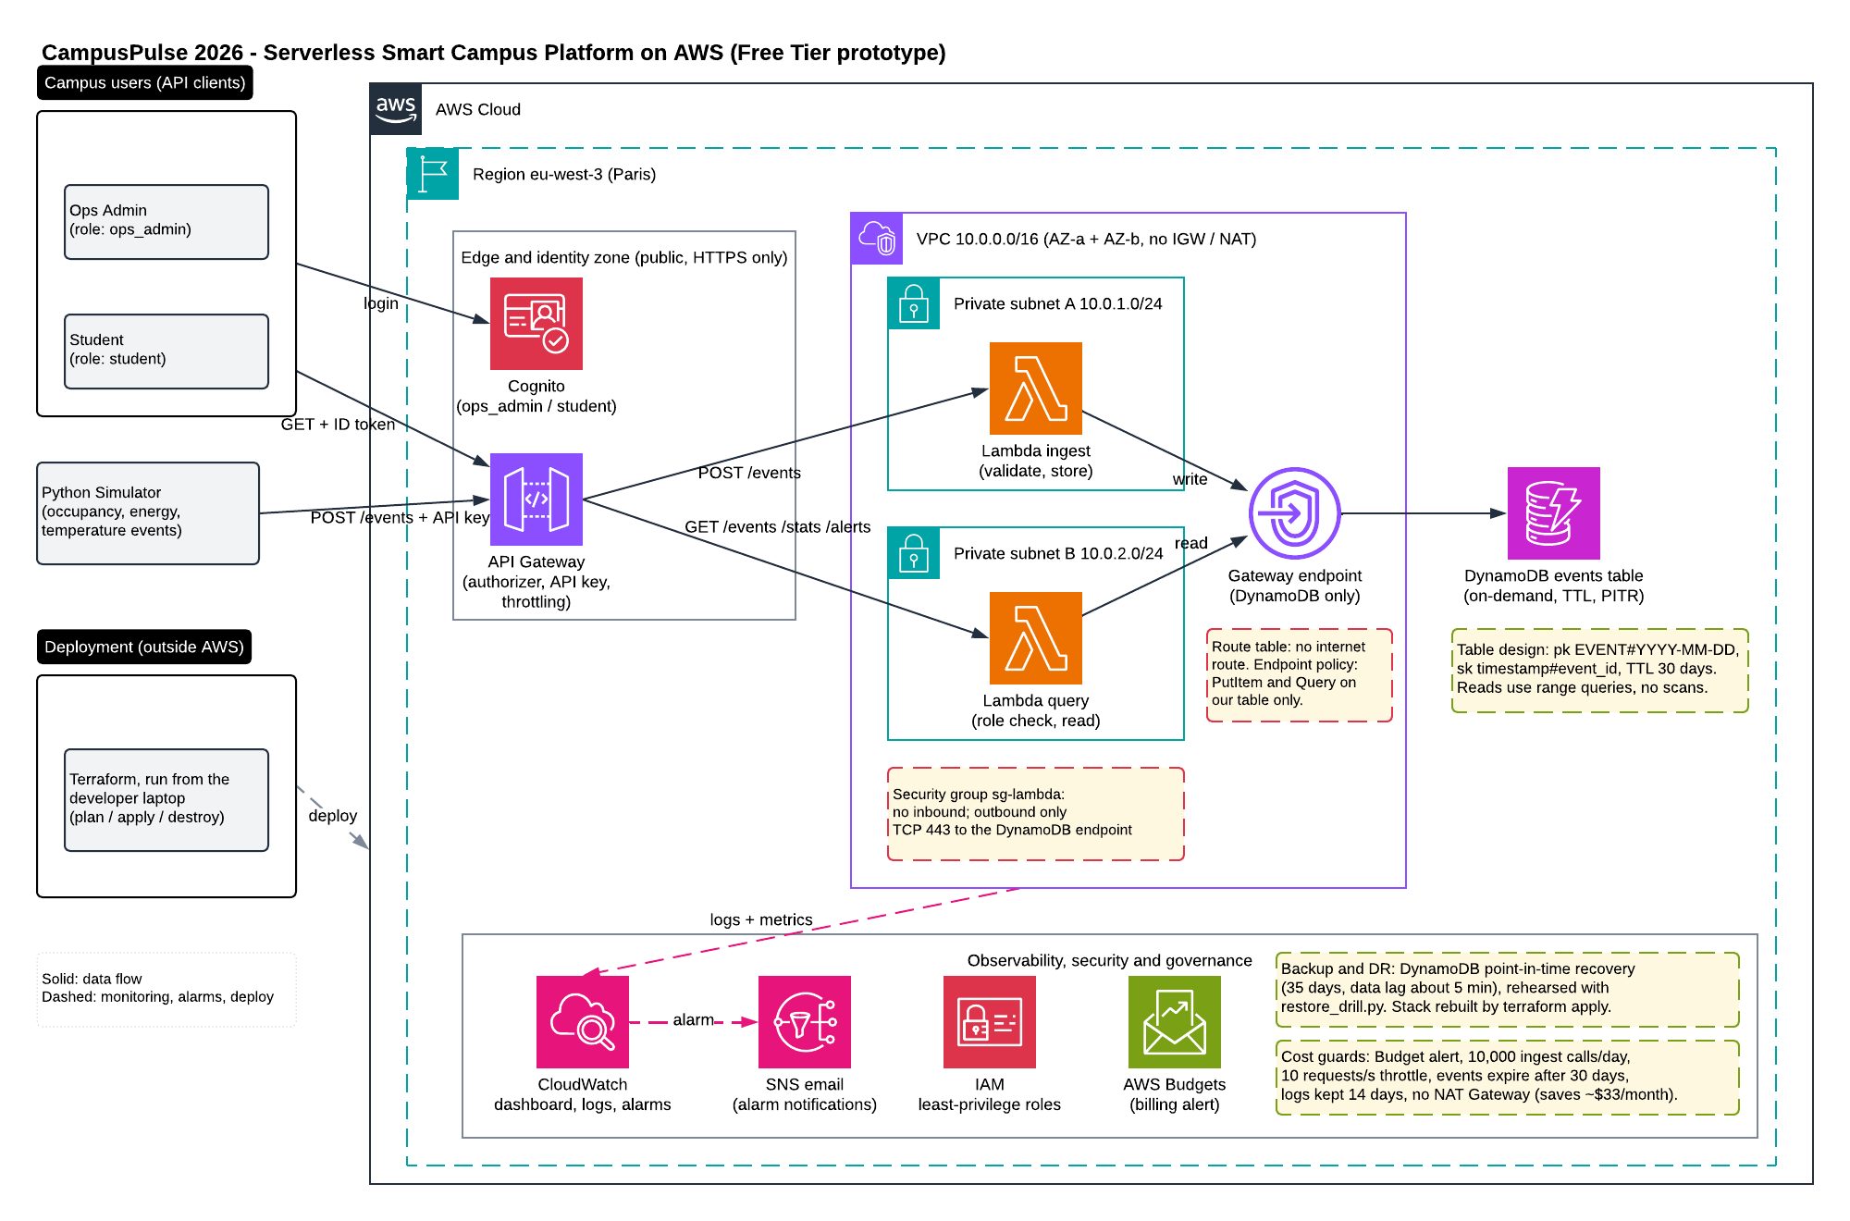
Figure I - CampusPulse 2026 architecture on AWS, region eu-west-3

Write Path
- The simulator sends POST /events with an x-api-key header.

- API Gateway checks the API key, applies the rate limit and the daily quota, and validates the body against a JSON schema. A bad body returns 400 and no Lambda runs.

- API Gateway invokes the ingest Lambda.

- The Lambda validates every field again, creates an event ID when the sender gives none, and builds the DynamoDB keys.

- The Lambda writes the item through the VPC gateway endpoint. A condition on the write refuses duplicates.

- The Lambda returns 201 for a stored event and 409 for a duplicate.

Read Path
- A user logs in to Cognito with email and password and receives an ID token valid for 60 minutes.

- The user sends a GET request with the token in the Authorization header.

- API Gateway verifies the token signature and expiry. A failure returns 401 and no Lambda runs.

- The query Lambda reads the cognito:groups claim and applies the rule for the route. A failure returns 403 and writes an access_denied log line.

- The Lambda queries DynamoDB and returns JSON.

Components
Amazon API Gateway: A regional REST API with stage v1 and four routes: POST /events, GET /events, GET /stats and GET /alerts. POST uses an API key tied to a usage plan of 10 requests per second, a burst of 20 and 10,000 requests per day. The GET routes use a Cognito authorizer. A request validator rejects malformed bodies at the edge.

Ingest Lambda: Python 3.12, 128 MB, 10 second timeout. Validates the event, builds the keys and writes one item. The function runs inside the VPC.

Query Lambda: Same runtime and size. Handles three routes. Checks the role of the caller, runs range queries on DynamoDB and computes statistics in memory.

Amazon DynamoDB: One table named campuspulse-events in on demand mode. The partition key is the word EVENT followed by the UTC date of the event. The sort key is the timestamp followed by the event ID. A time to live attribute deletes events 30 days after writing.

Amazon Cognito: One user pool. Public sign up is off. An administrator creates each account. Passwords need at least 12 characters. Two groups exist: ops_admin and student.

Amazon VPC: Network 10.0.0.0/16 with two private subnets (10.0.1.0/24 and 10.0.2.0/24) in two Availability Zones. The network has no internet gateway and no NAT gateway. A free gateway endpoint gives the Lambdas a private path to DynamoDB.

Amazon CloudWatch: Two log groups with 14 day retention, two metrics built from log lines, one dashboard named campuspulse-operations and four alarms.

Amazon SNS: One topic. CloudWatch alarms publish to the topic, and the topic sends email to the operations address.

AWS IAM: One role per Lambda with the smallest set of actions.

AWS Budgets: A monthly budget of 5 US dollars with email alerts.

Data Design
The access pattern drives the key design. Users ask for the latest events, for statistics over a time window and for alerts over a time window. All three read a time range. Using the UTC date as the partition key and the timestamp as the sort key turns each request into a Query on one or a few partitions. The system never scans the table.

The sort key holds the event ID after the timestamp. Two events with the same timestamp stay separate, and a retried event hits the same key. The write condition then refuses the second copy.

Design Choices and Justification
Serverless instead of virtual machines: Lambda, API Gateway and DynamoDB cost nothing while idle. A campus workload is quiet at night and during holidays. A virtual machine would bill every hour and need patching.

REST API instead of HTTP API: The REST type supports API keys, usage plans and request validation. The simulator needs the first two. The edge validation stops bad bodies before the Lambda runs. The HTTP API costs less per call and offers none of these controls.

DynamoDB instead of a relational database: The data is a stream of timestamped events read by time range. DynamoDB handles this pattern with on demand billing, free expiry through time to live and no server to manage. A relational database would add a fixed hourly cost.

Cognito instead of a custom login route: The brief lists a POST /login route. We replaced the route with Cognito. Our code never stores or checks a password. Cognito issues signed tokens and API Gateway verifies them before any of our code runs.

Private network without NAT: A NAT gateway costs about 33 US dollars a month at list price. The Lambdas need only DynamoDB, so the gateway endpoint covers the need at no cost. Removing the internet route also limits what a compromised function could reach.

Terraform instead of console clicks: Code gives a repeatable build, a reviewable history and a one command teardown. The teardown matters for cost control.

One table and one region: The prototype serves one campus. A second region would double the operational work and add cost for no gain at this scale.

Point in time recovery: The architecture includes DynamoDB point in time recovery for protection against human error. The prototype leaves the feature off because AWS bills the feature outside the Free Tier. The “Disaster Recovery Strategy” section gives the reasoning.

Technology Stack

Cloud Services
- Amazon API Gateway (REST API) for the public entry point, authentication, validation and throttling.
- AWS Lambda (Python 3.12) for compute.
- Amazon DynamoDB (on demand) for storage.
- Amazon Cognito (user pool) for login and roles.
- Amazon VPC with subnets, route table, security group and gateway endpoint for networking.
- Amazon CloudWatch (Logs, Metrics, Alarms, Dashboards, Logs Insights) for observability.
- Amazon SNS for alarm email.
- AWS IAM for access control.
- AWS Budgets for the billing alert.

Programming Languages
- Python 3.12 runs the Lambdas, the simulator, the user scripts, the load test and the cost estimator.
- HCL, the Terraform language, describes the infrastructure.

Libraries and Frameworks
- boto3 connects Python to AWS.
- requests sends HTTP calls in the simulator and the load test.
- pytest runs the tests.
- moto simulates DynamoDB and Cognito, so integration tests run without an AWS account.
- python-hcl2 reads the Terraform files in the guardrail tests.

Deployment and Working Tools
- Terraform with the AWS provider (5.60 or newer, below version 6) and the archive provider. The archive provider zips the Lambda source folders, so no separate build step exists.
- AWS CLI for credentials and for the evidence commands.
- Git and GitHub for version control.
- Lucidchart with the AWS 2024 shape library for the diagram.

Terraform state stays local in the file terraform.tfstate. The .gitignore file excludes the state, the variables file and build output from the repository.

Implementation Process

Preparation
The AWS account started as a root account. Daily work with root credentials exposes the whole account, so we created an IAM user with administrator rights, turned on multi factor authentication and stopped using root. We configured the AWS CLI with the IAM user and created the GitHub repository.

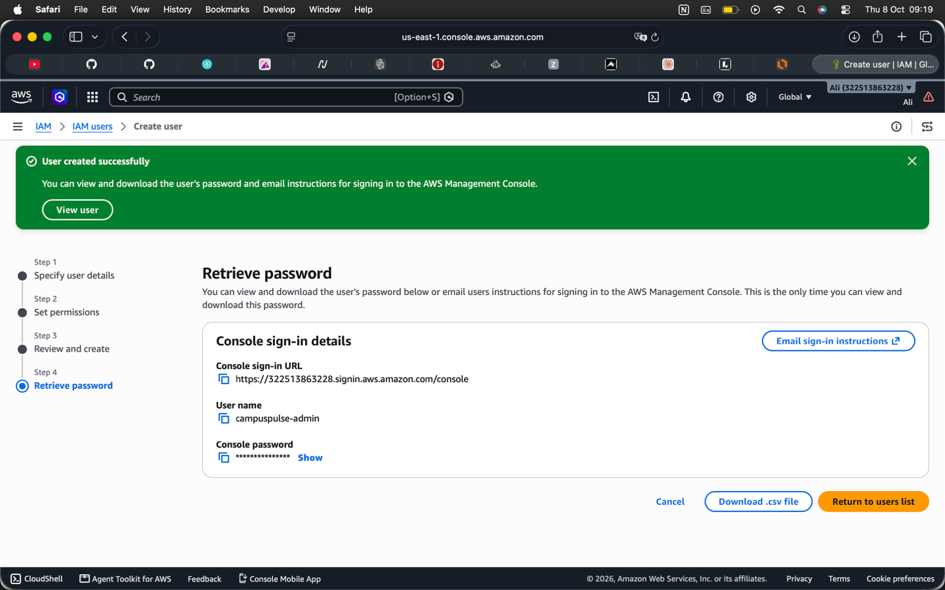
Figure II - IAM user creation

Build in Four Slices
We built the platform in four slices. Each slice ended with a deployment and a test against the live system.

Slice 1 - core pipeline: DynamoDB table, ingest Lambda, query Lambda, API Gateway, API key, usage plan and budget. The simulator sent events and a GET request returned them.

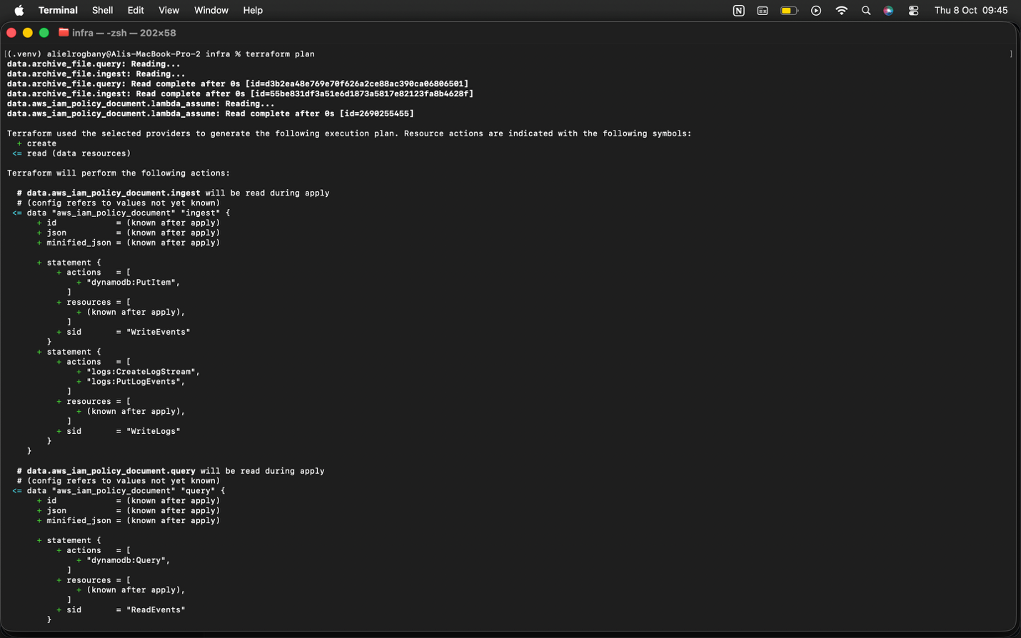
Figure III - Terraform plan output for slice 1

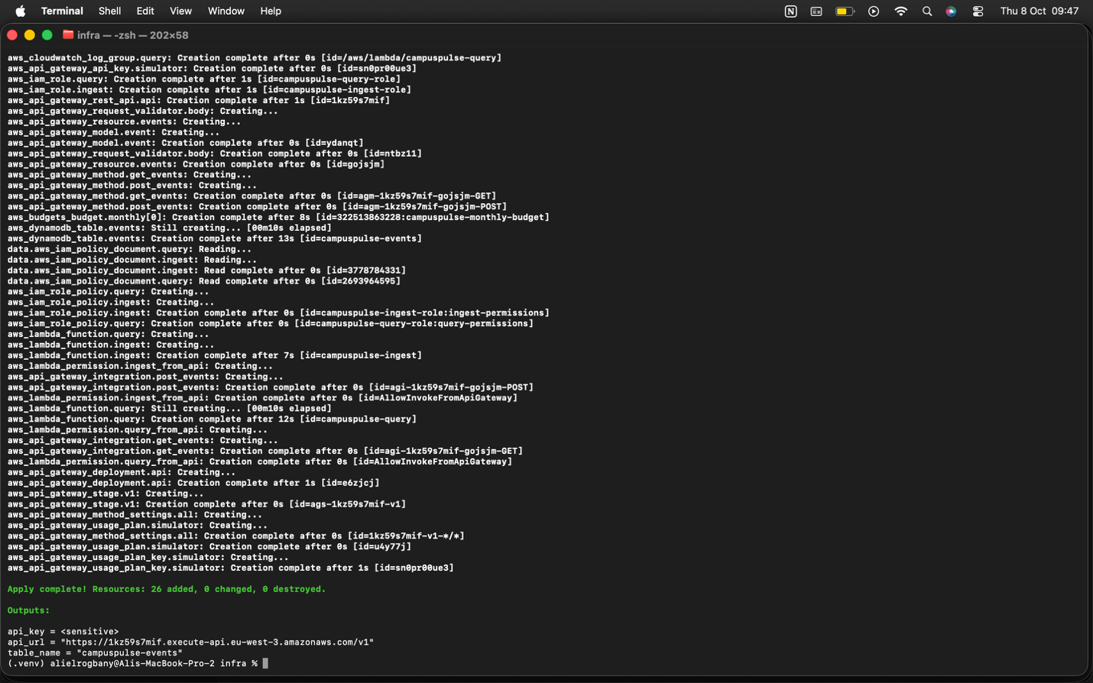
Figure IV - Terraform apply output for slice 1
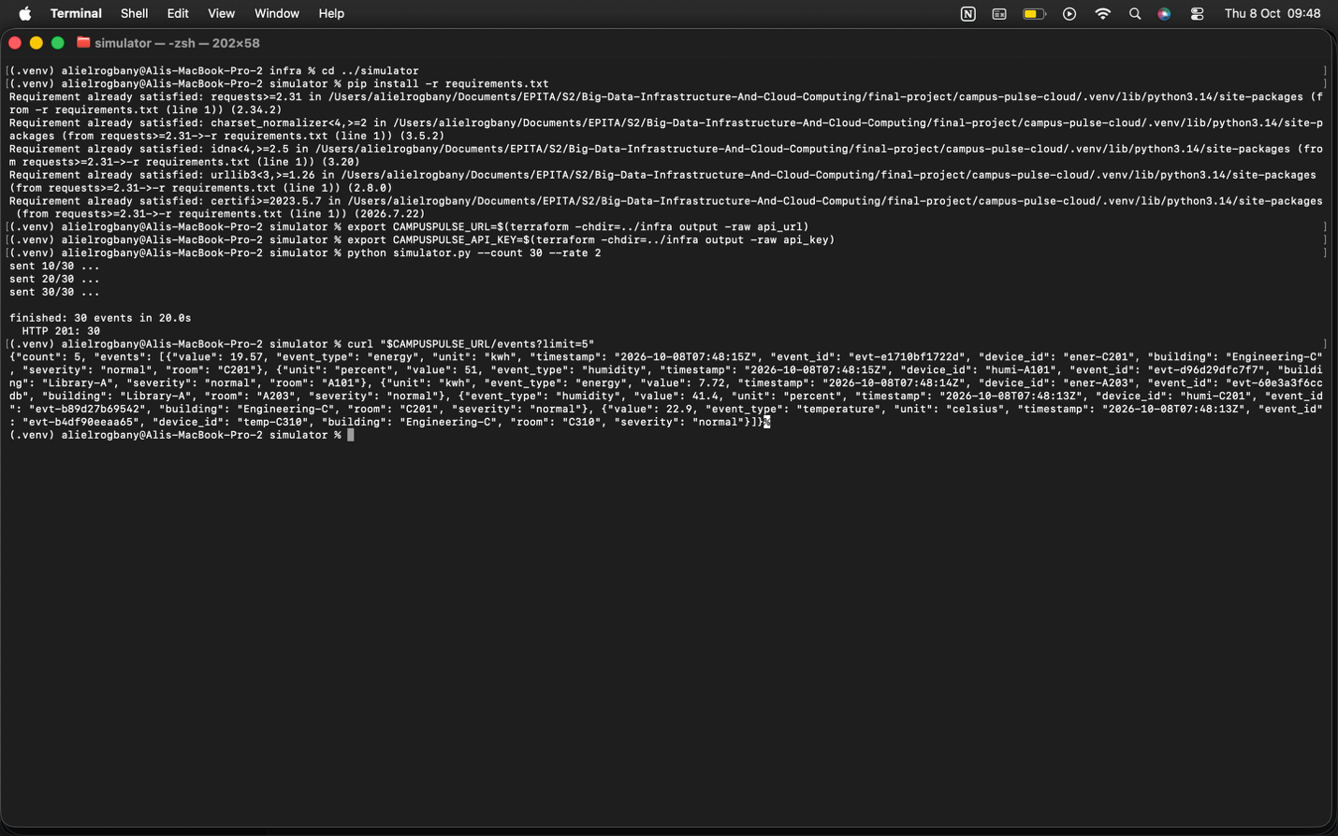
Figure V - Simulator output and GET /events response for slice 1

Slice 2 - identity and roles: Cognito user pool, two groups, a token authorizer on the GET routes, the /stats and /alerts routes and the role check in the query Lambda. Two scripts create users and fetch tokens.

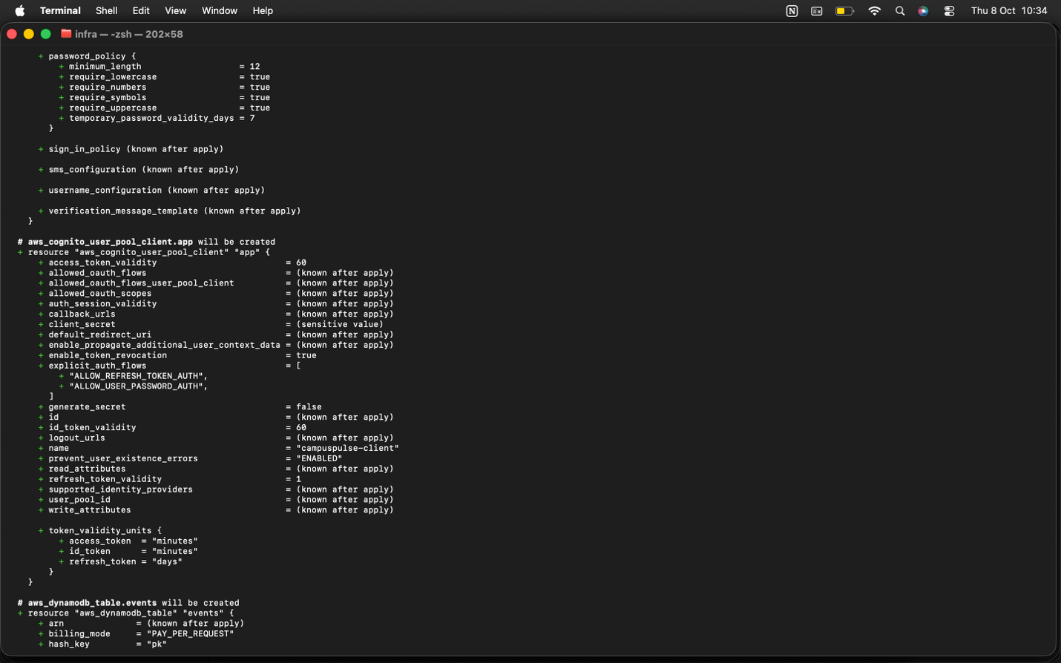
Figure VI - Terraform Cognito plan for slice 2

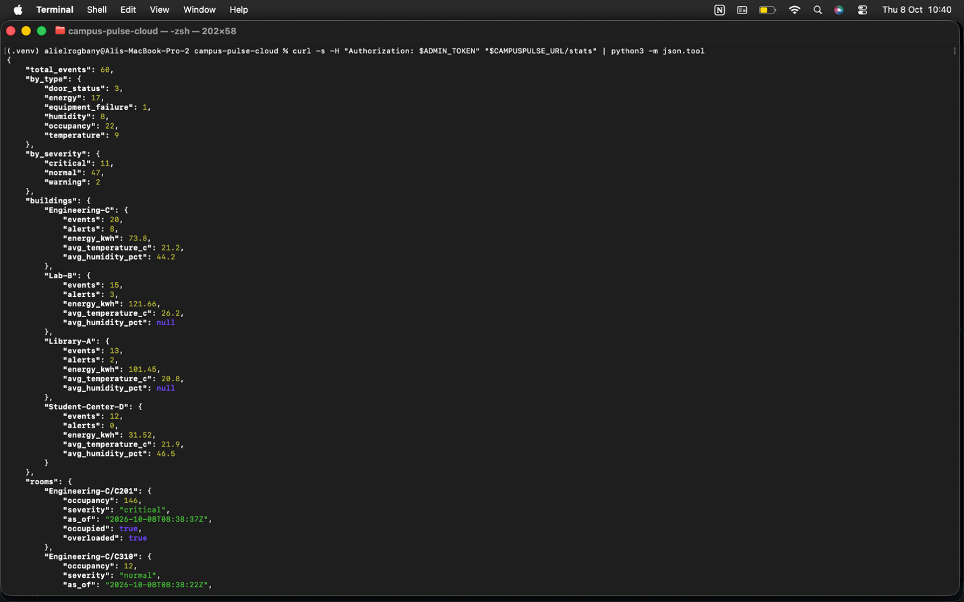
Figure VII - GET /stats output for slice 2

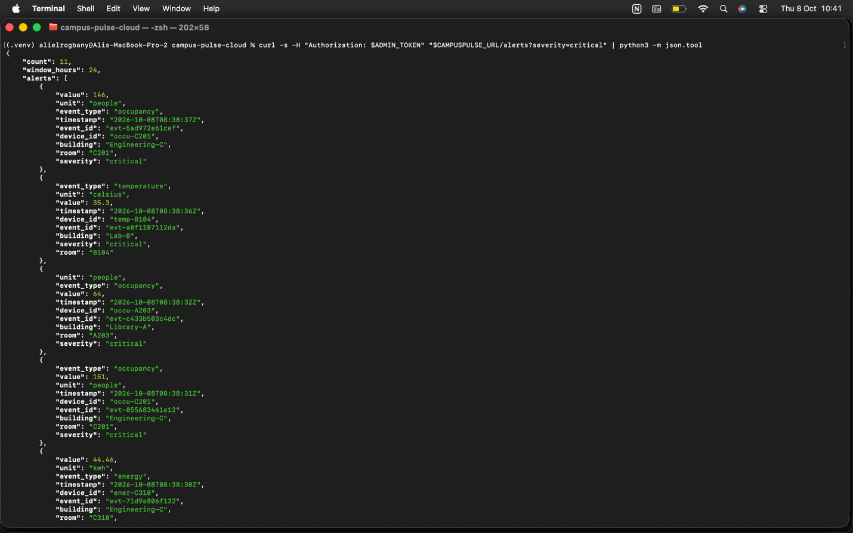
Figure VIII - GET /alerts output for slice 3

Slice 3 - network and monitoring: VPC, subnets, gateway endpoint, security group, Lambdas moved into the VPC, dashboard, metric filters, alarms and SNS email.

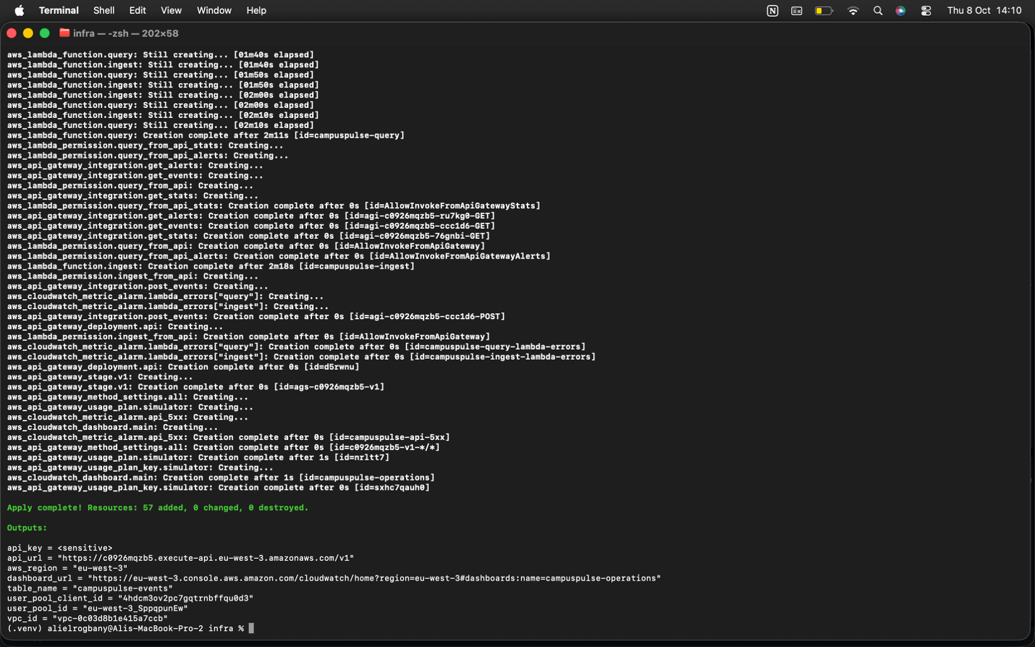
Figure IX - Terraform apply output for slice 3

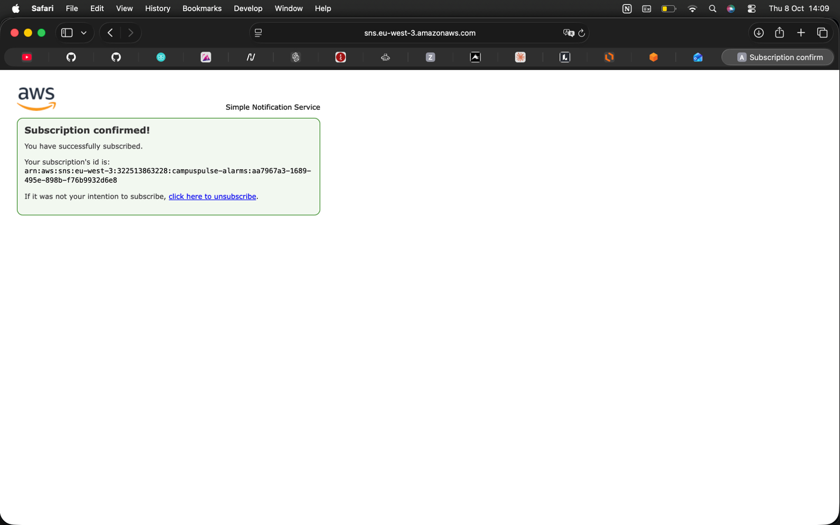
Figure X - SNS subscription confirmation

Slice 4 – evidence: Load test script, cost estimator and the resilience and cost documents. Slice 4 changed no deployed resource.

Deployment Workflow
The same workflow serves every slice.

- Run pytest. The suite must pass before any deployment.
- Run terraform init once, then terraform plan and read the list of creates, changes and destroys.
- Run terraform apply and type yes.
- Confirm the SNS subscription from the email AWS sends.
- Create the two users with the user script. The script asks for each password at a hidden prompt.
- Fetch tokens with the token script, run the simulator and call the API with curl.
- Collect evidence.
- Run terraform destroy at the end of each session.

Configuration Decisions
- Region eu-west-3. The team and the users sit in Europe, and Paris keeps latency low.
- Lambda memory 128 MB. The workload is light. The smallest size costs the least.
- Lambda timeout 10 seconds. A normal call finishes in milliseconds. A short timeout stops a stuck call from running up cost.
- Log retention 14 days. Logs expire on a schedule, so log storage stays inside the free allowance.
- Event expiry 30 days. DynamoDB deletes old events for free.
- API throttle 10 requests per second with a burst of 20. The limits protect cost and the database.
- Daily quota 10,000 requests for the simulator key. At list prices the quota caps the ingest bill near 1.30 US dollars a month.
- Budget 5 US dollars a month.

Technical Issues and Solutions
Root account. The account began as a root account. We created an IAM administrator with MFA and stopped using root.

Duplicate event test. The first test accepted either 201 or 409 for a repeated event, so the test proved nothing. We fixed the timestamp so the second call must return 409.

Role checks broke the query tests. Adding role checks made the old tests fail, because the tests sent no user identity. We moved the coverage to integration tests with moto. Those tests send realistic Cognito claims through the full handler.

Security Design

Assets and Threats
The assets are the sensor data, the user accounts, the AWS account and the monthly budget. Each threat below appears with the control against the threat.

Threat: an unauthenticated person reads data.
Control: the Cognito authorizer returns 401 before any code runs.

Threat: a student reads admin data.
Control: the query Lambda checks the group claim and returns 403 for /alerts.

Threat: a forged or flooded event stream.
Control: API key, rate limit, daily quota and validation at two layers.

Threat: malformed or hostile input.
Control: schema validation at the gateway, field validation in the Lambda, unknown fields dropped, and the DynamoDB API with no query string built from input.

Threat: leaked credentials.
Control: no secret in code, a .gitignore for state and variable files, and a test scanning the Terraform for AWS key patterns.

Threat: a compromised function sends data out.
Control: no route to the internet and a firewall rule allowing only DynamoDB.

Threat: a person or script deletes data through our code.
Control: neither Lambda role holds a delete or update permission.

Threat: account takeover.
Control: no root use and MFA on the administrator.

Threat: a cost attack.
Control: throttling, a daily quota and a budget alert.

IAM Strategy
Each Lambda has a dedicated role. The ingest role holds one data action, PutItem, on one table. The query role holds one data action, Query, on one table. Both roles write logs only to their own log group. Both roles hold the six EC2 network interface actions AWS requires for functions inside a VPC. No role holds delete, update, scan or wildcard data permissions.

The VPC endpoint policy adds a second lock. Traffic through the endpoint reaches only PutItem and Query on our table. A call must pass both the role and the endpoint policy.

Humans use the IAM administrator, not root. MFA protects the administrator.

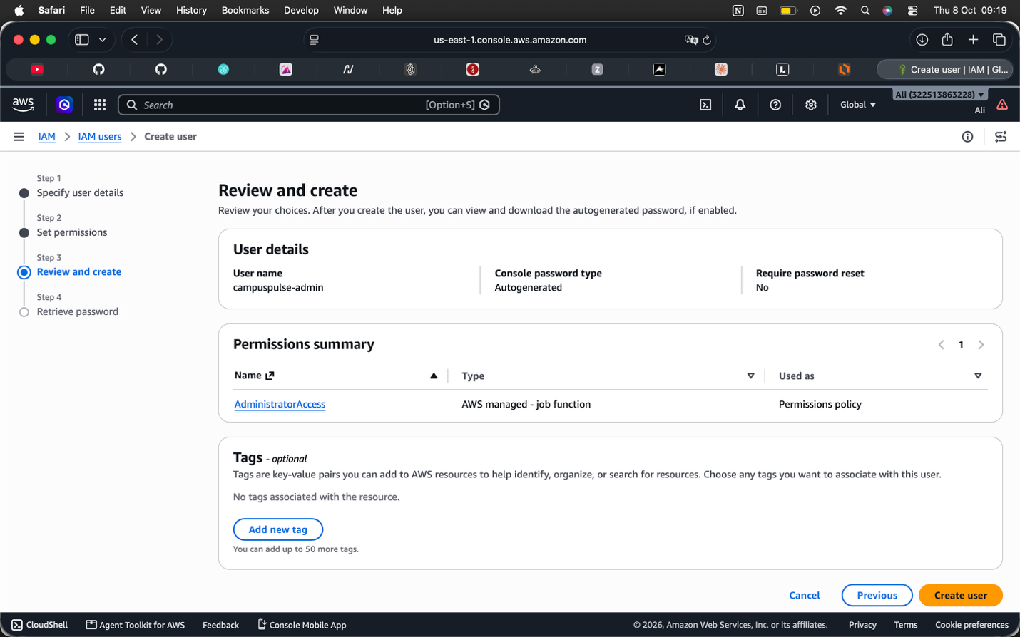
Figure XI - IAM user permissions

Secure Networking
The Lambdas run in two private subnets. The route table has no route to the internet. The account has no internet gateway and no NAT gateway. The security group has no inbound rule. The one outbound rule allows TCP port 443 to the DynamoDB prefix list.

API Gateway stays public by design. The gateway carries the protections: HTTPS only, API key, token verification, validation and throttling.

Guardrail tests read the Terraform files and fail on a NAT gateway, an internet gateway, a route, an inbound rule, an open address range or a function outside the VPC.

Encryption
In transit. API Gateway accepts HTTPS only. Traffic between the Lambdas and DynamoDB stays on the AWS network through the gateway endpoint and uses TLS.

At rest. DynamoDB encrypts every table by default. CloudWatch Logs and Lambda environment variables also use default encryption. We use AWS owned keys. A customer managed KMS key costs about 1 US dollar a month per key, and a guardrail test blocks KMS keys to protect the Free Tier. A production system with regulated data would use customer managed keys.

API Protection
Four layers check each request.

Layer 1: API Gateway checks the API key on POST, or the token signature and expiry on GET. Throttling and the quota apply here.

Layer 2: API Gateway validates the body against the JSON schema.

Layer 3: The Lambda applies the role rule.

Layer 4: The Lambda validates each field. The Lambda rejects a timestamp more than five minutes in the future.

Status codes tell the caller what failed without leaking detail. A 500 returns no stack trace. The stack trace goes to CloudWatch only. Logs never hold passwords, tokens, API keys or full request bodies, and a test enforces the last rule.

The security demonstration ran seven calls against the live API.

Call 1. GET /events with no token. Result 401.

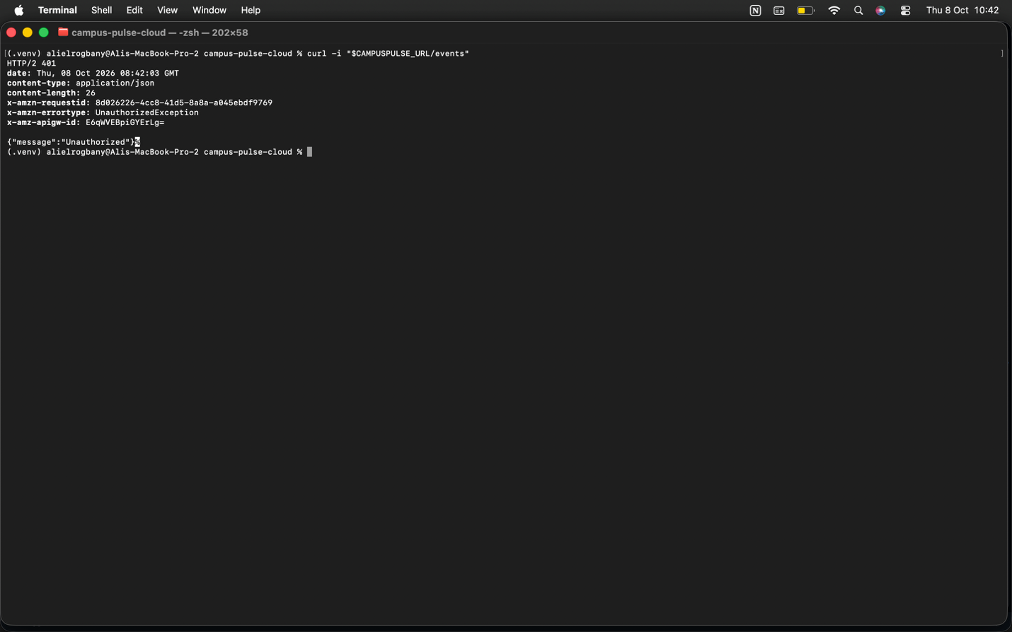
Figure XII - GET /events with no token output

Call 2. GET /events with a false token. Result 401.
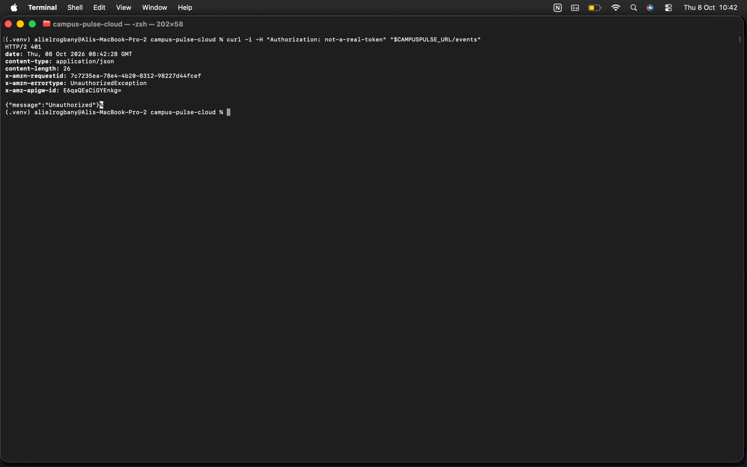
Figure XIII - GET /events with a false token output

Call 3. GET /stats as a student. Result 200.

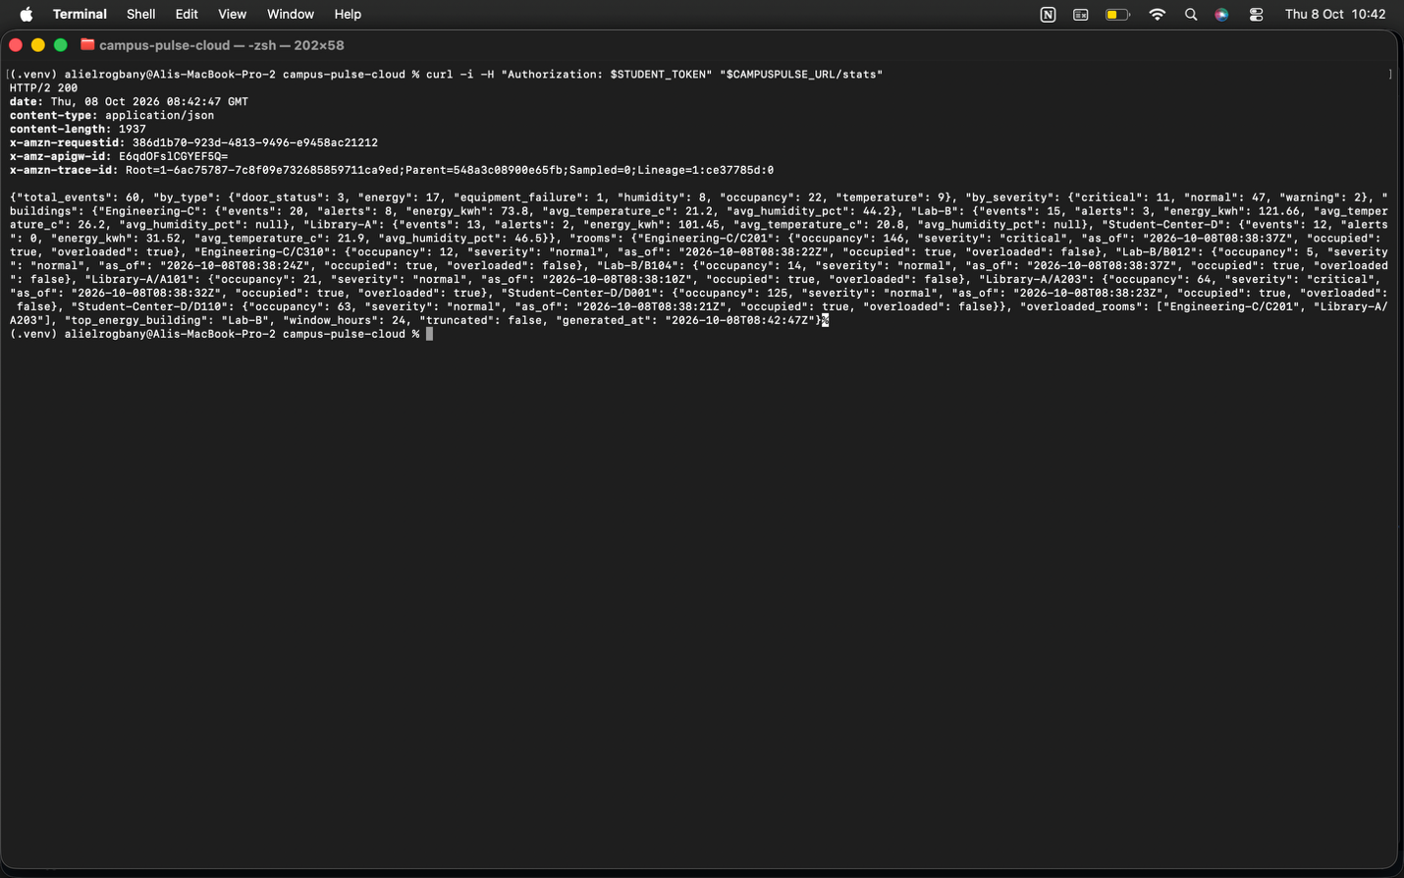
Figure XIV - GET /stats as a student output

Call 4. GET /alerts as a student. Result 403.

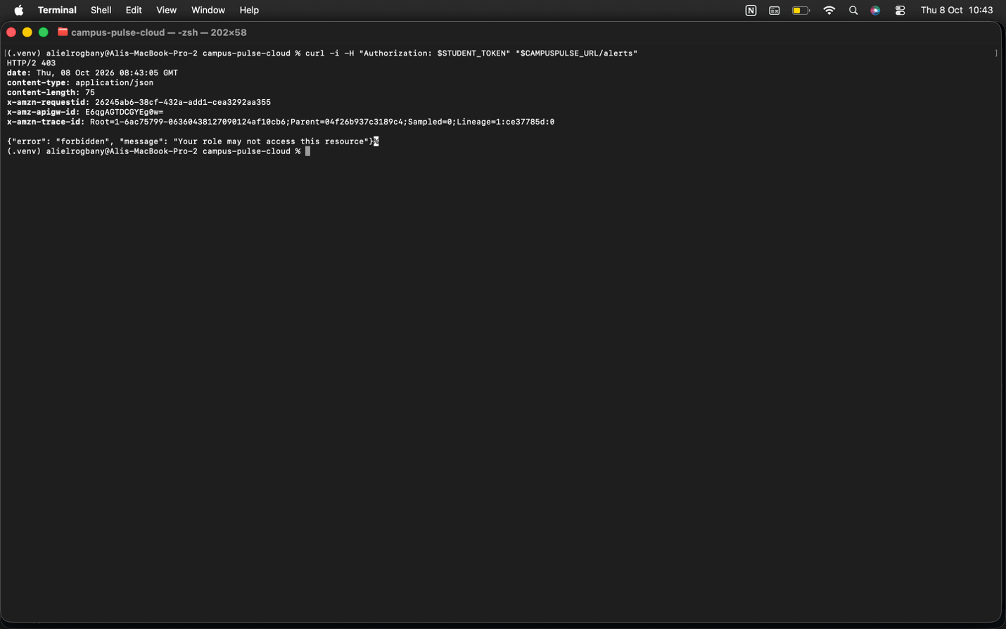
Figure XV - GET /alerts as a student output

Call 5. POST /events with no API key. Result 403.

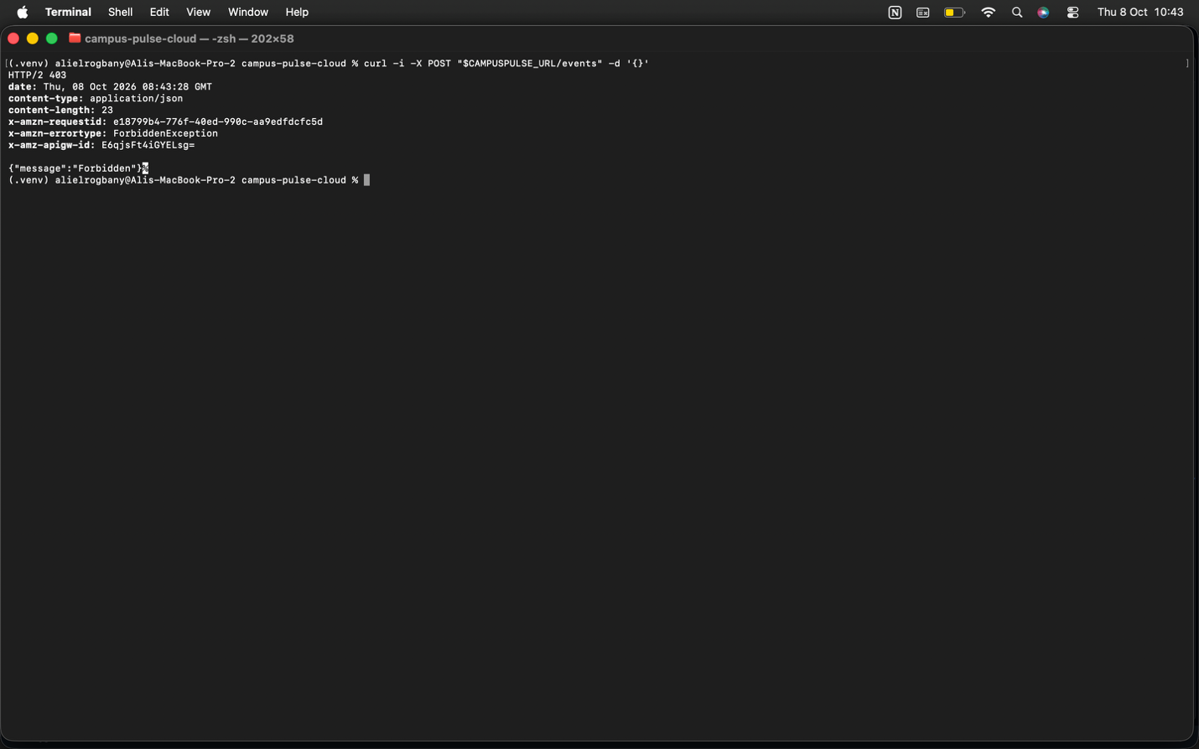
Figure XVI - POST /events with no API key output

Call 6. POST /events with a valid key and the body {“foo”: 1}. Result 400 from API Gateway.

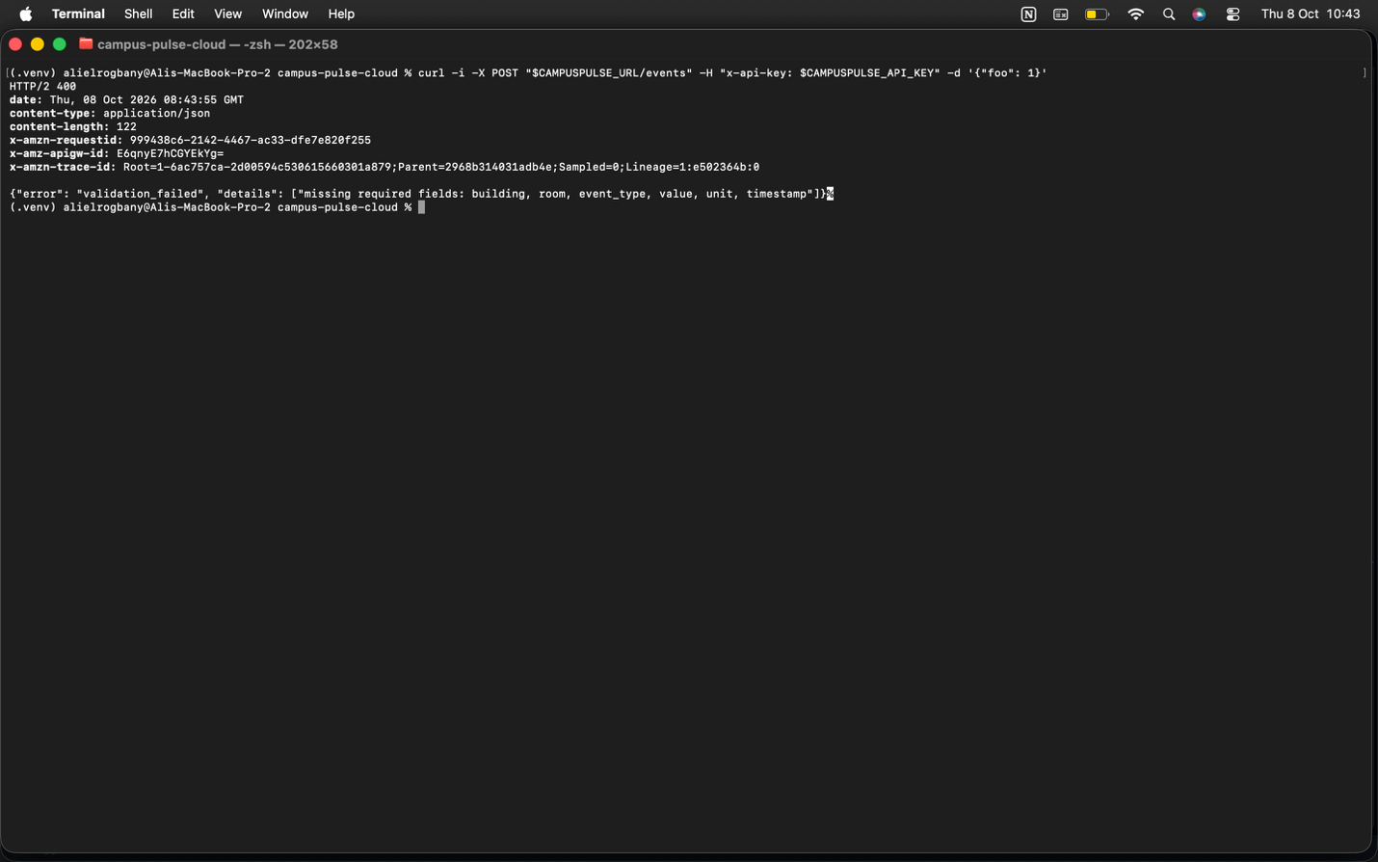
Figure XVII - POST /events with a valid key and an invalid body output

Call 7. POST /events with a valid key and event_type set to banana. Result 400 from the Lambda, with the reason in the body.

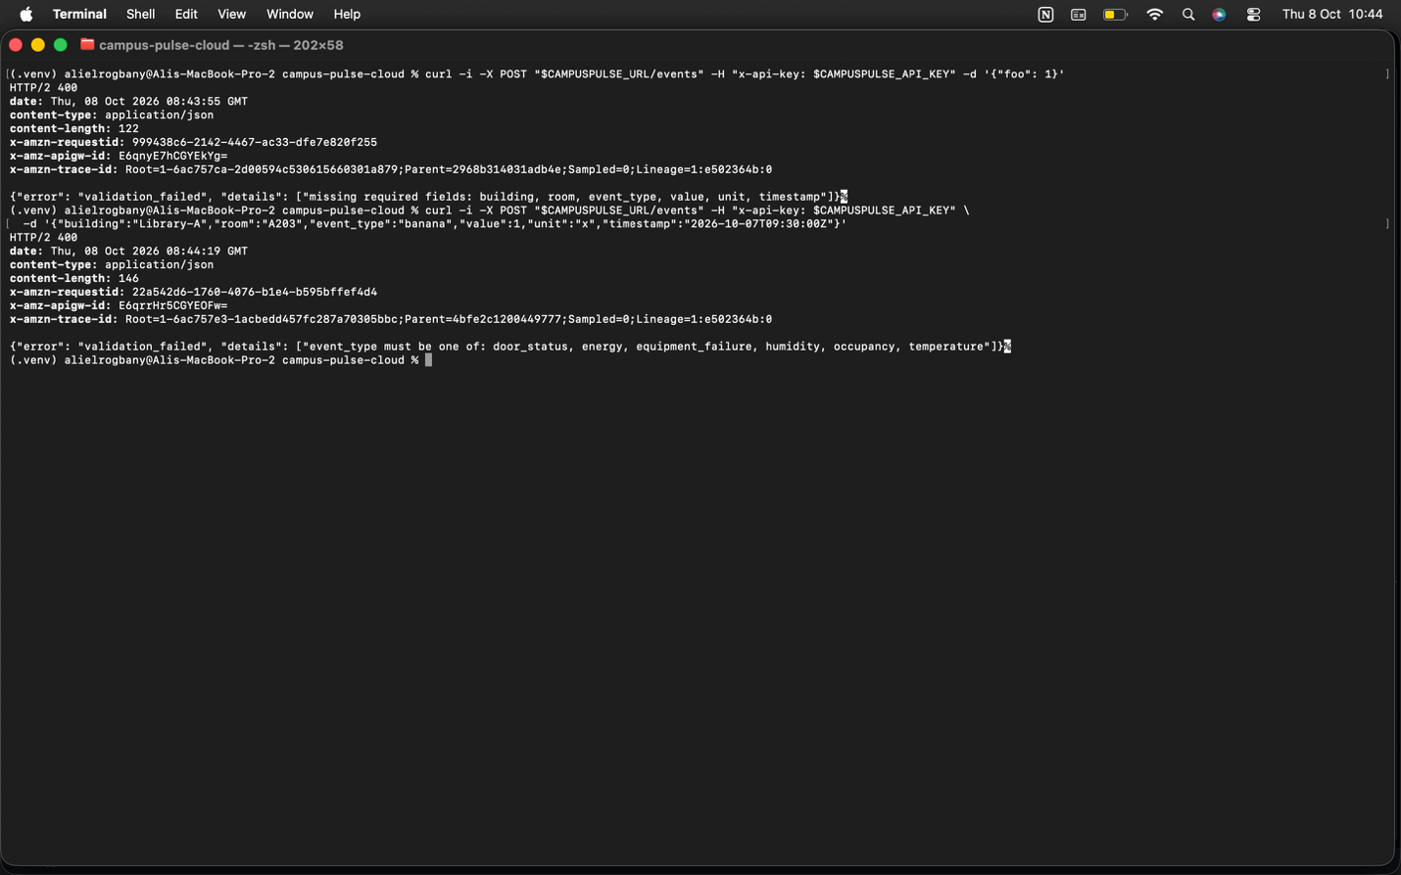
Figure XVIII - POST /events with a valid key and wrong event type output

Secrets Management
The project holds three kinds of secret. AWS credentials live in the AWS CLI configuration on the developer machine and never enter the repository. User passwords go to Cognito through a hidden prompt, and no file or log stores them. The API key comes from Terraform, which marks the output as sensitive and keeps the value out of the plan display.

The API key still sits in the local Terraform state file as plain text. The .gitignore file excludes the state from Git. A production setup would store state in an encrypted S3 bucket with locking, and would keep secrets in AWS Secrets Manager. We chose not to add either, to stay inside the Free Tier and the project scope.

Known Limitations
The simulator shares one API key. A key identifies an application and does not identify a device. A production design would give each sensor a separate credential, for example through AWS IoT Core.

No web application firewall protects the API, because AWS WAF carries a monthly charge.

Cognito users sign in with a password only. Production would add MFA.

The Lambdas use AWS owned encryption keys.

Scalability Strategy

Expected Behavior as the Workload Grows
The prototype runs at small volume. The estimate in the “Cost Analysis” section defines two larger scenarios.

Campus scenario: 2,000 sensors send one reading every five minutes. This equals 17.28 million events a month, or 6.7 writes per second on average.

Large scenario: 20,000 sensors with the same rate. This equals 172.8 million events a month, or 67 writes per second on average.

Each layer responds as follows:

API Gateway: The stage limit of 10 requests per second is a deliberate cost control. Raising api_rate_limit and api_burst_limit in the variables file lifts the cap with no code change. Without the change, the gateway answers the excess with 429.

Lambda: AWS starts one execution environment per concurrent request. The account concurrency limit is the ceiling. A new account sometimes starts with a low limit, so the team checks the limit in the Lambda console before a load increase.

DynamoDB: On demand mode adapts to traffic with no capacity planning. A single partition key sustains about 1,000 writes per second. The Large scenario averages 67 writes per second, which leaves roughly 15 times the needed headroom. Above 1,000 writes per second, we would add a shard suffix to the partition key and query all shards.

Query Lambda: The /stats route reads a time window and computes in memory. The route stops at 5,000 events and sets a truncated flag in the response. The flag warns the caller of incomplete numbers. Heavy reading at larger volume needs pre computed summaries, for example a DynamoDB stream feeding an hourly summary table.

Load Test Results
The load test sends two phases. The steady phase sends 300 requests at 8 per second, below the limit of 10. The burst phase sends 200 requests, 25 at a time, with no pacing. A pass needs zero server errors (5xx). In the burst phase the gateway must refuse the excess with 429.

Steady phase results:
300 requests sent in 37.4 seconds (8 requests per second), 300 requests were stored with the 50 percentile latency at 45 ms and the max latency at 120 ms.

Burst phase results:
200 requests sent in 3.2 seconds (62.1 requests per second), 16 requests were stored, 30 were throttled by the API gateway and 154 got an HTTP 500 error. For the stored requests, the 50 percentole latency was 2879 ms and the max latency was 3205 ms.

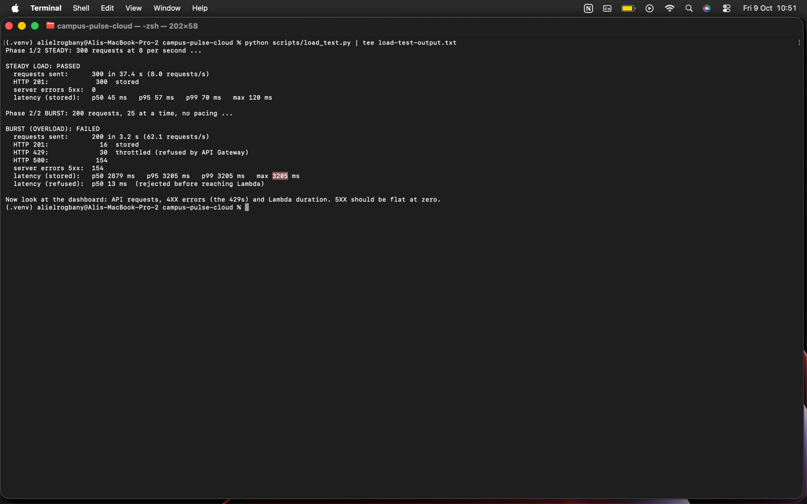
Figure XIX - Load tests results

How the System Scales Further
Step 1. Raise the API limits and the daily quota through variables.

Step 2. Batch several readings into one API call. This cuts the API Gateway bill, the largest cost line.

Step 3. Add a shard suffix to the partition key above about 1,000 writes per second.

Step 4. Add pre computed summaries for statistics.

Step 5. Deploy a second region behind Route 53 for regional failure.

Cost Analysis

Free Tier Assumptions
The estimate uses these allowances, taken from the AWS pricing pages:

- API Gateway: 1 million REST calls a month for the first 12 months after sign up.
- Lambda: 1 million requests and 400,000 GB seconds a month, with no expiry.
- DynamoDB: 25 GB of storage, with no expiry. On demand requests carry a charge. The free read and write units apply to provisioned tables only.
- CloudWatch: 10 alarms, 3 dashboards, 10 custom metrics and 5 GB of logs a month.
- Cognito: 10,000 monthly active users.

The platform uses 4 alarms, 1 dashboard and 2 custom metrics.

All prices come from the Paris region (eu-west-3) price lists.

Estimated Costs
The cost estimator is a Python script with every price as a named constant and tests comparing the arithmetic with hand calculations. The assumptions are an event size of 0.5 KB, 100 DynamoDB read units per read request, 300 ms per read and 600 bytes of logs per request.

As we have seen previously, the 45 ms of Lambda time per injest is also taken into account in the python script.

Prototype. 20,000 events and 2,000 reads a month. Cost 0.04 US dollars a month in the first year and 0.12 after the API Gateway allowance expires. DynamoDB requests make up almost all of the cost.

Campus scenario. 17.28 million events and 300,000 reads a month. Cost 81.52 US dollars a month in the first year and 85.02 after. API Gateway 58.03, DynamoDB 17.29, Lambda 3.32, CloudWatch 2.89.

Large scenario. 172.8 million events and 3 million reads a month. Cost 908.80 US dollars a month in the first year and 912.30 after. API Gateway 611.80, DynamoDB 194.83, Lambda 46.37, CloudWatch 55.80.

API Gateway is the largest cost line. Every reading is one billed call. Batching readings or moving to the HTTP API type would cut the line. The HTTP API removes request validation and API keys, so we would trade away two controls.

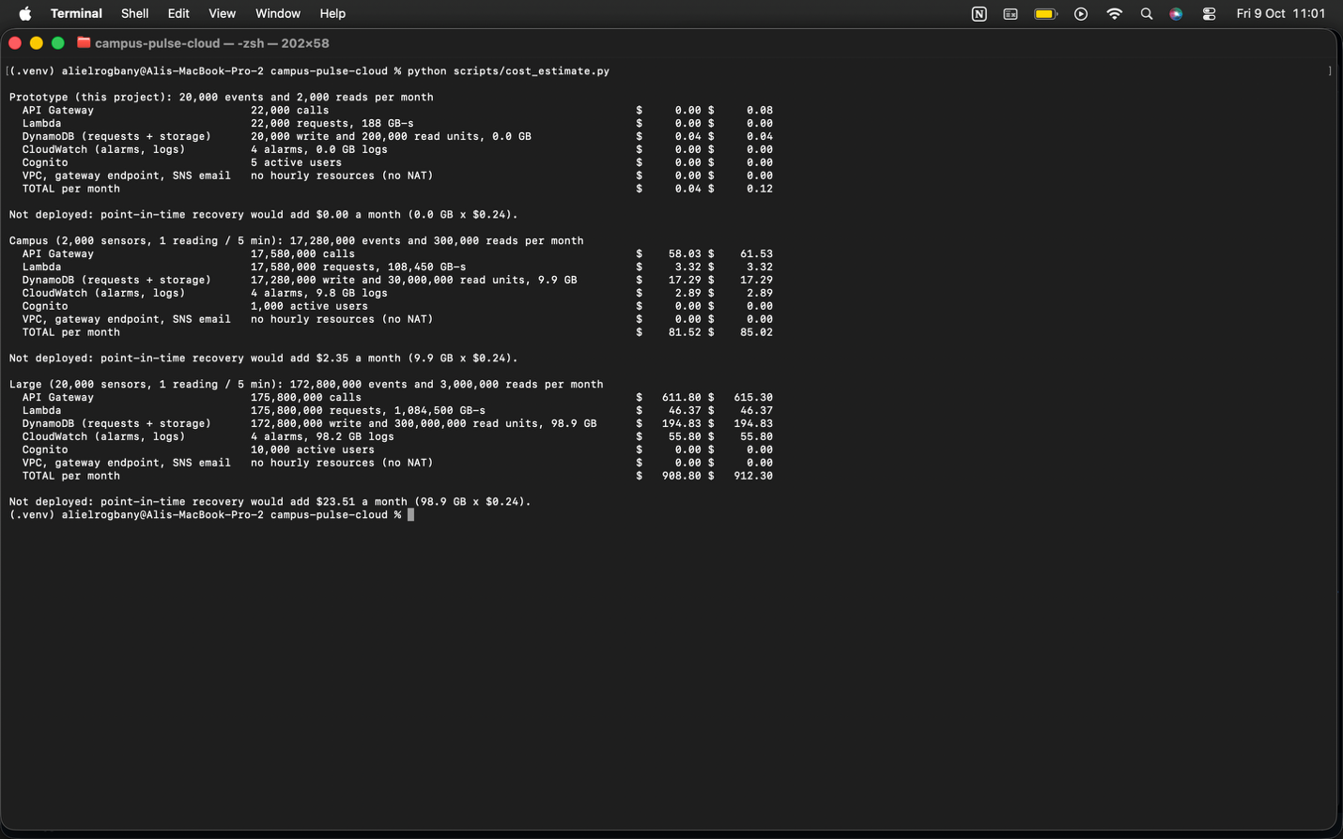
Figure XX - Cost estimate python script output

Billing Alert Evidence
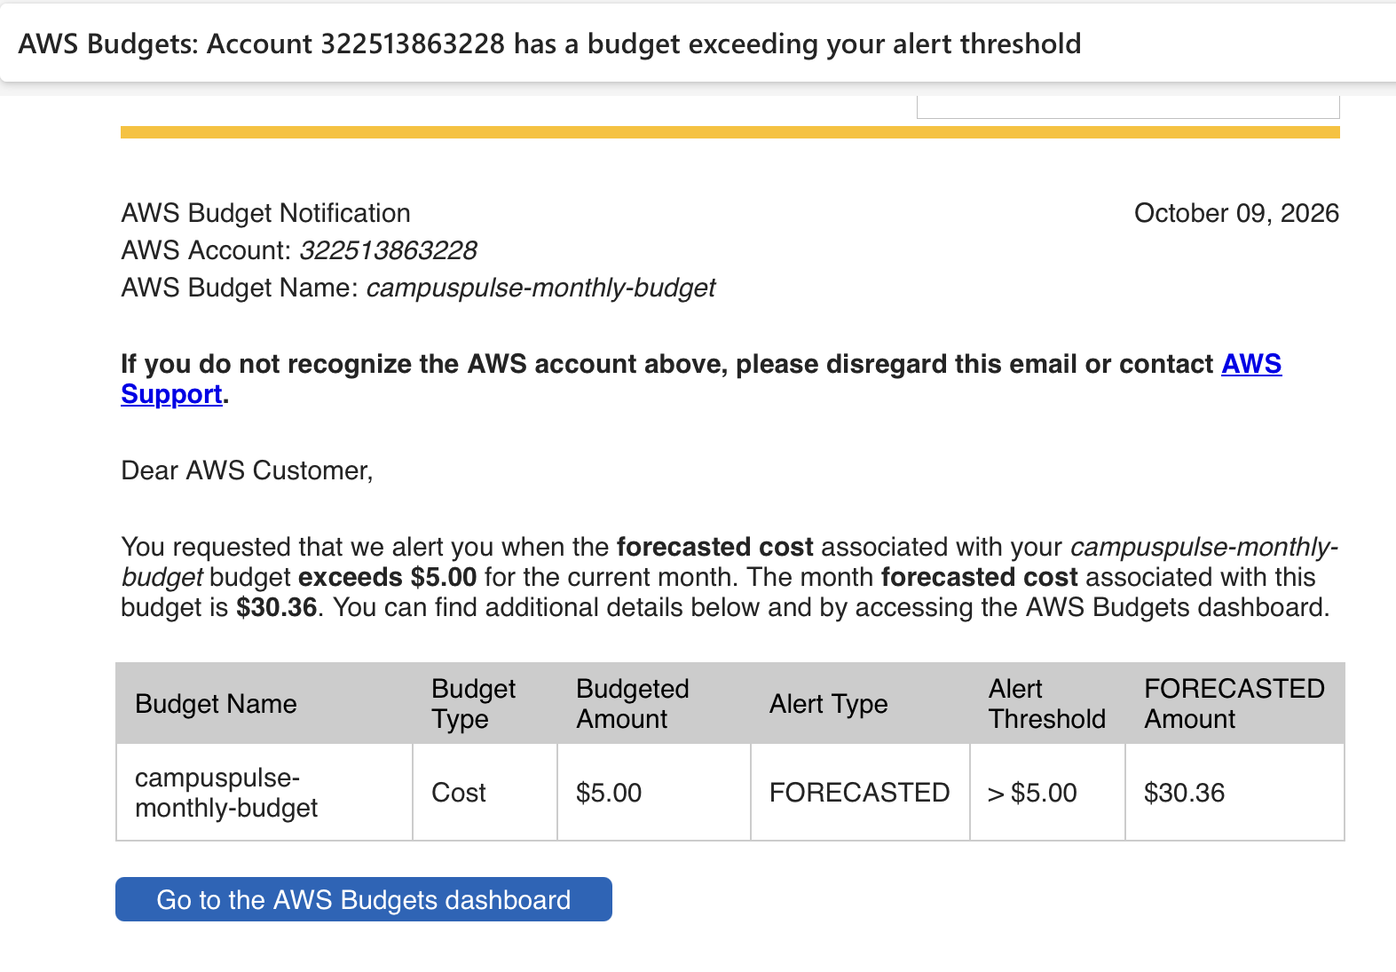
Figure XXI - Billing alert email

Cost Optimization Decisions
No NAT gateway. A NAT gateway costs about 33 US dollars a month at list price. The gateway endpoint to DynamoDB costs nothing.

No interface endpoints. Each costs about 7 US dollars a month per Availability Zone. We avoided them and dropped the feature needing one.

No servers. Nothing bills while the system sits idle.

Daily quota of 10,000 ingest calls. The quota caps the ingest bill near 1.30 US dollars a month.

Throttle of 10 requests per second per method. The throttle caps read traffic.

Event expiry after 30 days and log retention of 14 days. Storage stays bounded.

128 MB Lambda memory, the smallest size.

Guardrail tests. The suite fails when someone adds an hourly billed resource, more than 10 alarms, more than 3 dashboards, more than 10 custom metrics or point in time recovery.

Destroy after each session. Nothing bills while the team does not work.

Point in time recovery is the one protection we chose not to pay for. At Campus scale the feature adds about 1.98 US dollars a month, which equals 2.5 percent of the bill. The “Disaster Recovery Strategy” section gives the decision.

Observability

Logs
Each Lambda writes one line for each important event. A line holds a marker word followed by a JSON object.

- event_stored: an event reached the table.
- event_rejected: validation refused an event. The line lists the reasons and never the full body.
- read_request: a user read data.
- access_denied: a role check refused a user. The line names the route, the user and the groups.
- Crashes: the stack trace.

Both log groups keep 14 days of logs. Logs never hold passwords, tokens, API keys or full request bodies.

Metrics
AWS provides the built in metrics: API requests, 4XX and 5XX errors and latency, Lambda invocations, errors, throttles and duration, and DynamoDB capacity use. Two metric filters add custom metrics in the namespace CampusPulse. RejectedEvents counts event_rejected lines. AccessDenied counts access_denied lines.

Dashboard
The dashboard campuspulse-operations holds about 22 metrics in one view. The widgets show API requests and errors, API latency at p50, p90 and p99, Lambda invocations, errors and throttles, Lambda duration, DynamoDB load, the two security signals and two Logs Insights result tables.

Alarms
Four alarms watch the system. Each alarm treats missing data as healthy, so a quiet system raises no alarm. Each alarm emails the operations address through SNS on entering the alarm state and on returning to normal.

- campuspulse-api-5xx fires on one or more server errors in five minutes.
- campuspulse-ingest-lambda-errors fires on one or more crashes of the ingest function in five minutes.
- campuspulse-query-lambda-errors fires on one or more crashes of the query function in five minutes.
- campuspulse-access-denied-spike fires on five or more refused requests in five minutes.

To test the last alarm, a student account calls GET /alerts six times in a row. Each call returns 403. The alarm turns red and an email arrives.

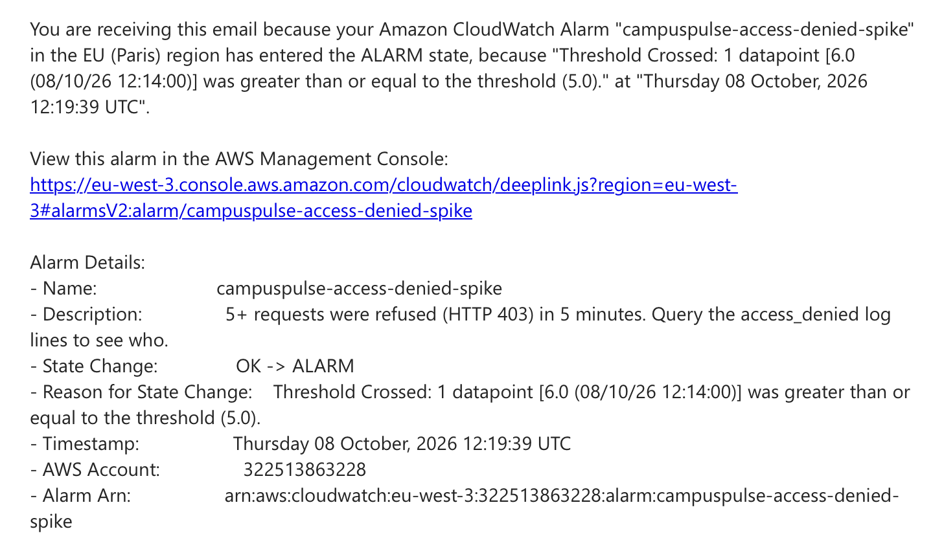
Figure XXII - campuspulse-access-denied-spike alert email

Troubleshooting Mechanisms
A runbook guides the first minutes of an incident.

Step 1: open the dashboard and find the failing layer:
- A red 5XX line points to the API. A Lambda error line points to compute.
- A DynamoDB throttle points to data.

Step 2: open the matching log group and run a Logs Insights query:
- Query for rejected events: filter the ingest log group for event_rejected, sort by time, limit 20.
- Query for refused users: filter the query log group for access_denied, sort by time, limit 20.
- Query for crashes: filter either log group for ERROR or Traceback.
- Query for slowness: filter the REPORT lines and compute the average, p95 and maximum of the duration in five minute bins.
- Query for cold starts: filter the REPORT lines holding an init duration, then count the lines and average the init duration.

Step 3: match the symptom to the cause.
- 5XX and Lambda errors both rise: a bug or a timeout in a function. Read the stack trace.
- 5XX rises and Lambda errors stay flat: API Gateway failed to reach or invoke the function. Check permissions and the deployment.
- Many 4XX and few 5XX: clients send bad data or expired tokens.
- A 403 spike: role misuse or probing. Read the access_denied lines.
- Duration jumps after a deployment: cold starts.

Limits
The system has no distributed tracing and no API Gateway access logs. We see a failed request and the reason inside a function. We do not see a per request trail through the gateway. Alarms evaluate every five minutes, so detection takes five to ten minutes. Email is the only notification channel. A production team would add a paging tool.

The observability stack uses 4 of 10 free alarms, 1 of 3 free dashboards and 2 of 10 free custom metrics.

Disaster Recovery Strategy

Threats and Protections in the Prototype
A data centre failure: DynamoDB, Lambda, API Gateway and Cognito run across several Availability Zones, and our Lambdas use two subnets in two zones.

A defect in our code: Neither Lambda role holds delete or update permission, and every write carries a condition refusing to overwrite an existing item. Our code has no way to destroy stored data.

Loss of the environment: Terraform rebuilds all infrastructure from the repository with one command.

Duplicate and retried writes: Idempotent writes make a retry safe.

Unbounded growth: Time to live removes events after 30 days.

Backups
The prototype has no data backup. A person who deletes items by hand, with the console or with the CLI, destroys data with no way to recover.

We accept this gap in the prototype. The data is simulated and the simulator regenerates the data within seconds. The events expire after 30 days in any case. The table holds nothing irreplaceable.

Designed Protection: Point in Time Recovery
The architecture includes DynamoDB point in time recovery. The feature keeps a continuous backup and restores the table to any second in the last 35 days. A restore creates a new table and never overwrites the live one. AWS bills the feature per GB of table size, at 0.20 US dollars per GB a month at US East list prices. The Free Tier does not cover the cost.

We left the feature off in the prototype for two reasons. The Free Tier is an objective of the project, and the data has no recovery value. A guardrail test fails if anyone turns the feature on, so the decision stays visible.

The cost of the feature stays small. The prototype table holds about 0.01 GB, which costs under one cent. The Campus scenario holds about 9.9 GB and adds 1.98 US dollars a month, which equals 2.5 percent of the bill. The Large scenario holds about 98.9 GB and adds 19.78 US dollars a month. We recommend turning the feature on for a production deployment. The change takes one block in the Terraform file.

Restore Procedure
The procedure applies once the feature runs.

Step 1. Stop the damage and note the time before the damage started.

Step 2. Restore the table to the noted time, into a new table.

Step 3. Check the data in the new table.

Step 4. Copy the missing items back into the live table, or point the application at the new table by changing the TABLE_NAME variable.

Step 5. Run terraform apply again. A restore does not bring back the time to live setting, the alarms, the IAM policies or the recovery setting itself.

We did not rehearse this procedure, because the prototype does not run the feature. A production team must restore a copy once and record the time before trusting the backup.

Recovery Objectives
Recovery point objective. As deployed, the recovery point for a manual deletion does not exist. With point in time recovery, the recovery point lies about five minutes behind the current time, because the continuous backup trails real time by a few minutes.

Recovery time objective. As deployed, recovery means running terraform apply and regenerating data with the simulator. According to the last run of the prototype architecture, terraform apply took around 2 minutes and 30 seconds. With point in time recovery, restore time grows with table size. A production team must measure the time on the real table.

Continuity Decisions
- Infrastructure as code gives a rebuild in minutes.
- Two Availability Zones keep the API running through the loss of one data centre.
- Idempotent writes let a sender retry safely after a timeout.
- Throttling and a daily quota keep a flood from taking the database down.
- The system runs in one region. A regional outage stops the service. A second region and DNS failover would close the gap and double the running cost.

Testing and Evaluation

Automated Tests
The project holds 119 automated tests. They run on a laptop in about six seconds and need no AWS account.

Validation tests check the field rules of the event format: required fields, allowed event types and severities, finite numbers, timestamp limits, string length and unknown fields.

Handler tests check the ingest function for a stored event, invalid JSON, an empty body, validation reasons, a duplicate and hidden internal errors.

Authorization and statistics tests check group parsing in the three shapes Cognito produces, the role table and the statistics math.

Integration tests run the full handlers against simulated DynamoDB and Cognito. They check the conditional write, the read paths, filters, time windows, pagination, the item cap, the role rules, the 403 response, user creation with login and the log markers.

Guardrail tests, 31 in total, read the Terraform files and check the cost and security rules from sections 5 and 7.

Load test and cost estimator tests check the percentile math, the counting of status codes against a local test server and the cost arithmetic against hand calculations.

We checked the tests themselves by breaking the code on purpose. For example, we switched on point in time recovery in a copy of the Terraform, and the matching guardrail test failed. We then restored the file.

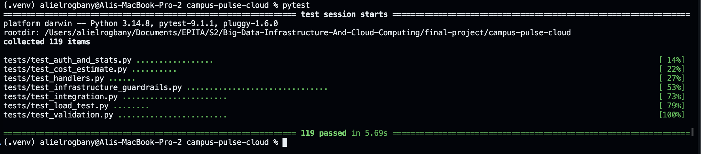
Figure XXIII - Pytest tests output

Functional and API Tests
The eight call security demonstration in “Security Design” section covers the authentication, the role rule, the API key and the two layers of validation. All eight calls returned the expected status code.

The GET routes return the expected data. GET /events returns the newest events first and accepts limit, days, building and event_type filters. GET /stats returns totals by type and severity, per building energy and climate averages, the latest occupancy of each room, the overloaded rooms and the building with the highest energy use. GET /alerts returns warning and critical events and accepts a severity filter.

Data Ingestion Tests
The simulator sent a batch of events with an abnormal share of 20 percent at two events per second. The simulator retries on 429 and 5xx responses with growing delays.

The duplicate test sends the same event twice. The first call returns 201 and the second returns 409. The invalid input tests return 400 with the reasons in the body.

Monitoring Evidence
The dashboard showed the traffic from the simulator and the access_denied spike. The alarm test in section 8 produced a red alarm and an email. Section 8 holds the screenshots.

Performance Observations
In our attempt to send 300 requests at a steady pace, 8 requests per second, all 300 requests were successfully stored with a 201 status. As far as latency was concerned, the 50 percentile was 45ms and the max latency was 120ms.

Evaluation Against the Objectives
Objective 1, ingestion. Met. The API stores events and refuses bad ones.

Objective 2, reading. Met. Three routes return events, statistics and alerts.

Objective 3, roles. Met. The role rule works at two layers and the demonstration shows the 403.

Objective 4, private network. Met. The Lambdas run in private subnets with no internet route.

Objective 5, monitoring. Met. The dashboard and four alarms work, and the email arrives after the SNS confirmation.

Objective 6, infrastructure as code. Met. One apply builds the system and one destroy removes the system.

Objective 7, Free Tier. Met for the prototype at about 0.04 US dollars a month. Point in time recovery stays off to hold the objective.

Objective 8, load behavior. Met once the load test results appear in the “Scalability Strategy” section.

Lessons Learned

Technical Challenges
Testing without AWS took the most design effort. Moto simulates DynamoDB and Cognito well enough for integration tests, but the simulation ignores IAM, the VPC and API Gateway behavior. The guardrail tests cover part of this gap, because they read the Terraform. The live demonstration covers the rest.

Log design matters for monitoring. Metric filters count text patterns. We rewrote the log format after the first version so a marker word stands alone and the details follow as JSON.

Networking decisions limit later features. Placing the Lambdas in a private network blocked the SNS call of the planned anomaly detector. An interface endpoint would cost about 7 US dollars a month. We dropped the feature and let CloudWatch alarms send the email.

Trade-offs
Cost against protection. We left point in time recovery off, left AWS WAF off and used AWS owned encryption keys. Each choice saves money and leaves a known gap, listed in the “Security Design” and “Disaster Recovery Strategy” sections.

Simplicity against features. We cut the web dashboard, the anomaly detector, the archive and the pipeline for deployment. The smaller system fits the Free Tier and takes less time to explain.

Security against convenience. The shared API key lets the simulator run with one header. The key identifies the application and not each device.

Limitations
The prototype has no backup of the data. The system runs in one region. The API key sits in the local Terraform state. Statistics read in memory and stop at 5,000 events per request. Alarms detect problems within five to ten minutes. The estimate uses US East prices.

Future Improvements
Improvement 1: Turn on point in time recovery and rehearse a restore. Cost about 2 US dollars a month at Campus scale.

Improvement 2: Store the Terraform state in an encrypted S3 bucket with locking and move secrets to AWS Secrets Manager.

Improvement 3: Give each sensor a separate credential through AWS IoT Core.

Improvement 4: Add pre computed summaries so statistics scale past 5,000 events.

Improvement 5: Batch readings into single API calls to cut the largest cost line.

Improvement 6: Add a web dashboard on S3 and CloudFront for the ops team and the students.

Improvement 7: Add an anomaly detector. Place the function outside the VPC, or buy an interface endpoint, so the function reaches SNS.

Improvement 8: Add a deployment pipeline with GitHub Actions so every merge runs the tests and the plan.

Improvement 9: Deploy a second region for regional failure.

