Building and Evaluating a Retrieval-Augmented Generation System on FinanceBench
Marwane Mhenni
Hamza El hamdi
Ali Cherri
NLP Graded Project A

Introduction
Retrieval-Augmented Generation (RAG) grounds a language model’s answers in a closed document collection: passages relevant to the question are retrieved from an indexed corpus and the model is instructed to answer from them alone. This report presents the design, implementation, and experimental evaluation of a complete RAG pipeline for financial question answering over SEC filings, evaluated on the FinanceBench benchmark.
Our goal is not a single headline score but a controlled study of which design decisions matter. We sweep 41 retrieval configurations across six axes (chunk size, chunk overlap, document structure preservation, embedding model, number of retrieved passages, and retrieval strategy, including a metadata prefilter derived from the question text), evaluate five free, locally executable generation models, and run oracle-context and closed-book ablations that attribute end-to-end errors to retrieval or to generation.
Three findings stand out. First, restricting the search space with metadata parsed from the question (company and fiscal period) is the single largest retrieval improvement we measured, worth 13 to 16 points of recall at every k, more than any chunking or embedding change. Second, two standard-recipe components, BM25 (alone or in hybrid fusion) and a general-purpose cross-encoder reranker, actively hurt on this corpus of dense financial tables. Third, the ablations show the system is at least as generation-limited as retrieval-limited: even when handed the gold evidence, the best local 14B model fully answers only 59 percent of the questions, and 40.7 percent of questions fail under oracle conditions, mostly on multi-step financial arithmetic.

Corpus Description
FinanceBench (Islam et al., 2023) is an industry benchmark for question answering over public financial filings. Its open source split contains 150 questions over 84 documents: 10-K and 10-Q filings, 8-K reports, and earnings releases from 40 public companies, fiscal years 2015 to 2023. Every question carries a gold answer and one to three evidence items, each annotated with the exact supporting text and its zero-based page number. Questions come in three types of 50 each: metrics-generated (read a value off a statement), domain-relevant (analyst questions requiring judgement), and novel-generated (unusual questions unlikely to be memorised), spanning information extraction, numerical reasoning, and logical reasoning.
The benchmark ships a document catalog with source URLs rather than the documents themselves, and about a quarter of those URLs have rotted since publication. Our downloader retries with SEC-compliant request headers and falls back to the official FinanceBench GitHub mirror; 61 documents arrived from their original URLs and 23 from the mirror, for full coverage of all 84 documents and therefore all 150 questions. A committed manifest records the provenance, size, and SHA-256 of every file.
Text is extracted per page with PyMuPDF: 12,013 pages and 40.0M characters across the 84 documents. Cleaning is deliberately conservative (unicode NFKC normalisation, control-character removal, whitespace bounding) because aggressive normalisation destroys the row and column adjacency that financial tables depend on. Only 78 pages (0.65 percent) yielded fewer than 20 characters, indicating scanned or graphical pages; no document required OCR. Pages are the atomic unit of ground truth throughout: retrieval is scored against the annotated evidence pages, and a text-level containment measure catches evidence lost inside a retrieved page.

Methodology

Segmentation
Three chunkers cover the structure-preservation axis. The token chunker slides fixed windows over the whole document, ignoring layout. The page chunker treats the PDF page as the atomic unit and splits only oversized pages. The structural chunker packs whole paragraphs greedily up to the token budget, never cutting through one. All chunk boundaries are measured with one fixed reference tokenizer (bert-base-uncased) regardless of the embedding model, so that when we compare embedding models they see literally identical chunks. Every chunk carries its document name and the page span it covers.

Retrieval
Chunks are embedded with sentence-transformer models, using the query and passage prefixes each model’s authors document (E5 and BGE are asymmetric; omitting their prefixes measurably degrades recall and would contaminate the comparison). Normalised embeddings are indexed in FAISS and searched by inner product. Three alternative strategies are implemented behind the same interface: Okapi BM25; a hybrid that min-max normalises dense and BM25 scores and combines them with weight alpha; and cross-encoder reranking (ms-marco-MiniLM-L-6-v2) applied to a dense candidate pool of configurable size.
The metadata filter restricts candidates to documents whose company is named in the question, narrowed further by fiscal year when one is mentioned. It is built by matching the catalog’s 40 company names (plus a small alias list) against the question string after both are lowercased and stripped of punctuation; 127 of the 150 questions name their company verbatim and the filter deactivates itself on the rest. It reads nothing from the gold record except the question text, so it uses only information a deployed system would have.

Generation
Answers are produced by free, locally executable instruction models served by Ollama, prompted to answer strictly from the numbered passages, to cite every fact as [n], to state numeric answers with units, and to abstain with a fixed phrase when the passages are insufficient. The context window (16,384 tokens) sits well above the largest measured prompt, and every response’s token accounting is checked against the window so silent truncation cannot pass unnoticed; zero truncations were flagged across all runs. Three context modes support the ablations: retrieved (the RAG system proper), oracle (the gold evidence passed directly, removing retrieval from the equation), and none (closed book, bounding how much of the score could be pre-training memorisation).

Evaluation
Retrieval is scored at page level against the annotated evidence:
- recall@k: some retrieved chunk covers a gold evidence page;
- strict recall@k: a single chunk contains at least half of an evidence item’s 5-grams, i.e. the evidence text itself was retrieved, not merely its page;
- document accuracy@k, MRR@k, and nDCG@k with page-level relevance;
- evidence coverage@k: the mean fraction of evidence 5-grams present anywhere in the retrieved set, the measure that exposes chunk-boundary evidence loss.
Generation is scored deterministically with scale-tolerant numeric accuracy (FinanceBench answers are mostly dollar amounts, percentages, and ratios; the scale-tolerant variant forgives unit mismatches such as millions versus raw dollars but not wrong digits), SQuAD-style token F1, citation rate and citation validity (whether a cited passage actually covers a gold page), and abstention rate. An LLM judge (qwen2.5-14B, temperature 0, JSON-constrained output) grades correctness (0 to 2) against the reference answer and groundedness (0 to 2) against the passages shown to the model. Throughout the results, accuracy means the fraction of answers the judge scores fully correct.
Because an LLM judge is an assertion until measured, we quantify its consistency against the deterministic numeric metric: over the 1,008 judged answers to numeric questions, the judge’s fully-correct verdict and the scale-tolerant numeric match agree on 81.6 percent of cases with Cohen’s kappa 0.607, substantial agreement given that the two measures also disagree legitimately (an answer can state the right number for the wrong reason, or a correct non-numeric qualification). No human labelling was performed; we flag this in the limitations.

Experimental Setup
All heavy computation ran on one RunPod A100-SXM4-80GB pod (CUDA 12, PyTorch 2.9, Python 3.12); development and the 64-test unit suite ran on a laptop. The retrieval grid comprises 41 configurations: a 4x4 chunk size (128, 256, 512, 1024 tokens) by overlap (0, 10, 25, 50 percent) sweep, three structure modes, six embedding models (all-MiniLM-L6-v2, gte-base, e5-base-v2, bge-base-en-v1.5, e5-large-v2, bge-large-en-v1.5), k in {1, 3, 5, 10, 20}, BM25 at two k values, hybrid at alpha in {0.3, 0.5, 0.7}, reranking with pools of 20, 50, and 100, and the metadata filter at three k values plus one filter-plus-rerank combination. Sweeps are one-factor-at-a-time around a fixed baseline (token chunks of 512 with 64 overlap, bge-base, dense, k=5) so each comparison isolates one decision. The grid completed in about 100 minutes on the A100; every run is cached under a hash of its configuration and is resumable.
Generation consumed the top passages of the best eligible retrieval run (the metadata-filtered dense run; its top 10 passages reach 0.627 recall, its top 20 reach 0.707) across five models spanning the four families named in the brief and two sizes of one family: llama3.1-8B, mistral-7B, qwen2.5-7B, phi4-14B, and qwen2.5-14B, all Q4 quantised. Ablations add oracle and closed-book runs for both qwen sizes and a k=20 variant for qwen2.5-14B. Generation is deterministic (temperature 0), checkpoints every ten questions, and the ten generation and judging runs together used roughly three hours of A100 time, run three streams in parallel against one Ollama server.

Results

Retrieval
headline retrieval results (the full 41-row table is in results/tables/retrieval_results.md).
Configuration | k | Recall@k | Strict@k | MRR@k | ms/query
dense + filter | 20 | 0.707 | 0.507 | 0.307 | 57
dense + filter | 10 | 0.627 | 0.407 | 0.301 | 37
dense, plain | 20 | 0.587 | 0.427 | 0.204 | 13
dense, plain | 10 | 0.500 | 0.333 | 0.198 | 8
dense + filter | 5 | 0.493 | 0.300 | 0.284 | 25
e5-large-v2 (best embedding) | 5 | 0.453 | 0.327 | 0.316 | 7
rerank, pool 20 | 10 | 0.447 | 0.340 | 0.203 | 178
baseline (bge-base) | 5 | 0.333 | 0.240 | 0.177 | 6
hybrid, best alpha 0.7 | 10 | 0.320 | 0.233 | 0.152 | 341
BM25 | 10 | 0.153 | 0.127 | 0.096 | 229
Metadata filtering dominates every other intervention. At each k the filter adds 13 to 16 recall points over plain dense search and raises MRR by half. The mechanism is visible in the error taxonomy: wrong-document retrievals drop to 2 percent of questions. Filtering costs a few milliseconds and no training; on a corpus whose documents are near-duplicates of each other in vocabulary (every 10-K contains an income statement), identity metadata carries information that embeddings recover only partially.
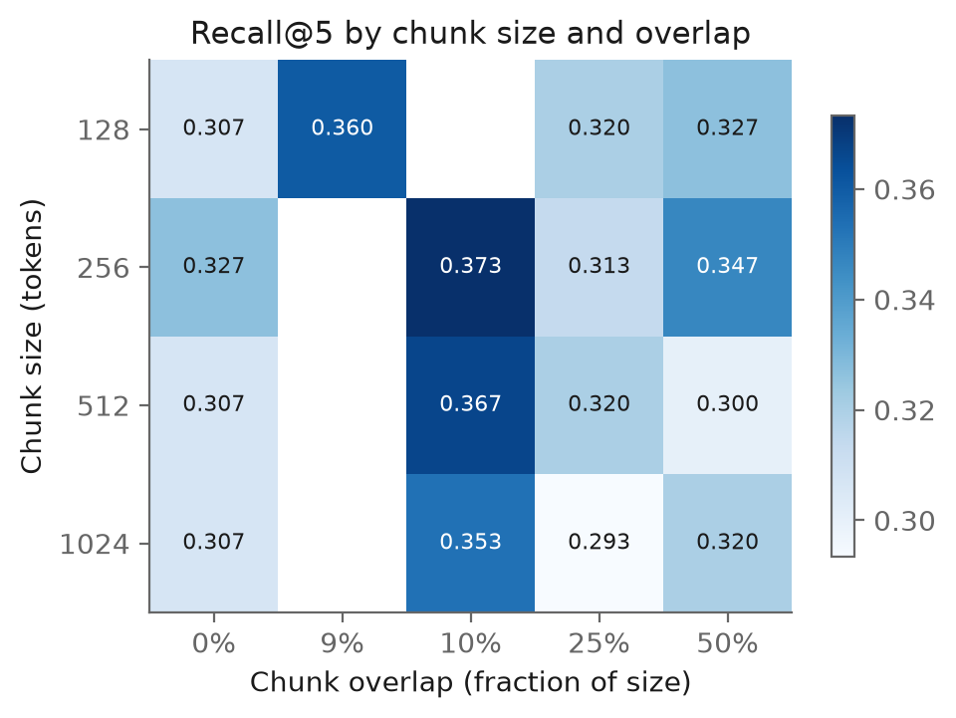
Recall@5 by chunk size and overlap.
Chunking. The 16-point chunk sweep spans 0.293 to 0.373 recall at k=5, a smaller range than the filter’s effect at any k. A 10 percent overlap is best at every size; 256 and 512-token chunks lead on recall. Evidence coverage tells the other half of the story: it doubles from 128-token chunks (0.11 to 0.15) to 1024-token chunks (0.26), because small windows retrieve the right page but hand the generator a fragment of the evidence. This tension (small chunks rank better, large chunks carry more of the evidence once found) motivates the 512/64 compromise used downstream.
Structure preservation. Page-bounded chunks beat token windows (0.367 versus 0.333) with structural packing between (0.347). The gold labels are page-level, and financial statements are laid out one per page, so respecting the page boundary aligns chunks with both the annotation unit and the document’s own semantics.
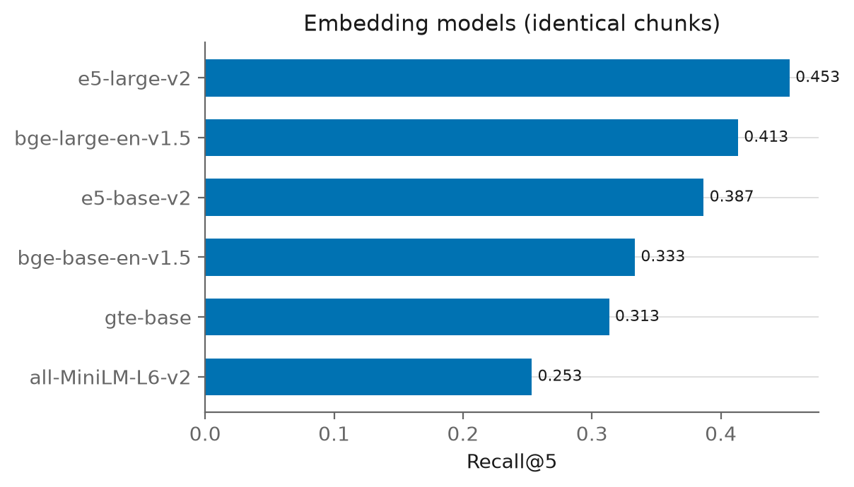
Embedding models compared on identical chunks.
Embedding models. e5-large-v2 is the strongest (0.453 recall and 0.316 MRR, the best MRR of any configuration including filtered ones), followed by bge-large (0.413), e5-base (0.387), bge-base (0.333), gte-base (0.313), and MiniLM (0.253). The E5 family wins at equal parameter count and scale helps within each family; yet swapping bge-base for e5-large is still worth less than adding the metadata filter on top of bge-base.
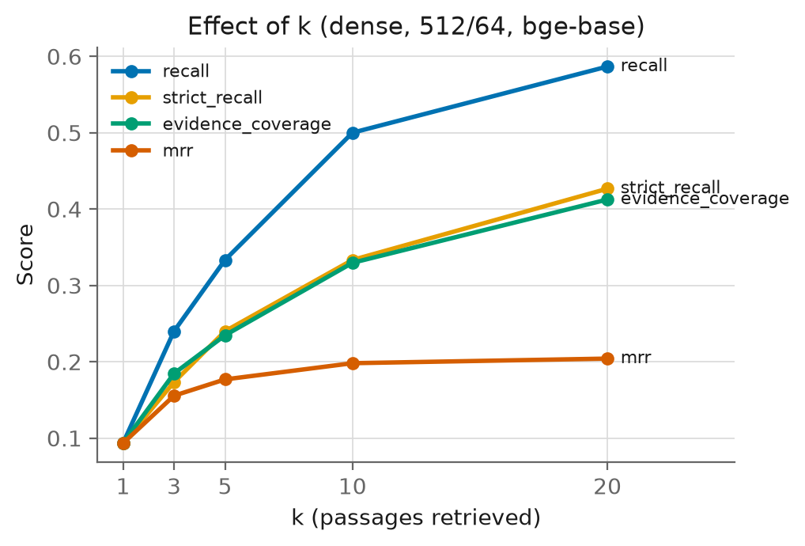
Effect of k on the four retrieval metrics.
k. Recall grows monotonically from 0.093 at k=1 to 0.587 at k=20 with no plateau, so the retriever keeps finding gold pages deeper in the ranking; the cost is prompt length and distraction for the generator, quantified by the k=20 generation ablation below.
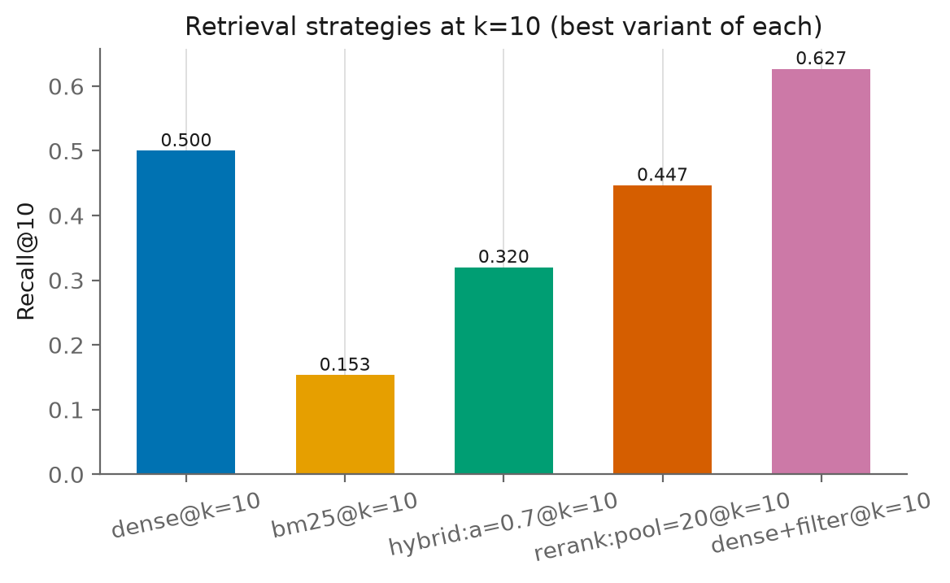
Retrieval strategies at matched k=10.
Negative results: BM25, hybrid, and reranking. BM25 reaches only 0.153 at k=10, one third of dense retrieval, and it drags every hybrid mixture below pure dense (best hybrid 0.320 at alpha 0.7). Filings are boilerplate: the terms in a question (“capital expenditure”, “fiscal 2018”) appear on dozens of pages of every document, so term frequency barely discriminates, while paraphrase (the statement line reads “purchases of property, plant and equipment”) defeats exact matching outright. The ms-marco cross-encoder also underperforms the dense ranking it reranks (0.380 to 0.447 versus 0.500 at k=10), and enlarging its pool makes it worse, the opposite of the usual pattern: trained on web passages, it mis-scores dense financial tables, and a larger pool only gives it more distractors to promote. Both components would be net-negative additions to this system despite their standard-recipe status.

Generation
generation results. Accuracy is the judge’s fully-correct rate; Numeric is scale-tolerant numeric accuracy; Halluc. is the judge’s hallucination rate.
Run | Context | k | Accuracy | Numeric | Abstain | Cited | Cite valid | Halluc. | s/q
qwen2.5-14B oracle | oracle | 5 | 0.593 | 0.627 | 0.13 | 0.94 | 0.94 | 0.20 | 3.2
qwen2.5-7B oracle | oracle | 5 | 0.427 | 0.437 | 0.34 | 0.63 | 0.63 | 0.32 | 2.7
qwen2.5-14B | retrieved | 20 | 0.387 | 0.421 | 0.19 | 0.60 | 0.27 | 0.28 | 17.6
phi4-14B | retrieved | 10 | 0.367 | 0.381 | 0.49 | 0.66 | 0.31 | 0.28 | 5.2
qwen2.5-14B | retrieved | 10 | 0.367 | 0.381 | 0.36 | 0.65 | 0.34 | 0.27 | 12.3
mistral-7B | retrieved | 10 | 0.253 | 0.222 | 0.51 | 0.47 | 0.17 | 0.33 | 2.8
qwen2.5-7B | retrieved | 10 | 0.247 | 0.262 | 0.55 | 0.43 | 0.21 | 0.31 | 2.3
llama3.1-8B | retrieved | 10 | 0.200 | 0.278 | 0.46 | 0.66 | 0.33 | 0.45 | 3.4
qwen2.5-14B closed book | none | 0 | n/a | 0.111 | 0.00 | 0.00 | 0.00 | n/a | 12.5
qwen2.5-7B closed book | none | 0 | n/a | 0.087 | 0.00 | 0.00 | 0.00 | n/a | 2.0
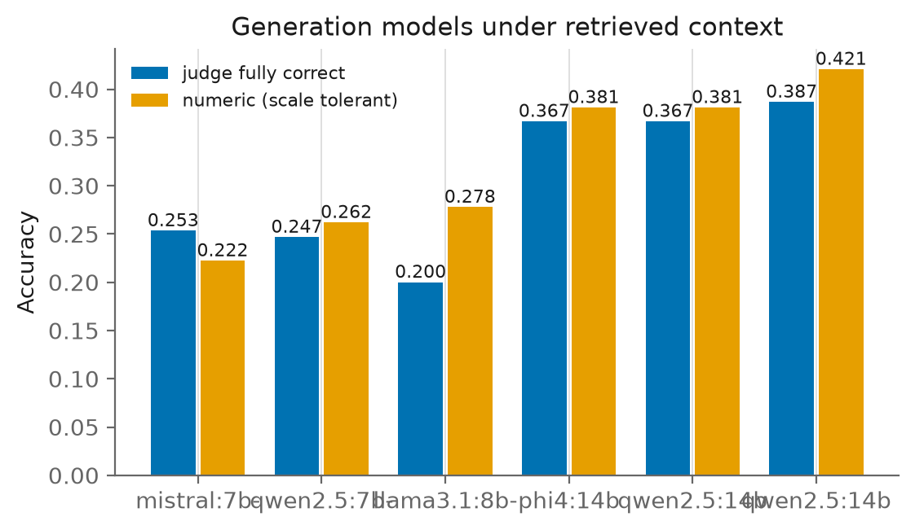
Generation models under retrieved context.
Model comparison. The two 14B models tie at 0.367 under identical retrieved context, well ahead of the 7B and 8B class (0.200 to 0.253). Within the qwen family, doubling parameters is worth 12 points (0.247 to 0.367). llama3.1-8B pairs the lowest accuracy with the highest hallucination rate (0.45) despite citing frequently, the worst combination for a system meant to be trusted. Notably, phi4-14B matches qwen2.5-14B while abstaining far more often (0.49 versus 0.36): it trades coverage for precision.
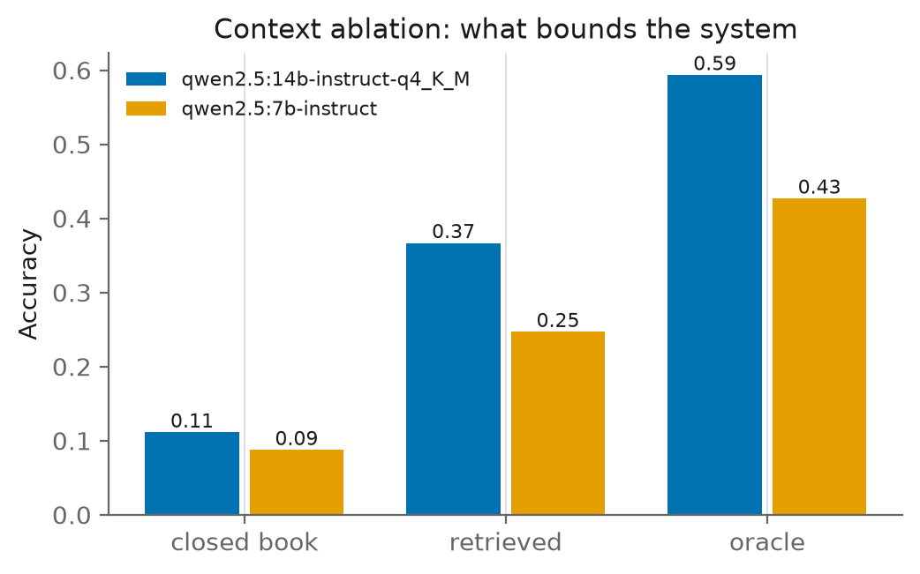
Accuracy under closed book, retrieved, and oracle context.
Context ablations. The closed-book runs collapse to 0.09 to 0.11 numeric accuracy with zero citations, so essentially nothing the RAG system gets right comes from pre-training memory. The oracle runs bound what better retrieval could buy: with gold evidence in the prompt, qwen2.5-14B reaches 0.593 (and cites validly on 94 percent of answers). Raising k from 10 to 20 lifts context recall from 0.627 to 0.707 but end-to-end accuracy only from 0.367 to 0.387: the generator recovers just a fifth of the extra evidence it is given, at a 43 percent latency premium.
Citation behaviour. Under oracle context, citation validity equals citation rate (0.94 for the 14B): when the right evidence is present, the model cites it. Under retrieved context, validity drops to roughly half the citation rate (0.27 to 0.34 valid against 0.60 to 0.66 cited): models keep citing fluently even when the cited passage does not contain the evidence, which is exactly the failure mode citation validity was designed to expose.

Error Analysis

Retrieval failures
At the filtered k=10 operating point, 56 of 150 questions (37.3 percent) miss the gold page:
Failure mode | Count | Share
Wrong document retrieved | 3 | 2.0%
Right document, wrong page | 53 | 35.3%
Gold page hit but evidence text mostly absent | 19 | 12.7%
Document discrimination is essentially solved by the filter; what remains is ranking inside a single filing, where the query must distinguish the income statement from ten pages that mention the same terms. The third row is invisible to page-level metrics: the right page was retrieved but the chunk boundary cut the evidence away (median coverage 0.03 among those 19). Failure rates differ sharply by question type: 16 percent for metrics-generated questions, whose phrasing mirrors statement line items, versus 56 percent for domain-relevant and 40 percent for novel-generated questions, whose analyst phrasing shares little vocabulary with the evidence.

Attributing end-to-end errors
Comparing qwen2.5-14B under retrieved (k=10) and oracle context on the same 150 questions:
Outcome | Count | Share | Meaning
Solved | 43 | 28.7% | correct with retrieved and with gold evidence
Retrieval-limited | 46 | 30.7% | correct with gold evidence, wrong with retrieved
Generation-limited | 61 | 40.7% | wrong even with gold evidence
Retrieval-rescued | 12 | 8.0% | wrong with gold evidence, right with retrieved
The retrieval-limited share (30.7 percent) is the headroom a perfect retriever could recover; the generation-limited share (40.7 percent) is the model’s own ceiling and is the larger of the two. The small retrieval-rescued share is consistent with the near-floor closed-book accuracy: little arrives from memory.
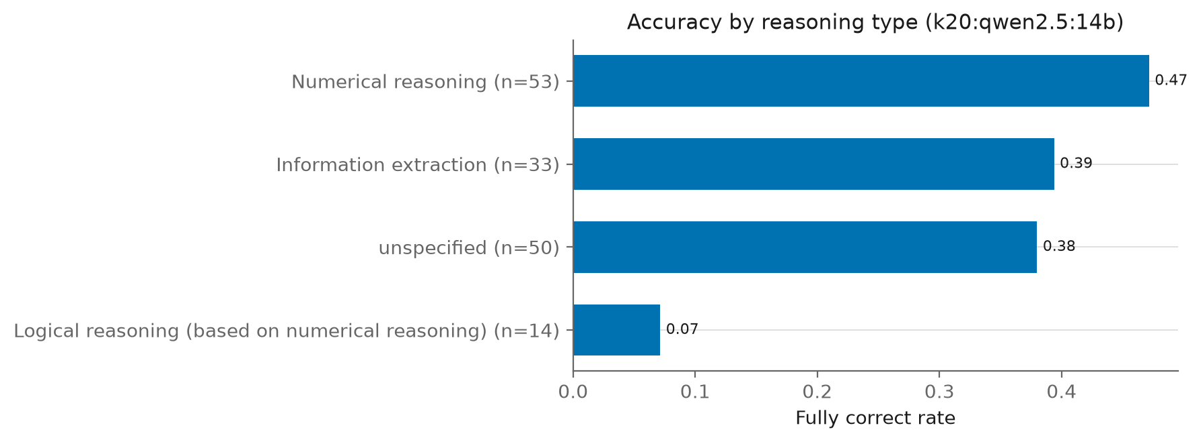
Fully-correct rate by reasoning type for the best RAG run.
Generation-limited failures concentrate in multi-step arithmetic: of the 61, 25 are labelled numerical or numerically-grounded logical reasoning, 14 information extraction, and 22 unlabelled (mostly novel-generated questions that also require computation). Two representative oracle-context failures: asked for AES Corporation’s FY2022 inventory turnover, the model set up the correct formula, then mis-computed the average inventory and produced a wrong ratio; asked for Amazon’s FY2017 days payable outstanding, it applied the given formula and landed on 94.78 days against a gold 93.86, an arithmetic slip inside an otherwise correct derivation. These are not retrieval or comprehension errors; they are calculator errors, and no retrieval improvement can fix them.

Discussion
What mattered. One cheap, training-free intervention (metadata filtering) outweighed every embedding and chunking change we measured, which inverts the usual tuning priority for corpora of homogeneous, near-duplicate documents. Embedding choice came second (e5-large-v2), chunk geometry third and mostly as a coverage-versus-ranking trade-off. The standard additions, BM25 hybrid and cross-encoder reranking, were net negative here, a reminder that recipe components carry domain assumptions: term-frequency discrimination and web-passage relevance both fail on boilerplate filings.
Where the system is bound. With the best retrieval we built (0.707 context recall at k=20), end-to-end accuracy is 0.387 while the oracle bound is 0.593. Closing the entire retrieval gap would therefore still leave more than 40 percent of questions failing on generation, dominated by financial arithmetic. The most promising next steps split accordingly: on the retrieval side, table-aware chunking and rerankers trained on financial text to attack the within-document ranking problem; on the generation side, tool-augmented arithmetic (a calculator the model must route computations through) or larger unquantised models.
Limitations. Ground truth is page-level, so a chunk from the right page counts as relevant even if tables on that page mislead the model, and our strict-recall and coverage metrics only approximate span-level relevance. The judge is qwen2.5-14B, which also appears as a system under test; a judge may prefer its own outputs, and although its verdicts agree substantially with the deterministic numeric metric (kappa 0.607 over 1,008 answers) and the model ranking is unchanged under the purely deterministic metrics, no human labels were collected. All models are Q4 quantised, which may understate their unquantised accuracy, particularly on arithmetic. Runs are deterministic (temperature 0) single passes, so we report no variance. The metadata filter depends on the company being named in the question (127 of 150 here); conversational queries with pronouns would need coreference handling before this gain transfers. Finally, 23 of 84 documents came from the benchmark’s mirror rather than the original URLs; the manifest records this, but a fully link-rot-proof reproduction depends on that mirror persisting.

Conclusion
We built and evaluated a complete, fully local RAG pipeline for FinanceBench: 84 documents and 12,013 pages ingested with full question coverage, 41 retrieval configurations, five generation models, and ablations that separate retrieval from generation failures. The best system (metadata-filtered dense retrieval with bge-base embeddings feeding qwen2.5-14B at k=20) answers 38.7 percent of the 150 questions fully correctly by LLM-judge assessment, with a 0.707 context recall and near-zero reliance on pre-training memory. The experimental program yielded three transferable lessons: exploit document identity metadata before tuning anything else on homogeneous corpora; do not assume BM25 hybrids or general-purpose rerankers transfer to financial text; and measure the oracle bound early, because past a point, and we are past it, the generator’s arithmetic, not the retriever, is the binding constraint.

