

Rock,paper,Scissors

**Welcome everyone to the ultimate showdown of rock, paper, scissors! The game that has been entertaining people for centuries and continues to be a favorite pastime for all ages.**

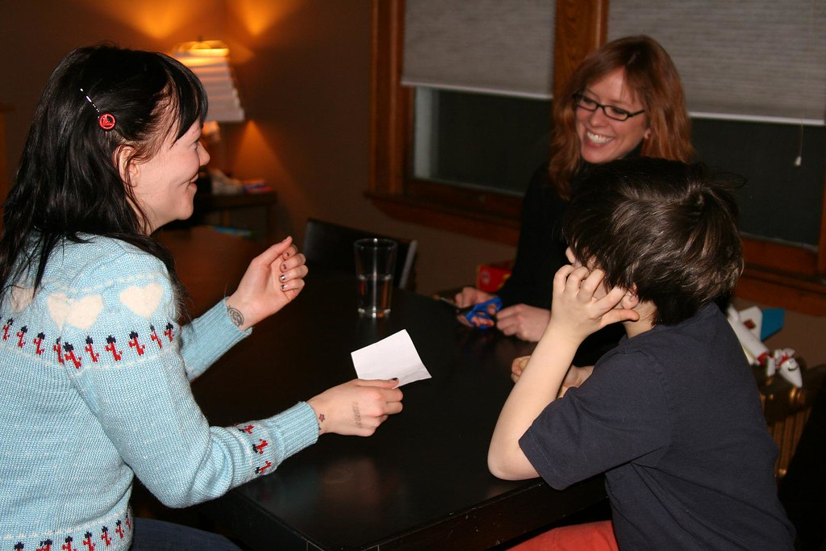

**Before we begin, let's take a moment to appreciate the true champions of this game: rocks. They're tough, they're durable, and they're always ready for a fight**

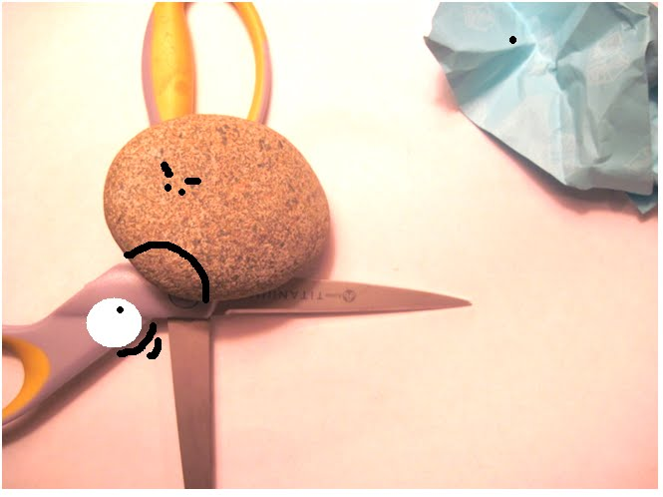

**But let's not forget about paper, the silent killer. It may seem weak, but it always has the upper hand .**

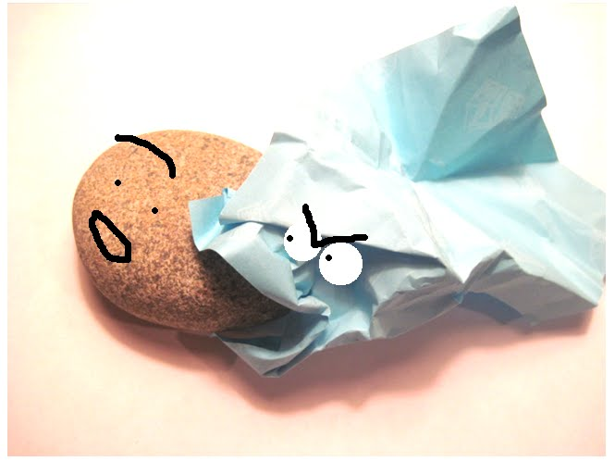

**And last but not least, scissors. They're sharp, they're precise, and they're always ready to cut through the competition.**

1. 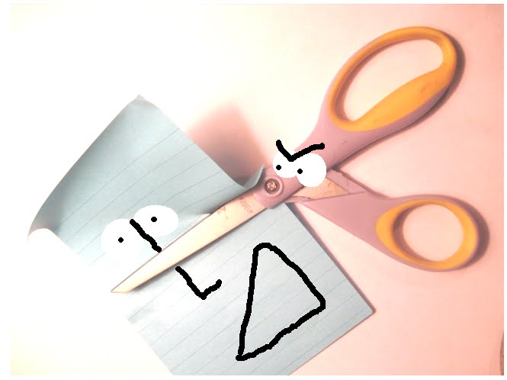

**Now, let's get ready to rumble! In this game, you'll be facing off against the computer in a series of intense RPS battles. But don't worry, you won't be alone. You'll have the support of your trusty rock, paper, and scissors, ready to do your bidding.**

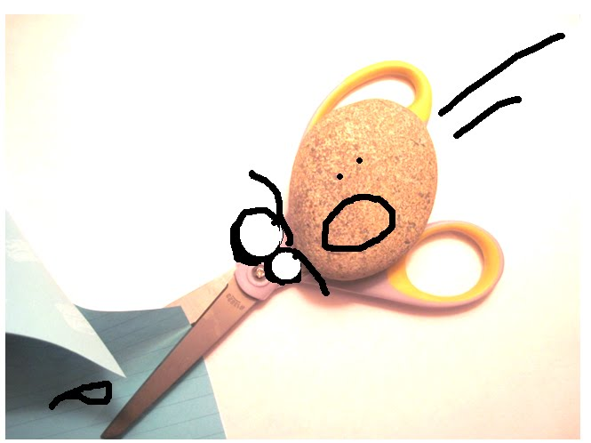

**As you play, remember that rock crushes scissors, scissors cut paper, and paper covers rock. But don't be fooled by the simplicity of this game, because it's not just about winning or losing. It's about the thrill of the battle and the satisfaction of a well-timed move.**