L2CAP, an Overview
L2CAP permits higher level protocols and applications to transmit and receive L2CAP data packets up to 64 kilobytes in length.
The L2CAP Specification is defined for only Asynchronous Connection-Less (ACL) links and no support for Synchronous Connection-Oriented (SCO) links is planned.

Features of L2CAP Layer

Protocol Multiplexing
Baseband Protocol does not support any field identifying the higher layer protocol being multiplexed
L2CAP must be able to distinguish between upper layer protocols such as the Service Discovery Protocol, RFCOMM, and Telephony Control
- Segmentation & Reassembly
The data packets defined by the Baseband Protocol are limited in size. It limits the efficient use of bandwidth for higher layer protocols that are designed to use larger packets.
Large L2CAP packets must be segmented into multiple smaller Baseband packets prior to their transmission over the air. Similarly, multiple received Baseband packets may be reassembled into a single larger L2CAP packet following a simple integrity check.
- Fragmentation and Recombination
Some Controllers may have limited transmission capabilities and may require fragment sizes different from those created by L2CAP segmentation. Therefore layers below L2CAP may further fragment and recombine L2CAP PDUs to create fragments which fit each layer’s capabilities. During transmission of an L2CAP PDU, many different levels of fragmentation and recombination may occur in both peer devices.
- Flow control per L2CAP channel
Controllers provide error and flow control for data going over the air and HCI flow control exists for data going over an HCI transport. When several data streams run over the same Controller using separate L2CAP channels, each channel requires individual flow control. A window based flow control scheme is provided.
- Error Control and Retransmissions
When L2CAP channels are moved from one Controller to another data can be lost. Also, some applications require a residual error rate much smaller than some Controllers can deliver. L2CAP provides error checks and retransmissions of L2CAP PDUs (Protocol Data Units). The error checking in L2CAP protects against errors due to Controllers falsely accepting packets that contain errors but pass Controller-based integrity checks. L2CAP error checking and retransmission also protect against loss of packets due to flushing by the Controller. The error control works in conjunction with flow control in the sense that the flow control mechanism will throttle retransmissions as well as first transmissions.
- Quality of Service
The L2CAP connection establishment process allows the exchange of information regarding the quality of service (QoS) expected between two Bluetooth devices. Each L2CAP implementation monitors the resources used by the protocol and ensures that QoS contracts are honored.
For a BR/EDR or BR/EDR/LE Controller, L2CAP may support both isochronous (Guaranteed) and asynchronous (Best Effort) data flows over the same ACL logical link by marking packets as automatically-flushable or non-automatically-flushable by setting the appropriate value for the Packet_Boundary_Flag in the HCI ACL Data Packet
- Groups
Many protocols include the concept of a group of addresses. The Baseband Protocol supports the concept of a piconet, a group of devices synchronously hopping together using the same clock. The L2CAP group abstraction permits implementations to efficiently map protocol groups on to piconets. Without a group abstraction, higher level protocols would need to be exposed to the Baseband Protocol and Link Manager functionality in order to manage groups efficiently.

L2CAP General Operation
The L2CAP layer is based around the concept of channels. Each one of the end-points of an L2CAP channel is referred to by a channel identifier.
- Channel Identifiers
Channel identifiers (CIDs) are local names representing a logical channel end-point on the device (here end-point refers to the device the channels “ends at” i.e. the device it connects to). Implementations are free to manage the CIDs in a manner best suited for that particular implementation, with the provision that the same CID is not reused as a local L2CAP channel endpoint for multiple simultaneous L2CAP channels between a local device and some remote device.
CID assignment is relative to a particular device and a device can assign CIDs independently from other devices (with the exception of certain reserved CIDs, such as the signaling channel). Thus, even if the same CID value has been assigned to (remote) channel endpoints by several remote devices connected to a single local device, the local device can still uniquely associate each remote CID with a different device.
The CID name space for the ACL-U and AMP-U logical links are as follows:
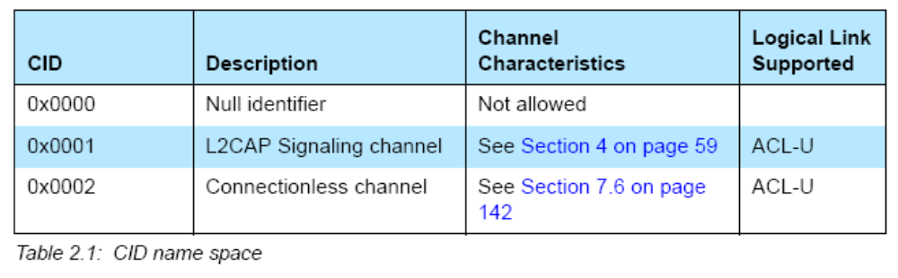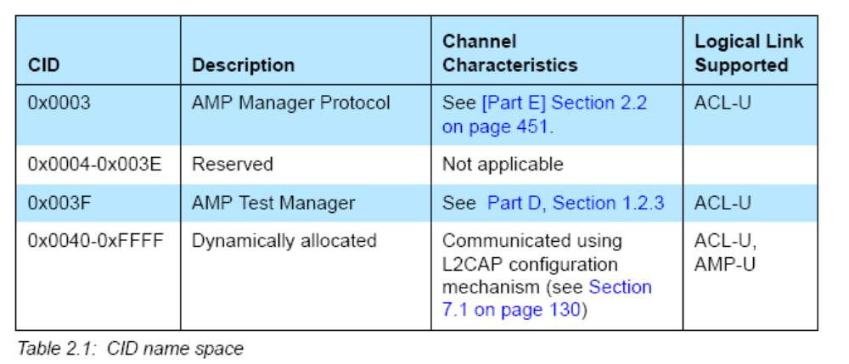
The CID name space for the LE-U logical link is as follows:
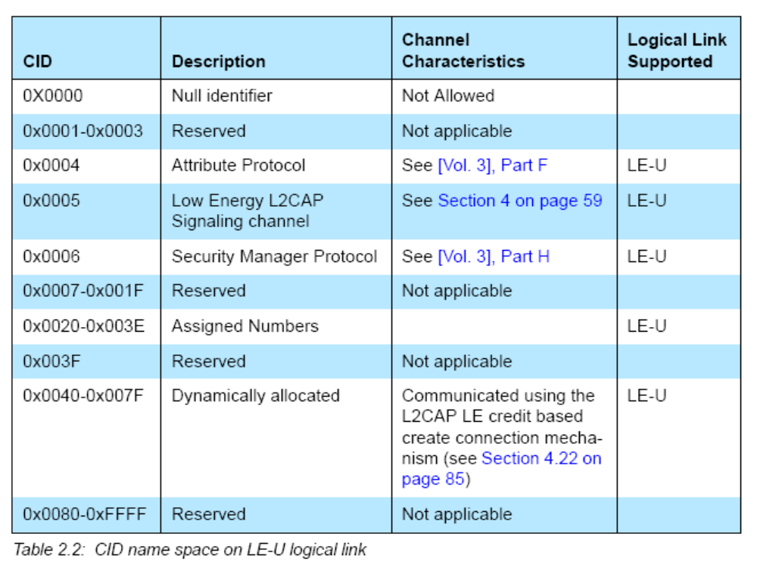
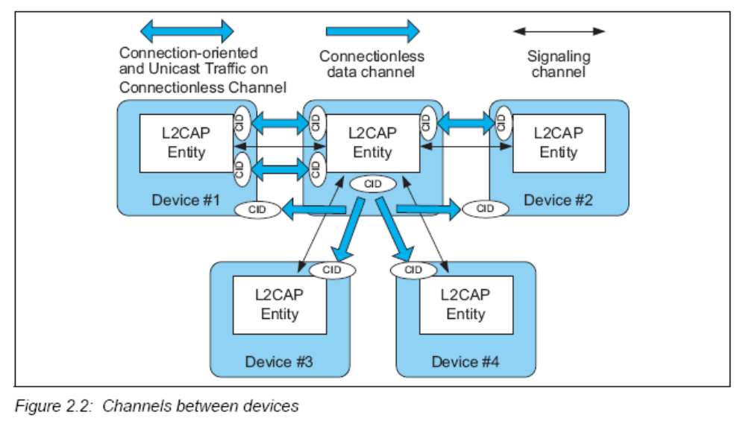

- Operation between Devices
The connection-oriented data channels represent a connection between two devices, where a CID identifies each endpoint of the channel. There are also a number of CIDs reserved for special purposes. The signaling channel (mandatory) is one example of a reserved channel. This channel is used to create and establish connection-oriented data channels and to negotiate changes in the characteristics of these channels. Another CID is reserved for all incoming connectionless data traffic. The connectionless channels restrict data flow to a single direction.
Unicast data sent on the L2CAP connectionless channel provides an alternate mechanism to send data with the same level of reliability as an L2CAP connection-oriented channel operating in Basic mode but without the additional latency incurred by opening an L2CAP connection-oriented channel.
If the application does not require delivery of data in frames, possibly because it includes in-stream framing, or because the data is a pure stream, then it may avoid the use of L2CAP channels and make direct use of a baseband logical link.
- Operation between Layers
L2CAP implementations must transfer data between higher layer protocols and the lower layer protocol. Each implementation must also support a set of signaling commands for use between L2CAP implementations.
L2CAP implementations should also be prepared to accept certain types of events from lower layers and generate events to upper layers. How these events are passed between layers is an implementation-dependent process.
- Modes of Operation
L2CAP channels may operate in one of five different modes as selected for each L2CAP channel. The modes are:
- Basic L2CAP Mode (equivalent to L2CAP specification in Bluetooth v1.1) 1
- Flow Control Mode
- Retransmission Mode
- Enhanced Retransmission Mode
- Streaming Mode
- LE Credit Based Flow Control Mode
The Basic L2CAP Mode shall be the default mode, which is used when no other mode is agreed. Enhanced Retransmission mode shall be used for all reliable channels created over AMP-U logical links and for ACL-U logical links operating. Enhanced Retransmission mode should be enabled for reliable channels created over ACL-U logical links not operating.
In Flow Control mode, Retransmission mode, and Enhanced Retransmission mode, PDUs exchanged with a peer entity are numbered and acknowledged. The sequence numbers in the PDUs are used to control buffering, and a TxWindow size is used to limit the required buffer space and/or provide a method for flow control.
In Flow Control Mode no retransmissions take place, but missing PDUs are detected and can be reported as lost.
In Retransmission Mode a timer is used to ensure that all PDUs are delivered to the peer, by retransmitting PDUs as needed. A go-back-n repeat mechanism is used to simplify the protocol and limit the buffering requirements.
Enhanced Retransmission mode is similar to Retransmission mode. It adds the ability to set a POLL bit to solicit a response from a remote L2CAP entity, adds the SREJ S-frame to improve the efficiency of error recovery and adds an RNR S-frame to replace the R-bit for reporting a local busy condition.
Streaming mode is for real-time isochronous traffic. PDUs are numbered but are not acknowledged. A finite flush timeout is set on the sending side to flush packets that are not sent in a timely manner. On the receiving side if the receive buffers are full when a new PDU is received then a previously received PDU is overwritten by the newly received PDU. Missing PDUs can be detected and reported as lost. TxWindow size is not used in Streaming mode.
LE Credit Based Flow Control Mode is used for LE L2CAP connection oriented channels for flow control using a credit based scheme for L2CAP data (i.e. not signaling packets). This is the only mode that shall be used for LE L2CAP connection oriented channels.
- Mapping Channels to Logical Links
L2CAP maps channels to Controller logical links, which in turn run over Controller physical links. All logical links going between a local Controller and remote Controller run over a single physical link. There is one ACL-U logical link per BR/EDR physical link and one LE-U logical link per LE physical link, while there may be multiple AMP-U logical links per AMP physical link.
All Best Effort and Guaranteed channels going over a BR/EDR physical link between two devices shall be mapped to a single ACL-U logical link. All Best Effort channels going over an AMP physical link between two Controllers shall be mapped to a single AMP-U logical link while each Guaranteed channel going between two Controllers shall be mapped to its own AMP-U logical link with one AMP-U logical link per Guaranteed channel. All channels going over an LE physical link between two devices shall be treated as best effort and mapped to a single LE-U logical link.
When a Guaranteed channel is created or moved to a Controller, a corresponding Guaranteed logical link shall be created to carry the channel traffic. Creation of a Guaranteed logical link involves admission control. Admission control is verifying that the guarantee can be achieved without compromising existing guarantees. For an AMP Controller, L2CAP shall tell the controller to create a Guaranteed logical link and admission control shall be performed by the Controller. For a BR/EDR Controller, admission control (creation of a Guaranteed logical link) shall be performed by the L2CAP layer.

Data Packet Format
L2CAP is packet-based but follows a communication model based on channels. A channel represents a data flow between L2CAP entities in remote devices. Channels may be connection-oriented or connectionless. All packet fields use Little Endian byte order.
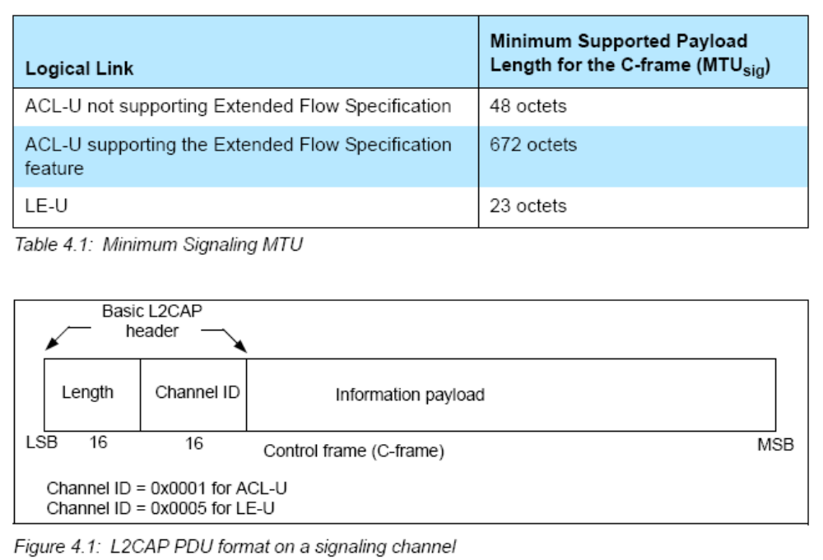
Some specific formats of the packets are described below. Note that this is not a complete list, but merely a subset for the sake of understanding the implementation.
- Command Format (Code 0x01)
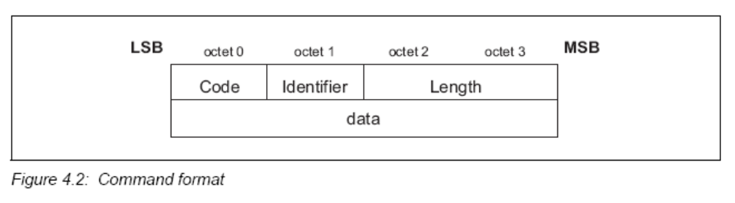

The fields shown are:
• Code (1 octet)
The Code field is one octet long and identifies the type of command. When a packet is received with a Code field that is unknown or disallowed on the signaling channel it is received on, a Command Reject packet is sent in response.
• Identifier (1 octet)
The Identifier field is one octet long and matches responses with requests. The requesting device sets this field and the responding device uses the same value in its response. Within each signaling channel a different Identifier shall be used for each successive command. Following the original transmission of an Identifier in a command, the Identifier may be recycled if all other Identifiers have subsequently been used.
• Length (2 octets)
The Length field is two octets long and indicates the size in octets of the data field of the command only, i.e., it does not cover the Code, Identifier, and Length fields.
• Data (0 or more octets)
The Data field is variable in length. The Code field determines the format of the Data field. The length field determines the length of the data field.
- Command Reject (Code 0x02)
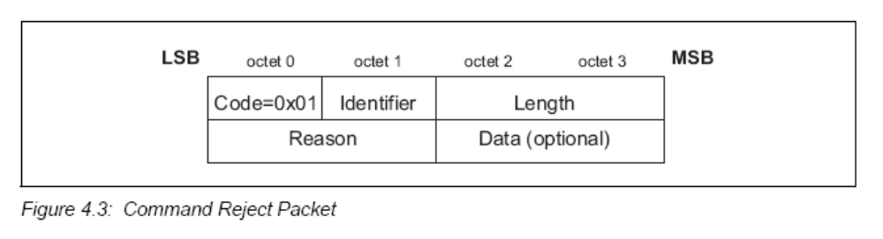
• Reason (2 octets)
The Reason field describes why the Request packet was rejected, and is set to one of the defined Reason codes.
• Data (0 or more octets)
The length and content of the Data field depends on the Reason code. If the Reason code is 0x0000, “Command not understood”, no Data field is used. If the Reason code is 0x0001, “Signaling MTU Exceeded”, the 2-octet Data field represents the maximum signaling MTU the sender of this packet can accept.
- Connection Request (Code 0x02)
Connection request packets are sent to create an L2CAP channel between two devices. The L2CAP channel shall be established before configuration begins.
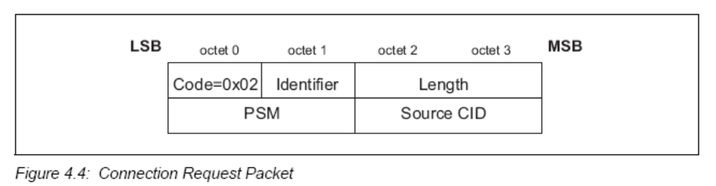
• Protocol/Service Multiplexer - PSM (2 octets (minimum))
The PSM field is at least two octets in length. The structure of the PSM field is based on the ISO 3309 extension mechanism for address fields. All PSM values shall be ODD, that is, the least significant bit of the least significant octet must be ’1’. Also, all PSM values shall have the least significant bit of the most significant octet equal to ’0’. This allows the PSM field to be extended beyond 16 bits. PSM values are separated into two ranges. Valid values in the first range are assigned by the Bluetooth SIG and indicate protocols.
The second range of values are dynamically allocated and used in conjunction with the Service Discovery Protocol (SDP). The dynamically assigned values may be used to support multiple implementations of a particular protocol.
• Source CID - SCID (2 octets)
The source CID is two octets in length and represents a channel endpoint on the device sending the request. Once the channel has been configured, data packets flowing to the sender of the request shall be sent to this CID. Thus, the Source CID represents the channel endpoint on the device sending the request and receiving the response.

- Connection Response (Code 0x03)
When a device receives a Connection Request packet, it shall send a Connection Response packet.
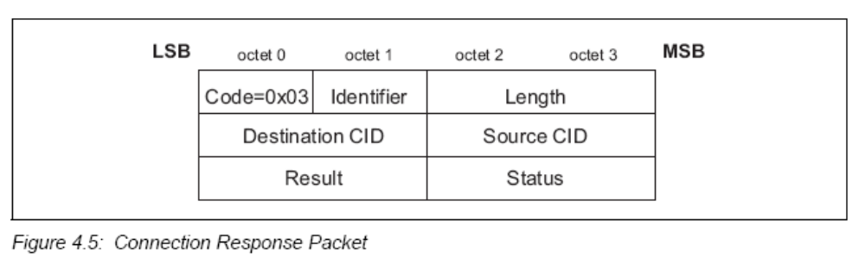
The data fields are:
• Destination Channel Identifier - DCID (2 octets)
This field contains the channel endpoint on the device sending this Response packet. Thus, the Destination CID represents the channel endpoint on the device receiving the request and sending the response.
• Source Channel Identifier - SCID (2 octets)
This field contains the channel endpoint on the device receiving this Response packet. This is copied from the SCID field of the connection request packet.
• Result (2 octets)
The result field indicates the outcome of the connection request. The result value of 0x0000 indicates success while a non-zero value indicates the connection request failed or is pending. A logical channel is established on the receipt of a successful result.
• Status (2 octets)
Only defined for Result = Pending. Indicates the status of the connection. It can be set to No information available, Authentication or Authorization pending and other status values.

- Create Channel Request (Code 0x0C)
The Create Channel request packet, shown in Figure 4.16, is sent to create an L2CAP channel between two devices over the Controller identified by the Controller ID.
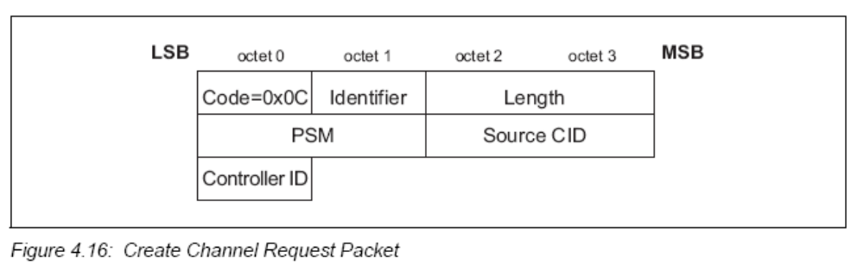
• Controller Identifier –Controller ID (1 octet)
The Controller ID is one octet in length and represents the Controller physical link over which the channel shall be created. The Controller ID is the identifier of the Controller on the remote device obtained via an AMP Manager Discover Available AMPs request.
- Create Channel Response (Code 0x0D)
When a device receives a Create Channel Request Packet, it shall send a Create Channel Response packet.
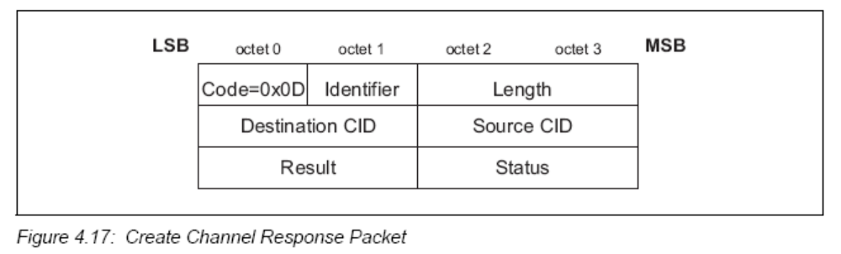

Service Primitives
Several services are offered by L2CAP in terms of service primitives and parameters. The service interface is required for testing. They include primitives to:
Connection: setup, configure, disconnect
Data: read, write
Group: create, close, add member, remove member, get membership
Information: ping, get info, and request a call-back at the occurrence of an event
Connection-less Traffic: enable, disable

Overview of BR/EDR Operation
The Basic Rate / Enhanced Data Rate (BR/EDR) radio (physical layer or PHY) operates in the unlicensed ISM band at 2.4 GHz. The system employs a frequency hopping transceiver to combat interference and fading and provides many FHSS carriers. Basic Rate radio operation uses a shaped, binary frequency modulation to minimize transceiver complexity. The symbol rate is 1 Mega symbol per second (Ms/s) supporting the bit rate of 1 Megabit per second (Mb/s) or, with Enhanced Data Rate, a gross air bit rate of 2 or 3Mb/s. These modes are known as Basic Rate and Enhanced Data Rate respectively.
During typical operation a physical radio channel is shared by a group of devices that are synchronized to a common clock and frequency hopping pattern. One device provides the synchronization reference and is known as the master. All other devices synchronized to a master’s clock and frequency hopping pattern are known as slaves. A group of devices synchronized in this fashion form a piconet.
Devices in a piconet use a specific frequency hopping pattern, which is algorithmically determined by certain fields in the Bluetooth address and clock of the master. The basic hopping pattern is a pseudo-random ordering of the 79 frequencies, separated by 1 MHz, in the ISM band. The hopping pattern can be adapted to exclude a portion of the frequencies that are used by interfering devices.
The physical channel is sub-divided into time units known as slots. Data is transmitted between Bluetooth devices in packets that are positioned in these slots. Bluetooth technology provides the effect of full duplex transmission through the use of a Time-Division Duplex (TDD) scheme.

Packet Information
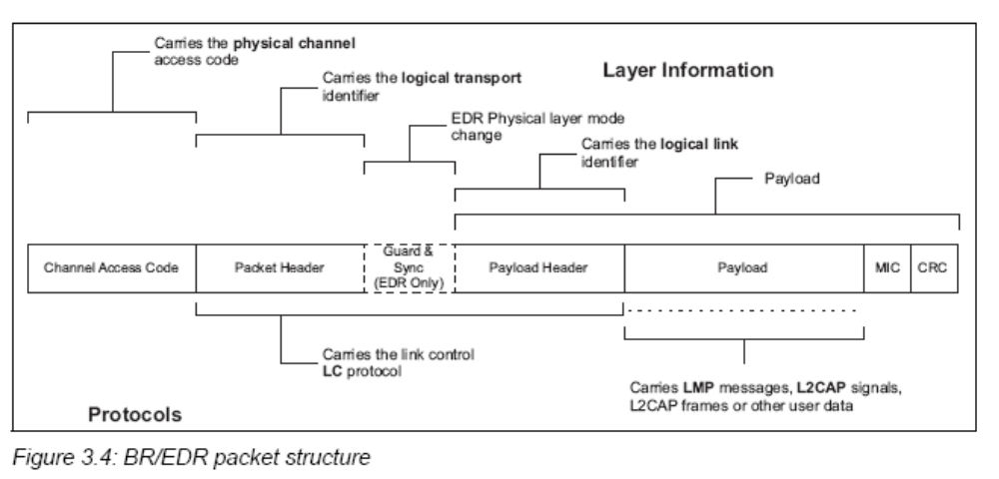

Packets normally only include the fields that are necessary to represent the layers required by the transaction. Thus a simple inquiry request over an inquiry scan physical channel does not create or require a logical link or higher layer and therefore consists only of the channel access code (associated with the physical channel).
All packets include the channel access code. This is used to identify communications on a particular physical channel, and to exclude or ignore packets on a different physical channel that happens to be using the same RF carrier in physical proximity.
There is no direct field within the BR/EDR packet structure that represents or contains information relating to physical links. This information is implied by the combination of the logical transport address (LT_ADDR) carried in the packet header and the channel access code (CAC).
Most BR/EDR packets include a packet header. The packet header is always present in packets transmitted on physical channels that support physical links, logical transports and logical links. The packet header carries the LT_ADDR, which is used by each receiving device to determine if the packet is addressed to the device and is used to route the packet internally.
The BR/EDR packet header also carries part of the link control (LC) protocol that is operated per logical transport (except for ACL and SCO transports that operate a shared LC protocol carried on either logical transport).
The payload header is present in all packets on logical transports that support multiple logical links. The payload header includes a logical link identifier field used for routing the payload, and a field indicating the length of the payload body. Some packet types also include a CRC at the end of the packet payload that is used to detect most errors in received packets. When AES-CCM encryption is enabled, ACL packets include a Message Integrity Check (MIC) just prior to the CRC field.
EDR packets have a trailer after the CRC.
The packet payload body is used to transport the user data. The interpretation of this data is dependent on the logical transport and logical link identifiers. For ACL logical transports Link Manager Protocol (LMP) messages and L2CAP signals are transported in the packet payload body, along with general user data from applications.

Overview of Bluetooth Low Energy Operation
Like the BR/EDR radio, the LE radio operates in the unlicensed 2.4 GHz ISM band. The LE system employs a frequency hopping transceiver to combat interference and fading and provides many FHSS carriers. LE radio operation uses a shaped, binary frequency modulation to minimize transceiver complexity. The symbol rate is 1 Megasymbol per second (Ms/s) supporting the bit rate of 1 Megabit per second (Mb/s).
LE employs two multiple access schemes: Frequency division multiple access (FDMA) and time division multiple access (TDMA). Forty (40) physical channels, separated by 2 MHz, are used in the FDMA scheme. Three (3) are used as advertising channels and 37 are used as data channels. A TDMA based polling scheme is used in which one device transmits a packet at a predetermined time and a corresponding device responds with a packet after a predetermined interval.
The physical channel is sub-divided into time units known as events. Data is transmitted between LE devices in packets that are positioned in these events. There are two types of events: Advertising and Connection events.
Transmissions on the advertising PHY channels occur in advertising events. At the start of each advertising event, the advertiser sends an advertising packet corresponding to the advertising event type.
Depending on the type of advertising packet, the scanner (device that receives the advertised packet without establishing a connection) may make a request to the advertiser on the same advertising PHY channel which may be followed by a response from the advertiser on the same advertising PHY channel. The advertising PHY channel changes on the next advertising packet sent by the advertiser in the same advertising event. The advertiser may end the advertising event at any time during the event. The first advertising PHY channel is used at the start of the next advertising event.

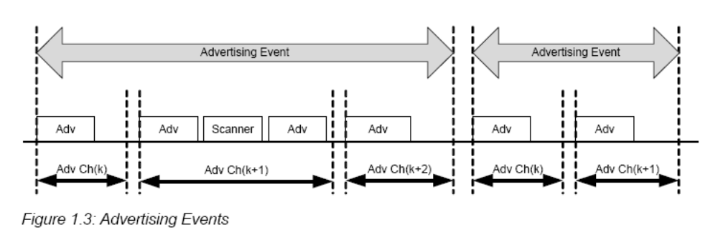
LE devices may fulfill the entire communication in the case of unidirectional or broadcast communication between two or more devices using advertising events. They may also use advertising events to establish pair-wise bi-directional communication between two or more devices using data channels.
Devices that need to form a connection to another device listen for connectable advertising packets. Such devices are referred to as initiators. If the advertiser is using a connectable advertising event, an initiator may make a connection request using the same advertising PHY channel on which it received the connectable advertising packet. The advertising event is ended and connection events begin if the advertiser receives and accepts the request for a connection be initiated. Once a connection is established, the initiator becomes the master device in what is referred to as a piconet and the advertising device becomes the slave device. Connection events are used to send data packets between the master and slave devices. In connection events, channel hopping occurs at the start of each connection event. Within a connection event, the master and slave alternate sending data packets using the same data PHY channel. The master initiates the beginning of each connection event and can end each connection event at any time.
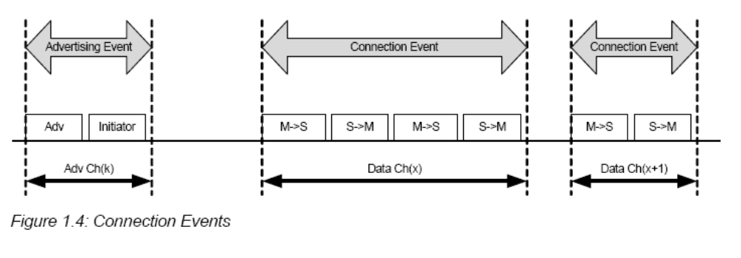
Devices in a piconet use a specific frequency hopping pattern, which is algorithmically determined by a field contained in the connection request sent by an initiating device. The initiating device provides the synchronization reference known as a hop interval. The hopping pattern used in LE is a pseudo-random ordering of the 37 frequencies in the ISM band. The hopping pattern can be adapted to exclude a portion of the frequencies that are used by interfering devices.
Master-Slave Relations
Within a physical channel, a physical link is formed between a master and each slave. Direct physical links between slaves in a piconet are not supported. Slaves are permitted to have physical links to more than one master at a time. A device is permitted to be master and slave at the same time. Role changes between a master and slave device are not supported at this time.
Additional Layers over L2CAP
In addition to L2CAP, LE provides two additional protocol layers that reside on top of L2CAP. The Security Manager protocol (SMP) uses a fixed L2CAP channel to implement the security functions between devices. The other is the Attribute protocol (ATT) that provides a method to communicate small amounts of data over a fixed L2CAP channel. The Attribute protocol is also used by devices to determine the services and capabilities of other devices. The Attribute protocol may also be used over BR/EDR.

Packet Information
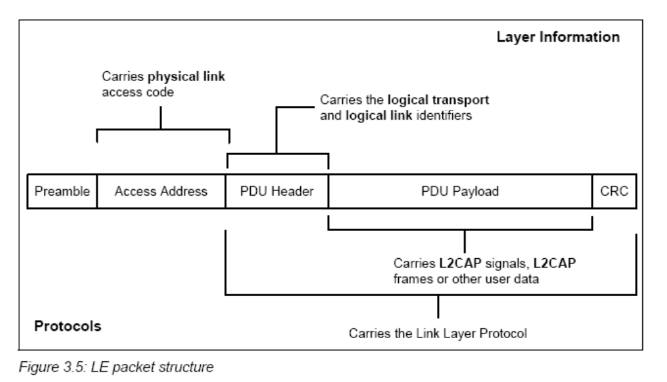
The physical channel identifier is not contained in the link layer air interface packet. The physical channel identifiers are either fixed or are determined at connection setup. All LE packets include the Access Address. This is used to identify communications on a physical link, and to exclude or ignore packets on different physical links that are using the same PHY channels in physical proximity.
The Access Address determines whether the packet is directed to the advertising physical link or to an active physical link to a device. All LE advertising physical links use a fixed Access Address. LE active physical links use a randomly generated 32-bit value as their Access Address. This provides an high number of active devices that can be addressed in an LE piconet.
All LE packets include a PDU header. The PDU header determines the type of advertisement broadcast or logical link carried over the physical channel.
For advertising channel PDUs, the PDU header contains the type of advertisement payload, the device address type for addresses contained in the advertisement and advertising channel PDU payload length.
- Most advertising channel PDU payloads contain the advertiser's address and advertising data.
- One advertising channel PDU payload only contains the advertiser's device address and the initiator's device address in which the advertisement is directed.
- Advertising channel PDUs with scan requests payloads contain the scanner's device address and the advertiser's device address.
- Advertising channel PDUs with scan responses contain advertiser's device address and the scan response data.
- Advertising channel PDUs with connection request payloads contain the initiator's device address, advertiser's device address and connection setup parameters.
For data channel PDUs, the PDU header contains the Logical Link Identifier (LLID), the Next Expected Sequence Number (NESN), Sequence Number (SN), More Data (MD) and payload length.
For data channel PDUs that contain control commands, the data channel PDU payload contains a command opcode and control data that is specific to the command. There is an optional Message Integrity Check (MIC) value that is used to authenticate the data PDU.
For data channel PDUs that are data, the data channel PDU payload contains L2CAP data.

Overview of AMP Operation
Alternate MAC/PHYs (AMP) are secondary Controllers in the Bluetooth core system. The BR/EDR radio, the primary radio, is used to perform discovery, association, connection establishment, and connection maintenance. Once an L2CAP connection has been established between two devices over the BR/EDR radio, the AMP Managers can discover the AMPs that are available on the other device. When an AMP is common between the two devices, the Core system provides mechanisms for moving data traffic from BR/EDR Controller to an AMP Controller.
Each AMP consists of a Protocol Adaptation Layer (PAL) on top of a MAC and PHY. The PAL is responsible for mapping the Bluetooth protocols and behavior (as specified by HCI) to the specific protocols of the underlying MAC and PHY. L2CAP channels may be created on, or moved to, an AMP. L2CAP channels may also be moved back to the BR/EDR radio when those capabilities are not necessary or when the AMP physical link has a link supervision timeout. A link supervision timeout on an ACL link connecting two BR/EDR devices forces a disconnection of all AMP physical links between those devices. AMPs may be enabled or disabled as needed in order to minimize power consumption in the system.

