Overview of the Service Discovery Protocol

General Description
The service discovery protocol (SDP) provides a means for applications to discover which services are available and to determine the characteristics of those available services. The set of services that are available changes dynamically based on the RF proximity of devices in motion.
- SDP shall provide the ability for clients to search for needed services based on specific attributes of those services.
- SDP shall permit services to be discovered based on the class of service.
- SDP shall enable browsing of services without a priori knowledge of the specific characteristics of those services.
- SDP shall provide the means for the discovery of new services that become available when devices enter RF proximity with a client device as well as when a new service is made available on a device that is in RF proximity with the client device.
- SDP shall provide a mechanism for determining when a service becomes unavailable when devices leave RF proximity with a client device as well as when a service is made unavailable on a device that is in RF proximity with the client device.
- SDP shall provide for services, classes of services, and attributes of services to be uniquely identified.
- SDP shall allow a client on one device to discover a service on another device without consulting a third device.
- SDP shall function while using L2CAP as its transport protocol and be transport independent.

SDP Client-Server Architecture
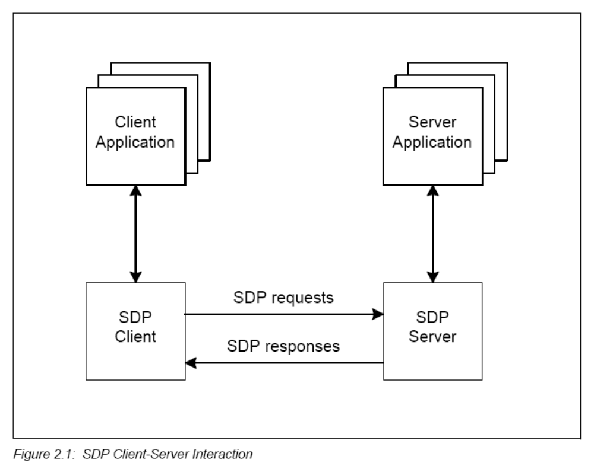

Service Records
SDP involves communication between an SDP server and an SDP client. The server maintains a list of service records that describe the characteristics of services associated with the server. Each service record contains information about a single service. A client can retrieve information from a service record maintained by the SDP server by issuing an SDP request.

Using a service
If the client, or an application associated with the client, decides to use a service, it opens a separate connection to the service provider in order to utilize the service. SDP provides a mechanism for discovering services and their attributes (including associated service access protocols), but it does not provide a mechanism for utilizing those services (such as delivering the service access protocols).

Multiple services
If multiple applications on a device provide services, an SDP server can act on behalf of those service providers to handle requests for information about the services that they provide. Similarly, multiple client applications can utilize an SDP client to query servers on behalf of the client applications.

Dynamic Servers
The set of SDP servers that are available to an SDP client will change dynamically based on the RF proximity of the servers to the client. When a server becomes available, a potential client must be notified by a means other than SDP so that the client can use SDP to query the server about its services. Similarly, when a server leaves proximity or becomes unavailable for any reason, there is no explicit notification via the service discovery protocol. However, the client can use SDP to poll the server and may infer that the server is not available if it no longer responds to requests.

Service Record
A service is any entity that can provide information, perform an action, or control a resource on behalf of another entity. A service may be implemented as software, hardware, or a combination of hardware and software. All of the information about a service that is maintained by an SDP server is contained within a single service record. The service record shall only be a list of service attributes.
A service record handle is a 32-bit number that shall uniquely identify each service record within an SDP server. It is important to note that, in general, each handle is unique only within each SDP server. If SDP server S1 and SDP server S2 both contain identical service records (representing the same service), the service record handles used to reference these identical service records are completely independent. The handle used to reference the service on S1 will be meaningless if presented to S2.

Service Attribute
Each service attribute describes a single characteristic of a service. Some examples of service attributes are:
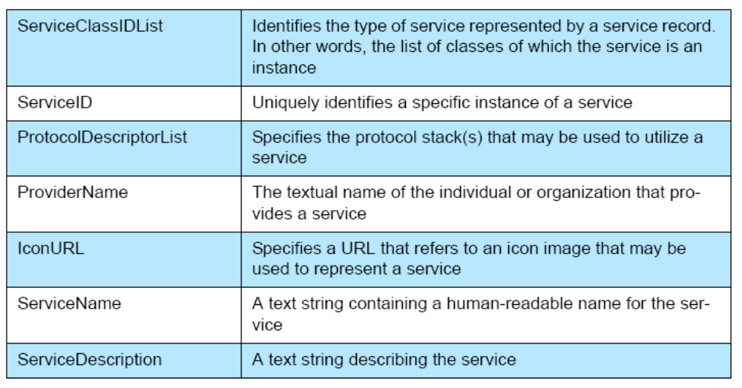

Service Class
Each service is an instance of a service class. The service class definition provides the definitions of all attributes contained in service records that represent instances of that class. Each attribute definition specifies the numeric value of the attribute ID, the intended use of the attribute value, and the format of the attribute value. A service record contains attributes that are specific to a service class as well as universal attributes that are common to all services.

Searching For Services
The Service Search transaction allows a client to retrieve the service record handles for particular service records based on the values of attributes contained within those service records. Once an SDP client has a service record handle, it can request the values of specific attributes. The capability search for service records based on the values of arbitrary attributes is not provided. Rather, the capability is provided to search only for attributes whose values are Universally Unique Identifiers1 (UUIDs). Important attributes of services that can be used to search for a service are represented as UUIDs.

UUIDs
A UUID is a universally unique identifier that is guaranteed to be unique across all space and all time. UUIDs can be independently created in a distributed fashion. No central registry of assigned UUIDs is required. A UUID is a 128-bit value.
To reduce the burden of storing and transferring 128-bit UUID values, a range of UUID values has been pre-allocated for assignment to often-used, registered purposes.
A list of UUIDs can be found here. UUID values in the pre-allocated range have aliases that are represented as 16-bit or 32-bit values. These aliases are often called 16-bit and 32-bit UUIDs, but it is important to note that each actually represents a 128-bit UUID value.

Service Search Patterns
Service Search Patterns is a list of UUIDs sent by the client to the server to get a particular service record. The algorithm would return a match only when the UUIDs in the Service Search Pattern form a subset or are equal to the UUIDs in the attributes of a service record.

Browsing For Services
There are times when it is desirable to discover which types of services are described by an SDP server’s service records without any a priori information about the services. This process of looking for any offered services is termed browsing.
In SDP, the mechanism for browsing for services is based on an attribute shared by all service classes. This attribute is called the BrowseGroupList attribute. The value of this attribute contains a list of UUIDs. Each UUID represents a browse group with which a service may be associated for the purpose of browsing.
When a client desires to browse an SDP server’s services, it creates a service search pattern containing the UUID that represents the root browse group. All services that may be browsed at the top level are made members of the root browse group by having the root browse group’s UUID as a value within the BrowseGroupList attribute.

Data Representation
Attribute values can contain information of various types with arbitrary complexity; thus enabling an attribute list to be generally useful across a wide variety of service classes and environments.
SDP defines a simple mechanism to describe the data contained within an attribute ID, attribute ID range, and attribute value. The primitive construct used is the data element.

Data Element
A data element is a typed data representation. It consists of two fields: a header field and a data field. The header field, in turn, is composed of two parts: a type descriptor and a size descriptor. The data is a sequence of bytes whose length is specified in the size descriptor and whose meaning is (partially) specified by the type descriptor.

Data Element Type Descriptor
A data element type is represented as a 5-bit type descriptor. The type descriptor is contained in the most significant (high-order) 5 bits of the first byte of the data element header. The following types have been defined.
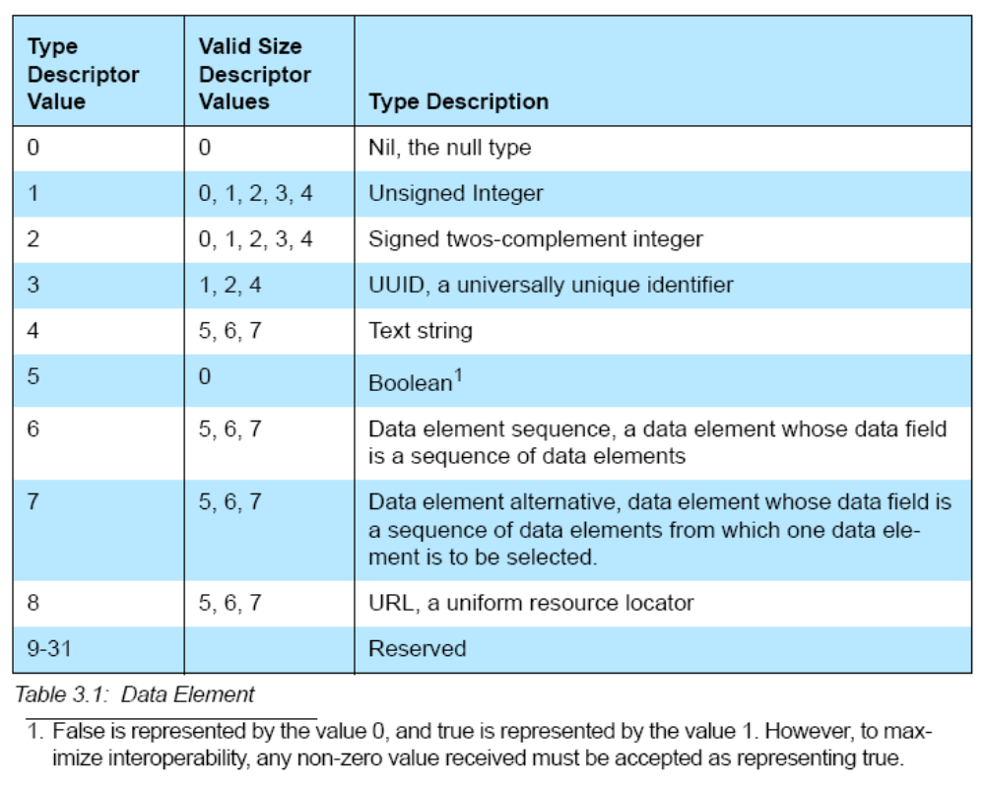

Data Element Size Descriptor
The data element size descriptor is represented as a 3-bit size index followed by 0, 8, 16, or 32 bits. The size index is contained in the least significant (low order)
3 bits of the first byte of the data element header. The size index is encoded as follows.
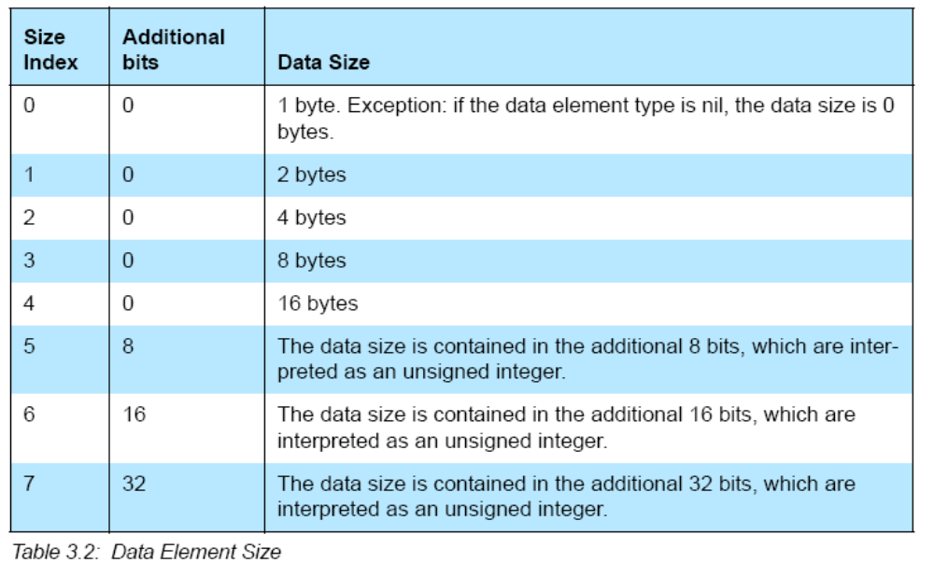

Data Element Examples
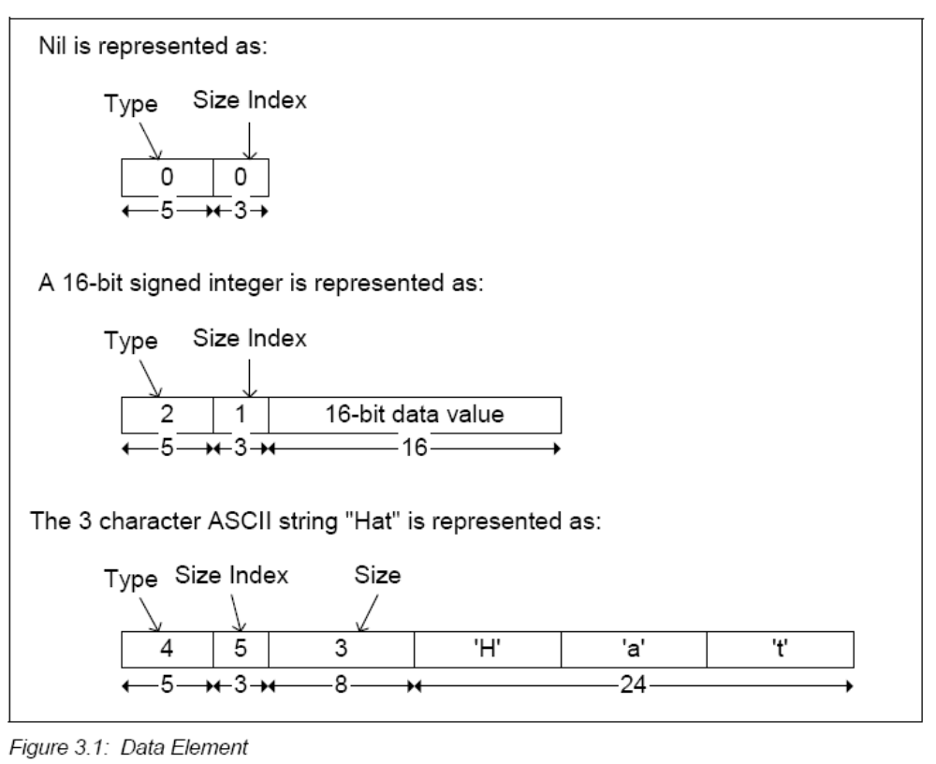

Protocol Description
SDP uses a request/response model where each transaction consists of one request protocol data unit (PDU) and one response PDU. In the case where SDP is used with the Bluetooth L2CAP transport protocol, a client does not issue a further request to a server prior to receiving a response to the current request before issuing another request on the same L2CAP connection.

Transfer Byte Order
The service discovery protocol shall transfer multiple-byte fields in standard network byte order (Big Endian), with more significant (high-order) bytes being transferred before less-significant (low-order) bytes.

Protocol Data Unit Format
Every SDP PDU consists of a PDU header followed by PDU-specific parameters.
The header contains three fields: a PDU ID, a Transaction ID, and a
ParameterLength.
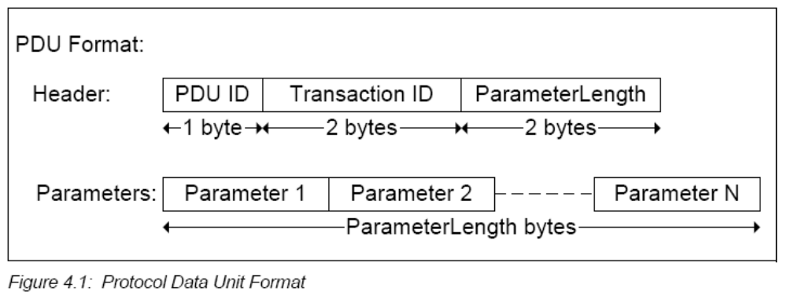
- The PDU ID field identifies the type of PDU. I.e. its meaning and the specific parameters.
- The TransactionID field uniquely identifies request PDUs and is used to match response PDUs to request PDUs. The SDP client can choose any value for a request’s TransactionID provided that it is different from all outstanding requests. The TransactionID value in response PDUs is required to be the same as the request that is being responded to.
- The ParameterLength field specifies the length (in bytes) of all parameters contained in the PDU.

Partial Responses and Continuation State
Some SDP requests may require responses that are larger than can fit in a single response PDU. In this case, the SDP server shall generate a partial response along with a continuation state parameter. The continuation state parameter can be supplied by the client in a subsequent request to retrieve the next portion of the complete response.
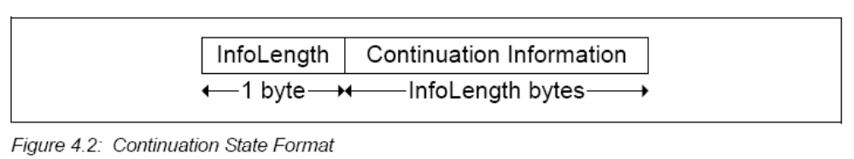
After a client receives a partial response and the accompanying continuation state parameter, it can re-issue the original request (with a new transaction ID) and include the continuation state in the new request indicating to the server that the remainder of the original response is desired. The maximum allowable value of the InfoLength field is 16 (0x10).

Error Handling
Each transaction consists of a request and a response PDU. Generally, each type of request PDU has a corresponding type of response PDU. However, if the server determines that a request is improperly formatted or for any reason the server cannot respond with the appropriate PDU type, it shall respond with an SDP_ErrorResponse PDU.
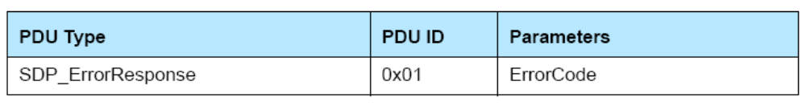

Service Related PDUs

SDP_ServiceSearchRequest/Response PDU
The SDP client generates an SDP_ServiceSearchRequest to locate service records that match the service search pattern given as the first parameter of the PDU. Upon receipt of this request, the SDP server shall examine its service record data base and return an SDP_ServiceSearchResponse containing the service record handles of service records within its service record database that match the given service search pattern, or an appropriate error response.

SDP_ServiceAttributeRequest/Response PDU
The SDP client generates an SDP_ServiceAttributeRequest to retrieve specified attribute values from a specific service record. The service record handle of the desired service record and a list of desired attribute IDs to be retrieved from that service record are supplied as parameters.
The SDP server generates an SDP_ServiceAttributeResponse upon receipt of a valid SDP_ServiceAttributeRequest. The response contains a list of attributes (both attribute ID and attribute value) from the requested service record.

SDP_ServiceSearchAttributeRequest/Response PDU
The SDP_ServiceSearchAttributeRequest transaction combines the capabilities of the SDP_ServiceSearchRequest and the SDP_ServiceAttributeRequest into a single request. As parameters, it contains both a service search pattern and a list of attributes to be retrieved from service records that match the service search pattern. The SDP_ServiceSearchAttributeRequest and its response are more complex and can require more bytes than separate SDP_ServiceSearch and SDP_ServiceAttribute transactions. However, using SDP_ServiceSearchAttributeRequest can reduce the total number of SDP transactions, particularly when retrieving multiple service records.

