

Proposal / Application
for
ICT-Related Development
and Research Grant

<Project Title>

<submitted by>

Read carefully before filling the form.

- Please do not alter the layout of the application form. Information must be filled in the spaces provided, under set format.
- Guidance notes in various fields should not be deleted.
- Required information should be duly filled in the specified fields.
- Required heads/fields which are not relevant to the project should be marked N/A (Not Applicable) or left blank and should not be deleted.
- Specifications, justifications, purposes must be provided against each item in the Budget file.
- Please do not change the formulas in the budget sheets.
- We have prepared financial guidelines to evaluate the remuneration for human resource associated with the proposed project. The guidelines are available on our website (click application forms>Financial Guidelines for Preparation of R&D and HRD Proposals>.

List of Abbreviations and Acronyms

EE | External Evaluators
ICT | Information and Communication Technologies
IPR | Intellectual Property Rights
CPI | Co-Principal Investigator
PI | Principal Investigator
PIO | Principal Investigator’s Organization  "Principal Investigator’s Organization" means the person, company, partnership, undertaking, concern, association of persons, body of individuals, consortium or joint venture which receives funding from the Company to execute a research and development project.”
R&D | Research and Development

List of Abbreviations and Acronyms Used by PI in the Proposal
(Please add abbreviations and acronyms in the table below, if any.)
Application for ICT-Related Development and Research Grant
Guidelines and Forms

Introduction
National ICT R&D Fund was created in January 2007 by Ministry of IT with the vision to transform Pakistan's economy into a knowledge-based economy by promoting efficient, sustainable, and effective ICT (IT and Telecommunications) initiatives through synergic development of industrial and academic resources. Collaborative efforts between academia, research institutions, and industry are greatly encouraged to ensure that local economy can reap the monetary benefits of investment in research. This organization has significant funds available for proposals that are geared towards creating ICT related technologies.

Research grants will be awarded for high-level and promising ICT-related development and research projects by individuals or groups from academia and/or industry actively involved in the research and development individually or collaboratively. These projects should be based on either a universally known technology or a new technology developed by the applicant and should be aimed at achieving economically viable systems, products, or processes beneficial to the nation.

The grant will cover the honoraria of the principal investigator and co- principal investigators, salaries of professional researchers and developers at market rate, stipends for student research assistants, and supporting staff. It will also cover travel(s) within and outside the country for project-related activities and for scientific conferences where project team’s research paper, an outcome of the project, has been selected for presentation. The grant may be used to purchase very specific unavoidable equipment kept to the bare minimum, consumable materials, and other items needed for the project.

Submission Procedure
Duly filled application forms complete in all respects along with any documents should be submitted online through Fund’s website www.ictrdf.org.pk. A hard copy should also be submitted by registered post or by fax at our mailing address given below. On receipt of the applications the proposals will be evaluated internally as well as externally as laid down in our policy documents. The PI may need to revise the proposal in light of the evaluator’s recommendations.

There is no deadline for submission of the application forms for Unsolicited Projects. The deadline for Solicited Projects will be given in the RFPs whenever floated.

Joint Funding
The project proposal may be jointly funded by ICT R&D Fund and other funding agencies/industry. The efforts to obtain joint funding will be at the discretion of the Principal Investigator Organization (PIO) to which Principal Investigator belongs. However any such information must be provided to ICT R&D Fund. The funds released will be provided to the PI.

Agreement
A written agreement will be made between National ICT R&D Fund and PI. The PI will undertake to administer the grant according to the agreement and to provide laboratory space, and other facilities necessary for the project. The equipment purchased with ICT R&D Fund for the approved project will remain the property of ICT R&D Fund. The laptops will be returned to ICT R&D Fund after completion of the project. The grantee is required to submit a final narrative and financial report within one month of the completion of the project. The IPR issues will be sorted according to the policy in vogue.

For further information, please contact:

Manager Administration,
National ICT R&D Fund,
6th Floor, HBL Towers,
Jinnah Avenue, Blue Area, Islamabad
Tel.: (+92-51) 921 5360 - 65
Fax: (+92-51) 921 5366
Website: www.ictrdf.org.pk

Table of Contents
Description Page #
1. Project Identification 1
A. Reference Number: 1
B. Project Title: 1
C. Principal Investigator (PI): 1
D. Principal Investigator’s Organization (PIO): 1
E. Other Organizations Involved in the Project: 2
F. Key Words: 2
G. Research and Development Theme: 3
H. Project Status: 3
I. Project Duration: 3
J. Executive Summary: 3
2. Scope, Introduction and Background of the Project 3
A. Scope of the Project: 3
B. Introduction: 4
B1. Literature Review: 7
B2. Current State of the Art: 22
C. Challenges: 22
D. Motivation and Need: 22
3. Objectives of the Project 24
A. Specific Objectives Being Addressed by the Project: 24
4. Research Approach 26
A. Development / Research Methodology: 26
B. Project Team: 31
C. Team Structure: 31
D. Project Activities: 31
E. Key Milestones and Deliverables: 32
5. Benefits of the Project 32
A. Direct Customers / Beneficiaries of the Project: 32
B. Outputs Expected from the Project: 32
C. Organizational / HRD Outcomes Expected: 32
D. Technology Transfer / Diffusion Approach: 33
6. Risk Analysis 33
A. Risks of the Project: 33
A1. Comments: 33
7. Contractual Matters 33
A. Contractual Obligations under this Project: 33
B. Ownership of Intellectual Property Rights: 33
C. Competent Authority of the Principal Investigator’s Organization: 33
8. Project Schedule / Milestone Chart 35
9. Proposed Budget 36
Annexure A – Curriculum Vitae 37
Bibliography 39

Note: To update the table of contents, right click in the table and select ‘update field’ and then select ‘Update Entire Table’.

Application for ICT-Related Development and Research Grant

1. Project Identification
- Reference Number:
(for office use only)

- Project Title:
<type here>

- Principal Investigator (PI):
Name: |  |  | Dr. Muhammad Khurram
Designation: |  |  | Associate Professor
Organization: |  |  | Department of Computer & Information Systems Engineering, NED University of Engineering and Technology, Karachi, Pakistan
Mobile # : |  |  | 0335-3046110 |  |  |  | Tel.#:
Email: |  |  | Khurram.ned@gmail.com
(A letter from the competent authority regarding PI’s time commitment for the proposed research project must be provided.)
C1. Co-Principal Investigator (CPI):
Name:
Designation:
Organization:
Mobile # : |  |  |  |  |  |  | Tel. # :
Email:
C2. Contact Person: (If different from PI.)
Name:
Designation:
Organization:
Mobile # : |  |  |  |  |  |  | Tel. # :
Email:
- Principal Investigator’s Organization (PIO):
(Please indicate the name, address, telephone and fax of the Principal Investigator’s Organization. The Principal Investigator should belong to this organization.)
Name:
Address:
Registration #: |  |  |  |  |  |  |  |  |  | (Please attach certified copy)
National Tax #: |  |  |  |  |  |  |  |  |  | (Please attach certified copy)
Tel. # : |  |  |  |  |  | Fax # :
Website:
- Other Organizations Involved in the Project:
(Please identify all affiliated organizations collaborating in the project, and describe their role/contribution to the project.)
E1. Industrial Organizations:
# | Organization Name |  |  |  |  | Role / Contribution
E2. Academic Organizations:
# | Organization Name |  |  |  | Role / Contribution
E3. Funding Organizations:
# | Organization Name |  |  |  |  | Role / Contribution
E4. Other Organizations:
# | Organization Name |  |  |  |  | Role / Contribution
- Key Words:
(Please provide a maximum of 5 key words that describe the project. The key words will be incorporated in our database.)
<type here>

- Research and Development Theme:
(If the proposal belongs to a theme specified by NICT R&D Fund, please identify the Research Theme.)
<type here>

- Project Status:
(Please mark ☑)
  New  Modification to previous Project
❑ Extension of existing project

H1. Project URL:
(The project URL should be provided. This URL should be hosted by the project executing agency. Sufficient details such as executive summary, objectives are expected on the website. Once the proposal is approved, the website should also provide final copy of the proposal and deliverables/progress.)
<type here>

- Project Duration:
Expected Starting Date:
Planned Duration in months:
- Executive Summary:
<type here>

2. Scope, Introduction and Background of the Project
- Scope of the Project:
The most efficient use of fresh water is burning need of the time. Therefore efficient and intelligent management of irrigation is a major concern in agriculture. People are working on automated and intelligent irrigation systems because of its principal advantages especially in labor and water savings. The proposed system is an application of modern technology that is now being implemented worldwide. The proposed system shall aid in reduced water usage as studies shows that this type of automated irrigation system consumes 40-50% less water [1] as compared to the traditional system.
Irrigation systems without a continuous feedback can result in over-irrigation, negatively affect soil salinization, increase rate of soil degradation, limit crop growth. The proposed system will be applicable to most field sizes and crop types regardless of existing water distribution method and maintain scheduling of irrigation activities. It shall reduce overall water usage, adaptable for most crop and soil types, modular in design and predictive. The system will be cost effective solution for the existing agricultural practices and offers robustness of sensor networks.
The smart irrigation system prolongs watering time of plants when needed and the sprinklers are self-adjustable according to the environmental conditions and no manual adjustments and settings are required hence it will save time. The field’s data will be timely collected and maintained on a remote storage i.e. cloud for future analysis. Cloud storage shall relieve the burden of managing and maintaining a standalone server in which probability of loss of data is very high and consumes power. The proposed system will have all the data from different remote fields centrally stored on cloud storage and access can be offered to experts for future studies in the field of agriculture. This system directly provide research opportunities to the following:
Entomologists, who will extend their studies on pests for quality production of pesticides,
Agriculture Economist, Agriculture Engineers and Educators, Researchers and Agriculture Ministry for future planning. Further study on cloud based technological advancements is also possible by adapting the proposed system.
Through the application of this system, firstly, the cost can be greatly reduced, and on the other hand, water and electricity can be saved. Increasing the production of healthy food benefits directly to the farm holders and consumers.
The following are direct and indirect beneficiaries of this system:
• Farmers will be left free from the burden of timely observation of the plants and sufficient crops can be cultivated within sufficient time.
• Ordinary people who are consumers will get good quality food and due to their production in abundance, the product will be available at cheap cost.
• Traders will obtain desired amount of crops and goods for retail.
• Industries in different sectors like Agriculture, Food, Electricity, and Electronics will experience mutual benefits.
• Provincial Government and the Government of Pakistan would be facilitated for future decision making and evolving new and effective policies in the field of agriculture.

The system shall resolve major issues of inefficient agricultural practices and thus problems like water-logging, salinity, over watering and inefficient handling of equipment are supposed to be solved.

- Introduction:
Agriculture plays an important direct and indirect role in generating economic growth. It provides food to consumers and fibers for the domestic industry. It is a source of scarce foreign exchange earnings and provides the market for industrial goods. Agriculture is the backbone of Pakistan’s economy. Half of the population’s direct source of income is agriculture. Agriculture is facing a lot of problems today, which is causing an increase in the proportion of poverty each year.
Most of the Pakistan's economy depends on agriculture; 50% of the total population is based on agriculture and the cultivation of their income. Today the agriculture is facing some major issues and agriculture growth rate decreases each year. It has been seen that a major proportion of the area under cultivation is decreasing which was 19.63(Area in million hectares) in 2009-2010[2] which results in decrease in GDP.

Table-1 Area Irrigated by Different Sources[2]
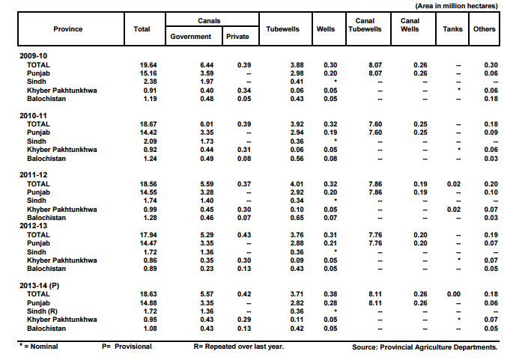

In 1947, 53% of the total GDP of Pakistan was based on agriculture, but unfortunately today contributes only 21.0% of GDP and 43.7% of employment [3].The agriculture sector has four subsectors including: crops, livestock, fisheries and forestry. During fiscal year 2013-14, the overall performance of agriculture sector witnessed a growth of 2.1 percent against the growth of 2.9 percent last year. The decline in its growth was due to drop in cotton production and other minor crops due to extreme weather but somehow compensated by the better output of rice, sugarcane, wheat and maize crops[3].
The reason for such a rapid decline is that crops and fields are not adequately managed and controlled; also farmers disagree with the need to apply scientific technology as other countries worldwide are adopting. In Pakistan old traditional forms of agriculture are still in practice, farmers use only their experience to take care of their fields. Water availability is the main concern to increase productivity in the agriculture sector. Currently the archaic method of irrigation, which is in practice throughout the country waste almost 50% - 60% of water resources of Pakistan. Because freshwater resources are already scarce in Pakistan so there is the need to propose irrigation technology based on using water efficiently solutions.
Mainly we want to guide the waste water because agriculture uses 85% of available freshwater resources worldwide, and this percentage will remain dominant in water consumption due to population growth and increased demand for food. Because freshwater resources are declining, therefore, we must make efficient use of it. There is an urgent need for strategies based on science and technology for sustainable water use. Deposits of water in Pakistan are decreasing day by day and water storage dams are also very less in number and few dams and other reservoirs lacks attention which ultimately results in drought most of the time. It does not only destroyed green fields, but cattle and a threat to human lives as water is an essential need of life. The construction of new dams / deposit requires a lot of investment and time, while the need for water savings can be achieved by using self-watering and accurate digital or smart irrigation system. The development of precision agriculture is an important strategic choice of agriculture and development of agricultural science worldwide.
Dwindling water supplies and poor water health are very real threats. When water supply is at risk, people and the planet end up suffering. Adverse environmental effects such as harmful pesticides, toxic fertilizers and animal waste results due to insensitive irrigation. This automatic irrigation system helps keep our water supplies clean by stopping that polluted runoff. It also helps to conserve water. Following graphs visualizes predicted trends and behavior of different effects over State of the Art Computing System Deployment to Improve Agricultural Sector of Pakistan by adoption of smart irrigation strategies.

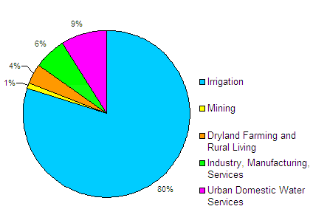
Figure1: Water Usage without technological advancements

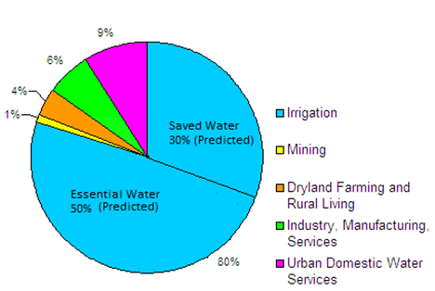
Figure 2: Water Usage with technological advancements

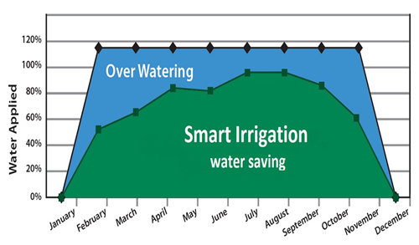

Figure3:Predicted water saving by "Smart Irrigation” State of the Art Computing System Deployment to Improve Agricultural Sector of Pakistan

These objectives can be achieved by the current state of the art technology i.e. "Internet of things".
The "Internet of things" refers to the idea that the Internet is no longer just a global network for people to communicate with each other using computers, but is also a platform for devices to communicate electronically with each other and, as with all things present in their environment.
It is under worldwide research and analyzes done next era will be flourished for the implementation of the IO. Since the development of the smart grid to the health system of remote monitoring, including automation, object tracking, GPS tracking and precision agriculture. IoT has played a vital role serving humanity.
Cloud storage is also popular these days. Cloud storage provides ease of remote data monitoring through mobile phones or on internet. The agriculture sector can also benefit from cloud as data from different remote areas is centrally stored on cloud and the access of data can be offered to research purposes.
Cloud storage guarantees 100% data security and thus ensures prevention from data loss.
The data can be easily available to the field owners through desktop mobile applications through internet.

B1. Literature Review:
(Detailed summary of what all has been done internationally in the proposed area quoting references and bibliography. Please note that this section demonstrates the depth of knowledge of the project team and builds the confidence of the evaluators about capability of the team in achieving the stated objectives.)
Agriculture is one of major source of income for Pakistan. The country’s economy highly depends on it. Agriculture accounts to be a major source of development. There has been a lot of research in this area, which could greatly improve the crop productivity [4]. Keeping in front the agricultural problems faced by our country in which water deficiency is the most prominent one, decision have been taken to develop a smart irrigation system that can achieve water conservation up to 40%.
Nowadays, there are different approaches for solutions that are being used to improve crop production. For enhancing crop production we need to monitor the crops constantly using sensors. Wireless Sensor Network in agriculture is showing progress [5]-[8]. WSNs provide possibilities to gather sensors data and information, regarding the environmental and crop condition. One of the application areas of WSN is Smart irrigation. A smart irrigation method is where the amount of inputs (like seed, fertilizer, pesticides, water etc.) given to a specific farm field is important to control and monitor the condition of the farm. It helps to determine the amount of the crop output. Wireless sensor networks (WSNs) have been increasingly popular, which attracts attention worldwide. WSN is now one of the key enablers for the Internet of Things (IoT) where WSNs will play an important role on future internet by collecting surrounding context and environment information. IoT provides potential motivation to the development of the following research areas[9]:
- Conceptual frameworks, architecture, components, RFID, sensors, and actuator technologies for IoT
- Online program update technology and test or debug technology
- Large-scale distributed WSNs for future internet
- Sensing technology for IoT
- Security, privacy, identity, trust, and reputation management on WSNs for IoT
- Data transmission and processing in WSNs for IoT
- Configuration and integration of WSNs into IoT
- Social networking for IoT
- Enabling computational technologies for IoT
- Applications, business, and social issues of WSNs for IoT

B1.1 Introduction to IoT(Internet of Things):
Internet of Things is creating an environment of convergence in the society. Researchers have predicted that IoT will rule in near future. The technology environment change that IoT has reflected brings a paradigm shift in our professional and personal life. As a connected environment, IoT adds customer value and loyalty. Today, IoT is being implemented everywhere which is of human concern like smart agriculture, smart environment, security, smart business process, home automation and healthcare throughout the world.
IoT is a concept where an object is assigned to an IP address and through that IP address we make that device identifiable on internet [10].
A Team of International Telecommunications Union defined IoT as a global infrastructure for the information society, enabling advanced services by interconnecting (physical and virtual) things based on existing and evolving interoperable information and communication technologies. The network can be a combination of people-things, things-things and people-people. It happens only because of the conjugation of various technologies such as wireless communication, Micro Electromechanical System that includes wireless sensor, networks and control system. The most important elite presence of cloud space on Internet is shaping the architecture of IoT in a feasible and rational form. Certainly, what IoT can do is beyond imagination. It connects additional of heterogeneous object.
IP and non IP based technology solutions are used for Wireless Sensor Networks. Zigbee, Z-wave, Insteon and Wavevenis are non IP Based solution. IPv6 and 6LoWPAN are IP based solutions of WSN. A proposed architecture is described in the figure 04.

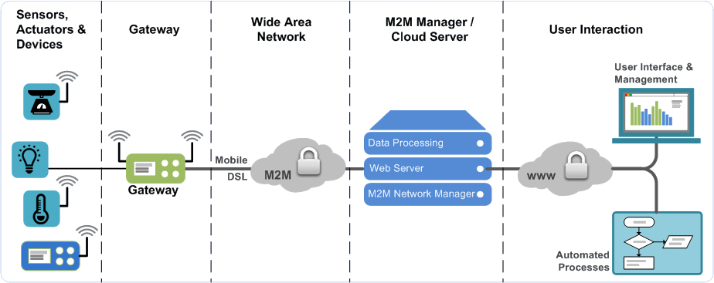

Figure 04: A proposed architecture with layer-wise communication protocol description[11]

B1.3: Scope And Benefits of IoT:
It’s the technology of today which is connecting and transforming every aspect of our real life. IoT has given a concept of Machine to-Machine (M2M) communication. IoT is going to have huge impact on home automation, automated farming, building automation system and everywhere there’s a need of convenience that can be achieved by the interconnected devices on IoT. As a preliminary example a smart city is proposed in Songdo, South Africa, the first of its own kind fully equipped and wired smart city is near to completion ( known as Ubiquitous City). With the personal electronics good connected to Internet will enable us to “author” our lives. In medical science field, IoT has given a privilege to devices and system to sense fore coming diseases and prevent it, for e.g. It can make a person recover from different diseases and can make them healthier with wearables that can predict heart attack and cardiovascular strokes. As per report of TheSunDaily, consumers will start initiating the usage of IoT in a better way during 2015 and onwards compared to past usage. It is expected that IoT products with interoperable capability will dominate the market. Awareness of IoT products is also vital for market saturation along with security features. Many interesting IoT products like automatic door locks, Wi-Fi connected ceiling fans, light switches, LED bulbs, smart watches, 3-D printers and smart gardens are becoming popular among consumers. MyBrain Technology in France has developed "Melomind". This EEG Headset can measure a human's brain waves and adjust music in a Smartphone app as they change. This product can be used as a digital meditation aid. A smart baby pacifier can measure the temperature of a baby and transmit the same to the Smartphone of parents.
IoT is proved to be an emerging technological innovation. Many scopes will be created for technology companies to release offerings as per the behavior of consumers. It may so happen that Netflix which is an online entertaining application can know when a person is sad and alone by monitoring the smart watch, smart thermostat and in-home camera. Subsequently, Netflix may offer a movie to change the mood. In a consumer electronics show in Los Vegas, Samsung informed that the company would invest 100 million dollar for progress of IoT. The company will also promote an open technology ecosystem for facilitating the usage of IoT.
Different fields of scientific interest shall benefit from IoT, for e.g. IoT will make irrigation systems in agriculture smart that will result in better productivity; good quality crops with required amount of resources instead of wasting enormous amount of water. Farmers can easily maintain their farming activities through smart apps and intelligent system. Smart garden is also an emerging field of interest and research.

B1.4 Future Research Directions in IoT:
The ongoing research in the field of IoT and its implementation in full or partial manner will definitely improve the quality of life of human civilization .Today IOT is being implemented everywhere which is of human concern like Smart city, smart environment, security and emergencies, smart business process, smart agriculture, domestic and home automation and healthcare. Search engine giant Google has already taken initiatives to mark its presence in the field of IoT. It is trying to transform the IoT by putting their enthrall concept of making the physical URL as future of IoT instead of apps which we commonly use. In this process, the browser will display a beacon style broadcast in which the nearby object will appear which will be present in the near proximity and can be communicated directly with the help of URL’s according to the preference of users and signal strength of the smart object. On the other hand IBM and Libelium has launched 6LoWPAN development platform for IoT which will enable every single sensor and devices to connect directly to the Internet using the new IPv6 protocols. China and many European countries are investing high amount of their GDP in making smart architectural infrastructure for e.g. Smart Roads and Bridges for the safety of people. In this smart bridges if corrosion or if any malfunction happens it will communicate directly so that repair work can be done at the proper time. Smart agriculture is also in research; Waspmote has taken this initiative for optimum productivity using the sensor networks to maintain monitoring capacity of crop cultivation throughout the production cycle. For example, depending on soil humidity Waspmote can send a message (through the ZigBee network or by SMS) to automatically switch off watering or to change water supply, thus contributing towards efficient water management. Over 50 million sensors and smart watches, smart meters and smart phones, washing machines, fridges, wearable devices and many more things will be connected over internet by 2020. The Internet of Things, Industrial Internet and Internet of Everything in 2015 will morph into the Internet of Anything. IoA will input all data in a unified way with a common software "ecosystem". Though many IT companies are now busy in addressing interoperability issues and the challenge of controlling hardware devices through software, the world community is now moving towards creating opportunity to live in a "connected life" environment.
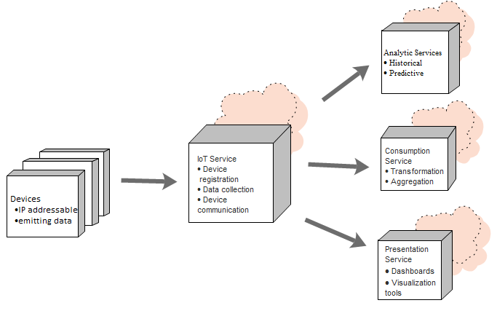
Figure 0 :IoT Reference Architecture
http://theundocumentedapi.com/2014/12/07/internet-of-things-a-reference-architecture/

B1.5 Smart Irrigation

Smart irrigation is eventually playing a leading role in country’s wealth and economy round the globe. With the growing number of applications in IoT, a lot of issues can be resolved by automating our lives into well scheduling events within 24/7.

Policies proposed by the Government of Pakistan:
(National/Provincial Development Plan & Sector Development Plan)
The key elements of government’s development plan are agriculture and availability of enough food supplies. According to the Framework for Economic Growth, "Vision 2030", the Medium Term Development Framework and the Poverty Reduction Strategy Paper II (PRSP-II) pay major attention on the role of agriculture. However, these plans may or may not be considered a substitute sufficient for comprehensive agricultural policy. Agriculture Policies for Growth & Poverty Alleviation by the Government of Pakistan through irrigation efficiency has following main components [5]:
- To make the Water usage efficient by lining the water courses.

- Judicious use of the surface and water tube, the lining of water should be pre planned keeping in mind the surface area. The jobs of the farmer holds no security, the intent is to form organizations which would provide respectable & permanent jobs with sophisticated salaries, increased public investment, urge the public to take more interest in the agricultural sector. Another motive is to experiment with sprinkle and drip irrigation.

- In Pakistan Government policy, Irrigation scheme generally proposes raising the irrigation water from the underground resources and low water ponds by pumping devices, bringing the water to the fields located at higher elevations through GI and PVC pipes and water supply to areas of lower or equal elevation through open channels. Connecting various areas in three RCC depressions or PVC pipes and making a central distribution points and providing turnouts at those distribution points.

- Government of Punjab province is taking interest in high efficiency irrigation systems like “drip irrigation” and “sprinkle irrigation”. They also wanted to convert these irrigation systems which are powered by solar energy to save electricity.

Need for Smart Irrigation
- Reduce energy consumption
When an existing system consumes a lot of resources i.e. labor, water and other energy resources.
- Advanced technological requirements
A need for automation requirement occurs in the fields.
- Water Preservation is needed
When storage of a lot of water for use is requisite.
- Government Policies
Proper calculations and precautions are need to be practiced as per Government policies justify water needs.
- Beneficial utilization of existing resources
To fully utilize all resources available in a beneficial manner for mutual benefits.
- Reduce human labor
By automating the irrigation man power will get reduced, instead of humans, kits will be there to read the crop situation.
- Agricultural productivity increase
By having measured amount of water whenever soil needs will protect yield from getting wasted either from over watering or lack of water.
- Waterlogging
Soil may not be water logged when exact amount of water will be provided whenever soil need.
- Soil salinization
Salinity of soil will remain persistent when correct amount of water is supplied, as increase in salinity will also be harmful for crops.
- Ecological damage
Environment will be benefited after all when number of crops will increase eventually.
- Socioeconomic
Social or economic factors will increase gradually as yield increases, profit rises.
- Literacy
Rate of literacy may rise as farmers will get educated to monitor kits.
- Save water
Reduction in water consumption as minimal water will be supplied on need of soil.
- Environment protection
Greater number of crops will protect environment from pollution as well as from inflation and dependency of crops to other countries.
- Energy saving
Reduction in energy consumption as kits will be able to control power.
- Healthy crops
Healthier the crops would be as sufficient as appropriate amount of water will be supplied.
- Scientific methods
Scientific calculations will be applied to the sensor to give predictable readings.
- Justified water use
By the help of flow sensor water will totally be justified by having how much amount to supply to a certain place.
- Farmers’ lifestyle standard increase
Farmers will be paid high as having quality crops and increment in quantity of yield.

- Efficient weather prediction with alerts
Rainfall detectors and others like them will be able to predict weather through efficient programming.
- Increase in GDP
Broadest quantitative measure of a nation's total economic activity will definitely be increased as yield rises.
Above mentioned points are the reason behind which tend us to develop an IoT application over agriculture, as it is being a major issue faced by Pakistanis lately. A great number of encroachments has been seen lastly in two decades around the world, but Pakistan can be outnumbered from those developed countries. Pakistan is totally deprived from all sorts of innovations and advancements taking place all over the world and it is quite useless to hard work over those developments which are not even getting in use to mankind here, cannot decrease the man power, why are we even thinking that much innovative after all? Besides along with the advancements in the technology the applications should be economical as well, so that even after lack of employment and inflation, people will be able to purchase it and walk along the increasing tech based ground-breaking developments. So the basic ambitions of this application that it should be cost effective so that farmers can afford and will be able to replace their manual work into automation. What we are here proposing is that we will be designing such module and kits that can monitor their progress of farm wirelessly and can able to take decisions effectively along with the growth of different of crops. Energy will be effectively consumed when it can control its supply of kits individually, even of individual sensors of every kits. By the help of precise readings one can able to know how much water needs to be supplied to reach that level of soil moisture in which crops will give maximum yield. Smart kits are available since a decade or two but it is usually outnumbered just because not being that cost effective. It will really be simple to install this kit as it does not need any effort and we just have to place it within soil and fit flow sensors in between pipes that are allotted to just water those farms. A huge topology will be made between those kits for e.g. mesh network. The RF based kits co-ordinate with each other send the reading to coordinator node or server node. There will other shields be available as well such as Wi-Fi so that the user may have different flavors according to usability and preferences.

A smart irrigation can be defined as, “an electronic networking technology to integrate the agriculture mechanism by monitoring and controlling the supply of farms and their needs according to changes in weather or lack of water supply, from a single server node attached to machine.” With the advancements in IoT, it may help in developing a lot of applications which will not only reduce the consumption of power but even helping in ease of different people life in both social and financial way. Sensors, playing a vital role in our product to help calculate readings and make the irrigation to produce effective yield. It is been almost two decades since development is been continually going in this field. It will target a lot of areas of irrigation where a local farmer cannot be that much into such as,
- Soil moisture
- Water flow
- Internal temperature
- Humidity
- Raindrop
- Leaf wetness
- Ambient
- Solar radiation
The Smart irrigation System shall facilitate the farmer in many ways. Some of the important features of the system are as follows:
- Remote Monitoring
- Data from gauges and sensors (soil moisture, pressure, environmental, etc.)
- Status of farm gates and building doors (open/close)
- Status of irrigation valves
- Status of pumping equipment
- Live video of operations
- monitoring of greenhouses, livestock enclosures, and storage facilities
- Audible or other alarms

- Remote Control
- Opening and closing valves & gates
- Turning on and off lights, pumps, heaters, etc.
- Guiding robotic vehicles
3. Information transfer
- Automatic incorporation of environmental data into decision support systems and Crop models
- uploading maps to variable rate application equipment
- Weather, market, & operational information to remote locations & vehicles
- Real-time information such as DGPS correction signals
4. Communication
- Text, graphical, voice and video messages can be sent between operators
5. Asset tracking
- Position of irrigation systems
- Location of farm vehicles
- Location of livestock
6. Remote diagnosis
- Remotely located technicians and specialists can access, monitor and control on farm assets with the permission of the local manager.

B1.6 Overview of Proposed Projects related to Smart Irrigation around the Globe:

B1.6.1 A system [6] is deployed using a ZigBee network. It consists of soil moisture and temperature sensors. A microcontroller based gateway is used for controlling the water quantity. It transmits data to the Web server. The researchers [7] also conduct a simulation work using various sensors. The sink node is responsible for aggregating and sending data through internet to the control center where the information is processed. A mathematical calculations based irrigation management system has been proposed [8]. The system is using wireless sensor technology for monitoring potato crops to improve their production. In a research paper [9] monitoring of agriculture is described which consists of several XBee sensors and a microcontroller. The data is first interfaced to the computer by using UART which is a serial protocol then analyzed and monitor by using a FPGA element. Certain unnecessary events may occur in irrigation process, to avoid this kind of events an automatic irrigation system has proposed [10]. It is using a timer that is triggered when a threshold is reached. The gathered data facilitates the farmer to schedule the process of irrigation. In a proposed system [11] sensors are placed in the field where it converts moisture content into equivalent voltage. The reference voltage can be set by the farmer. The difference between these two voltages is directly proportional to the amount of water needed for irrigation. The application [12] deals with combating with a fungal disease in potatoes. The data is gathered at a field gateway and then transferred to a PC for data logging through Wi-Fi. Smart irrigation [13] can also use the smartphone technology to manage urban and agricultural irrigation.
B1.6.2 The application [1] deals with combating with a fungal disease in potatoes Phytophtora, which can attack the potato field from various sources. The development of the disease depends on the climatic condition such as humidity, temperature etc. A total of 150 sensor boards are used namely Tnodes, each TNOdes consist of sensors that measures temperature and humidity. In order to improve connectivity some sensor less TNOdes behaves as communication relays. Furthermore some weather stations are set up in the field to monitor the luminosity, air pressure, precipitation, wind strength and direction. The TNOdes is recording temperature and humidity every minute but in order to conserve energy the data is reported only once in ten minutes. To save more energy, rather than transmitting complete files over wireless link, the data is transmitted in compressed form using delta encoding. TinyOS is used as operating system for nodes and hence data is sent on multihop routing protocol MintRoute which is available within the TinyOS.
The collected data by all the TNOdes are gathered at a field gateway and then transferred to a PC for data logging through Wi-Fi. The data is then uploaded to a server and further distributed to different servers in XML format.
[1] Baggio, Aline: Wireless sensor networks in precision agriculture. In: REALWSN 2005 proceedings, 2005

B1.6.3 Smart irrigation apps [4] use the smartphone technology to manage urban and agricultural irrigation. The app mainly focuses on the development of four models to be used in smartphones apps using real time and forecasting aspects. The four models are citrus, urban, strawberry and cotton. These models will be performing water balance calculations. Meteorological data (daily mean temperature, wind speed, relative humidity, and solar radiation) for these calculations will be obtained from FAWN (Florida Automated Weather Network) and GAEMN (Georgia Automated Environmental Monitoring Network).In addition information from the National Weather Service will be used to provide forecasting information for improving irrigation. The app provides the access information only to the location that are with the weather stations FAWN or GAEMN.
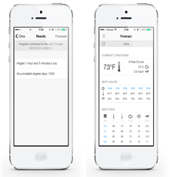
Figure : A Smart Irrigation App Description

B1.6.4 SoilNet [1] focuses on real time monitoring and estimation of soil water content. It belongs to Underground Wireless sensor networks. It is based on low cost Zigbee protocol. Within any wireless sensor network that is based on Zigbee Protocol, there are mainly three devices
- Zigbee Coordinator
- Zigbee Router
- Zigbee end device
It has used hybrid topology to provide transmission on wider range. In order to monitor the soil water content, the capacitance sensors have been used which are inexpensive and easy to operate.
The higher contents of coarse fragments may produce contact problems between sensor rods and soil matrix which may lead to underestimation of soil water content by sensors used (EC-5 and TE) due to their low measurement volume.

B1.6.5 WaterBee [3] is a smart irrigation and water management system. It consists of a web driven wireless sensor network that is centrally monitored through a server. The smart sensors are distributed over the field that monitors the soil moisture content and environmental parameters that can affect the crop growth. The sensors send data to GPRS gateway through ZigBee wireless sensor network, and then goes to a web service which analyzes and models the data and provide farmers with expert advices. The results are sent to application on user’s smartphones or tablet.
The developers have observed that WaterBee has improved the plant health, crop yield and reduced the water usage. WaterBee is already in use at 14 reference sites in Estonia, Malta, Italy, Spain, Sweden, and the UK.
B1.6.6 The paper [7] described details about a low cost automated irrigation system that was saving up to 53% water by using a network of sensors which integrated with decision support software. The system is implemented by using soil moisture and temperature sensors. By using these sensors a network is deployed at the bottom of the plant root zones. The designed system contains a gateway which is microcontroller based and by using an algorithm it is used to control the water quantity. This gateway has three basic operations:
- Handle information from sensors.
- Trigger actuators.
- Push data to the Web.
The communication between the sensor nodes and the gateway is via a protocol named Zigbee. This gateway is a wireless information unit, containing GPRS module which transmits the data to the Web server through a mobile network.
For real time monitoring and programming of the acquired data from sensors the system is using a Software Application. This application enables the user to graphically view the data from each Wireless Sensor Unit via Internet.

B1.6.7 This paper [11] reports an application for effective irrigation. The researchers basically conduct a simulation work based on program code by using PowerTOSSIM simulation environment. The main work proposed by them based on the acoustic emission principle for crop water stress i.e. tension increases as soon as the soil becomes dry. A threshold value is set for the tension, whenever this value arrives, an acoustic signal is emitted. During the execution this signal is detected by the acoustic sensors so that they will indicate the dryness of plants. These sensors will be sensing, acquiring and processing the emission signals throughout the wireless sensors network area. The data from the nodes is routed to the sink node using multi-hop routing mechanism based and ultimately to the cluster node. This node is responsible for aggregating and sending data through internet to the remote control centre where the information is processed.

B1.6.8 This paper [#] proposes an irrigation management system that is based on mathematical calculations for Soil Water tension (SWT) and Depth of water to apply (DWA). The system is using wireless sensor technology for monitoring potato crops to improve their production by measuring the humidity of the potato field and SWT. These sensors also transforms the measured physical quantities into a signal and for processing it produce digital output for using RF data communication which is responsible for sending data to the base receiver. This station basically processes and analyzes the data. As a result processed information of SWT facilitates to find the general trends of soil moisture and in a log run it will modify the irrigation system to predict a schedule to achieve an increased crop yield.

B1.6.9 The proposed remote monitoring of agriculture consists of several sensors e.g. temperature sensor, soil moisture sensor, relative humidity sensor and a microcontroller. The microcontroller is multiplexing the data obtained and converting it from analog to digital form. A wireless XBee module is used to communicate the gathered data; this data is first interfaced to the computer by using UART which is a serial protocol then analyzed and monitor by using a FPGA element. To display the analyzed data the system uses a display unit.

B1.6.10 The paper [1] has described details about a low cost automated irrigation system that is saving up to 53% water by using a network of sensors which are integrated with decision support software. The system is implemented by using soil moisture and temperature sensors. By using these sensors a network is deployed at the bottom of the plant root zones. A gateway is also used which is microcontroller based and by using an algorithm it is controlling the water quantity. This gateway has three basic operations:
- Handle information from sensors.
- Trigger actuators.
- Push data to the Web.
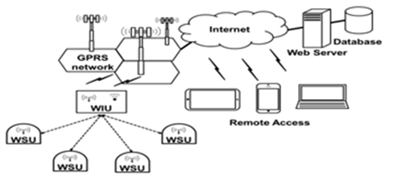
Figure : Configuration of the automated irrigation system. WSUs and WIU, based on microcontroller,Zigbee and GPRS technologes
The communication between the sensor nodes and the gateway is via a protocol named Zigbee. This gateway is a wireless information unit, containing GPRS module which transmits the data to the Web server through a mobile network.
For real time monitoring and programming of the acquired data from sensors the system is using a Software Application. This application enables the user to graphically view the data from each Wireless Sensor Unit via Internet.
B1.6.11 This paper [2] reports an application for effective irrigation. The researchers basically conduct a simulation work based on program code by using PowerTOSSIM simulation environment. The main work proposed by them is based on the acoustic emission principle for crop water stress i.e. tension increases as soon as the soil becomes dry. A threshold value is set for the tension, whenever this value arrives, an acoustic signal is emitted. During the execution, this signal is detected by the acoustic sensors so that they will indicate the dryness of plants. These sensors are basically sensing, acquiring and processing the emission signals throughout the wireless sensors network area. The data from the nodes is routed to the sink node using multi-hop routing mechanism and ultimately to the cluster node. This node is responsible for aggregating and sending data through internet to the remote control centre where the information is processed.

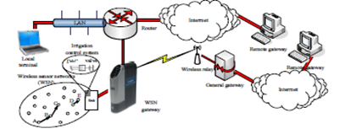

Figure :A system based on multi-hop mechanism of data flow
B1.6.12 This paper [3] proposes an irrigation management system that is based on mathematical calculations for Soil Water tension (SWT) and Depth of water to apply (DWA). The system is using wireless sensor technology for monitoring potato crops to improve their production by measuring the humidity of the potato field and SWT. These sensors also transforms the measured physical quantities into a signal and for processing it, a digital output is produce for using RF data communication which is responsible for sending data to the base receiver. This station (i.e. base receiver) basically processes and analyzes the data. As a result the processed information of SWT facilitates to find the general trends of soil moisture and in a log run it will modify the irrigation system to predict a schedule to achieve an increased crop yield.
B1.6.13The paper [4] describes a remote monitoring of agriculture consists of several sensors e.g. temperature sensor, soil moisture sensor, relative humidity sensor and a microcontroller. The microcontroller is multiplexing the data obtained and converting it from analog to digital form. A wireless XBee module is used to communicate the gathered data; this data is first interfaced to the computer by using UART which is a serial protocol then analyzed and monitor by using a FPGA element. To display the analyzed data the system uses a display unit.
B1.6.14 Certain unnecessary events may occur in irrigation process, to avoid this kind of events an automatic irrigation system is proposed [5], which is using a timer that is triggered when a threshold is reached. Some soil moisture sensors are also used to maintain soil moisture at prime levels; it will ultimately maximize the efficiency of water usage. This system is proposed for the farmers in the United Arab Emirates because of low water holding capacity in the soil of this country therefore plants may die in case of water shortage. The system consists of soil moisture sensors to detect the soil’s volumetric water content; depends on the permittivity of the soil. The gathered data will facilitate the farmer to schedule the process of irrigation.
B1.6.15 A proposed system in research paper [6] mainly consists of two modules:
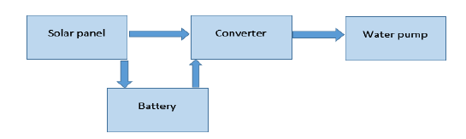
- Solar Pumping Module:

Figure :Block Diagram of Solar Pumping Module
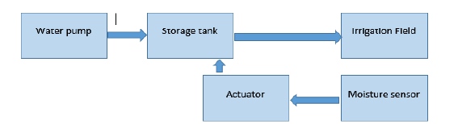
- Automatic Irrigation Module:

Figure : Block Diagram of Automatic Irrigation Module

Sensor is placed in the field where it converts moisture content into equivalent voltage. The reference voltage can be set by the farmer depending on the moisture content required by different crops. The difference between these two voltages is directly proportional to the amount of water needed for irrigation. The outlet valve of the tank is connected to a stepper motor which acts as an actuator control for the valve. When the moisture content of the soil is equal to the reference value set by the farmer, the valve is closed slowly, power to the driver circuit dies off and control goes in sleeping mode thus consuming less power. When the moisture level is again low, control comes out of sleep mode and flow of water is regulated. This mechanism controls the opening and closing of the valve depending on the moisture level of soil. The moisture content of the soil is found by using the soil moisture sensor such as VG400 which produces an equivalent output voltage proportional to the conductivity between the two probes. In that way the solar powered smart irrigation system conserves electricity, water and saves crops from over flooding. Furthermore, it requires minimal attention reducing human intervention for the farmers.
B1.6.15 The application [7] deals with combating with a fungal disease in potatoes Phytophtora, which can attack the potato field from various sources. The development of the disease depends on the climatic condition such as humidity, temperature etc. A total of 150 sensor boards are used namely TNodes, each TNode consists of sensors that measure temperature and humidity. In order to improve connectivity some sensors behaves as communication relays. Furthermore some weather stations are set up in the field to monitor the luminosity, air pressure, precipitation, wind strength and direction. The TNOdes are recording temperature and humidity every minute but in order to conserve energy the data is reported only once in ten minutes. To save more energy, rather than transmitting complete files over wireless link, the data is transmitted in compressed form using delta encoding. TinyOS is used as operating system for nodes and hence data is sent on multihop routing protocol MintRoute which is available within the TinyOS. The collected data by all the TNOdes are gathered at a field gateway and then transferred to a PC for data logging through Wi-Fi. The data is then uploaded to a server and further distributed to different servers in XML format.
B1.6.16 In paper [11] the proposed work after focusing on open canal irrigation networks which are common around the world. Mostly these kind of systems are energy efficient but with several limitations and causes a large water loss. Therefore, the use of multi-agent framework modeling of Management Systems of Gravity Irrigation Networks (MSGIN) is proposed, operating with a water rotation. The process of this approach is conducted in several stages:

First Stage relates data gathering for the decisions making during the negotiation process.
Second Stage concerns analysis which relates to the functional specification requirements.
Third Stage concerns the system structuring i.e. dividing the system into sub systems based on the macros functions, the structuring of each sub system in agents and the definition of the inter-systems interactions and the inter-agents interactions.
Fourth Stage concerns the implementation and the development of the agents using the specific JADE platform.
In Multi-Agent System, the JADE Agents communicate through the exchange of messages represented in FIPA-ACL. Each JADE agent has a kind of mailbox which contains the messages sent to him by the other agents. The roles of the agents, composing the system, are already defined. In that way this system provides flexibility allowing to dynamically adapting the agent behaviors that will enable the system to deal with dynamic problems ultimately ensures a better adaptability of the system to its environment.
B1.6.17 An automatic irrigation system [12] based on wireless sensor network is designed using ZigBee Technology that features low power, low cost and easy installation and use. The system consists of a microcontroller, wireless sensor node, a weather station and several wireless actuators. The wireless sensor node collects temperature and humidity data of particular area whereas the weather station monitors the climatic condition. All the data collected is transmitted to controller wirelessly. The actuator nodes that are present in field are used to control the electromagnetic valves and pumps, and are wirelessly controlled by the controller .The controller act as a ZigBee coordinator that builds and maintain WSN and also manage the irrigation system. The project used ZigBee star network topology due to low power consumption. When the coordinator node is started, it creates a Personal Area Network (PAN) and allows the actuator nodes to join the network. The coordinator then assigns network addresses and collects the sensor data for processing on the basis of which intelligent decisions are made. The paper showed the details of hardware design and software algorithm for irrigation management.
B2. Current State of the Art:
(Please describe the current state of the art specific to this research topic.)
B2.1 Growing Garden in Brooklyn to a Company Selling Prototypes:
Amit Kumar, a software engineer moved to Brooklyn, started to develop a hankering in his own garden. Need arises when he wanted to monitor his plants even when he’s not available to look after it. He met a hardware engineer and started to learn about Arduino, an open source microcontroller. They planned to use it in building a system with a base module connected to sensors that could monitor everything from a garden's pH level to its humidity, then relay that information through the cloud to growers' computers and, in many cases, automatically correct any problems that might arise—say, turning on a fan connected to the base module when the temperature rises to 90 ○.
Bitponics, a company founded after a year and half ago. They raised $20,000 through Kickstarter. He says "Our major mission is to make gardening as simple as possible so people can have thriving gardens in their home”. He gave a complete “grow plan” to very start to finish of the plant maintenance successfully by everything from what kind of lighting to buy to the type of nutrients needed, automatic scheduling and actions that the system can't take care of automatically, like adding water, it will send an email with an alert.
Example: A grow plan for lettuce or herbs calls for a three-ft. by three-ft. flood drainage system and a 24-gallon reservoir. After that, the plan includes steps for additional phases of growth, each with appropriate requirements. The two-week-long seedling stage, for example, needs 16 hours of light per day. Next phase, gardeners transplant the seedlings into a grow bed and there's an automatically triggered schedule for turning off and on lights and pumps.
Last but not the least, an online dashboard through which users can connect to other growers and share their plans to community.

B2.2 Waspmote:
Libelium, six-year old company takes a different approach, introduced an open source sensor platform having multiple applications in 12 sectors, including farming and agriculture. It is based on “plug and sense device” to which 50 or more sensors potentially can be connected. Having a lot of sensors sending date wirelessly to computer anywhere in the world.
Company targets not only consumer, but to system integrators who in turn aims consumers of specific industries with applications they have developed themselves.

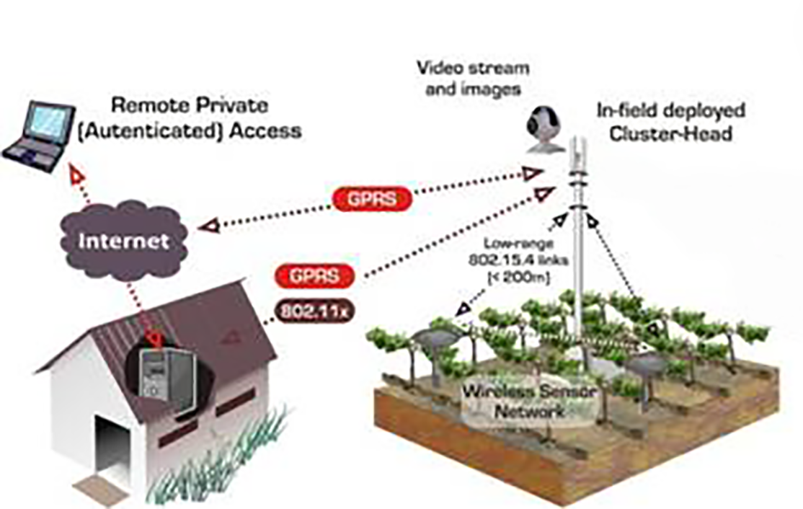

Figure : Figure to depict general working of WSN with GPRS

Example: Take Alan Campbell, who runs Northwest Vineyard Consulting in Tualatin, Ore. According to Campbell, a big problem facing regional vineyard managers is how much water stress their vines experience. "Grapes do better in a slightly stressed environment," he says. Campbell wanted a way to send sensor data about soil moisture from vineyards to the computers of vineyard managers.
To that end, he recently launched a pilot with six vineyards, where he places six sensors one, two or three feet deep in the soil. They detect such information as temperature, humidity level and moisture. The system then collects that intelligence every 15 minutes, ultimately sending it to vineyard managers in a form that allows them to make decisions based on the amount of available water in the soil and its impact on grapes. Says Campbell: "We're hoping this has a big effect on the quality of the wine."
After all, the IoE isn't just about connecting devices, but also about the collection and use of data made possible by hooking up all those "things" in systems unavailable before.

B2.3 WaterSense Labeled Irrigation Controllers:
United States utilizes over more than 9 billion gallons of water each day, mainly for landscape irrigation. More than 50% of this water is wasted due to inefficiencies in irrigation methods and systems. Technologies can abundantly reduce overwatering by automating it whenever plants are in need. Just like thermostats Irrigation controllers significantly decrease our home’s outdoor water usage.
WaterSense labeled irrigation controllers, a thermostat for our sprinklers use local weather and landscape conditions to adapt watering schedules to actual conditions on the site, to control the sprinklers. With proper installation, programming, and maintenance, homeowners and businesses can use WaterSense labeled controllers instead of standard clock-timer controllers on their existing systems, and no longer worry about wasted water.
WaterSense labeled irrigation controller can save a typical home approximately 8,800 gallons of water annually. This could save $435 million in water costs and 120 billion gallons of water through-out the country annually from not overwatering lawns and landscapes.

B 2.4 Smart Irrigation in New Zealand:
Different irrigation technologies and decision support tools are continually being innovated in New Zealand and globally. Water and energy use efficiency are the main focuses of these revolutions. Luckily, proficiency is linked to improved quality production and lucrativeness. Over the last two eras there has been a major change in the irrigation technology used in New Zealand. There has been a common move from physical flood irrigation to remotely controlled spray irrigation such as centre pivots, dripline and micro sprinklers.
The five elements are:

Figure : Modular depiction
Each module has to be done well for an irrigator to become a smart irrigator. An irrigation method being correctly planned, mounted, custom-built and retained makes it easier for an irrigator to operate it well. An irrigation system designed, installed, commissioned and maintained to industry standards means the precise amount of water can be delivered at the correct time and in the right place. Operating an irrigation system well is a vital component of smart irrigation, being able to rationalize the use of water is the most applied method for representing the irrigation system is being operated well.
To enable and support all irrigators to achieve smart irrigation recognition, Irrigation New Zealand has a continually evolving set of resources. These include :
- Industry standards, codes of practice and guidelines – the backbone of the Smart Irrigation programme.
- Training workshops – to provide practical information for irrigators.
- Industry accreditation and certification programmes which set standards for the irrigation service industries.
- An irrigation knowledge resource and certification programmes.
- Decision support tools and resources.
B2.5 WaterBee, Smart Irrigation and Water Management:
WaterBee is a complete, robust, economical Smart Irrigation and Water Management system that enables growers, vineyards, golf clubs, public authorities and landscape managers to enhance their commercial and maintainable environmental operations. The web sensor networked irrigation system is centrally monitored and coordinated, and the WaterBee services are provided across Europe through collaborating Business Partners, who work closely with their local customers. The WaterBee system provides a range of advantages to come across current growers needs:
- Greater control over your irrigation necessities and be paid additional revenue per acre through the efficient use of water and extra inputs.
- Precise and comprehensive information on crop and field situations.
- Easy-to-use Smartphone and Web Apps to upkeep crop irrigation results with real-time data.
- Software support or equipment maintenance.
- Lower functional costs, great yields and higher quality crops.

WaterBee smart irrigation modelling and scheduling system goes well beyond the state-of-art, with its unique Soil-Moisture Model for optimum water use, constantly self-adapting to each user’s situation and business purposes, using machine learning tactics, and its open web-enabled architecture eases future integration with all environmental data in line. This enables you not only to optimize the use of water by irrigating only when and where it is needed, but also enhancing plant growth and quality.
The system has been installed and is in use at 14 reference sites across Europe in Estonia, Malta, Italy, Spain, Sweden & the UK.

- Challenges:
(Please describe the challenges, specific to this research topic, currently being faced internationally.)
The main challenge is to develop interest in farmers to adopt smart irrigation. It involves awareness-raising by disseminating the results of research on smart irrigation, and providing education and practical support in cooperation with the farmers and irrigation sector.

Once the farmers agree to adopt the smart irrigation system, they will need to be provided with specific information on the daily irrigation requirements of their crops. This will be achieved through the development of a mobile application which will make the information available to the farmers at any time.
After a thorough literature review we have finalized an approach to implement smart irrigation system. Our proposed system will be using Wireless Sensor Networks (WSNs)
The WSNs mainly consists of two main parts:
- Wireless Sensor Units (WSUs)
- Wireless Information Unit (WIU)
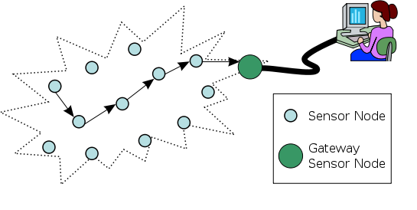
WSUs
WIU
Sink Node

Figure : A typical Wireless Sensor Network
A WSU will be comprised of sensors, a microcontroller and Radio Frequency (RF) transceiver or ZigBee. Several WSUs can be deployed in-field to configure a distributed sensor network for the implementation of smart agriculture system.
We have decided to use soil moisture, humidity and temperature sensor in the field because these sensors have the capability to observe soil moisture, temperature and humidity frequently and over large regions. In that way this could significantly enhance our ability to monitor, analyze and improve crop conditions over a period of time.
The data from each WSU will be received and analyzed in the WIU. The WIU consists of a master microcontroller, an RF or ZigBee modem (to receive data from the WIUs).
For the purpose of power harvesting we will be using solar panels to power up the WSN, this panel can also switch the sensors in sleep mode when there is no need to sense data. This kind of WSN approach in smart agriculture will improve performance, increase the production efficiency with decreased cost, consumes low-power and will have the ability to collect distributed data. The sink node is the main microcontroller. This is basically an information unit that will be responsible to send the gathered data to the Web server through 3G, GPRS or GSM module (to communicate with the Web Server).
The Smart Irrigation System will be using a Software Application (later on it can be extend by enforcing artificial intelligence). This Application will improve the level of agriculture information process and enhance the intelligent management and decision of agricultural production. The Agriculture Management Information System (AMIS) will mainly include data analysis and processing. We can use different data analyzing tools like databases , data mining to summarize the data collected from sensors into useful information that can increase crop productivity and hence revenue.
This application will process the data and provide decision support to the system and a Mobile Application will be developed to provide farmers an easier access to their farms and field information through their mobile devices. Having access to timely and accurate data can help in making better decisions that can save precious agricultural resources, time and money. Features of the proposed Mobile Application are: Interactive Google Maps displaying location of field’s nodes, Timely access to the field’s data using web services or messaging facility, Historical record of sensor’s data and notifications
- GPS tracking
- Field navigation

- Motivation and Need:
(Please describe the motivation and need for this work.)
The new technological advancements have encouraged researchers to formulate new ideas and propose methods for solving present problems faced by their country’s economy. Agriculture is the major sector that fulfills the need of food for the country’s population and also generates large amount of revenue by cotton and other canned exports.
The most important crops of Pakistan are wheat, sugarcane, cotton, and rice, which together account for more than 75% of the value of total crop output. Pakistan's largest food crop is wheat. In 2005, Pakistan produced 21,591,400 metric tons of wheat, more than all of Africa (20,304,585 metric tons) and nearly as much as all of South America (24,557,784 metric tons), according to the Food and Agriculture Organization (FAO). The country is expected to harvest 47 to 64 million tons of wheat in the present year 2015.
Currently over watering of crops is practiced throughout the country and water is wasted which is one of the precious natural resource, it is need of time to propose techniques that reduces water consumption and facilitates quality crops harvesting, contribute to deeper plant root growth, reduced soil runoff/leaching and ensures less favorable conditions for insects and fungal disease.
Following are the major causes of agricultural problems in Pakistan which disturb the agricultural growth or development in Pakistan. The reasons that motivates the need of Smart Irrigation System deployment are as follows:
- Soil Erosion
No mechanism has been adopted to eradicate the soil erosion and even after harvesting nothing is done to improve or restore the soil energy. Therefore, the fertility of soil is decreasing day by day. The thickness of fertile layer of soil in Pakistan is more than 6 inches but the average yield is lower than other countries where layer of fertile soil is only 4 inches.
- Water wastage Practices
Water wastage is very high in our country. The archaic method of flood irrigation is still in practice in whole of the country which wastes almost 50 to 60 percent of water. A new irrigation system is definitely necessary to overcome the effects of present practices and for preservation of water.
- Traditional methods of cultivation
Due to old methods of cultivation and harvesting, Pakistan has low yield per acre that means the average crop in Pakistan is just 1/4th of that of advance states. Where as in Nepal, India and Bangladesh are using modern scientific methods to increase their yield per acre. For this purpose, these states are using modern machines to improve their yield.
- Division of Areas
The native farmers are increasing in our country as the lands are dividing generation by generation. So, there are a large number of farmers who own only 4 acres of land. These small farmers do not get credit facilities to purchase seeds, pesticides, fertilizers etc. Additionally, a large area of land is owned by feudalists and the farmers, who work on their lands, are just tenants. This uncertain situation of occupancy neither creates incentive of work nor does attract capital investment.
- Water Logging
Water logging and salinity is increasing also affects the quality and quantity of crop yield. No effective measures have been taken to curb it. As the storage capacity of the dams is not very much, the water availability per acre is also limited. Therefore, the farmers are installing more and more tube wells to irrigate their crops. This is why salinity is becoming the major issue in most parts of Punjab and Sindh. There is a vigorous need for a new system that solves the problem of water scarcity.
- Ignorance of farmers
Focusing more on land, crops and yield problems the man behind the plough is always ignored. While formulating the 5 or 10 years plan, no emphasize has been laid on the importance of solving the problems of farmers.
- Limited means of Communication and lack of Awareness
The only mean of communication in rural areas is Television or radio so it is urgently needed on the part of these mass communication resources to air the promos related to the new agricultural techniques and allied sciences. But these programmes should be telecast in regional or local languages as lack of understanding and guidance is the main reason of farmer’s backwardness and old irrigation practices. The communication gap between well qualified experts and simple farmers has not been bridged. Availability of these experts is not ensured in rural areas as they are reluctant to go there.
- Systems of Feudalism
Pakistan is rich in fertile land yet the land is being wasted in different ways. 79.6% million hectors of land is under cultivation whereas only 20.43% million hectors is cultivated. The reason can be described in two points.
8.1 A major area is owned by feudal system and it is difficult to manage such a huge area so only that part is cultivated which is easy to manage, the rest is left ignored.
  - The rise of industrialization has given threat to this sector. People are migrating to cities and cities are expanding, thus new towns and colonies are constructed on fertile lands.

- Need for Technological Advancements
New technology brings with it new opportunities and paves path to new ideas. Introduction of wireless sensor nodes within the field will not only save the farmers energy but also provide accurate results of different parameters to facilitate the growth of next lot of the same crop. The system will be able to predict the future crop outcome.
- Full Access of the field from Remote Areas
The farmers are given full access to the field via mobile application which interacts with the cloud server that centrally stores the data collected from all over the field.

The irrigation system of Pakistan needs improvement as about 67% of the land is irrigated with canals. The need for new system shall in-cooperate wireless communication for reliable data transmission to the cloud as data is never lost and is 100% secure. The cloud based customized user access shall provide individual users with their customized field data and analytical results, Also in future specially designed electronic systems can be installed in a central monitoring room finished with desktop application for proper monitoring for large areas under cultivation.

3. Objectives of the Project
- Specific Objectives Being Addressed by the Project:
(Please describe the measurable objectives of the project and define the expected results. Use results-oriented wording with verbs such as ‘to develop..’, ‘to implement..’, ‘to research..’, ‘to determine..‘, ‘to identify..’ The objectives should not be statements and should not include explanations and benefits. The objective should actually specify in simple words what the project team intends to achieve (something concrete and measurable/ deliverable). Fill only those objectives that are applicable to the proposed project.)
The major objective of the project is to develop a wide variety of tools which will enable farmers to better utilize their water resources. The project aims to develop smart wireless sensing systems equipped with important parameters measuring sensors and smartphone apps for scheduling irrigation.
A1. Research Objectives: (if any)
- To obtain a low cost optimal design for smart sensing units providing maximum efficiency in both power consumption and accurate computation.
- To explore high processing capabilities of the microcontrollers for scheduling and multitasking purposes.
- To contribute research based knowledge about climatic effects on the agriculture field.
- To discover different methods of preserving water by both means of smart sensing and utilizing water only when needed.
- To find a way that only stores critical data on cloud and perform computation to estimate different parameters around the field where sensing nodes are not deployed which not only reduces the cost but also open doors to new findings.

A2. Academic Objectives: (if any)
- To promote ongoing studies on present state of agricultural systems at academic level.
- To demonstrate the effectiveness of a smart irrigation system that meets the real needs based on measurements of climate parameters through data obtained from sensors.
- To promote knowledge about new technological advancements in wireless communication, sensors and microcontrollers.
- To conduct different workshops and seminars on sensor node assembly and wireless communication protocols.
- To create awareness about the importance of preserving water resources and encourage discovering quality crop production to meet the need of the nation.
- To improve the ranking of our academia in international research community by producing quality based research publications from this project.
- To flourish the quality of Research & Development culture in Academia.
- To create opportunity for students to conduct applied research in contrast to theoretical research usually part of our academia.
- To enhance the academic activities and participation of students by successful implementation of this project.
- To open a new door for academia to conduct similar research projects in future.

A3. Industrial Objectives: (if any)
- To present the successful designed prototype to different vendors in Pakistan so that the designed system will become the part of most of the agricultural areas in Pakistan.
- To encourage industries to get involved with the agriculture sector for quality production and invest their resources for mutual benefits.
- To promote cloud managing industries to create customized private clouds for individual field owners so as to eliminate need of separate servers.
A4. Human Resource Development Objectives: (if any)
- To bring more opportunities of employment to the people engaged in hardware and software development.
- To reduce the burden on local farmers and encouraging them to give time to new crops harvesting.
A5. Other Objectives: (if any)
- To beautify the field location by proper monitoring and watering of crops

4. Research Approach
- Development / Research Methodology:
(Please describe the technical details and justification of your development and research plan. Identify specialized equipment, facilities and infrastructure which are required for the project and their utilization plan. The block diagrams, system flow charts, high level algorithm details etc. have to be provided in this section.)
This application is dedicated to the agricultural field of Pakistan. Through this application, an efficient and sustainable use of water is possible. It also saves power by using solar panels. It contains an Easy-to-Use-Design, developed in consultation with users to deliver an excellent navigation and easy access interface.

The application has adopted a set of guiding principle from the agricultural sector of Pakistan and then establishes a strategic plan. This strategic plan is helpful for the farmer

It provides up-to-date condition and alerts of the field to its respective farmer i.e. measurements of soil moisture, temperature, pH value, humidity etc. of the field. It also notifies the farmer about any hardware related issue and the state of the water pump, timely.
Use of Smart Irrigation in different areas of Pakistan to get numerous benefits is itself a valuable concept. The focus of this application is to get information from the Wireless Sensor Network (WSN) that employs various sensors to acquire different environmental parameters. It performs processing and takes decision if there is a need of watering the crops.

The pumps are switched ON/OFF as and when necessary. It also defines the proper quantity of water to be provided. The history log is uploaded onto the server to take intelligent decisions, where it will be shared through the handheld sets for monitoring. The user will be updated about the water level in farms and can manually control the irrigation system too.

Through this Smart application the combination of emerging technologies including ubiquitous computing with sensor network can be applied on agriculture domain to make the agriculture smarter.
The major goals of this application are:

- Facilitate the development of infrastructure schemes to reduce the risks of water shortages in the agriculture sector.
- Development and implementation of an intelligent agriculture development to strengthen the crops productivity.
- Development and enhancement of farmer decision support tools.
- Enable the farmers to balance nutrient management, improve productivity and save water.
- Introduces a sustainable approach to food production.
Terms Of services
Smart irrigation For Agricultural Area of Pakistan (SIAAP) welcomes you to visit and use our website to find agricultural information and access services. SIAAP is committed to respecting data privacy and protecting the field information. We have taken appropriate measures to protect the privacy of any field information that is provided to us or that we collect when the admin visits our website.
This Application will be collecting data either from the base station or provided by the admin at the time of registering any particular farm. The collection will be limited to that which is absolutely necessary for further processing and decision support.
Our servers do automatically collect limited amounts of standard for agriculture monitoring when the admin visits our website. The standard types of information collected include:
- Soil Moisture.
- Temperature.
- Humidity.
This type of information is used for operational and performance trends, and for ways to improve the crop productivity, save power and water i.e. to provide quality of services.
Another hurdle concerns how to deal with areas where soil salinity is high and water quality is low. Such areas have so far been excluded from the research, and outcomes are likely to be less good, but farmers in these areas need support.

Smart Irrigation for Agricultural Area of Pakistan (SIAAP) is committed to ensuring the integrity and confidentiality of the field information provided to us through our website. We use security software and procedures to protect information from unauthorized access or disclosure.

References:
[1] Muzammil Hussain*, Prof. S. P. Gawate, Prof. Dr. P. S. Prasad, Prof. P. A. Kamble,”
Smart Irrigation System Using WSN and GPRS Module with Three Level Access Mechanisms”, Computer Technology Department PCE Nagpur, Maharashtra, India.

[2]http://www.pbs.gov.pk/sites/default/files//tables/Table%204%20%20Area%20Irrigated%20by%20Different%20Sources.pdf

[3]http://www.finance.gov.pk/survey/chapters_14/Highlights_ES_201314.pdf
[4]: Joaquín Gutiérrez, Juan Francisco Villa-Medina, Alejandra Nieto-Garibay, and Miguel Ángel Porta-Gándara” Automated Irrigation System Using a Wireless Sensor Network and GPRS Module” IEEE TRANSACTIONS ON INSTRUMENTATION AND MEASUREMENT, VOL. 63, NO. 1, JANUARY 2014.

[5]: XIONG Shu-ming, WANG Liang-min, QU Xiao-qian,ZHAN Yong-zhao “Application Research of WSN in Precise Agriculture Irrigation” Environmental Science and Information Application Technology, 2009. ESIAT 2009. International Conference on (Volume:2 )
[6] Kshitij shinghal, Dr. Arti noor, Dr. Neelam srivastava , Dr. Raghuvir singh, India, “Wireless sensor networks in agriculture: for potato farming”, International Journal of Engineering Science and Technology,Vol. 2(8), 2010, 3955-3963.

[7] Swarup S. Mathurkar, D. S. Chaudhar, “A Review on Smart Sensors Based Monitoring
System for Agriculture”, International Journal of Innovative Technology and Exploring Engineering (IJITEE) ISSN: 2278-3075, Volume-2, Issue-4, March, 2013.

[8] Case study — United Arab Emirates, “Smart irrigation for sustainable agriculture in Abu Dhabi”

[9] http://www.hindawi.com/journals/ijdsn/si/359423/cfp/
[10] Jyotiranjan Hota¹, Pritish Kumar Sinha²,” Scope and challenges of Internet of Things :An Emerging Technological Innovation”, KIIT School of Management, KIIT University
Krishna Campus, Patia, Bhubaneswar, Odisha, India

[4] http://smartirrigationapps.org/
- “SoilNet - A Zigbee based soil moisture sensor network” Project Group, Institute Of Chemistry And Dynamics Of The Geosphere (ICG), Agrosphere Institute, ICG 4, Forschungszentrum Jülich GmbH, 52425 Jülich, http://www.fz-juelich.de/icg/icg-4/index.php.index=739
[3] www.waterbee.eu

B1.6.9
[7]: Joaquín Gutiérrez, Juan Francisco Villa-Medina, Alejandra Nieto-Garibay, and Miguel Ángel Porta-Gándara” Automated Irrigation System Using a Wireless Sensor Network and GPRS Module” IEEE TRANSACTIONS ON INSTRUMENTATION AND MEASUREMENT, VOL. 63, NO. 1, JANUARY 2014.

[11]: XIONG Shu-ming, WANG Liang-min, QU Xiao-qian,ZHAN Yong-zhao “Application Research of WSN in Precise Agriculture Irrigation” Environmental Science and Information Application Technology, 2009. ESIAT 2009. International Conference on (Volume:2 )
[#] Kshitij shinghal, Dr. Arti noor, Dr. Neelam srivastava , Dr. Raghuvir singh, India, “Wireless sensor networks in agriculture: for potato farming”, International Journal of Engineering Science and Technology,Vol. 2(8), 2010, 3955-3963.

[] Swarup S. Mathurkar, D. S. Chaudhar, “A Review on Smart Sensors Based Monitoring
System for Agriculture”, International Journal of Innovative Technology and Exploring Engineering (IJITEE) ISSN: 2278-3075, Volume-2, Issue-4, March, 2013

[21]:J. M. Blonquist, Jr., S. B. Jones, and D. A. Robinson, “Precise irrigation scheduling for turfgrass using a subsurface electromagnetic soil moisture sensor,” Agricult. Water Manag., vol. 84, nos. 1–2, pp. 153–165,Jul. 2006

[6] S. Harishankar1, R. Sathish Kumar2, Sudharsan K.P, U. Vignesh and T.Viveknath, “
Solar Powered Smart Irrigation System”, Department of Electrical and Electronics Engineering, Amrita University Ettimadai, Coimbatore, India

[7] Baggio, Aline: Wireless sensor networks in precision agriculture. In: REALWSN 2005 proceedings, 2005
[8] http://smartirrigationapps.org/

[10] www.waterbee.eu
[11] Salwa Belaqziz, Abdelaziz El fazziki, Mohammed El adnani ; Michel Le page,“An agent-based modeling approach for decision making in gravity irrigation systems”, Department of Computer Science Laboratoire d’Ingénierie des Systèmes Informatiques, LISI Marrakech, Morocco ; Institut de Recherche pour le Développement - Centre d'Etudes Spatiales de la Biosphère, IRD-CESBIO Toulouse, France
[12] Yiming Zhou, Xianglong Yang, Liren Wang, Yibin Ying, A wireless design of low-cost irrigation system using ZigBee technology

- Project Team:
(Please attach the curriculum vitae (CV) of PI and CPI(s). Also attach the CVs of key research/ development personnel if available. Please follow the format included in Annexure A.
The numbers in the table below must tally with the HR Cost sheet in the Budget file.)
Title / Position |  |  |  |  |  |  | Number
Team Leads
Researchers / Developers
Researcher / Development Assistants
Support Staff
Contract Staff (please specify)
Others (please specify)
Add more rows if required
- Team Structure:
(Please define the team structure (organogram) and role/key responsibilities of each member. If in collaboration with another partner, the division of manpower at various locations of partners be provided.)
<paste organogram here>

Title/Position  (of each member) | Role/Key Responsibilities | Minimum Qualification Required | Expertise / Background Required | Minimum Experience Required (years)

- Project Activities:
(Please list and describe the main project activities, including those associated with the transfer of the research results to customers/beneficiaries. The timing and duration of research activities are to be shown in the Gantt chart in Section 8.)
<type here>

- Key Milestones and Deliverables:
(Please list and describe the principal milestones and associated deliverables of the project. A key milestone is reached when a significant phase in the project is concluded, e.g. selection and simulation of algorithms, completion of architectural design and design documents, commissioning of equipment, completion of test, etc.) The timing of milestones is also to be shown in the Gantt chart in Section 8. Quarterly deliverables are preferred.
The information given in this table will be the basis of monitoring and release of funds by the National ICT R&D Fund.
No. |  | Elapsed time from start (in months) of the project |  | Milestone |  | Deliverables
(Please add more rows if required.)

5. Benefits of the Project
- Direct Customers / Beneficiaries of the Project:
(Please identify clearly the potential customers/beneficiaries of the research results and provide details of their relevance, e.g. size, economic contribution, etc.)
<type here>

- Outputs Expected from the Project:
<type here>

- Organizational / HRD Outcomes Expected:
<type here>

- Technology Transfer / Diffusion Approach:
(Please describe how the outputs of the project will be transferred to the direct beneficiaries/customers. Please also state if the project outputs are sustainable, i.e. if they can be utilized without further external assistance.)
<type here>

6. Risk Analysis
- Risks of the Project:
(Please describe the factors that may cause delays in, or prevent implementation of, the project as proposed above; estimate the degree of risk.)
(Please mark ☑ where applicable) | Low | Medium | High
- Technical risk | ❑ | ❑ | ❑
- Timing risk | ❑ | ❑ | ❑
- Budget risk | ❑ | ❑ | ❑

A1. Comments:
<type here>

7. Contractual Matters
- Contractual Obligations under this Project:
(Please indicate any contractual obligations with third parties that will be entered into for this project.)
<type here>

- Ownership of Intellectual Property Rights:
All newly developed intellectual property rights arising out of or capable of legal recognition with respect to the projects implemented by the National ICT R&D Fund (The “Company”) shall vest with the Company.

The Company may assign or license its rights in the said intellectual property to any person on such terms as it may deem appropriate.

- Competent Authority of the Principal Investigator’s Organization:
(Documentary proof of the Competent Authority (VC/Rector/CEO..) as being the authorized signatory for the PIO is mandatory for approval of the Project Proposal. Please attach copy of the proof.)
Name:
Designation:
Email:
Date: |  |  | Signature  & stamp:

8. Project Schedule / Milestone Chart

(Project schedule using MS-Project (or similar tools) with all tasks, deliverables, milestones, cost estimates, payment schedules clearly indicated are preferred.)

Example:
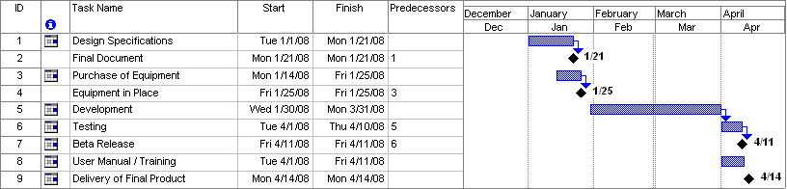
SPECIMEN

9. Proposed Budget

Please use the embedded Excel Worksheet for providing budget details.

Double click the icon to open the worksheet.



Annexure A – Curriculum Vitae

Please provide relevant information and also attach CVs of key research / development personnel (if available) and PI, CPI.
- Professional Information
- Name :
- Title or Position Held :
- Experience : (yrs)
- Email Address :
- Research Papers in Relevant Area
<type here>

- Courses Taught in Relevant Area
<type here>

- Thesis / Projects Supervised in Relevant Area
<type here>

- Grants Received in Relevant Area
<type here>

- Industrial Work Done in Relevant Area
<type here>

Please provide relevant information and also attach CVs of key research / development personnel (if available) and PI, CPI.
- Professional Information
- Name :
- Title or Position Held :
- Experience : (yrs)
- Email Address :
- Research Papers in Relevant Area
<type here>

- Courses Taught in Relevant Area
<type here>

- Thesis / Projects Supervised in Relevant Area
<type here>

- Grants Received in Relevant Area
<type here>

- Industrial Work Done in Relevant Area
<type here>

Bibliography

<type here>

