

Proposal / Application
for
ICT-Related Development
and Research Grant

<Project Title>

<submitted by>

Read carefully before filling the form.

- Please do not alter the layout of the application form. Information must be filled in the spaces provided, under set format.
- Guidance notes in various fields should not be deleted.
- Required information should be duly filled in the specified fields.
- Required heads/fields which are not relevant to the project should be marked N/A (Not Applicable) or left blank and should not be deleted.
- Specifications, justifications, purposes must be provided against each item in the Budget file.
- Please do not change the formulas in the budget sheets.
- We have prepared financial guidelines to evaluate the remuneration for human resource associated with the proposed project. The guidelines are available on our website (click application forms>Financial Guidelines for Preparation of R&D and HRD Proposals>.

List of Abbreviations and Acronyms

EE | External Evaluators
ICT | Information and Communication Technologies
IPR | Intellectual Property Rights
CPI | Co-Principal Investigator
PI | Principal Investigator
PIO | Principal Investigator’s Organization  "Principal Investigator’s Organization" means the person, company, partnership, undertaking, concern, association of persons, body of individuals, consortium or joint venture which receives funding from the Company to execute a research and development project.”
R&D | Research and Development

List of Abbreviations and Acronyms Used by PI in the Proposal
(Please add abbreviations and acronyms in the table below, if any.)
Application for ICT-Related Development and Research Grant
Guidelines and Forms

Introduction
National ICT R&D Fund was created in January 2007 by Ministry of IT with the vision to transform Pakistan's economy into a knowledge-based economy by promoting efficient, sustainable, and effective ICT (IT and Telecommunications) initiatives through synergic development of industrial and academic resources. Collaborative efforts between academia, research institutions, and industry are greatly encouraged to ensure that local economy can reap the monetary benefits of investment in research. This organization has significant funds available for proposals that are geared towards creating ICT related technologies.

Research grants will be awarded for high-level and promising ICT-related development and research projects by individuals or groups from academia and/or industry actively involved in the research and development individually or collaboratively. These projects should be based on either a universally known technology or a new technology developed by the applicant and should be aimed at achieving economically viable systems, products, or processes beneficial to the nation.

The grant will cover the honoraria of the principal investigator and co- principal investigators, salaries of professional researchers and developers at market rate, stipends for student research assistants, and supporting staff. It will also cover travel(s) within and outside the country for project-related activities and for scientific conferences where project team’s research paper, an outcome of the project, has been selected for presentation. The grant may be used to purchase very specific unavoidable equipment kept to the bare minimum, consumable materials, and other items needed for the project.

Submission Procedure
Duly filled application forms complete in all respects along with any documents should be submitted online through Fund’s website www.ictrdf.org.pk. A hard copy should also be submitted by registered post or by fax at our mailing address given below. On receipt of the applications the proposals will be evaluated internally as well as externally as laid down in our policy documents. The PI may need to revise the proposal in light of the evaluator’s recommendations.

There is no deadline for submission of the application forms for Unsolicited Projects. The deadline for Solicited Projects will be given in the RFPs whenever floated.

Joint Funding
The project proposal may be jointly funded by ICT R&D Fund and other funding agencies/industry. The efforts to obtain joint funding will be at the discretion of the Principal Investigator Organization (PIO) to which Principal Investigator belongs. However any such information must be provided to ICT R&D Fund. The funds released will be provided to the PI.

Agreement
A written agreement will be made between National ICT R&D Fund and PI. The PI will undertake to administer the grant according to the agreement and to provide laboratory space, and other facilities necessary for the project. The equipment purchased with ICT R&D Fund for the approved project will remain the property of ICT R&D Fund. The laptops will be returned to ICT R&D Fund after completion of the project. The grantee is required to submit a final narrative and financial report within one month of the completion of the project. The IPR issues will be sorted according to the policy in vogue.

For further information, please contact:

Manager Administration,
National ICT R&D Fund,
6th Floor, HBL Towers,
Jinnah Avenue, Blue Area, Islamabad
Tel.: (+92-51) 921 5360 - 65
Fax: (+92-51) 921 5366
Website: www.ictrdf.org.pk

Table of Contents
Description Page #
1. Project Identification 1
A. Reference Number: 1
B. Project Title: 1
C. Principal Investigator (PI): 1
D. Principal Investigator’s Organization (PIO): 1
E. Other Organizations Involved in the Project: 2
F. Key Words: 2
G. Research and Development Theme: 3
H. Project Status: 3
I. Project Duration: 3
J. Executive Summary: 3
2. Scope, Introduction and Background of the Project 3
A. Scope of the Project: 3
B. Introduction: 3
B1. Literature Review: 3
B2. Current State of the Art: 4
C. Challenges: 4
D. Motivation and Need: 4
3. Objectives of the Project 4
A. Specific Objectives Being Addressed by the Project: 4
4. Research Approach 5
A. Development / Research Methodology: 5
B. Project Team: 5
C. Team Structure: 5
D. Project Activities: 6
E. Key Milestones and Deliverables: 6
5. Benefits of the Project 6
A. Direct Customers / Beneficiaries of the Project: 6
B. Outputs Expected from the Project: 6
C. Organizational / HRD Outcomes Expected: 7
D. Technology Transfer / Diffusion Approach: 7
6. Risk Analysis 7
A. Risks of the Project: 7
A1. Comments: 7
7. Contractual Matters 7
A. Contractual Obligations under this Project: 7
B. Ownership of Intellectual Property Rights: 7
C. Competent Authority of the Principal Investigator’s Organization: 8
8. Project Schedule / Milestone Chart 9
9. Proposed Budget 10
Annexure A – Curriculum Vitae 11
Bibliography 13

Note: To update the table of contents, right click in the table and select ‘update field’ and then select ‘Update Entire Table’.

Application for ICT-Related Development and Research Grant

1. Project Identification
- Reference Number:
(for office use only)

- Project Title:
<type here>

- Principal Investigator (PI):
Name:
Designation:
Organization:
Mobile # : |  |  |  |  |  |  | Tel. # :
Email:
(A letter from the competent authority regarding PI’s time commitment for the proposed research project must be provided.)
C1. Co-Principal Investigator (CPI):
Name:
Designation:
Organization:
Mobile # : |  |  |  |  |  |  | Tel. # :
Email:
C2. Contact Person: (If different from PI.)
Name:
Designation:
Organization:
Mobile # : |  |  |  |  |  |  | Tel. # :
Email:
- Principal Investigator’s Organization (PIO):
(Please indicate the name, address, telephone and fax of the Principal Investigator’s Organization. The Principal Investigator should belong to this organization.)
Name:
Address:
Registration #: |  |  |  |  |  |  |  |  |  | (Please attach certified copy)
National Tax #: |  |  |  |  |  |  |  |  |  | (Please attach certified copy)
Tel. # : |  |  |  |  |  | Fax # :
Website:
- Other Organizations Involved in the Project:
(Please identify all affiliated organizations collaborating in the project, and describe their role/contribution to the project.)
E1. Industrial Organizations:
# | Organization Name |  |  |  |  | Role / Contribution
E2. Academic Organizations:
# | Organization Name |  |  |  | Role / Contribution
E3. Funding Organizations:
# | Organization Name |  |  |  |  | Role / Contribution
E4. Other Organizations:
# | Organization Name |  |  |  |  | Role / Contribution
- Key Words:
(Please provide a maximum of 5 key words that describe the project. The key words will be incorporated in our database.)
<type here>

- Research and Development Theme:
(If the proposal belongs to a theme specified by NICT R&D Fund, please identify the Research Theme.)
<type here>

- Project Status:
(Please mark ☑)
  New  Modification to previous Project
❑ Extension of existing project

H1. Project URL:
(The project URL should be provided. This URL should be hosted by the project executing agency. Sufficient details such as executive summary, objectives are expected on the website. Once the proposal is approved, the website should also provide final copy of the proposal and deliverables/progress.)
<type here>

- Project Duration:
Expected Starting Date:
Planned Duration in months:
- Executive Summary:
<type here>

2. Scope, Introduction and Background of the Project
- Scope of the Project:
The most efficient use of fresh water is burning need of the time. Therefore an efficient and intelligent management of irrigation is a major concern in agriculture. People are working in automatic and intelligent irrigation because of its biggest advantages especially in labor and water savings in this sector of wireless technology is the best option to develop the irrigation network and now becomes an important research topic.
Through the application of this system, firstly, the cost can be greatly reduced, and on the other hand, water and electricity can be saved. Increasing the production of healthy food benefits directly.

The following are direct and direct beneficiaries of this system:
• Farmers
• Ordinary people
• Traders
• Industrial
• Provincial Government and the Government of Pakistan

The proposed system is an application of modern technology that is being implemented worldwide. Probably expected state of the computer systems of art to the area of ​​agriculture in Pakistan to give a boost in the agricultural sector of Pakistan freshwater required by each individual in Pakistan, so the water saved through this project It is used indirectly by individuals. The overall beneficiaries of this project are individuals who live in the country.

- Introduction:
Agriculture plays an important direct and indirect role in generating economic growth. It provides food to consumers and fibers for the domestic industry. It is a source of scarce foreign exchange earnings and provides the market for industrial goods. Agriculture is the backbone of Pakistan. Half of the population direct source of income is agriculture. Agriculture is facing a lot of problems today, which is causing an increase in the proportion of poverty each year
Most of the Pakistan's economy depends on agriculture; 50% of the total population is based on agriculture and the cultivation of their income. Today the agriculture is finding many major issues and their growth rate decreases each year the results decrease in GDP. In 1947, 53% of the total GDP of Pakistan is based on agriculture, but unfortunately today contributes only 23%. The reason for such a rapid decline is that crops and fields are not adequately controlled. No need to apply scientific technology as other countries are adopting worldwide. Pakistan still old traditional forms of agriculture are, in practice, farmers use only their experience to take care of their fields Water availability is the main factor to increase productivity in the agricultural sector. Currently the archaic method of irrigation, which is in practice throughout the country waste almost 50% - 60% of water resources of Pakistan. Because freshwater resources are already scarce in Pakistan so there is the need to propose irrigation technology based on using water efficiently solutions.
Mainly we want to guide the waste water because agriculture uses 85% of available freshwater resources worldwide, and this percentage will remain dominant in water consumption due to population growth and increased demand for food. Because freshwater resources are declining, therefore, we must make efficient use of it. There is an urgent need for strategies based on science and technology for sustainable water use. Deposits of water daily in Pakistan are decreasing storage available. Which it lacks dams and other reservoirs results in drought sometimes. It does not only destroyed green fields, but cattle and a threat to human lives. The construction of new dams / deposit requires a lot of investment and time, while the need for water savings can be achieved by using self-watering and accurate digital or smart irrigation system. The development of precision agriculture is an important strategic choice of agriculture and development of agricultural science worldwide.

Dwindling water supplies and poor water health are very real threats. When water supply is at risk, people and the planet end up suffering. Adverse environmental effects such as harmful pesticides, toxic fertilizers and animal waste results due to insensitive irrigation. This automatic irrigation system helps keep our water supplies clean by stopping that polluted runoff. It also helps to conserve water. Following graphs visualizes predicted trends and behavior of different effects over State of the Art Computing System Deployment to Improve Agricultural Sector of Pakistan by adoption of smart irrigation strategies.

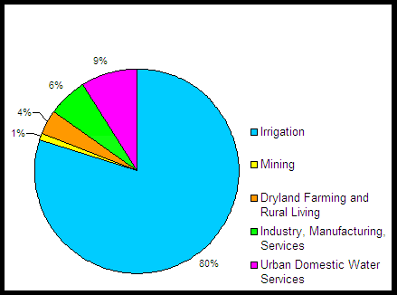
Fig5 Water Usage without technological advancements

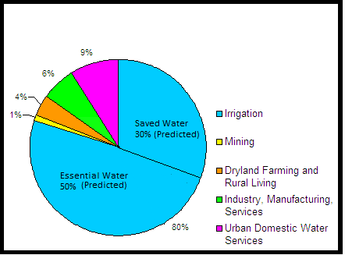
Fig6 Water Usage with technological advancements

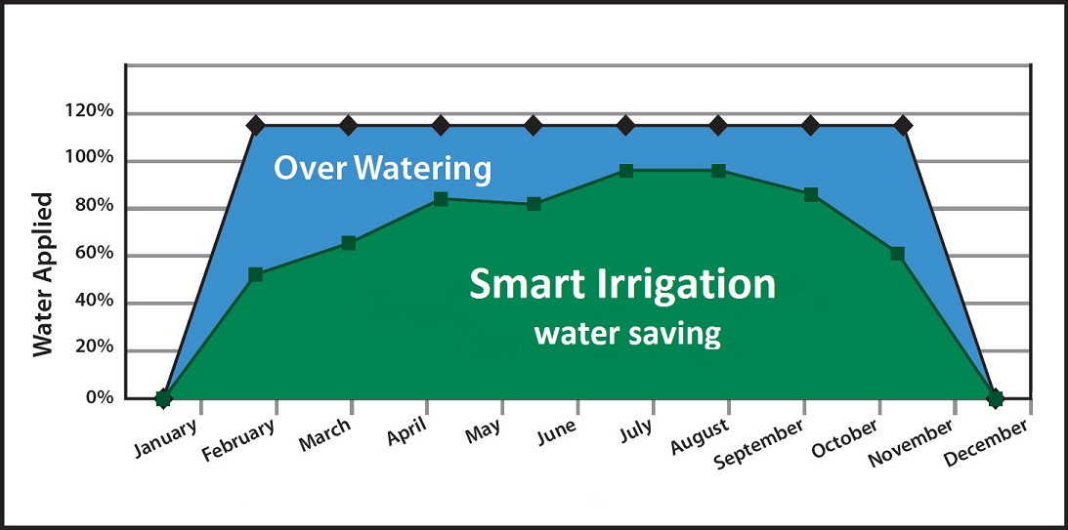

Figure7. predicted water saving by "Smart Irrigation” State of the Art Computing System Deployment to Improve Agricultural Sector of Pakistan

These objectives can be achieved by the current state of the art technology ie "Internet of things".
The "Internet of things" refers to the idea that the Internet is no longer just a global network for people to communicate with each other using computers, but is also a platform for devices to communicate electronically with each other and, as with all things present in their environment.
It is under worldwide research and analyzes done next era will be flourished for the implementation of the IO. Since the development of the smart grid to the health system of remote monitoring, including automation, object tracking, GPS tracking and precision agriculture.it it has played a vital role serving humanity.

B1. Literature Review:
(Detailed summary of what all has been done internationally in the proposed area quoting references and bibliography. Please note that this section demonstrates the depth of knowledge of the project team and builds the confidence of the evaluators about capability of the team in achieving the stated objectives.)
<type here>

B2. Current State of the Art:
(Please describe the current state of the art specific to this research topic.)
- Growing Garden in Brooklyn to a Company Selling Prototypes:

Amit Kumar, a software engineer moved to Brooklyn, started to develop a hankering in his own garden. Need arises when he wanted to monitor his plants even when he’s not available to look after it. He met a hardware engineer and started to learn about Arduino, an open source microcontroller. They planned to use it in building a system with a base module connected to sensors that could monitor everything from a garden's pH level to its humidity, then relay that information through the cloud to growers' computers and, in many cases, automatically correct any problems that might arise—say, turning on a fan connected to the base module when the temperature rises to 90 degrees.
Bitponics, a company founded after a year and half ago. They raised $20,000 through Kickstarter. He says "Our major mission is to make gardening as simple as possible so people can have thriving gardens in their home”. He gave a complete “grow plan” to very start to finish of the plant maintenance successfully by everything from what kind of lighting to buy to the type of nutrients needed, automatic scheduling and actions that the system can't take care of automatically, like adding water, it will send an email with an alert.

Example: A grow plan for lettuce or herbs calls for a three-ft. by three-ft. flood drainage system and a 24-gallon reservoir. After that, the plan includes steps for additional phases of growth, each with appropriate requirements. The two-week-long seedling stage, for example, needs 16 hours of light per day. Next phase, gardeners transplant the seedlings into a grow bed and there's an automatically triggered schedule for turning off and on lights and pumps.
Last but not the least, an online dashboard through which users can connect to other growers and share their plans to community.

- Waspmote, A Platform that Allows Lots of Applications:

Libelium, six-year old company takes a different approach, introduced an open source sensor platform having multiple applications in 12 sectors, including farming and agriculture. It is based on “plug and sense device” to which 50 or more sensors potentially can be connected. Having a lot of sensors sending date wirelessly to computer anywhere in the world.
Company targets not only consumer, but to system integrators who in turn aims consumers of specific industries with applications they have developed themselves.

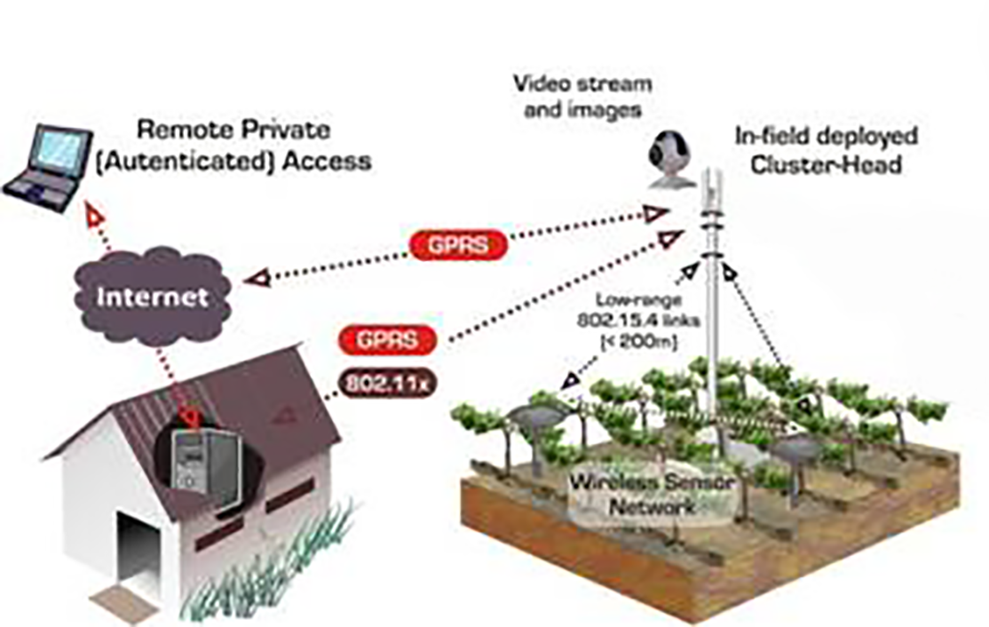

Example: Take Alan Campbell, who runs Northwest Vineyard Consulting in Tualatin, Ore. According to Campbell, a big problem facing regional vineyard managers is how much water stress their vines experience. "Grapes do better in a slightly stressed environment," he says. Campbell wanted a way to send sensor data about soil moisture from vineyards to the computers of vineyard managers.
To that end, he recently launched a pilot with six vineyards, where he places six sensors one, two or three feet deep in the soil. They detect such information as temperature, humidity level and moisture. The system then collects that intelligence every 15 minutes, ultimately sending it to vineyard managers in a form that allows them to make decisions based on the amount of available water in the soil and its impact on grapes. Says Campbell: "We're hoping this has a big effect on the quality of the wine."

After all, the IoE isn't just about connecting devices, but also about the collection and use of data made possible by hooking up all those "things" in systems unavailable before.

- WaterSense Labeled Irrigation Controllers:

United States utilizes over more than 9 billion gallons of water each day, mainly for landscape irrigation. More than 50% of this water is wasted due to inefficiencies in irrigation methods and systems. Technologies can abundantly reduce overwatering by automating it whenever plants are in need. Just like thermostats Irrigation controllers significantly decrease our home’s outdoor water usage.
WaterSense labeled irrigation controllers, a thermostat for our sprinklers use local weather and landscape conditions to adapt watering schedules to actual conditions on the site, to control the sprinklers. With proper installation, programming, and maintenance, homeowners and businesses can use WaterSense labeled controllers instead of standard clock-timer controllers on their existing systems, and no longer worry about wasted water.
WaterSense labeled irrigation controller can save a typical home approximately 8,800 gallons of water annually. This could save $435 million in water costs and 120 billion gallons of water through-out the country annually from not overwatering lawns and landscapes.

- Smart Irrigation in New Zealand:

Different irrigation technologies and decision support tools are continually being innovated in New Zealand and globally. Water and energy use efficiency are the main focuses of these revolutions. Luckily, proficiency is linked to improved quality production and lucrativeness. Over the last two eras there has been a major change in the irrigation technology used in New Zealand. There has been a common move from physical flood irrigation to remotely controlled spray irrigation such as centre pivots, dripline and micro sprinklers.
The five elements are:
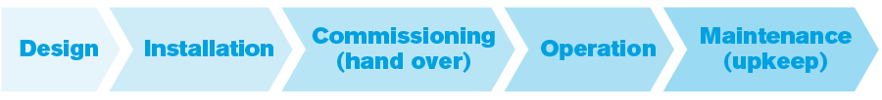

Each module has to be done well for an irrigator to become a smart irrigator.
An irrigation method being correctly planned, mounted, custom-built and retained makes it easier for an irrigator to operate it well. An irrigation system designed, installed, commissioned and maintained to industry standards means the precise amount of water can be delivered at the correct time and in the right place.
Operating an irrigation system well is a vital component of smart irrigation. Being able to rationalize the use of water is the most applied method for representing the irrigation system is being operated well.

To enable and support all irrigators to achieve smart irrigation recognition, Irrigation New Zealand has a continually evolving set of resources. These include :
- Industry standards, codes of practice and guidelines – the backbone of the smart Irrigation programme
- Training workshops – to provide practical information for irrigators
- Industry accreditation and certification programmes which set standards for the irrigation service industries
- An irrigation knowledge resource and certification programmes
- Decision support tools and resources

- WaterBee, Smart Irrigation and Water Management:

WaterBee is a complete, robust, economical Smart Irrigation and Water Management system that enables growers, vineyards, golf clubs, public authorities and landscape managers to enhance their commercial and maintainable environmental operations.
The web sensor networked irrigation system is centrally monitored and coordinated, and the WaterBee services are provided across Europe through collaborating Business Partners, who work closely with their local customers. TheWaterBee system provides a range of advantages to come across current growers needs:
- Greater control over your irrigation necessities and be paid additional revenue per acre through the efficient use of water and extra inputs.
- Precise and comprehensive information on crop and field situations.
- Easy-to-use Smartphone and Web Apps to upkeep crop irrigation results with real-time data.
- Software support or equipment maintenance
- Lower functional costs, great yields and higher quality crops

WaterBee smart irrigation modelling and scheduling system goes well beyond the state-of-art, with its unique Soil-Moisture Model for optimum water use, constantly self-adapting to each user’s situation and business purposes, using machine learning tactics, and its open web-enabled architecture eases future integration with all environmental data in line. This enables you not only to optimize the use of water by irrigating only when and where it is needed, but also enhancing plant growth and quality.
The system has been installed and is in use at 14 reference sites across Europe in Estonia, Malta, Italy, Spain, Sweden & the UK.

- Challenges:
(Please describe the challenges, specific to this research topic, currently being faced internationally.)
<type here>
- Motivation and Need:
(Please describe the motivation and need for this work.)
<type here>

3. Objectives of the Project
- Specific Objectives Being Addressed by the Project:
(Please describe the measurable objectives of the project and define the expected results. Use results-oriented wording with verbs such as ‘to develop..’, ‘to implement..’, ‘to research..’, ‘to determine..‘, ‘to identify..’ The objectives should not be statements and should not include explanations and benefits. The objective should actually specify in simple words what the project team intends to achieve (something concrete and measurable/ deliverable). Fill only those objectives that are applicable to the proposed project.)
A1. Research Objectives: (if any)
- <type here>

A2. Academic Objectives: (if any)
- <type here>

A3. Industrial Objectives: (if any)
- <type here>

A4. Human Resource Development Objectives: (if any)
- <type here>

A5. Other Objectives: (if any)
- <type here>

4. Research Approach
- Development / Research Methodology:
(Please describe the technical details and justification of your development and research plan. Identify specialized equipment, facilities and infrastructure which are required for the project and their utilization plan. The block diagrams, system flow charts, high level algorithm details etc. have to be provided in this section.)
<type here>

- Project Team:
(Please attach the curriculum vitae (CV) of PI and CPI(s). Also attach the CVs of key research/ development personnel if available. Please follow the format included in Annexure A.
The numbers in the table below must tally with the HR Cost sheet in the Budget file.)
Title / Position |  |  |  |  |  |  | Number
Team Leads
Researchers / Developers
Researcher / Development Assistants
Support Staff
Contract Staff (please specify)
Others (please specify)
Add more rows if required
- Team Structure:
(Please define the team structure (organogram) and role/key responsibilities of each member. If in collaboration with another partner, the division of manpower at various locations of partners be provided.)
<paste organogram here>

Title/Position  (of each member) | Role/Key Responsibilities | Minimum Qualification Required | Expertise / Background Required | Minimum Experience Required (years)

- Project Activities:
(Please list and describe the main project activities, including those associated with the transfer of the research results to customers/beneficiaries. The timing and duration of research activities are to be shown in the Gantt chart in Section 8.)
<type here>

- Key Milestones and Deliverables:
(Please list and describe the principal milestones and associated deliverables of the project. A key milestone is reached when a significant phase in the project is concluded, e.g. selection and simulation of algorithms, completion of architectural design and design documents, commissioning of equipment, completion of test, etc.) The timing of milestones is also to be shown in the Gantt chart in Section 8. Quarterly deliverables are preferred.
The information given in this table will be the basis of monitoring and release of funds by the National ICT R&D Fund.
No. |  | Elapsed time from start (in months) of the project |  | Milestone |  | Deliverables
(Please add more rows if required.)

5. Benefits of the Project
- Direct Customers / Beneficiaries of the Project:
(Please identify clearly the potential customers/beneficiaries of the research results and provide details of their relevance, e.g. size, economic contribution, etc.)
<type here>

- Outputs Expected from the Project:
<type here>

- Organizational / HRD Outcomes Expected:
<type here>

- Technology Transfer / Diffusion Approach:
(Please describe how the outputs of the project will be transferred to the direct beneficiaries/customers. Please also state if the project outputs are sustainable, i.e. if they can be utilized without further external assistance.)
<type here>

6. Risk Analysis
- Risks of the Project:
(Please describe the factors that may cause delays in, or prevent implementation of, the project as proposed above; estimate the degree of risk.)
(Please mark ☑ where applicable) | Low | Medium | High
- Technical risk | ❑ | ❑ | ❑
- Timing risk | ❑ | ❑ | ❑
- Budget risk | ❑ | ❑ | ❑

A1. Comments:
<type here>

7. Contractual Matters
- Contractual Obligations under this Project:
(Please indicate any contractual obligations with third parties that will be entered into for this project.)
<type here>

- Ownership of Intellectual Property Rights:
All newly developed intellectual property rights arising out of or capable of legal recognition with respect to the projects implemented by the National ICT R&D Fund (The “Company”) shall vest with the Company.

The Company may assign or license its rights in the said intellectual property to any person on such terms as it may deem appropriate.

- Competent Authority of the Principal Investigator’s Organization:
(Documentary proof of the Competent Authority (VC/Rector/CEO..) as being the authorized signatory for the PIO is mandatory for approval of the Project Proposal. Please attach copy of the proof.)
Name:
Designation:
Email:
Date: |  |  | Signature  & stamp:

8. Project Schedule / Milestone Chart

(Project schedule using MS-Project (or similar tools) with all tasks, deliverables, milestones, cost estimates, payment schedules clearly indicated are preferred.)

Example:
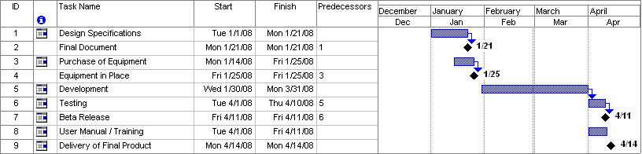
SPECIMEN

9. Proposed Budget

Please use the embedded Excel Worksheet for providing budget details.

Double click the icon to open the worksheet.



Annexure A – Curriculum Vitae

Please provide relevant information and also attach CVs of key research / development personnel (if available) and PI, CPI.
- Professional Information
- Name :
- Title or Position Held :
- Experience : (yrs)
- Email Address :
- Research Papers in Relevant Area
<type here>

- Courses Taught in Relevant Area
<type here>

- Thesis / Projects Supervised in Relevant Area
<type here>

- Grants Received in Relevant Area
<type here>

- Industrial Work Done in Relevant Area
<type here>

Please provide relevant information and also attach CVs of key research / development personnel (if available) and PI, CPI.
- Professional Information
- Name :
- Title or Position Held :
- Experience : (yrs)
- Email Address :
- Research Papers in Relevant Area
<type here>

- Courses Taught in Relevant Area
<type here>

- Thesis / Projects Supervised in Relevant Area
<type here>

- Grants Received in Relevant Area
<type here>

- Industrial Work Done in Relevant Area
<type here>

Bibliography

<type here>

