

Proposal / Application
for
ICT-Related Development
and Research Grant

<Project Title>

<submitted by>

Read carefully before filling the form.

- Please do not alter the layout of the application form. Information must be filled in the spaces provided, under set format.
- Guidance notes in various fields should not be deleted.
- Required information should be duly filled in the specified fields.
- Required heads/fields which are not relevant to the project should be marked N/A (Not Applicable) or left blank and should not be deleted.
- Specifications, justifications, purposes must be provided against each item in the Budget file.
- Please do not change the formulas in the budget sheets.
- We have prepared financial guidelines to evaluate the remuneration for human resource associated with the proposed project. The guidelines are available on our website (click application forms>Financial Guidelines for Preparation of R&D and HRD Proposals>.

List of Abbreviations and Acronyms

EE | External Evaluators
ICT | Information and Communication Technologies
IPR | Intellectual Property Rights
CPI | Co-Principal Investigator
PI | Principal Investigator
PIO | Principal Investigator’s Organization  "Principal Investigator’s Organization" means the person, company, partnership, undertaking, concern, association of persons, body of individuals, consortium or joint venture which receives funding from the Company to execute a research and development project.”
R&D | Research and Development

List of Abbreviations and Acronyms Used by PI in the Proposal
(Please add abbreviations and acronyms in the table below, if any.)
Application for ICT-Related Development and Research Grant
Guidelines and Forms

Introduction
National ICT R&D Fund was created in January 2007 by Ministry of IT with the vision to transform Pakistan's economy into a knowledge-based economy by promoting efficient, sustainable, and effective ICT (IT and Telecommunications) initiatives through synergic development of industrial and academic resources. Collaborative efforts between academia, research institutions, and industry are greatly encouraged to ensure that local economy can reap the monetary benefits of investment in research. This organization has significant funds available for proposals that are geared towards creating ICT related technologies.

Research grants will be awarded for high-level and promising ICT-related development and research projects by individuals or groups from academia and/or industry actively involved in the research and development individually or collaboratively. These projects should be based on either a universally known technology or a new technology developed by the applicant and should be aimed at achieving economically viable systems, products, or processes beneficial to the nation.

The grant will cover the honoraria of the principal investigator and co- principal investigators, salaries of professional researchers and developers at market rate, stipends for student research assistants, and supporting staff. It will also cover travel(s) within and outside the country for project-related activities and for scientific conferences where project team’s research paper, an outcome of the project, has been selected for presentation. The grant may be used to purchase very specific unavoidable equipment kept to the bare minimum, consumable materials, and other items needed for the project.

Submission Procedure
Duly filled application forms complete in all respects along with any documents should be submitted online through Fund’s website www.ictrdf.org.pk. A hard copy should also be submitted by registered post or by fax at our mailing address given below. On receipt of the applications the proposals will be evaluated internally as well as externally as laid down in our policy documents. The PI may need to revise the proposal in light of the evaluator’s recommendations.

There is no deadline for submission of the application forms for Unsolicited Projects. The deadline for Solicited Projects will be given in the RFPs whenever floated.

Joint Funding
The project proposal may be jointly funded by ICT R&D Fund and other funding agencies/industry. The efforts to obtain joint funding will be at the discretion of the Principal Investigator Organization (PIO) to which Principal Investigator belongs. However any such information must be provided to ICT R&D Fund. The funds released will be provided to the PI.

Agreement
A written agreement will be made between National ICT R&D Fund and PI. The PI will undertake to administer the grant according to the agreement and to provide laboratory space, and other facilities necessary for the project. The equipment purchased with ICT R&D Fund for the approved project will remain the property of ICT R&D Fund. The laptops will be returned to ICT R&D Fund after completion of the project. The grantee is required to submit a final narrative and financial report within one month of the completion of the project. The IPR issues will be sorted according to the policy in vogue.

For further information, please contact:

Manager Administration,
National ICT R&D Fund,
6th Floor, HBL Towers,
Jinnah Avenue, Blue Area, Islamabad
Tel.: (+92-51) 921 5360 - 65
Fax: (+92-51) 921 5366
Website: www.ictrdf.org.pk

Table of Contents
Description Page #
1. Project Identification 1
A. Reference Number: 1
B. Project Title: 1
C. Principal Investigator (PI): 1
D. Principal Investigator’s Organization (PIO): 1
E. Other Organizations Involved in the Project: 2
F. Key Words: 2
G. Research and Development Theme: 3
H. Project Status: 3
I. Project Duration: 3
J. Executive Summary: 3
2. Scope, Introduction and Background of the Project 3
A. Scope of the Project: 3
B. Introduction: 3
B1. Literature Review: 3
B2. Current State of the Art: 4
C. Challenges: 4
D. Motivation and Need: 4
3. Objectives of the Project 4
A. Specific Objectives Being Addressed by the Project: 4
4. Research Approach 5
A. Development / Research Methodology: 5
B. Project Team: 5
C. Team Structure: 5
D. Project Activities: 6
E. Key Milestones and Deliverables: 6
5. Benefits of the Project 6
A. Direct Customers / Beneficiaries of the Project: 6
B. Outputs Expected from the Project: 6
C. Organizational / HRD Outcomes Expected: 7
D. Technology Transfer / Diffusion Approach: 7
6. Risk Analysis 7
A. Risks of the Project: 7
A1. Comments: 7
7. Contractual Matters 7
A. Contractual Obligations under this Project: 7
B. Ownership of Intellectual Property Rights: 7
C. Competent Authority of the Principal Investigator’s Organization: 8
8. Project Schedule / Milestone Chart 9
9. Proposed Budget 10
Annexure A – Curriculum Vitae 11
Bibliography 13

Note: To update the table of contents, right click in the table and select ‘update field’ and then select ‘Update Entire Table’.

Application for ICT-Related Development and Research Grant

1. Project Identification
- Reference Number:
(for office use only)

- Project Title:
<type here>

- Principal Investigator (PI):
Name:
Designation:
Organization:
Mobile # : |  |  |  |  |  |  | Tel. # :
Email:
(A letter from the competent authority regarding PI’s time commitment for the proposed research project must be provided.)
C1. Co-Principal Investigator (CPI):
Name:
Designation:
Organization:
Mobile # : |  |  |  |  |  |  | Tel. # :
Email:
C2. Contact Person: (If different from PI.)
Name:
Designation:
Organization:
Mobile # : |  |  |  |  |  |  | Tel. # :
Email:
- Principal Investigator’s Organization (PIO):
(Please indicate the name, address, telephone and fax of the Principal Investigator’s Organization. The Principal Investigator should belong to this organization.)
Name:
Address:
Registration #: |  |  |  |  |  |  |  |  |  | (Please attach certified copy)
National Tax #: |  |  |  |  |  |  |  |  |  | (Please attach certified copy)
Tel. # : |  |  |  |  |  | Fax # :
Website:
- Other Organizations Involved in the Project:
(Please identify all affiliated organizations collaborating in the project, and describe their role/contribution to the project.)
E1. Industrial Organizations:
# | Organization Name |  |  |  |  | Role / Contribution
E2. Academic Organizations:
# | Organization Name |  |  |  | Role / Contribution
E3. Funding Organizations:
# | Organization Name |  |  |  |  | Role / Contribution
E4. Other Organizations:
# | Organization Name |  |  |  |  | Role / Contribution
- Key Words:
(Please provide a maximum of 5 key words that describe the project. The key words will be incorporated in our database.)
<type here>

- Research and Development Theme:
(If the proposal belongs to a theme specified by NICT R&D Fund, please identify the Research Theme.)
<type here>

- Project Status:
(Please mark ☑)
  New  Modification to previous Project
❑ Extension of existing project

H1. Project URL:
(The project URL should be provided. This URL should be hosted by the project executing agency. Sufficient details such as executive summary, objectives are expected on the website. Once the proposal is approved, the website should also provide final copy of the proposal and deliverables/progress.)
<type here>

- Project Duration:
Expected Starting Date:
Planned Duration in months:
- Executive Summary:
<type here>

2. Scope, Introduction and Background of the Project
- Scope of the Project:
The most efficient use of fresh water is burning need of the time. Therefore efficient and intelligent irrigation management is a major concern in agriculture. People are working on automatic and intelligent irrigation systems because of their greater advantages especially in labor and water saving, in this sector wireless technology is most suitable choice to develop irrigation network and it is now become a significant topic of research.
Through the application of this system, on one hand, the cost can be greatly reduced, and on the other hand, water and electricity can be saved. It directly benefits the increase in healthy food production.

- Introduction:
A huge portion of Pakistan’s economy is dependent on the agricultural sector; 50% of the total population relies on farming & cultivation for their income. Nowadays the agriculture sector is encountering numerous major problems and its growth rate decreasing every year which results declining in GDP. In 1947, 53% of the total GDP of Pakistan was based on agriculture but unfortunately today it contributes only 23%. The reason for such a rapid downfall is that the crops and fields are not monitored properly. There is need to apply scientific technology as other countries are adopting worldwide. In Pakistan still old traditional ways of farming are in practice, farmers solely use his experience to look after his fields Water availability is the major factor to increase productivity in agriculture sector. Currently the archaic method of irrigation which is in practice all over the country wastes almost 50% - 60% of Pakistan’s water resources. Since fresh water resources are already scarce in Pakistan so there is need to propose technology based solutions of irrigation which utilized water in efficient manner.

B1. Literature Review:
(Detailed summary of what all has been done internationally in the proposed area quoting references and bibliography. Please note that this section demonstrates the depth of knowledge of the project team and builds the confidence of the evaluators about capability of the team in achieving the stated objectives.)
Agriculture is one of major source of income for Pakistan. The country’s economy highly depends on it. Agriculture accounts to be a major source of development. There has been a lot of research in this area, which could greatly improve the crop productivity [1]. Keeping in front the agricultural problems faced by our country in which water deficiency is the most prominent one, decision have been taken to develop a smart irrigation system that can achieve water conservation up to 40%.
Nowadays, there are different approaches for solutions that are being used to improve crop production. For enhancing crop production we need to monitor the crops constantly using sensors. Wireless Sensor Network in agriculture is showing progress [2]-[5]. WSNs provide possibilities to gather sensors data and information, regarding the environmental and crop condition. One of the application areas of WSN is Smart irrigation. A smart irrigation method is where the amount of inputs (like seed, fertilizer, pesticides, water etc.) given to a specific farm field is important to control and monitor the condition of the farm. It helps to determine the amount of the crop output.
A system [6] is deployed using a ZigBee network. It consists of soil moisture and temperature sensors. A microcontroller based gateway is used for controlling the water quantity. It transmits data to the Web server. The researchers [7] also conduct a simulation work using various sensors. The sink node is responsible for aggregating and sending data through internet to the control center where the information is processed. A mathematical calculations based irrigation management system has been proposed [8]. The system is using wireless sensor technology for monitoring potato crops to improve their production. In a research paper [9] monitoring of agriculture is described which consists of several XBee sensors and a microcontroller. The data is first interfaced to the computer by using UART which is a serial protocol then analyzed and monitor by using a FPGA element. Certain unnecessary events may occur in irrigation process, to avoid this kind of events an automatic irrigation system has proposed [10]. It is using a timer that is triggered when a threshold is reached. The gathered data facilitates the farmer to schedule the process of irrigation. In a proposed system [11] sensors are placed in the field where it converts moisture content into equivalent voltage. The reference voltage can be set by the farmer. The difference between these two voltages is directly proportional to the amount of water needed for irrigation. The application [12] deals with combating with a fungal disease in potatoes. The data is gathered at a field gateway and then transferred to a PC for data logging through Wi-Fi. Smart irrigation [13] can also use the smartphone technology to manage urban and agricultural irrigation. SoilNet [14] focuses on real time monitoring and estimation of soil water content. It belongs to Underground ZigBee WSN. Coordinator, Router and End device are the main three devices in WSN. It has used hybrid topology to provide transmission on wider range. WaterBee [15] is a smart water management system. It consists of a web driven WSN that is centrally monitored through a server. A web service analyzes and models the data. A system has proposed [16].The system consists of various agents to gather information. In that way this system provides flexibility allowing to dynamically adapting the agent behaviors. It enables the system to deal with dynamic problems ultimately ensures a better adaptability to its environment. A system [17] consists of a microcontroller, ZigBee WSN, a weather station and several wireless actuators. The wireless sensor node collects temperature and humidity data, transmits it to the controller wirelessly. The actuator nodes are used to control the electromagnetic valves and pumps. The coordinator assigns network addresses and collects the sensor data for processing on the basis of which intelligent decisions are taken. Reference [18] validates a setup of ZigBee WSN. The sensors are powered through solar panels. They also measure the water level in canals.
/////////////////////////////////
The application [1] deals with combating with a fungal disease in potatoes Phytophtora, which can attack the potato field from various sources. The development of the disease depends on the climatic condition such as humidity, temperature etc. A total of 150 sensor boards are used namely Tnodes, each TNOdes consist of sensors that measures temperature and humidity. In order to improve connectivity some sensor less TNOdes behaves as communication relays. Furthermore some weather stations are set up in the field to monitor the luminosity, air pressure, precipitation, wind strength and direction. The TNOdes is recording temperature and humidity every minute but in order to conserve energy the data is reported only once in ten minutes. To save more energy, rather than transmitting complete files over wireless link, the data is transmitted in compressed form using delta encoding. TinyOS is used as operating system for nodes and hence data is sent on multihop routing protocol MintRoute which is available within the TinyOS.
The collected data by all the TNOdes are gathered at a field gateway and then transferred to a PC for data logging through Wi-Fi. The data is then uploaded to a server and further distributed to different servers in XML format.
[1] Baggio, Aline: Wireless sensor networks in precision agriculture. In: REALWSN 2005 proceedings, 2005
///////////////////////////////////

Smart irrigation apps [4] use the smartphone technology to manage urban and agricultural irrigation. The app mainly focuses on the development of four models to be used in smartphones apps using real time and forecasting aspects. The four models are citrus, urban, strawberry and cotton. These models will be performing water balance calculations. Meteorological data (daily mean temperature, wind speed, relative humidity, and solar radiation) for these calculations will be obtained from FAWN (Florida Automated Weather Network) and GAEMN (Georgia Automated Environmental Monitoring Network).In addition information from the National Weather Service will be used to provide forecasting information for improving irrigation. The app provides the access information only to the location that are with the weather stations FAWN or GAEMN.

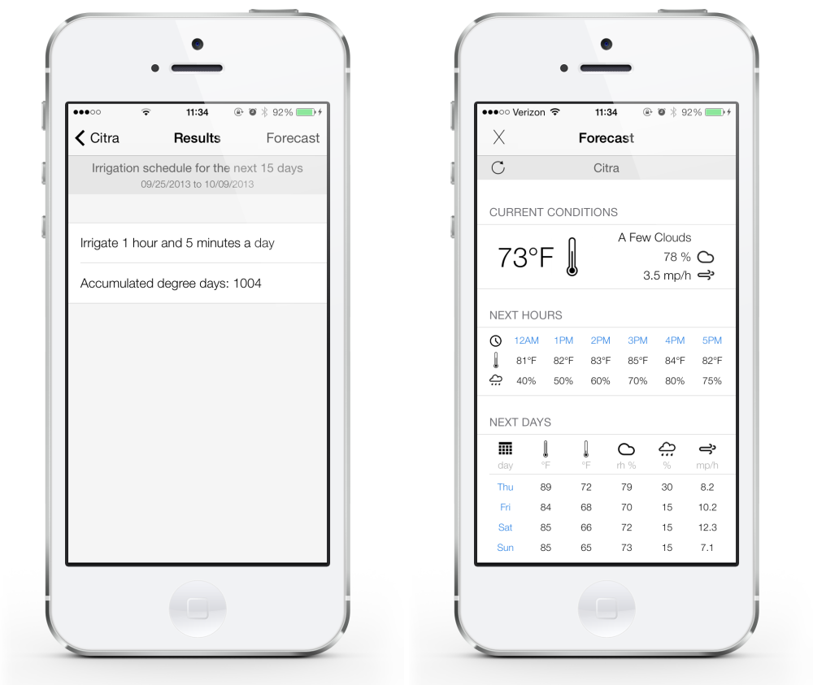

[4] http://smartirrigationapps.org/

//////////////////////////////////////////////////////////////////////

SoilNet [1] focuses on real time monitoring and estimation of soil water content. It belongs to Underground Wireless sensor networks. It is based on low cost Zigbee protocol. Within any wireless sensor network that is based on Zigbee Protocol, there are mainly three devices
- Zigbee Coordinator
- Zigbee Router
- Zigbee end device
It has used hybrid topology to provide transmission on wider range. In order to monitor the soil water content, the capacitance sensors have been used which are inexpensive and easy to operate.

The higher contents of coarse fragments may produce contact problems between sensor rods and soil matrix which may lead to underestimation of soil water content by sensors used (EC-5 and TE) due to their low measurement volume.

- “SoilNet - A Zigbee based soil moisture sensor network” Project Group, Institute Of Chemistry And Dynamics Of The Geosphere (ICG), Agrosphere Institute, ICG 4, Forschungszentrum Jülich GmbH, 52425 Jülich, http://www.fz-juelich.de/icg/icg-4/index.php.index=739

/////////////////////////////////////////////////////////////////////////

WaterBee [3] is a smart irrigation and water management system. It consists of a web driven wireless sensor network that is centrally monitored through a server. The smart sensors are distributed over the field that monitors the soil moisture content and environmental parameters that can affect the crop growth. The sensors send data to GPRS gateway through ZigBee wireless sensor network, and then goes to a web service which analyzes and models the data and provide farmers with expert advices. The results are sent to application on user’s smartphones or tablet.
The developers have observed that WaterBee has improved the plant health, crop yield and reduced the water usage. WaterBee is already in use at 14 reference sites in Estonia, Malta, Italy, Spain, Sweden, and the UK.
[3] www.waterbee.eu

/////////////////////
- The paper [7] described details about a low cost automated irrigation system that was saving up to 53% water by using a network of sensors which integrated with decision support software. The system is implemented by using soil moisture and temperature sensors. By using these sensors a network is deployed at the bottom of the plant root zones. The designed system contains a gateway which is microcontroller based and by using an algorithm it is used to control the water quantity. This gateway has three basic operations:
- Handle information from sensors.
- Trigger actuators.
- Push data to the Web.
The communication between the sensor nodes and the gateway is via a protocol named Zigbee. This gateway is a wireless information unit, containing GPRS module which transmits the data to the Web server through a mobile network.
For real time monitoring and programming of the acquired data from sensors the system is using a Software Application. This application enables the user to graphically view the data from each Wireless Sensor Unit via Internet.

- This paper [11] reports an application for effective irrigation. The researchers basically conduct a simulation work based on program code by using PowerTOSSIM simulation environment. The main work proposed by them based on the acoustic emission principle for crop water stress i.e. tension increases as soon as the soil becomes dry. A threshold value is set for the tension, whenever this value arrives, an acoustic signal is emitted. During the execution this signal is detected by the acoustic sensors so that they will indicate the dryness of plants. These sensors will be sensing, acquiring and processing the emission signals throughout the wireless sensors network area. The data from the nodes is routed to the sink node using multi-hop routing mechanism based and ultimately to the cluster node. This node is responsible for aggregating and sending data through internet to the remote control centre where the information is processed.

- This paper [#] proposes an irrigation management system that is based on mathematical calculations for Soil Water tension (SWT) and Depth of water to apply (DWA). The system is using wireless sensor technology for monitoring potato crops to improve their production by measuring the humidity of the potato field and SWT. These sensors also transforms the measured physical quantities into a signal and for processing it produce digital output for using RF data communication which is responsible for sending data to the base receiver. This station basically processes and analyzes the data. As a result processed information of SWT facilitates to find the general trends of soil moisture and in a log run it will modify the irrigation system to predict a schedule to achieve an increased crop yield.

- The proposed remote monitoring of agriculture consists of several sensors e.g. temperature sensor, soil moisture sensor, relative humidity sensor and a microcontroller. The microcontroller is multiplexing the data obtained and converting it from analog to digital form. A wireless XBee module is used to communicate the gathered data; this data is first interfaced to the computer by using UART which is a serial protocol then analyzed and monitor by using a FPGA element. To display the analyzed data the system uses a display unit.

[7]: Joaquín Gutiérrez, Juan Francisco Villa-Medina, Alejandra Nieto-Garibay, and Miguel Ángel Porta-Gándara” Automated Irrigation System Using a Wireless Sensor Network and GPRS Module” IEEE TRANSACTIONS ON INSTRUMENTATION AND MEASUREMENT, VOL. 63, NO. 1, JANUARY 2014.

[11]: XIONG Shu-ming, WANG Liang-min, QU Xiao-qian,ZHAN Yong-zhao “Application Research of WSN in Precise Agriculture Irrigation” Environmental Science and Information Application Technology, 2009. ESIAT 2009. International Conference on (Volume:2 )
[#] Kshitij shinghal, Dr. Arti noor, Dr. Neelam srivastava , Dr. Raghuvir singh, India, “Wireless sensor networks in agriculture: for potato farming”, International Journal of Engineering Science and Technology,Vol. 2(8), 2010, 3955-3963.

[] Swarup S. Mathurkar, D. S. Chaudhar, “A Review on Smart Sensors Based Monitoring
System for Agriculture”, International Journal of Innovative Technology and Exploring Engineering (IJITEE) ISSN: 2278-3075, Volume-2, Issue-4, March, 2013

[21]:J. M. Blonquist, Jr., S. B. Jones, and D. A. Robinson, “Precise irrigation scheduling for turfgrass using a subsurface electromagnetic soil moisture sensor,” Agricult. Water Manag., vol. 84, nos. 1–2, pp. 153–165,Jul. 2006

/////////////////////////////////////
A literature review is necessary before devising a project plan because it a key milestone which situates our research focuses. It is basically an important showcase of your talents of: understanding, interpretation, clarity of thought and development of arguments. It is valuable in light of the knowledge explosion and the consequent impossibility of reading everything.

By conducting and reporting this process, we will be able to clarify our own thoughts about the project. It can also be helpful to establish a framework within which to present and analyze the findings. Basically we have used the literature review to address a rationale for the need of our own study. We used it at the beginning of the study to explain what is known about our Smart Irrigation and provides a clear picture of our project that we will be are planning. In addition, the literature review is helpful to design our study and identify promising data collection practices or instruments that can be used in our project.
- The paper [1] has described details about a low cost automated irrigation system that is saving up to 53% water by using a network of sensors which are integrated with decision support software. The system is implemented by using soil moisture and temperature sensors. By using these sensors a network is deployed at the bottom of the plant root zones. A gateway is also used which is microcontroller based and by using an algorithm it is controlling the water quantity. This gateway has three basic operations:
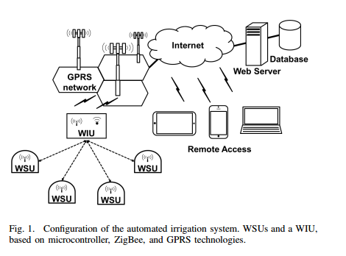
- Handle information from sensors.
- Trigger actuators.
- Push data to the Web.

The communication between the sensor nodes and the gateway is via a protocol named Zigbee. This gateway is a wireless information unit, containing GPRS module which transmits the data to the Web server through a mobile network.
For real time monitoring and programming of the acquired data from sensors the system is using a Software Application. This application enables the user to graphically view the data from each Wireless Sensor Unit via Internet.

- This paper [2] reports an application for effective irrigation. The researchers basically conduct a simulation work based on program code by using PowerTOSSIM simulation environment. The main work proposed by them is based on the acoustic emission principle for crop water stress i.e. tension increases as soon as the soil becomes dry. A threshold value is set for the tension, whenever this value arrives, an acoustic signal is emitted. During the execution, this signal is detected by the acoustic sensors so that they will indicate the dryness of plants. These sensors are basically sensing, acquiring and processing the emission signals throughout the wireless sensors network area. The data from the nodes is routed to the sink node using multi-hop routing mechanism and ultimately to the cluster node. This node is responsible for aggregating and sending data through internet to the remote control centre where the information is processed.
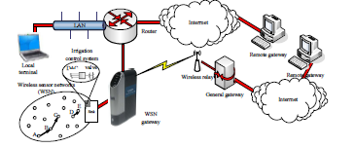

- This paper [3] proposes an irrigation management system that is based on mathematical calculations for Soil Water tension (SWT) and Depth of water to apply (DWA). The system is using wireless sensor technology for monitoring potato crops to improve their production by measuring the humidity of the potato field and SWT. These sensors also transforms the measured physical quantities into a signal and for processing it, a digital output is produce for using RF data communication which is responsible for sending data to the base receiver. This station (i.e. base receiver) basically processes and analyzes the data. As a result the processed information of SWT facilitates to find the general trends of soil moisture and in a log run it will modify the irrigation system to predict a schedule to achieve an increased crop yield.

- The paper [4] describes a remote monitoring of agriculture consists of several sensors e.g. temperature sensor, soil moisture sensor, relative humidity sensor and a microcontroller. The microcontroller is multiplexing the data obtained and converting it from analog to digital form. A wireless XBee module is used to communicate the gathered data; this data is first interfaced to the computer by using UART which is a serial protocol then analyzed and monitor by using a FPGA element. To display the analyzed data the system uses a display unit.

- Certain unnecessary events may occur in irrigation process, to avoid this kind of events an automatic irrigation system is proposed [5], which is using a timer that is triggered when a threshold is reached. Some soil moisture sensors are also used to maintain soil moisture at prime levels; it will ultimately maximize the efficiency of water usage. This system is proposed for the farmers in the United Arab Emirates because of low water holding capacity in the soil of this country therefore plants may die in case of water shortage. The system consists of soil moisture sensors to detect the soil’s volumetric water content; depends on the permittivity of the soil. The gathered data will facilitate the farmer to schedule the process of irrigation.

- A proposed system in research paper [6] mainly consists of two modules.
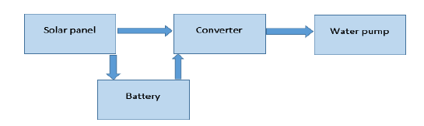
- Solar pumping module

Block diagram of Solar pumping module
- Automatic irrigation module
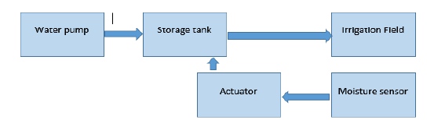

Block diagram of Automatic irrigation module

Sensor is placed in the field where it converts moisture content into equivalent voltage. The reference voltage can be set by the farmer depending on the moisture content required by different crops. The difference between these two voltages is directly proportional to the amount of water needed for irrigation. The outlet valve of the tank is connected to a stepper motor which acts as an actuator control for the valve. When the moisture content of the soil is equal to the reference value set by the farmer, the valve is closed slowly, power to the driver circuit dies off and control goes in sleeping mode thus consuming less power. When the moisture level is again low, control comes out of sleep mode and flow of water is regulated. This mechanism controls the opening and closing of the valve depending on the moisture level of soil. The moisture content of the soil is found by using the soil moisture sensor such as VG400 which produces an equivalent output voltage proportional to the conductivity between the two probes. In that way the solar powered smart irrigation system conserves electricity, water and saves crops from over flooding. Furthermore, it requires minimal attention reducing human intervention for the farmers.
- The application [7] deals with combating with a fungal disease in potatoes Phytophtora, which can attack the potato field from various sources. The development of the disease depends on the climatic condition such as humidity, temperature etc. A total of 150 sensor boards are used namely TNodes, each TNode consists of sensors that measure temperature and humidity. In order to improve connectivity some sensors behaves as communication relays. Furthermore some weather stations are set up in the field to monitor the luminosity, air pressure, precipitation, wind strength and direction. The TNOdes are recording temperature and humidity every minute but in order to conserve energy the data is reported only once in ten minutes. To save more energy, rather than transmitting complete files over wireless link, the data is transmitted in compressed form using delta encoding. TinyOS is used as operating system for nodes and hence data is sent on multihop routing protocol MintRoute which is available within the TinyOS.
The collected data by all the TNOdes are gathered at a field gateway and then transferred to a PC for data logging through Wi-Fi. The data is then uploaded to a server and further distributed to different servers in XML format.

- Smart irrigation application [8] uses the smartphone technology to manage urban and agricultural irrigation. The app mainly focuses on the development of four models to be used in smartphones apps using real time and forecasting aspects. The four models are citrus, urban, strawberry and cotton. These models are performing water balance calculations. Meteorological data (daily mean temperature, wind speed, relative humidity, and solar radiation) for these calculations obtained from FAWN (Florida Automated Weather Network) and GAEMN (Georgia Automated Environmental Monitoring Network). In addition information from the National Weather Service is used to provide forecasting information for improving irrigation. The app provides the access information only to the location that are with the weather stations FAWN or GAEMN.

- SoilNet [9] focuses on real time monitoring and estimation of soil water content. It belongs to Underground Wireless sensor networks. It is based on low cost Zigbee protocol. Within any wireless sensor network that is based on Zigbee Protocol, there are mainly three devices
- Zigbee Coordinator
- Zigbee Router
- Zigbee end device

It has used hybrid topology to provide transmission on wider range. In order to monitor the soil water content, the capacitance sensors have been used which are inexpensive and easy to operate.The higher contents of coarse fragments may produce contact problems between sensor rods and soil matrix which may lead to underestimation of soil water content by sensors used (EC-5 and TE) due to their low measurement volume.

- WaterBee [10] is a smart irrigation and water management system. It consists of a web driven wireless sensor network that is centrally monitored through a server. The smart sensors are distributed over the field that monitors the soil moisture content and environmental parameters that can affect the crop growth. The sensors send data to GPRS gateway through ZigBee wireless sensor network, and then goes to a web service which analyzes and models the data and provide farmers with expert advices. The results are sent to application on user’s smartphones or tablet.
The developers have observed that WaterBee has improved the plant health, crop yield and reduced the water usage. WaterBee is already in use at 14 reference sites in Estonia, Malta, Italy, Spain, Sweden, and the UK.

- In paper [11] the proposed work after focusing on open canal irrigation networks which are common around the world. Mostly these kind of systems are energy efficient but with several limitations and causes a large water loss. Therefore, the use of multi-agent framework modeling of Management Systems of Gravity Irrigation Networks (MSGIN) is proposed, operating with a water rotation. The process of this approach is conducted in several stages:

FIRST STAGE relates data gathering for the decisions making during the negotiation process.
SECOND STAGE concerns analysis which relates to the functional specification requirements.
THIRD STAGE concerns the system structuring i.e. dividing the system into sub systems based on the macros functions, the structuring of each sub system in agents and the definition of the inter-systems interactions and the inter-agents interactions.
FOURTH STAGE concerns the implementation and the development of the agents using the specific JADE platform.
In Multi-Agent System, the JADE Agents communicate through the exchange of messages represented in FIPA-ACL. Each JADE agent has a kind of mailbox which contains the messages sent to him by the other agents. The roles of the agents, composing the system, are already defined. In that way this system provides flexibility allowing to dynamically adapting the agent behaviors that will enable the system to deal with dynamic problems ultimately ensures a better adaptability of the system to its environment.
- An automatic irrigation system [12] based on wireless sensor network is designed using ZigBee Technology that features low power, low cost and easy installation and use. The system consists of a microcontroller, wireless sensor node, a weather station and several wireless actuators. The wireless sensor node collects temperature and humidity data of particular area whereas the weather station monitors the climatic condition. All the data collected is transmitted to controller wirelessly. The actuator nodes that are present in field are used to control the electromagnetic valves and pumps, and are wirelessly controlled by the controller .The controller act as a ZigBee coordinator that builds and maintain WSN and also manage the irrigation system. The project used ZigBee star network topology due to low power consumption. When the coordinator node is started, it creates a Personal Area Network (PAN) and allows the actuator nodes to join the network. The coordinator then assigns network addresses and collects the sensor data for processing on the basis of which intelligent decisions are made. The paper showed the details of hardware design and software algorithm for irrigation management.

B2. Current State of the Art:
(Please describe the current state of the art specific to this research topic.)
<type here>

- Challenges:
(Please describe the challenges, specific to this research topic, currently being faced internationally.)
<type here>
- Motivation and Need:
(Please describe the motivation and need for this work.)
The new technological advancements have encouraged researchers to formulate new ideas and propose methods for solving present problems faced by their country’s economy. A huge portion of Pakistan’s economy is dependent on the agricultural sector. Nowadays the agriculture sector is facing numerous problems which results in a reduced production of quality crops and wastage of water resources. Each year the growth rate in agriculture sector is declining due to floods, unbalanced watering and no proper monitoring. In 1947, 53% of the total GDP of Pakistan was based on agriculture but unfortunately today it contributes only 23%. The reason for such a rapid downfall is that the crops and fields are not monitored properly, there is no correct way of finding out that whether the crop is ready to harvest or not, the pesticides being used are effective or not, what amount of water is required by crop; the farmer solely uses his experience to look after his fields. Over amount of water is flown into the fields which not only affects the health of crop but also results in the wastage of water. Currently the archaic method of irrigation which is in practice all over the country wastes almost 50% - 60% of Pakistan’s water resources.
The need for new system shall in-cooperate wireless communication for reliable data transmission to the cloud as data is never lost and is 100% secure. The cloud based customized user access shall provide individual users with their customized field data and analytical results.

3. Objectives of the Project
- Specific Objectives Being Addressed by the Project:
(Please describe the measurable objectives of the project and define the expected results. Use results-oriented wording with verbs such as ‘to develop..’, ‘to implement..’, ‘to research..’, ‘to determine..‘, ‘to identify..’ The objectives should not be statements and should not include explanations and benefits. The objective should actually specify in simple words what the project team intends to achieve (something concrete and measurable/ deliverable). Fill only those objectives that are applicable to the proposed project.)
The major objective of the project is to develop a wide variety of tools which will enable farmers to better utilize their water resources. The project aims to develop smart wireless sensing systems equipped with important parameters measuring sensors and smartphone apps for scheduling irrigation.
A1. Research Objectives: (if any)
- To obtain a low cost optimal design for smart sensing units providing maximum efficiency in both power consumption and accurate computation.
- To explore high processing capabilities of the microcontrollers for scheduling and multitasking purposes.
- To contribute research based knowledge about climatic effects on the agriculture field.
- To discover different methods of preserving water by both means of smart sensing and utilizing water only when needed.
- To find a way that only stores critical data on cloud and perform computation to estimate different parameters around the field where sensing nodes are not deployed which not only reduces the cost but also open doors to new findings.

A2. Academic Objectives: (if any)
- To promote ongoing studies on present state of agricultural systems at academic level.
- To demonstrate the effectiveness of a smart irrigation system that meets the real needs based on measurements of climate parameters through data obtained from sensors.
- To promote knowledge about new technological advancements in wireless communication, sensors and microcontrollers.
- To conduct different workshops and seminars on sensor node assembly and wireless communication protocols.
- To create awareness about the importance of preserving water resources and encourage discovering quality crop production to meet the need of the nation.
- To improve the ranking of our academia in international research community by producing quality based research publications from this project.
- To flourish the quality of Research & Development culture in Academia.
- To create opportunity for students to conduct applied research in contrast to theoretical research usually part of our academia.
- To enhance the academic activities and participation of students by successful implementation of this project.
- To open a new door for academia to conduct similar research projects in future.

A3. Industrial Objectives: (if any)
- To present the successful designed prototype to different vendors in Pakistan so that the designed system will become the part of most of the agricultural areas in Pakistan.
- To encourage industries to get involved with the agriculture sector for quality production and invest their resources for mutual benefits
To promote cloud managing industries to create customized private clouds for individual field owners so as to eliminate need of separate servers.
A4. Human Resource Development Objectives: (if any)
- To provide opportunities of employment to the people associated with hardware designing.
- To bring more opportunities to the people engaged in hardware and software development.
- To reduce the burden on local farmers and encouraging them to give time to new crops harvesting.
A5. Other Objectives: (if any)
- To beautify the field location by proper monitoring and watering of crops

4. Research Approach
- Development / Research Methodology:
(Please describe the technical details and justification of your development and research plan. Identify specialized equipment, facilities and infrastructure which are required for the project and their utilization plan. The block diagrams, system flow charts, high level algorithm details etc. have to be provided in this section.)
The aim of the project is to make intelligent and automated irrigation system which involves remote monitoring, remote control, communication, asset tracking, remote diagnosis and cloud services and information transfer. All these functions are based upon wireless sensing network, which is the bone of project.

Development of Wireless Sensing Network
WSN introduces new capabilities for measurement and control applications. The power of wireless sensor networks lies in the ability to deploy large numbers of tiny nodes that assemble and configure themselves. It consists of different wireless nodes and these nodes are spread in a particular environment to monitor certain parameters (i.e. collect and route data). The concept of WSN can be defined by the Equation (1):
Sense + Process + radio frequency (RF) = WSN Application ---------------------Eq. (1)
The Wireless Sensor Network is linked by transceivers. The transceivers make the nodes wireless in order to transfer sensor’s data and other status parameters to a remote site/main server wirelessly. The main server node has a LAN connection through which it sends the entire gathered information from the field to the Web and mobile Application using internet.

In WSN, various sensors are interfaced with each node. They require battery to sustain at a remote location. The key features of WSN are low power and low cost but less memory and processing capability. ZigBee technology supports these features as compare to other wireless technologies like Bluetooth (802151 standard) and Wi-Fi (80111b standard). The transmission range of ZigBee is 1000-1500m. It can support 65,000 nodes in a network while other technologies cannot support such a big number of nodes. In short, ZigBee is more scalable, flexible, reliable, and less complexes as compare to other wireless protocols. The only limitation while using ZigBee is its low data rates (250 kbps). In WSN the data transmissions do not require high bandwidth. Therefore, ZigBee is the best suited technology to be used for this application.
The sub-modules of this part of project are Wireless Sensor Units (WSUs), Wireless Coordinator Node (WCN), Wireless Server Module (WSM) which are define below:

Wireless Sensor Unit (WSU)
Wireless Sensor Unit is one of the most salient components of the deployed system. Each unit incorporates power source, microcontroller, sensors and RF transceiver for this application. A variety of sensors have been used. This includes water flow sensors, humidity sensors, Hygrometers (soil moisture sensors), rain detector, light intensity sensor, external/internal temperature sensors, switches, carbon-di-oxide (CO2) sensor, and camera. All these sensors will provide the data about the field. This information is used to take further agricultural intelligent decisions. All the sensors are interfaced with the high performance, low power AVR series microcontrollers ATmega8/ATmega328 The pins of the controller are interfaced with sensors and Xbee, through the serial port. A separate board for providing the sensors power has been created. A 13V Lithium battery is used to provide the voltage. It is regulated by a 78H05K regulator to maintain the voltage at 5V for microcontroller which then further lowers the voltage to 33V for Xbee. Moisture sensors provide analog values to be read by Arduino. They range from 0 to 1023, from wet to dry. The microcontroller is programmed to receive data parameters from these sensors and organized the entire data in the form of a packet. The data is then transmitted serially through ZigBee transceiver. Xbee series 1 has used in sensor node. Encryption and checksum/CRC techniques are also introduced in the ZigBee transceiver to make data secure and error free.

Wireless Coordinator Node (WCN)
The WCN of a typical WSN works as a sink node. It is very similar to the sensor node and operates as a master microcontroller. It has several crucial tasks to perform. The additional features in it are filtering data, alarm generation system and communication with wireless server module. The architecture of WCN consists of power source, sensors, alarm system, Processing Unit (AVR microcontroller) and wireless communication module (XBee Pro series 2). The sensors provide data from the field which goes to ADC block for data sampling and quantization further it is processed in processing unit and stores in memory for short term history logging. If there is any disturbance in hardware it generates an alarm. All the gathered data will then be sent to the server module through wireless communication.

Wireless Server Module (WSM)
Fig. l l 1 Architectural Layout of Web Application
This module basically acts as a bridge between the WSN and the remote site. This module consists of power source, XBee transceiver, Raspberry Pi (R-Pi), SD card and LAN connection. The UART (universal asynchronous receiver transmitter) pins of Raspberry Pi (R-Pi) single board computer are considered as a powerful feature to connect it with the external world. These pins are used to interface XBee Series 1 transceiver with R-pi. Through this transceiver R-Pi is wirelessly receiving information from the WCN. The SD card provides storage to Operating System and files. It is used to maintain history logging of the fields’ parameters. R-Pi is configured to enable LAN connection. Socket programming has been implemented using python on R pi to send the received packets to the software application. TCP communication protocol has been used as a GPRS transmission plane. It enables two hosts to establish a connection and exchange streams of data. It guarantees delivery of data and in order transmission. Here, it is required that information from the field should not be lost because certain processing parameters on the remote Site rely on the nature of collected data from the field.

Remote monitoring
The monitoring nodes of wireless sensing network are used for this purpose. its main functionalities are define below:

- Take data from gauges and sensors (water flow sensors, humidity sensors, Hygrometers (soil moisture sensors), rain detector, light intensity sensor, external/internal temperature sensors, switches, carbon-di-oxide (CO2) sensor, and camera)
- Status of irrigation valves
- Status of pumping equipment
- Monitoring of greenhouses and storage facilities
- Audible or other alarms
- Live video of operations

Block diagram.

Sensors

sensors will be interfaced with the monitoring wireless nodes are following:
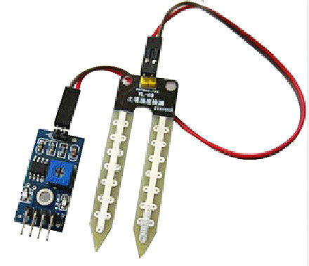
- Soil moisture - The Soil Moisture Sensor is used to measure the volumetric water present in soil. This is typically used in many of the branches for e.g. soil science, agricultural science, environmental science, cultivation, botany, and biology.

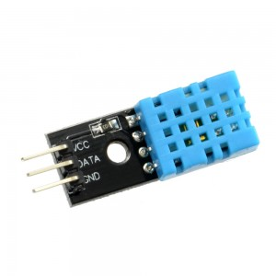
- Humidity - Humidity is defined as the amount of water in air. This content of water in air as vapor affects human life style and many developing processes in industries. The presence of water vapor also impacts various processes. Therefore, humidity sensing is essential typically in the systems of industrial manufacture and comfy for humans.
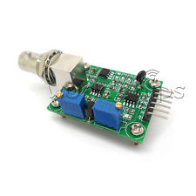
- PH - The pH Sensor is typically for automated data collection besides traditional pH readings. Characteristically it includes activity like:
- Monitoring pH change during chemical reactions.
- Investigations of acid rain and buffering.
- Analysis of water quality.

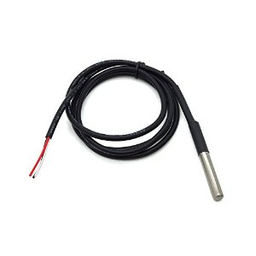
- Temperature - DS18B20 accurately measure temperatures in all of practical environments with having 1-Wire interface. It provides 9 to 12-bit temperature readings over a 1-Wire interface, so that only one wire and ground needs to be connected from a central microprocessor, it usually includes:
- 3.0-5.5V input voltage
- Waterproof
- -55°C to+125°C temperature range
- ±0.5°C accuracy from -10°C to +85°C
- 1 Wire interface
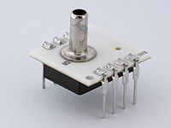
- Air /atmospheric Pressure - The pressure sensor measures pressure, usually of gases or liquids. Pressure is a force needed to stop a fluid from expanding, and is typically defined in terms of force per unit area.

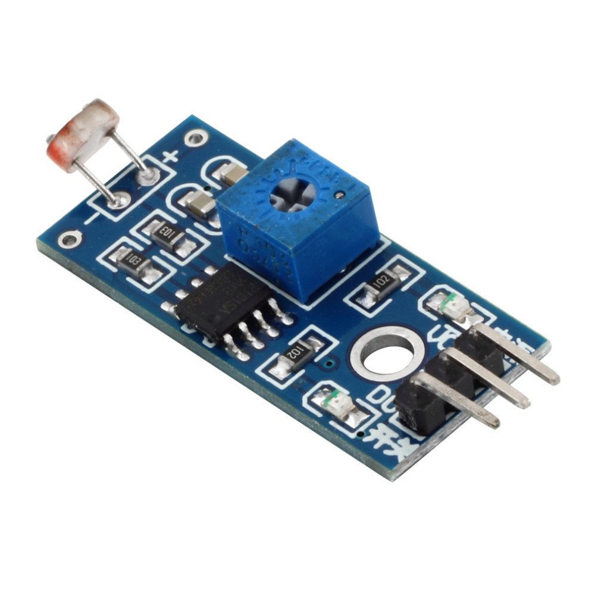
- Light intensity - The light sensor is a device for computing the intensity of light. It is from one of the inexpensive detectors that can be used, usually known as Photo resistor.
Photo resistors, also called light detecting resistors (LDR) are made from cadmium sulfide (CdS) cells that are sensitive to visible and near infrared light. It then amplifies the readings and convert into precise analog and digital values.

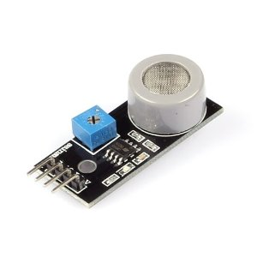
- Co2 detector – The carbon dioxide sensor is a gadget for the measurement of CO2 gas. The usual principles for CO2 sensors are infrared gas sensors (NDIR) and chemical gas sensors. Evaluating carbon dioxide is significant in monitoring air quality in agricultural processes.
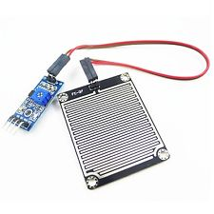
- Rain detector – The rain sensor is triggered by event of rainfall. One of the main applications out of many for rain sensors are:
- Water conservation device connected to an automatic irrigation system that causes the system to shut down in the incident of rainfall.

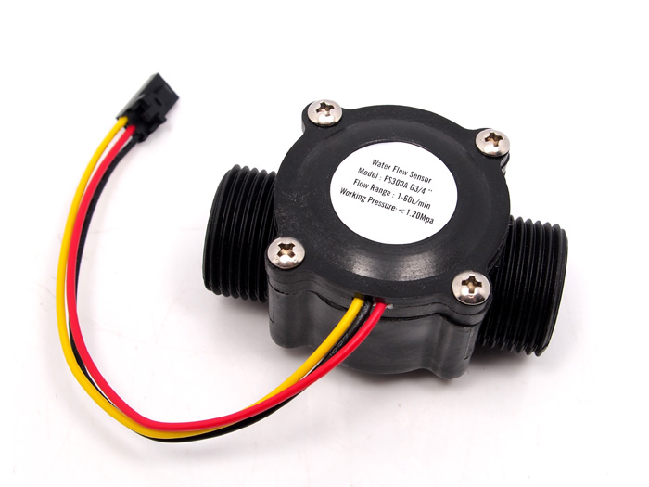
- Water flow - Water flow sensor comprises of a plastic valve body, a rotor, and a hall-effect sensor. When water flows through the rotor, rotor rolls and changes its speed with different rate of flow. The hall-effect sensor outputs the corresponding pulse signal.
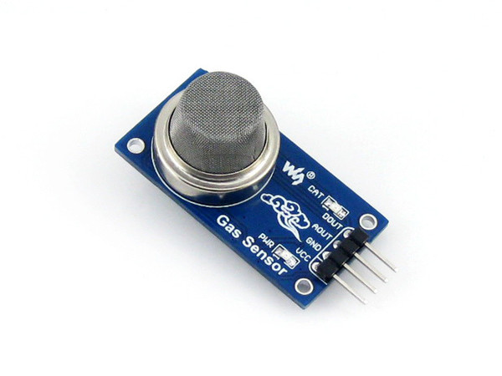
- Smoke detector - Smoke detector is a device that senses smoke. Commercial safety devices issue a signal to a fire alarm control panel as part of a fire alarm system.

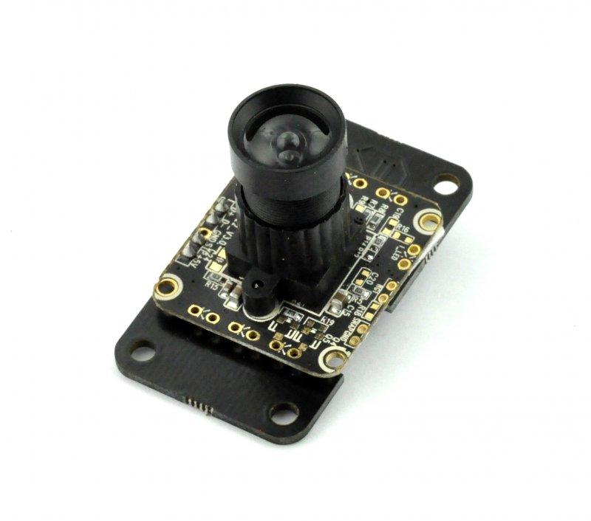
- Camera - USB enabled Camera Module can stream images as large as 320x240 with up to 20fps on smaller images.

All these sensors are attached with sensor unit that gives data to the computing unit that process this data and convert it into a user understanding form. After processing and data conversion it makes a data packet which encapsulates sensor data, sensor ID, time stamp, monitoring node ID, error checking fields. The transceiver send this data to the next hop or destination.it send data only after a particular time stamp or if it is requested by coordinator or server nodes. While there is no transmission the node will be in the sleep mode in order to save power. The power is provided by power unit which involves power harvesting and voltage regulation and status of battery.

Remote Control
`
The control module is responsible for all automation specific tasks. Its operations and activities are all depend upon remote monitoring module ,users commands and if particular scheduling is initiated by user

This application is dedicated to the agricultural field of Pakistan. Through this application, an efficient and sustainable use of water is possible. It also saves power by using solar panels. It contains an Easy-to-Use-Design, developed in consultation with users to deliver an excellent navigation and easy access interface.

The application has adopted a set of guiding principle from the agricultural sector of Pakistan and then establishes a strategic plan. This strategic plan is helpful for the farmer

It provides up-to-date condition and alerts of the field to its respective farmer i.e. measurements of soil moisture, temperature, pH value, humidity etc. of the field. It also notifies the farmer about any hardware related issue and the state of the water pump, timely.
Use of Smart Irrigation in different areas of Pakistan to get numerous benefits is itself a valuable concept. The focus of this application is to get information from the Wireless Sensor Network (WSN) that employs various sensors to acquire different environmental parameters. It performs processing and takes decision if there is a need of watering the crops.

The pumps are switched ON/OFF as and when necessary. It also defines the proper quantity of water to be provided. The history log is uploaded onto the server to take intelligent decisions, where it will be shared through the handheld sets for monitoring. The user will be updated about the water level in farms and can manually control the irrigation system too.

Through this Smart application the combination of emerging technologies including ubiquitous computing with sensor network can be applied on agriculture domain to make the agriculture smarter.
The major goals of this application are:

- Facilitate the development of infrastructure schemes to reduce the risks of water shortages in the agriculture sector.
- Development and implementation of an intelligent agriculture development to strengthen the crops productivity.
- Development and enhancement of farmer decision support tools.
- Enable the farmers to balance nutrient management, improve productivity and save water.
- Introduces a sustainable approach to food production.
Terms Of services
Smart irrigation For Agricultural Area of Pakistan (SIAAP) welcomes you to visit and use our website to find agricultural information and access services. SIAAP is committed to respecting data privacy and protecting the field information. We have taken appropriate measures to protect the privacy of any field information that is provided to us or that we collect when the admin visits our website.
This Application will be collecting data either from the base station or provided by the admin at the time of registering any particular farm. The collection will be limited to that which is absolutely necessary for further processing and decision support.
Our servers do automatically collect limited amounts of standard for agriculture monitoring when the admin visits our website. The standard types of information collected include:
- Soil Moisture.
- Temperature.
- Humidity.
This type of information is used for operational and performance trends, and for ways to improve the crop productivity, save power and water i.e. to provide quality of services.
Another hurdle concerns how to deal with areas where soil salinity is high and water quality is low. Such areas have so far been excluded from the research, and outcomes are likely to be less good, but farmers in these areas need support.

Smart Irrigation for Agricultural Area of Pakistan (SIAAP) is committed to ensuring the integrity and confidentiality of the field information provided to us through our website. We use security software and procedures to protect information from unauthorized access or disclosure.
Challenges in Smart Irrigation

The main challenge is to develop interest in farmers to adopt smart irrigation. It involves awareness-raising by disseminating the results of research on smart irrigation, and providing education and practical support in cooperation with the farmers and irrigation. sector.

Once the farmers agree to adopt the smart irrigation system, they will need to be provided with specific information on the daily irrigation requirements of their crops. This will be achieved through the development of a mobile application which will make the information available to the farmers at any time.

After a thorough literature review we have finalized an approach to implement smart irrigation system. Our proposed system will be using Wireless Sensor Networks (WSNs)
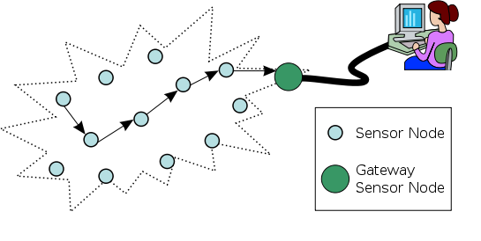
The WSNs mainly consists of two main parts:
WSUs
WIU

- Wireless Sensor Units (WSUs)
- Wireless Information Unit (WIU)
Sink Node

A WSU will be comprised of sensors, a microcontroller and Radio Frequency (RF) transceiver or ZigBee. Several WSUs can be deployed in-field to configure a distributed sensor network for the implementation of smart agriculture system.
We have decided to use soil moisture, humidity and temperature sensor in the field because these sensors have the capability to observe soil moisture, temperature and humidity frequently and over large regions. In that way this could significantly enhance our ability to monitor, analyze and improve crop conditions over a period of time.
The data from each WSU will be received and analyzed in the WIU. The WIU consists of a master microcontroller, an RF or ZigBee modem (to receive data from the WIUs).
For the purpose of power harvesting we will be using solar panels to power up the WSN, this panel can also switch the sensors in sleep mode when there is no need to sense data. This kind of WSN approach in smart agriculture will improve performance, increase the production efficiency with decreased cost, consumes low-power and will have the ability to collect distributed data. The sink node is the main microcontroller. This is basically an information unit that will be responsible to send the gathered data to the Web server through 3G, GPRS or GSM module (to communicate with the Web Server).

The Smart Irrigation System will be using a Software Application (later on it can be extend by enforcing artificial intelligence). This Application will improve the level of agriculture information process and enhance the intelligent management and decision of agricultural production. The Agriculture Management Information System (AMIS) will mainly include data analysis and processing. We can use different data analyzing tools like databases , data mining to summarize the data collected from sensors into useful information that can increase crop productivity and hence revenue.
This application will process the data and provide decision support to the system and a Mobile Application will be developed to provide farmers an easier access to their farms and field information through their mobile devices. Having access to timely and accurate data can help in making better decisions that can save precious agricultural resources, time and money. Features of the proposed Mobile Application are: Interactive Google Maps displaying location of field’s nodes, Timely access to the field’s data using web services or messaging facility, Historical record of sensor’s data and notifications
- GPS tracking
- Field navigation

[1]: Joaquín Gutiérrez, Juan Francisco Villa-Medina, Alejandra Nieto-Garibay, and Miguel Ángel Porta-Gándara” Automated Irrigation System Using a Wireless Sensor Network and GPRS Module” IEEE TRANSACTIONS ON INSTRUMENTATION AND MEASUREMENT, VOL. 63, NO. 1, JANUARY 2014.

[2]: XIONG Shu-ming, WANG Liang-min, QU Xiao-qian,ZHAN Yong-zhao “Application Research of WSN in Precise Agriculture Irrigation” Environmental Science and Information Application Technology, 2009. ESIAT 2009. International Conference on (Volume:2 )
[3] Kshitij shinghal, Dr. Arti noor, Dr. Neelam srivastava , Dr. Raghuvir singh, India, “Wireless sensor networks in agriculture: for potato farming”, International Journal of Engineering Science and Technology,Vol. 2(8), 2010, 3955-3963.

[4] Swarup S. Mathurkar, D. S. Chaudhar, “A Review on Smart Sensors Based Monitoring
System for Agriculture”, International Journal of Innovative Technology and Exploring Engineering (IJITEE) ISSN: 2278-3075, Volume-2, Issue-4, March, 2013.

[5] Case study — United Arab Emirates, “Smart irrigation for sustainable agriculture in Abu Dhabi”
[6] S. Harishankar1, R. Sathish Kumar2, Sudharsan K.P, U. Vignesh and T.Viveknath, “
Solar Powered Smart Irrigation System”, Department of Electrical and Electronics Engineering, Amrita University Ettimadai, Coimbatore, India

[7] Baggio, Aline: Wireless sensor networks in precision agriculture. In: REALWSN 2005 proceedings, 2005
[8] http://smartirrigationapps.org/
[9] “SoilNet - A Zigbee based soil moisture sensor network” Project Group, Institute Of Chemistry And Dynamics Of The Geosphere (ICG), Agrosphere Institute, ICG 4, Forschungszentrum Jülich GmbH, 52425 Jülich, http://www.fz-juelich.de/icg/icg-4/index.php.index=739

[10] www.waterbee.eu
[11] Salwa Belaqziz, Abdelaziz El fazziki, Mohammed El adnani ; Michel Le page,“An agent-based modeling approach for decision making in gravity irrigation systems”, Department of Computer Science Laboratoire d’Ingénierie des Systèmes Informatiques, LISI Marrakech, Morocco ; Institut de Recherche pour le Développement - Centre d'Etudes Spatiales de la Biosphère, IRD-CESBIO Toulouse, France
[12] Yiming Zhou, Xianglong Yang, Liren Wang, Yibin Ying, A wireless design of low-cost irrigation system using ZigBee technology

- Project Team:
(Please attach the curriculum vitae (CV) of PI and CPI(s). Also attach the CVs of key research/ development personnel if available. Please follow the format included in Annexure A.
The numbers in the table below must tally with the HR Cost sheet in the Budget file.)
Title / Position |  |  |  |  |  |  | Number
Team Leads
Researchers / Developers
Researcher / Development Assistants
Support Staff
Contract Staff (please specify)
Others (please specify)
Add more rows if required
- Team Structure:
(Please define the team structure (organogram) and role/key responsibilities of each member. If in collaboration with another partner, the division of manpower at various locations of partners be provided.)
<paste organogram here>

Title/Position  (of each member) | Role/Key Responsibilities | Minimum Qualification Required | Expertise / Background Required | Minimum Experience Required (years)

- Project Activities:
(Please list and describe the main project activities, including those associated with the transfer of the research results to customers/beneficiaries. The timing and duration of research activities are to be shown in the Gantt chart in Section 8.)
<type here>

- Key Milestones and Deliverables:
(Please list and describe the principal milestones and associated deliverables of the project. A key milestone is reached when a significant phase in the project is concluded, e.g. selection and simulation of algorithms, completion of architectural design and design documents, commissioning of equipment, completion of test, etc.) The timing of milestones is also to be shown in the Gantt chart in Section 8. Quarterly deliverables are preferred.
The information given in this table will be the basis of monitoring and release of funds by the National ICT R&D Fund.
No. |  | Elapsed time from start (in months) of the project |  | Milestone |  | Deliverables
(Please add more rows if required.)

5. Benefits of the Project
- Direct Customers / Beneficiaries of the Project:
(Please identify clearly the potential customers/beneficiaries of the research results and provide details of their relevance, e.g. size, economic contribution, etc.)
<type here>

- Outputs Expected from the Project:
<type here>

- Organizational / HRD Outcomes Expected:
<type here>

- Technology Transfer / Diffusion Approach:
(Please describe how the outputs of the project will be transferred to the direct beneficiaries/customers. Please also state if the project outputs are sustainable, i.e. if they can be utilized without further external assistance.)
<type here>

6. Risk Analysis
- Risks of the Project:
(Please describe the factors that may cause delays in, or prevent implementation of, the project as proposed above; estimate the degree of risk.)
(Please mark ☑ where applicable) | Low | Medium | High
- Technical risk | ❑ | ❑ | ❑
- Timing risk | ❑ | ❑ | ❑
- Budget risk | ❑ | ❑ | ❑

A1. Comments:
<type here>

7. Contractual Matters
- Contractual Obligations under this Project:
(Please indicate any contractual obligations with third parties that will be entered into for this project.)
<type here>

- Ownership of Intellectual Property Rights:
All newly developed intellectual property rights arising out of or capable of legal recognition with respect to the projects implemented by the National ICT R&D Fund (The “Company”) shall vest with the Company.

The Company may assign or license its rights in the said intellectual property to any person on such terms as it may deem appropriate.

- Competent Authority of the Principal Investigator’s Organization:
(Documentary proof of the Competent Authority (VC/Rector/CEO..) as being the authorized signatory for the PIO is mandatory for approval of the Project Proposal. Please attach copy of the proof.)
Name:
Designation:
Email:
Date: |  |  | Signature  & stamp:

8. Project Schedule / Milestone Chart

(Project schedule using MS-Project (or similar tools) with all tasks, deliverables, milestones, cost estimates, payment schedules clearly indicated are preferred.)

Example:
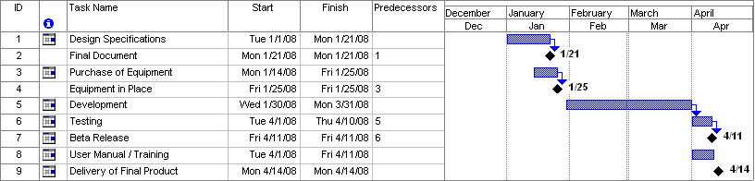
SPECIMEN

9. Proposed Budget

Please use the embedded Excel Worksheet for providing budget details.

Double click the icon to open the worksheet.



Annexure A – Curriculum Vitae

Please provide relevant information and also attach CVs of key research / development personnel (if available) and PI, CPI.
- Professional Information
- Name :
- Title or Position Held :
- Experience : (yrs)
- Email Address :
- Research Papers in Relevant Area
<type here>

- Courses Taught in Relevant Area
<type here>

- Thesis / Projects Supervised in Relevant Area
<type here>

- Grants Received in Relevant Area
<type here>

- Industrial Work Done in Relevant Area
<type here>

Please provide relevant information and also attach CVs of key research / development personnel (if available) and PI, CPI.
- Professional Information
- Name :
- Title or Position Held :
- Experience : (yrs)
- Email Address :
- Research Papers in Relevant Area
<type here>

- Courses Taught in Relevant Area
<type here>

- Thesis / Projects Supervised in Relevant Area
<type here>

- Grants Received in Relevant Area
<type here>

- Industrial Work Done in Relevant Area
<type here>

Bibliography

<type here>

