

Proposal / Application
for
ICT-Related Development
and Research Grant

Smart Irrigation for Agricultural Area of Pakistan

Dr. Muhammad Khurram

Read carefully before filling the form.

- Please do not alter the layout of the application form. Information must be filled in the spaces provided, under set format.
- Guidance notes in various fields should not be deleted.
- Required information should be duly filled in the specified fields.
- Required heads/fields which are not relevant to the project should be marked N/A (Not Applicable) or left blank and should not be deleted.
- Specifications, justifications, purposes must be provided against each item in the Budget file.
- Please do not change the formulas in the budget sheets.
- We have prepared financial guidelines to evaluate the remuneration for human resource associated with the proposed project. The guidelines are available on our website (click application forms>Financial Guidelines for Preparation of R&D and HRD Proposals>.

List of Abbreviations and Acronyms

EE | External Evaluators
ICT | Information and Communication Technologies
IPR | Intellectual Property Rights
CPI | Co-Principal Investigator
PI | Principal Investigator
PIO | Principal Investigator’s Organization  "Principal Investigator’s Organization" means the person, company, partnership, undertaking, concern, association of persons, body of individuals, consortium or joint venture which receives funding from the Company to execute a research and development project.”
R&D | Research and Development

List of Abbreviations and Acronyms Used by PI in the Proposal
(Please add abbreviations and acronyms in the table below, if any.)
Application for ICT-Related Development and Research Grant
Guidelines and Forms

Introduction
National ICT R&D Fund was created in January 2007 by Ministry of IT with the vision to transform Pakistan's economy into a knowledge-based economy by promoting efficient, sustainable, and effective ICT (IT and Telecommunications) initiatives through synergic development of industrial and academic resources. Collaborative efforts between academia, research institutions, and industry are greatly encouraged to ensure that local economy can reap the monetary benefits of investment in research. This organization has significant funds available for proposals that are geared towards creating ICT related technologies.

Research grants will be awarded for high-level and promising ICT-related development and research projects by individuals or groups from academia and/or industry actively involved in the research and development individually or collaboratively. These projects should be based on either a universally known technology or a new technology developed by the applicant and should be aimed at achieving economically viable systems, products, or processes beneficial to the nation.

The grant will cover the honoraria of the principal investigator and co- principal investigators, salaries of professional researchers and developers at market rate, stipends for student research assistants, and supporting staff. It will also cover travel(s) within and outside the country for project-related activities and for scientific conferences where project team’s research paper, an outcome of the project, has been selected for presentation. The grant may be used to purchase very specific unavoidable equipment kept to the bare minimum, consumable materials, and other items needed for the project.

Submission Procedure
Duly filled application forms complete in all respects along with any documents should be submitted online through Fund’s website www.ictrdf.org.pk. A hard copy should also be submitted by registered post or by fax at our mailing address given below. On receipt of the applications the proposals will be evaluated internally as well as externally as laid down in our policy documents. The PI may need to revise the proposal in light of the evaluator’s recommendations.

There is no deadline for submission of the application forms for Unsolicited Projects. The deadline for Solicited Projects will be given in the RFPs whenever floated.

Joint Funding
The project proposal may be jointly funded by ICT R&D Fund and other funding agencies/industry. The efforts to obtain joint funding will be at the discretion of the Principal Investigator Organization (PIO) to which Principal Investigator belongs. However any such information must be provided to ICT R&D Fund. The funds released will be provided to the PI.

Agreement
A written agreement will be made between National ICT R&D Fund and PI. The PI will undertake to administer the grant according to the agreement and to provide laboratory space, and other facilities necessary for the project. The equipment purchased with ICT R&D Fund for the approved project will remain the property of ICT R&D Fund. The laptops will be returned to ICT R&D Fund after completion of the project. The grantee is required to submit a final narrative and financial report within one month of the completion of the project. The IPR issues will be sorted according to the policy in vogue.

For further information, please contact:

Manager Administration,
National ICT R&D Fund,
6th Floor, HBL Towers,
Jinnah Avenue, Blue Area, Islamabad
Tel.: (+92-51) 921 5360 - 65
Fax: (+92-51) 921 5366
Website: www.ictrdf.org.pk

Table of Contents
Description Page #
1. Project Identification 1
A. Reference Number: 1
B. Project Title: 1
C. Principal Investigator (PI): 1
D. Principal Investigator’s Organization (PIO): 1
E. Other Organizations Involved in the Project: 2
F. Key Words: 2
G. Research and Development Theme: 3
H. Project Status: 3
I. Project Duration: 3
J. Executive Summary: 3
2. Scope, Introduction and Background of the Project 4
A. Scope of the Project: 4
B. Introduction: 4
B1. Literature Review: 8
B2. Current State of the Art: 19
C. Challenges: 23
D. Motivation and Need: 23
3. Objectives of the Project 25
A. Specific Objectives Being Addressed by the Project: 25
4. Research Approach 26
A. Development / Research Methodology: 26
B. Project Team: 39
C. Team Structure: 39
D. Project Activities: 42
E. Key Milestones and Deliverables: 43
5. Benefits of the Project 46
A. Direct Customers / Beneficiaries of the Project: 46
B. Outputs Expected from the Project: 46
C. Organizational / HRD Outcomes Expected: 47
D. Technology Transfer / Diffusion Approach: 47
6. Risk Analysis 47
A. Risks of the Project: 47
A1. Comments: 47
7. Contractual Matters 47
A. Contractual Obligations under this Project: 47
B. Ownership of Intellectual Property Rights: 48
C. Competent Authority of the Principal Investigator’s Organization: 48
8. Project Schedule / Milestone Chart 49
9. Proposed Budget 51
Annexure A – Curriculum Vitae 52
Bibliography 54

Note: To update the table of contents, right click in the table and select ‘update field’ and then select ‘Update Entire Table’.

Application for ICT-Related Development and Research Grant

1. Project Identification
- Reference Number:
(for office use only)

- Project Title:
Smart Irrigation for agricultural Area of Pakistan

- Principal Investigator (PI):
Name: |  |  | Dr. Muhammad Khurram
Designation: |  |  | Associate Professor
Organization: |  |  | Department of Computer & Information Systems Engineering, NED University of Engineering and Technology, Karachi, Pakistan
Mobile # : |  |  | 0335-3046110 |  |  |  | Tel.#:
Email: |  |  | Khurram.ned@gmail.com
(A letter from the competent authority regarding PI’s time commitment for the proposed research project must be provided.)
C1. Co-Principal Investigator (CPI):
Name:
Designation:
Organization:
Mobile # : |  |  |  |  |  |  | Tel. # :
Email:
C2. Contact Person: (If different from PI.)
Name:
Designation:
Organization:
Mobile # : |  |  |  |  |  |  | Tel. # :
Email:
- Principal Investigator’s Organization (PIO):
(Please indicate the name, address, telephone and fax of the Principal Investigator’s Organization. The Principal Investigator should belong to this organization.)
Name:
Address:
Registration #: |  |  |  |  |  |  |  |  |  | (Please attach certified copy)
National Tax #: |  |  |  |  |  |  |  |  |  | (Please attach certified copy)
Tel. # : |  |  |  |  |  | Fax # :
Website:
- Other Organizations Involved in the Project:
(Please identify all affiliated organizations collaborating in the project, and describe their role/contribution to the project.)
E1. Industrial Organizations:
# | Organization Name |  |  |  |  | Role / Contribution
E2. Academic Organizations:
# | Organization Name |  |  |  | Role / Contribution
E3. Funding Organizations:
# | Organization Name |  |  |  |  | Role / Contribution
E4. Other Organizations:
# | Organization Name |  |  |  |  | Role / Contribution
- Key Words:
(Please provide a maximum of 5 key words that describe the project. The key words will be incorporated in our database.)
WSN, Smart Irrigation, MCU, Sensors, Remote and Automated Control

- Research and Development Theme:
(If the proposal belongs to a theme specified by NICT R&D Fund, please identify the Research Theme.)
Improve productivity and quality of products in agriculture
- Project Status:
(Please mark ☑)
- New  Modification to previous Project
❑ Extension of existing project
H1. Project URL:
(The project URL should be provided. This URL should be hosted by the project executing agency. Sufficient details such as executive summary, objectives are expected on the website. Once the proposal is approved, the website should also provide final copy of the proposal and deliverables/progress.)
http://www.neduet.edu.pk/cise/KFRL%20Website/Smart.html

- Project Duration:
Expected Starting Date:
Planned Duration in months:
- Executive Summary:
The Internet of Things (IoT)is the next generation of internet and can change the world. "Internet of Things" points out a vision of machines communicating with each other by forming a network, sharing information relevant to their tasks and acting on them with little to no external human interaction.
The applications of IoT are innumerable. Embedded devices can be in-charge of collecting and distributing information across a network with limited processing capabilities and low power requirements. Among countless applications of the IoT one is known as Smart Irrigation. Through this Smart application the combination of emerging technologies including ubiquitous computation with Wireless sensor network (WSN) can be applied on agriculture realm to make the agriculture technology efficient.
The purpose of this project is to make this system reliable, efficient, accurate, and user friendly for the farmers of Pakistan. A cloud based smart irrigation using wireless sensing network, for agricultural areas of Pakistan is employing using the IoT infrastructure. The main goal of the project is to make intelligent and automated irrigation system which involves remote monitoring, remote control, communication, asset tracking, remote diagnosis, cloud services and information transfer.
Use of Smart Irrigation in different areas of Pakistan to get numerous benefits is itself a valuable concept. One way to boost water efficiency is to promote technologically advanced irrigation methodology In this way, it adds some suppleness to the farmer’s works, strengthens the plants and supports to maintain good productivity.

2. Scope, Introduction and Background of the Project
- Scope of the Project:
The most efficient use of fresh water is an elementary need of present and is crucial for sustainable future therefore an efficient and intelligent management system for irrigation is a major concern in agriculture in Pakistan. People are working on automated and intelligent irrigation systems because of its principal advantages especially in labor and water savings. The proposed system is an application of modern technology that is now being implemented worldwide. The proposed system shall aid in reduced water usage as studies shows that this type of automated irrigation system consumes 40-50% less water [1] as compared to the traditional system.

The smart irrigation system prolongs watering time of plants when needed and the sprinklers are self-adjustable according to the environmental conditions and no manual adjustments and settings are required hence it will save time. The field’s data will be timely collected and maintained on a remote storage i.e. cloud for future analysis. Cloud storage shall relieve the burden of managing and maintaining a standalone server in which probability of loss of data is very high and consumes power. The proposed system will have all the data from different remote fields centrally stored on cloud storage and access can be offered to experts for future studies in the field of agriculture. This system directly provide research opportunities to the following:
Agriculture Economist, Agriculture Engineers and Educators, Researchers, Agriculture Ministry for future planning, Entomologists, who will extend their studies on pests for quality production of pesticides. Further study on cloud based technological advancements is also possible by adapting the proposed system.
Through the application of this system, firstly, the cost can be greatly reduced, and on the other hand, water and electricity can be saved. Increasing the production of healthy food benefits directly to the farm holders and consumers.
The following are direct and indirect beneficiaries of this system:
• Farmers will be left free from the burden of timely observation of the plants and sufficient crops can be cultivated within sufficient time.
• Ordinary people who are consumers will get good quality food and due to their production in abundance, the product will be available at cheap cost.
• Traders will receive demanded amount of crops and goods for retail.
• Industries in different sectors like Agriculture, Food, Electricity, and Electronics will experience mutual benefits.
• Provincial Government and the Government of Pakistan would be facilitated for future decision making and evolving new and effective policies in the field of agriculture.

The system shall resolve major issues of inefficient agricultural practices and thus problems like water-logging, salinity, over watering and inefficient handling of equipment are supposed to be solved.

- Introduction:
Agriculture is the pillar of Pakistan’s economy. Partial of the population’s source of income is farming. Farming is facing lots of snags today, which is causing an increase in the proportion of poverty.
Most of the Pakistan's economy depends on agriculture; 50% of the total population is based on agriculture and the cultivation of their income. Today the agriculture is facing some major issues and agriculture growth rate decreases each year. It has been seen that a major proportion of the area under cultivation is decreasing which was 19.63(Area in million hectares) in 2009-2010[2] which results in decrease in GDP.

Table-1 Area Irrigated by Different Sources[2]
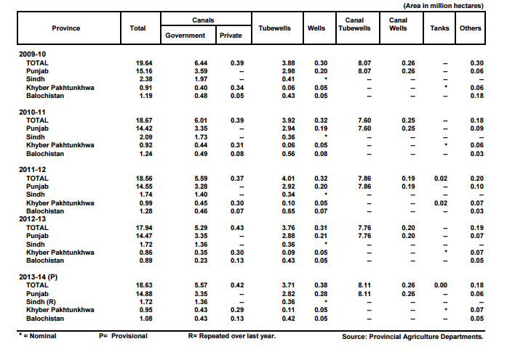

In 1947, 53% of the total GDP of Pakistan was based on agriculture, but unfortunately today contributes only 21.0% of GDP and 43.7% of pay [3].The reason for such a rapid decline is that crops and fields are not adequately managed and controlled; also farmers disagree with the need to apply scientific technology as other countries worldwide are adopting. In Pakistan old traditional forms of agriculture are still in practice, farmers use only their experience to take care of their fields. Water availability is the main concern to increase productivity in the agriculture sector. Currently the archaic way of irrigation, which is in run-through all over the country and wastes almost 50% - 60% of water resources of Pakistan. Because freshwater resources are already scarce in Pakistan so there is the need to propose irrigation technology based on using water efficiently solutions.
Mainly the proposed project target to save waste water because agriculture uses 85% of available freshwater resources worldwide and this percentage will remain dominant in water consumption due to population growth and increased demand for food. Because freshwater resources are declining, therefore, we must make efficient use of it. There is an urgent need for strategies based on science and technology for sustainable water use. Deposits of water in Pakistan are decreasing day by day and water storage dams are also very less in number and few dams and other reservoirs lacks attention which ultimately results in drought most of the time. It does not only destroyed green fields, but cattle and a threat to human lives as water is an essential need of life. The construction of new dams / deposit requires a lot of investment and time, while the need for water savings can be achieved by using self-watering and accurate digital or smart irrigation system. The development of precision agriculture is an important strategic choice of agriculture and development of agricultural science worldwide.
Following graphs visualizes predicted trends and behavior of different effects over State of the Art Computing System Deployment to Improve Agricultural Sector of Pakistan by adoption of smart irrigation strategies.

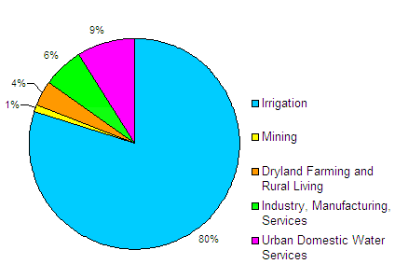
Figure1: Water Usage without technological advancements

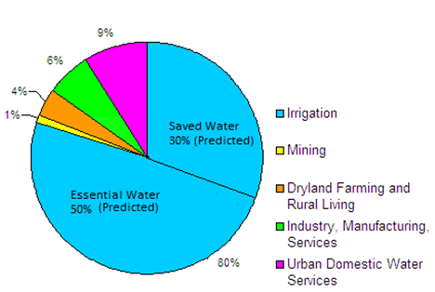
Figure 2: Water Usage with technological advancements

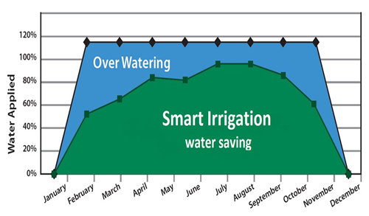

Figure 3: Predicted water saving by "Smart Irrigation” State of the Art Computing System Deployment to Improve Agricultural Sector of Pakistan

These objectives can be accomplished by latest technology i.e. "Internet of things". It is under worldwide research and analyzes done next era will be flourished for the implementation of the IO. Since the development of the smart grid to the health system of remote monitoring, including automation, object tracking, GPS tracking and precision agriculture. IoT has played a vital role serving humanity.
Cloud storage is also popular these days. Cloud storage provides ease of remote data monitoring through mobile phones or on internet. The agriculture sector can also benefit from cloud as data from different remote areas is centrally stored on cloud and the access of data can be offered to research purposes.
Cloud storage guarantees 100% data security and thus ensures prevention from data loss.
The data can be easily available to the field owners through desktop mobile applications through internet.

USAID Initiatives for development in Agriculture Sector of Pakistan
According to USAID report related to “Pakistan food and agriculture systems” highlighted main reason for degradation of agriculture sector is not espousing new technology, little investment in research and improvement, in developing or propagating higher production packages, in preserving an nominal agricultural education and lean system, and in sustaining physical groundwork. USAID has started many projects related to agriculture some of them are following [5-7]:
- USAID & ASF Launch Ag
- Agribusiness Project
- USAID Pakistan, Irrigation Support Project for Asia and Near East
- USAID/Pakistan buy-in, Agricultural Policy Analysis IQC (subcontracted by Abt Associates)
- USAID/Pakistan Agricultural Research Council/Abt Associates, Agricultural Policy Analysis and Teaching Workshop (December 1991-January 1992).
- USAID Mission in collaboration with EDC in Pakistan
- USAID, Irrigation Support Project for Asia and the Near-East
B1. Literature Review:
(Detailed summary of what all has been done internationally in the proposed area quoting references and bibliography. Please note that this section demonstrates the depth of knowledge of the project team and builds the confidence of the evaluators about capability of the team in achieving the stated objectives.)
Today, WSN is amongst the key triggers of the Internet of Things (IoT) and is believed to play a distinct role in contributing to future internet services by gathering environment information from nearby region. IoT provides potential motivation to the development of the following research areas[8]:
- Theoretical network architecture, frameworks and components, RFID based system structure, sensors and actuator enabled technologies
- Real-time data collection and critical data online update technology
- Statistical data gathering to utilize critical data via WSNs
- Advanced sensing technology
- Extensive distributed WSNs for near-future internet
- Security, identification and credential management on WSNs
- Empowering computation processing technologies

B1.1 Introduction to IoT(Internet of Things):
Internet of Things is creating a sense of curiosity in the society with its research and development based expansions. Researchers have predicted that IoT will rule in near future. The technological environment change that IoT has reflected will completely change our professional and personal life. As IoT has introduced a connected environment around the world, IoT adds consumer value, loyalty and trustworthiness. Today, we can see implementation of IoT everywhere like advanced agriculture monitoring systems, smart environment monitoring technologies, security, home automation and healthcare throughout the world.
IoT brings the concept where an IP address is assigned to the device object and the object becomes identifiable on internet via the IP address assigned to it [9].
A Team of International Telecommunications Union identified IoT to be a universal infrastructure for discrete devices which form a network and thereby enabling advances computation services via interconnecting (physical and virtual) the identifiable things on the basis of existing and evolving interoperable information and communication technological advancements. IoT has great flexibility in acceptance of different networks which can be a combination of people-things, things-things and people-people only. The conjugation of various technologies such as wireless communication, Micro Electromechanical System that includes wireless sensor, networks and control systems facilitate the idea and implementation of IoT based projects. The elite aspect of IoT is the presence of cloud storage space on Internet which is feasibly and rationally reshaping the architecture of IoT. Certainly, IoT can do things beyond imagination. It connects additional of heterogeneous object.
IP and non IP based technology solutions are used for Wireless Sensor Networks. Zigbee, Z-wave, Insteon and Wavevenis are non IP Based solution. IPv6 and 6LoWPAN are IP based solutions of WSN. A proposed architecture is described in the figure 04
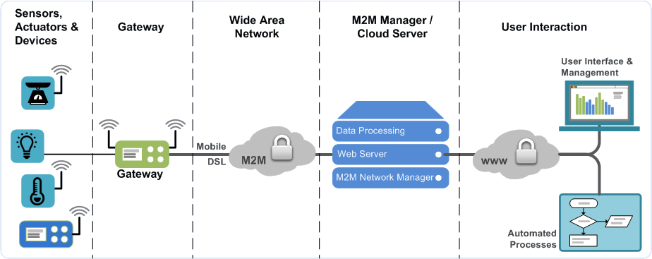

Figure 4: A proposed architecture with layer-wise communication protocol description[10]

B1.3: Scope And Benefits of IoT:
IoT is connecting and transforming every aspect of our real life and proves to be the technology of today. The concept of Machine to-Machine (M2M) communication is given by IoT and is going to have huge impact on home automation, automated farming, building automation system and everywhere there’s a need of convenience that can be achieved by the interconnected devices on IoT.
IoT is an emerging technological innovation. Many scopes will be created for technology companies to release offerings as per the behavior of consumers.
In Los Vegas, in a consumer electronics show, Samsung announced that 100 million dollars would be invested for the progress of IoT. An open technology ecosystem for the facilitation and usage of IoT will promote the advancements in IoT.
IoT has vast scope and potential. Collection of critical data from huge volumes of data i.e. ‘Big Data’ is accomplished by IoT enabled infrastructure which in turn will bring improved decision–making ability and enable proactive and predictive insights for future data analysis.
Different fields of scientific interest shall benefit from IoT, for e.g. IoT will make irrigation systems in agriculture smart that will result in better productivity; good quality crops with required amount of resources instead of wasting enormous amount of water. Farmers can easily maintain their farming activities through smart apps and intelligent system. Smart garden is also an emerging field of interest and research.
B1.4 Future Research Directions in IoT:
The quality of life of human civilization will definitely improve in full or partial manner with the ongoing implementation and research in IoT. Today, we can see IoT is playing the fundamental role in the development of smart applications and is involved directly or indirectly everywhere which is of human concern like smart business process, smart agriculture, smart city and home automation and healthcare etc. Google, the giant search engine is already playing an active role to mark its presence in the field IoT. Google is trying to change the general perspective of IoT in which common apps are used to manage the network of discrete devices, the devices will no more be identifiable through Address or MAC Address instead distinct physical URLs will be assigned to them. In prescribed process, a beacon style broadcast will be displayed by the browser which objects that are nearby and present in the close proximity will appear and can be communicating directly with the help of URL’s according to user’s preference and signal strength of the smart object.
Smart architectural infrastructures for e.g. Smart Roads and Bridges for the safety of people, Incident Management System for real-time incident management are projects in which China and European countries are investing high amount of their GDP. In the project of smart bridges, if any malfunction or corrosion occurs it will be directly communicated to the concern authorities so that at the proper time repair work can be done to reduce security risk. By 2020, internet will connect over 50 million devices including smart sensors and watches, smart meters and phones, smart actuators and other wearable electronic patches and devices etc. An integration of present forms of Internet services will give rise to the emerging concept of Internet of Anything (IoA) and these forms of Internet services include the Industrial Internet and associated intranet, Internet of Things and Internet of Everything. All data will be input in a unified in IoA aided with common software referred as "ecosystem". The issue of interoperability and the challenge of controlling hardware through software are now being addressed by a number of companies while the world community is also showing signs to live in an improved "connected life" environment.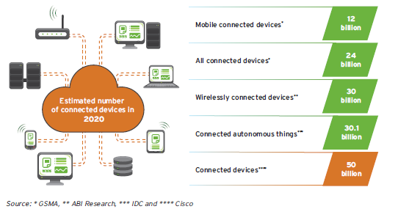

Figure 5: Graph for expected growth in number of internet connected devices

IoT is the future of present internet and plays significant role in scientific research and development. IoT will not only provide benefits to the industrial sectors but also provide assistance to the human living. A proposed future architecture states that devices forming interconnected networks will be IP addressable and emitting data at different intervals of time, these devices will interact with the IoT Service layer that will take care of device registration, data collection and devices communication while the most abstract layer will provide Analytic Services, Consumption Services and Presentation Services with visualization and dashboard applications [11].

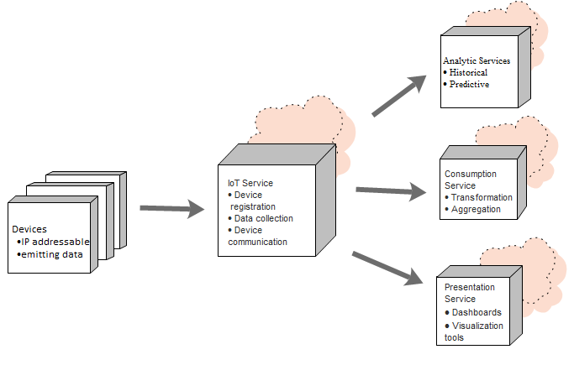
Figure 6 :IoT Reference Architecture[11]

B1.5 Smart Irrigation
A smart irrigation can be defined as, “an advanced technological system that integrates with the agriculture mechanism to monitor and control the water supply to the farms according to their needs and changes in weather condition.” With the advancements in IoT, it may help in developing a lot of applications which will not only reduce the consumption of power but even helping in ease of different people life in both social and financial way. Sensors, playing a vital role in our product to help calculate readings and make the irrigation to produce effective yield. It is been almost two decades since development is been continually going in this field. It will target a lot of areas of irrigation where a local farmer cannot be that much into such as,
- Soil moisture
- Water flow
- Underground temperature
- Humidity
- Raindrop
- Leaf wetness
- Ambient
- Solar radiation

The Smart irrigation System shall facilitate the farmer in many ways. Some of the important features of the system are as follows:

- Remote Monitoring

- Remote Control

- Information transfer

- Communication

- Workers & Asset tracking

Smart irrigation is eventually playing a leading role in country’s wealth and economy round the globe. With the growing number of applications in IoT, a lot of issues can be resolved by automating our lives into well scheduling events within 24/7.

Policies proposed by the Government of Pakistan:
(National/Provincial Development Plan & Sector Development Plan)
The key elements of government’s development plan are agriculture and availability of enough food supplies. Agriculture Policies for Growth & Poverty Alleviation by the Government of Pakistan through irrigation efficiency has following main components [12]:
- To make the Water usage efficient by lining the water courses.
- Judicious use of the surface and water tube, the lining of water should be pre planned keeping in mind the surface area. The jobs of the farmer holds no security, the intent is to form organizations which would provide respectable & permanent jobs with sophisticated salaries, increased public investment, urge the public to take more interest in the agricultural sector. Another motive is to experiment with sprinkle and drip irrigation.
- In Pakistan Government policy, Irrigation scheme generally proposes raising the irrigation water from the underground resources and low water ponds by pumping devices, bringing the water to the fields located at higher elevations through GI and PVC pipes and water supply to areas of lower or equal elevation through open channels. Connecting various areas in three RCC depressions or PVC pipes and making a central distribution points and providing turnouts at those distribution points.
- Government of Punjab province is taking interest in high efficiency irrigation systems like “drip irrigation” and “sprinkle irrigation”. They also wanted to convert these irrigation systems which are powered by solar energy to save electricity.

Need for Smart Irrigation

- Reduce energy consumption
When an existing system consumes a lot of resources i.e. labor, water and other energy resources.
- Advanced technological requirements
A need for automation requirement occurs in the fields.
- Water Preservation
When storage of a lot of water for use is requisite.
- Government Policies
Proper calculations and precautions are need to be practiced as per Government policies justify water needs.
- Beneficial utilization of existing resources
To fully utilize all resources available in a beneficial manner for mutual benefits.
- Reduce human labor
By automating the irrigation man power will get reduced, instead of humans, kits will be there to read the crop situation.
- Increase in Agricultural productivity
By having measured amount of water whenever soil needs will protect yield from getting wasted either from over watering or lack of water.
- Waterlogging
Soil may not be water logged when exact amount of water will be provided whenever soil need.
- Soil salinization
Salinity of soil will remain persistent when correct amount of water is supplied, as increase in salinity will also be harmful for crops.
- Ecological damage
Environment will be benefited after all when number of crops will increase eventually.
- Socioeconomic
Social or economic factors will increase gradually as yield increases, profit rises.
- Literacy
Rate of literacy may rise as farmers will get educated to monitor kits.
- Save water
Reduction in water consumption as minimal water will be supplied on need of soil.
- Environment protection
Greater number of crops will protect environment from pollution as well as from inflation and dependency of crops to other countries.
- Energy saving
Reduction in energy consumption as kits will be able to control power.
- Healthy crops
Healthier the crops would be as sufficient as appropriate amount of water will be supplied.
- Scientific methods
Scientific calculations will be applied to the sensor to give predictable readings.
- Justified water use
By the help of flow sensor water will totally be justified by having how much amount to supply to a certain place.
- Farmers’ lifestyle standard increase
Farmers will be paid high as having quality crops and increment in quantity of yield.
- Efficient weather prediction with alerts
Rainfall detectors and others like them will be able to predict weather through efficient programming.
- Increase in GDP
The GDP growth will definitely be increased as yield rises.

Above mentioned points are the reason behind which tend us to develop an IoT application over agriculture, as it is being a major issue faced by Pakistanis lately. A great number of encroachments have been seen lastly in two decades around the world, but Pakistan can be outnumbered from those developed countries. Pakistan is totally deprived from all sorts of innovations and advancements taking place all over the world and it is quite useless to hard work over those developments which are not even getting in use to mankind here, cannot decrease the man power, why are we even thinking that much innovative after all? Besides along with the advancements in the technology the applications should be economical as well, so that even after lack of employment and inflation, people will be able to purchase it and walk along the increasing tech based ground-breaking developments. So the basic ambitions of this application that it should be cost effective so that farmers can afford and will be able to replace their manual work into automation. What we are here proposing is that we will be designing such module and kits that can monitor their progress of farm wirelessly and can able to take decisions effectively along with the growth of different of crops. Energy will be effectively consumed when it can control its supply of kits individually, even of individual sensors of every kit. By the help of precise readings one can able to know how much water needs to be supplied to reach that level of soil moisture in which crops will give maximum yield. Smart kits are available since a decade or two but it is usually outnumbered just because not being that cost effective. It will really be simple to install this kit as it does not need any effort and we just have to place it within soil and fit flow sensors in between pipes that are allotted to just water those farms. A huge topology will be made between those kits for e.g. mesh network. The RF based kits co-ordinate with each other send the reading to coordinator node or server node. There will other shields be available as well such as Wi-Fi so that the user may have different flavors according to usability and preferences.

B1.6 Overview of Proposed Projects related to Smart Irrigation around the Globe:
Irrigation in agriculture plays an important role in sufficient yield of crop to feed the nation. A number of research based approaches have been proposed which accounts the solutions to the existing problems in the field of agriculture and are stated below:

B1.6.1 Nowadays, there are different approaches for solutions that are used to increase crop production. Wireless Sensor Network in farming is displaying improvement [13]-[16]. WSNs offer capabilities to collect sensors data concerning the ecological and crop conditions.

B1.6.2 A system [17] is deployed using a ZigBee network. It comprises of soil moisture and temperature sensors. A microcontroller gateway is used for adjusting the water amount. It transfers information to the Web server. The researchers also made a model work using various sensors [18]. The sink node is answerable for combining and transfer of information through internet to the control center where the data is sort out. A mathematical scheming based irrigation management system has been proposed [19]. The system is using wireless sensor technology for 24-hour care to potato crops to improve their production. In a research paper [20] observation of farming is described which comprises of several XBee devices and a microcontroller. The data is scrutinized and observed by using a FPGA element. Certain unnecessary events may occur in irrigation process, to avoid this kind of events an automatic irrigation system has proposed [21]. In a system [22] soil moisture sensors are placed in field in pre-calculated area and after analysis of their the irrigation process scheduled. The application [23] was intended for diseases detection and wireless transmission of data is carried out using Wi-Fi. Smart irrigation [24] can also use the smartphone technology to manage urban and agricultural irrigation.
B1.6.3 The application [25] deals with combating with a fungal disease in potatoes Phytophtora, which can attack the potato field from various sources. The development of the disease depends on the climatic condition such as humidity, temperature etc. A total of 150 sensor boards are used namely Tnodes, each TNOdes consist of sensors that measures temperature and humidity. In order to improve connectivity some sensor less TNOdes behaves as communication relays. Furthermore some weather stations are set up in the field to monitor the luminosity, air pressure, precipitation, wind strength and direction. To more energy, rather than transmitting complete files over wireless link, the data is transmitted in compressed form using delta encoding. TinyOS is used as operating system for nodes and hence data is sent on multihop routing protocol MintRoute which is available within the TinyOS.
The collected data by all the TNOdes transmitted by Wi-Fi. The data is then uploaded to a server and further distributed to different servers in XML format.

B1.6.4 Smart irrigation apps [26] use the smartphone technology to manage urban and agricultural irrigation. The app mainly focuses on the development of four models to be used in smartphones apps using real time and forecasting aspects. The four models are citrus, urban, strawberry and cotton. These models will be performing water balance calculations.. The app provides the access information only to the location that are with the weather stations.
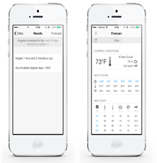
Figure 7: A Smart Irrigation App Description[26]

B1.6.5 SoilNet [27] focuses on estimation of soil water content and real time monitoring of soil. It belongs to Underground Wireless sensor networks. It is based on low cost Zigbee protocol. Within any wireless sensor network that is based on Zigbee Protocol, there are mainly three devices
- Zigbee Coordinator
- Zigbee Router
- Zigbee end device
It has used hybrid topology to provide transmission on wider range. In order to monitor the soil water content, the capacitance sensors have been used which are inexpensive and easy to operate.
The higher contents of coarse fragments may produce contact problems between sensor rods and soil matrix which may cause loss of soil water content by sensors used (EC-5 and TE) due to their low measurement volume.

B1.6.6 WaterBee [28] is a smart irrigation and water management system proposed to monitor the agriculture field. A web driven wireless sensor network that is centrally monitored through a server constitutes the major part of WaterBee system. The smart sensors are distributed over the field that monitors the soil moisture content and environmental parameters that can affect the crop growth. The data from the sensors reaches the GPRS gateway via widespread ZigBee wireless sensor network, from where it goes to a web service which analyzes and models the data and expert advices are provided to the farmers. The results are sent to application on user’s smartphones or tablet.
The developers have observed that WaterBee has improved the plant health, crop yield and reduced the water usage. WaterBee is already in use at 14 reference sites in Estonia, Malta, Italy, Spain, Sweden, and the UK.
B1.6.7 The paper [29] described details about a low cost automated irrigation system that was saving up to 53% water by using a network of sensors which integrated with decision support software. The system is implemented by using soil moisture and temperature sensors. By using these sensors a network is deployed at the bottom of the plant root zones. The designed system contains a gateway which is microcontroller based and by using an algorithm it is used to control the water quantity. This gateway has three basic operations:
- Handle information from sensors.
- Trigger actuators.
- Push data to the Web.
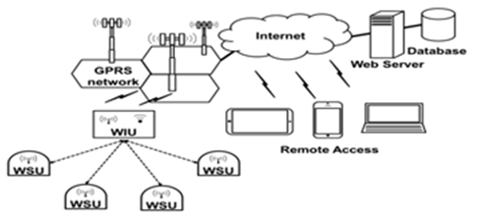
Figure 8: Configuration of the automated irrigation system. WSUs and WIU, based on microcontroller,Zigbee and GPRS technologes[29]
The communication channel between the sensor nodes and the gateway is provided by a protocol named Zigbee. This gateway is a wireless information unit, containing GPRS module which transmits the data to the Web server through a mobile network.
For real time monitoring and programming of the acquired data from sensors the system is using a Software Application. This application enables the user to graphically view the data from each Wireless Sensor Unit via Internet.

B1.6.8 This paper [30] reports an application for effective irrigation. The researchers basically conduct a simulation work based on program code by using PowerTOSSIM simulation environment. The main work proposed by them based on the acoustic emission principle for crop water stress i.e. tension increases as soon as the soil turns out to be dry. A threshold value is set for the tension, whenever this value arrives, an acoustic signal is emitted. During the execution this signal is detected by the acoustic sensors so that they will indicate the dryness of plants. These sensors will be sensing, acquiring and processing the emission signals throughout the wireless sensors network area. The data from the nodes is routed to the sink node which uses multi-hop routing mechanism to gather data from the cluster node. This node is responsible for aggregating and sending data through internet to the remote control centre where the information is processed.
.

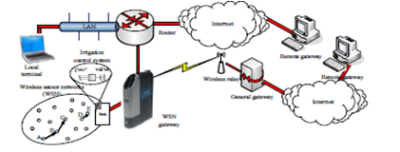
Figure 9: A system based on multi-hop mechanism of data flow[30]

B1.6.9 This paper [31] proposes an irrigation management system that is based on mathematical calculations for Soil Water tension (SWT) and Depth of water to apply (DWA). The system is monitoring potato crops by using wireless sensor technology to improve their production by measuring the humidity of the potato field and SWT. These sensors also transforms the measured physical quantities into a signal and for processing it produce digital output for using RF data communication which is responsible for sending data to the base receiver. This station basically processes and analyzes the data. As a result processed information of SWT facilitates to find the general trends of soil moisture and in a log run it will modify the irrigation system to predict a schedule to achieve an increased crop yield.

B1.6.10 The paper [32] proposed remote monitoring of agriculture consists of several sensors e.g. temperature sensor, soil moisture sensor, relative humidity sensor and a microcontroller. The microcontroller is multiplexing the data obtained and converting it from analog to digital form. A wireless XBee module is used to communicate the gathered data; UART pins of the computer which uses serial protocol receives this data and it is then analyzed and monitor by using a FPGA element. To display the analyzed data the system uses a display unit.

B1.6.11 Certain unnecessary events may occur in irrigation process, to avoid this kind of events an automatic irrigation system is proposed [33], which is using a timer that is triggered when a threshold is reached. Some soil moisture sensors are also used to maintain soil moisture at prime levels; it will ultimately maximize the efficiency of water usage. This system is proposed for the farmers in the United Arab Emirates because of low water holding capacity in the soil of this country therefore plants may die in case of water shortage. The system consists of soil moisture sensors to detect the soil’s volumetric water content; depends on the permittivity of the soil. The gathered data will facilitate the farmer to schedule the process of irrigation.
B1.6.12 A proposed system in research paper [34] mainly consists of two modules:
- Solar Pumping Module
- Automatic Irrigation Module
Sensor is placed around the agriculture field where it converts moisture content into equivalent voltage. The farmer can set the reference voltage depending on the moisture content required by different crops in different seasons. The amount of water needed for irrigation is directly proportional to the difference of the two voltages. The outlet valve of the tank is connected to a stepper motor which acts as an actuator control for the valve. When the moisture content of the soil is equal to the reference value set by the farmer, the valve is closed slowly, power to the driver circuit dies off and control goes in sleeping mode thus consuming less power. When the moisture level is again low, control comes out of sleep mode and flow of water is regulated. This mechanism controls the opening and closing of the valve depending on the moisture level of soil. In that way the solar powered smart irrigation system conserves electricity, water and saves crops from over flooding. Furthermore, it requires minimal attention reducing human intervention for the farmers.
B1.6.13 In paper [35] the proposed work after focusing on open canal irrigation networks which are common around the world. Mostly these kind of systems are energy efficient but with several limitations and causes a large water loss. Therefore, modeling of Management Systems of Gravity Irrigation Networks (MSGIN) is proposed with the feature of valve operation of water rotation with the use of multi-agent framework. The process of this approach is conducted in several stages:
First Stage relates data gathering for the decisions making during the negotiation process.
Second Stage concerns analysis which relates to the functional specification requirements.
Third Stage concerns the system structuring i.e. dividing the system into sub systems based on the macros functions, the structuring of each sub system in agents and the definition of the inter-systems interactions and the inter-agents interactions.
Fourth Stage concerns the implementation and the development of the agents using the specific JADE platform.
In Multi-Agent System, the JADE Agents communicate through the exchange of messages represented in FIPA-ACL. Each JADE agent has a kind of mailbox which contains the messages sent to him by the other agents. The roles of the agents, composing the system, are already defined. In that way this system provides flexibility allowing to dynamically adapting the agent behaviors that will enable the system to deal with dynamic problems ultimately ensures a better adaptability of the system to its environment.

B1.6.14 An automatic irrigation system [36] based on WSNs is designed using ZigBee Technology that features low power, low cost, easy installation and easy to use solution. The system consists of a microcontroller, wireless sensor node, a weather station and several wireless actuators. The wireless sensor node collects temperature and humidity data of particular area whereas the weather station monitors the climatic condition. All the data collected is transmitted to controller wirelessly. The actuator nodes that are present in field are used to control the electromagnetic valves and pumps, and are wirelessly controlled by the controller .The controller act as a ZigBee coordinator that builds and maintain WSN and also manage the irrigation system. The project used ZigBee star network topology due to low power consumption. When the coordinator node is started, it creates a Personal Area Network (PAN) and allows the actuator nodes to join the network. The coordinator then assigns network addresses and collects the sensor data for processing on the basis of which intelligent decisions are made. The paper showed the details of hardware design and software algorithm for irrigation management.
B2. Current State of the Art:
(Please describe the current state of the art specific to this research topic.)
Responsible use of water represents today a priority in different sectors, and has a direct impact not only on the operating costs of the facilities with taking care of the environmental conditions. For this reason, companies and institutions are seeking new solutions to help ensure that the irrigation meet sustainable criteria and the highest standards of efficiency and functionality.
There are many smart irrigation systems that are in practice around the world. Many countries have achieved significant amount water and energy savings worldwide. Some of the ongoing research based projects are described below:
B2.1 Growing Garden in Brooklyn to a Company Selling Prototypes:
Amit Kumar, a software engineer moved to Brooklyn, started to develop a hankering in his own garden. Need arises when he wanted to monitor his plants even when he’s not available to look after it. He met a hardware engineer and started to learn about Arduino, an open source microcontroller. They planned to use it in building a system with a base module connected to sensors that could monitor everything from a garden's pH level to its humidity, then relay that information through the cloud to growers' computers and, in many cases, automatically correct any problems that might arise—say, turning on a fan connected to the base module when the temperature rises to 90 ○ [37].
Bitponics, a company founded after a year and half ago. They raised $20,000 through Kickstarter. He says "Our major mission is to make gardening as simple as possible so people can have thriving gardens in their home”. He gave a complete “grow plan” to very start to finish of the plant maintenance successfully by everything from what kind of lighting to buy to the type of nutrients needed, automatic scheduling and actions that the system can't take care of automatically, like adding water, it will send an email with an alert.
Example: A grow plan for lettuce or herbs calls for a three-ft. by three-ft. flood drainage system and a 24-gallon reservoir. After that, the plan includes steps for additional phases of growth, each with appropriate requirements. The two-week-long seedling stage, for example, needs 16 hours of light per day. Next phase, gardeners transplant the seedlings into a grow bed and there's an automatically triggered schedule for turning off and on lights and pumps.
Last but not the least, an online dashboard through which users can connect to other growers and share their plans to community.

B2.2 Waspmote:
Libelium, six-year old company takes a different approach, introduced an open source sensor platform having multiple applications in 12 sectors, including farming and agriculture. It is based on “plug and sense device” to which 50 or more sensors potentially can be connected. Having a lot of sensors sending date wirelessly to computer anywhere in the world [38].
Company targets not only consumer, but to system integrators who in turn aims consumers of specific industries with applications they have developed themselves.

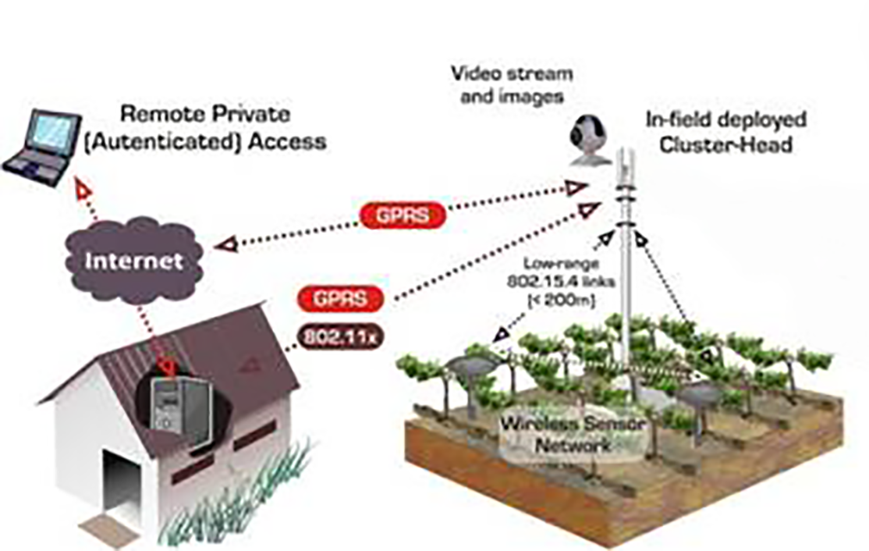

Figure 10: Figure to depict general working of WSN with GPRS [38]

Example: Take Alan Campbell, who runs Northwest Vineyard Consulting in Tualatin, Ore. According to Campbell, a big problem facing regional vineyard managers is how much water stress their vines experience. "Grapes do better in a slightly stressed environment," he says. Campbell wanted a way to send sensor data about soil moisture from vineyards to the computers of vineyard managers.
To that end, he recently launched a pilot with six vineyards, where he places six sensors one, two or three feet deep in the soil. They detect such information as temperature, humidity level and moisture. The system then collects that intelligence every 15 minutes, ultimately sending it to vineyard managers in a form that allows them to make decisions based on the amount of available water in the soil and its impact on grapes. Says Campbell: "We're hoping this has a big effect on the quality of the wine."
After all, the IoE isn't just about connecting devices, but also about the collection and use of data made possible by hooking up all those "things" in systems unavailable before.

B2.3 WaterSense Labeled Irrigation Controllers:
United States utilizes over 9 billion gallons of water daily, usually for landscape irrigation. Just because of inefficiencies in the system tend to waste more than 50% of this water. By the use of technologies we can abundantly decrease swamping through automating it whenever plants are in need. Just like thermostats Irrigation controllers significantly decrease our home’s outdoor water usage.
WaterSense labeled irrigation controllers [39], a thermostat for our sprinklers get controlled by homegrown climate and land conditions to adapt sprinkling plans to actual conditions on the location, to control the sprinklers. So now no longer wastage of water will be there when you can use WaterSense labeled controllers having proper programmed and maintained.
WaterSense labeled controller can save usage of home approximately 8,800 gallons of water annually. That could save $435 million in water costs and 120 billion gallons of water through-out the country annually from not swamping lawns and landscapes.

B 2.4 Smart Irrigation in New Zealand:
Worldwide Innovations are being done in the field of irrigation. The key areas of focus are water and energy efficiency. Past decades have witnessed a major change in methods of irrigation especially in New Zealand. Conventional flood irrigation methods in now replaced by improved and automated sprinklers, pivots and dripline[40].The five elements are:

Figure 11: Modular depiction[40]
Smart irrigation system ensures controlled water flow at appropriate time and place. The essence of well operated irrigation system is to rationalize the use of water. Irrigation New Zealand has been putting its efforts to support irrigators working on smart irrigation. These include:
- Ensuring industry standards and provision of guidelines.
- Educating irrigators by organizing workshops.
- Industry recognized certification programs
- Provision of resources and support tools.
B2.5 WaterBee, Smart Irrigation and Water Management:
WaterBee [41] is user-friendly, cost effective Water management system that helps to maintain their orchids and farms in an effective way, which optimizes their production per unit area. Working continually with their European business partners WaterBee provide its services across the continent. This system meets the requirements of grower in the following ways:
- Additional grants for efficient use of water and extra inputs
- Comprehensive literature of soil and crop details
- Real time data processing via smart gadgets.
- Reduced labor cost, improved yield and good quality crops.
WaterBee is a great state-of-art for optimum use of water. Machine learning methods and open internet - enabled aids the data to transfer, and watering the yield whenever it is exactly needed which will also make the growth optimized.
The product is being across the globe such as Europe, Estonia, Malta, Italy, Spain, Sweden & the UK.
B2.6 FIGARO
(Gentle and precision Irrigation Sector to Improve Farm Scale Water production) [42] A European research project under the 7th Framework Program (FP7) for Research and Technological development can. This is related to irrigation and the decision to support the development of intelligent systems.

- Challenges:
(Please describe the challenges, specific to this research topic, currently being faced internationally.)
- The main defy is to develop interest in farmers to adopt smart irrigation. It required awareness campaign by publicizing the results of research on smart irrigation, also by providing education and practical assistance and support in cooperation with the farmers and irrigation sector.
- Another obstacle concerns how to deal with areas where soil salinity is high and water quality is low. For this may be we need map soil mapping information.
- Technical challenges which would be faced are following:
  - Robustness of system
  - Wireless sensor network management and ensuring its reliability
  - Outlier detection in data
  - Database management and development of semantic based procedures
  - Accurately determine water quantity needs by particular crop
  - Implementation of decision support system by proposing efficient data analyzing techniques and trends identification
  - Transmission and data packets problems
  - Power efficiency
  - Scaling up pilot to large scale
  - Evaluation at different level from ordinary to expert growers

- Motivation and Need:
(Please describe the motivation and need for this work.)
The new technological advancements have encouraged researchers to formulate new ideas and methods to solve existing problems faced by the economy of the country and play a responsible in the development and progress of the country. The main sector of agriculture not only meets the country's need for food for the population but also contribute to a significant amount of revenue generated by cotton and other exports canned.
Today, flood crop irrigation is practiced throughout the country, and the water is wasted and that is a precious natural resource, reduced water consumption with minimum required time for harvesting can be achieved with the help of developing techniques and research to facilitate the harvesting of crops.
The reasons that motivates the need of Smart Irrigation System deployment are as follows:

- Soil Erosion
To eliminate the soil erosion no method has been adapted to date and even after cultivation of crops nothing is done to restore the soil energy. Therefore, the fertility and ability of soil to produce good quality crops is decreasing day by day.
- Water wastage Practices
Water waste is very high in our country. Archaic flood irrigation method is still practiced in the country and almost 50 to 60 per cent of water is wasted in the practice entirely. A new irrigation system is definitely necessary to increase cultivation growth rate on 79.6% million hectors of land in comparison to only 20.43% million hectors which is actually cultivated.
- Traditional methods of cultivation
Due to the old methods of cultivation and harvesting, Pakistan produces low yields per acre and average harvest just 1 / 4th of the notice states. At present, Nepal, India and Bangladesh are the countries who are using modern scientific methods and strategies to increase the yield per acre and ultimately provides strong economic support by their overall revenue generated and exports worldwide. To achieve this, these states are using modern machines, to improve their performance and are adopting revolutionized mechanisms with greater efficiencies.
- Division of Areas
As native farmers in our country are growing they are dividing the land generation by generation. So, a large number of farmers own only 4 acres of land. These small farmers do not get the credit facility for the purchase of seeds, pesticides, fertilizers, etc. In addition, the feudalists mostly own large areas of land and the farmers are left unrewarded for their hard work and are just thought as tenants. The uncertain status of occupancy and the government policies does not provide support to the farmers or announces incentives to attract capital investment.
- Flooding
Flooding and salinity greatly effects the growth of crops and causes harm to the quality and quantity of crop yield. No effective measures have been taken to curb the existing situation till present. The storage capacity of the dams is not sufficient and many acres of water storage availability are also limited. Therefore, more and more farmers are installing tube wells to irrigate their crops. Therefore, Punjab and Sindh salinity is becoming a major issue for the most part. There is no solution to the present problem of water scarcity is a strong need for a new system.
- Ignorance of farmers
Focusing more on land, crops and yield problems are only known to the man behind the plow and is not always taken into account. While formulating the plan for 5 or 10 years, the problems should be highlighted and the importance of solving these problems of farmers should be taken into account.
- Limited means of Communication and lack of Awareness
Both experts and farmers should bridge the communication gap between with simple talks. Also, the availability of these experts in rural areas discourages advancements in the agricultural fields as they are reluctant to go to those remote rural areas.

- Systems of Feudalism
Pakistan is still the land of rich soil fertility but still water is being wasted in different ways. Only % 79.6 million hectors of land remains under cultivation, while final cultivated output yield is harvested from only 20.43% million hectors land. The reason can be explained in two.
8.1 is a major area owned by the medieval system, and the management of such a large area becomes difficult with time, so that part is cultivated which is easy to handle and forget the rest of the land which was planned to be cultivated initially.
8.2 The upswing of industrialization in this sector is a threat. People are transferring to towns, and cities are intensifying so newly emerging colonies are built on the fertile land.

- Need for technological advances
The new technology brings new opportunities and opens the way for new ideas. Implementation of wireless sensor nodes within the field of energy will not only save the farmers, but it also gives detailed results of the different parameters to facilitate the growth of the next crop. The system will be able to predict the outcome of future crop.
- Full access to the remote areas of the field
Farmers have full access to the field of mobile applications which interact with data stored in the cloud via a centralized server are all over the field.

3. Objectives of the Project
- Specific Objectives Being Addressed by the Project:
(Please describe the measurable objectives of the project and define the expected results. Use results-oriented wording with verbs such as ‘to develop..’, ‘to implement..’, ‘to research..’, ‘to determine..‘, ‘to identify..’ The objectives should not be statements and should not include explanations and benefits. The objective should actually specify in simple words what the project team intends to achieve (something concrete and measurable/ deliverable). Fill only those objectives that are applicable to the proposed project.)
The project aims to develop smart wireless sensing system that is equipped with important parameters measuring sensors, wireless transceivers, automatic controlling of valves using smartphone apps or web interface for scheduling irrigation.
A1. Research Objectives: (if any)
- To obtain a cost effective optimal design for smart sensing units providing maximum efficiency in both power consumption and accurate computation.
- To enable high processing capabilities in wireless sensing nodes for processing, scheduling and multitasking purposes.
- To contribute research based knowledge about climatic effects on the agriculture field.
- To discover different methods of preserving water by both means of smart sensing and utilizing water only when needed.
- To find a way that only stores critical data on cloud and perform computation to estimate different parameters around the field where sensing nodes are not deployed which not only reduces the cost but also open doors to new findings.

A2. Academic Objectives: (if any)
- To promote ongoing studies on present state of agricultural systems at academic level.
- To reveal the effectiveness of a smart irrigation system that meets the real Requirements through data obtained from field sensors.
- To promote knowledge about new technological advancements in wireless communication, sensors and microcontrollers.
- To conduct different workshops and seminars on sensor node assembly and wireless communication protocols.
- To create awareness about the importance of preserving water resources and encourage discovering quality crop production to meet the need of the nation.
- To increase the position of our academia in international research community by producing quality based research publications from this project.
- To embellishment the quality of Research & Development culture in University

A3. Industrial Objectives: (if any)
- To display the efficacious deliberate prototype to different vendors in Pakistan so that the developed system will deploy in most of the agricultural areas in Pakistan.
- To encourage industries to get involved with the agriculture sector for quality production and invest their resources for mutual benefits.
- To promote cloud managing industries to create customized private clouds for individual field owners so as to eliminate need of separate servers.
A4. Human Resource Development Objectives: (if any)
- To bring more opportunities of employment to the people engaged in hardware and software development.
- To reduce the burden on local farmers and encouraging them to give time to new crops harvesting.
A5. Other Objectives: (if any)
- To beautify the field location by proper monitoring and watering of crops

4. Research Approach
- Development / Research Methodology:
(Please describe the technical details and justification of your development and research plan. Identify specialized equipment, facilities and infrastructure which are required for the project and their utilization plan. The block diagrams, system flow charts, high level algorithm details etc. have to be provided in this section.)
The aim of the project is to make intelligent and automated irrigation system which involves remote monitoring, remote control, communication, asset tracking, remote diagnosis, cloud services and information transfer. All these functions are based upon wireless sensing network, which is the bone of project.

Note: The initial prototype has been developed which verify the concept of our proposed methodology. For reference detail document is attached.
Complexes as compare to other wireless protocols. The only limitation while using ZigBee is its low data rates (250 kbps). In WSN the data transmissions do not require high bandwidth. Therefore, ZigBee is the best suited technology to be used for this application.

Remote Monitoring
Remote monitoring offers crucial data analysis opportunities and provides user with comfort of distant data observing for future intensive care of the fields. The monitoring nodes of wireless sensing network are used for several useful purposes and are optimized in both design and working configuration. The main functionalities are define below:

- Gather raw form of data from gauges and sensors (water flow sensors, humidity sensors, Hygrometers (soil moisture sensors), rain detector, light intensity sensor, external/internal temperature sensors, switches, carbon-di-oxide (CO2) sensor, and camera) and performs computation to relieve the burden of exhaustive computation at coordinator node.
- Stores and maintain history log of status of irrigation valves.
- It keeps track of status of pumping equipment and maintains a history log.
- Monitors greenhouses and storage facilities for efficient control and management of the system.
- Auto generate audible alarms alerts on mobile phones via mobile app and desktop web application when sense alarming conditions such as instant increase in temperature in case of fire, sufficient increase in soil moisture in case of rain etc.
- Live monitoring and analysis of field parameters and ongoing operations on the land under cultivation.
- These nodes are capable of transmitting data wirelessly via wireless data transmission ZigBee protocol thus eliminating the cost of wiring and reduce overall power consumption of the system.

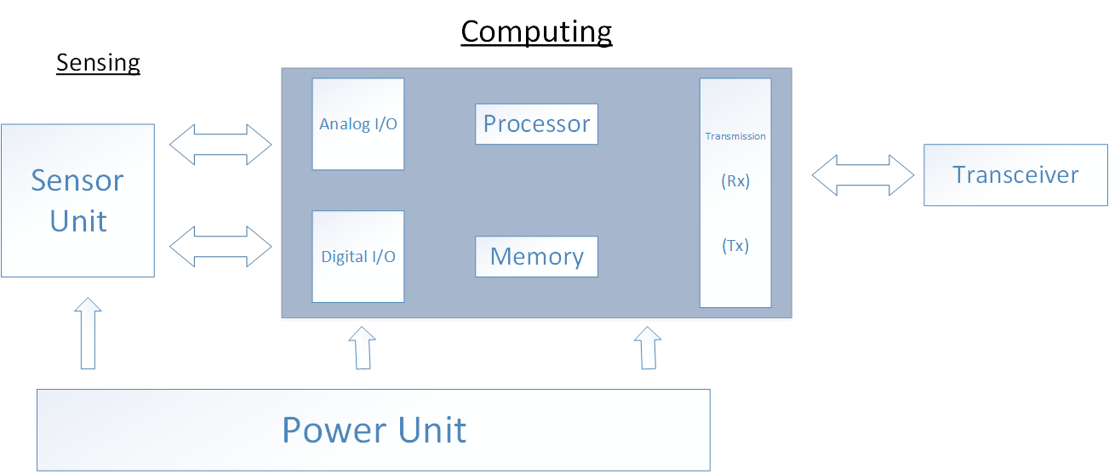

Figure 12: Monitoring Module

Sensors

Sensors will be interfaced with the monitoring wireless nodes are following:
- Soil moisture
- Humidity
- PH
- Temperature
- Pressure
- Light intensity
- Co2 detector
- Rain detector
- Water flow
- Smoke detector
- camera
- Switches

- Soil moisture –this sensor is used measure water content in soil. It is typically used in many of the branches for e.g. soil science, agricultural science, environmental science, cultivation, botany, and biology.

- Humidity - Humidity is defined as the amount of water in air. This content of water in air as vapor affects human life style and many developing processes in industries. The presence of water vapor also impacts various processes. Therefore, humidity sensing is essential typically in the systems of industrial manufacture and comfy for humans.
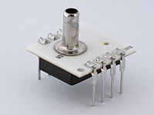
- PH - The pH Sensor is typically for automated data collection besides traditional pH readings. Characteristically it includes activity like:
- Monitoring pH change during chemical reactions.
- Investigations of acid rain and buffering.
- Analysis of water quality.

- Temperature - DS18B20 accurately measure temperatures in all of practical environments with having 1-Wire interface and 9 bit resolution. It is water proof as well.

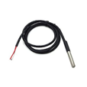
- Air/Atmospheric Pressure – this is used to sense air pressure for weather station parameters.
- Light Intensity – this sensor is used to measure the intensity of sun light. It then amplifies the readings and converts into precise analog and digital values.

- CO₂ detector –the carbon dioxide is very important for plant growth and nutrition. This sensor sensed the CO₂ content in air.

- Rain detector – The rain sensor is triggered by event of rainfall. If rainfall present then this sensor output is used to shutting down the irrigation equipment.
- Water flow - Water flow sensor sensed amount of water quantity flow through valves/showers. This work on the principle of Hall Effect.
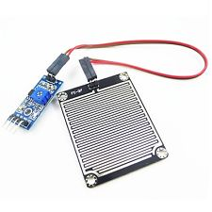
- Smoke detector – for fire alarm generation this sensor is used to detect smoke/fumes in field area.

- Camera – this is used for asset and worker tracking. The video stream is send to user interface.

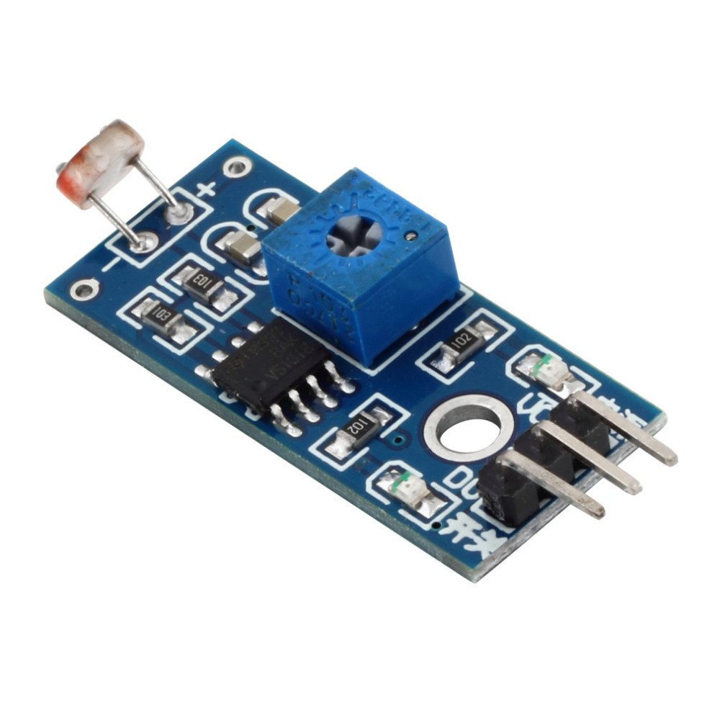
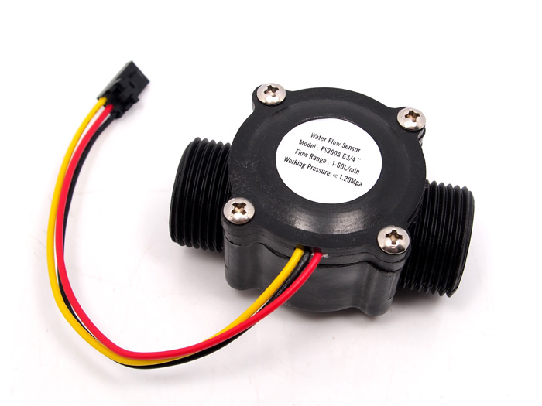
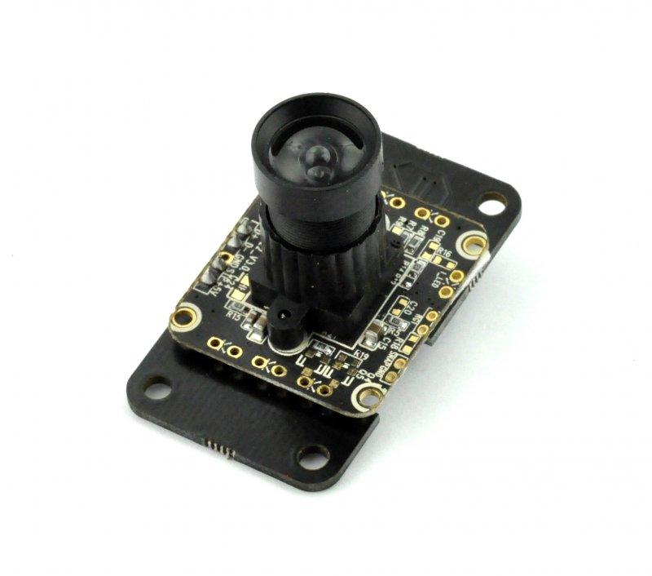
All these sensors are attached with sensor unit that gives data to the computing unit that process this data and convert it into a user understanding form. After processing and data conversion it makes a data packet which encapsulates sensor data, sensor ID, time stamp, monitoring node ID, error checking fields. The transceiver send this data to the next hop or destination.it send data only after a particular time stamp or if it is requested by coordinator or server nodes. While there is no transmission the node will be in the sleep mode in order to save power. The power is provided by power unit which involves power harvesting and voltage regulation and status of battery.

Remote Control
The control module is responsible for all automation specific tasks. The operations and activities of control module wholly depends upon the remote monitoring module The control node is responsible for the activation of particular scheduling of watering the plant on users event driven commands and this feature is initiated or enabled by the remote user through mobile app and web application. The associated nodes with these functionalities of module are called “Control Nodes” which contributes controlling and scheduling of different activities like timely watering using actuators and sprinklers, automatic timely activation of sleep and active modes of node. The major functionalities of control node are given below:

- Control node is responsible for opening and closing of valves at main water supply resources and pipelines.
- They will trigger the mechanism of turning off and on lights in the field, pumps, sprinklers etc.
- Control node also keeps track of water usage.

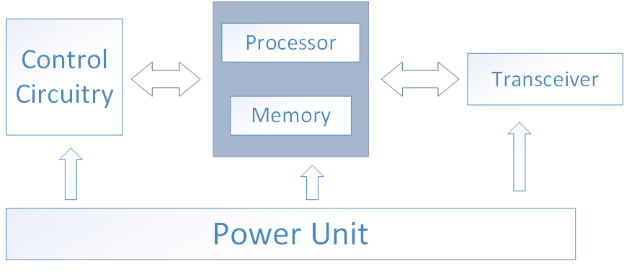

Figure 13: Block Diagram of Remote Control Module

Automatic Valve Regulation
The automatic valve regulation module function is to ON/OFF water pumps and release needed amount of water from tank according to plant needs after analyzing other field sensors data. The user can also control the sprinkles and valves by generating commands from user interface.

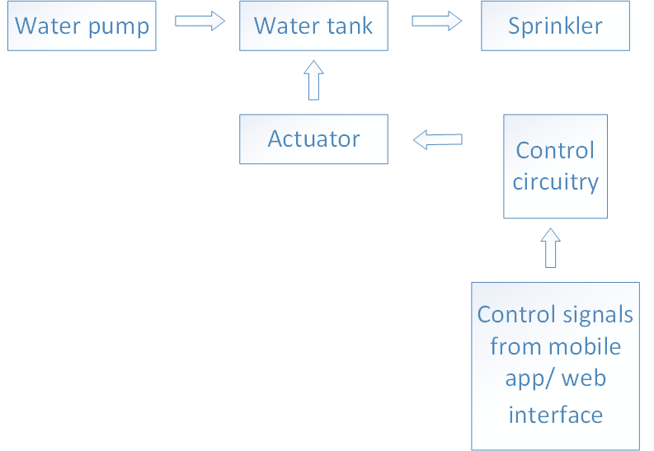
Figure 14: Block Diagram of Automatic Valve Regulation Module

Automatic Water Tank Pump Switcher:

Traditional water level controller has many problems and it can burn the pump as well if no or less water (below limits) is reached. Therefore automatic pump controller switch is being established. Automatic Water Tank Pump Switcher can be implemented by using Micro-controller, water level sensors. An electromagnetic relay for switching pumping motor and some other components attached to controller. Water level will be detected by making firmware this will enable to detect the high and low of overhead tank.
Reed-switch will be vertically mounted on different heights of overhead tank. The basement water tank also be consisting of single point level switch to check whether the tank is dry or not, this will save the pump from getting the motor burned. The circuit will be functional between 9-12V of DC supply. This assures that 1A current can energize the whole system. Voltage regulator is still needed to make sure that clean dc supply will run through circuitry.
Two sensors at different position will be attached in overhead tank to determine the high/low levels of water. If the water level is low i.e. L sensor, trigger the low level port of controller and the pump will get activated. Similarly, when high level of tank will be reached i.e. H sensor, will be activated and will trigger high level port of controller, which will make the pump off temporarily, until the water will reach the low level sensor.
An optional sensor will be attached in the basement tank to make sure whether the water is available in underground tank or not to inform the controller not to turn ON the pump, no matter if the overhead tank gets empty.

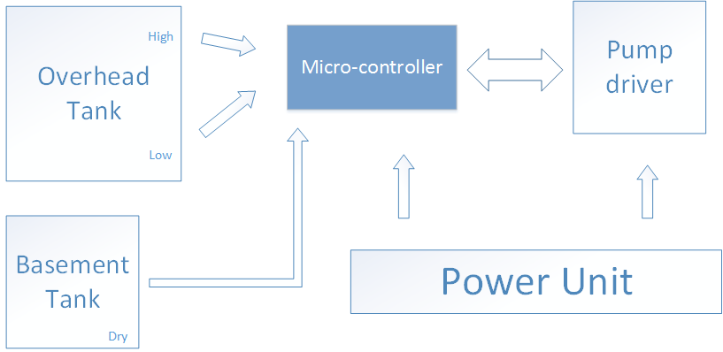

Figure 15: Block Diagram of Automatic Water Tank Pump Switcher
Workers and Asset Tracking:
This module is responsible for the safety of field assets like motors, plastic tanks, tractors or any other thing which is costly. A worker tracking their position in farm is also important this can also be easily track using this module. GSM/GPRS based solution is used for this purpose.
Special hand mount strip is designed for this purpose.in which GSM/GPRS SIM900/908 module is placed with dry rechargeable battery and with host controller. That is responsible for sending position coordinates to the remote site or mobile app. Using google maps several worker position can be shown at a time using markers.
Using this we can also keep track which worker is doing work or not. If its position coordinate not varying by the time this means workers not doing any type of work.

Processor
Memory
Analog
I/O

DIGITAL
I/O
RS2
3
2

RX

TX
GSM/GPRS

Remote server
Mobile app

Figure 16 :Block Diagram of Server Module

Power Harvesting And Energy Management:
This is responsible for powering the overall system. It comprises of two parts power harvesting and energy management and its functionalities are following

- Energy harvesting using solar panel
- Charging of batteries
- Battery status monitoring
- Voltage regulation
- DC to AC supply conversion
- Supplying power to all the modules of system

Solar panels of 150WE or greater are interface from batteries (12V) using some intermediate voltage regulation circuitry and protection circuitry to avoid over charging. The overall system except motor/valve drivers needs 5V or 3.3V, after voltage regulation multiple headers are provided for supplying of voltage. DC to AC conversion is needed for motor or valves driving, this is done using inverters. The battery status monitoring is also provided to avoid power failure; this status is transmit on remote server to inform the user.

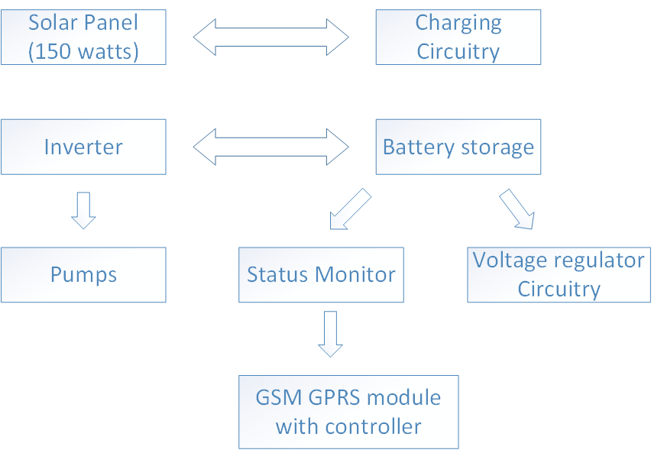

Figure17: Block Diagram of Power Harvesting and Energy Management Module

Software Implementation
The software layer mainly consists of three parts as follows:
1. A user friendly GUI for feeding supported code into the sensor board and other modules i.e. Nodes Programmer.
2. A user responsive web interface for remote observation and visualization of data i.e. Smart Irrigation for Agricultural Areas of Pakistan.
3. An executable program for receiving and storing data into the database.
4. Mobile Application for Smart Irrigation.
5. Cloud compatible integration software.

Information Transfer and tracking Capabilities:
The system will be capable of tracking position of different components of the irrigation system. System keeps track of the number of nodes installed, number of nodes active, the workers around the field, number of valves operating etc. Controlled transfer of essential information is offered by the system to provide maximum benefit to the farm holders and workers.
• Decision support systems and crop simulations is the ultimate goal of the system so that useful data collection can benefit different aspects of study and life.
• Uploading real time locations of sensor nodes on google maps can provide ease of access for maintenance purposes.
• Weather related information from metrological department can be compared to enhance decision support system and further operational information is transferred to remote location for future analysis.
• Locality of farm automobiles is tracked.
• Location of cattle’s can be tracked.

Nodes Programmer
This software unit will be a graphical user friendly interface to provide software compatible hardware support to the sensor board for ease of setting up the system without any keen knowledge of hardware or software. This application will hide all the complicated code scripting and handling, real-time exception handling thus all the critical tasks that can be troublesome for a naïve user. A flowchart can better explain the application flow.

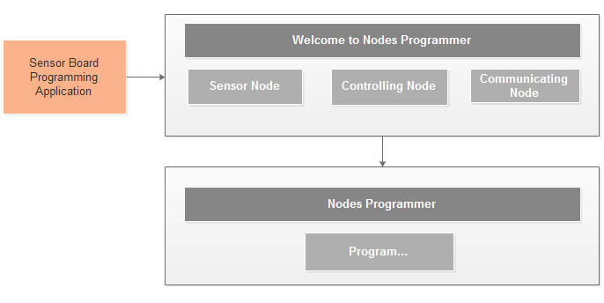
Figure 18:Pictorial Representation of Nodes Programmer

Smart Irrigation for Agricultural Areas of Pakistan
The Software Application is user friendly web interface for monitoring, calculating, storing and visualizing the field parameters is programmed in C#. stored procedures which are a collection of scripts for multiple time execution and reduce space. SQL Server 2008 Management Studio is used in this productive application for table management. The major features offered by the web interface are:
- Customized User and Administrator Authentication which includes processes for Registration and Login.
- Customized real-time field data display.
- Real-time visualization of collected data for real-time field monitoring.
- Comprehensive report generation for visualizing daily, weekly and monthly water consumption and critical field parameters for threshold comparisons.
- Real-time water valve status observation.
- System does worker tracking i.e. it keeps track of the farmers in the field as they enter the farm premises an alert is sent to the management web hosting system or cloud via the communicating node.
- Asset tracking is achieved through routine monitoring.
- Automatic controls can actuate the on field activities which is an essential feature.

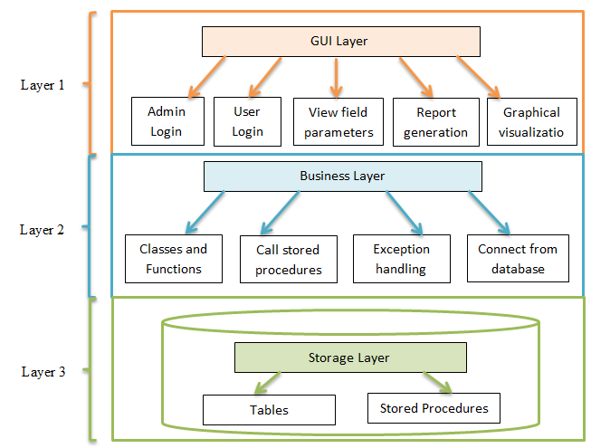
Graphical visualization

visualization
Figure 19: Architectural Layout of Web Application
The web application is basically a division of three main layers (Fig. 19).

Web Application Flow Charts
• User Login:
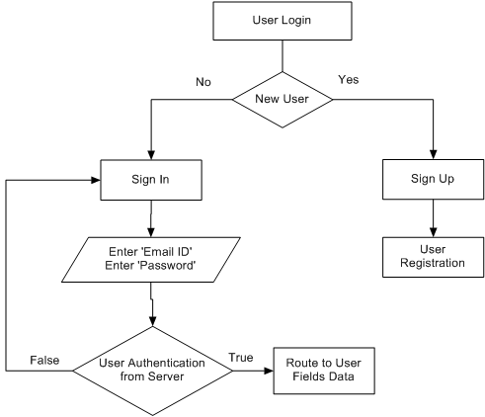
- Admin Login
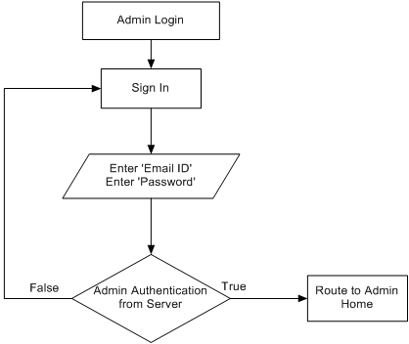

- Admin Home
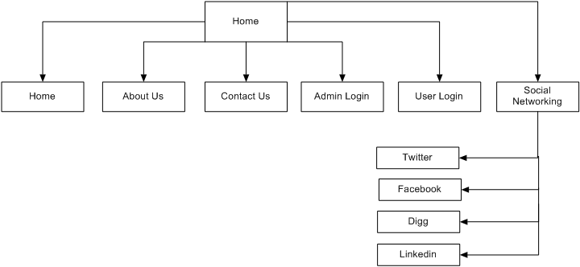
Web Application Routing Scheme
- Home Page
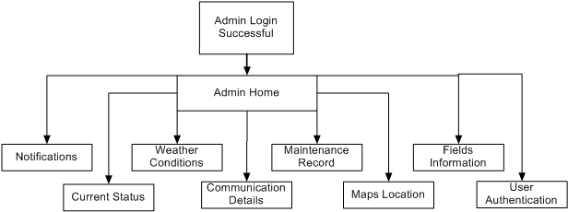
- User Login
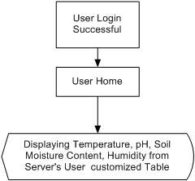

Dataflow Diagram (DFD)
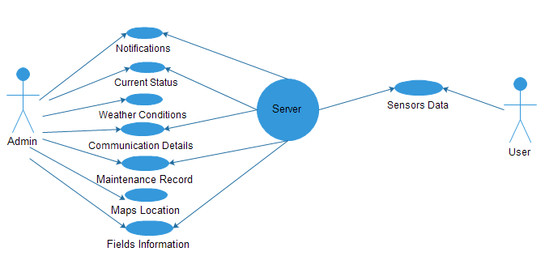
Figure 20: Dataflow Diagram of Software Application
Executable program for Synchronization with Database
The executable file runs automatically on a button click or can made to be executed as OS boot up in the case of dedicated server and receives data from remote site and performs the function of storing data into the database which timely fills the database while raw form of data is also maintained in a log file which can be used as a backup option.
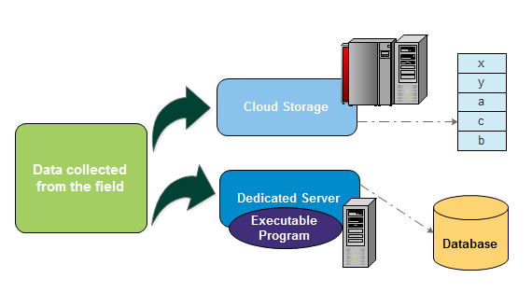
Figure 21: Receiving and Storing Data
Mobile Application for Smart Irrigation
The mobile application provides user with the ease of remote access to the data, remote control of control units and real-time data analysis. The application aims to generate alerts when the field parameters exceed the threshold values. Farmers can also draw predictions of the overall outcomes from the cultivated areas.
The smart irrigation mobile application compatible with most of the android operating system versions will offer the following main functionalities:
- Real-time monitoring and data analysis.
- Real-time control of different control units.
- Visualization of real-time data in the form of grid views and charts.
- Report with hourly, daily, weekly and monthly analyzed parameters.

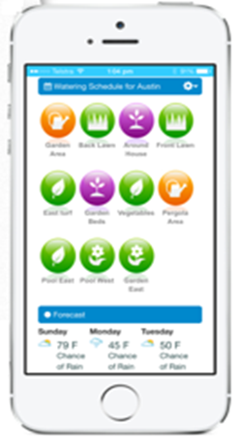

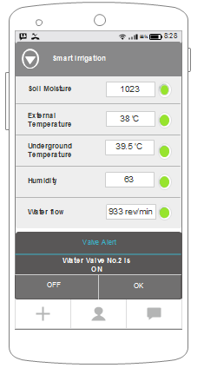
Figure 22: Mobile Apps Design

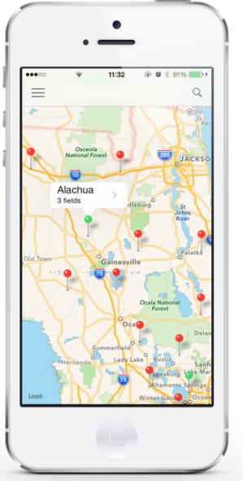
Cloud Compatible Integrated Software
This module of software layer comprises of programming code that is feed to the communicating code so that the data to be stored is sent to the cloud storage database. The cloud compatibility is a challenging task which involves an intense study of cloud software layers and communication and protocols. Database development and integration within cloud environment is an essential part which will be carefully keeping in mind the customized user requirements.
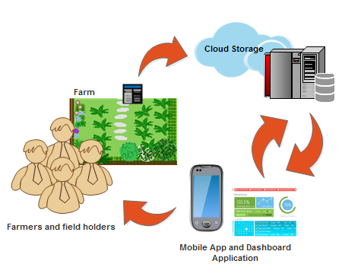
Figure 23: DataFlow with Cloud Storage

- Project Team:
(Please attach the curriculum vitae (CV) of PI and CPI(s). Also attach the CVs of key research/ development personnel if available. Please follow the format included in Annexure A.
The numbers in the table below must tally with the HR Cost sheet in the Budget file.)

Title / Position |  |  | Number
Team Leads (PI) |  |  | 02
Researchers / Developers |  |  | 06
Researcher / Development Assistants |  |  | 08 (UG)
Support Staff |  |  | 02
Technical staff |  |  | 02
Others (please specify)Gardener |  |  | 02
Agriculture Expert |  |  | 01
- Team Structure:
(Please define the team structure (organogram) and role/key responsibilities of each member. If in collaboration with another partner, the division of manpower at various locations of partners be provided.)

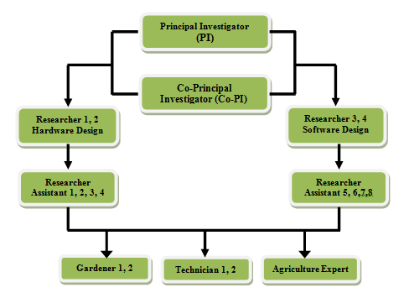
Gardener 1, 2
Agriculture Expert

Title/Position  (of each member) | Role/Key Responsibilities | Minimum Qualification Required | Expertise / Background Required | Minimum Experience Required (years)
Researcher 1, 2 | Hardware Support System design, Wireless Sensor Node design, Wireless Communication Node , Control Node design integration of sub modules | Student of M.E  (EL/ COMP.ARCH) | Good programming skills, circuit designs | 2
Researcher 3, 4 | database design, GUI design, synchronization with database, real time capturing of control signals and secure transmission of commands generated, communication network and protocol design and configuration, data scheduling and future outcome forecasting algorithms. Mobile App design and development, Cloud based Services implementation. | M. E ( COMPUTER SYSTEMS,SOFTWARE) | OOP(object oriented programming),  Database managemnt | 2
Researcher Assistants 1,2,3,4 | Assist researchers in hardware design and development. | B.E (  Electronics/Computer system) | Programming, hardware design and documentation skills | N/A
Research Assistants 5,6 | Assist Researchers in software design and development. | B. E (in progress)  Software/ Computer systems. | Programming, software design and documentation skills Understanding of LATEX. | N/A
Technical Staff 1 | Technician | DAE(Electronic Engineering) | PCB design, Soldering, Electronic Component troubleshooting. | 5
Technical Staff 2 | Technician | DAE(Electrical Engineering) | Capability to handle electric lines, Experience of installation and maintenance. | 5
Gardener 1, 2 | Caretaker of fields | Matric | Good observer of plants growth and environmental conditions | 5
Agriculture Expert 1 | Analyst of field data | Masters in Agriculture preferred Ph.D. | Capable of diving useful conclusions after intense study on environmental observation of fields and guide farmers for enhanced crop output | 5
Accountant | For budget administration | BBA,MBA |  | 2

- Project Activities:
(Please list and describe the main project activities, including those associated with the transfer of the research results to customers/beneficiaries. The timing and duration of research activities are to be shown in the Gantt chart in Section 8.)
The anticipated duration of the project is 24 months and encompasses 7 phases. The major project tasks associated with each phase are described below. For the assigned timings of the different phases and individual tasks please refer to the Gantt charts in section 8.
Phase 1: Survey and Startup (3 - Months).
Tasks:
T1.1: HR and Equipment Procurement
T1.2: Literature survey
T1.3: specification of design
T1.4 Project Management and Planning
Phase 2: Design and Implementation of WSN Nodes (3 - Months).
Tasks:
T2.1: Design Specification of Sensor Node (Hardware).
T2.2: Design Specification of Coordinator Node (Hardware).
T2.3: Design of software flow of Web Application and Relational Database and Document SRS (System Requirements Specification) in the form of report (Software).
T2.4: Decide which software tools to be used acquire complete software packages.
Phase 3: Development of WSN (3 - Months).
Tasks:
T3.1: Design Specification of Power Harvesting Unit (Hardware).
T3.2: Implementation of Sensor node with PCB designs (Hardware).
T3.3: Interfacing sensors with Microcontroller for final integration in sensor node (Hardware)
T3.4: Implementation of Web Application and Database (Software)
Phase 4: Design of Development of Control Module (4 - Months).
Tasks:
T4.1: Design of Control Module to provide users with ease of controlling valves (Hardware).
T4.2: Design and implemented Wi-Fi, GSM and LAN based data transmitting node.
T4.3: Design and develop node programming application (Software).
Phase 5: Design and implementation of Workers and Assets Tracking Module (4 - Months).
Tasks:
T5.1: Implementation of Asset and worker tracking Capabilities with hardware support (Hardware).
T5.2: Finished PCB designs of different hardware modules (Hardware).
T5.3: Development and Testing of Mobile App (Software).
Phase 6: Mobile App Development and Integration with Cloud (4- Months)
T6.1: Complete testing and performance evaluation of individual modules and integrated version.
T6.2: Implement hardware support for Integrating Cloud Services (Hardware).
T6.3: Explore and Implement Cloud based Services for Data on Cloud Integration (Software).
T6.4: Design and develop a dashboard application for cloud based activities (Software).
Phase 7: Finalization and Deployment of the Prototype, Benchmarking and Publications, Training (3 - Months).
Tasks:
T7.1:Detailed Project Documentation
T7.2: Verification and dissipating of Results.
T7.3: Deployment of final prototype.
T7.4: Testing and Training of the System.
- Key Milestones and Deliverables:
(Please list and describe the principal milestones and associated deliverables of the project. A key milestone is reached when a significant phase in the project is concluded, e.g. selection and simulation of algorithms, completion of architectural design and design documents, commissioning of equipment, completion of test, etc.) The timing of milestones is also to be shown in the Gantt chart in Section 8. Quarterly deliverables are preferred.
The information given in this table will be the basis of monitoring and release of funds by the National ICT R&D Fund.
No. | Elapsed time from start (in months) of the project | Milestone | Deliverables
 | 3 months | (Phase-1)  M1.1: Completion of Literature Survey.  M1.2: project design specifications. | D1.1: Thorough literature evaluation of all the hitches and solutions in processes proposed and produce a cost effective design.  D1.2: Detailed synopsis of design strategies and specifications for the upcoming system. A report containing details of various elements with the required specification for the proposed system.
 | 6 months | (Phase-2)  M2.1: Successfully interfaced the sensors and map their readings according to land, weather and crop type under the direction of agricultural expert.  M2.2: Detailed documented SRS (System Requirement Specification) on Web Application design and data analysis algorithm implementation under the guidance of Agriculture Expert. | D2.1: Fully tested sensor interfacing board PCB. Placement of sensor in field with proper wiring. Designed sensor interfaces for kinds of sensors both analog and digital type  D2.2: A report explaining the design procedure, flow charts Used case diagrams and UML diagrams explaining web application.
 | 9 months | (Phase-3)  M3.1: Successful design of sensing node with multiple sensor interfaces and coordinator node design.  M3.2: Complete designed and implemented Power Harvesting Unit equipped with solar panels.  M3.3: Implementation of Web Application and Database (Software). | D3.1: A multipurpose web application with both monitoring and controlling capabilities and database integration.  D3.2: Fully tested real time multitasking software web application.
 | 13 months | (Phase 4)  M4.1: Proper configuration of wireless sensor network (WSN).  M4.2: Successful design and implementation of Server node with Wi-Fi, LAN and GSM supported data transmission.  M4.3: Interactive GUI based node programmer for remote WSN configuration and debugging. Using remote over the air programming.  M4.4: Successful design and implementation of Control Node. | D4.1: Design specifications of different modes of configuration of WSNs.  D4.2: Complete interfaces for different modes of data transmission via LAN, GSM or Wi-Fi in Server node.  D4.3: Testing of the designed programming terminal of nodes.  D4.4: Report describing the working and design of the node programmer.
 | 17 months | (Phase 5)  M5.1: Effectively implemented Asset and worker tracking capabilities.  M5.2: Decision support system to produce intelligent prediction about crop environment and future crop output.  M5.3: Finished PCB designs of major hardware modules.  M5.4: Successful development of Mobile Application for remote user. | D5.1: Introduction of fully developed hardware and software supported asset and worker tracking capabilities.  D5.2: An interactive mobile app for remote viewing of data and control of field.  D5.3: Implementation, testing, debugging and PCB design of integrated version of all nodes.
 | 21 months | (Phase 6)  M6.1: Successful implementation of all Nodes with complete testing.  M6.2: Performance Evaluation and testing of modules.  M6.3: System integration with available Cloud Services.  M6.4: Fully developed dashboard application. | D6.1: Submission of a report analyzing all the observations using flow charts, block diagrams and tables obtained during testing phase.  D6.2: Hardware supported development of software for cloud integration and cloud storage.  D6.3: An interactive dashboard application for user ease of monitoring the fields.
 | 24 months | (Phase 7)  M7.1: Implementation of proposed prototype with complete system integration.  M7.2: Performance evaluation  And system testing in different scenarios.  M7.3: Finalizing the documentation and research paper on prototype with training campaigns for farmers and field holders. | D7.1: Deployment of complete prototype system with useful conclusions along with observed versus calculated data values and comparison of water usage before and after installation of system.  D7.2: A project report with example configurations and testing setups.  D7.3: Final description of complete system with software and its detailed documentation, hardware design details, research papers, will be written and submitted.  D7.4: The final system along with Manual and system dependencies will be forwarded to ICT R & D.
(Please add more rows if required.)

5. Benefits of the Project
- Direct Customers / Beneficiaries of the Project:
(Please identify clearly the potential customers/beneficiaries of the research results and provide details of their relevance, e.g. size, economic contribution, etc.)
The following are direct and indirect beneficiaries of this system:
• Farmers will be left free from the burden of timely observation of the plants and sufficient crops can be cultivated within sufficient time.
• Ordinary people who are consumers will get good quality food and due to their production in abundance, the product will be available at cheap cost.
• Traders will obtain desired amount of crops and goods for retail.
• Industries in different sectors like Agriculture, Food, Electricity, and Electronics will experience mutual benefits.
• Provincial Government and the Government of Pakistan would be facilitated for future decision making and evolving new and effective policies in the field of agriculture.
- Researchers and Agriculturists will have an opportunity to further extend their research and study in the field of agriculture for future quality production of crops.

- Outputs Expected from the Project:
- Assisted farming with productive crop growth.
- Remote monitoring and diagnosis of fields.
- Healthy and quality crops outcome.
- Timely observation and watering of crops.
- Complete design and deployment of Wireless Sensing Network.
- Mobile Application for Remote Monitoring.
- Intelligent Web interface generates alerts on unexpected data.
- Complete Smart Irrigation solution.
- Asset and farmer tracking.
- Abundant water saving.
- Automated watering system via actuated sprinklers.
- Complete power harvesting module design solution.

- Organizational / HRD Outcomes Expected:
The following are the major outcomes expected from this project:
- Graduate/Undergraduate thesis of various students on different modules of system during the process.
- A research lab will be setup for research projects.

- Research based articles/magazines and papers published will provide knowledge for reference to other students who wanted to add extension to the existing system.
- HEC ranking improves if such type of research projects takes place in campus.

- Technology Transfer / Diffusion Approach:
(Please describe how the outputs of the project will be transferred to the direct beneficiaries/customers. Please also state if the project outputs are sustainable, i.e. if they can be utilized without further external assistance.)
<type here>

6. Risk Analysis
- Risks of the Project:
(Please describe the factors that may cause delays in, or prevent implementation of, the project as proposed above; estimate the degree of risk.)
(Please mark ☑ where applicable) | Low | Medium | High
- Technical risk | -  | ❑ | ❑
- Timing risk | -  | ❑ | ❑
- Budget risk | -  | ❑ | ❑

A1. Comments:
<type here>

7. Contractual Matters
- Contractual Obligations under this Project:
(Please indicate any contractual obligations with third parties that will be entered into for this project.)
NIL
- Ownership of Intellectual Property Rights:
All newly developed intellectual property rights arising out of or capable of legal recognition with respect to the projects implemented by the National ICT R&D Fund (The “Company”) shall vest with the Company.

The Company may assign or license its rights in the said intellectual property to any person on such terms as it may deem appropriate.

- Competent Authority of the Principal Investigator’s Organization:
(Documentary proof of the Competent Authority (VC/Rector/CEO..) as being the authorized signatory for the PIO is mandatory for approval of the Project Proposal. Please attach copy of the proof.)
Name:
Designation:
Email:
Date: |  |  | Signature  & stamp:

8. Project Schedule / Milestone Chart

(Project schedule using MS-Project (or similar tools) with all tasks, deliverables, milestones, cost estimates, payment schedules clearly indicated are preferred.)
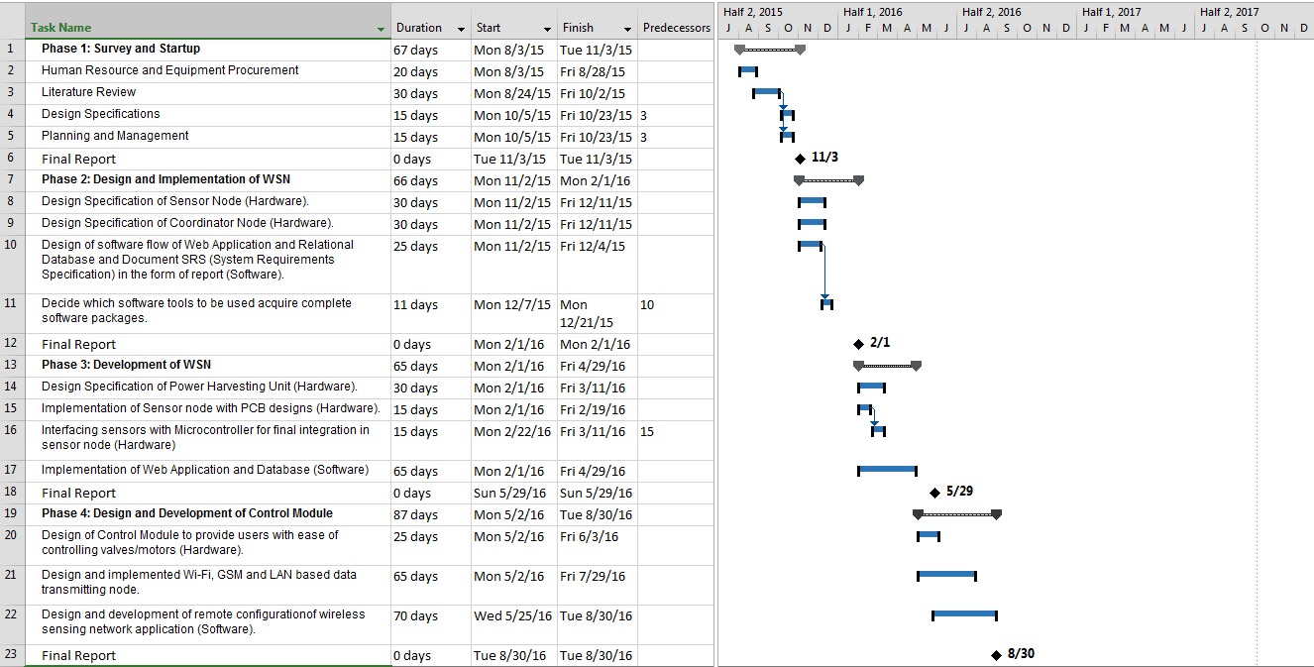
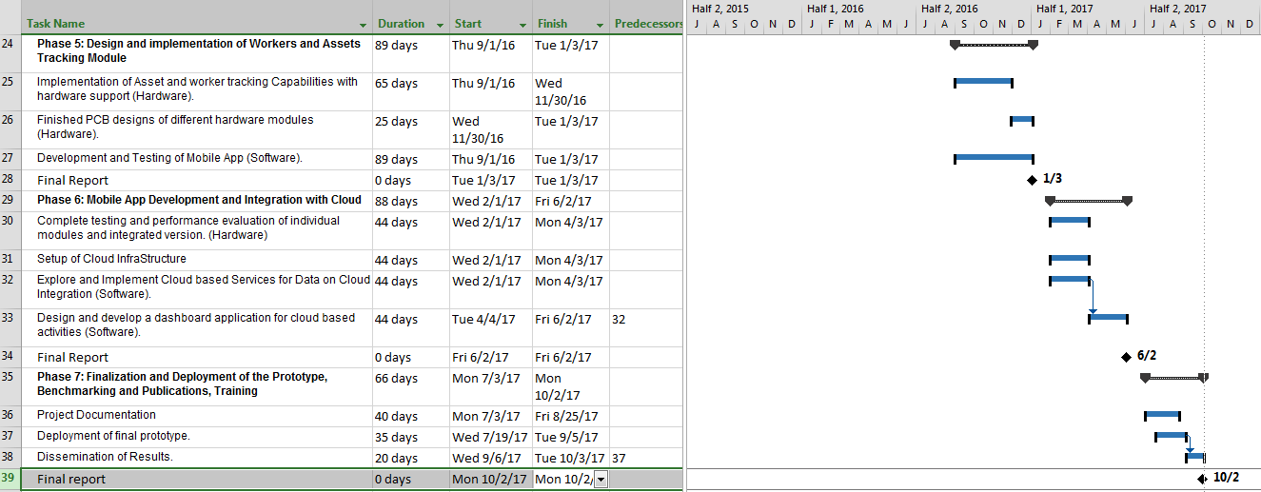

9. Proposed Budget

Please use the embedded Excel Worksheet for providing budget details.

Double click the icon to open the worksheet.



Note: Initial Prototype



Annexure A – Curriculum Vitae

Please provide relevant information and also attach CVs of key research / development personnel (if available) and PI, CPI.
- Professional Information
- Name :
- Title or Position Held :
- Experience : (yrs)
- Email Address :
- Research Papers in Relevant Area
<type here>

- Courses Taught in Relevant Area
<type here>

- Thesis / Projects Supervised in Relevant Area
<type here>

- Grants Received in Relevant Area
<type here>

- Industrial Work Done in Relevant Area
<type here>

Please provide relevant information and also attach CVs of key research / development personnel (if available) and PI, CPI.
- Professional Information
- Name :
- Title or Position Held :
- Experience : (yrs)
- Email Address :
- Research Papers in Relevant Area
<type here>

- Courses Taught in Relevant Area
<type here>

- Thesis / Projects Supervised in Relevant Area
<type here>

- Grants Received in Relevant Area
<type here>

- Industrial Work Done in Relevant Area
<type here>

Bibliography

[1] Muzammil Hussain*, Prof. S. P. Gawate, Prof. Dr. P. S. Prasad, Prof. P. A. Kamble,”
Smart Irrigation System Using WSN and GPRS Module with Three Level Access Mechanisms”, Computer Technology Department PCE Nagpur, Maharashtra, India.

[2]http://www.pbs.gov.pk/sites/default/files//tables/Table%204%20%20Area%20Irrigated%20by %20Different%20Sources.pdf

[3]http://www.finance.gov.pk/survey/chapters_14/Highlights_ES_201314.pdf

[4] Joaquín Gutiérrez, Juan Francisco Villa-Medina, Alejandra Nieto-Garibay, and Miguel Ángel Porta-Gándara” Automated Irrigation System Using a Wireless Sensor Network and GPRS Module” IEEE TRANSACTIONS ON INSTRUMENTATION AND MEASUREMENT, VOL. 63, NO. 1, JANUARY 2014.

[5] XIONG Shu-ming, WANG Liang-min, QU Xiao-qian,ZHAN Yong-zhao “Application Research of WSN in Precise Agriculture Irrigation” Environmental Science and Information Application Technology, 2009. ESIAT 2009. International Conference on (Volume:2 )

[6] Kshitij shinghal, Dr. Arti noor, Dr. Neelam srivastava , Dr. Raghuvir singh, India, “Wireless sensor networks in agriculture: for potato farming”, International Journal of Engineering Science and Technology,Vol. 2(8), 2010, 3955-3963.
[7] Swarup S. Mathurkar, D. S. Chaudhar, “A Review on Smart Sensors Based Monitoring
System for Agriculture”, International Journal of Innovative Technology and Exploring Engineering (IJITEE) ISSN: 2278-3075, Volume-2, Issue-4, March, 2013.

[8] http://www.hindawi.com/journals/ijdsn/si/359423/cfp/

[9] Jyotiranjan Hota1, Pritish Kumar Sinha2,” Scope and challenges of Internet of Things :An Emerging Technological Innovation”, KIIT School of Management, KIIT University
Krishna Campus, Patia, Bhubaneswar, Odisha, India

[10] http://all.net/books/document/secman/Part5.html

[11] Reaping the Benefits of the Internet of Things, Cognizant reports | May 2014

[12] An Overview of Government’s Poverty Alleviation Policies and Programmes
Sarfraz Khan Qureshi, Former Director, Pakistan Institute Of Development Economics
Islamabad, Pakistan

[13] XIONG Shu-ming, WANG Liang-min, QU Xiao-qian,ZHAN Yong-zhao “Application Research of WSN in Precise Agriculture Irrigation” Environmental Science and Information Application Technology, 2009. ESIAT 2009. International Conference on (Volume:2 )

[14] Kshitij shinghal, Dr. Arti noor, Dr. Neelam srivastava , Dr. Raghuvir singh, India, “Wireless sensor networks in agriculture: for potato farming”, International Journal of Engineering Science and Technology,Vol. 2(8), 2010, 3955-3963.

[15] Swarup S. Mathurkar, D. S. Chaudhar, “A Review on Smart Sensors Based Monitoring
System for Agriculture”, International Journal of Innovative Technology and Exploring Engineering (IJITEE) ISSN: 2278-3075, Volume-2, Issue-4, March, 2013.

[16] Case study — United Arab Emirates, “Smart irrigation for sustainable agriculture in Abu Dhabi”

[17] S. Harishankar1, R. Sathish Kumar2, Sudharsan K.P, U. Vignesh and T.Viveknath, “
Solar Powered Smart Irrigation System”, Department of Electrical and Electronics Engineering, Amrita University Ettimadai, Coimbatore, India

[18] Thyagaraju G, Rakshith M ,”Conceptual Design and Implementation of Simulated Version of Context Aware Agricultural Land Monitoring System “, Department of Computer Science & Engineering, SDMIT, Ujire

[19] Warabandi in Pakistan's Canal Irrigation Systems: Widening Gap between Theory and
Practice, By D. J. Bandaragoda, Saeed ur Rehman

[20] Dhawan S. Thakur, Aditi Sharma, Dileep Kumar Sharma, “A Low Cost Design & Monitoring Of Automatic Irrigation System Based On Zigbee Technology”, International Journal of Engineering Research & Technology

[21] Swarup S. Mathurkar, D. S. Chaudhari, “A Review on Smart Sensors Based Monitoring System for Agriculture”, International Journal of Innovative Technology and Exploring Engineering (IJITEE)

[22] Xing ZHEN, * Shen CHANGJUN, Yan HUA, Zhang SHIRUI, “Research and Design of Soil Water Content Sensor Based on High-frequency Capacitive”, National Engineering Research Center for Information Technology in Agriculture, Beijing 100097, China

[23] “Combating Agricultural Pests And Diseases Through Cultural Means”
Abdelrahim Satti, The Experiment, December .2012 Vol. .5(4), 304-314

[24] “Zigbee IEEE 802.15.4 Standard for Building Automation”,Ulya Sabeel*, Saima Maqbool, Nidhi Chandra, International Journal of Advanced Research in Computer Science and Software Engineering, Department of Computer Science and Technology, Amity University, Noida, India.

[25]Baggio, Aline ” Wireless sensor networks in precision agriculture”, In: REALWSN 2005 proceedings, 2005

[26] http://smartirrigationapps.org/

[27] “SoilNet – “A Zigbee based soil moisture sensor network” Project Group, Institute Of Chemistry And Dynamics Of The Geosphere (ICG), Agrosphere Institute, ICG 4, Forschungszentrum Jülich GmbH, 52425 Jülich, http://www.fz-juelich.de/icg/icg-4/index.php.index=739

[28] www.waterbee.eu

[29] “Automated irrigation system for optimizing water consumption and pest detection using wireless sensor networks”,Soundararajan. S, Hemalatha.S, Velammal institute of technology, Panchetti,India

[30] “A Simulation Model for Wireless Sensor Networks Based on TOSSIM”,Francisco J. Rincón, Alexandru E. Şuşu, Marcos Sánchez-Élez, David Atienza,Giovanni de Micheli
DACYA, Complutense University of Madrid (UCM), Madrid, Spain

[31] “Wireless sensor networks in agriculture: for potato farming”, KSHITIJ SHINGHAL Department of E&C Engg., Moradabad Institute of Technology, Moradabad, INDIA.
DR. ARTI NOOR Department of M. Tech. VLSI Design Group, C-DAC, Noida, INDIA
DR. NEELAM SRIVASTAVA Department of E&C Engg., Institute of Engineering & Technology, Lucknow, INDIA. DR. RAGHUVIR SINGH Academic Advisor, Shobhit University, Merrut, INDIA.

[32] “A Review on Precision agriculture using Wireless
Sensor Networks”,Pratibha Gangurde, Department of Computer Engg.Pad. Dr. D.Y. Patil Institute of Engineering and Techology, Pimpri, PunePune, India
Manisha Bhende, Department of Computer Engg.Pad. Dr. D.Y. Patil Institute of Engineering and Techology, Pimpri, Pune
Pune, India

[33]”The state of the world’s land and water resources for food and agriculture managing systems at risk”, Report by The Food and Agriculture Organization of the United Nations and Earthscan

[34] “Solar Powered Smart Irrigation System”, S. Harishankar1, R. Sathish Kumar2, Sudharsan K.P,U. Vignesh and T.Viveknath Department of Electrical and Electronics Engineerin

[35] Solar Powered Gravity-Feed Drip Irrigation System Using
Wireless Sensor Network
Angelina M. Y. Ho, Hawa Ze Jaafar, Ionel Valeriu Grozescu, and Muhammad Zaharul Asyraf Bin
Zaharin

[36] Automated Irrigation System Using a Wireless Sensor Network and GPRS Module Joaquín Gutiérrez, Juan Francisco Villa-Medina, Alejandra Nieto-Garibay, and Miguel Ángel Porta-Gándara

[37]http://www.brooklynfeed.com/2009/05/getting-started-what-you-need-to-grow-vegetables/

[38] http://www.libelium.com/libeliumworld/agriculture/

[39]www.epa.gov/watersense/docs/factsheet_irrigation_controllers508.pdf

[40]irrigationnz.co.nz/about-us/our-work/smart-irrigation

[41] http://waterbee.iris.cat/

[42]www.figaro-irrigation.net/fileadmin/user.../figaro/.../figaro_brochure.pdf

