Software Requirements Specification
for
Node Programmer
Version 1.0 approved
Prepared by Umm-e-Farwa
Koshish Foundation Research Lab,
NED University of Engineering and Technology
<date created>
Table of Contents
Table of Contents ii
Revision History ii
1. Introduction 1
1.1 Purpose 1
1.2 Document Conventions 1
1.3 Intended Audience and Reading Suggestions 1
1.4 Product Scope 1
1.5 References 1
2. Overall Description 2
2.1 Product Perspective 2
2.2 Product Functions 2
2.3 User Classes and Characteristics 2
2.4 Operating Environment 2
2.5 Design and Implementation Constraints 2
2.6 User Documentation 2
2.7 Assumptions and Dependencies 3
3. External Interface Requirements 3
3.1 User Interfaces 3
3.2 Hardware Interfaces 3
3.3 Software Interfaces 3
3.4 Communications Interfaces 3
4. System Features 4
4.1 System Feature 1 4
4.2 System Feature 2 (and so on) 4
5. Other Nonfunctional Requirements 4
5.1 Performance Requirements 4
5.2 Safety Requirements 5
5.3 Security Requirements 5
5.4 Software Quality Attributes 5
5.5 Business Rules 5
6. Other Requirements 5
Appendix A: Glossary 5
Appendix B: Analysis Models 5
Appendix C: To Be Determined List 6

Revision History
Name | Date | Reason For Changes | Version

Introduction

Purpose
Node Programmer is specialized software for customized programming of microcontrollers accompanied by series of Windows Forms to guide naïve user to program the microcontrollers (i.e. a variety of nodes in a broader sense) on button clicks, generate customized code or simply attach sensors on click events. The final version will cover a large domain of applications but major area of focus is Wireless Sensor Networks (WSN) in Agricultural areas.

Document Conventions
The document describes complete characteristics and features offered by the node programmer.
The different conventions used throughout the document are as follows:
MCU- Microcontroller Unit

Intended Audience and Reading Suggestions
This manual is solely intended for agriculturists, farmers, hardware and software developers and software programmers. The manual is prepared to facilitate the users associated to the sector of agriculture. The concept of smart irrigation involves smart sensing node and automated sprinkler systems and to bring this idea to reality, the software application is a tool to configure the different types of nodes and provide customization features according to the application specification.

Product Scope
The objective of the product is to make it possible in the near future to use the different microcontroller’s boards like variety of Arduino Boards, Wireless Communication Modules etc. to facilitate the users with no keen understanding of programming and MCU. The users will be able to configure Wireless Sensor Networks within clicks without any hesitation of writing code as the software is designed to follow easy-to-use approach and with the same simplicity and an environment comparable to that of Arduino. The application is based on Windows IDE into which the different libraries are integrated afterwards together with corresponding entries for the different microcontrollers. The application is then able to compile and burn programs into these microcontrollers on button clicks and users are guide to every step with how-to-proceed instructions.
It is hoped that these microcontrollers can be used for experiments and initiation projects using the embedded technology and especially for programming nodes to form WSNs for testing the system in harsh environment.

References

Overall Description

Product Perspective
The Internet of Things (IoT) has the potential to change the world. "Internet of Things" points out a vision of machines communicating with each other by forming a network, sharing information relevant to their tasks and acting on them with little to no external human interaction. In the nineteenth century, machines learned to do, in the twentieth century, they learned to think, in the twenty-first century they are learning to perceive so they can actually sense and respond to their environment.
The applications of Internet of Things are innumerable. Embedded devices can be in-charge of collecting and distributing information across a network with limited processing capabilities and low power requirements. Among countless applications of the IoT one is known as Smart Irrigation. Through this smart application, the combination of emerging technologies including ubiquitous computing with sensor network can be applied on agriculture domain to make the agriculture smarter.
The purpose of the project is to build a system reliable, efficient, accurate, and user friendly for the farmers of Pakistan. The system aims to design and implement an irrigation system for fields in Pakistan to become efficient in water usage. It also aims to educate clients about their specific irrigation needs and allows them to take advantage of the latest technological innovations available. Ultimately, this system helps the farmer to cultivate healthy crops without stress. In this way, it adds some flexibility to the farmer’s schedule strengthens the plants and helps to maintain good productivity.
The basic layer-wise distribution of the system is as follows:

WSN- a wireless sensor network configured to monitor the fields in harsh environment and collective data from the fields is transmitted to the Server Module which is also part of WSN.

Server Module- comprises of central processing unit to process raw data into useful data set and deal with the outlier detection mechanism thus forwards the maintained data to remote cloud storage over internet.

Remote Cloud Storage- Cloud promises secure data storage and prevents the installation of standalone servers which consumes a lot energy and maintenance. Multiple fields’ data is centrally stored and is available for analytical purposes.
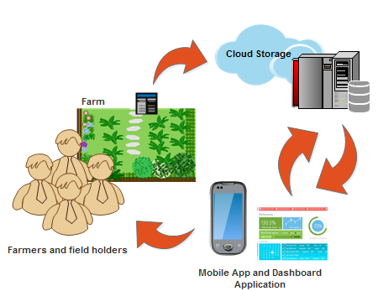

Product Functions

The salient functions and features offered by the Node Programmer are as follows:
- It supports the programming of MCU boards in modular approach.
- It provides assistance to fast set-up WSNs for users interested in critical and testing application.
- Designed to follow easy-to-use approach and integrated user guide.
- It is essentially integrated with the related set of libraries needed for sensors integration.
- Radio modules attachment and customized communication becomes possible.

This software unit is a graphical user friendly interface to provide software compatible hardware support to the sensor board for ease of setting up the system without any keen knowledge of hardware or software. All the complicated tasks are abstracted such as code scripting, real-time exception handling, code writing and logic implementation to the Microcontrollers all within no time thus all the critical tasks that can be troublesome for a naïve user are performed. A flowchart can better explain the application flow.
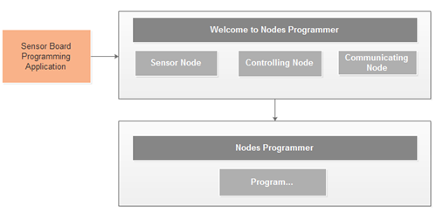

User Classes and Characteristics
The software possesses great attraction for users from all fields of research and scientific development. Code Programmer is made to use for configuring sensor nodes and control nodes server module in a WSN and for educational training purposes. Code Programmer is designed for hardware and software developers, agriculturists and farms for ease of efficient cultivation.

Operating Environment
We suppose to use Windows OS 7 / 8 / 8.1Pro for installing the environment and USB port should be more than 2.0.
Although Windows 8 may not detect the node to be programmed so it is mandatory to disable the signed software driver installation settings before procession.

Design and Implementation Constraints
During the development phase, there will be a need of different MCU to check flexibility of the software. This software has a dependency of arduino-1.0.1 version of Arduino software since underlying set of layers is implemented using the Arduino software files to get MCU board configuration.
All the hardware should be implemented so as to test the software.

User Documentation
The product comes with Node Programmer software, complete user manual/user guide, arduino-1.0.1.

Assumptions and Dependencies
The software has dependency on arduino-1.0.1 version of Arduino software.

External Interface Requirements

User Interfaces
<Describe the logical characteristics of each interface between the software product and the users. This may include sample screen images, any GUI standards or product family style guides that are to be followed, screen layout constraints, standard buttons and functions (e.g., help) that will appear on every screen, keyboard shortcuts, error message display standards, and so on. Define the software components for which a user interface is needed. Details of the user interface design should be documented in a separate user interface specification.>

The software is divided into 3 main windows forms:
- The port and board verifying window.
- The Node selection window.

Next, the series of windows forms depends on the selected node.

For sensor node:
- The sensor attachment window.

For control node:
- The automated sprinklers attachment window.

For Radio Modules:
- The radio modules configuration window to form complete WSN.

For Server Module:
- The communication protocol and interface selection window.
- Data Processing configuration window.

- Finally comes the pin configuration window assembled by the software for integrated development.

Hardware Interfaces
<Describe the logical and physical characteristics of each interface between the software product and the hardware components of the system. This may include the supported device types, the nature of the data and control interactions between the software and the hardware, and communication protocols to be used.>

The first interface deals with the verification of port and board connections and displays if the respective MCU Boards are detected by the corresponding COM Ports. Make sure that the port is in working condition and is not ruptured.

Window 2 deals with the node selection option. Based on the selected node the next window appears.

Software Interfaces
Following are the software interfaces:

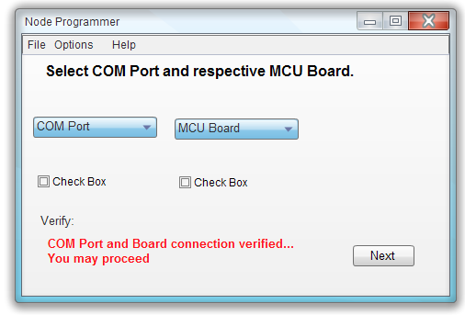
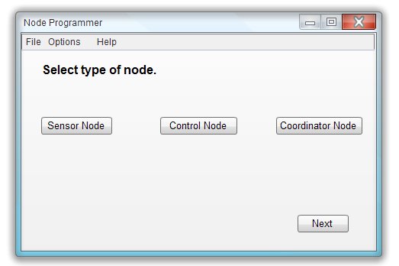
Interface 1:

Interface 2:

Only sensor node’s interfaces are discussed below.

For Sensor Node, Interface 2.1:
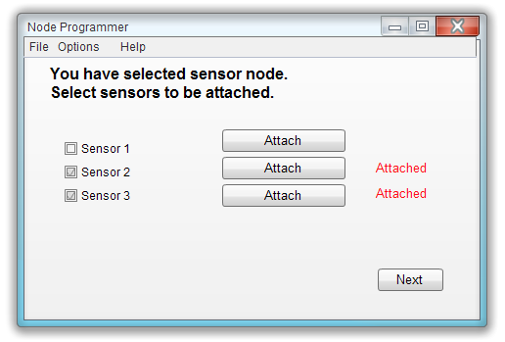

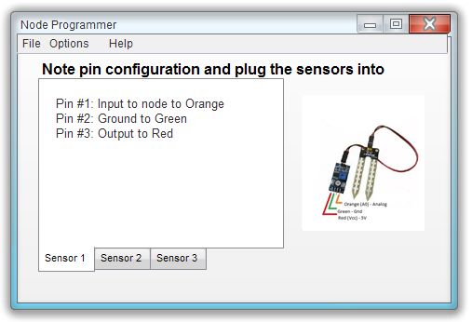
Interface 2.2:

Communications Interfaces
A version of at least 2.0 USB port interface and driver installion is mandatory for programming nodes.

System Features
<This template illustrates organizing the functional requirements for the product by system features, the major services provided by the product. You may prefer to organize this section by use case, mode of operation, user class, object class, functional hierarchy, or combinations of these, whatever makes the most logical sense for your product.>

System Feature 1
<Don’t really say “System Feature 1.” State the feature name in just a few words.>
4.1.1 Description and Priority
<Provide a short description of the feature and indicate whether it is of High, Medium, or Low priority. You could also include specific priority component ratings, such as benefit, penalty, cost, and risk (each rated on a relative scale from a low of 1 to a high of 9).>
4.1.2 Stimulus/Response Sequences
<List the sequences of user actions and system responses that stimulate the behavior defined for this feature. These will correspond to the dialog elements associated with use cases.>
4.1.3 Functional Requirements
<Itemize the detailed functional requirements associated with this feature. These are the software capabilities that must be present in order for the user to carry out the services provided by the feature, or to execute the use case. Include how the product should respond to anticipated error conditions or invalid inputs. Requirements should be concise, complete, unambiguous, verifiable, and necessary. Use “TBD” as a placeholder to indicate when necessary information is not yet available.>

<Each requirement should be uniquely identified with a sequence number or a meaningful tag of some kind.>

REQ-1:
REQ-2:

System Feature 2 (and so on)

Other Nonfunctional Requirements

Performance Requirements
<If there are performance requirements for the product under various circumstances, state them here and explain their rationale, to help the developers understand the intent and make suitable design choices. Specify the timing relationships for real time systems. Make such requirements as specific as possible. You may need to state performance requirements for individual functional requirements or features.>

Safety Requirements
<Specify those requirements that are concerned with possible loss, damage, or harm that could result from the use of the product. Define any safeguards or actions that must be taken, as well as actions that must be prevented. Refer to any external policies or regulations that state safety issues that affect the product’s design or use. Define any safety certifications that must be satisfied.>

Security Requirements
<Specify any requirements regarding security or privacy issues surrounding use of the product or protection of the data used or created by the product. Define any user identity authentication requirements. Refer to any external policies or regulations containing security issues that affect the product. Define any security or privacy certifications that must be satisfied.>

Software Quality Attributes
<Specify any additional quality characteristics for the product that will be important to either the customers or the developers. Some to consider are: adaptability, availability, correctness, flexibility, interoperability, maintainability, portability, reliability, reusability, robustness, testability, and usability. Write these to be specific, quantitative, and verifiable when possible. At the least, clarify the relative preferences for various attributes, such as ease of use over ease of learning.>

Business Rules
<List any operating principles about the product, such as which individuals or roles can perform which functions under specific circumstances. These are not functional requirements in themselves, but they may imply certain functional requirements to enforce the rules.>

Other Requirements
<Define any other requirements not covered elsewhere in the SRS. This might include database requirements, internationalization requirements, legal requirements, reuse objectives for the project, and so on. Add any new sections that are pertinent to the project.>
Appendix A: Glossary
<Define all the terms necessary to properly interpret the SRS, including acronyms and abbreviations. You may wish to build a separate glossary that spans multiple projects or the entire organization, and just include terms specific to a single project in each SRS.>
Appendix B: Analysis Models
<Optionally, include any pertinent analysis models, such as data flow diagrams, class diagrams, state-transition diagrams, or entity-relationship diagrams.>
Appendix C: To Be Determined List
<Collect a numbered list of the TBD (to be determined) references that remain in the SRS so they can be tracked to closure.>

Source: http://www.frontiernet.net/~kwiegers/process_assets/srs_template.doc

