Software Requirements Specification
for
Node Programmer
Version 1.0 approved
Prepared by Umm-e-Farwa
Koshish Foundation Research Lab,
NED University of Engineering and Technology
<date created>
Table of Contents
Table of Contents ii
Revision History ii
1. Introduction 1
1.1 Purpose 1
1.2 Document Conventions 1
1.3 Intended Audience and Reading Suggestions 1
1.4 Product Scope 1
1.5 References 1
2. Overall Description 2
2.1 Product Perspective 2
2.2 Product Functions 2
2.3 User Classes and Characteristics 2
2.4 Operating Environment 2
2.5 Design and Implementation Constraints 2
2.6 User Documentation 2
2.7 Assumptions and Dependencies 3
3. External Interface Requirements 3
3.1 User Interfaces 3
3.2 Hardware Interfaces 3
3.3 Software Interfaces 3
3.4 Communications Interfaces 3
4. System Features 4
4.1 System Feature 1 4
4.2 System Feature 2 (and so on) 4
5. Other Nonfunctional Requirements 4
5.1 Performance Requirements 4
5.2 Safety Requirements 5
5.3 Security Requirements 5
5.4 Software Quality Attributes 5
5.5 Business Rules 5
6. Other Requirements 5
Appendix A: Glossary 5
Appendix B: Analysis Models 5
Appendix C: To Be Determined List 6

Revision History
Name | Date | Reason For Changes | Version

Introduction

Purpose
Node Programmer is specialized software for customized programming of microcontrollers accompanied by series of Windows Forms to guide naïve user to program the microcontroller on button clicks, write customized code or simply attach sensors on click events. The final version will cover a large domain of applications.

Document Conventions
The document describes complete characteristics and features offered by the node programmer.
The different conventions used throughout the document are as follows:
MCU- Microcontroller Unit

Intended Audience and Reading Suggestions
<Describe the different types of reader that the document is intended for, such as developers, project managers, marketing staff, users, testers, and documentation writers. Describe what the rest of this SRS contains and how it is organized. Suggest a sequence for reading the document, beginning with the overview sections and proceeding through the sections that are most pertinent to each reader type.>

This manual is solely intended for agriculturists, farmers, developers, hardware, and software programmers. The manual is prepared to facilitate the users associated to the sector of agriculture. The concept of smart irrigation comprises the smart sensing node and automated sprinkler systems and to bring this idea to reality, the software application is a tool to configure the different types of nodes and provide customization features according to the application specification.

Product Scope
<Provide a short description of the software being specified and its purpose, including relevant benefits, objectives, and goals. Relate the software to corporate goals or business strategies. If a separate vision and scope document is available, refer to it rather than duplicating its contents here.>
The objective of the product is to make it possible in the near future to use the different microcontroller’s boards like variety of Arduino Boards, Wireless Communication Modules etc. The users will be able to configure Wireless Sensor Networks within clicks without any hesitation of writing code as the software is designed to follow easy-to-use approach and with the same simplicity and an environment comparable to that of Arduino. The application is based on Windows IDE into which the different libraries are integrated afterwards together with corresponding entries for the different microcontrollers. The application is then able to compile and burn programs into these microcontrollers on button clicks and users are guide to every step with how-to-proceed instructions.
It is hoped that these microcontrollers can be used for experiments and initiation projects using the embedded technology and especially for programming nodes to form WSNs for testing the system in harsh environment.

References
<List any other documents or Web addresses to which this SRS refers. These may include user interface style guides, contracts, standards, system requirements specifications, use case documents, or a vision and scope document. Provide enough information so that the reader could access a copy of each reference, including title, author, version number, date, and source or location.>

Overall Description

Product Perspective
<Describe the context and origin of the product being specified in this SRS. For example, state whether this product is a follow-on member of a product family, a replacement for certain existing systems, or a new, self-contained product. If the SRS defines a component of a larger system, relate the requirements of the larger system to the functionality of this software and identify interfaces between the two. A simple diagram that shows the major components of the overall system, subsystem interconnections, and external interfaces can be helpful.>

The Internet of Things (IoT) has the potential to change the world. "Internet of Things" points out a vision of machines communicating with each other by forming a network, sharing information relevant to their tasks and acting on them with little to no external human interaction. In the nineteenth century, machines learned to do, in the twentieth century, they learned to think, in the twenty-first century they are learning to perceive so they can actually sense and respond to their environment.
The applications of Internet of Things are innumerable. Embedded devices can be in-charge of collecting and distributing information across a network with limited processing capabilities and low power requirements. Among countless applications of the IoT one is known as Smart Irrigation. Through this smart application, the combination of emerging technologies including ubiquitous computing with sensor network can be applied on agriculture domain to make the agriculture smarter.
The purpose of the project is to build a system reliable, efficient, accurate, and user friendly for the farmers of Pakistan. The system aims to design and implement an irrigation system for fields in Pakistan to become efficient in water usage. It also aims to educate clients about their specific irrigation needs and allows them to take advantage of the latest technological innovations available. Ultimately, this system helps the farmer to cultivate healthy crops without stress. In this way, it adds some flexibility to the farmer’s schedule strengthens the plants and helps to maintain good productivity.
The basic layer-wise distribution of the system is as follows:

WSN- a wireless sensor network configured to monitor the fields in harsh environment and collective data from the fields is transmitted to the Server Module which is also part of WSN.

Server Module- comprises of central processing unit to process raw data into useful data set and deal with the outlier detection mechanism thus forwards the maintained data to remote cloud storage over internet.

Remote Cloud Storage- Cloud promises secure data storage and prevents the installation of standalone servers which consumes a lot energy and maintenance. Multiple fields’ data is centrally stored and is available for analytical purposes.

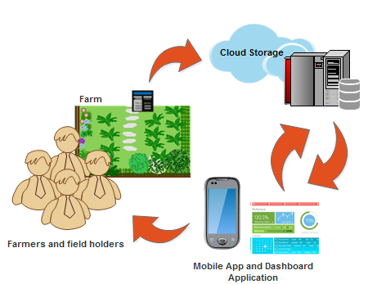

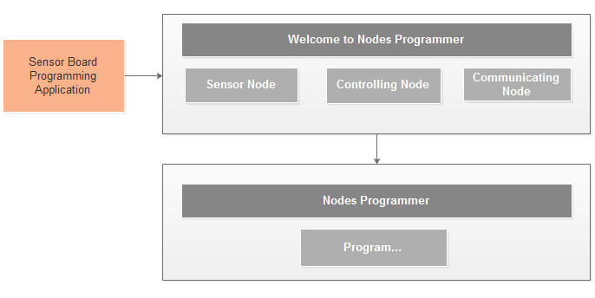

Product Functions
<Summarize the major functions the product must perform or must let the user perform. Details will be provided in Section 3, so only a high level summary (such as a bullet list) is needed here. Organize the functions to make them understandable to any reader of the SRS. A picture of the major groups of related requirements and how they relate, such as a top level data flow diagram or object class diagram, is often effective.>

The salient functions and features offered by the Node Programmer are as follows:
- It supports the programming of MCU boards in modular approach.
- It provides assistance to fast set-up WSNs for users interested in critical and testing application.
- Designed to follow easy-to-use approach and integrated user guide.
- It is essentially integrated with the related set of libraries needed for sensors integration.
- Radio modules attachment and customized communication becomes possible.

This software unit is a graphical user friendly interface to provide software compatible hardware support to the sensor board for ease of setting up the system without any keen knowledge of hardware or software. All the complicated tasks are abstracted such as code scripting, real-time exception handling, code writing and logic implementation to the Microcontrollers all within no time thus all the critical tasks that can be troublesome for a naïve user are performed. A flowchart can better explain the application flow.
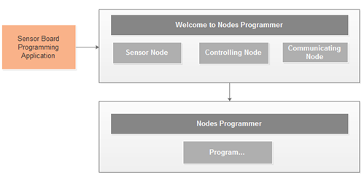

User Classes and Characteristics
<Identify the various user classes that you anticipate will use this product. User classes may be differentiated based on frequency of use, subset of product functions used, technical expertise, security or privilege levels, educational level, or experience. Describe the pertinent characteristics of each user class. Certain requirements may pertain only to certain user classes. Distinguish the most important user classes for this product from those who are less important to satisfy.>

The software possesses great attraction for users from all fields of research and scientific development. Code Programmer is made to use for configuring sensor nodes and control nodes server module in a WSN and for educational training purposes. Code Programmer is designed for hardware and software developers, agriculturists and farms for ease of efficient cultivation.

Operating Environment
<Describe the environment in which the software will operate, including the hardware platform, operating system and versions, and any other software components or applications with which it must peacefully coexist.>

We suppose to use Windows OS 7 / 8 / 8.1Pro for installing the environment and USB port should be more than 2.0.
Although Windows 8 may not detect the node to be programmed so it is mandatory to disable the signed software driver installation settings before procession.

Design and Implementation Constraints
<Describe any items or issues that will limit the options available to the developers. These might include: corporate or regulatory policies; hardware limitations (timing requirements, memory requirements); interfaces to other applications; specific technologies, tools, and databases to be used; parallel operations; language requirements; communications protocols; security considerations; design conventions or programming standards (for example, if the customer’s organization will be responsible for maintaining the delivered software).>

User Documentation
<List the user documentation components (such as user manuals, on-line help, and tutorials) that will be delivered along with the software. Identify any known user documentation delivery formats or standards.>

Assumptions and Dependencies
<List any assumed factors (as opposed to known facts) that could affect the requirements stated in the SRS. These could include third-party or commercial components that you plan to use, issues around the development or operating environment, or constraints. The project could be affected if these assumptions are incorrect, are not shared, or change. Also identify any dependencies the project has on external factors, such as software components that you intend to reuse from another project, unless they are already documented elsewhere (for example, in the vision and scope document or the project plan).>

External Interface Requirements

User Interfaces
<Describe the logical characteristics of each interface between the software product and the users. This may include sample screen images, any GUI standards or product family style guides that are to be followed, screen layout constraints, standard buttons and functions (e.g., help) that will appear on every screen, keyboard shortcuts, error message display standards, and so on. Define the software components for which a user interface is needed. Details of the user interface design should be documented in a separate user interface specification.>

Hardware Interfaces
<Describe the logical and physical characteristics of each interface between the software product and the hardware components of the system. This may include the supported device types, the nature of the data and control interactions between the software and the hardware, and communication protocols to be used.>

Software Interfaces
<Describe the connections between this product and other specific software components (name and version), including databases, operating systems, tools, libraries, and integrated commercial components. Identify the data items or messages coming into the system and going out and describe the purpose of each. Describe the services needed and the nature of communications. Refer to documents that describe detailed application programming interface protocols. Identify data that will be shared across software components. If the data sharing mechanism must be implemented in a specific way (for example, use of a global data area in a multitasking operating system), specify this as an implementation constraint.>

Communications Interfaces
<Describe the requirements associated with any communications functions required by this product, including e-mail, web browser, network server communications protocols, electronic forms, and so on. Define any pertinent message formatting. Identify any communication standards that will be used, such as FTP or HTTP. Specify any communication security or encryption issues, data transfer rates, and synchronization mechanisms.>

System Features
<This template illustrates organizing the functional requirements for the product by system features, the major services provided by the product. You may prefer to organize this section by use case, mode of operation, user class, object class, functional hierarchy, or combinations of these, whatever makes the most logical sense for your product.>

System Feature 1
<Don’t really say “System Feature 1.” State the feature name in just a few words.>
4.1.1 Description and Priority
<Provide a short description of the feature and indicate whether it is of High, Medium, or Low priority. You could also include specific priority component ratings, such as benefit, penalty, cost, and risk (each rated on a relative scale from a low of 1 to a high of 9).>
4.1.2 Stimulus/Response Sequences
<List the sequences of user actions and system responses that stimulate the behavior defined for this feature. These will correspond to the dialog elements associated with use cases.>
4.1.3 Functional Requirements
<Itemize the detailed functional requirements associated with this feature. These are the software capabilities that must be present in order for the user to carry out the services provided by the feature, or to execute the use case. Include how the product should respond to anticipated error conditions or invalid inputs. Requirements should be concise, complete, unambiguous, verifiable, and necessary. Use “TBD” as a placeholder to indicate when necessary information is not yet available.>

<Each requirement should be uniquely identified with a sequence number or a meaningful tag of some kind.>

REQ-1:
REQ-2:

System Feature 2 (and so on)

Other Nonfunctional Requirements

Performance Requirements
<If there are performance requirements for the product under various circumstances, state them here and explain their rationale, to help the developers understand the intent and make suitable design choices. Specify the timing relationships for real time systems. Make such requirements as specific as possible. You may need to state performance requirements for individual functional requirements or features.>

Safety Requirements
<Specify those requirements that are concerned with possible loss, damage, or harm that could result from the use of the product. Define any safeguards or actions that must be taken, as well as actions that must be prevented. Refer to any external policies or regulations that state safety issues that affect the product’s design or use. Define any safety certifications that must be satisfied.>

Security Requirements
<Specify any requirements regarding security or privacy issues surrounding use of the product or protection of the data used or created by the product. Define any user identity authentication requirements. Refer to any external policies or regulations containing security issues that affect the product. Define any security or privacy certifications that must be satisfied.>

Software Quality Attributes
<Specify any additional quality characteristics for the product that will be important to either the customers or the developers. Some to consider are: adaptability, availability, correctness, flexibility, interoperability, maintainability, portability, reliability, reusability, robustness, testability, and usability. Write these to be specific, quantitative, and verifiable when possible. At the least, clarify the relative preferences for various attributes, such as ease of use over ease of learning.>

Business Rules
<List any operating principles about the product, such as which individuals or roles can perform which functions under specific circumstances. These are not functional requirements in themselves, but they may imply certain functional requirements to enforce the rules.>

Other Requirements
<Define any other requirements not covered elsewhere in the SRS. This might include database requirements, internationalization requirements, legal requirements, reuse objectives for the project, and so on. Add any new sections that are pertinent to the project.>
Appendix A: Glossary
<Define all the terms necessary to properly interpret the SRS, including acronyms and abbreviations. You may wish to build a separate glossary that spans multiple projects or the entire organization, and just include terms specific to a single project in each SRS.>
Appendix B: Analysis Models
<Optionally, include any pertinent analysis models, such as data flow diagrams, class diagrams, state-transition diagrams, or entity-relationship diagrams.>
Appendix C: To Be Determined List
<Collect a numbered list of the TBD (to be determined) references that remain in the SRS so they can be tracked to closure.>

Source: http://www.frontiernet.net/~kwiegers/process_assets/srs_template.doc

