* **Brief Overview**

Prototype will be having three additional parts which will be integrated at the end along with the minimization of kit.

1. Solar operated connectivity.
2. Automation of water pump switching.
3. Automatic watering through sprinklers.

* **Solar Operated:**

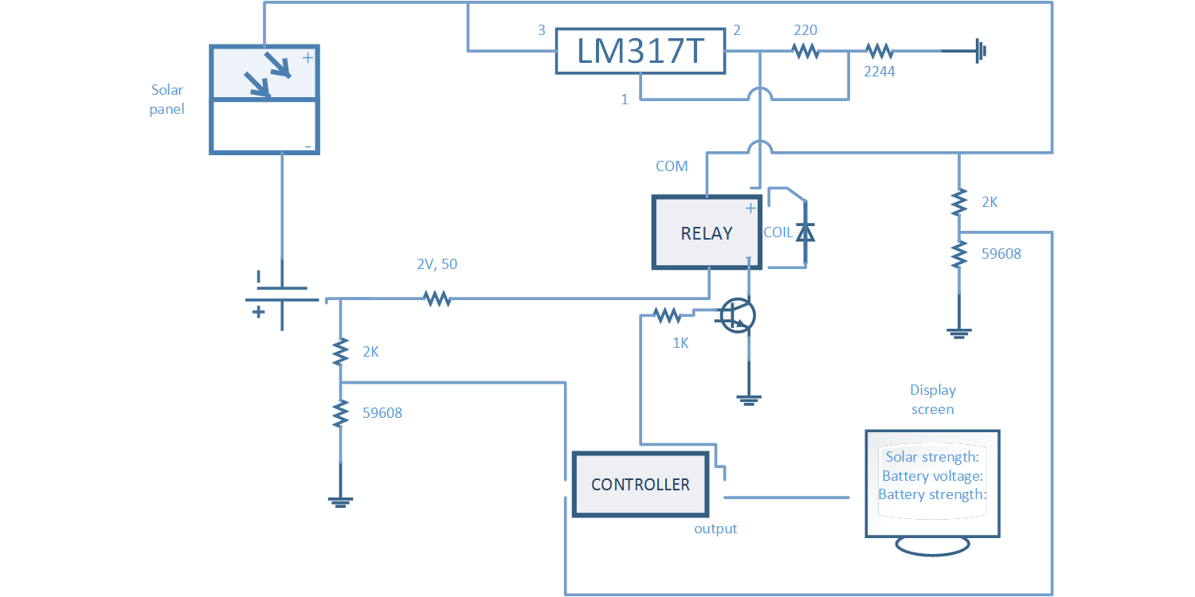**Explanation:**

Solar panel will be receiving energy from sun which will be transformed into electrical energy. The –ve part of the panel will be connected to cathode of 12V battery. The +ve part will be further divided into two parallel connections:

* One will be going through voltage regulator which will be energize the one side of relay coil.
* Another one will be directly going through COM port of relay.

Two VDRs’ are used to map the voltage within 5V for controller to keep the check of the strength. A flywheel diode will be connected in reverse of the polarity of coil to give protection all of the connected components to relay. Controller’s output will be connected through switching circuit of transistor using NPN. As soon as the controller give HIGH, battery will be stop charging. The controller will further display the different status of the components.

* **Automation of water pump switching:**

**Explanation:**

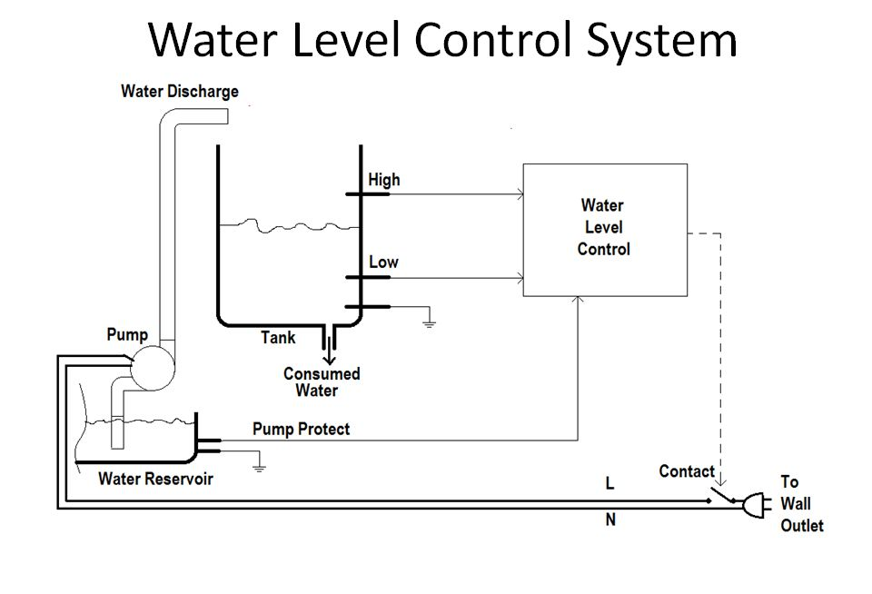

This is a relay controlled circuit with a switching transistor connected along to the output of controller. The pump will be operated by Vac, though. Relay will be turned on as soon as the tank will reach to the lower electrode, representing the lower portion of water has been reached, filling up the tank again till top up till the higher electrode representing the higher portion of tank.

A safety circuit will also be connected with underground tank to make sure when to turn on the pump exactly.

* **Automatic watering through sprinklers:**

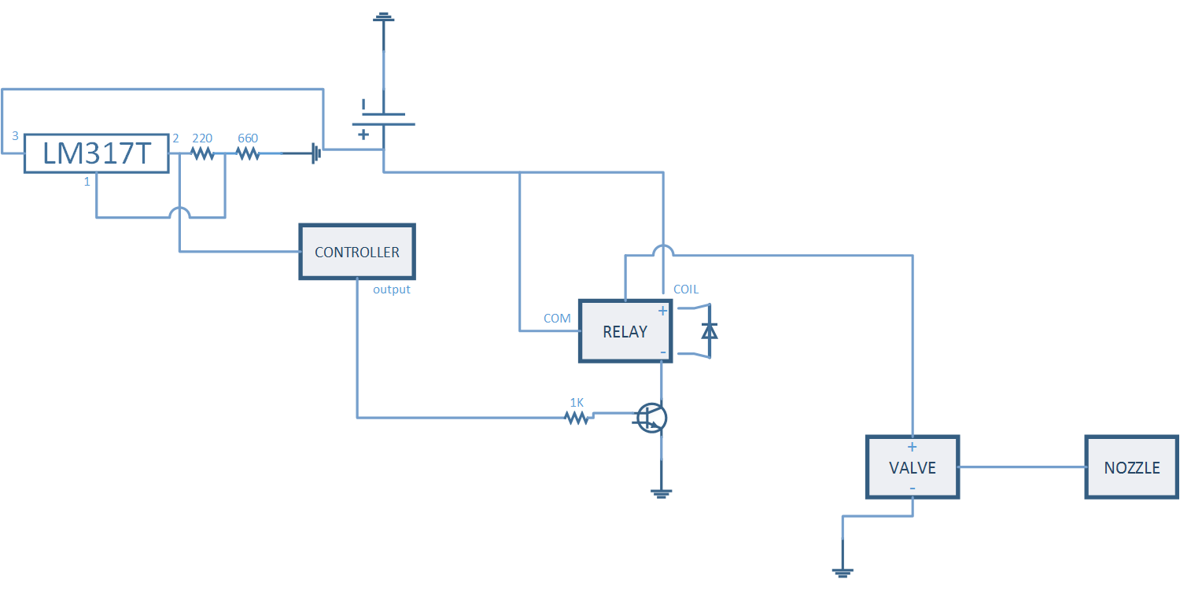**Explanation:**

This is also controlled by relay and switching transistor with help of controller. The voltage will be regulated through voltage regulator to limit the voltage for controlling the controller. The relay will further control valve and a nozzle will be attached to it to act as a sprinkler.