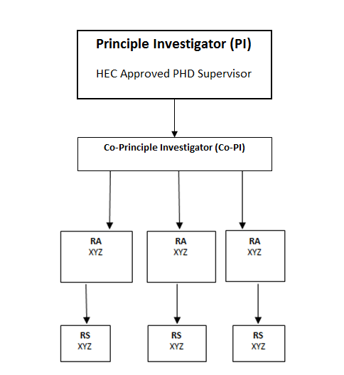

**Principle Investigator (PI)**

HEC Approved PHD Supervisor

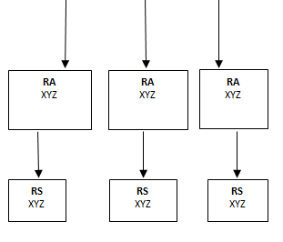

**Co-Principle Investigator (Co-PI)**