**NED University of Engineering & Technology**

**Computer Information & Systems Engineering**

Intelligent & Automated Irrigation System

Irrigation system is critical in the development of agriculture of every country. At Present, the application of the IoT develops rapidly so by integrating modern technologies in irrigation management systems is one of the ways of enhancing the irrigation processes to optimize the use of water, electric power consumption, and labor costs.

# Introduction

Agriculture plays an important role directly and indirectly in generating Economic growth. It provides food to consumers and fibers for domestic industry. It is a Source of scarce foreign exchange earnings and provides market for industrial goods. Agriculture is the backbone of Pakistan. Half of the population’s direct source of income is agriculture. Agriculture is facing a lot of problems nowadays, which is resulting in increase in poverty ratio every year [1].

In 1947, the 53% GDP of Pakistan based on agriculture but later slowly and gradually it deceased to 23% at the current stage [1] [2]. A major part of the economy depends on farming through production, processing and distribution of major agricultural commodities. About 65% of population of Pakistan live in villages and is dependent on agriculture formally or informally [3] [4]. Though the agricultural sector is facing problems in Pakistan yet the major chunk of money comes from this sector. Following are the major causes of agricultural problems in Pakistan which disturb the agricultural growth or development in Pakistan [5] [6].

* No mechanism has been adopted to eradicate the soil erosion and even after harvesting nothing is done to improve or restore the soil energy. Therefore, the fertility of soil is decreasing day by day.
* Water wastage is very high in our country. The archaic method of flood irrigation is still in practice in whole of the country which wastes almost 50 to 60 per cent of water.
* Owing to old methods of cultivation and harvesting, Pakistan has low per acre yield.
* Water logging and salinity is increasing day by day.
* Pesticides detection
* Farmer has to travel to offices of agricultural department for information. This is a costly and time consuming activity.
* Radio or TV programs are broadcast at a predefined schedule which may or may not be convenient for the farmer.
* Field agents of pesticide or seed companies are unable to pay frequent and timely visits to all farmers.

# Target Sector

Mainly we want to target water wastage because agriculture uses 85% of available freshwater resources worldwide, and this percentage will continue to be dominant in water consumption because of population growth and increased food demand [7]. Since fresh water resources are decreasing, therefore we should make the efficient use of it [8]. There is an urgent need to create strategies based on science and technology for sustainable use of water [9] [10]. Daily water reservoirs in Pakistan are decreasing its available storage. The lacking of dams and other reservoirs results in drought sometimes. It not only destroys the green fields but livestock and a threat to human lives. The construction of new dams/reservoir needs a lot of investment and time whereas this necessity of saving water can be achieved by the use of digital & precise auto-irrigation or smart irrigation system[11],[7],[8]. The development of precision agriculture is a significant strategic choice of agriculture and agricultural science development worldwide [11]-[13].

These targets can be achieved by the current state of the art technology i.e. “Internet of Things” [14], [15].

The "Internet of Things" refers to the concept that the Internet is no longer just a global network for people to communicate with one another using computers, but it is also a platform for devices to communicate electronically with each other and as well as with all the things present in its environment[14]-[16].

It is under worldwide research and the fact is analyzed the upcoming era will be flourished by the implementation of IoT. From the development of smart grid to the remote monitoring health system, including home automation, object tracking, GPS monitoring & precision and agriculture [6].it has played a vital role to serve the humanity.

# Needs & Benefits

The most efficient use of fresh water is burning need of the time. Therefore efficient and intelligent irrigation management is a major concern in agriculture. People are working on automatic and intelligent irrigation systems because of their greater advantages specially in labor and water saving [16], in this sector wireless technology is most suitable choice to develop irrigation network and it is now become a significant topic of research [7].

Through the application of this system, on one hand, the cost can be greatly reduced, and on the other hand, water and electricity can be saved. It directly benefits the increase in healthy food production.

# Methodology and System Architecture

We can implement automated irrigation system by measuring different parameters like ambient temperature, canopy temperature, soil moisture, humidity & weather forecast in a real time [17][18].Crop irrigation needs can also be determined by evapotranspiration process, electromagnetic sensors and evaporimeter for measuring soil moisture.by using them the developed systems saved water up to 42-53% as compared to conventional methods [19]-[22] .

The idea is to design a Wireless Sensing Network (WSN) that employs various sensors which measure above mentioned parameters [23]-[25]. Acquisition model receives the data from WSN nodes and process by the processing module to take decision if the there is a need of water by the crops or not and switch ON/OFF the pumps as and when necessary. It also defines the proper quantity of water to be injected. The filtered history log is uploaded onto the server to take intelligent decisions, where it will be shared to handheld sets. The user will be updated about the water level in farms and can manually control the irrigation system too

The system is powered by power harvesting module utilizing solar panels. And make the efficient use of energy by power management schemes [26], [27].

Mobile cloud computing

Operational body

**Block Diagram Modules Explanation**

## 1: Power Harvesting

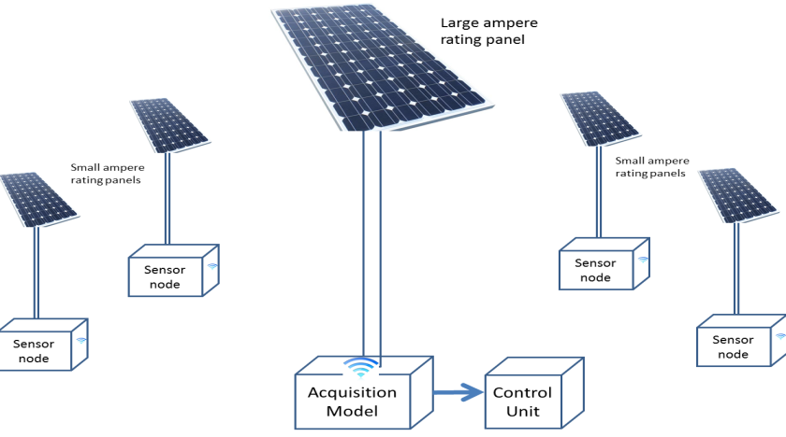The ambient energy sources like (solar, wind, thermal, environmental vibration etc.) converted into useable electrical energy this phenomenon called power harvesting. [28], [29]. Method of utilizing solar energy to pump irrigation water is to convert the energy directly into electricity through a device called a photovoltaic, or solar, cell. Focusing in the field of agriculture, the most appropriate energy source is wind and solar.

### Solar Energy

Discussing the use of solar energy source and the way to implement its harvesters we should not ignore the fact of cost effectiveness, durability & reliability [32], [33]. The technology is based on photo-electric effect in which photo-voltaic cells combine in series and parallel combination provide a power .Since water irrigation is not the every time need, so there is no need of any battery backup for night time. Water can be supplied in day time only and it is more than enough for plants.

Taking a broader view of the field where multiple panels above sensor nodes are attached and a central acquisition model with control unit holding a high ampere rating panel to power the water pump including acquisition model.

### Wind Energy

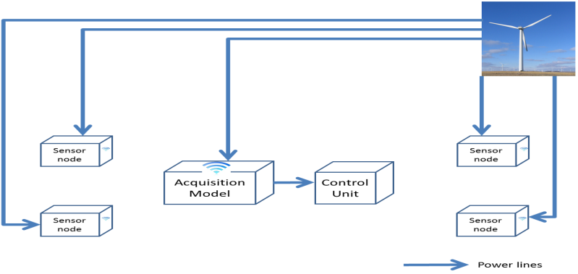Now coming to the second approach of wind energy, it would be less expensive to invest to produce huge electrical energy, but it would include mechanical maintenance costs and it is very hazardous in the areas that are affected by hurricane or tornadoes following schematic will help you to understand the power distribution easily

But the main problem in using the wind energy is that the distribution of power lines does not let us to make the smart precision agriculture system purely wireless.

2: **Operational Body (WSN, Data Acquisition & Processing module (AP), Control System (CS**)

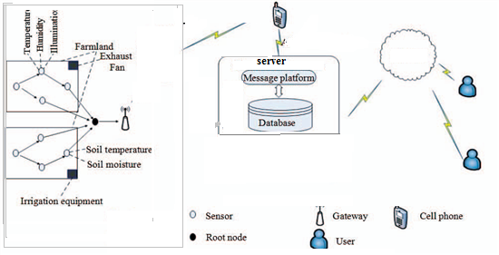As a novel technology of information acquisition and processing, WSN possesses a great strategic meaning in overall improving the modernize level of precision agriculture [34]-[37].

The field irrigation management system is an important element of agricultural activity.

After literature survey we find that Wireless Sensor Network (WSN) is the most preferred platform due to its small size, low power consumption, reduced maintenance, great flexibility, portability and scalability features. Many WSN based system is proposed to provide optimized water supply [38]-[40].

A wireless sensor network is a collection of nodes organized into a cooperative network. Each node consists of process capability can contain various types of memory with an RF transceiver, having a power source (e.g. batteries and solar cells), and accommodate multiple sensors. The data

Stream ends at special nodes called base stations (sometimes they are also known as sinks). A base station connects the sensor network to another network (like a gateway) to disseminate data for further processing.

The AP module will be single board computer which has communication link with server and hand held devices. All the data is accumulated in AP module and after applying data mining/filtering algorithms it takes the decision and transmits signals to control system. It is microcontroller based system that derived water pumps/showers [39], [41].

## 3: Cloud, Server & Handheld Device

We aim to introduce information technology (IT) into agricultural practices in our country.

In agriculture sector ,For weather forecasting , Farmers Education and Awareness, Crop Advice and Analysis, available resources (water, seeds, fertilizers),market demands , intelligent decision making, For machine-to-machine communication and for controlling devices(pumps etc.) remotely, worldwide many work has done using cloud computing ,history log management and hand held devices[42]-[44].This can be regarded as “Mobile Cloud Computing” [45]. We will use the same technology in our system.

**Conclusion**

Through modular design approach, the proposed system builds hierarchical management structure to meet different application requirements. This system will be very economical in terms of the hardware cost, power consumption. Our proposed system is the application of modern IoT technology that is being implemented worldwide introducing “Internet of Things” first time in Pakistan through this smart irrigation system that is likely expected to give a boost in Pakistan agriculture sector.

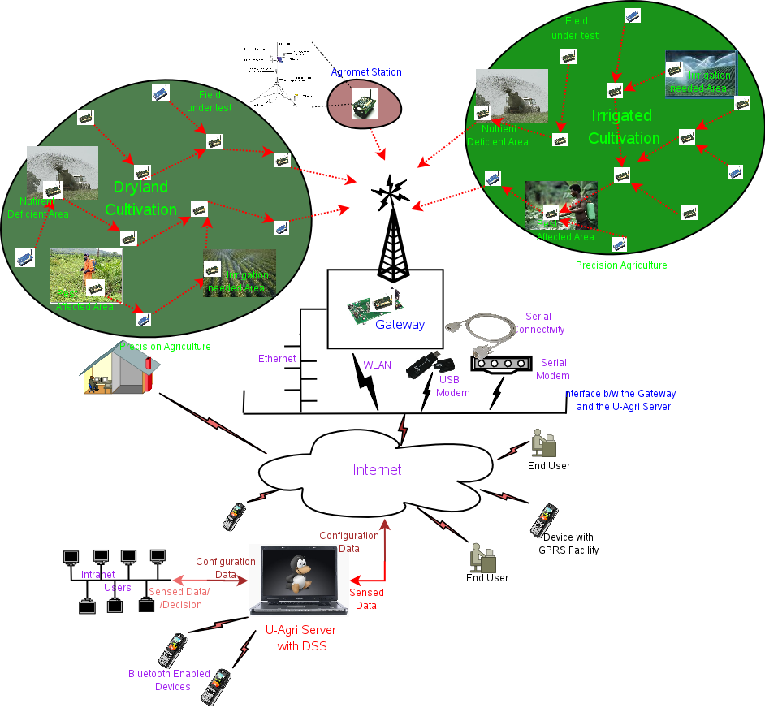

**Ubiquitous Agriculture [46]**

**References:**

[1]:http://en.wikipedia.org/wiki/Economy_of_Pakistan

[2]:<http://en.wikipedia.org/wiki/Agriculture_in_Pakistan>

[3]:[http://siteresources.worldbank.org/PAKISTANEXTN/Resources/293051-1241610364594/6097548-s1257441952102/balochistaneconomicreportvol2.pdf](http://siteresources.worldbank.org/PAKISTANEXTN/Resources/293051-1241610364594/6097548-1257441952102/balochistaneconomicreportvol2.pdf)

[4]: <http://prr.hec.gov.pk/Chapters/695S-3.pdf>

[5]: Muhammad Iqbal and Munir Ahmad” SCIENCE & TECHNOLOGY BASED AGRICULTURE VISION OF PAKISTAN AND PROSPECTS OF GROWTH “

[6]:Fawad Zafar Ahmad Khan, Muhammad Sagheer,Mansoor ul Hasan,Hafiza Tahira Gul,Feehan Hassan,Syed Amir Manzoor,Atif Wahid” GRICULTURAL DYNAMICS IN PAKISTAN: CURRENT ISSUES AND SOLUTIONS” Russian Journal of Agricultural and Socio-Economic Sciences, 8(20) 2013.

[7]: Joaquín Gutiérrez, Juan Francisco Villa-Medina, Alejandra Nieto-Garibay, and Miguel Ángel Porta-Gándara” Automated Irrigation System Using a Wireless Sensor Network and GPRS Module” IEEE TRANSACTIONS ON INSTRUMENTATION AND MEASUREMENT, VOL. 63, NO. 1, JANUARY 2014.

[8]:development of research programme in Pakistan related to irrigation and drainage by Food and Agriculture Organization of the United Nations(FAO).<ftp://ftp.fao.org/agl/iptrid/PFR_9.pdf>.

[9]:<http://www.who.int/water_sanitation_health/takingcharge.html>.

[10]:Ali AL-HAMDI, Muhammad AKRAM, Ahmed Monjurul HASAN”Development of an ICT-based layer model for improving managerial decision making on water issuesin arid and semi-arid regions” International Journal of Computer and Information Technology (ISSN: 2279 –0764) Volume 01–Issue 02, November 2012.

[11]: [1] XIONG Shu-ming, WANG Liang-min, QU Xiao-qian,ZHAN Yong-zhao “Application Research of WSN in Precise Agriculture Irrigation” [Environmental Science and Information Application Technology, 2009. ESIAT 2009. International Conference on](http://ieeexplore.ieee.org/xpl/mostRecentIssue.jsp?punumber=5199613)  (Volume:2 )

[12]: AlineBaggio, (2004), “Wireless sensor networks in precision agriculture”, The Netherlands IEEE Pervasive Computing, 3(1):38–45, Jan-Mar 2004

[13]: Jonathan Jao, Bo Sun*, KuiWu,”A Prototype Wireless Sensor Network for PrecisionAgriculture”2013 IEEE 33rd International Conference on Distributed Computing Systems Workshops.

[14]: Vision and Challengesfor Realising the Internet of Things(cluster of European research projects on IoT) [https://www.google.com.pk/search?q=wireless+sensing+network+in+irrigation&source=lnms&sa=X&ei=oFilU5SVNuuR1AXig4CADQ&ved=0CAUQ_AUoAA&biw=1150&bih=520&dpr=1.1#](https://www.google.com.pk/search?q=wireless+sensing+network+in+irrigation&source=lnms&sa=X&ei=oFilU5SVNuuR1AXig4CADQ&ved=0CAUQ_AUoAA&biw=1150&bih=520&dpr=1.1).

[15]: “Internet of Things: Converging Technologies for Smart Environments and Integrated Ecosystems”[https://www.google.com.pk/search?q=wireless+sensing+network+in+irrigation&source=lnms&sa=X&ei=oFilU5SVNuuR1AXig4CADQ&ved=0CAUQ_AUoAA&biw=1150&bih=520&dpr=1.1#](https://www.google.com.pk/search?q=wireless+sensing+network+in+irrigation&source=lnms&sa=X&ei=oFilU5SVNuuR1AXig4CADQ&ved=0CAUQ_AUoAA&biw=1150&bih=520&dpr=1.1)

[16]: L. Atzori, A. Iera, G. Morabito, “The Internet Of Things: A survey, computer networks”.

[17] :Y. Erdem, L. Arin, T. Erdem, S. Polat, M. Deveci, H. Okursoy, andH. T. Gültas, “Crop water stress index for assessing irrigation schedulingof drip irrigated broccoli (Brassica oleracea L. var. italica),” *Agricult.Water Manag.*, vol. 98, no. 1, pp. 148–156, Dec. 2010.

[18]: K. S. Nemali and M. W. Van Iersel, “An automated system for controlling drought stress and irrigation in potted plants,” *Sci. Horticult.*,vol. 110, no. 3, pp. 292–297, Nov. 2006.

[19]: S. A. O’Shaughnessy and S. R. Evett, “Canopy temperature based system effectively schedules and controls center pivot irrigation of cotton,”*Agricult. Water Manag.*, vol. 97, no. 9, pp. 1310–1316, Apr. 2010.

[20]: R. G. Allen, L. S. Pereira, D. Raes, and M. Smith, *Crop Evapotranspiration-Guidelines for Computing Crop Water Requirements—FAO Irrigation and Drainage Paper 56*. Rome, Italy:FAO, 1998.

*[21]: J. M. Blonquist, Jr., S. B. Jones, and D. A. Robinson, “Precise irrigation scheduling for turfgrass using a subsurface electromagnetic soil moisture sensor,” Agricult. Water Manag., vol. 84, nos. 1–2, pp. 153–165,Jul. 2006.*

*[22]: O. M. Grant, M. J. Davies, H. Longbottom, and C. J. Atkinson,“Irrigation scheduling and irrigation systems: Optimising irrigation efficiency for container ornamental shrubs,” Irrigation Sci., vol. 27, no. 2,pp. 139–153, Jan. 2009.*

[23]: I. F. Akyildiz, W. Su, Y. Sankarasubramaniam, and E. Cayirci, “A surveyon sensor networks,” *IEEE Commun. Mag.*, vol. 40, no. 8, pp. 104–112,Aug. 2002.

[24]: N. Wang, N. Zhang, and M. Wang, “Wireless sensors in agriculture and food industry—Recent development and future perspective,” *Comput.Electron. Agricult.*, vol. 50, no. 1, pp. 1–14, Jan. 2006.

[25]: D. D. Chaudhary, S. P. Nayse, and L. M. Waghmare, “Application o wireless sensor networks for green house parameters control in precision agriculture,” *Int. J. Wireless Mobile Netw.*, vol. 3, no. 1, pp. 140–149,Feb. 2011.

[26]: I. Marin, E. Arceredillo, A. Zuloaga, and J. Arias,“Wireless sensor networks: A survey on ultra-low power aware design,” in *Proc. WASET*, vol. 8. Oct. 2005,pp. 1–6.

[27]: S. Kolli and M. Zawodniok, “Energy-efficient multi-key security scheme for wireless sensor network,” in *Proc. IEEE 34th Conf. LCN*, Oct. 2009,pp. 937–944.

[28]: W. K. G. Seah, Z. A. Eu, and H.-P. Tan, “Wireless sensor networks powered by ambient energy harvesting (WSN-HEAP)—Survey and challenges,” in *Proc. 1st Int. Conf. Wireless VITAE*, May 2009, pp. 1–5.

[29]: Y. K. Tan and S. K. Panda, “Self-autonomous wireless sensor nodes with wind energy harvesting for remote sensing of wind-driven wildfire spread,” *IEEE Trans. Instrum. Meas.*, vol. 60, no. 4, pp. 1367–1377,Apr. 2011.

[32]: Lukens, L.L., A.M. Perino, and S.G. Vandevender. Preliminary Economic Analysis of Solar Irrigation Systems (SIS) for Selected Locations, SAND 77-1403. Albuquerque, New Mexico: Sandia Laboratories. Nov. 1977.

[33]: <http://www.renewableenergyworld.com/rea/blog/post/2011/03/busting-4-myths-about-solar-pv-vs-concentrating-solar-power>.

[34]: Maitan, J., (1994) “Overview of the Emerging Control and Communication Algorithms Suitable for Embedding Into Smart Sensors”, Proc. Sensors Expo, Cleveland, Sept. 20.22, pp. 485-500

[35]:AlineBaggio, (2004), “Wireless sensor networks in precision agriculture”, The Netherlands IEEE Pervasive Computing, 3(1):38–45, Jan-Mar 2004.

[36]: Jonathan Jao, Bo Sun*, KuiWu,”A Prototype Wireless Sensor Network for Precision Agriculture”2013 IEEE 33rd International Conference on Distributed Computing Systems Workshops.

[37]: XIONG Shu-ming, WANG Liang-min, QU Xiao-qian,ZHAN Yong-zhao “Application Research of WSN in Precise Agriculture Irrigation” <http://ieeexplore.ieee.org/stamp/stamp.jsp?tp=&arnumber=5199894>

[38]:Jignesh B Patel, Chetan B Bhatt, Bhargav Patel, KunalParwani and ChiragSohaliya “Field Irrigation Management System Using Wireless Sensor Network “INSTITUTE OF TECHNOLOGY, NIRMA UNIVERSITY, AHMEDABAD – 382 481, 08-10 DECEMBER, 2011

[39]: <http://www.pump-zone.com/pumps/may-2014-cloud-based-monitoring-control-alternative-irrigation-systems>

[40]: RavalBhavesh,ParmarMohit, “Parameter Monitoring and Controlling in Irrigation System and Data Transfer using Zigbee “, IJSRD Vol. 2, Issue 02, 2014

[41] [Hanswal, P.](http://ieeexplore.ieee.org/search/searchresult.jsp?searchWithin=p_Authors:.QT.Hanswal,%20P..QT.&newsearch=true) [Dale, O.](http://ieeexplore.ieee.org/search/searchresult.jsp?searchWithin=p_Authors:.QT.Dale,%20O..QT.&newsearch=true) ; [Gupta, D.](http://ieeexplore.ieee.org/search/searchresult.jsp?searchWithin=p_Authors:.QT.Gupta,%20D..QT.&newsearch=true) ; [Yadav, R.N.](http://ieeexplore.ieee.org/search/searchresult.jsp?searchWithin=p_Authors:.QT.Yadav,%20R.N..QT.&newsearch=true)”DESIGNING A CENTRAL CONTROL UNIT AND SOIL MOISTURE SENSOR BASED IRRIGATION WATER PUMP SYSTEM” [India Educators' Conference (TIIEC), 2013 Texas Instruments](http://ieeexplore.ieee.org/xpl/mostRecentIssue.jsp?punumber=6750805)

[42]: [Li, C.](http://ieeexplore.ieee.org/search/searchresult.jsp?searchWithin=p_Authors:.QT.Li,%20C..QT.&newsearch=true), [Dutta, R.](http://ieeexplore.ieee.org/search/searchresult.jsp?searchWithin=p_Authors:.QT.Dutta,%20R..QT.&newsearch=true) ; [Kloppers, C.](http://ieeexplore.ieee.org/search/searchresult.jsp?searchWithin=p_Authors:.QT.Kloppers,%20C..QT.&newsearch=true) ; [D'este, C.](http://ieeexplore.ieee.org/search/searchresult.jsp?searchWithin=p_Authors:.QT.D%27este,%20C..QT.&newsearch=true) ; [Morshed, A.](http://ieeexplore.ieee.org/search/searchresult.jsp?searchWithin=p_Authors:.QT.Morshed,%20A..QT.&newsearch=true) ; [Almeida, A.](http://ieeexplore.ieee.org/search/searchresult.jsp?searchWithin=p_Authors:.QT.Almeida,%20A..QT.&newsearch=true) ; [Das, A.](http://ieeexplore.ieee.org/search/searchresult.jsp?searchWithin=p_Authors:.QT.Das,%20A..QT.&newsearch=true) ; [Aryal, J.](http://ieeexplore.ieee.org/search/searchresult.jsp?searchWithin=p_Authors:.QT.Aryal,%20J..QT.&newsearch=true)”Mobile application based sustainable irrigation water usage decision support system: An intelligent sensor CLOUD approach ” [SENSORS, 2013 IEEE](http://ieeexplore.ieee.org/xpl/mostRecentIssue.jsp?punumber=6679330) conference.

[43]: Jayade, K. G., Gaikwad, C. J ”Cloud Computing for Agricultural Information Management in India” Jayade et al., International Journal of Software and Web Sciences 6(1), September-November, 2013, pp. 38-42

[44]: Mitsuyoshi Hori, Eiji Kawashima, Tomihiro Yamazaki “Application of Cloud Computing to

Agriculture and Prospects in Other Fields” 446 FUJITSU Sci. Tech. J., Vol. 46, No. 4, pp. 446–454 (October2010).

[45]: Shitala Prasad, Sateesh K. Peddoju,Debashis Ghosh “AgroMobile: A Cloud-Based Framework for Agriculturists on Mobile Platform” International Journal of Advanced Science and TechnologyVol.59, (2013), pp.41-52http://dx.doi.org/10.14257/ijast.2013.59.04.

[46]: <http://www.ubicomp.in/uagri/>

//////////////////////////////////////////////////////////////

An irrigation system that can be controlled remotely by cell phones.

Nano Ganesh is an electronic device which allows farmers to use mobile phones to remotely monitor and switch on irrigation pumps used for watering crops in remote locations. It is a GSM mobile based remote control system exclusively for the use with water pump sets in agriculture areas. Nano Ganesh is, in fact, a modem which converts signals received on a mobile phone into commands for the switch of the pump sets to switch on or off.

Under the service, farmers have to buy a mobile connection and a mobile modem (Nano – Ganesh) that is attached to the starter of the pump set. After registration, the subscriber (farmer) is provided with a unique code number. Using the mobile handset, the farmer can remotely switch on and switch off the pump set with the assigned code number.

**eatures**

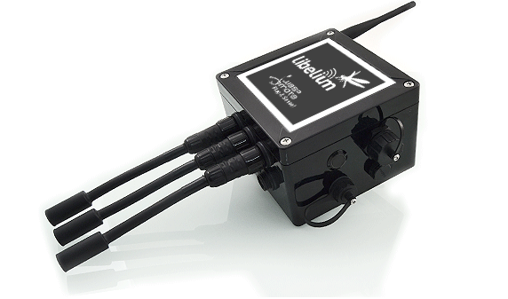

[Waspmote Plug & Sense! encapsulated line](http://www.libelium.com/products/plug-sense/) offers to users:

* Robust waterproof IP65 enclosure.
* Nine models integrating more than 60 sensors.
* Add or change a sensor probe in seconds.
* Solar powered with internal and external panel.
* Radios: Zigbee, 802.15.4, WiFi, 3G/GPRS and Bluetooth Low Energy (BLE).
* Over the air programming (OTAP).
* Special brackets ready for street lights installation.
* Graphical and intuitive programming interface.

**[Download Technical Guide](http://www.libelium.com/development/plug-sense/documentation/waspmote-plug-sense-technical-guide/?action=download)**

**› Sensor Probes**

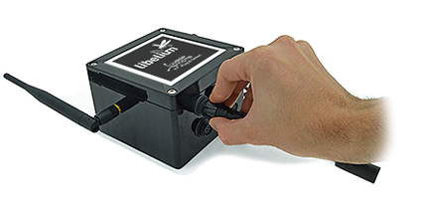

**Change sensor probes in just seconds**

Sensor probes can be attached easily by just screwing them into the bottom sockets. This allows you to add new sensing capabilities to existing networks in just minutes.

In the same way, sensor probes may be easily replaces in order to ensure the lowest maintenance cost of the sensor network.

**› Solar Powered**

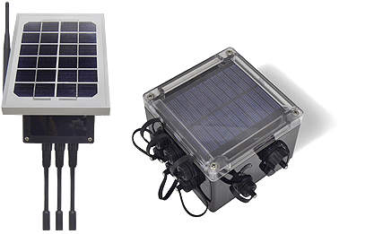

**External and internal Solar Panel**

Battery can be recharged using the internal or external solar panel options.

The **external solar panel** is mounted on a 45º holder which ensures the maximum performance of each outdoor installation.

For the **internal option**, the solar panel is embedded on the front of the enclosure, perfect for use where space is a major challenge.

The rechargeable battery has a load of 6600mAh what ensures non stop working time during the weeks where the sunlight is lower.

A non rechargeable battery option of extreme load (26Ah) is also possible for projects where solar panel can not be used.

**› Installation**

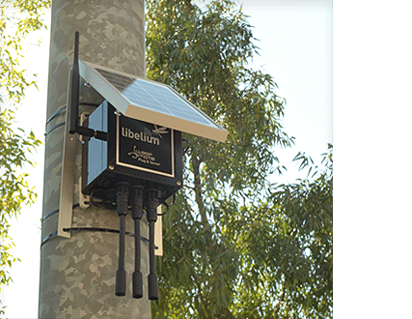

**Fast Deployment**

Waspmote Plug and Sense counts with holders specially designed for outdoor installations in street-lights and building fronts.

Metal cable ties are provided to easily adjust the node to street light posts.

Installation can be done in minutes as you only need to tie the cables on the enclosure holders and then to the post. Once the node is secured just press the ON button and the node will start automatically to send the data gathered from the sensors to the [Gateway](http://www.libelium.com/products/meshlium/).

**› Radio Technologies**

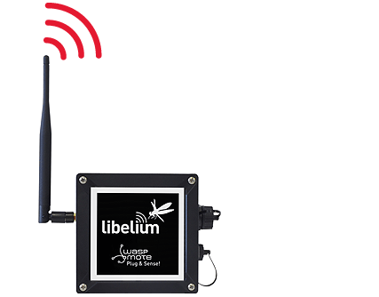

**High Sensitivity and Trasmission Power**

There are multiple radio options in order to communicate the sensor nodes with the Gateway. ZigBee and 802.15.4 are used commonly in order to create tree and start topologies. WiFi can be used to connect with any WiFi AP while the 3G/GPRS radio can be used in order to send the sensor data directly to the Cloud without using an intermediate Gateway.

The complete list of the available radios is:

* ZigBee (2.4GHz)
* 802.15.4 (2.4GHz)
* WiFi (2.4GHz)
* RF (868MHz)
* RF (900MHz)
* 3G/GPRS (Quadband: 850/900/1900/2100)
* Bluetooth Low Energy (2.4GHz)

**› Geolocation Tracking + Sensing**

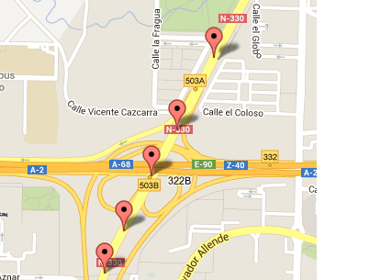

**Realtime Tracking Applications**

The new 3G+GPS and GPRS+GPS modules for Plug & Sense! allow to easily perform realtime tracking applications.

The idea is simple: read the GPS coordinates (longitude and latitude) and send them by using a HTTP request to a web server along with extra information from the sensors included in the node. Then use a browser to load the PHP webpage which uses Googlemaps to show the location in realtime.

You can find more information and complete examples in the [3G+GPS](http://www.libelium.com/development/waspmote/documentation/3g-gps-networking-guide/) and [GPRS+GPS](http://www.libelium.com/development/waspmote/documentation/gprs-gps-networking-guide/) guides.

**› External SIM Socket**

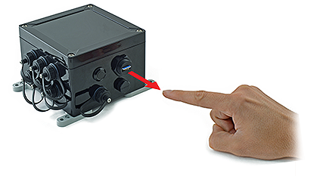

**Choose your own Mobile Cell Operator**

Plug & Sense! has available now an External SIM socket which allows developers to easily add and change a carrier SIM card in order to connect the devices to any GSM / GPRS / 3G / UMTS / WCDMA / HSPA network (in the options which support mobile phone cell connectivity).

**› Program in minutes**

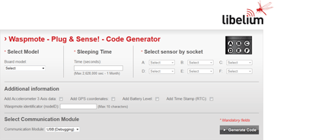

**Code Generator**

In order to program the nodes an intuitive graphic interface has been developed. Developers just need to fill a web form in order to obtain the complete source code for the sensor nodes. This means the complete program for an specific application can be generated just in minutes.

Check the [Code Generator](http://www.libelium.com/development/waspmote/code_generator) to see how easy it is.

**› Data to the Cloud**

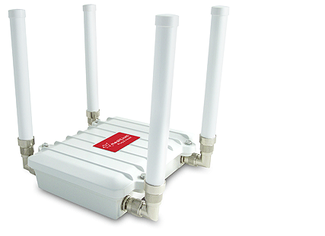

**Fully Compatible**

The Sensor data gathered by the Waspmote Plug & Sense! nodes is sent to the Cloud by [Meshlium](http://www.libelium.com/products/meshlium/), the Gateway router specially designed to connect Waspmote sensor networks to the Internet via Ethernet, WiFi and 3G interfaces.

[**Smart Agriculture**](http://www.libelium.com/101651651444/)**platform** can be used to monitor different environmental parameters related to agriculture such as temperature, humidity, soil temperature/humidity, weather station, leaf wetness and many other parameters. The monitoring of these parameters allows to minimize time and money as well as **maximize agriculture results**. The Smart Agriculture board enables control with a finer granularity than existing precision agriculture techniques. Our solution brings extreme precision to crop growing in, for example, vineyards and greenhouses, by enabling irrigation and climate control to be matched to local conditions.

[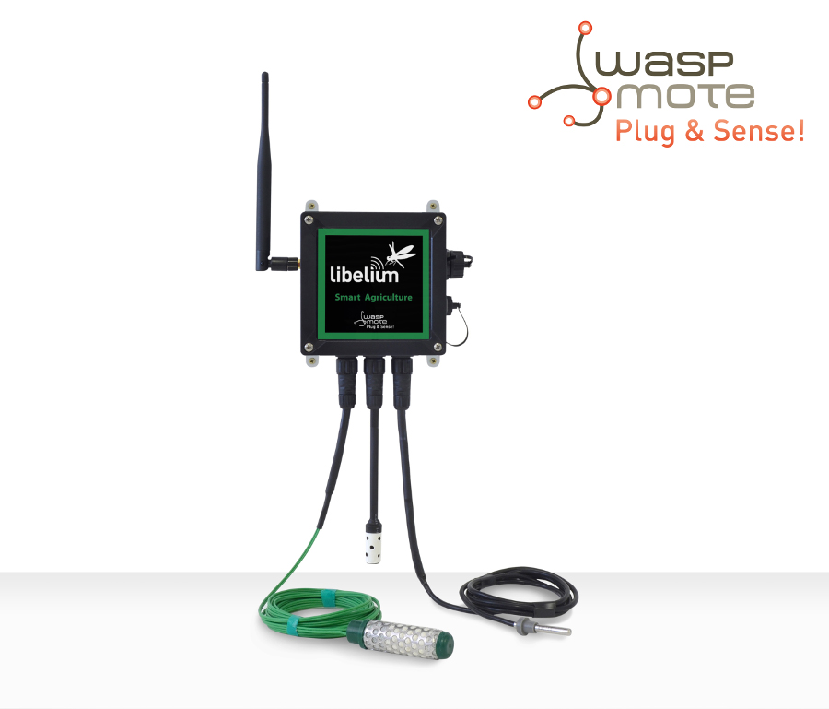](http://www.libelium.com/wp-content/uploads/2014/10/models_agriculture_logo_small.jpg)

*Plug & Sense! Smart Agriculture*

[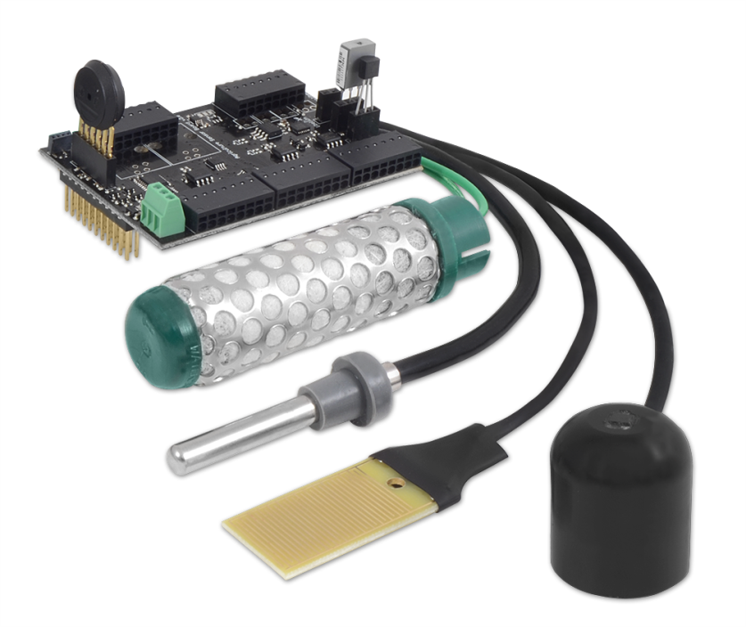](http://www.libelium.com/wp-content/uploads/2014/10/smart_agriculture_v2.png)

*Waspmote Smart Agriculture OEM Solution*

[**Open Garden**](http://www.cooking-hacks.com/documentation/tutorials/open-garden-hydroponics-irrigation-system-sensors-plant-monitoring) is our Open Source hardware alternative to commercial home automation to remotely control indoor and outdoor plants. There are three different kits, each ready for a specific kind of growing plant scenario: indoor (houses and greenhouses), outdoor (gardens and fields) and hydroponics (plants in water installations). The kits include a suite of sensors form measuring parameters such as humidity, light, temperature, or soil moisture to **monitor plants** for optimal care wherever they are situated. The Hydroponics kit includes pH and conductivity probes. Its actuators can control irrigation, and activate lights and oxygen pumps.

[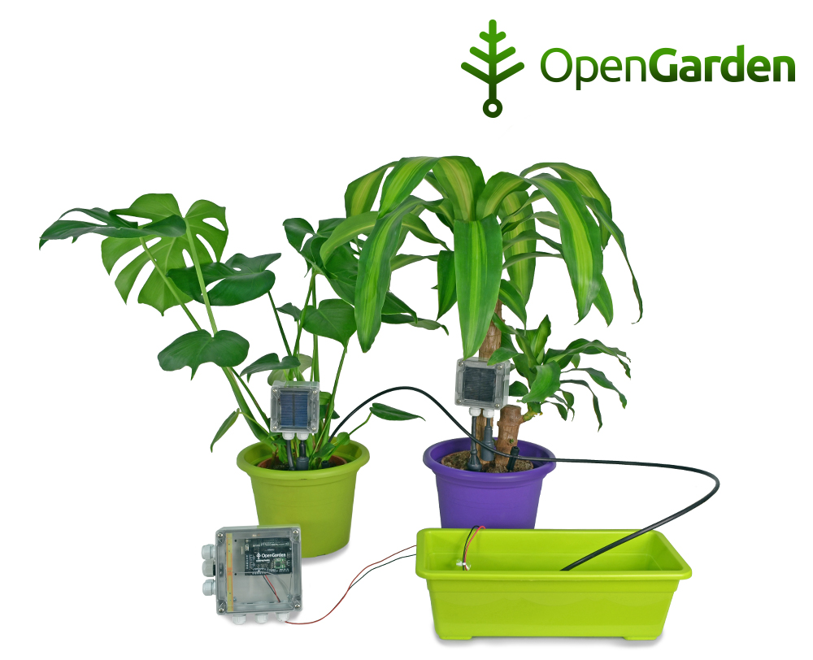](http://www.libelium.com/wp-content/uploads/2014/10/indoor_plants_1_press_release_rev_1_big.jpg)

**Smart Agriculture VS Open Garden Comparative Table**

|  |  |  |
| --- | --- | --- |
| **Key Features** | **Smart Agriculture** | **Open Garden** |
| Intended for | Companies, environmental consultancies, city councils and municipalities that need to monitor fields, vineyards and greenhouses. | Makers and individuals that want to control in-house gardens, small greenhouses, outdoor gardens and small fields, and also hydroponics – plants in water installations. |
| Applications | – Control micro-climate conditions to maximize crop quality and production. – Selective irrigation in dry zones to reduce the water resources required. – Study of weather conditions in fields to forecast ice formation, rain, drought, snow or wind changes. – Control of humidity and temperature levels to prevent fungus and other microbial contaminants. – Crop growth monitor. | – Plants water needs control – Irrigating the plants and activating lights and oxygen pumps in hydroponics crops. |
| Sensing | Up to 14 environmental parameters to be monitored: air temperature, air humidity, soil temperature, soil moisture, leaf wetness, atmospheric pressure, solar PAR radiation, ultraviolet radiation, trunk/stem/fruit diameter, wind speed/direction and rainfall. | Up to 7 different parameters: soil moisture, temperature, humidity, light… and has three water sensors: water pH, conductivity and temperature. |
| Actuators | Smart Agriculture focus on remote sensing and has no actuators available. | Different types of actuators to modify the state of the plants: water pump, droppers for drip irrigation, electro valve, sprinklers, oxygen pump and growing light. |
| Autonomy | 10 years. Waspmote implements power saving mode. Solar panels may be added for continuous measuring. | Open Garden must be powered by an external power supply (12V – 2A). The nodes are powered by a 2300 mAh battery that can be recharged using a solar panel. According to the frequency of the sensors measures, the durability of the battery can be up to 3 months. |
| Nodes Maintenance | Smart Agriculture nodes are ready to deploy out of the box and sensor probes can be recalibrated or changed in the field. | Open Garden is a DIY product and makers maintain and improve the installation. |
| Connectivity | Waspmote may use cellular (3G, GPRS, WCDMA) and long range 802.15.4/ZigBee/RF (2.4 GHz,868/900 MHz) connectivity to send information to the Cloud. It ensures real-time water control, even from sensor nodes situated in remote locations. | The platform can send information using wireless interfaces such as Wi-Fi, GPRS and 3G. |
| Price | Smart Agriculture is a customized product. Approximate price with similar components than Open Garden Indoor Kit: 800€. [Contact with our commercial team](http://www.libelium.com/contact/) for a customized proposal. | All of our Open Garden kits at 199€ each. Check our online shop – [www.cooking-hacks.com](http://www.cooking-hacks.com/shop/arduino/designed-by-ch/open-garden) |
| Gateway | [Meshlium](http://www.libelium.com/products/meshlium/) is the Linux GW for Waspmote and Plug & Sense! devices. It counts with 8GB of internal storage and allows to connect the information to many Cloud platforms such as Axeda, Thingworks, MQTT, Telefónica, etc. It counts with many connectivity options: ethernet, WiFi, 3G, ZigBee, etc. | Data is sent from Open Garden to a laptop via an USB cable or via WiFi or GPRS to the Internet. |

For more information about our **Waspmote product lines**:

* [Waspmote](http://www.libelium.com/products/waspmote/)
* [Plug & Sense!](http://www.libelium.com/products/plug-sense/)

[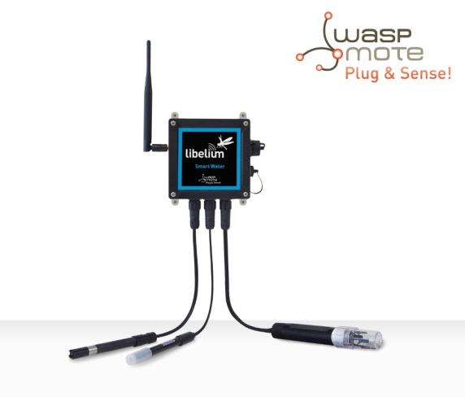](http://www.libelium.com/wp-content/uploads/2014/10/models_water_logo_small.jpg)

*Waspmote Plug & Sense!  
Smart Water model*

[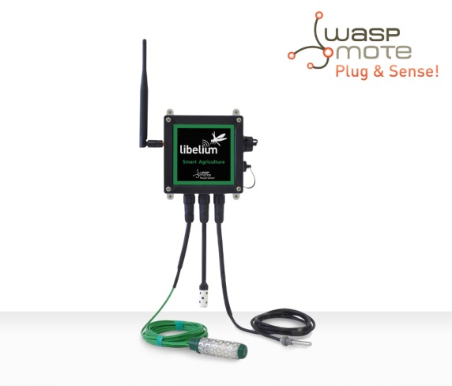](http://www.libelium.com/wp-content/uploads/2014/10/models_agriculture_logo_small.jpg)

*Waspmote Plug & Sense!  
Smart Agriculture model*