**Irrigation:**

Irrigation is the practice of artificially watering dryland. Growers use tubes and irrigators to water flowerbeds, vegetable gardens and lawns. Large scale irrigation is where planters, farmers, orchardists and grape growers apply water at acute times to support plant growth and therefore produce quality crops.

Irrigation water can come from nearby rivers or underground water. Pipes, waterways and wells dug into the ground allow water to be taken from its source to the farms, vineyards and orchards where it will be used. Growth of good crop is totally dependent on amount of water needed, quality soil and number of rainfall occurs around the year.

**Cause of Irrigation:** In utmost nations more water is used for watering land than for any other purpose. Generally 70% of all water taken from river, lake and groundwater systems supports irrigated crops and the nurturing and watering of animals.

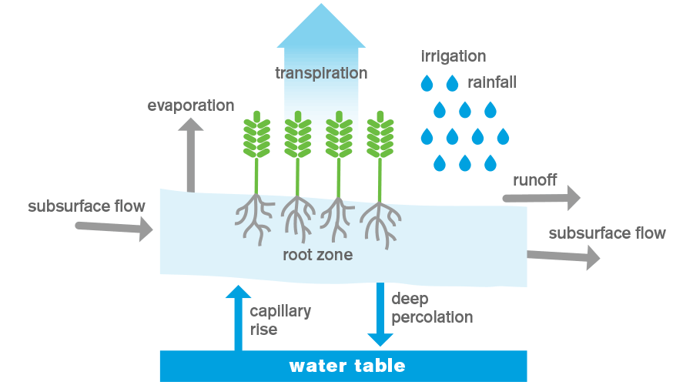 Irrigation permits farmers and gardeners to efficiently use water to guarantee plant growth. Stock farmers use irrigation to ensure they can grow enough feed for their animals and to maintain health. Many new crop and plant varieties require regular moisture which has led to increasing interest in irrigation.

The accessibility, price and variety of milk, cheese, meat, fresh fruit and vegetables and wine are all allied to irrigation.

Reason for irrigation perhaps to struggle a particularly a drought or to ensure high value crops always have the right amount of water during a critical growth phase.

# Ways of Irrigation:

Old technologies are rapidly being replaced by more efficient means of transporting water and applying it to land. Irrigation may have certain steps:

* **Collect and distribute water**

The water are tend to be collected and scattered to different parts of the land. Farmers store water so that it will get useful when there will be lack of water to irrigate lands, in a number of ways:

* **Groundwater via wells** –water is pumped from aquifers by a well. Some of the wells can be more than 200m deep.
* **Flow of river via pipes or canals** –water is pumped by gravity from the river, the possibility of movement of water through river is totally dependent if the river is above its minimum flow.
* **Large storage** – water is pumped into a large dam, it can be man-made reservoir as well.
* **Farm storage** – water is thrusted into a small storage pond on the farm.
* **Piped systems** –   water is moved through an underground network of pipes.
* **Channel systems** – water is relocated through man-made waterways.
* **Applying water:**

This phase involves a lot of arrangement to make sure if the water is used sensibly and sustainably. Different technologies and irrigator types are used dependent on the site and yield to be irrigated.

There are different ways that a farm can be irrigated:

* Centre pivot and linear move irrigators
* Traveling irrigators
* Spray lines and long lateral
* Solid set sprinklers
* Dripline
* Micro sprinklers
* **Economy:**

Agriculture production remains the pillar of every country’s economy. Some of the affects are notably observed are:

* Export of cotton yarn fell by 12 percent to $1.990 billion in the last fiscal year 2013-14, according to official figures. Cotton yarn export declined by $262 million in the last fiscal year 2013-14 from $2.252 billion in the corresponding fiscal year 2012-13.
* The country spent $1.859 billion on the import of palm oil during the last fiscal year 2013-14, which is 5.25 percent lower than the spending in financial year 2012-13, official figures say. The country’s palm oil import remained lower by $103 million in the last fiscal year as compared to the edible oil import.
* Insufficient government’s efforts to expand trade, energy shortage, poor law and order and political uncertainty hurt the apparel textile export growth during the just ended fiscal year 2013-14.
* Pakistan’s rice exports during June-2014 registered a decrease of 8.44 per cent as compared to May-2014. Export figures released by Pakistan Bureau of Statistics (PBS) indicated that Pakistan has exported rice worth US $149million down by US $13.75m i.e. 8.44 per cent and in terms of volume, the country’s export of rice went down by 5, 792 metric tons i.e. 2.3 percent to 248, 789 metric tons.

Reference: http://par.com.pk/tag/pakistan-bureau-of-statistics/

# Environment:

Irrigation provides many environmentally friendly benefits; but these can only be attained with a consistent water supply. Effective irrigation needs on-demand water – much the same as a town’s water supply. This allows irrigators to apply water as and when a crop needs, while maximizing natural rainfall. A reliable water supply combined with a ‘whenever needed’ irrigation strategy reduces the amount of water a farmer will need to take by scheduling water supply.

**Modern irrigation** is very energy effective. Power costs is a major component of functioning irrigation, so an emphasis in recent years has been energy efficiency strategies which reduce expenditures. Irrigation systems are now designed to minimize power use. Recently developed technologies have significantly reduced the amount of energy required to control an irrigation pump. An increasing number of irrigators also monitor soil water levels before applying irrigation. This ensures actual energy use is optimized for production.

**New irrigation schemes** frequently have a hydroelectric power generation element using barrages, canals or tubes. Most existing irrigation schemes are being modernized, mainly through tubing the water supply method. Tubing creates two environmental benefits.

* It ensures water is not lost through the supply system by leaky canals. This means less water needs to be taken from the river.
* Piping also delivers a pressurized water supply to the irrigator, often by using gravity. If you put water in a pipe and run it downhill you produced pressurized water. This significantly reduces pumping costs.

**A number of modern irrigation schemes** have been established to solve significant river and stream current issues, while at the same interval providing irrigation.

Environmentally friendly support community initiatives to restore native vegetation and boost local rivers availability through a growing number of irrigation schemes. Other schemes have created their own environmental reestablishment plans.

# Smart Irrigation:

Smart Irrigation is Sustainably Managed, Liable and Trusted irrigation. Smart irrigators aim to minimize their environmental footprint through efficient water use, and must also run a profitable business. This allows them to reinvest in new and improved technologies which will make certain about responsible irrigation over a period.

**New irrigation technologies** and decision support tools are needed to be innovated in **Pakistan**. Use of water and energy proficiency are the main focuses of these innovations. Fortunately, efficiency is linked to better quality production and improved profitability. We are stuck in old traditional farming all the way round in Pakistan, unfortunately. There should be a general change from manual flood irrigation to remotely controlled spray irrigation such as centre pivots, dripline and micro sprinklers.

There are three components to smart Irrigation:

* The irrigation system can apply water efficiently,
* The use of water is justified,
* Irrigators can provide proof of the above and are held responsible for their actions.

There are essentials which subsidize to successful irrigation. If all are done well an irrigation system can perform to industrial ethics, and the operator is able to apply water efficiently. This is what **smart irrigation**.

Each component has to be done well for an irrigator to become a smart irrigator.

An irrigation system being correctly

* designed,
* installed,
* Commissioned,
* Maintained,

makes it easier for an irrigator to operate it well. A smart irrigation system to industry standards means the right amount of water can be delivered at the right time and in the right place.

Operating an irrigation method well is a vital component of smart irrigation. To explain the use of water is the most practical method for representing the irrigation system is being operated well.

. These include:

* Industry standards, codes of practice and guidelines – the backbone of the smart irrigation programme
* Training workshops – to provide practical information for irrigators
* Industry authorization and certification programmes which set standards for the irrigation service industries
* An irrigation awareness and certification programmes
* Decision support tools and resources.

# Accountability:

The irrigators are responsible for their actions in smart irrigation. It is obvious that there should be consequences for poor performance, and importantly that there should be incentives for good performance. **This is the fundamental idea of smart irrigation.**

All smart irrigators should have an agreement to take and use water for a specified length of time, and must fulfill their conditions. Measuring water take and providing water use data to a regional council should now be a part of these conditions.

**For example**, a river take will specify the flow level under which they cannot take water. An irrigator breaking the conditions of their approval can result in a fine.