**IoT (Internet of Things)**

**INTRODUCTION TO IoT:**

Internet of Things is creating an environment of convergence in the society. Researchers have predicted that IoT will rule in near future. The technology environment change that IoT has reflected brings a paradigm shift in our professional and personal life. As a connected environment, IoT adds customer value and loyalty. Today, IoT is being implemented everywhere which is of human concern like smart agriculture, smart environment, security, smart business process, home automation and healthcare throughout the world.

IoT is a concept where an object is assigned to an IP address and through that IP address we make that device identifiable on internet. A Team of International Telecommunications Union defined IoT as a global infrastructure for the information society, enabling advanced services by interconnecting (physical and virtual) things based on existing and evolving interoperable information and communication technologies. The network can be a combination of people-things, things-things and people-people. It happens only because of the conjugation of various technologies such as wireless communication, Micro Electromechanical System that includes wireless sensor, networks and control system. The most important elite presence of cloud space on Internet is shaping the architecture of IoT in a feasible and rational form. Certainly, what IoT can do is beyond imagination. It connects additional of heterogeneous object.

IP and non IP based technology solutions are used for Wireless Sensor Networks. Zigbee, Z-wave, Insteon and Wavevenis are non IP Based solution. IPv6 and 6LoWPAN are IP based solutions of WSN.

**SCOPE AND BENEFITS OF IoT:**

It’s the technology of today which is connecting and transforming every aspect of our real life. IOT has given a concept of Machine to-Machine (M2M) communication. Companies like Microsoft and SAP are implementing strategy to capitalize on the Internet of Things so that you can just stop your business and starts making it thrive. IOT is going to have huge impact on home automation and building automation system where every convenience will be taken care of by the interconnected devices on IOT. It is also deployed on large scale for example in Songdo , South Africa , the first of its own kind fully equipped and wired smart city is near to completion ( known as Ubiquitous City). With the personal electronics good connected to Internet will enable us to “author” our lives. In medical science field, IOT has given a privilege to devices and system to sense forecoming diseases

and prevent it, for eg: It can make a person healthier with wearables that can predict heart attack and cardiovascular strokes. As per a report of **Thesunsdaily**, consumers will start initiating the usage of IoT in a better way during 2015 and onwards compared to past usage. It is expected that IoT products with interoperable capability will dominate the market. Awareness of IoT products is also vital for market saturation along with security features. Many interesting IoT products like automatic door locks, Wi-Fi connected ceiling fans, light switches, LED bulbs, smart watches, 3-D printers and smart gardens will be popular among consumers. MyBrain Technology in France has developed "Melomind". This EEG Headset can measure a human's brain waves and adjust music in a Smartphone app as they change. This product can be used as a digital meditation aid. A smart baby pacifier can measure the temperature of a baby and transmit the same to the Smartphone of parents.

IoT is proved to be an emerging technological innovation. Many scopes will be created for technology companies to release offerings as per the behavior of consumers. It may so happen that Netflix which is an online entertaining application can know when a person is sad and alone by monitoring the smart watch, smart thermostat and in-home camera. Subsequently, Netflix may offer a movie to change the mood. In a consumer electronics show in Los Vegas, Samsung informed that the company would invest 100 million dollar for progress of IoT. The company will also promote an open technology ecosystem for facilitating the usage of IoT.

Different fields of scientific interest shall benefit from IoT, for e.g. IoT will make irrigation systems in agriculture smart that will result in better productivity; good quality crops with required amount of resources instead of wasting enormous amount of water. Farmers can easily maintain their farming activities through smart apps and intelligent system. Smart garden is also an emerging field of interest and research.

**CONCLUSION AND FUTURE RESEARCH DIRECTION**

The ongoing research in the field of IoT and its implementation in full or partial manner will definitely improve the quality of life of human civilization .Today IOT is being implemented everywhere which is of human concern like Smart city, smart environment, security and emergencies, smart business process, smart agriculture, domestic and home automation and healthcare. Search engine giant Google has already taken initiatives to mark its presence in the field of IoT. It is trying to transform the IoT by putting their enthrall concept of making the physical URL as future of IoT instead of apps which we commonly use. In this process, the browser will display a beacon style broadcast in which the nearby object will appear which will be present in the near proximity and can be communicated directly with the help of URL’s according to the preference of users and signal strength of the smart object. On the other hand IBM and Libelium has launched 6LoWPAN development platform for IoT which will enable every single sensor and devices to connect directly to the Internet using the new IPv6 protocols. China and many European countries are investing high amount of their GDP in making smart architectural infrastructure for e.g. Smart Roads and Bridges for the safety of people. In this smart bridges if corrosion or if any malfunction happens it will communicate directly so that repair work can be done at the proper time. Smart agriculture is also in research; Waspmote has taken this initiative for optimum productivity using the sensor networks to maintain monitoring capacity of crop cultivation throughout the production cycle. For example, depending on soil humidity Waspmote can send a message (through the ZigBee network or by SMS) to automatically switch off watering or to change water supply, thus contributing towards efficient water management. Over 50 million sensors and smart watches, smart meters and smart phones, washing machines, fridges, wearable devices and many more things will be connected over internet by 2020. The Internet of Things, Industrial Internet and Internet of Everything in 2015 will morph into the Internet of Anything. IoA will input all data in a unified way with a common software "ecosystem". Though many IT companies are now busy in addressing interoperability issues and the challenge of controlling hardware devices through software, the world community is now moving towards creating opportunity to live in a "connected life" environment.

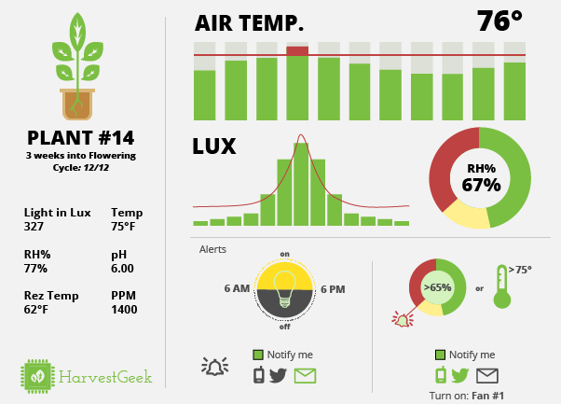

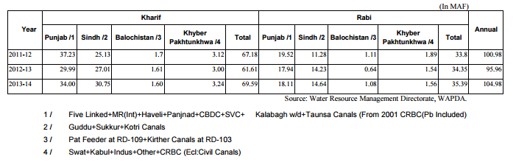

http://www.pbs.gov.pk/sites/default/files//tables/Table%209%20%20%20Province-wise%20Canal%20Withdrawals.pdf