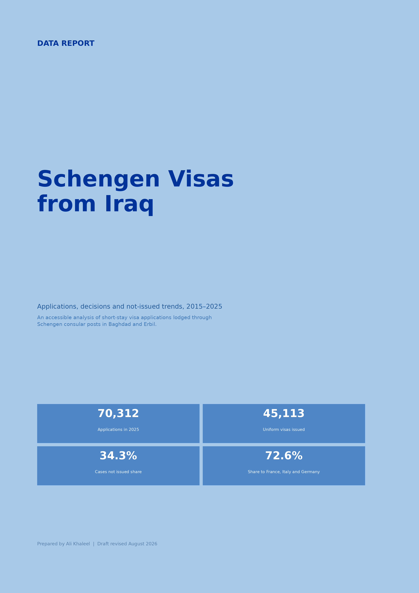

Executive summary
In 2025, Schengen consular posts located in Iraq recorded 70,312 short-stay visa applications, the highest annual total in the 2015–2025 series. Applications increased by 6.6% compared with 2024 and by 22.3% compared with 2019, the last full pre-pandemic year.
A total of 45,113 uniform visas were issued and 23,692 cases were recorded as not issued. Using recorded decisions as the denominator, cases not issued represented 34.3% of decisions. This measure is not identical to a pure refusal rate: European Commission metadata states that “not issued” also includes applications whose examination was discontinued. [2]
France, Italy and Germany accounted for 72.6% of all applications. Baghdad handled 54.4% of applications and Erbil 45.6%. The raw cases-not-issued share was 28.4% in Baghdad and 41.3% in Erbil; after standardising for the mix of destination states operating in both locations, the comparison narrows to approximately 27.5% and 35.9%.
Main takeaway: Iraq’s application volume has moved above its pre-pandemic level even though global Schengen demand remains below 2019. Outcomes, however, vary substantially across destination states and consular locations, and those differences must be interpreted with care.

Key findings
- 2025 recorded the highest application volume in the 2015–2025 series: 70,312 applications.
- Global application volume in 2025 remained about 28% below 2019, while applications lodged in Iraq were 22.3% above 2019.
- The cases-not-issued share peaked at 48.0% in 2018 and stood at 34.3% in 2025.
- France was the largest destination by application volume in 2025, followed by Italy and Germany.
- In the author’s separate analysis of the complete 2025 global consular dataset, Hungary’s post in Erbil recorded the highest cases-not-issued share worldwide, at 84.2%.
- German applications in Erbil fell from 11,693 in 2024 to 6,814 in 2025 (-41.7%); Erbil accounted for about 85% of Germany’s total decline in Iraq.
- Multiple-entry visas represented 35.9% of uniform visas issued in 2025, down from 45.6% in 2024.

About the report
This report examines the development of short-stay Schengen visa applications processed through consular posts located in Iraq between 2015 and 2025. It focuses on application volumes, recorded decisions, cases not issued, multiple-entry visas, destination concentration and differences between Baghdad and Erbil.
The report treats visa statistics as the product of both travel demand and access conditions. Pandemic restrictions, regional instability, airspace closures and temporary interruptions to consular or visa-centre operations can change the number of applications that are actually lodged. Annual application counts should therefore not always be read as a direct measure of underlying travel demand.
The Germany–Erbil case in 2025 illustrates this distinction. German applications in Erbil fell sharply during a year in which appointments at the German Visa Application Centre in Erbil were temporarily cancelled from 22 June until further notice “due to the current situation.” [4] The timing coincided with the June 2025 regional security escalation, but the available annual data cannot establish that the interruption was the sole cause of the decline.
The report is designed as an accessible public-data product rather than an individual visa-advice tool. It aims to help readers understand how the system has changed, identify patterns that warrant further investigation, and separate evidence from common assumptions about Schengen visa outcomes.

How to read the findings
- The statistics describe where applications were lodged and processed; they do not represent the nationality of every applicant.
- Comparisons between states or locations are descriptive and do not measure the probability that a particular applicant will receive a visa.
- Large year-to-year changes can reflect both demand and changes in access to appointments or consular capacity.
- Where the report discusses possible explanations, these are labelled as contextual interpretations rather than proven causal effects.

Methodology and definitions
Primary data source. The analysis uses the European Commission’s annual short-stay visa statistics for 2015–2025. The Commission publishes applications and decisions by the country where the application was made and by the consulate or Schengen state processing it. [1][2] For this report, records were filtered to consular posts located in Iraq and then aggregated by year, destination state and consular location.
Coverage. The main series covers applications processed through Baghdad and Erbil. Iraqi citizens who applied outside Iraq are not included, while non-Iraqi residents who applied through a consular post in Iraq may be included. The unit of analysis is therefore the consular post, not nationality.

Core indicators
Indicator | Calculation / definition | Interpretation
Applications | Uniform visa applications lodged | Demand successfully recorded by a consular post during the year.
Recorded decisions | Uniform visas issued + LTV visas issued + cases not issued | Decision outcomes recorded in the annual statistics.
Cases not issued share | Cases not issued ÷ recorded decisions | System-level outcome indicator. “Not issued” can include refusals and discontinued examinations. [2]
MEV share | Multiple-entry visas issued ÷ uniform visas issued | Share of issued uniform visas that permit multiple entries. LTVs are excluded.
Consular location | Baghdad or Erbil | Location of processing; not applicant nationality or necessarily place of residence.

Important limitations
- Applications and decisions do not have to balance exactly within the same calendar year because some decisions may relate to applications lodged earlier, while some applications remain pending at year-end.
- The dataset does not contain applicant-level variables such as nationality, income, travel purpose, previous travel history or documentation quality. It cannot explain why an individual case was issued or not issued.
- Baghdad and Erbil do not host the same mix of Schengen states. Direct location comparisons therefore combine destination-state composition with other unobserved differences.
- The worldwide Hungary–Erbil comparison cited in this report comes from the author’s separate analysis of the complete 2025 global consular dataset; the Iraq-only aggregation used for most other figures cannot independently establish that global ranking.
Terminology note: this revised report uses “cases not issued share” for the calculated indicator. The term “rejection rate” is common in public discussion, but the Commission’s metadata states that the “not issued” category also contains applications whose examination was discontinued. [2]

Global recovery, but a record year for applications lodged in Iraq
In 2025, EU and Schengen-associated consulates received 12,201,026 short-stay visa applications worldwide. Although global demand continued to recover, it remained approximately 28% below the pre-pandemic level of 16,955,541 applications recorded in 2019. [1]
Against this global background, 70,312 applications were lodged through Schengen consular channels in Iraq, including posts in Baghdad and Erbil. This represented about 0.58% of global applications and an increase of 6.6% from 2024, when 65,944 applications were recorded.
The contrast is more visible when both series are indexed to 2019. By 2025, global applications stood at about 72 on a 2019=100 index, while applications lodged in Iraq reached about 122. In other words, the global system remained below its pre-pandemic scale while the Iraq-based series had already moved substantially above it.
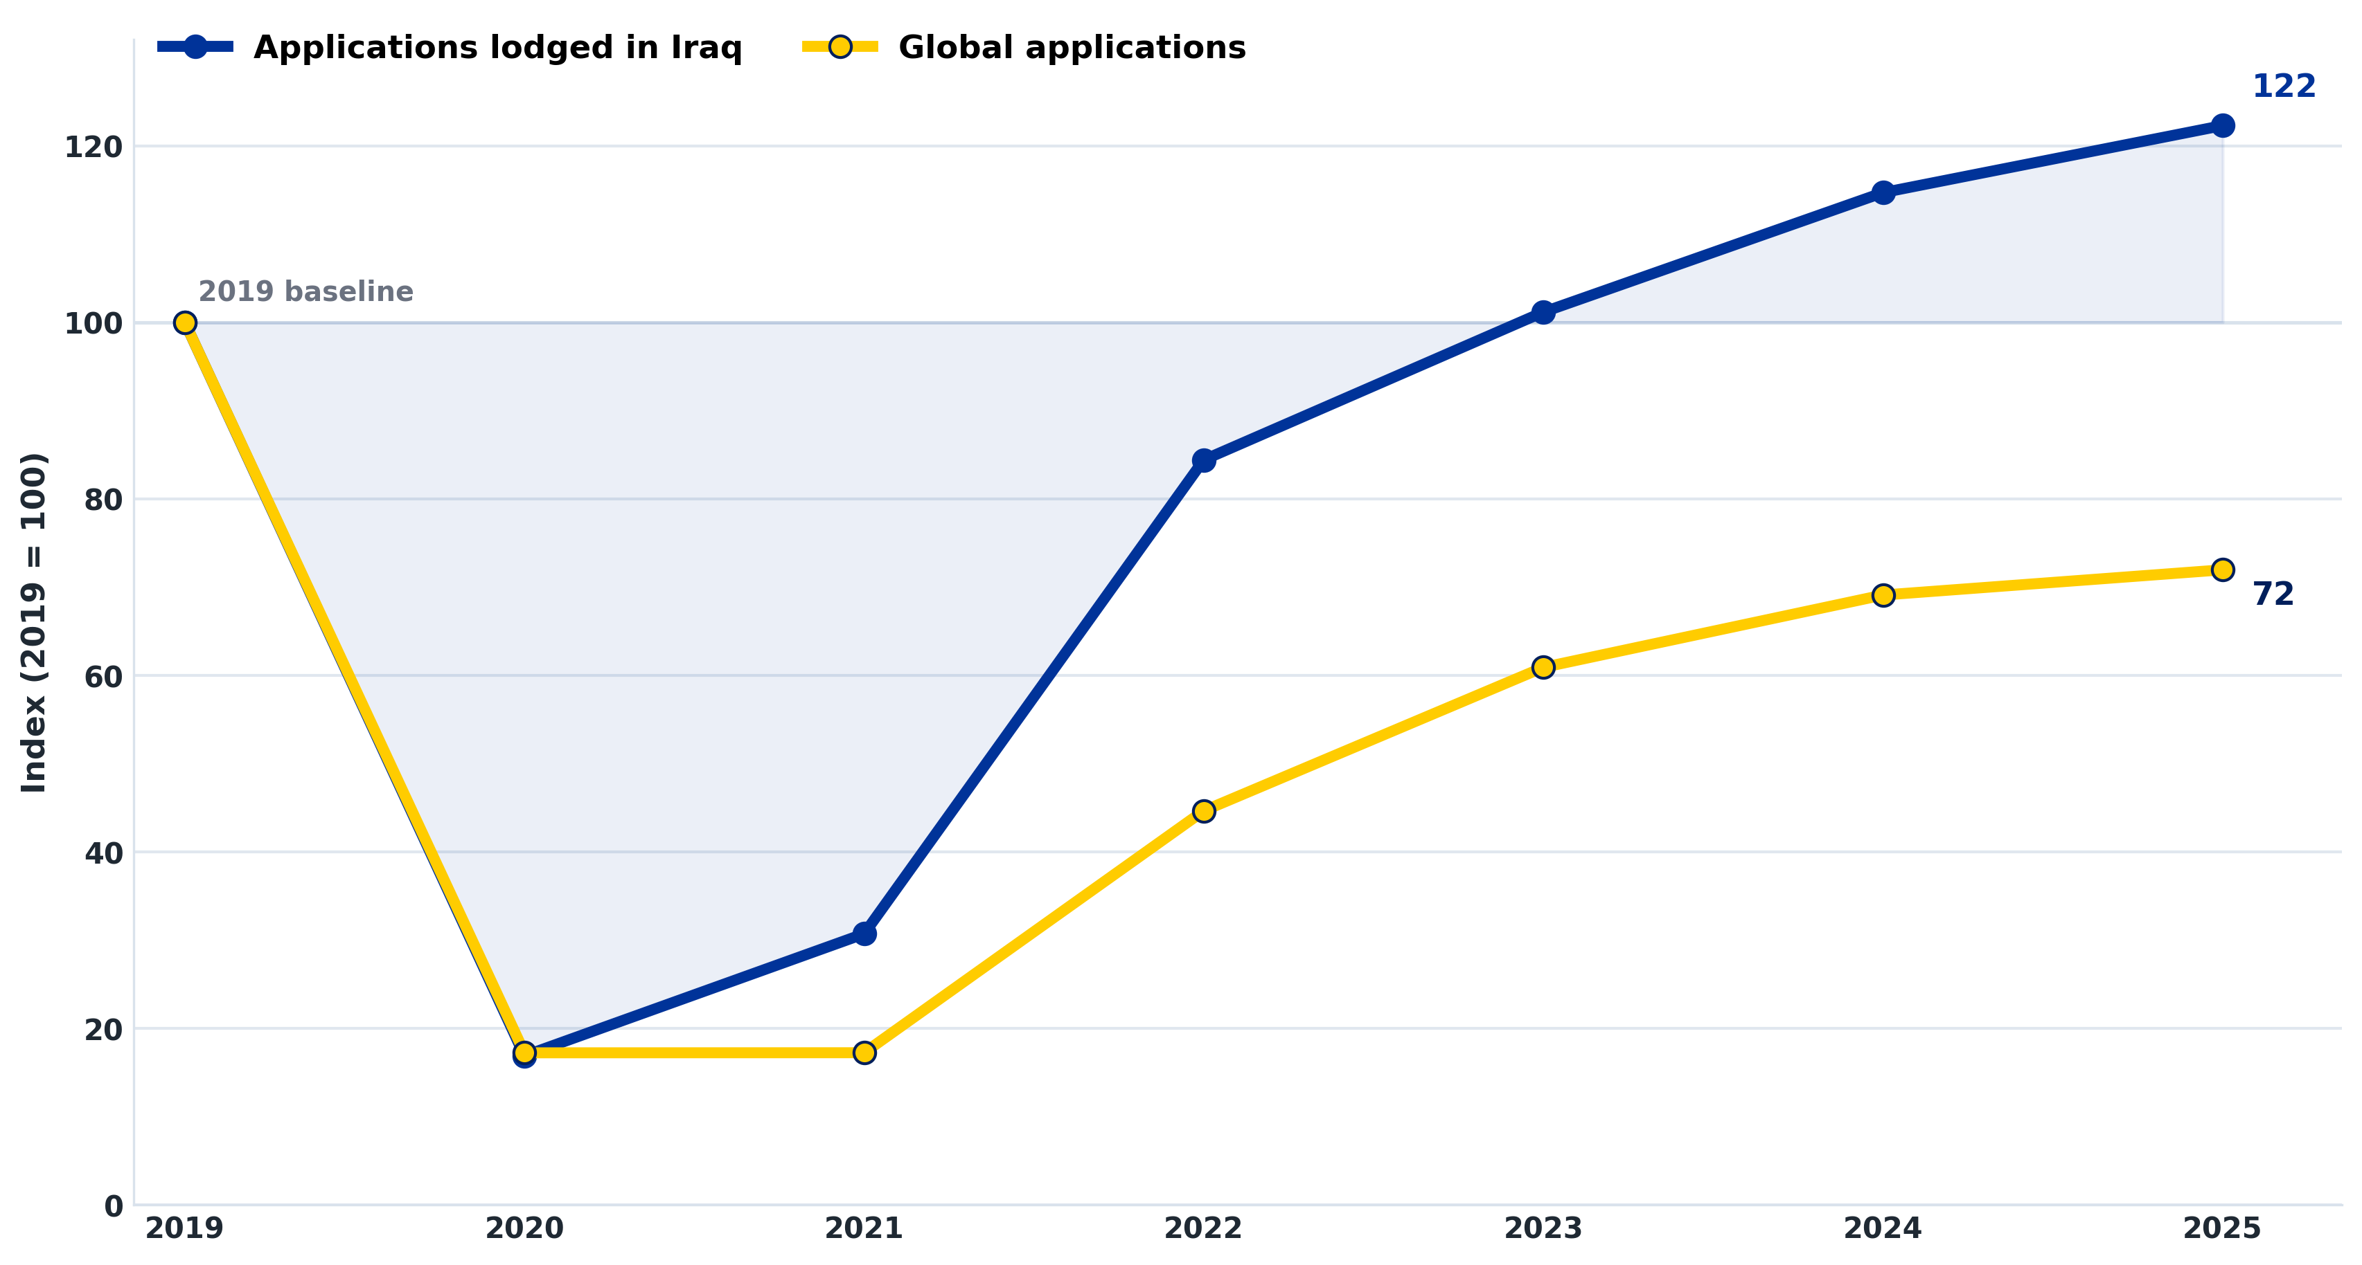
Figure A. Global and Iraq-based Schengen visa applications indexed to 2019 = 100.
Iraq ranked 34th worldwide in 2025 when countries were ordered by the number of applications lodged through consulates located within them. Across 2015–2025, Iraq’s position ranged between 30th and 37th, indicating a relatively stable place in the global distribution despite major changes in absolute volumes.

Visa access from Iraq: the 2025 consular network
The 2025 statistics show that applications for 11 Schengen destination states were recorded through consular channels in Iraq. The map and table below describe the observed application network in the annual dataset; they should not be treated as a live appointment-availability guide, because consular and external-service-provider arrangements can change during the year. Under EU rules, applicants should lodge with the consulate of the main destination in the country where they are legally resident. [3]
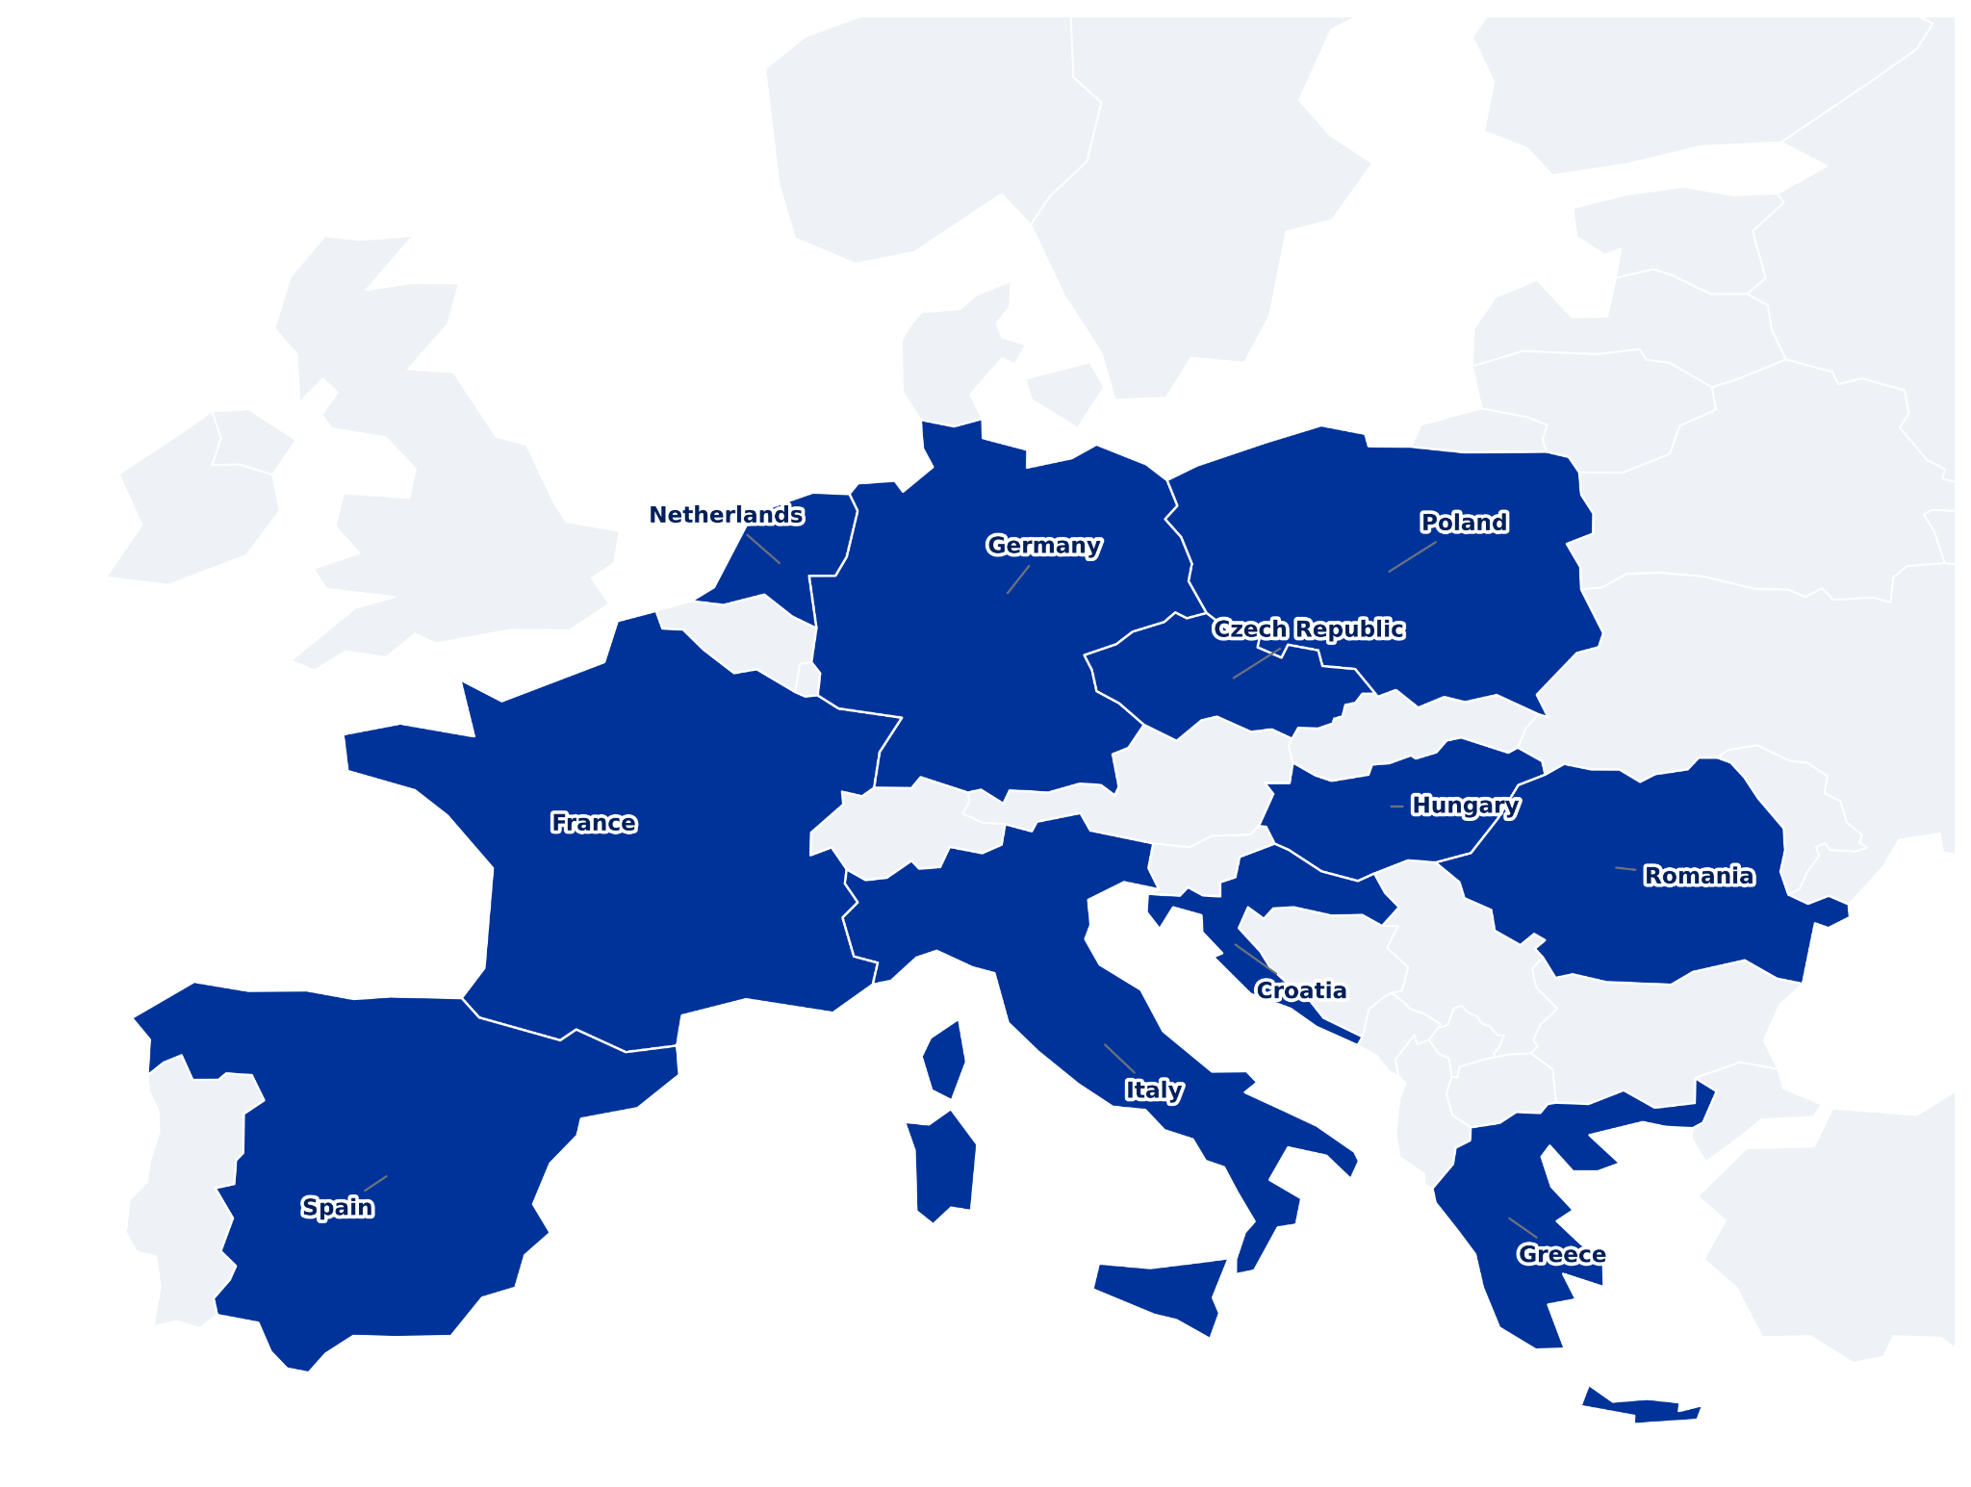
Figure B. Schengen states with applications recorded through consular posts in Iraq, 2025.
Schengen state | Baghdad | Erbil | 2025 total
France | 10,362 | 10,013 | 20,375
Italy | 12,290 | 4,606 | 16,896
Germany | 6,965 | 6,814 | 13,779
Greece | 1,420 | 5,279 | 6,699
Spain | 4,381 | — | 4,381
Netherlands | 1,196 | 1,981 | 3,177
Hungary | — | 1,373 | 1,373
Czech Republic | 456 | 871 | 1,327
Poland | — | 1,078 | 1,078
Romania | 787 | 35 | 822
Croatia | 405 | — | 405

1. Eleven years of changing demand
Visa demand increased substantially over the decade, although the series was interrupted by the pandemic. Applications rose from 38,475 in 2015 to 64,726 in 2018, fell to 57,501 in 2019 and collapsed to 9,722 in 2020. By 2025, applications had reached a new high of 70,312.
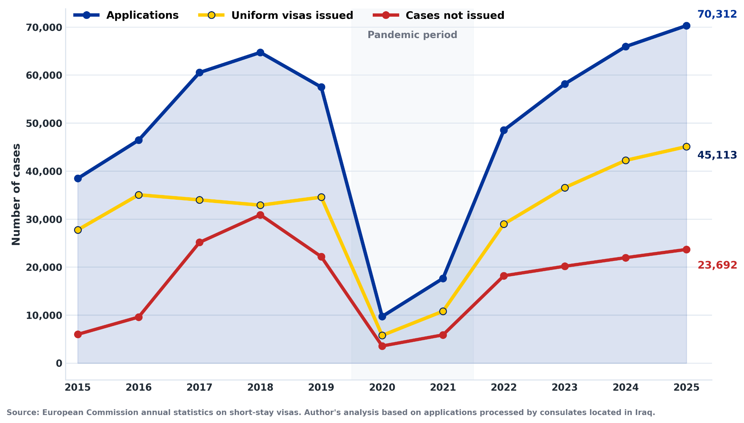
Figure 1. Annual applications, uniform visas issued and cases not issued, 2015–2025.
The difference between applications and recorded decisions in a given year may reflect pending cases, timing differences or decisions on applications lodged in another reporting period.

2. Cases not issued over time
The cases-not-issued share rose sharply between 2015 and 2018, reaching 48.0%. It then declined, although it remained above one third in most years after 2019. The 2025 value of 34.3% was only 0.3 percentage points higher than in 2024.
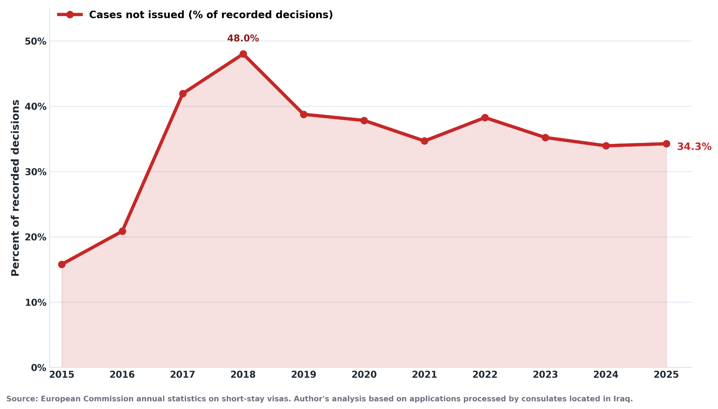
Figure 2. Cases not issued as a percentage of recorded decisions.

Interpretation
Annual changes may reflect shifts in travel demand, applicant profiles, documentation quality, consular capacity, visa policy and the mix of destination countries. The aggregate indicator should therefore be read as a system-level measure, not as an estimate of any individual applicant’s probability of approval.
Because the European Commission’s “not issued” category can include discontinued examinations as well as refusals, this report does not treat the indicator as a pure rejection probability. [2]

3. Where applicants applied in 2025
Applications were highly concentrated. France received 20,375 applications, Italy 16,896 and Germany 13,779. Together, these three states accounted for 72.6% of all applications submitted through Schengen consular posts in Iraq.
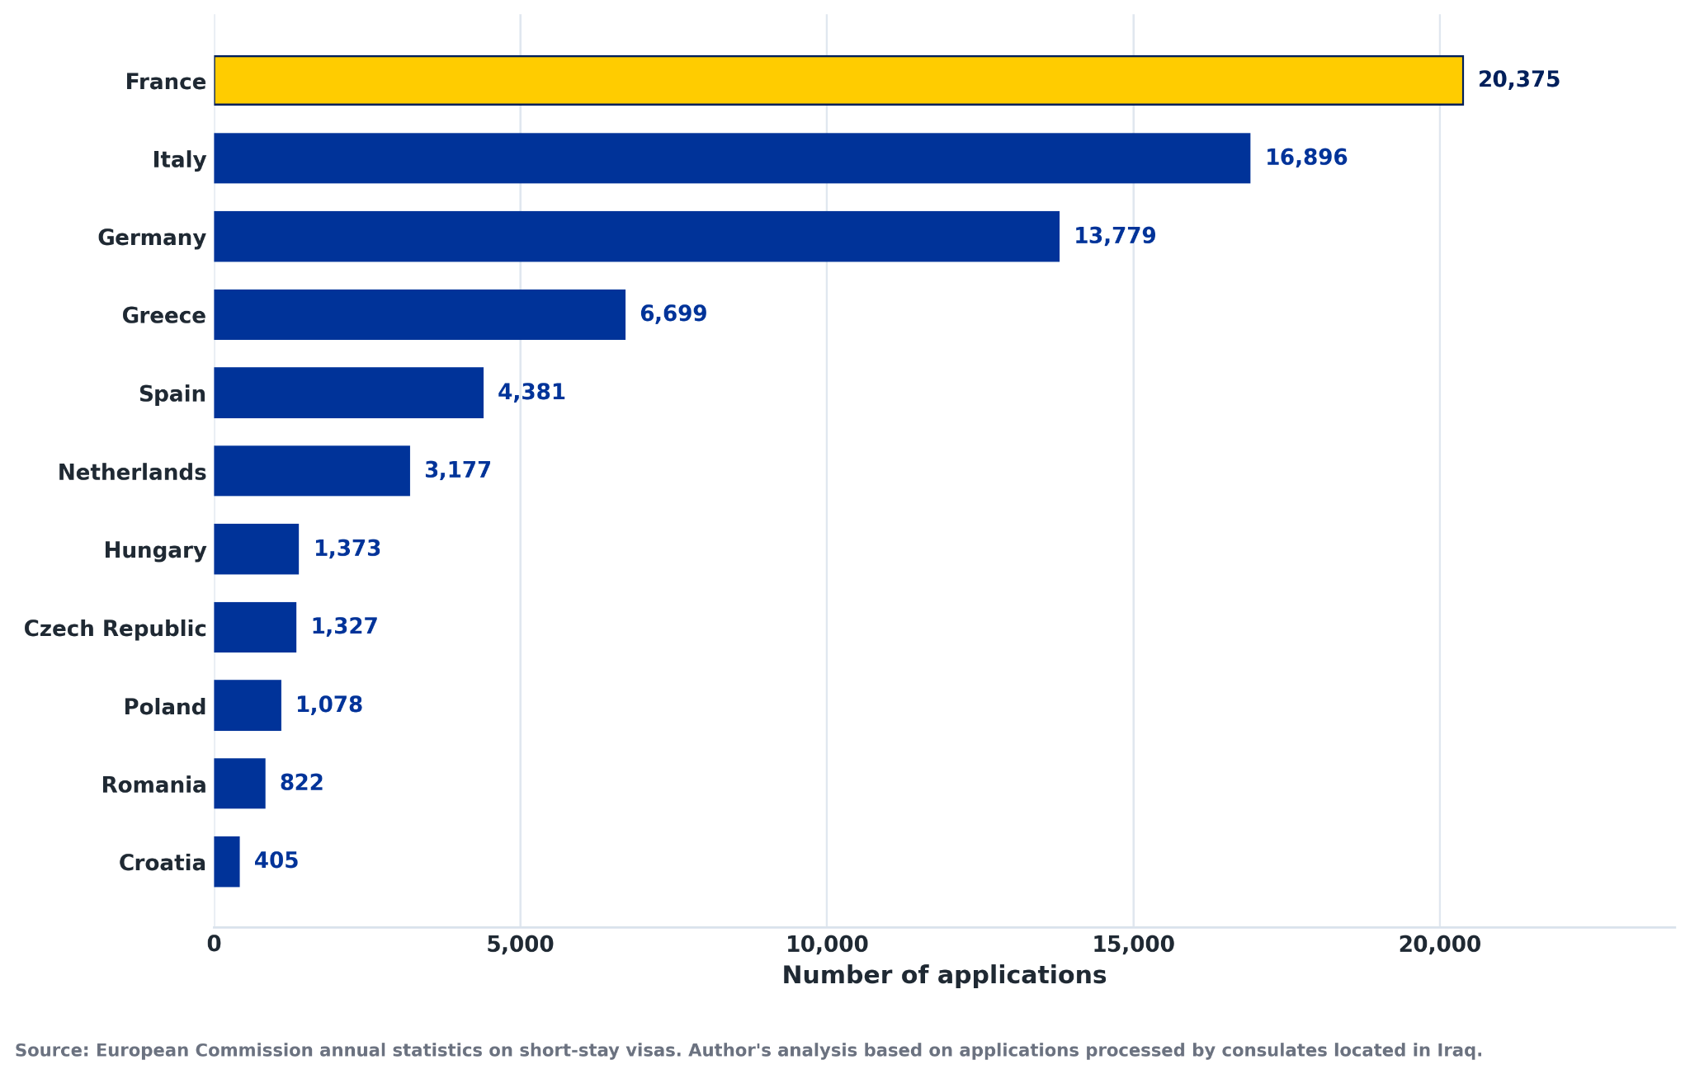
Figure 3. Number of applications by Schengen state, 2025.
These figures represent the consular location in Iraq, not the nationality of every applicant. Residents of other nationalities may be included, while Iraqi citizens applying outside Iraq are excluded.

4. Cases not issued by Schengen state in 2025
Outcome patterns differed substantially across Schengen states. Hungary recorded an 84.2% cases-not-issued share in Erbil. In the author’s separate analysis of the complete 2025 worldwide consular dataset, this was the highest value recorded by any consular post globally. Poland followed at 45.2% in the Iraq-based state aggregation, while Italy recorded the lowest state-level share in Iraq at 25.0%, closely followed by Spain and the Czech Republic.
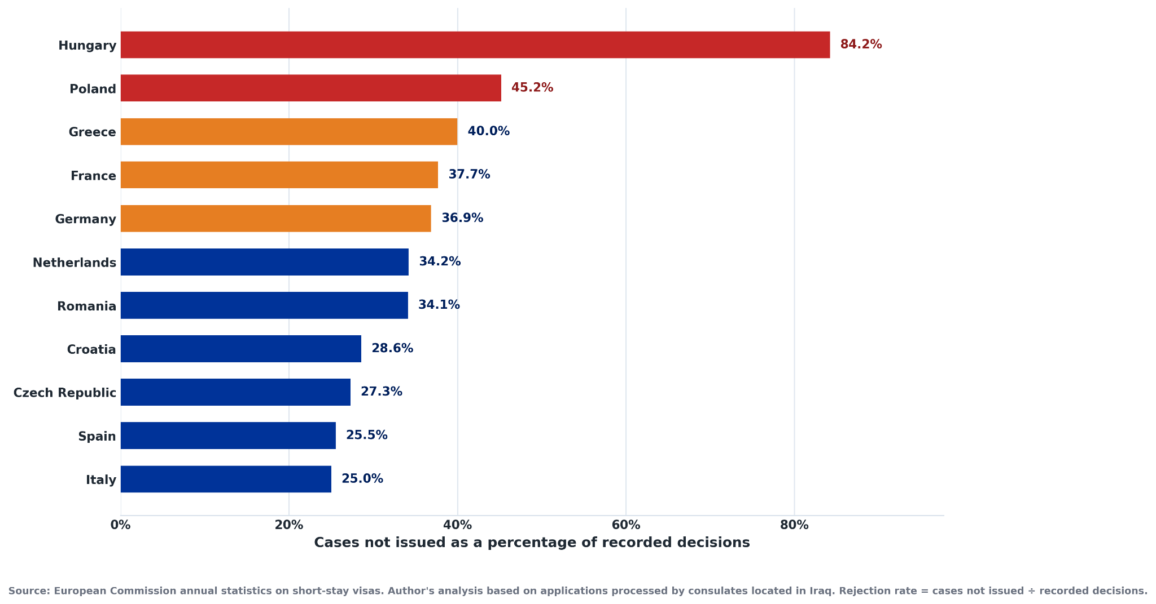
Figure 4. Cases not issued by Schengen state, calculated from recorded decisions.
A higher or lower value does not automatically mean that a state is “harder” or “easier.” Application volume, travel purpose, applicant characteristics, documentation and consular practice can all influence aggregate outcomes. The Hungary worldwide ranking is an author calculation from the full 2025 global consular dataset.

5. Baghdad and Erbil
Baghdad received 38,262 applications in 2025, representing 54.4% of the total. Erbil received 32,050, or 45.6%. The raw cases-not-issued share was 28.4% in Baghdad and 41.3% in Erbil, a difference of 12.9 percentage points.
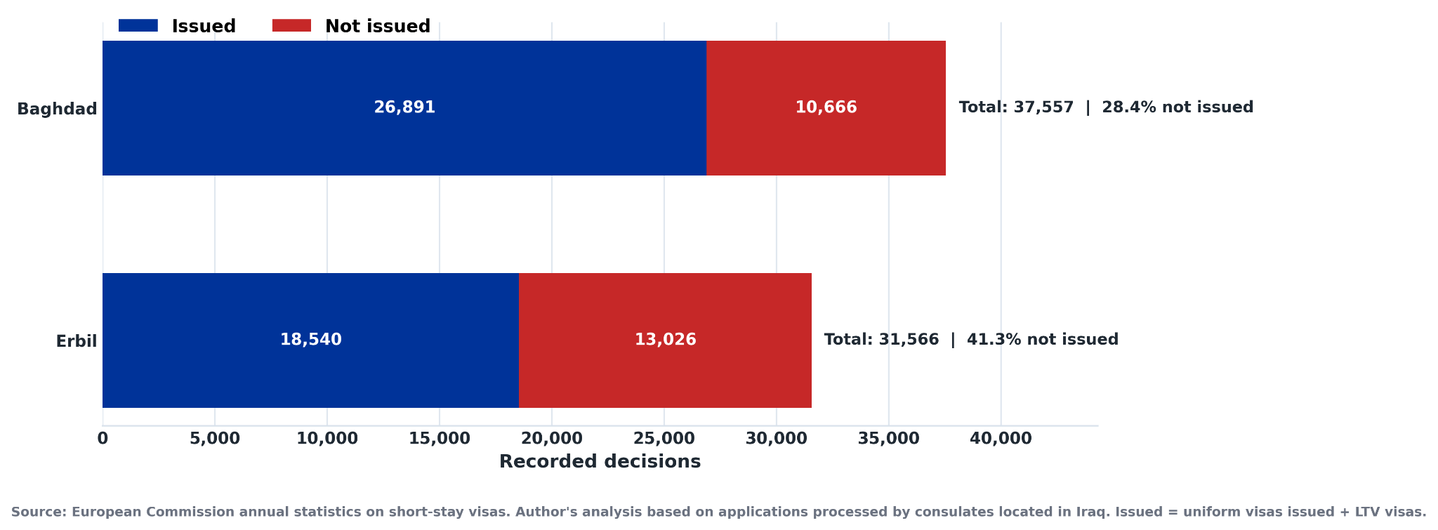
Figure 5. Decision outcomes by consular location, 2025. Issued combines uniform visas and LTV visas.

Adjusting for destination-state mix
A direct Baghdad–Erbil comparison is affected by the fact that the two locations do not host the same set of Schengen states. To test how much of the raw gap is associated with destination composition, the report recalculated both locations using a common set of seven destination states operating in both cities: the Czech Republic, France, Germany, Greece, Italy, the Netherlands and Romania. Each state was given the same pooled decision weight in both locations.
Comparison | Baghdad | Erbil | Gap
Raw 2025 cases not issued | 28.4% | 41.3% | 12.9 pp
Common-destination standardised | 27.5% | 35.9% | 8.5 pp
The standardised gap is smaller—about 8.5 percentage points—suggesting that destination-state composition explains part, but not all, of the raw difference. This still does not establish a causal “location effect”: applicant profiles, travel purposes, documentation and case mix remain unobserved.
The location comparison is descriptive. It should not be used to recommend applying through a location for which an applicant is not legally eligible.

6. Case study: Germany and the 2025 decline in Erbil
German applications fell from 19,509 in 2024 to 13,779 in 2025, a decline of 29.4%. The decline was heavily concentrated in Erbil: applications there fell from 11,693 to 6,814 (-41.7%), while Baghdad declined from 7,816 to 6,965 (-10.9%). Erbil therefore accounted for approximately 85.1% of Germany’s total reduction in applications lodged in Iraq.
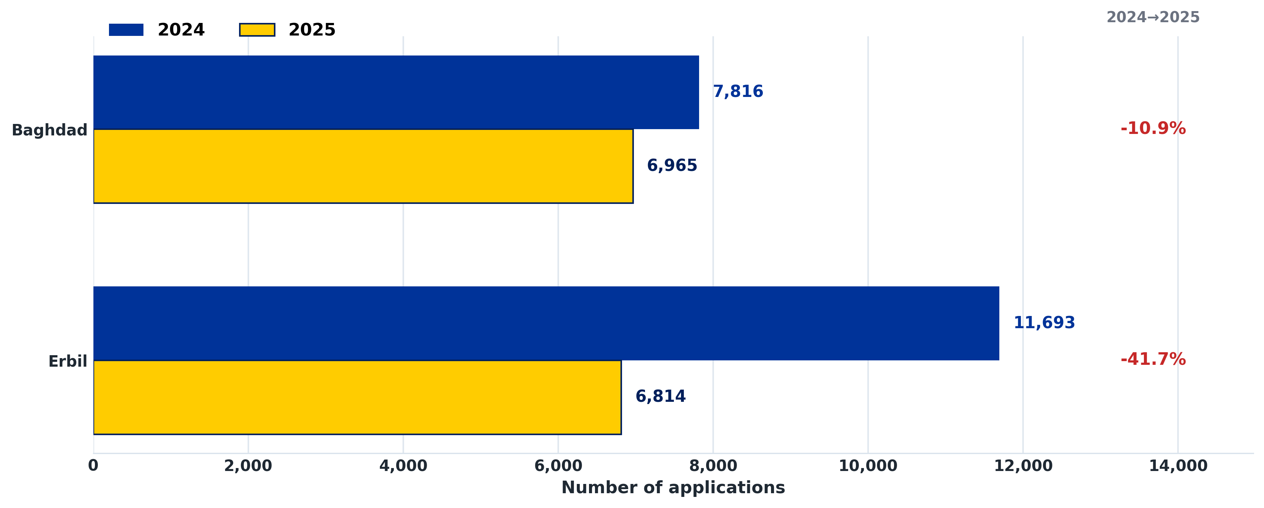
Figure 6. German visa applications in Baghdad and Erbil, 2024–2025.

Operational context
On 21 June 2025, VFS Global announced that all appointments at the Germany Visa Application Centre in Erbil scheduled from 22 June until further notice were temporarily cancelled “due to the current situation”; affected applicants were to be contacted and rescheduled later. The centre remained open for other services. [4]
The suspension coincided with the June 2025 Israel–Iran regional conflict, during which international airlines cancelled or rerouted services across the region and Iraq was included in security alerts concerning missile and drone threats. [5] This provides a plausible operational context for the sharp Erbil decline, but the annual statistics do not show how long appointment capacity was reduced, how many appointments were later rescheduled, or whether applicants shifted to a later reporting period.
Interpretation: the timing and concentration of the decline are consistent with security-related disruption being an important contributing factor. The evidence does not establish that the temporary suspension was the sole cause of the annual fall.

7. Multiple-entry visas
Multiple-entry visas allow repeated travel during the validity period of the visa. Their share among uniform visas issued rose from 33.9% in 2015 to a peak of 59.2% in 2021. It then declined to 35.9% in 2025.
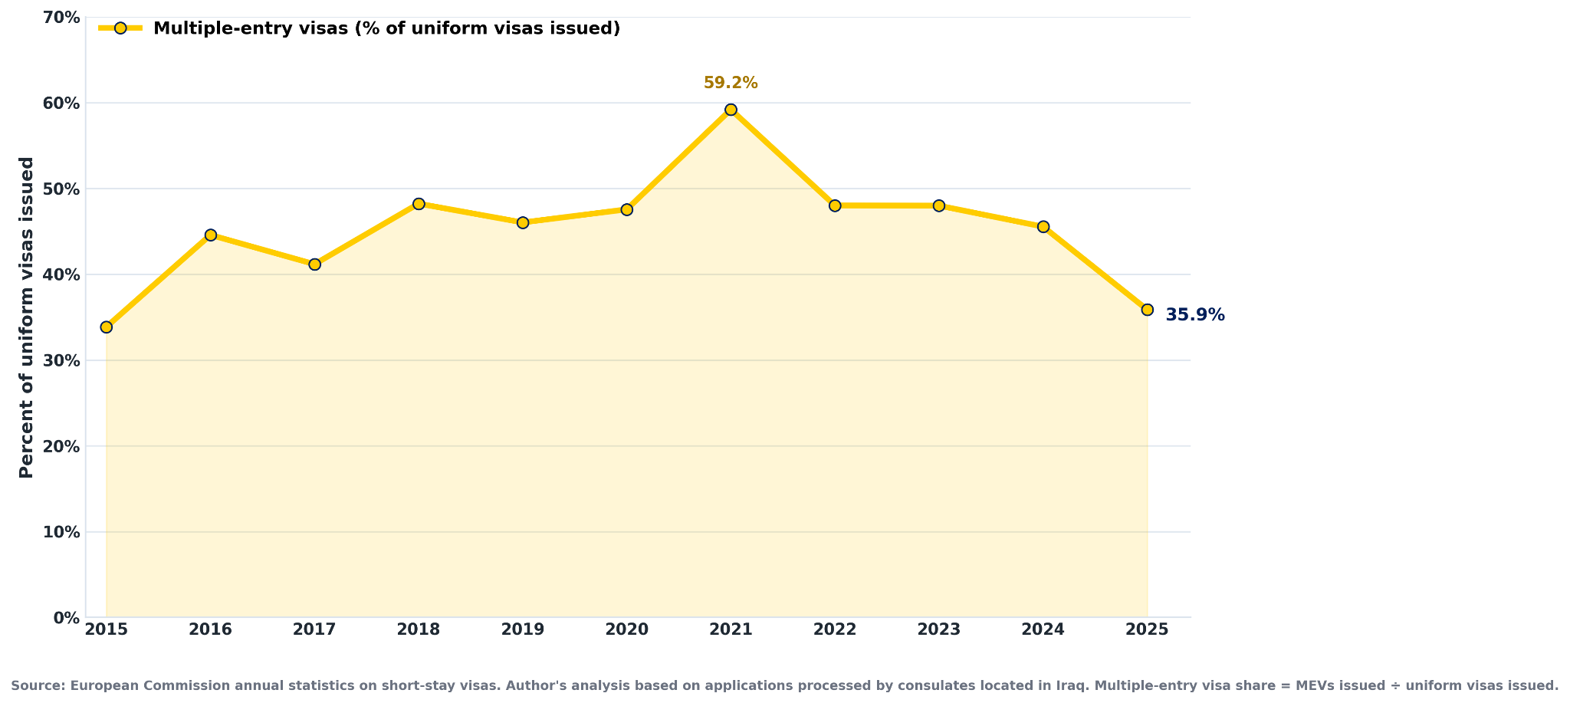
Figure 7. Multiple-entry visas as a share of uniform visas issued.
Formula: multiple-entry visas issued ÷ uniform visas issued. Limited-territorial-validity (LTV) visas are not included in the numerator or denominator.

Conclusion
The 2015–2025 data show a Schengen visa system in Iraq that has recovered strongly from the pandemic and is processing record demand. The recovery in Iraq has been faster than the global recovery: by 2025, applications lodged in Iraq were 22.3% above 2019, while worldwide applications remained about 28% below that benchmark.
At the same time, the aggregate outcome indicators remain high and vary considerably across destination states and consular locations. The revised analysis shows why those differences should not be reduced to simplistic rankings. The Baghdad–Erbil gap narrows when the destination mix is standardised, and the Germany–Erbil case demonstrates how operational disruption can affect annual application counts independently of underlying travel demand.
The report’s most responsible use is therefore to describe broad patterns, identify anomalies that deserve further investigation and provide transparent context around the numbers. It should not be used to predict individual visa outcomes or to encourage applicants to choose a consulate other than the one legally responsible for their main destination and place of residence.

What this report can and cannot tell us
- It can show long-term demand, destination concentration, decision outcomes and how the consular network in Iraq changed over time.
- It can identify unusual statistical patterns—such as the Germany–Erbil decline or the exceptionally high Hungary–Erbil not-issued share—that merit qualitative follow-up.
- It cannot determine why an individual application was refused, issued or discontinued.
- It cannot establish causation from annual aggregate data alone; operational and political context must be sourced separately.

Reproducibility note
The final public release should be accompanied by the cleaned calculation workbook used for the figures, together with a short data dictionary and version date. This would allow journalists, researchers and other users to reproduce the main indicators and distinguish the author’s calculations from the European Commission’s original fields.

Selected sources and data notes
1. European Commission — Short-stay visas issued by Schengen countries (annual statistics and 2025 data). Open source
2. European Commission — Visa statistics: quality and metadata reporting (definitions, coverage, data-quality process and “not issued” category). Open source
3. European Commission — Applying for a Schengen visa (general rules on the responsible consulate and main destination). Open source
4. VFS Global — “Important Notice: Temporary Suspension of Appointments at the Germany Visa Application Centre in Erbil,” 21 June 2025. Open source
5. Reuters — regional aviation and security disruption following the June 2025 Israel–Iran escalation. Open source

Author calculations
Unless otherwise stated, figures are calculated from the European Commission annual Excel files after filtering records to “Country where consulate is located = IRAQ.” The worldwide Hungary–Erbil ranking is based on a separate author analysis of the complete 2025 global consular dataset. Percentages may differ slightly from Commission-provided fields when the report uses recorded decisions as a custom denominator.
Suggested citation: Khaleel, A. (2026). Schengen Visas from Iraq: Applications, decisions and not-issued trends, 2015–2025. Data report, working draft.

