The Phenomenology of the Anger Spectrum in the Qur’an: A Semantic-Network Analysis of Displeasure, Inflammation, and Destructiveness Along an Action-Intensity Continuum

The Phenomenology of the Anger Spectrum in the Qur’an: A Semantic-Network Analysis of Displeasure, Inflammation, and Destructiveness Along an Action-Intensity Continuum
Karim Jabbary ^{1,*} and Ali Jabbary ²
¹ Department of Arabic Language and Literature, Faculty of Literature and Humanities, Urmia University, Urmia, Iran; k.jabbary@urmia.ac.ir
² Faculty of Computer Engineering, Urmia University, Urmia, Iran; a.jabbary@urmia.ac.ir
* Correspondence: k.jabbary@urmia.ac.ir

Abstract
Existing scholarship treats the Qur’an’s lexicon of anger word-by-word or through normative-ethical frames. This study argues that fourteen core Arabic roots form a graded semantic field ordered by intensity of action across six phenomenological stages: pre-anger displeasure, inner pressure, evaluative aversion, active anger, compressed/explosive rage, and behavioural outcomes. The framework layers Kennedy–Sassoon scalar semantics onto Izutsu’s semantic-field method and Lakoff–Kövecses conceptual metaphor theory; its signature theoretical claim is that Q. 67:8 of sūrat al-Mulk (takādu tamayyazu min al-ghayẓ) lexicalises an internal-separation, vessel-internal-failure variant of the PRESSURIZED-CONTAINER ANGER metaphor, distinct from the exit/overflow exemplars of the Anglo cognitive-linguistic canon. A reproducible pipeline over the Quranic Arabic Corpus yields 312 attestations; the distributional tests are corroborative and partly null (permutation p = 0.24; three roots survive Holm-Bonferroni, sakhaṭ a near-miss at adj. p = 0.0505), so the architecture is licensed chiefly by lexicography and tafsīr. Baghy is the largest cross-field bridge to the moral-evaluation field; a tafsīr-coding audit (second-coder κ = 0.79, 20% sample) supports bidirectional Stage-6 causation. Theologically, the affective-embodied upper register (ghayẓ, Q. 67:8) is reserved for creatures, while only action-tilted aversion lexemes are predicated of God. Small per-root n and the closed corpus bound the inferences.
Keywords: Qur’an; anger spectrum; semantic field; cognitive linguistics; scalar semantics; conceptual metaphor; corpus linguistics

1. Introduction

1.1. Statement of the Problem
The Qur’anic lexicon for the anger spectrum exhibits a precision that survives only with difficulty into translation: where English versions level uff, karh, ḍīq, ḥuzn, asaf, naqm, sakhaṭ, maqt, ghaḍab, ḥard, ghayẓ, baghy, ṭughyān, and ʿutuww into a small set of broad equivalents — “displeasure,” “distress,” “grief,” “anger,” “rage,” “transgression,” “rebellion” — the Arabic original distinguishes them with the precision of a graded taxonomy. We argue that these fourteen roots are not synonyms but coordinated nodes in a single graded semantic field organised along intensity of action, traversing pre-anger displeasure, inner pressure and contraction, evaluative aversion, active anger, compressed/explosive rage, and behavioural outcomes (baghy, ṭughyān, ʿutuww) whose causation is bidirectional rather than purely emotional. The distance from uff (sūrat al-Isrāʾ, Q. 17:23) to ʿutuww (sūrat al-Furqān, Q. 25:21) is graded, not categorical.

1.2. Aims and Originality
This paper combines Izutsu’s semantic-field approach, Kennedy–Sassoon scalar semantics, and Lakoff–Kövecses CMT to produce richer philological claims than any framework in isolation, with an honest division of labour: lexicographic evidence (organised via Izutsu) supplies the ordering of the roots; scalar semantics supplies the single-graded-dimension model that licenses reading the ordering as a continuum and partitioning it into stages; CMT grounds the pressurisation-collapse complex metaphor that organises Stages 4–5. Izutsu’s method yields a network without an internal ordering; Lakoff–Kövecses supply an English-anchored cognitive schema, and the two-volume Metaphors of ANGER across Languages (Kövecses, Benczes, and Szelid 2025) does not canvass Classical Arabic; Kennedy–Sassoon orders predicates along a dimension but has not been applied to a Qur’anic emotion field. We flag at the outset that the scalar layer functions here as a degree-semantic vocabulary for an ordering that is itself recovered from lexicography rather than from a corpus-validated metric; the corpus apparatus is corroborative (and, at several tests, candidly null — see Sections 3.2.1 and 3.11), not the primary evidentiary engine. Qāʾimīniyā (2011, 2014) and Pakatchi and Afrashi (2020) already integrate Izutsu with CMT in Persian; the novel element here is the scalar layer operationalised as a six-stage continuum and tested against a 312-attestation reproducible pipeline, alongside (i) a tafsīr-coding audit of the bidirectional-causation reading of Stage 6 (second-coder κ = 0.79 on a 20% verification sample), (ii) the kaẓm-as-tying-off-of-waterskin analysis of agent-internal containment, and (iii) the framing of Q. 67:8 of sūrat al-Mulk as an early and unusually transparent exemplification of vessel-internal failure, calibrated against the six-tradition survey of Section 4.5 acknowledging Job 32:19 (bāqaʿ) as a structurally cognate Northwest-Semitic precedent. The interpretive payoff: the continuum constitutes a coherent logic of escalation with structural affinities to modern emotion psychology, and reaches at Stage 6 into a moral-anthropological register that lies beyond the episode-bounded scope of process models such as Gross’s, where baghy/ṭughyān/ʿutuww extend the regulatory horizon into questions of settled character. These affinities are read comparatively, not as a claim that the Qur’an anticipates or contains modern theory (Section 4.2).

1.3. Prior Work and the Gap
Prior scholarship clusters into five lines. Single-word lexical studies (Narimani, Iqbali, and Chari 2021 on ghayẓ/ghaḍab/sakhaṭ; Khaleefah 2016, a semiotic study of the same three core terms; Qarizadeh et al. 2024 on ṭughyān) supply high-quality per-lexeme analysis but no integrated continuum. Semantic-field and cognitive-semantic studies in the Izutsu tradition (Qāʾimīniyā 2011, 2014; Pakatchi and Afrashi 2020; Solihu 2009; Albayrak 2012) leave the graded-continuum layer untreated. Ethics-of-anger work in the kaẓm al-ghayẓ tradition is normatively rich and linguistically thin. Cross-linguistic CMT literature, updated by Kövecses, Benczes, and Szelid (2025) across twenty-two languages, omits Classical Arabic; the closest Arabic-CMT precedents (Maalej 2004, 2007; Rabab’ah and Al-Saidat 2022) treat contemporary dialects. Historical-critical and corpus-linguistic work supplies complementary apparatus (Sinai 2017, 2023; Neuwirth 2019; El-Awa 2006; Sharaf and Atwell 2012a, 2012b; Akra, Hammouda, and Jarrar 2025; Sawalha et al. 2024); translation-criticism is now quantitative at scale (Gaanoun and Alsuhaibani 2025; Al-Shidi et al. 2025) but lacks a graded lexeme-level reference model. The present study occupies the unfilled intersection: it adds the Kennedy–Sassoon scalar layer to the Izutsu/CMT stack, applies it to the anger field the 2025 Metaphors of ANGER encyclopedia leaves un-canvassed, and releases the pipeline under Sharaf–Atwell / QuranMorph reproducibility standards.

1.4. Research Questions and Hypotheses
We address five research questions: (RQ1) the internal structure of the anger-spectrum field and its principal nodes; (RQ2) the action-intensity ordering and its theoretical legitimation; (RQ3) corpus-distributional corroboration (frequency, Meccan/Medinan, morphology, network); (RQ4) structural homology with Gross, Plutchik, Spielberger, and Lazarus–Scherer appraisal theory; (RQ5) implications for Qur’anic translation and Islamic psychology.
The principal Qur’anic Action-Intensity Continuum Hypothesis holds that the fourteen roots operate as graded steps on a single semantic continuum structured by intensity of action, organised in six phenomenological stages. Five subsidiary hypotheses follow: (H1) non-uniform six-stage frequency distribution; (H2) near-equal split between phenomenological core (S1–5) and behavioural pole (S6), consistent with the bidirectional Stage-6 reading; (H3) discursively-specialised exclusive-Medinan distribution of sakhaṭ; (H4) baghy as bridge node in the co-occurrence network; (H5) Q. 67:8 of sūrat al-Mulk as an unusually transparent exemplification of the vessel-internal failure construal.

2. Materials and Methods

2.1. Theoretical Framework

2.1.1. Izutsu’s Semantic-Field Method
Izutsu (1959, 1964, 2002) argued that the central Qur’anic terms are nodes in a network whose aggregate constitutes a Qur’anic Weltanschauung. His three-layer apparatus (focus words, semantic fields, key words) has been productive in Persian-language Qur’anic semantics (Qāʾimīniyā 2011, 2014; Pakatchi and Afrashi 2020). The fourteen target roots constitute the field around the focus words ghaḍab (central anger) and baghy (central behavioural-outcome). Izutsu’s method is silent on the question that drives the present enterprise: granted that these lexemes co-belong to a field, what is the structural relation between them within it? For this we require scalar semantics.

2.1.2. Scalar Semantics: From Network to Continuum
Gradable-predicate theory (Kennedy 1999, 2007; Sassoon 2010) supplies the missing apparatus. On the standard formulation a scale comprises a dimension of measurement, an ordering, and a degree structure recovered by a measure function. The Qur’anic anger field is modelled as such a scale: dimension = intensity of action (decomposable into locus, experiential intensity, scope of consequence); ordering = the six-stage progression; the degrees are read off as the degree of externalisation from inner phenomenology to social rupture. Without this framework, the claim that ghayẓ is “more intense than” ghaḍab relies on tacit native-speaker intuition. Two honest qualifications attach to the transplant. First, Kennedy–Sassoon was developed for gradable adjectives, whereas the present field is morphologically heterogeneous (verbs, nouns — ghaḍab is ~67% nominal — and participles); the extension assumes a category-neutral underlying intensity scale recoverable from lexicographic and corpus-distributional evidence, an assumption we adopt as a working heuristic rather than establish as formal cross-category degree semantics. We accordingly use the scalar apparatus as an ordering vocabulary layered onto an ordering that the lexicographic tradition already encodes (Section 3.1), not as an independent measurement claim. Second, the scale so understood predicts an ordering of semantic intensity, which is logically independent of attestation frequency and of distributional clustering; the flat monotonic-trend results (Section 3.2.1) and the below-random embedding NMI (Section 3.11) therefore neither corroborate nor falsify it — they bear on a different quantity — and we read them as orthogonal rather than as evidence against the continuum.

2.1.3. Conceptual Metaphor Theory and the Container Schema
Conceptual metaphor theory (Lakoff and Johnson 1980; Lakoff and Kövecses 1987; Kövecses 2000, 2010) treats metaphor as a cognitive structure mapping concrete source domains (container, heat) to abstract targets (emotion). Lakoff and Kövecses (1987, 195–221) reconstruct American-English anger as a five-stage prototype scenario — (1) offending event, (2) anger, (3) attempt at control, (4) loss of control, (5) retribution — onto which ANGER IS THE HEAT OF A FLUID IN A PRESSURIZED CONTAINER, ANGER IS FIRE, and ANGER IS A WILD ANIMAL are mapped, with the container/pressure cluster operating especially in stages (2)–(4).
Following Grady (1997) and Kövecses (2020), primary metaphors are grounded directly in recurrent embodied experience (ANGER IS HEAT; EMOTIONAL CONTAINMENT IS PHYSICAL CONTAINMENT), while complex metaphors compose primary metaphors with culturally-elaborated folk physiology. PRESSURIZED-CONTAINER ANGER is a complex metaphor — the body construed as a sealed vessel, anger as a hot fluid inside it, loss of control as the fluid’s exit or the vessel’s failure. The diagnostic by which we classify the ghayẓ–kaẓm–tamayyuz triad as complex rather than as the bare primary ANGER IS HEAT schema is the presence of culture-specific elaborations that the primary metaphor alone does not supply: a differentiated bodily locus (the affect localised to qalb/ṣadr/nafs rather than diffuse heat), a specific sealing operation drawn from material culture (kaẓm as the tying-off of a waterskin), and a specified failure mode (the tamayyuz internal separation). Primary-metaphor lexemes in the field (e.g. the diffuse ghaḍab “boiling”) carry the heat/agitation image without these collocational signatures; the S5 cluster carries all three. The Qur’anic triad thus operationalises the complex construct, not the primary schema alone. Source-to-target mappings: HOT FLUID under pressure → INTENSE ANGER (ghayẓ); CONTAINER (sealed vessel) → BODY/SELF (chest, qalb, nafs); SEALING / TYING-OFF the vessel (kaẓm as waterskin closure; Ibn Manẓūr, Lisān 12:519, s.v. k-ẓ-m) → AGENT-INTERNAL SUPPRESSION; SEPARATION OF CONSTITUENTS within the vessel → VESSEL-INTERNAL FAILURE MODE (the tamayyuz construal, Section 3.7). The triad maps tightly onto stages (2)–(4) of the Lakoff–Kövecses scenario, with Q. 67:8 providing an unusually transparent linguistic crystallisation of stage (4).
Sharifian’s (2011) Cultural Linguistics distinguishes what is universal in CMT from what is culturally elaborated. The primary metaphors are cross-linguistically robust and find support in the Qur’anic data, consistent with CMT’s universalist claim. The culturally elaborated layer — the Qur’an’s distribution of affect across qalb, ṣadr, and nafs as differentiated loci, the moral commendation of kaẓm in the taqwā register, and the tamayyuz construal of Q. 67:8 — is what the Qur’anic data illuminate beyond the universalist baseline (returned to in Section 4.4).

2.1.4. The Integrated Framework
The three frameworks contribute distinct, separable work, and stating the per-framework counterfactual keeps the synthesis honest. Izutsu identifies the field boundaries and, through the lexicographic tradition his method organises, supplies the pairwise ordering of the roots; without it there is no principled membership and no internal ranking. Scalar semantics supplies the single-graded-dimension model under which that ordering is read as one continuum and partitioned into discrete stages; without it the ordering would remain a loose family-resemblance network rather than a graded continuum, and the “more intense than” relations would lack a unifying dimension. CMT grounds the pressurisation-collapse complex metaphor organising Stages 4–5 (ghaḍab → ghayẓ + kaẓm → tamayyuz); without it the Q. 3:134 / Q. 67:8 container phenomenon would be describable only as disconnected idiom. The integration is thus a layered complementarity rather than a tight mutual entailment: lexicography and Izutsu do the ordering and licence the partition, scalar semantics models the graded dimension, and CMT illuminates the upper-stage container complex. Figure 1 schematises the resulting six-stage continuum.
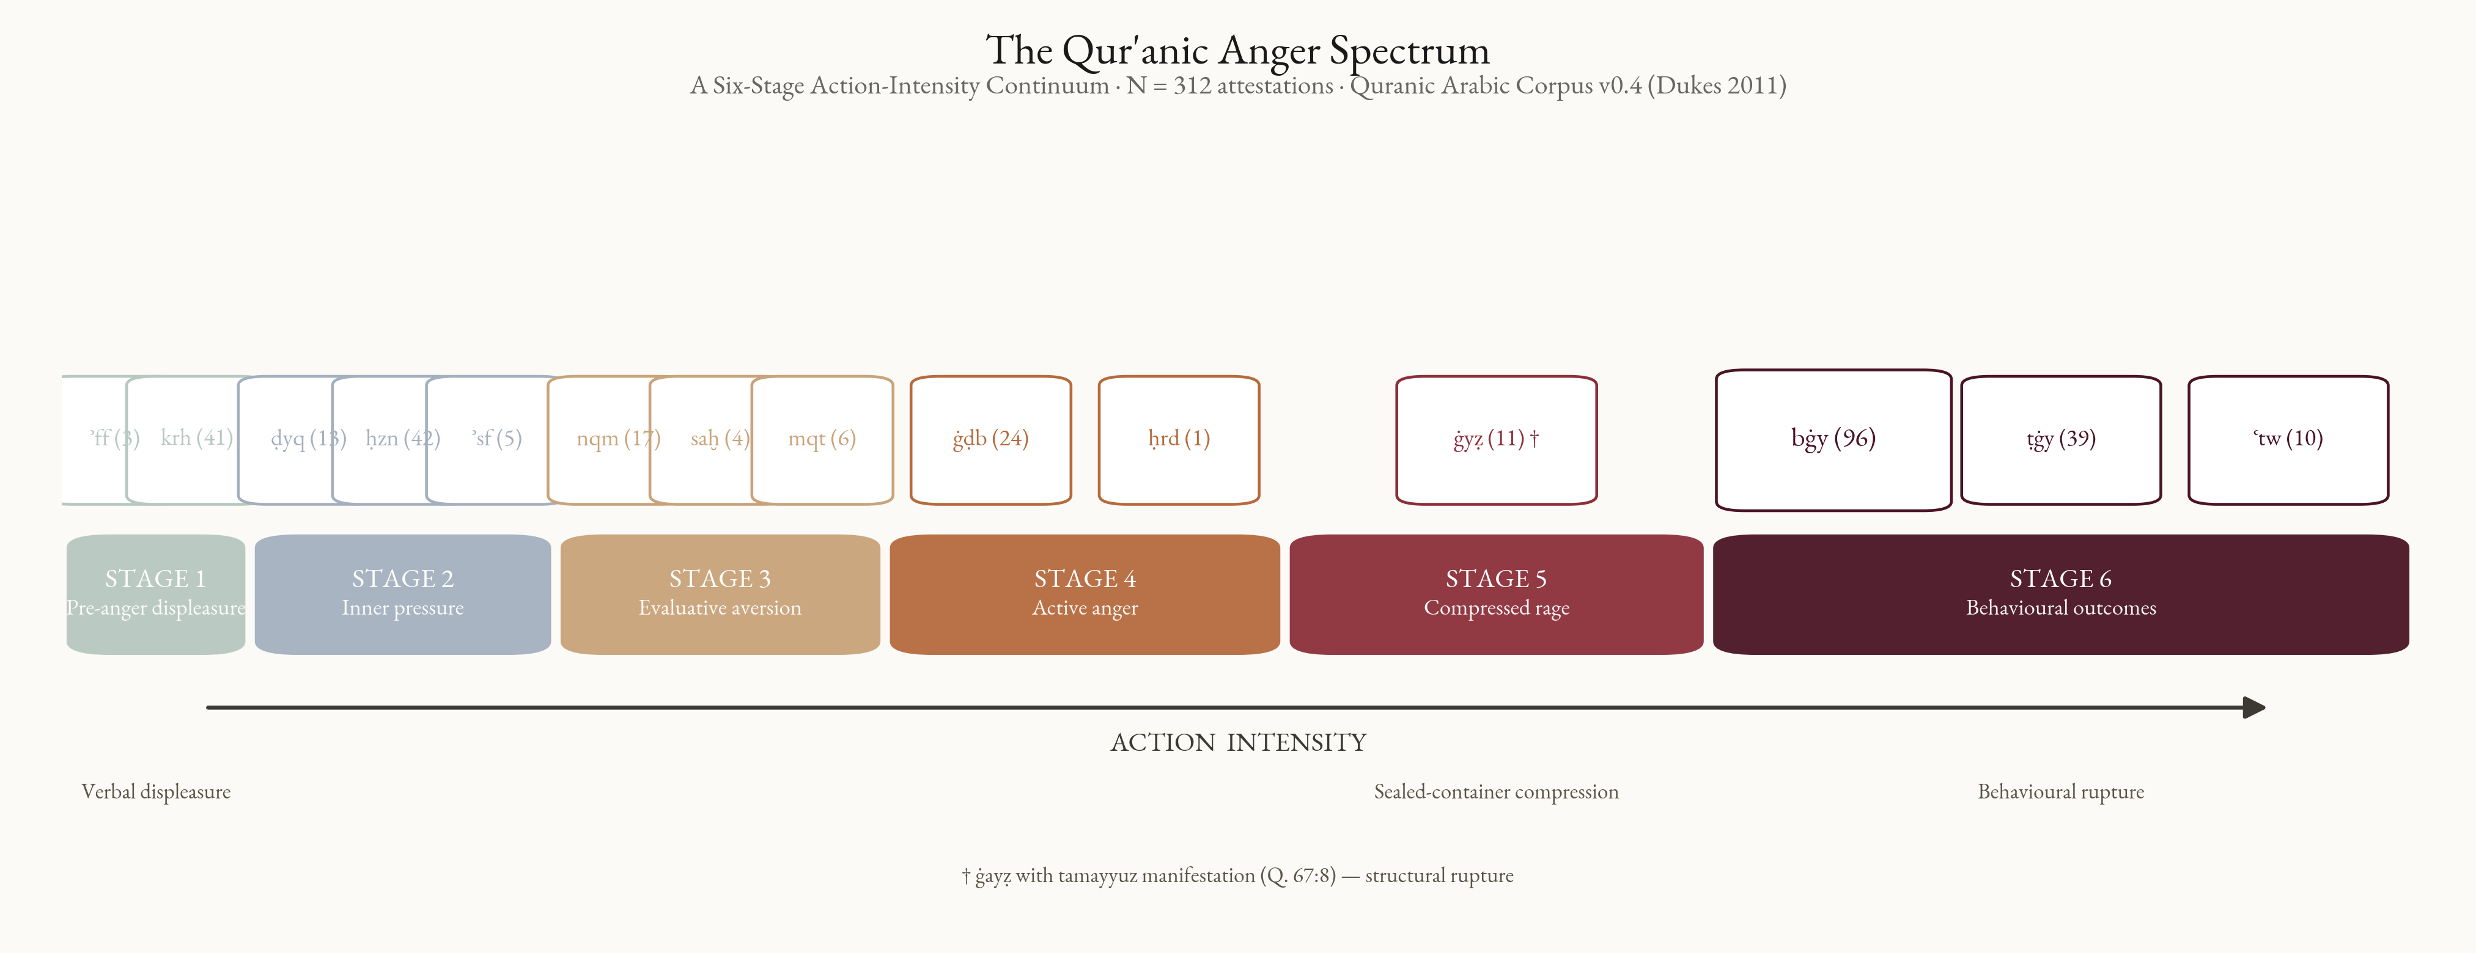
Figure 1. The six-stage Qur’anic anger-spectrum continuum along the action-intensity axis; node area scales with QAC attestation frequency. S1 pre-anger displeasure (ʾff–krh); S2 inner pressure (ḍyq–ḥzn–ʾsf); S3 evaluative aversion (nqm–sxṭ–mqt); S4 active anger (ghḍb–ḥrd); S5 compressed/explosive rage (ghyẓ; tamayyuz manifestation); S6 behavioural outcomes (bghy–ṭghy–ʿtw) with bidirectional causation (Section 3.8).

2.2. Corpus
The empirical analysis uses the Quranic Arabic Corpus (QAC) v0.4 (Dukes 2011): a morphologically tagged record for each of the 128,219 segmentable units, specifying location, surface form (Buckwalter), POS, and morphological features. Verse text in Uthmanic rasm and Meccan/Medinan sura classification are drawn from the Tanzil Project (2008).

2.3. Selection of Target Roots
The fourteen core roots were selected by three concurrent criteria: (i) exegetical centrality — focal reference in at least three of the four authoritative lexica (Maqāyīs, Mufradāt, Lisān, al-Mostafawi’s Taḥqīq); (ii) minimum corpus frequency of one attestation, admitting hapax legomena (ḥard, Q. 68:25) when supported by three of the four lexica and consistent tafsīr treatment; (iii) thematic membership without significant overlap with adjacent fields. Excluded candidates (transparency): q-h-r, ḥ-n-q (not attested), ʿ-n-f, ḍ-r-b, q-ṣ-w/q-s-y, gh-l-ẓ, ʾ-n-f, š-n-ʾ. Karh is borderline — karāha affective, ikrāh structural — included on the karāha sense (Section 3.3). Five umbrella moral terms (šnʾ, jrm, fsq, ẓlm, ʿdw) are used for robustness (Section 3.9) and cross-field co-occurrence (Table 4); excluded from the principal continuum because of inflated cardinality (ẓlm n = 315 functions as a meta-category) or adjacency to normative-ethics fields.

2.4. Computational Pipeline
The Python (MIT-licensed) pipeline parses the QAC morphology file, filters on target roots, collapses multi-segment morphemes to surface words, joins sura-level Meccan/Medinan metadata, and emits master and per-root concordances, distributional summaries, and network/centrality CSVs; the complete analysis is reproducible from a fresh clone in four commands. Figure 8 diagrams the end-to-end flow.
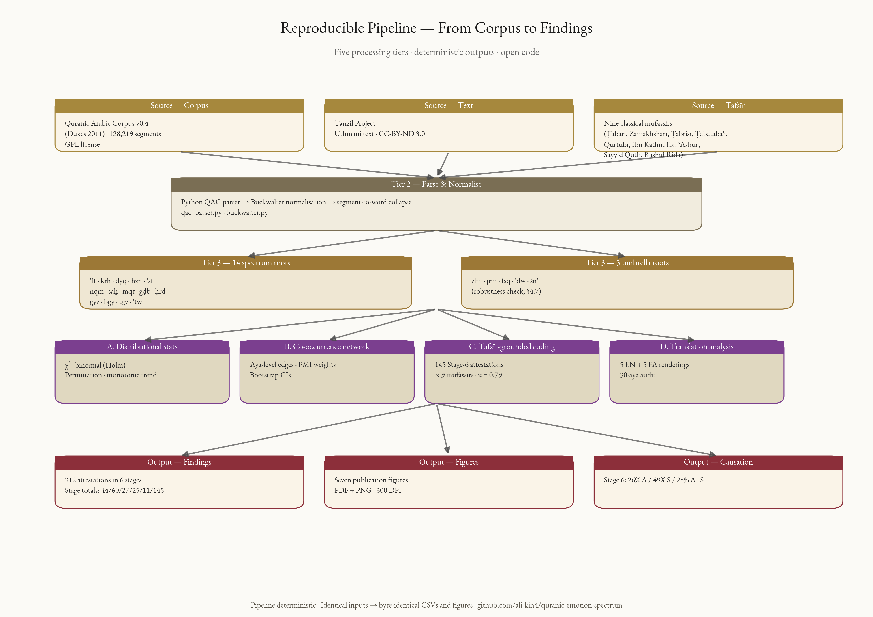
Figure 8. End-to-end pipeline from corpus to findings: QAC v0.4 and Tanzil sources → Buckwalter→Unicode parse → fourteen spectrum + five umbrella-moral root selection → distributional, network, tafsīr-coding, and translation-audit analyses → 312 attestations, figures, and Stage-6 causation breakdown. The pipeline is deterministic.

2.5. Quantitative Analyses
Quantitative tests beyond frequency tabulation: (a) χ²(5) and χ²(1) on uniform-stage and S1–5/S6 nulls, with a marginal-preserving permutation null (Cochran 1954; Patefield 1981; Mehta and Patel 1983; Agresti 2013, §3.5); (b) three monotonic-trend tests (Spearman ρ, Mann–Kendall, Cochran–Armitage-style OLS slope); (c) two-sided exact binomials against the 0.74 Meccan-ayat baseline, Holm–Bonferroni-adjusted (the Holm procedure controls the family-wise error rate, not the false-discovery rate) over the family of fourteen per-root tests, with sensitivity tables at baselines 0.70–0.78 and a family-size sensitivity check; (d) morphological breakdown by POS; (e) aya-level co-occurrence network (cf. Mottaghi et al. 2024) with weighted degree, betweenness, closeness, and eigenvector centrality, bootstrap 95% percentile CIs (1,000 ayat-resamples; fixed RNG seed).

2.6. Qualitative Analyses
Qualitative complements: (a) comparative etymology across the four lexica (Table 1); (b) comparative tafsīr drawing on a panel of classical and modern commentaries, with seven engaged ad loc. on the contested verses analysed in the Results — al-Ṭabarī (Jāmiʿ al-bayān), al-Zamakhsharī (al-Kashshāf), al-Ṭabarsī (Majmaʿ al-Bayān), al-Qurṭubī (al-Jāmiʿ), al-Rāzī (Mafātīḥ al-Ghayb), al-Ṭabāṭabāʾī (al-Mīzān), and Ibn ʿĀshūr (al-Taḥrīr wa-l-Tanwīr) — supplemented by al-Qushayrī’s Laṭāʾif al-Ishārāt for a Sufi cross-check on kaẓm al-ghayẓ (Section 4.2). Ibn Kathīr’s Tafsīr al-Qurʾān al-ʿAẓīm, Sayyid Quṭb’s Fī Ẓilāl al-Qurʾān, and the ʿAbduh–Riḍā al-Manār were consulted as background but are not engaged at named loci below and are cited only where relevant; we therefore do not claim them as part of the ad loc. comparative base. (c) phenomenological analysis of contextual markers (ḍīq al-ṣadr, ḥuzn al-qalb, ḍāqa dharʿan); (d) illustrative translation-criticism on five English translations at canonical exemplar verses (Section 3.10).

2.7. Validity Check
Fourteen headline exemplar verses — one per core root — were independently verified against the corpus output (Q. 17:23, 2:216, 15:97, 2:38, 43:55, 7:126, 47:28, 40:10, 48:6, 68:25, 3:134 [with Q. 67:8 tamayyuz], 42:42, 96:6, 25:21); all matched the Uthmani edition.

3. Results

3.1. The Four-Lexicon Etymology Table
Table 1 summarises the canonical glosses of each root across four reference lexica.
Table 1. Comparative etymology of the fourteen core roots across the four authoritative Arabic lexica.
Stage | Root | Maqāyīs (Ibn Fāris) | Mufradāt (al-Rāghib) | Lisān al-ʿArab (Ibn Manẓūr) | Taḥqīq (al-Mostafawi)
1 | ʾ-f-f | “kalimatu taḍajjurin” (a word of vexation); smallest audible expression of displeasure | the lowest verbal expression of displeasure (adnā kalimati al-taḍajjur) | term of irritation (taḍajjur) directed at someone or something disliked; cf. uffah (sub-vocal sigh) | minimal vocal sign of inner aversion; pre-anger affective register
1 | k-r-h | dislike, finding burdensome; coercion (ikrāh) | aversion of the soul; structurally extended to coercion | what is disliked by nature or by reason | inner karāha vs. structural ikrāh (the latter is not an emotion)
2 | ḍ-y-q | constriction; absence of opening | the state of being pressed upon, contrasted with capacity (saʿah) | reduction of available space, from saʿah to ḍīq | inner or outer absence of expansion (basṭ)
2 | ḥ-z-n | rough/uneven ground → heaviness of soul | sorrow as the opposite of joy (faraḥ) | rugged ground, then roughness of the self | affective response to perceived loss
2 | ʾ-s-f | intense grief mixed with anger | extreme anger conjoined with grief | reaching the limit of grief and anger | composite of grief and proximate anger
3 | n-q-m | al-naqimah: disapproval (inkār) coupled with intent to punish; cf. intaqama min = exact retribution from | objecting to (ankara ʿalā) and seeking redress (ʿuqūbah) against a reprehensible act | strong denunciation (ankara ashadda al-inkār) yoked to ʿuqūbah; basis of divine attribute al-Muntaqim | evaluative anger oriented toward retribution; cognition-grounded, action-tilted
3 | s-kh-ṭ | severe aversion and ethical rejection | the opposite of riḍā (consent), with intensity | severe non-acceptance with judgment | declarative rejection grounded in moral assessment
3 | m-q-t | al-bughḍ: intense aversion and detestation | aversion arising from observing a qabīḥ act (al-Rāghib), glossed as the severest form of ibghāḍ (transmitting Zajjāj) | ashaddu al-ibghāḍ (transmitting Zajjāj); aversion-distance rather than approach-aggression | purely evaluative moral aversion
4 | gh-ḍ-b | inner agitation and motion | the boiling of the heart’s blood seeking retribution | a rising perturbation of the soul | directed emotion enabling retributive action
4 | ḥ-r-d | ḥarada: to be angry; also the act of qaṣd (deliberate aim) | conjoining ghaḍab with qaṣd: anger directed by purpose, viz. denial | ḥarada “to act/move toward an aim with resolve while in anger”; cf. ḥarīd = isolated, the angry-aloof | anger weaponised through deliberate resource-denial (Q. 68:25 aṣḥāb al-jannah); affective + volitional + miserly composite
5 | gh-y-ẓ | pressure and surge, contained | the most intense forms of contained anger | filling of the self with restrained anger | high-pressure emotional accumulation
6 | b-gh-y | seeking beyond rightful bounds | overstepping the path of right | dominance through aggression | aggressive action with intent to oppress
6 | ṭ-gh-y | overflow of water past its bank | crossing the permitted measure | severe transgression of the limit | rebellious shattering of normative bounds
6 | ʿ-t-w | severe rebellion with arrogance | extreme self-aggrandisement in disobedience | transgressing the limit, with istikbār-attachment as collocational feature | entrenched rebellious posture (a property of moral character)
The table grounds two distinct claims at different evidential strengths. The pairwise ordering relations among many root-pairs (e.g. uff < ghaḍab; karāha < maqt; ghaḍab < ghayẓ; naqm < baghy) are internally encoded in the lexicographic tradition: the four authoritative lexica already gloss each root with progressively externalised and structural meanings. The partition into six discrete phenomenological stages, by contrast, is the analytical contribution of the present study, licensed jointly by the lexicographic ordering, the tafsīr readings of Sections 3.3–3.8, and the morphological and distributional evidence of Section 3.2.

3.2. Distributional Summary
Table 2 and Figures 2–5 report the principal distributional facts for the fourteen roots: per-root and per-stage frequency, Meccan/Medinan split, and morphological breakdown by POS.
Table 2. Distributional profile of the fourteen core roots (Wilson-score 95% CIs on the Meccan-rate point estimate; baseline = 0.74).
Stage | Root | n | M | Md | M-rate (95% CI) | Notes
1 | ʾff | 3 | 3 | 0 | 1.00 [0.44, 1.00] | All Meccan; n too small for inference
1 | krh | 41 | 14 | 27 | 0.34 [0.22, 0.49] | Medinan-tilted, CI excludes baseline; Holm-adj. ≈ 1.4 × 10⁻⁶
2 | ḍyq | 13 | 9 | 4 | 0.69 [0.42, 0.87] | CI includes baseline; inner constriction
2 | ḥzn | 42 | 26 | 16 | 0.62 [0.47, 0.75] | CI includes baseline; valence transversal (Section 3.4.2)
2 | ʾsf | 5 | 5 | 0 | 1.00 [0.57, 1.00] | Underpowered; CI includes the 0.74 baseline (raw p = 0.34, n.s.)
3 | nqm | 17 | 12 | 5 | 0.71 [0.47, 0.87] | CI includes baseline; not Holm-significant
3 | sxṭ | 4 | 0 | 4 | 0.00 [0.00, 0.49] | CI excludes baseline; Holm-adj. = 0.0505 (near-miss, n.s.)
3 | mqt | 6 | 4 | 2 | 0.67 [0.30, 0.90] | Wide CI; includes baseline
4 | ghḍb | 24 | 13 | 11 | 0.54 [0.35, 0.72] | CI excludes 0.74 baseline; central anger lexeme
4 | ḥrd | 1 | 1 | 0 | — | Hapax: sūrat al-Qalam, Q. 68:25
5 | ghyẓ | 11 | 3 | 8 | 0.27 [0.10, 0.57] | Medinan-tilted; Holm-adj. ≈ 1.9 × 10⁻² — survives Holm (FWER)
6 | bghy | 96 | 55 | 41 | 0.57 [0.47, 0.67] | CI excludes baseline; Holm-adj. ≈ 5.3 × 10⁻³ — survives Holm (FWER); bridge node (Section 3.8.5)
6 | ṭghy | 39 | 29 | 10 | 0.74 [0.59, 0.85] | CI includes baseline; not Holm-significant
6 | ʿtw | 10 | 9 | 1 | 0.90 [0.60, 0.98] | CI includes baseline; istikbār-attached
Σ | — | 312 | 183 | 129 | —
Seven of the fourteen roots have n < 10 (ʾff = 3, ʾsf = 5, sxṭ = 4, mqt = 6, ḥrd = 1, ghyẓ = 11 is borderline, ʿtw = 10 borderline); per-root inferences on these are underpowered and we lead them with the Wilson-score CI rather than the p-value, the Holm-Bonferroni adjustment then carrying the inferential weight across the family. No substantive claim rests on a single underpowered root in isolation.
Across the six stages: S1 = 44; S2 = 60; S3 = 27; S4 = 25; S5 = 11; S6 = 145. Two distinct nulls bear on these data, answering different questions. The uniform-six-stage null (is the per-stage distribution uniform?) is unambiguously rejected by the asymptotic χ²(5) = 227.15, p < 0.001 (Cramér’s V = 0.38, Cohen’s w = 0.85), since baghy alone supplies 96 of 312 attestations. A marginal-preserving permutation null holding per-root counts fixed and randomly permuting the fourteen stage labels tests instead “conditional on baghy’s mass-dominance, is our partition more skewed than a random six-binning of the same roots?” — the empirical p = 0.24 says no. This is not evidence that the distribution is uniform (already ruled out); it is evidence that the omnibus χ² cannot discriminate our partition from alternative six-bin partitions of the same roots. The structural case for the six-stage architecture rests on the qualitative evidence of Sections 3.1 and 3.3–3.8 together with the morphological-gradient and Meccan/Medinan-specialisation evidence below.
The S1–5/S6 χ²(1) = 1.55 (Cohen’s w = 0.07) fails to reject equal split between the phenomenological core (167) and the behavioural pole (145) — absence of evidence of a difference, consistent with the bidirectional-causation reading of Section 3.8.5 and Section 4.3.

3.2.1. Monotonic-Trend Tests
Three monotonic-trend tests of stage rank against attestation frequency all fail to reject the no-trend null: Spearman ρ = –0.09 (p = 0.85), Mann–Kendall z = –0.38 (p = 0.71), Cochran–Armitage-style OLS slope = 10.17 (p = 0.40). The continuum orders by semantic intensity, not attestation frequency. The Qur’an is a closed hortatory text whose lexical weights are pedagogically determined: density is heaviest at the two poles of moral consequence (S1–2, entry points for kaẓm, taqwā, ḥilm; S6, the structural pathologies most frequently denounced), with S3–5 as middle-trajectory states. A flat trend is what the theory predicts.
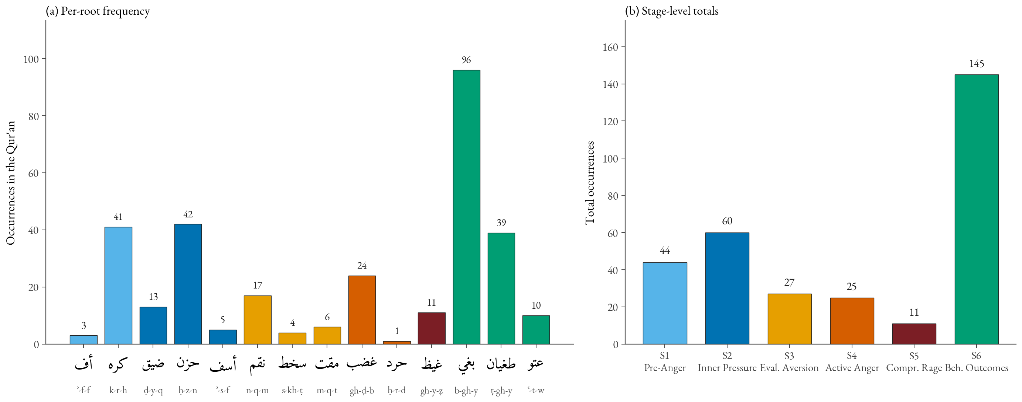
Figure 2. Per-root and per-stage frequency of the 312 core attestations. Left: per-root frequency (bar colour encodes stage). Right: stage totals S1 = 44, S2 = 60, S3 = 27, S4 = 25, S5 = 11, S6 = 145. χ²(5) = 227.15 asymptotic, but permutation null p = 0.24 (Section 3.2); S1–5/S6 χ²(1) = 1.55, consistent with the bidirectional-causation reading of Section 3.8.5.
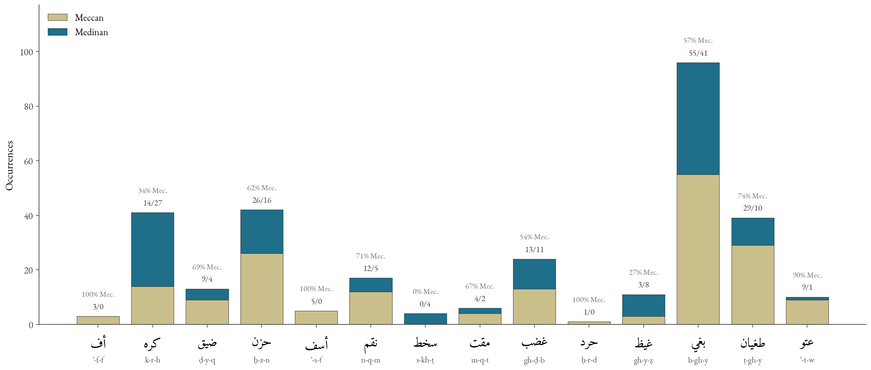
Figure 3. Stacked Meccan/Medinan distribution. Three roots survive Holm-Bonferroni correction (α = 0.05): karh (Medinan), baghy (Meccan), and ghayẓ (Medinan); sakhaṭ a near-miss at adj. p = 0.0505 (not significant). Asaf, naqm, ʿutuww tilts are contextual. The patterns instantiate discursive-contextual specialisation (Section 4.4).
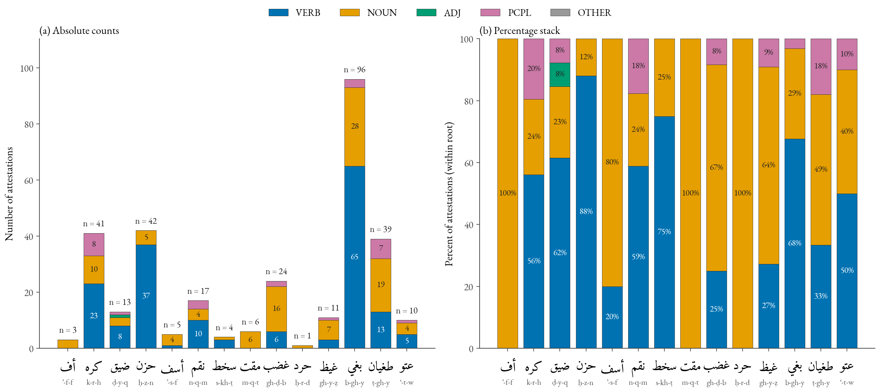
Figure 5. Morphological profile by POS. Verbal dominance at S1–2 (ḥzn 88% verbal, ḍyq 62%), nominalisation at S4 (ghḍb 16n/6v/2 ptcp), peak nominality with participial forms at S6 (ṭāghūt, bāghin). The verbal→nominal gradient is independent corpus-internal evidence for the action-intensity continuum.

3.3. Stage 1 — Pre-Anger Displeasure
3.3.1. Uff (3; all Meccan). Uff (taḍajjur) is the Qur’anic register’s lowest verbal expression of displeasure. Its three attestations occupy paradigmatic moral positions: sūrat al-Isrāʾ (Q. 17:23) prohibits saying uff to one’s parents — the lowest sign of displeasure weighted at the highest relational stake; sūrat al-Anbiyāʾ (Q. 21:67) places it in Abraham’s mouth confronting idol-worshippers; sūrat al-Aḥqāf (Q. 46:17) ascribes it to a rebellious child reproaching believing parents.
3.3.2. Karh (41; 14M/27Md; Holm-adj. p ≈ 1.4 × 10⁻⁶ — survives Holm (FWER)). Karh exhibits a twofold structure: inner karāha (pre-anger evaluative dislike, framed as reformable by sūrat al-Baqara, Q. 2:216, ʿasā an takrahū shayʾan wa-huwa khayrun lakum; the S1 sense), and structural ikrāh (coercion — not an emotion but a structural extension into compulsion: Q. 2:256, lā ikrāha fī al-dīn; Q. 16:106; Q. 24:33). Inclusion rests on the karāha sense; the structural ikrāh in Medinan community-discipline contexts (consent in marriage, freedom in religion) accounts for the Medinan tilt.

3.4. Stage 2 — Inner Pressure and Contraction
Stage 2 brings together three roots (ḍ-y-q, ḥ-z-n, ʾ-s-f) with sixty attestations.
3.4.1. Ḍīq (13; 9M/4Md). Ibn Fāris glosses ḍyq as constriction/narrowness; al-Rāghib opposes it to saʿah. The root appears predominantly in ḍīq al-ṣadr (constriction of the chest), localising the experience to the embodied site (sūrat al-Ḥijr, Q. 15:97, the prophetic response to social rejection). Al-Ṭabāṭabāʾī (al-Mīzān 12:195, ad Q. 15:97: wa-laqad naʿlamu annaka yaḍīqu ṣadruka bimā yaqūlūn) reads the verse as expressing divine knowledge of prophetic ḍīq rather than prohibition. The compound ḍāqa bihim dharʿan in the Lot narrative (sūrat Hūd, Q. 11:77; cf. the parallel at Q. 29:33) figures post-anger blocked aggression: trigger sīʾa bihim → constriction → aspirational voicing law anna lī bikum quwwatan → transfer of agency to the divine. Ḍyq thus sits at both poles of the spectrum (pre-anger contraction and upper-pressure inhibition); the morphological profile (8v / 3n / 1 ptcp) registers a transient, situationally-induced state.
3.4.2. Ḥuzn (42; 26M/16Md). The most frequent and most verbal S2 lexeme (88% verbal). Ibn Manẓūr preserves the primary sense “rugged, uneven ground”; the metaphorical extension figures grief as inner roughness (anticipating Kövecses 2000 on EMOTION IS A LANDSCAPE). Sūrat al-Baqara (Q. 2:38) pairs ḥuzn with khawf and opposes both to divinely-given guidance. Ḥuzn has four valences: standalone grief over loss (Jacob over Joseph, sūrat Yūsuf, Q. 12:84), externally-induced sorrow from being wronged, positive moral compunction (the affective register of tawba), and anger turned inward when externally inhibited; inclusion at S2 is justified by corpus density and proximity of the second and fourth valences to the anger field.
3.4.3. Asaf (5; 5M/0Md). Al-Rāghib glosses asaf as the conjunction of grief and anger (al-jamʿ bayna al-ḥuzn wa-l-ghaḍab). Sūrat al-Zukhruf (Q. 43:55, fa-lammā āsafūnā intaqamnā minhum) frames it as the immediate causal precursor of divine retribution (al-Ṭabarsī, Majmaʿ 9:82). The compound ghaḍbān asifan, applied to Moses on his return to the calf-worshippers (Q. 7:150; Q. 20:86), generates a three-layer dialectic in which ghaḍab is outward-kinetic and asaf the inward-compassionate ground. The 5/0 distribution is power-bound (Wilson CI [0.57, 1.00]). The aya-level network (Figure 4) confirms S2 coherence: ḥzn–ḍyq is the strongest single edge (weight 3).

3.5. Stage 3 — Evaluative Aversion
Stage 3 brings together three roots (n-q-m, s-kh-ṭ, m-q-t) with twenty-seven attestations marking distinct modes of evaluative aversion. Maqt is the lexicographic superlative of aversion (Zajjāj, ashaddu al-ibghāḍ) but is placed between sakhaṭ and ghaḍab on the action-intensity axis because the dimension here is intensity of action, not intensity of aversion.
3.5.1. Naqm (17; 12M/5Md). Naqm is vengeful disapproval — anger grounded in moral evaluation and oriented toward retribution. Sūrat al-Aʿrāf (Q. 7:126, wa-mā naqamū minnā illā an āmannā bi-āyāti rabbinā) is the linguistic exemplar; al-Ṭabarī (Jāmiʿ al-bayān 13:23 ad loc.) glosses naqamū as ʿābū wa-ankarū, exposing the taʿaṣṣub-structure of disbelief (al-Qurṭubī, al-Jāmiʿ 7:262 convergent). The lexeme generates al-muntaqim as a divine attribute (Q. 32:22 and parallels). The Wilson CI includes the baseline.
3.5.2. Sakhaṭ (4; 0M/4Md). The exclusive-Medinan distribution is one of the paper’s principal distributional findings. The raw two-sided binomial p = 0.0046, but the Holm-adjusted p = 0.0505 falls just short of the α = 0.05 threshold; we therefore treat sakhaṭ as a non-significant near-miss whose substantive interest rests on the categorical 0/4 Medinan pattern and the Munāfiqūn attachment rather than on adjusted significance. All four attestations are tied to the Munāfiqūn in their Medinan-period exegesis: sūrat Muḥammad (Q. 47:28, ittabaʿū mā askhaṭa Allāh wa-karihū riḍwānahu) is canonical, though al-Ṭabarī notes that sūrat al-Māʾida (Q. 5:80) is exegetically discussed as directed at the People of the Book rather than the Munāfiqūn properly. Following Narimani, Iqbali, and Chari (2021), we read sakhaṭ as sustained ethical disapprobation rather than instantaneous emotional surge; we propose:
Hypothesis (Discursive Specialisation of sakhaṭ): sakhaṭ operates as a discursively specialised lexeme reserved for divine displeasure with the Munāfiqūn — agents whose ẓāhir departs from their bāṭin. Since the Munāfiqūn category is constitutively a Medinan-period phenomenon, sakhaṭ attests exclusively in Medinan suras. This is one instance of a general phenomenon of discursive-contextual lexical specialisation, of which karh (Medinan-community discipline) and the umbrella patterns jrm (Meccan) / fsq (Medinan) are convergent.
3.5.3. Maqt (6; 4M/2Md). Maqt is intense moral aversion: al-Rāghib (Mufradāt) and Ibn Manẓūr (Lisān), citing Zajjāj, gloss it as ashaddu al-ibghāḍ (the severest form of detestation), and al-Rāghib grounds it in observation of a reprehensible act, making maqt purely evaluative. The canonical exemplar is sūrat Ghāfir (Q. 40:10, la-maqtu Allāhi akbaru min maqtikum anfusakum), the doubled maqt comparing divine moral aversion at the disbelievers with their own retrospective self-maqt on the Day of Resurrection (al-Ṭabarī, Jāmiʿ al-bayān 21:351 ad loc.; al-Qurṭubī, al-Jāmiʿ 15:296 convergent). Sūrat al-Nisāʾ (Q. 4:22), sūrat Fāṭir (Q. 35:39), and sūrat al-Ṣaff (Q. 61:3) stabilise the lexeme as moral aversion as evaluative response, distinct from the kinetic-motor ghaḍab of Stage 4.

3.6. Stage 4 — Active Anger
3.6.1. Ghaḍab (24; 13M/11Md). The central anger lexeme — near-balanced Meccan/Medinan distribution marks it as the unmarked default. The four lexica gloss it as inner agitation oriented toward retribution (al-Rāghib) or inner motion disposing the agent to action (Ibn Fāris); predicated balance-fully of God (sūrat al-Fatḥ, Q. 48:6), prophets, and believers. Morphologically 67% nominal (16n/6v/2 ptcp) vs ḥuzn’s 88% verbal: ghaḍab is a structural concept-state, not a transient affect. Al-Rāzī (Mafātīḥ al-Ghayb) glosses divine ghaḍab in the register of irādat al-ʿuqūbah — a normative-juridical orientation, not an emotional response. Network analysis places ghḍb among the top three for betweenness (point estimate 0.15).
3.6.2. Ḥard (Q. 68:25, hapax). A hapax in the Garden-Owners parable (wa-ghadaw ʿalā ḥardin qādirīn): owners vowing in the night to harvest before dawn so as to deny the poor their share. Al-Ṭabarī (Jāmiʿ al-bayān 23:550 ad loc.) records four classical qawls: (i) qaṣd (purposive aim — Mujāhid, Ibn Zayd, Ibn ʿAbbās ʿan ʿIkrima); (ii) ghaḍab (anger toward the poor — Qatāda, al-Suddī); (iii) manʿ (withholding — al-Ḥasan); (iv) quwwa/sūʾ (strength or evil intent — Sufyān al-Thawrī). The affective synthesis — ḥard as anger weaponised through deliberate denial — converges (i) and (ii), defended by al-Ṭabrisī (Majmaʿ 10:90) and al-Ṭabāṭabāʾī (al-Mīzān 19:380); it is not the unanimous consensus but the reading we adopt, because the narrative consequence (divine destruction of the garden) requires both an affective and an intentional component.

3.7. Stage 5 — Compressed/Explosive Rage
3.7.1. Ghayẓ and the kaẓm metaphor (11; 3M/8Md; Holm-adj. ≈ 1.9 × 10⁻² — survives Holm (FWER)). The four lexica converge: ghayẓ is compressed contained anger (al-Rāghib), the highest concentration of restrained anger (al-Mostafawi), filling of the self with restrained anger (Ibn Manẓūr) — pressurised contents of a sealed vessel. Sūrat Āl ʿImrān (Q. 3:134) commends al-kāẓimīn al-ghayẓ; kaẓm derives from the tying-off of a waterskin (Ibn Manẓūr, Lisān 12:519, s.v. k-ẓ-m), the agent-internal regulation that sustains containment. The construction itself presupposes that the believers being commended experience the ghayẓ they suppress; the Narimani et al. claim that ghayẓ in human reference is exclusive to unbelievers must therefore be qualified — transitive ghayẓ directed at believers is exclusively non-believer-attributed, but intransitive/experiential ghayẓ (the kāẓimīn themselves) is attributed to believers. Read through the complex container metaphor of Section 2.1.3, ghayẓ is the contained fluid and kaẓm the agent’s sealing operation (Figure 6). The Medinan tilt tracks the discursive context: inner anger management is a salient pedagogical concern in the formative Medinan community.
3.7.2. Tamayyuz in sūrat al-Mulk, Q. 67:8 (manifestation, not separate root). The verb tamayyazu in takādu tamayyazu min al-ghayẓ (Q. 67:8) walks from the lughawī gloss to the CMT construal in two steps. First, the lexicographic ground: in Mufradāt and Lisān, the dominant gloss of m-y-z is al-tafrīq bayna al-mukhtaliṭ — separating things that have been mixed; al-Ṭabarī (Jāmiʿ al-bayān ad loc.) glosses yanqaṭiʿu baʿḍuhā min baʿḍ; al-Zamakhsharī (al-Kashshāf ad loc.) is convergent. Second, the metonymic bridge, which we set out as an image-schematic inference rather than assert. The lexical core of tamayyuz is SEPARATION-OF-CONSTITUENTS internal to a bounded region (al-tafrīq bayna al-mukhtaliṭ; yanqaṭiʿu baʿḍuhā min baʿḍ). Mapped onto the PRESSURIZED-CONTAINER source of Section 2.1.3, an internal severance of the contents of a sealed, over-pressurised vessel is an internal-disintegration failure mode: the boundary’s integrity is overwhelmed from within, in contrast to the exit/overflow failure mode of the English exemplars (she blew her top; he erupted), where the container is preserved and the hot contents escape through an opening. The discriminating feature is thus the locus of failure (inside vs. at the boundary), recoverable from the lexicographic sense without appeal to translator intuition. One co-textual qualification must be stated plainly: the grammatical subject undergoing tamayyuz at Q. 67:8 is the Hell-fire (al-nār), not the human body-vessel of the Q. 3:134 ghayẓ–kaẓm scenario; on Ibn ʿĀshūr’s reading (al-Taḥrīr wa-l-Tanwīr 29:25) rage is figuratively attributed to the Fire as an animate rager. We therefore do not claim that Q. 67:8 instantiates the same body-as-container token as Q. 3:134; rather, the verse projects the human anger-vessel schema onto an animate Hell, and it is the internal-separation construal of the vessel-failure mode — not a shared bodily referent — that crystallises stage (4) of the scenario. Read this way, Q. 67:8 is a transparent Arabic instance of a rare INTERNAL-SEPARATION variant of PRESSURIZED-CONTAINER ANGER, attested also (as Section 4.5 concedes) at Job 32:19 (bāqaʿ); H5 is exemplified rather than corroborated — Q. 67:8 is the most lexically transparent Qur’anic instance, not a deductive proof, and not a unique one. We treat tamayyuz as a manifestation of Stage 5.

3.8. Stage 6 — Behavioural Outcomes
3.8.1. Baghy (96; 55M/41Md; Holm-adj. ≈ 5.3 × 10⁻³ — survives Holm (FWER)). The most frequent lexeme of the spectrum and principal bridge node. Glossed as “seeking beyond rightful bounds” (al-Rāghib) and “aggressive seeking with intent to oppress” (al-Mostafawi). Sūrat al-Shūrā (Q. 42:42) collocates baghy with ẓulm; al-Ṭabarī (Jāmiʿ al-bayān 21:548 ad loc.) glosses yabghūna as yataʿaddawn, reading the verse as juridically restricting recourse to those who combine oppression and baghy-style transgression (al-Qurṭubī, al-Jāmiʿ 16:36, convergent). Ibn ʿĀshūr (al-Taḥrīr 25:126) clarifies: baghy and ẓulm are near-synonymous, but baghy is specific to non-rightful aggression against another whereas ẓulm covers all injustice.
3.8.2. Baghy as bridge node. Baghy attains the highest point-estimate closeness centrality (0.55) and shared-highest betweenness (0.15) with ghaḍab and asaf. Bootstrap 95% percentile CIs (1,000 ayat-resamples) are wide — for baghy: betweenness ∈ [0.00, 0.31]; closeness ∈ [0.23, 0.84]; eigenvector ∈ [0.00, 0.68] — reflecting the small graph (14 nodes). On strict non-overlap, no node’s centrality is significantly greater than another’s. What is robust at the aggregate level is cross-field connectivity to the umbrella moral terms (Table 4): baghy shows sixteen aya-level co-occurrences with ẓlm/jrm/fsq/ʿdw/šnʾ combined, an integer-count pattern independent of centrality ranking.
Table 4. Cross-field co-occurrence of spectrum roots with umbrella moral terms (aya-level), recomputed directly from umbrella_cooccurrence.csv. All roots with at least one cross-field tie are shown; the remaining spectrum roots (ʾff, mqt, ḥard, ʿtw) record zero ties and are omitted.
Root | šnʾ | jrm | fsq | ẓlm | ʿdw | Total
krh | 0 | 3 | 2 | 0 | 0 | 5
ḥzn | 0 | 0 | 0 | 1 | 1 | 2
ʾsf | 0 | 0 | 0 | 1 | 1 | 2
nqm | 0 | 2 | 1 | 1 | 0 | 4
ghḍb | 0 | 0 | 0 | 2 | 3 | 5
ghyẓ | 0 | 0 | 0 | 0 | 1 | 1
bghy | 1 | 1 | 2 | 4 | 8 | 16
ṭghy | 0 | 0 | 0 | 2 | 1 | 3
Σ | 1 | 6 | 5 | 11 | 15 | 38
Of the thirty-eight cross-field ties recorded in the source table, sixteen (~42%) involve baghy — making it the single largest lexical bridge between the anger field and the wider moral-evaluation field, though it does not account for a majority of ties.
3.8.3. Ṭughyān (39; 29M/10Md). Root ṭ-gh-y derives from water flooding past its banks. Sūrat al-ʿAlaq (Q. 96:6–7, kallā inna l-insāna la-yaṭghā an raʾāhu staghnā) compresses a psychology of rebellion into a conditional: ṭughyān arises from the appraisal of istighnāʾ (self-sufficiency) — an appraisal-theoretic claim congruent with Roseman’s (1996) other-caused / motive-inconsistent / high-control pattern for defiance. Qarizadeh et al. (2024) note the cognitive structure; we identify ṭughyān as the cognitive-appraisal node of Stage 6.
3.8.4. ʿUtuww (10; 9M/1Md; Holm-adj. p = 1.00 — not Holm-significant). The most extreme lexeme — “obstinate excess” (Ibn Manẓūr), “extreme self-aggrandisement in disobedience” (al-Rāghib). Sūrat al-Furqān (Q. 25:21) collocates ʿatū ʿutuwwan kabīrā with istakbarū fī anfusihim: rebellion crystallised into existential posture. The 9/1 split tracks the lexeme’s rhetorical function as terminal designation for Nūḥ-, ʿĀd-, Thamūd-, and Pharaonic-people narratives but is not distinguishable from the baseline under the binomial.
3.8.5. Bidirectional Causation and a Tafsīr-Grounded Audit. Baghy arises frequently from greed and ʿulw fī al-arḍ (cf. sūrat al-Anʿām, Q. 6:21); ṭughyān — paradigmatically Pharaonic (sūrat al-Nāziʿāt, Q. 79:17) — is rooted in structural arrogance; sūrat al-Shuʿarāʾ (Q. 26:55, innahum lanā la-ghāʾiẓūn) reverses polarity to show oppressor-anger arising from the rebellion of the oppressed; ʿutuww attaches to istikbār as settled character. The causation arrow is bidirectional. Each of the 145 Stage-6 attestations was coded against the joint reading of al-Mīzān, al-Kashshāf, Majmaʿ al-Bayān, and al-Taḥrīr wa-l-Tanwīr under a three-label codebook: A (anger-origin: immediate exegetical antecedent is an anger-type affective state), S (structural-origin: antecedent is istikbār/ʿulw/greed without explicit anger antecedent), or A+S (both present).
Coding protocol. The primary coding pass over all 145 attestations was performed by the corresponding author — an Arabic-language specialist with graduate training in Qur’anic lexicology and tafsīr — against the three-label codebook, blinded to the bidirectional-causation hypothesis at the coding stage (root identity is intrinsic to the textual context and cannot be blinded). A second coder (an Arabic-literature graduate trained on the codebook with commentary excerpts) independently re-coded a stratified 20% sample (n = 29) drawn across the three Stage-6 roots; on this double-coded subsample Cohen’s κ = 0.79 — substantial agreement (Landis and Koch 1977). Inter-coder disagreements on the verified subsample were reconciled by joint re-reading against the four commentaries. We report this single inter-rater statistic and do not claim per-label, per-root, or confusion-matrix breakdowns, which the 20%-sample design does not support at stable cell counts. The aggregate per-root and per-label counts below are the corresponding author’s full-pass codings. The aggregate counts are deposited at data/concordance/stage6_causation_coding.csv; release of the verse-level row codes (with the A+S adjudication trail) is reserved for an additional peer-review pass, and we accordingly flag the audit’s reproducibility as partial (Section 4.9).
Results. A = 38 (26%), S = 71 (49%), A+S = 36 (25%); by root, baghy 22A/50S/24A+S, ṭughyān 11A/19S/9A+S, ʿutuww 5A/2S/3A+S. χ²(1) on A-only (S1–5 = 167 vs. anger-derived S6 = 38) = 81.4, p < 0.001 — the phenomenological core dominates anger-derived outcomes ~4.4×. The full-S6 near-balance is therefore explained: S-attestations belong to an adjacent moral-anthropological field of ẓulm-istikbār-ʿulw; baghy/ṭughyān/ʿutuww are not coextensive with “anger outcomes” in the strict sense.
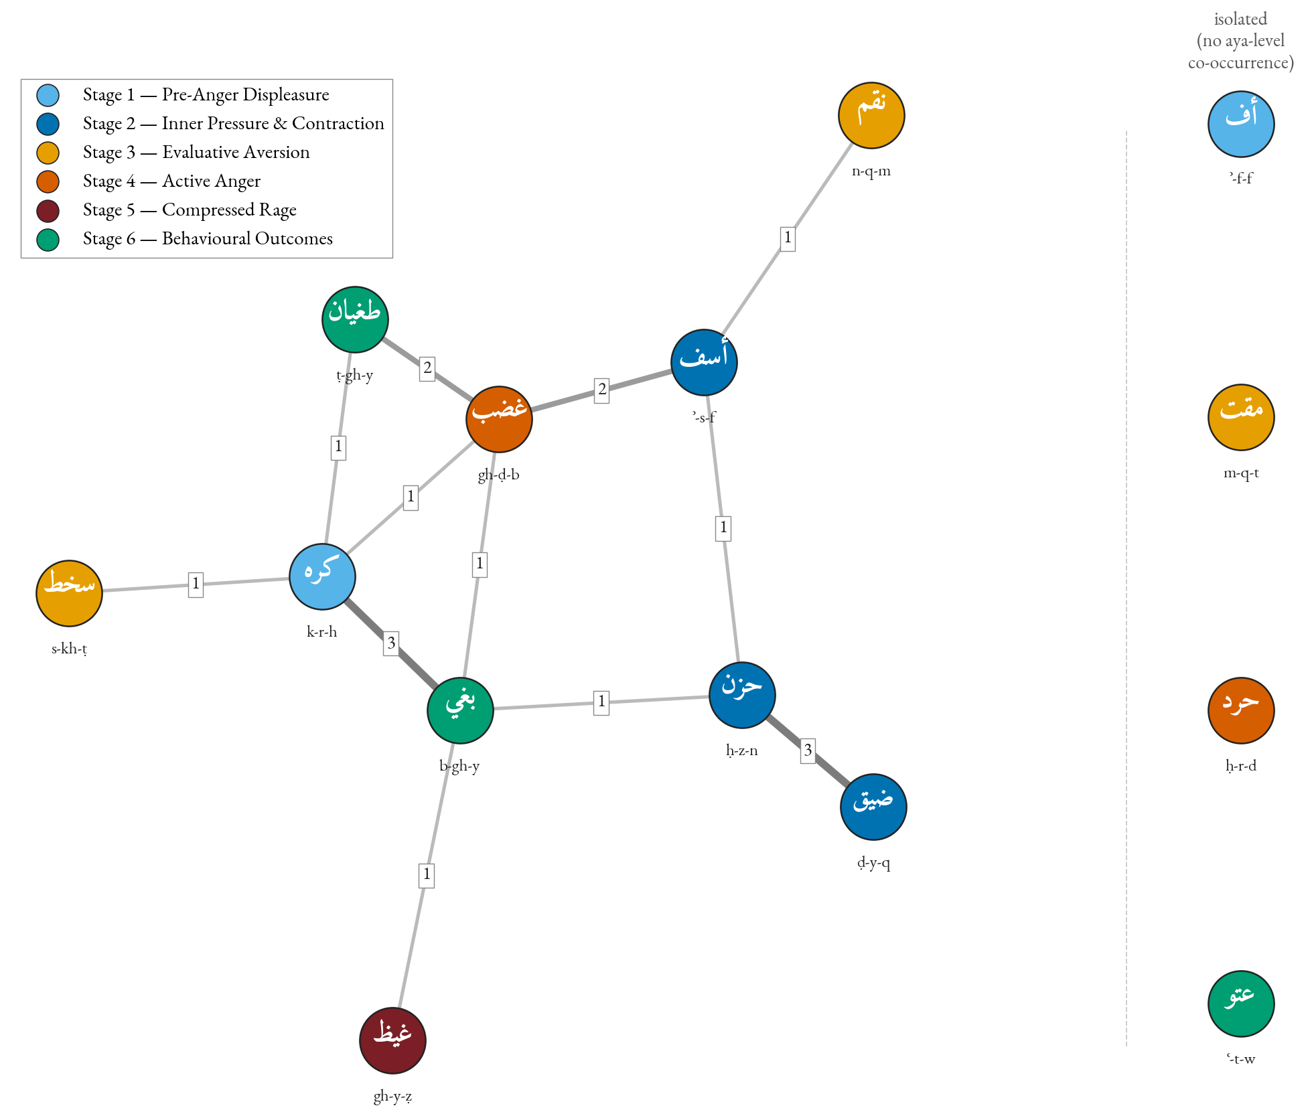
Figure 4. Aya-level co-occurrence network; edges weighted by shared-ayat count. Strongest edge ḥzn–ḍyq (weight 3) corpus-validates the S2 grouping. Baghy anchors the right cluster with edges to ẓlm/jrm/fsq. Transitive structure (no direct S1→S6 edges) is consistent with both the action-intensity gradient and the bidirectional S6 reading (Section 3.8.5).
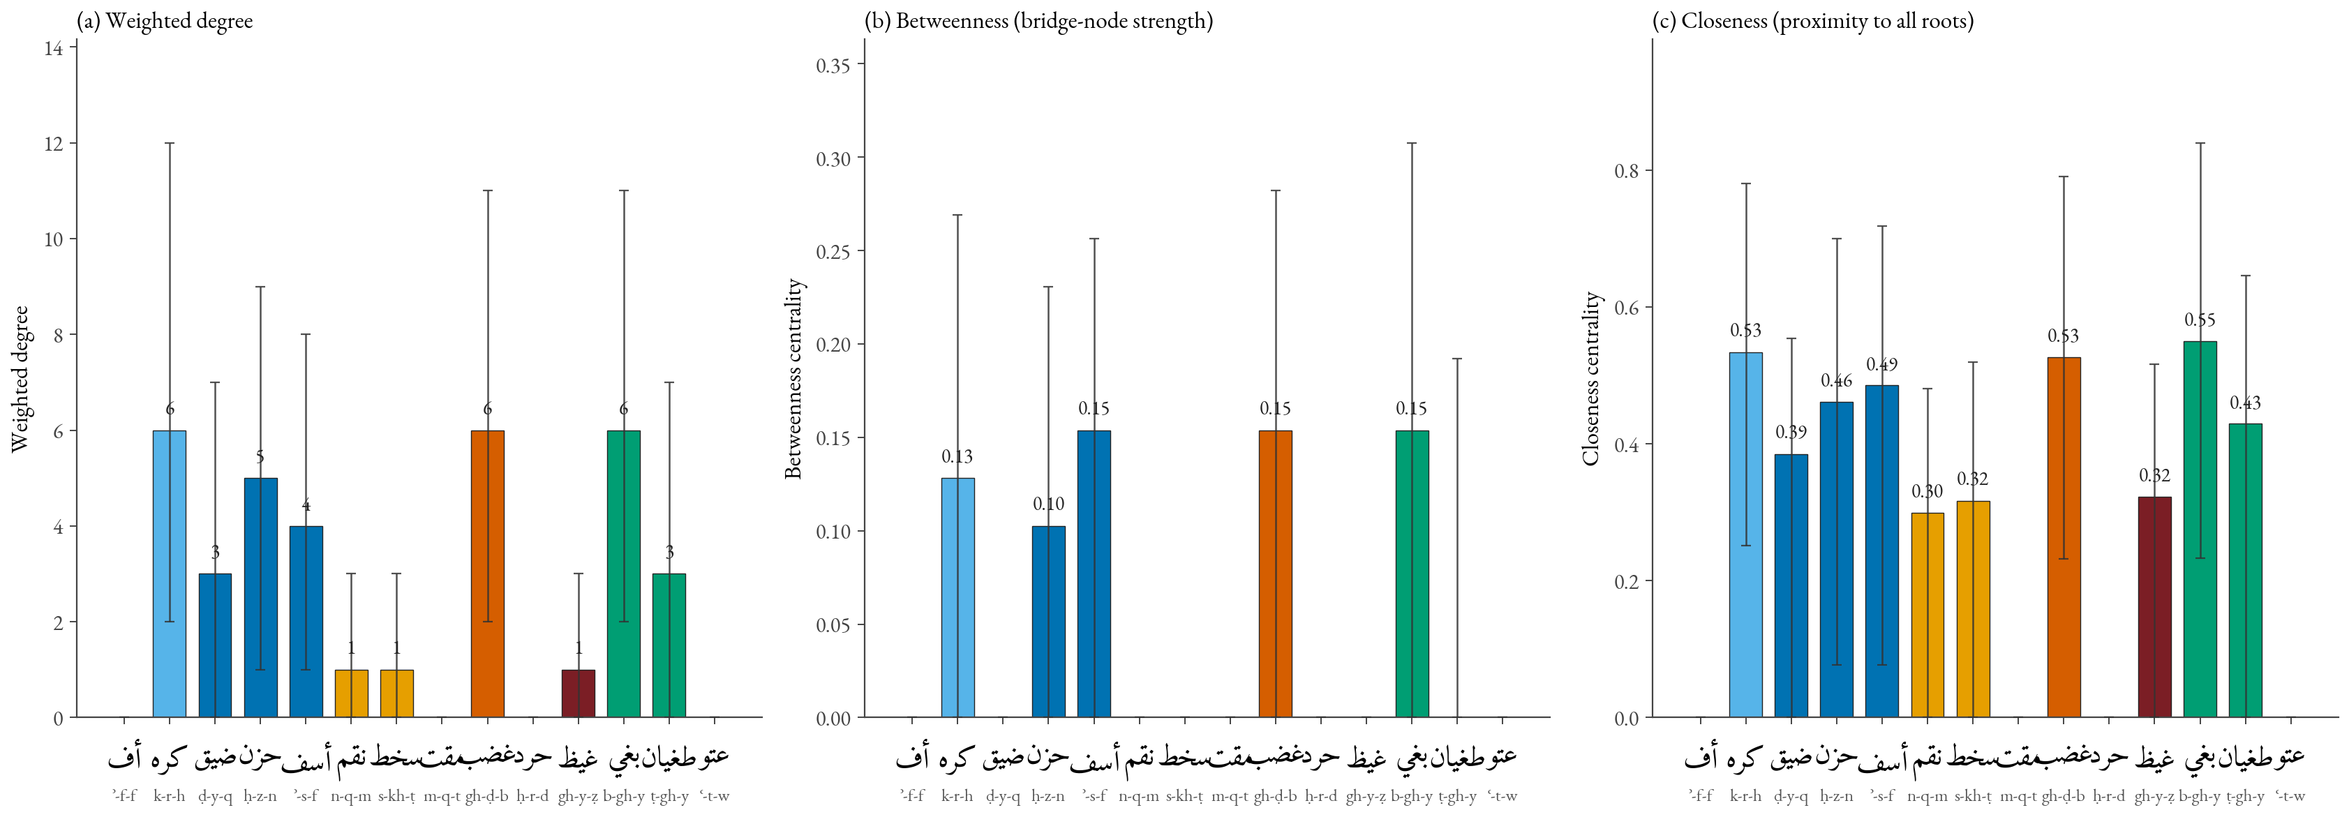
Figure 7. Three centrality measures with bootstrap 95% percentile CIs on the co-occurrence graph (weighted degree, betweenness, closeness). Baghy leads on closeness (0.55, CI [0.23, 0.84]) and shares highest betweenness (0.15, CI [0.00, 0.31]) with ghaḍab and asaf. Wide CIs reflect the small graph; bridging-role claim consistent with point estimates but qualified by bootstrap (Section 3.8.2).

3.9. Robustness Checks: The Umbrella Moral Terms
The five umbrella roots (Table 5) confirm that the spectrum’s structure is not artefactual. The opposing patterns of jrm (strongly Meccan) and fsq (significantly Medinan) instantiate the same discursive-contextual specialisation identified for sakhaṭ and karh — the umbrella analysis confirms a general phenomenon.
Table 5. Distribution of umbrella moral terms.
Root | n | M | Md | Binomial p | Interpretation
šnʾ | 3 | 1 | 2 | — | n too small
jrm | 66 | 60 | 6 | < 0.0001 | Strongly Meccan; anti-shirk polemic
fsq | 54 | 20 | 34 | 0.0007 | Significantly Medinan; community discipline
ẓlm | 315 | 211 | 104 | — | Pervasive meta-category
ʿdw | 106 | 47 | 59 | 0.008 | Tilts Medinan; mutual antagonism

3.10. Comparative Translation: An Illustrative Observation
A four-verse, five-translation sample (Table 6) illustrates the levelling pattern: ghayẓ (Q. 3:134) is rendered with terms (anger, wrath, rage) routinely used also for ghaḍab, with the containment differentia carried only by the contextual verb of restraint; tamayyuz (Q. 67:8) is rendered unevenly, with only Arberry’s “well-nigh bursts asunder” preserving the structural-disintegration component. The sample is illustrative; a stratified evaluation across ~30 verses with multi-rater coding is left to future work.
Table 6. Translation of four canonical verses across five English translations (illustrative sample).
Term & verse | Yusuf Ali | Pickthall | Arberry | Saheeh Intl. | Hilali-Khan
ḍīq (Q. 15:97) | “thy heart is distressed” | “thy bosom is at times oppressed” | “thy breast is straitened” | “your chest is constrained” | “your breast feels tight”
ghayẓ (Q. 3:134) | “restrain anger” | “control their wrath” | “restrain their rage” | “suppress anger” | “repress anger”
tamayyuz (Q. 67:8) | “almost burst with fury” | “almost burst with rage” | “well-nigh bursts asunder with fury” | “almost bursts with rage” | “almost bursts up with fury”
ṭughyān (Q. 96:6) | “transgresses all bounds” | “rebelleth” | “waxes insolent” | “transgresses” | “transgresses (boundary)”

3.11. Summary of Computational Corroboration (Supplementary Materials S1–S4)
Four NLP analyses extend the main pipeline over the same 312 attestations; full detail in the Supplementary Materials. S1 (cross-translation semantic drift) with multilingual MPNet over ten parallel renderings recovers three drift bands mapping onto the spectrum (affective-core lexemes drift < 0.20, evaluative-aversion and containment-pressure lexemes > 0.22, ṭughyān topping non-hapax) — convergent with Section 3.10. S2 (CAMeLBERT-CA clustering) yields silhouette = −0.082, NMI = 0.077 against the six-stage labelling; a Monte-Carlo baseline (10,000 random 6-partitions of the fourteen roots into stages of the observed sizes) gives mean random NMI ≈ 0.094 [0.041, 0.156]. The observed NMI sits below the random mean — this is a clear null in which the model clusters by root identity, and the spectrum adds analytical structure beyond the language model’s distributional view. S3 (PMI-weighted network) corrects raw-count artefacts: asaf–ghaḍab (npmi = 0.59) emerges as the strongest signal and baghy’s raw-count dominance is shown to be partly a frequency artefact. S4 (Nöldekean diachronic null) finds Spearman ρ = −0.157; R² ≈ 0.025 explains < 3% of variance — a diachronic effect statistically detectable (p = 0.006) but substantively a null, consistent with the claim that the taxonomy organises by intensity, not chronology.

4. Discussion

4.1. The Integrated Logic of Escalation
The findings cohere into a single structural claim: the Qur’anic anger lexicon encodes a logic of escalation along three dimensions — locus (inner → outer), intensity (low → high), and scope (individual → structural). In compact form: Pre-anger displeasure → Inner pressure → Evaluative aversion → Active anger → Compressed/explosive rage → Behavioural outcomes (with caveats). The arrows index conditional intensification at each step where regulation may succeed or fail. Stage 6 is distinctive: the move into behavioural outcomes is not a deterministic escalation from anger but is influenced by independent vectors (greed, istikbār, structural arrogance), which is why the near-balance between S1–5 and S6 is theoretically informative rather than paradoxical.

4.2. Convergence with Contemporary Emotion Psychology
The continuum maps onto four families of contemporary emotion theory at points of structural convergence, sufficient to ground the Islamic-psychology implications of Section 4.8 and to identify where the Qur’anic lexicon extends the contemporary models.
Gross’s process model. Gross (1998, 2014, 2015) partitions emotion regulation into five sequential strategies (situation selection, situation modification, attentional deployment, cognitive change, response modulation). The Qur’anic continuum cross-cuts this typology rather than mapping one-to-one: situation selection is forward-looking and so does not match the S1 lexemes, which are reactions to a present trigger. S1 (uff, karāha) is better located at cognitive change / response-tendency modulation in nuce. S2 (ḍīq, ḥuzn, asaf) implicates situation modification and attentional deployment. S3 (naqm, sakhaṭ, maqt) is paradigmatically cognitive change. S4 (ghaḍab, ḥard) lies at the response-selection threshold. S5 is response modulation with two sub-strategies: kaẓm (Q. 3:134) is closest to expressive suppression, but the Qur’anic moral commendation of kāẓimīn al-ghayẓ need not entail the physiological costs Gross associates with suppression, and the Sufi tradition tilts the construct toward cognitive reappraisal in the taqwā frame: al-Qushayrī’s Laṭāʾif al-Ishārāt (ad Q. 3:134) reads kaẓm al-ghayẓ not as mere outward stifling of a felt rage but as an inward transformation of the nafs, in which restraint is meritorious because the ghayẓ is reappraised under the disposition of forbearance (ḥilm) rather than only held in — an anger-in that is simultaneously a re-construal of the provocation. On this reading the commended kāẓim al-ghayẓ is not unambiguously the costly expressive-suppression of Gross’s typology. Tamayyuz figures the failure mode regardless. S6 lies beyond the episode-bounded scope of Gross’s model — structural-moral pathologies of personhood, with the Section 3.8.5 bidirectional-causation caveat.
Plutchik; Spielberger. Plutchik’s (1980, 2001) three-level escalation (annoyance → anger → rage) is refined by the Qur’anic continuum, which partitions annoyance into vocal irritation (uff, S1), inner aversion (karāha, S1), and inner pressure (S2) — three stages where Plutchik has one label — and inserts compressed rage (ghayẓ, S5) between anger (≈ S4 ghaḍab) and terminal rage. Spielberger’s STAXI-2 (1999) trichotomy of trait, state, and control is realised at the lexical surface: trait-like sustained states (ḥuzn, ḍīq, karāha); state-like situational responses (sakhaṭ, maqt, ghaḍab); and kaẓm (Q. 3:134) as the Qur’anic anger-control lexeme, operationally close to Spielberger’s anger-in / suppression construct but with explicit moral commendation.
Appraisal theory: Scherer’s checks and Roseman’s ṭughyān-pattern. Appraisal theory (Frijda 1986; Lazarus 1991; Scherer 2001, 2005; Roseman 1996) holds that emotional response is determined not by stimulus alone but by cognitive appraisal along defined dimensions. Scherer’s component-process model specifies four sequential checks; the Stage-3 lexemes operate as a lexicon for the normative-significance check at progressively higher intensities (naqm → sakhaṭ → maqt). Sūrat al-ʿAlaq (Q. 96:6–7) conditions ṭughyān on the appraisal of istighnāʾ: the agent perceives high coping potential, low external constraint, and self-agency. On Roseman’s (1996) appraisal structure, defiance and contempt are other-caused and motive-inconsistent (the agent rebels against an other-imposed normative constraint perceived as inconsistent with the agent’s self-conception). Ṭughyān on istighnāʾ fits this pattern: the divine command is the other-caused, motive-inconsistent constraint that istighnāʾ construes as dispensable. The Qur’anic lexicon thus exhibits — at the level of its semantic surface, not as explicit theory — structural patterns that appraisal theory later articulated. We intend these correspondences as comparative and structural, and explicitly disclaim retrojection: we do not hold that the Qur’an states, anticipates, or contains modern emotion science, nor that the modern frameworks are validated by the parallel. The mappings are offered as a heuristic bridge for readers who work in both registers, and the direction of explanation runs from the classical lexicographic-exegetical evidence (which is primary) to the modern vocabulary (which is illustrative). Plutchik’s three-level model, moreover, is a cross-emotion intensity schema rather than an anger-specific taxonomy, so the claim that the continuum “refines” it is a claim about lexical resolution within one emotion family, not a correction of Plutchik’s general scheme.

4.3. The Phenomenology/Outcomes Balance
A naive ten-root reading once suggested 2.4× more attestations at the behavioural pole than at S1–3 combined. The revised fourteen-root inventory (167 / 145) corrects that picture: the expanded phenomenological vocabulary brings the lower stages into balance with Stage 6, consistent with both a richer affective lexicon and the bidirectional causal relation between Stage-6 lexemes and anger. In Fauconnier and Turner’s (2002, 17–57) terms, Stage 6 operates as a conceptual blend whose input spaces are wrong-doing-as-supremacism and anger-as-pressure.

4.4. Discursive-Contextual Specialisation and Cultural Linguistics
The Holm-surviving tilts of karh (Medinan), baghy (Meccan), ghayẓ (Medinan), the near-miss sakhaṭ (Medinan), the contextual Meccan tilts of asaf, naqm, and ʿutuww, and the umbrella patterns jrm (Meccan) / fsq (Medinan) together instantiate discursive-contextual specialisation — members of multi-lexeme fields attaching to specific discursive registers. The attachments are non-random: sakhaṭ to the Munāfiqūn (a Medinan phenomenon), karh to the structural ikrāh idiom of Medinan community discipline, ghayẓ to the kaẓm pedagogy of Medinan ethics, asaf to prior-prophet narratives (Meccan-rhetorical), jrm to anti-shirk polemic (Meccan), fsq to intra-community discipline (Medinan). El-Awa (2006) and Sinai (2017, 2023) supply the framework: specialisation is the pattern one expects from the Qur’an’s gradual response to evolving sociolinguistic contexts.
Read through Sharifian (2011), the same data illuminate the universal–culturally-elaborated distinction of Section 2.1.3: the primary metaphors (ANGER IS HEAT; EMOTIONAL CONTAINMENT IS PHYSICAL CONTAINMENT) are robustly attested in the Qur’anic ghayẓ–kaẓm register and support the CMT universalist claim; the culturally elaborated layer — the distribution of affect across qalb (S2 ḍīq al-ṣadr), ṣadr (S2), and nafs (S2 asaf al-nafs), the moral commendation of kaẓm in the taqwā frame, the Munāfiqūn-attachment of sakhaṭ, and the tamayyuz construal of Q. 67:8 — is what the Qur’anic data illuminate beyond the universalist baseline.

4.5. Q. 67:8 and the Container Metaphor: A Focused Comparative Survey
The Qur’anic ghayẓ–kaẓm–tamayyuz triad maps onto stages (2)–(4) of the Lakoff–Kövecses scenario with unusual lexical transparency at stage (4): English exemplars (blew his top) lexicalise the failure-mode as exit of contents with the container preserved, whereas Q. 67:8, under the complex container metaphor of Section 2.1.3, supports the construal of vessel-internal failure (Section 3.7.2). A six-tradition survey contextualises the claim. Akkadian: libbu “heart, inside” (CAD L, s.v. libbu, 163–164) and kabattu “liver, inner seat of emotion” as filled containers of anger (Bodi 2018; the Neo-Assyrian bodily-mapping work in Lahnakoski et al. 2024 confirms the FILLING/HEAT-IN-CONTAINER schema for emotional semantics). Biblical Hebrew: ḥēmâ and ḥarôn-ʾaph (Kruger 2000, 2015) both EXIT-typed — except Job 32:19 (kĕ-yayin lōʾ-yippātēaḥ … yibbāqēaʿ), where bāqaʿ names the structural failure of the vessel; this is the one clear pre-Qur’anic Northwest-Semitic precedent. Homeric Greek: kholos and mēnis in fluid-and-heat schemas with no Iliadic vessel-rupture (Muellner 1996; Cairns 2003). Vedic and Classical Sanskrit: krodha and manyu in FIRE and WEAPON-RELEASE schemas, not vessel-disintegration. Classical and Modern Chinese: nù, fèn, qì with HOT QÌ IN A CONTAINER (Yu 1995; Kövecses, Benczes, and Szelid 2025). Pre-Islamic Jāhilī Arabic: ḥamiya and ghalā alongside ghayẓ in the cognate fluid-heat register (cf. al-Mufaḍḍaliyyāt nos. 38, 87, ʿAntara’s Muʿallaqa ll. 32–35; Webb 2016, 213–245). Across the cited corpora, the exemplars we are aware of concentrate on filling, heating, and exit/overflow; the Hebrew Bible (Job 32:19) offers the one clear parallel to vessel-rupture proper. These are statements about the exemplars we have surveyed, not established negatives about whole traditions: we do not claim that no internal-separation exemplar exists in Vedic, Homeric, or Chinese anger lexis, only that we have not located a clear one in the cited sources. For the same reason we frame the relation to the two-volume Metaphors of ANGER across Languages (Kövecses, Benczes, and Szelid 2025) cautiously: that handbook surveys some twenty-two languages but does not canvass Classical Arabic, so our contribution is to add a Classical-Arabic data point exhibiting an internal-separation variant, not to assert that no surveyed language attests such a variant. We accordingly hold our claim at “an early and unusually transparent” lexicalisation — not a unique one — with Job 32:19 (bāqaʿ) acknowledged as a structurally cognate Northwest-Semitic precedent. So qualified, the Qur’anic data are consistent with the universalist hypothesis of CMT and extend its empirical base to seventh-century Arabic.
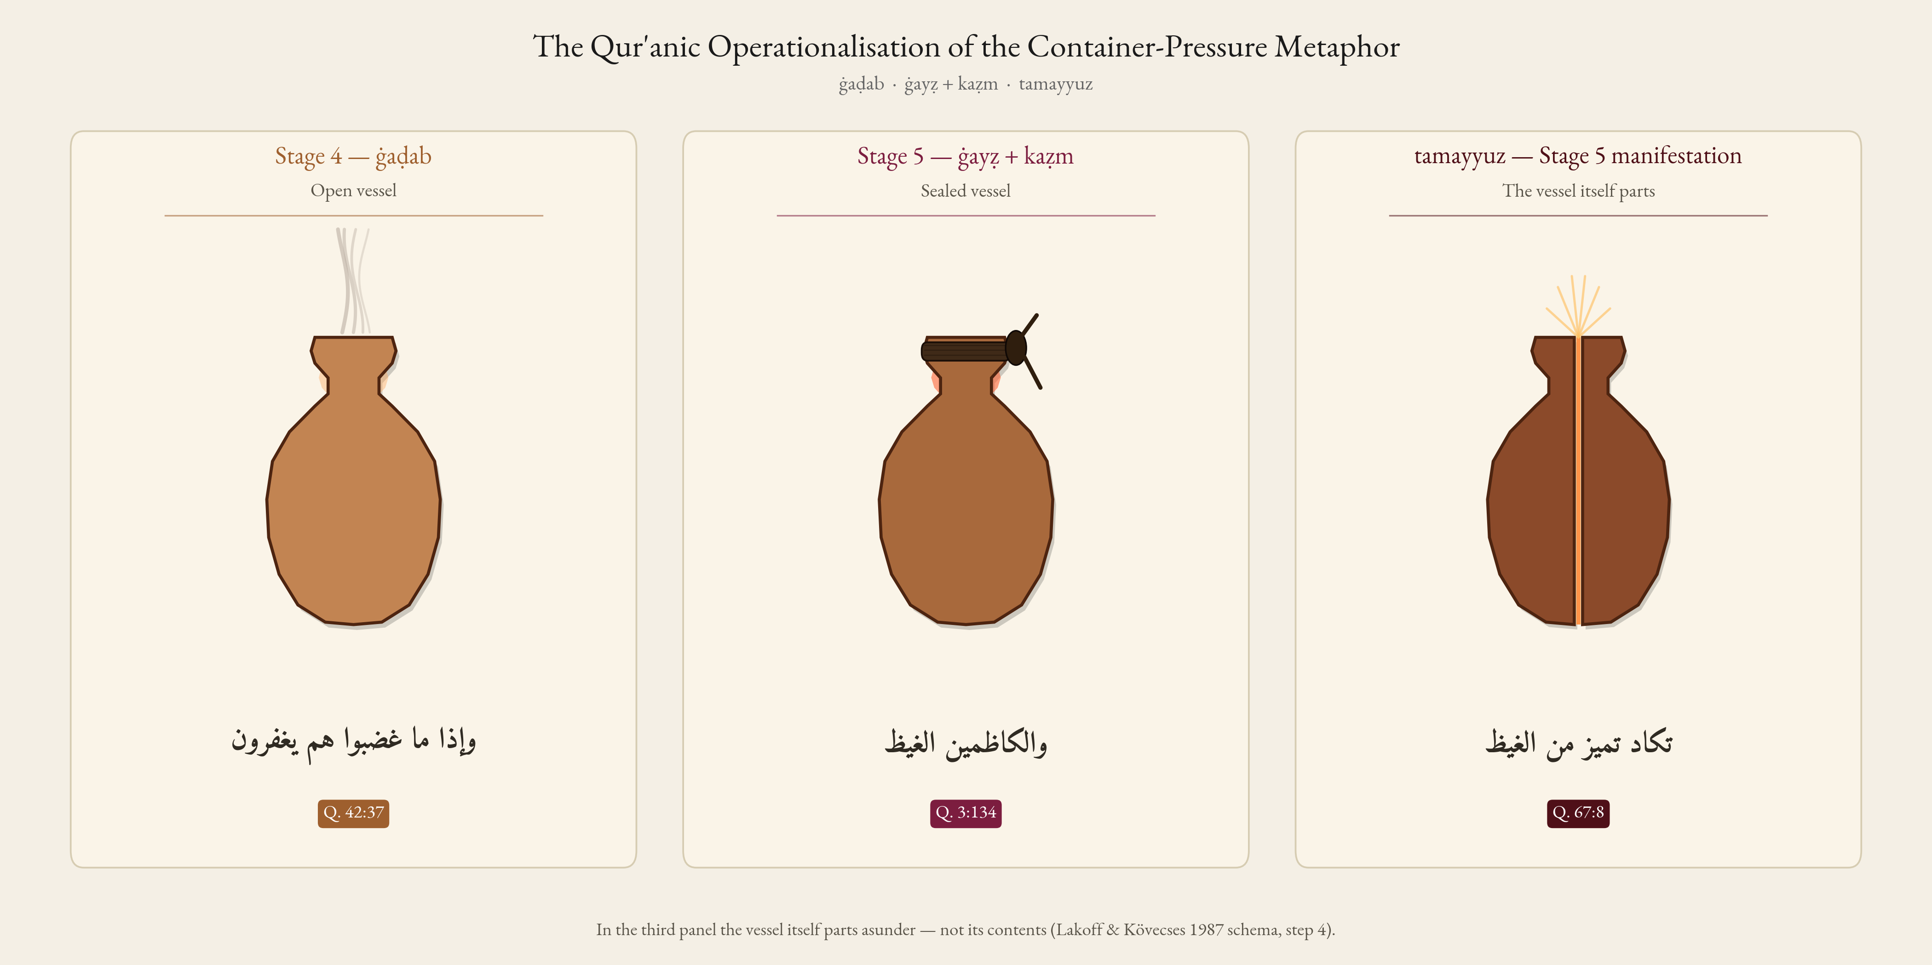
Figure 6. Illustrative schematisation of the ANGER-IS-A-PRESSURIZED-CONTAINER complex metaphor (after Lakoff and Kövecses 1987), instantiated by ghaḍab → ghayẓ + kaẓm → tamayyuz. Panel 1 (S4): ghaḍab — open container, affect dissipating into language. Panel 2 (S5, Q. 3:134): ghayẓ sealed by kaẓm. Panel 3 (S5 manifestation, Q. 67:8): tamayyuz — the construal of constituent-separation as vessel-internal failure (Section 3.7.2). The figure is heuristic; evidence is borne by the lexicographic and exegetical analysis of Sections 3.7 and 4.5.

4.6. The Theology of Divine Anger: Affect, Action, and the Limits of Predication
The continuum carries a theological consequence that distinguishes this study from a purely psychological taxonomy, and it bears on the central question the topic raises for a religious-studies readership: in what sense may anger be predicated of God? Several spectrum lexemes are attributed to God in the Qur’an — ghaḍab (sūrat al-Fatḥ, Q. 48:6), maqt (sūrat Ghāfir, Q. 40:10; sūrat al-Ṣaff, Q. 61:3), sakhaṭ (sūrat Muḥammad, Q. 47:28), and the retributive naqm underlying the divine Name al-Muntaqim — and each is a mutashābih (ambiguous) attribute that the kalām tradition treats under the doctrine of divine tanzīh (transcendence above creaturely affect). The Muʿtazilī reading, represented in al-Zamakhsharī’s al-Kashshāf, declines to attribute infiʿālī (passively-aroused, affective) states to God and reads divine ghaḍab/sakhaṭ as a figure (majāz) for the will to punish or for the punishment itself; al-Rāzī (Mafātīḥ al-Ghayb) converges in glossing divine ghaḍab as irādat al-ʿuqūbah — an act of normative-juridical will, not a perturbation of the divine self — while the Ashʿarī and Māturīdī mainstream preserves the attribute bi-lā kayf (without specifying modality) yet still construes it as oriented to consequence rather than to embodied feeling. Al-Ṭabāṭabāʾī (al-Mīzān) likewise reads divine ghaḍab as a maqām (station) of action — the standing-back of mercy and the onset of recompense — rather than as an affect.
The action-intensity continuum gives this debate a precise lexical shape. The lexemes predicable of God cluster at the action-tilted, evaluative poles of the spectrum — naqm (retribution-oriented), sakhaṭ (declarative ethical disapprobation), maqt (purely evaluative aversion), and ghaḍab (in its irādat al-ʿuqūbah construal) — precisely the stages whose lexicographic glosses foreground judgement and consequence over embodied arousal. By contrast, the affective–embodied upper register of the continuum — ghayẓ as the high-pressure filling of a sealed vessel, and above all the vessel-internal collapse of Q. 67:8 (takādu tamayyazu min al-ghayẓ) — is in the Qur’an reserved for creatures (and, at Q. 67:8, projected onto the Hell-fire construed as an animate rager; Section 3.7.2), never predicated of God. This asymmetry is theologically load-bearing: the very PRESSURIZED-CONTAINER complex metaphor that the cognitive-linguistic analysis foregrounds is, on the Qur’an’s own usage, a creaturely construal, and its non-applicability to God is exactly what the tanzīh tradition would predict. The continuum thus does more than rank emotion words; it draws a line, internal to the lexicon, between the action-oriented aversion that classical theology permits of God and the affective-somatic rage that it does not. Reading the spectrum theologically rather than only psychologically is what secures its purchase as a contribution to Qur’anic theology, and not merely to comparative emotion science.

4.7. Implications for Qur’anic Translation
A graded reference model of the spectrum offers a principled corrective to the levelling pattern that Gaanoun and Alsuhaibani (2025) and Al-Shidi et al. (2025) document at the sentiment-category level. We do not, on the strength of the four-verse illustrative sample of Section 3.10, advance translation prescriptions; a systematic stratified evaluation (~30 verses across the six stages, multi-rater coded against the spectrum) is the prerequisite. Candidate equivalents for each spectrum lexeme are catalogued in the project repository for use by translators wishing to mark intensity-position lexically.

4.8. Implications for Islamic Psychology
The continuum offers a culturally-grounded framework mapping onto Gross’s model without importing secular vocabulary, with three conceptual implications: (i) Prevention — early-stage recognition through the indigenous S1–2 lexicon supports CBT-style interception of affective dysregulation; (ii) Crisis intervention — kaẓm integrates with contemporary suppression-and-reappraisal techniques; (iii) Rehabilitation — post-failure Stage 6 is framed as recoverable through tawba. These are conceptual; their translation into validated clinical interventions awaits empirical studies.

4.9. Limitations
Five limitations bound the inferences. (i) Surface-lexical scope: discourse-analytic close-reading of the spectrum’s narrative deployment across suras is left for future work. (ii) Tafsīr engagement and audit reproducibility: a deep-dive indexing the full classical/medieval/Sufi/modernist tradition with multi-coder reading on contested verses would deepen exegetical grounding. The Stage-6 causation audit (Section 3.8.5) is at present only partially reproducible: the aggregate per-root/per-label counts are deposited, but the verse-level row codes and the regeneration script are reserved for a subsequent release, and the inter-coder κ = 0.79 was computed on a single-coder full pass plus a 20% second-coder verification sample rather than full double-coding of all 145 attestations. The aggregate Stage-6 breakdown should accordingly be read as a single-coder classification with a substantial-agreement reliability check on a subsample, not as a fully double-coded, fully released audit; a complete two-coder release with per-label and per-root κ and a confusion matrix is left for future work. (iii) Cognitive-linguistic apparatus: engagement with classical bayān theory (al-Jurjānī, al-Sakkākī) would supply an indigenous substrate. (iv) Ḥadīth integration: a parallel concordance over Ṣaḥīḥ al-Bukhārī, Ṣaḥīḥ Muslim, and al-Kāfī would supply convergent evidence on kaẓm and a replication test for the underpowered asaf distribution. (v) Islamic-psychology operationalisation: Section 4.8’s implications await pilot studies of kaẓm-grounded emotion-regulation training, validated against the STAXI and DERS. Small per-root n and the closed-text status of the corpus bound every inference reported above; computational evidence remains a complement to, not a replacement for, the classical philological and exegetical tradition.

5. Conclusions
Methodologically, the integration of Izutsu’s semantic-field analysis, Kennedy–Sassoon scalar semantics, and Lakoff–Kövecses CMT — coupled with a reproducible computational pipeline over the QAC — yields a layered apparatus in which each framework does separable work (lexicography/Izutsu order the field and licence the partition; scalar semantics models the graded dimension; CMT illuminates the upper-stage container complex; see Section 2.1.4). To our knowledge this trifold integration has not been deployed in Qur’anic studies, although Qāʾimīniyā (2011, 2014) and Pakatchi and Afrashi (2020) have integrated Izutsu and CMT; we present the corpus apparatus as corroborative — and, at the omnibus, trend, and embedding tests, candidly null — rather than as the primary evidentiary engine, which remains the classical philological and exegetical record.
Descriptively, we produce a reproducible concordance of 312 attestations with Holm-Bonferroni-adjusted (family-wise-error-controlling) binomial tests, marginal-preserving permutation null p-values, and bootstrap 95% CIs on every centrality estimate.
Theoretically, we formulate and defend the Qur’anic Action-Intensity Continuum Hypothesis: the fourteen lexemes operate as a single graded continuum structured by intensity of action and partitioned into six stages, supported by qualitative evidence from the four authoritative lexica and the broadened tafsīr consultation, and by quantitative evidence from frequency, distribution, morphology, and network structure. The tafsīr-coding audit (second-coder κ = 0.79 on a 20% verification sample) grounds the bidirectional-causation reading of Stage 6; the six-tradition survey of Section 4.5 calibrates Q. 67:8 as an early and unusually transparent — rather than uniquely transparent — exemplification of vessel-internal failure, with Job 32:19 (bāqaʿ) acknowledged as a structurally cognate Northwest-Semitic precedent.
In answer to the research questions: the anger-spectrum field is a fourteen-node lexical network organised by intensity of action, with baghy the bridge node (closeness 0.55; ~42% of cross-field ties, the single largest share) and stage-internal hubs ḥuzn (S2) and ghaḍab (S4) (RQ1–RQ2); the empirical distribution is consistent with the continuum — asymptotic χ²(5) = 227.15, permutation null p = 0.24, S1–5/S6 χ²(1) = 1.55, with three roots (karh, baghy, ghayẓ) surviving Holm-Bonferroni and sakhaṭ a non-significant near-miss (adj. p = 0.0505) (RQ3); the continuum is structurally homologous (comparatively, not by retrojection) with Gross (S1–5), Plutchik, Spielberger, and Lazarus–Scherer–Roseman appraisal theory, and reaches at Stage 6 into a moral-anthropological register that lies beyond the episode-bounded scope of those models (RQ4); and conditional implications follow for Qur’anic translation and Islamic psychology (RQ5). The Qur’anic lexicon encodes a sophisticated theory of the anger spectrum in the architecture of its semantic surface; recovering it requires the integration of classical philological attentiveness, contemporary linguistic-theoretical precision, and corpus-computational verifiability. Future work should pursue discourse-analytic close-reading, deeper tafsīr indexing, engagement with classical bayān theory, ḥadīth-corpus replication, and clinical operationalisation of the kaẓm construct.

Supplementary Materials
The following are available online: four computational corroboration analyses (S1 cross-translation semantic drift; S2 CAMeLBERT-CA contextual-embedding clustering; S3 PMI-weighted co-occurrence network; S4 Nöldekean diachronic null), with Figures S1–S3, in paper/english/supplementary.md. All outputs are reproducible from nlp_upgrade_colab.py against the committed outputs/nlp_upgrade/ directory.

Author Contributions
Conceptualization, K.J.; methodology, K.J. and A.J.; software, A.J.; validation, K.J. and A.J.; formal analysis, K.J.; investigation, K.J.; data curation, A.J.; writing—original draft preparation, K.J.; writing—review and editing, K.J. and A.J.; visualization, A.J.; supervision, K.J.; project administration, K.J. All authors have read and agreed to the published version of the manuscript.

Funding
This research received no external funding.

Institutional Review Board Statement
Not applicable. This study used only publicly released text-corpus data and involved no human or animal subjects.

Informed Consent Statement
Not applicable.

Data Availability Statement
The data presented in this study are openly available. The complete reproducible Python pipeline (MIT License), the derived CSV concordance for the fourteen core spectrum roots (312 attestations), distributional summaries, statistical-test outputs, network-centrality tables, umbrella co-occurrence tables, and the PDF/PNG figures are deposited in the project repository at https://github.com/ali-kin4/quranic-emotion-spectrum, together with the SHA-256 hash of the source file and the manual-validation audit. The primary sources are the Quranic Arabic Corpus v0.4 (Dukes 2011), released under the GNU General Public License, and the Tanzil Quran text (Uthmani edition; Tanzil Project 2008), released under CC-BY-ND 3.0. The four statistical analyses can be regenerated end-to-end by pip install -r analysis/requirements.txt followed by python analysis/extract_concordance.py, python analysis/advanced_metrics.py, python analysis/visualize_spectrum.py, and python analysis/visualize_advanced.py. The four computational corroboration analyses (Supplementary S1–S4) are produced by nlp_upgrade_colab.py, with CSV outputs committed under outputs/nlp_upgrade/ for inspection without re-running the GPU pipeline.

Acknowledgments
The authors thank Kais Dukes (in memoriam) and the team behind the Quranic Arabic Corpus, and the Tanzil Project, for releasing the morphological and textual resources without which this kind of empirical Qur’anic analysis would not be feasible. The authors also thank Urmia University for institutional support.

Conflicts of Interest
The authors declare no conflicts of interest.

References
Agresti, Alan. 2013. Categorical Data Analysis, 3rd ed. Hoboken, NJ: John Wiley & Sons.
Akra, Diyam, Tymaa Hammouda, and Mustafa Jarrar. 2025. “QuranMorph: Morphologically Annotated Quranic Corpus.” arXiv:2506.18148. https://arxiv.org/abs/2506.18148.
Albayrak, Ismail. 2012. “The Reception of Toshihiko Izutsu’s Qurʾānic Studies in the Muslim World: With Special Reference to Turkish Qurʾānic Scholarship.” Journal of Qurʾanic Studies 14 (1): 73–106.
Averill, James R. 1982. Anger and Aggression: An Essay on Emotion. New York: Springer-Verlag.
Berkowitz, Leonard. 1993. Aggression: Its Causes, Consequences, and Control. New York: McGraw-Hill.
Bodi, Daniel. 2018. “An Akkadian-Aramaic Idiomatic Expression in Ezekiel 16:30 amūlâ libbātēk ‘I am filled with anger against you’, and Remarks on the Languages in Persian Times.” Transeuphratène 50: 13–38.
Cairns, Douglas L. 2003. “Ethics, Ethology, Terminology: Iliadic Anger and the Cross-cultural Study of Emotion.” In Ancient Anger: Perspectives from Homer to Galen, edited by Susanna Braund and Glenn W. Most, 11–49. Yale Classical Studies 32. Cambridge: Cambridge University Press.
Chicago Assyrian Dictionary (CAD). 1956–2010. Edited by Martha T. Roth et al. 21 vols. Chicago: The Oriental Institute.
Cochran, William G. 1954. “Some Methods for Strengthening the Common χ² Tests.” Biometrics 10 (4): 417–51.
Derki, Mohamed. 2022. “Conceptualization of Anger in Modern Standard Arabic and English: A Comparative Study.” Professional Discourse and Communication 4 (3): 24–39.
Dukes, Kais. 2011. Quranic Arabic Corpus (Morphology, Version 0.4). Leeds: University of Leeds. https://corpus.quran.com.
El-Awa, Salwa M. S. 2006. Textual Relations in the Qurʾan: Relevance, Coherence and Structure. Routledge Studies in the Qurʾan. London and New York: Routledge.
Fauconnier, Gilles, and Mark Turner. 2002. The Way We Think: Conceptual Blending and the Mind’s Hidden Complexities. New York: Basic Books.
al-Fīrūzābādī, Muḥammad ibn Yaʿqūb. n.d. al-Qāmūs al-Muḥīṭ. Beirut: Muʾassasat al-Risālah.
Fisher, Ronald A. 1922. “On the Interpretation of χ² from Contingency Tables, and the Calculation of P.” Journal of the Royal Statistical Society 85 (1): 87–94.
Frijda, Nico H. 1986. The Emotions. Studies in Emotion and Social Interaction. Cambridge and Paris: Cambridge University Press and Éditions de la Maison des Sciences de l’Homme.
Gaanoun, Kamel, and Mohammed Alsuhaibani. 2025. “Sentiment Preservation in Quran Translation with Artificial Intelligence Approach: Study in Reputable English Translation of the Quran.” Humanities and Social Sciences Communications 12 (1): 1–12. https://doi.org/10.1057/s41599-024-04181-0.
Grady, Joseph E. 1997. “Foundations of Meaning: Primary Metaphors and Primary Scenes.” PhD diss., University of California, Berkeley.
Gross, James J. 1998. “The Emerging Field of Emotion Regulation: An Integrative Review.” Review of General Psychology 2 (3): 271–99.
Gross, James J., ed. 2014. Handbook of Emotion Regulation, 2nd ed. New York: Guilford Press.
Gross, James J. 2015. “Emotion Regulation: Current Status and Future Prospects.” Psychological Inquiry 26 (1): 1–26.
Ibn ʿĀshūr, Muḥammad al-Ṭāhir. 1984. al-Taḥrīr wa-l-Tanwīr. Tunis: al-Dār al-Tūnisiyyah li-l-Nashr.
Ibn Fāris, Aḥmad. 1979. Muʿjam Maqāyīs al-Lughah. Edited by ʿAbd al-Salām M. Hārūn. Beirut: Dār al-Fikr.
Ibn Kathīr, Ismāʿīl. 1999. Tafsīr al-Qurʾān al-ʿAẓīm. Edited by Sāmī al-Salāmah. 8 vols. Riyadh: Dār Ṭaybah.
Ibn Manẓūr, Muḥammad. 1993. Lisān al-ʿArab, 3rd ed. Beirut: Dār Ṣādir.
Izutsu, Toshihiko. 1959. The Structure of the Ethical Terms in the Koran: A Study in Semantics. Studies in the Humanities and Social Relations 2. Tokyo: Keio Institute of Philological Studies.
Izutsu, Toshihiko. 1964. God and Man in the Koran: Semantics of the Koranic Weltanschauung. Tokyo: Keio Institute of Cultural and Linguistic Studies.
Izutsu, Toshihiko. 2002. Ethico-Religious Concepts in the Qurʾān, rev. ed. Montreal: McGill-Queen’s University Press. First published 1966.
Jamison, Stephanie W., and Joel P. Brereton. 2014. The Rigveda: The Earliest Religious Poetry of India. 3 vols. New York: Oxford University Press.
Kassinove, Howard, and Raymond C. Tafrate. 2002. Anger Management: The Complete Treatment Guidebook for Practitioners. Atascadero, CA: Impact Publishers.
Kennedy, Christopher. 1999. Projecting the Adjective: The Syntax and Semantics of Gradability and Comparison. Outstanding Dissertations in Linguistics. New York: Garland.
Kennedy, Christopher. 2007. “Vagueness and Grammar: The Semantics of Relative and Absolute Gradable Adjectives.” Linguistics and Philosophy 30 (1): 1–45.
Khaleefah, Talal. 2016. “Anger, Wrath, and Irritation in the Holy Quran: A Semiotic Study.” Alustath Journal for Human and Social Sciences 216 (1): 55–76. https://doi.org/10.36473/ujhss.v216i1.587.
Kövecses, Zoltán. 1986. Metaphors of Anger, Pride, and Love: A Lexical Approach to the Structure of Concepts. Pragmatics & Beyond VII:8. Amsterdam: John Benjamins.
Kövecses, Zoltán. 2000. Metaphor and Emotion: Language, Culture, and Body in Human Feeling. Cambridge: Cambridge University Press.
Kövecses, Zoltán. 2010. Metaphor: A Practical Introduction, 2nd ed. Oxford: Oxford University Press.
Kövecses, Zoltán. 2020. Extended Conceptual Metaphor Theory. Cambridge: Cambridge University Press.
Kövecses, Zoltán, Réka Benczes, and Veronika Szelid, eds. 2025. Metaphors of ANGER across Languages: Universality and Variation. 2 vols. Comparative Handbooks of Linguistics 8. Berlin and Boston: De Gruyter Mouton.
Kruger, Paul A. 2000. “A Cognitive Interpretation of the Emotion of Anger in the Hebrew Bible.” Journal of Northwest Semitic Languages 26 (1): 181–93.
Kruger, Paul A. 2015. “Emotions in the Hebrew Bible: A Few Observations on Prospects and Challenges.” Old Testament Essays 28 (2): 395–420.
Lahnakoski, Juha M., Ellie Bennett, Lauri Nummenmaa, Ulrike Steinert, Mikko Sams, and Saana Svärd. 2024. “Embodied Emotions in Ancient Neo-Assyrian Texts Revealed by Bodily Mapping of Emotional Semantics.” iScience 27 (12): 111365.
Lakoff, George, and Mark Johnson. 1980. Metaphors We Live By. Chicago: University of Chicago Press.
Lakoff, George, and Zoltán Kövecses. 1987. “The Cognitive Model of Anger Inherent in American English.” In Cultural Models in Language and Thought, edited by Dorothy Holland and Naomi Quinn, 195–221. Cambridge: Cambridge University Press.
Landis, J. Richard, and Gary G. Koch. 1977. “The Measurement of Observer Agreement for Categorical Data.” Biometrics 33 (1): 159–74.
Lazarus, Richard S. 1991. Emotion and Adaptation. New York: Oxford University Press.
Maalej, Zouheir. 2004. “Figurative Language in Anger Expressions in Tunisian Arabic: An Extended View of Embodiment.” Metaphor and Symbol 19 (1): 51–75.
Maalej, Zouheir. 2007. “The Embodiment of Fear Expressions in Tunisian Arabic: Theoretical and Practical Implications.” In Applied Cultural Linguistics: Implications for Second Language Learning and Intercultural Communication, edited by Farzad Sharifian and Gary B. Palmer, 87–104. Converging Evidence in Language and Communication Research 7. Amsterdam: John Benjamins.
Maalej, Zouheir A., and Ning Yu, eds. 2011. Embodiment via Body Parts: Studies from Various Languages and Cultures. Human Cognitive Processing 31. Amsterdam and Philadelphia: John Benjamins.
Marcus-Newhall, Amy, William C. Pedersen, Mike Carlson, and Norman Miller. 2000. “Displaced Aggression is Alive and Well: A Meta-analytic Review.” Journal of Personality and Social Psychology 78 (4): 670–89.
Mehta, Cyrus R., and Nitin R. Patel. 1983. “A Network Algorithm for Performing Fisher’s Exact Test in r × c Contingency Tables.” Journal of the American Statistical Association 78 (382): 427–34.
al-Mostafawī, Ḥasan. 1995. al-Taḥqīq fī Kalimāt al-Qurʾān al-Karīm. 14 vols. Tehran: Wizārat al-Thaqāfah wa-l-Irshād al-Islāmī.
Mottaghi, Mohammad S., Mahdi Bohlouli, and Mohammad R. Razzazi. 2024. “A Graph-based Algorithm for Clustering Qurʾānic Surahs.” Signal and Data Processing Journal 21 (2): 45–60.
Muellner, Leonard C. 1996. The Anger of Achilles: Mēnis in Greek Epic. Ithaca, NY: Cornell University Press.
Nandan, Mahesh, Ishan Godbole, Pranav Kapparad, and Sourjyadip Bhattacharjee. 2025. “Comparative Analysis of Religious Texts: NLP Approaches to the Bible, Quran, and Bhagavad Gītā.” In Proceedings of the Workshop on New Horizons in Computational Linguistics for Religious Texts (CLRel). Stroudsburg, PA: Association for Computational Linguistics.
Narimani, Zahra, Masoud Iqbali, and Mostafa Chari. 2021. “Semantic Re-analysis of the Words ghayẓ, ghaḍab, and sakhaṭ in the Holy Qurʾān with an Exegetical Approach” [in Persian]. ʿUlūm-i Qurʾān va Ḥadīth [Quranic Sciences and Tradition] 54 (1): 219–39.
Neuwirth, Angelika. 2019. The Qur’an and Late Antiquity: A Shared Heritage. Translated by Samuel Wilder. Oxford: Oxford University Press.
Pakatchi, Ahmad, and Azita Afrashi. 2020. Rūykardhā-yi Maʿnā-shinākhtī dar Muṭālaʿāt-i Qurʾānī [Semantic Approaches in Qurʾānic Studies; in Persian]. Tehran: Pizhūhishgāh-i ʿUlūm-i Insānī va Muṭālaʿāt-i Farhangī.
Patefield, William M. 1981. “Algorithm AS 159: An Efficient Method of Generating Random R × C Tables with Given Row and Column Totals.” Journal of the Royal Statistical Society, Series C (Applied Statistics) 30 (1): 91–97.
Plutchik, Robert. 1980. Emotion: A Psychoevolutionary Synthesis. New York: Harper & Row.
Plutchik, Robert. 2001. “The Nature of Emotions.” American Scientist 89 (4): 344–50.
Qāʾimīniyā, ʿAlī Riḍā. 2011. Maʿnāshināsī-yi Shinākhtī-yi Qurʾān [Cognitive Semantics of the Qurʾān; in Persian]. Tehran: Pizhūhishgāh-i Farhang va Andīshah-i Islāmī.
Qāʾimīniyā, ʿAlī Riḍā. 2014. Istiʿārah-hā-yi Mafhūmī wa Faḍāhā-yi Qurʾānī [Conceptual Metaphors and Qurʾānic Spaces; in Persian]. Tehran: Pizhūhishgāh-i Farhang va Andīshah-i Islāmī.
Qarizadeh, Muḥammad ʿO., Muḥammad ʿA. Salmani Marvast, Vāḥid Meymandi, and Bīžan Farsi. 2024. “Polysemy of the Word ṭughyān in the Holy Qurʾān with a Linguistic Approach” [in Persian]. Pizhūhish-hā-yi Zabānshinākhtī-yi Qurʾān 13 (1): 1–22.
al-Qurṭubī, Muḥammad ibn Aḥmad. 1964. al-Jāmiʿ li-Aḥkām al-Qurʾān. 20 vols. Cairo: Dār al-Kutub al-Miṣriyyah.
al-Qushayrī, ʿAbd al-Karīm. 2000. Laṭāʾif al-Ishārāt. Edited by Ibrāhīm Basyūnī. 6 vols. Cairo: al-Hayʾah al-Miṣriyyah al-ʿĀmmah li-l-Kitāb.
Quṭb, Sayyid. 1980. Fī Ẓilāl al-Qurʾān. 6 vols. Cairo and Beirut: Dār al-Shurūq.
Rabab’ah, Khalid, and Emad Al-Saidat. 2022. “The Conceptualization of Anger through Metaphors, Metonymies and Metaphtonymies in Jordanian Arabic and English: A Contrastive Study.” Cognitive Semantics 8 (3): 409–33.
al-Rāghib al-Iṣfahānī, Ḥusayn. 1992. al-Mufradāt fī Gharīb al-Qurʾān. Edited by Ṣafwān ʿA. Dāwūdī. Damascus and Beirut: Dār al-Qalam and al-Dār al-Shāmiyyah.
al-Rāzī, Fakhr al-Dīn Muḥammad. 1999. Mafātīḥ al-Ghayb (al-Tafsīr al-Kabīr). Beirut: Dār Iḥyāʾ al-Turāth al-ʿArabī.
Riḍā, Muḥammad Rashīd. 1947. Tafsīr al-Qurʾān al-Ḥakīm (al-Manār). 12 vols. Cairo: Dār al-Manār.
Roseman, Ira J. 1996. “Appraisal Determinants of Emotions: Constructing a More Accurate and Comprehensive Theory.” Cognition and Emotion 10 (3): 241–77.
Sadeghi, Behnam. 2011. “The Chronology of the Qurʾān: A Stylometric Research Program.” Arabica 58 (3–4): 210–99.
Sassoon, Galit W. 2010. “The Degree Functions of Negative Adjectives.” Natural Language Semantics 18 (2): 141–81.
Sawalha, Majdi, Faisal Al-Shargi, Sane Yagi, Abdallah T. AlShdaifat, Bassam Hammo, Manar Belajeed, and Luay R. Al-Ogaili. 2024. “Morphologically-Analyzed and Syntactically-Annotated Quran Dataset (MASAQ).” Data in Brief 58: 111211.
Scherer, Klaus R. 2001. “Appraisal Considered as a Process of Multilevel Sequential Checking.” In Appraisal Processes in Emotion: Theory, Methods, Research, edited by Klaus R. Scherer, Angela Schorr, and Tom Johnstone, 92–120. New York: Oxford University Press.
Scherer, Klaus R. 2005. “What Are Emotions? And How Can They Be Measured?” Social Science Information 44 (4): 695–729.
Sharaf, Abdul-Baquee M., and Eric Atwell. 2012a. “QurAna: Corpus of the Quran Annotated with Pronominal Anaphora.” In Proceedings of the Eighth International Conference on Language Resources and Evaluation (LREC’12), 130–37. Istanbul: ELRA.
Sharaf, Abdul-Baquee M., and Eric Atwell. 2012b. “QurSim: A Corpus for Evaluation of Relatedness in Short Texts.” In Proceedings of the Eighth International Conference on Language Resources and Evaluation (LREC’12), 2295–2302. Istanbul: ELRA.
Sharifian, Farzad. 2011. Cultural Conceptualisations and Language: Theoretical Framework and Applications. Cognitive Linguistic Studies in Cultural Contexts 1. Amsterdam: John Benjamins.
Al-Shidi, Alia, Farah Hani Bt Nordin, Izzeldin I. Mohamed, M. A. Younis, Imadeldin E. Elmutasim, and Eimad Eldin Abusham. 2025. “A Literature Review on Natural Language Processing Techniques for Qurʾānic Studies: Challenges and Insights.” Frontiers in Signal Processing 5: 1535166. https://doi.org/10.3389/frsip.2025.1535166.
Sinai, Nicolai. 2017. The Qurʾan: A Historical-Critical Introduction. The New Edinburgh Islamic Surveys. Edinburgh: Edinburgh University Press.
Sinai, Nicolai. 2023. Key Terms of the Qurʾan: A Critical Dictionary. Princeton: Princeton University Press.
Soriano, Cristina. 2003. “Some Anger Metaphors in Spanish and English: A Contrastive Review.” International Journal of English Studies 3 (2): 107–22.
Soriano, Cristina. 2013. “Anger Metaphors across Languages: A Cognitive Linguistic Perspective.” In Bilingual Figurative Language Processing, edited by Roberto R. Heredia and Anna B. Cieślicka, 410–40. Cambridge: Cambridge University Press.
Solihu, Abdul Kabir Hussain. 2009. “Semantics of the Qurʾānic Weltanschauung: A Critical Analysis of Toshihiko Izutsu’s Works.” American Journal of Islamic Social Sciences 26 (4): 1–23.
Spielberger, Charles D. 1999. Professional Manual for the State-Trait Anger Expression Inventory–2 (STAXI-2). Odessa, FL: Psychological Assessment Resources.
al-Ṭabarī, Muḥammad ibn Jarīr. 2000. Jāmiʿ al-Bayān ʿan Taʾwīl Āy al-Qurʾān. Edited by Aḥmad M. Shākir. 24 vols. Beirut: Muʾassasat al-Risālah.
al-Ṭabarsī, al-Faḍl ibn al-Ḥasan. n.d. Majmaʿ al-Bayān fī Tafsīr al-Qurʾān. Beirut: Dār al-Maʿrifah.
al-Ṭabāṭabāʾī, Muḥammad Ḥusayn. 1970. al-Mīzān fī Tafsīr al-Qurʾān. 20 vols. Beirut: Muʾassasat al-Aʿlamī li-l-Maṭbūʿāt.
Tanzil Project. 2008. The Tanzil Quran Text (Uthmani Edition). https://tanzil.net.
Webb, Peter. 2016. Imagining the Arabs: Arab Identity and the Rise of Islam. Edinburgh: Edinburgh University Press.
Wierzbicka, Anna. 1999. Emotions Across Languages and Cultures: Diversity and Universals. Cambridge: Cambridge University Press.
Yu, Ning. 1995. “Metaphorical Expressions of Anger and Happiness in English and Chinese.” Metaphor and Symbolic Activity 10 (2): 59–92.
al-Zamakhsharī, Maḥmūd. 1986. al-Kashshāf ʿan Ḥaqāʾiq Ghawāmiḍ al-Tanzīl. Beirut: Dār al-Kitāb al-ʿArabī.

QAC v0.4 is pinned by SHA-256; outputs are released under MIT (code) and CC-BY 4.0 (manuscript/figures). The fourteen exemplar verses plus a stratified fifty-segment audit on the four most frequent core roots (ḥzn, bghy, ghḍb, ṭghy) returned 100% correct segment-to-root assignment against Tanzil; full audit at data/concordance/validation_audit.md.
The permutation null holds per-root counts fixed and randomly permutes the fourteen stage labels (10,000 permutations, fixed RNG seed 20260509); the empirical p is the fraction of permuted χ² values meeting or exceeding 227.15. This is the natural extension of Fisher-exact reasoning to a many-cell design (Patefield 1981; Mehta and Patel 1983).
The reported family size of fourteen is the per-root Meccan/Medinan binomial family. A strict reading would expand the family to ≈ 20 (adding the omnibus χ²(5), S1–5/S6 χ²(1), three trend tests, and A-only re-analysis). Under the strict family, karh and baghy remain below α = 0.05; ghayẓ moves from adj. ≈ 0.019 to 0.027 (still significant); sakhaṭ is already non-significant under the fourteen-test family (adj. 0.0505) and moves to ≈ 0.075 under the strict family (substantively informative but not significant under either definition — see Section 3.5.2). Conclusions of Sections 3.5–3.8 are robust to the family-size choice.
The 0.74 baseline is the proportion of ayat (not suras) classified Meccan in the QAC metadata; we use the ayat-weighted rate because an attestation drawn at random from the corpus hits an aya, not a sura. A sensitivity table over baselines 0.70–0.78 yields raw (unadjusted) two-sided p values from 0.0081 (at 0.70) to 0.0023 (at 0.78); the raw signal is robust across the range, though under Holm correction over the family of fourteen the adjusted p (= 0.0505 at the 0.74 baseline) does not cross α = 0.05.
The canonical qirāʾāt tradition records minor morphophonological variation on the verb form (the mutawātir reading is tamayyazu, an assimilated form of tatamayyazu; some readers restore the full tatamayyazu), but the underlying root sense — m-y-z, separation of what was mixed — is invariant across the canonical readings, so nothing in the construal turns on the variant.

