Supplementary Material: Computational Corroboration Analyses (S1–S4)
This supplement accompanies “The Phenomenology of the Anger Spectrum in the Qur’an: A Six-Stage Semantic-Network Analysis” (Jabbary and Jabbary) and reports four computational corroboration analyses referenced collectively at the end of §4 of the main manuscript. The analyses extend the main pipeline with neural-language-model and information-theoretic measurements applied to the same 312 attestations of the fourteen-root spectrum over the Quranic Arabic Corpus (Dukes 2011). All outputs are reproducible from nlp_upgrade_colab.py against the committed outputs/nlp_upgrade/ directory; figures S1–S3 (referenced in the main manuscript as fig9, fig10, fig11) are stored in figures/ alongside the principal figures.

S1. Cross-translation semantic drift
We complement the illustrative reading of §4.10 of the main manuscript with a corpus-wide quantification of inter-translator divergence. For each of the 312 spectrum attestations we collected ten parallel renderings — five English (Sahih International, Pickthall, Yusuf Ali, Arberry, Maududi) and five Persian (Fooladvand, Makarem-Shirazi, Elahi-Ghomshei, Moezzi, Ansarian) — encoded them with the multilingual sentence-transformer paraphrase-multilingual-mpnet-base-v2, and computed pairwise cosine similarity across the ten versions of each verse. Per-root mean drift (1 − mean pairwise cosine similarity) summarises the average semantic distance among translators.
The per-root drift ranking (Figure S1 / fig9_embeddings_umap) divides the spectrum into three bands. Translation-stable roots (drift < 0.20) cluster at the affective core: ghaḍab (0.172), naqm (0.185), ḥuzn (0.190), baghy (0.191), uff (0.194). These are the lexemes for which translators most reliably converge. Translation-volatile roots (drift > 0.22) include the evaluative-aversion cluster (sakhaṭ 0.228, maqt 0.223), inner-pressure (ḍyq 0.218), compressed rage (ghayẓ 0.214), and the Stage-6 structural-defiance pair (ṭughyān 0.234). The hapax ḥard (drift 0.40, n = 1) is an outlier carrying no inferential weight. The marginal cases lie around 0.20: ʿutuww (0.206), karh (0.204).
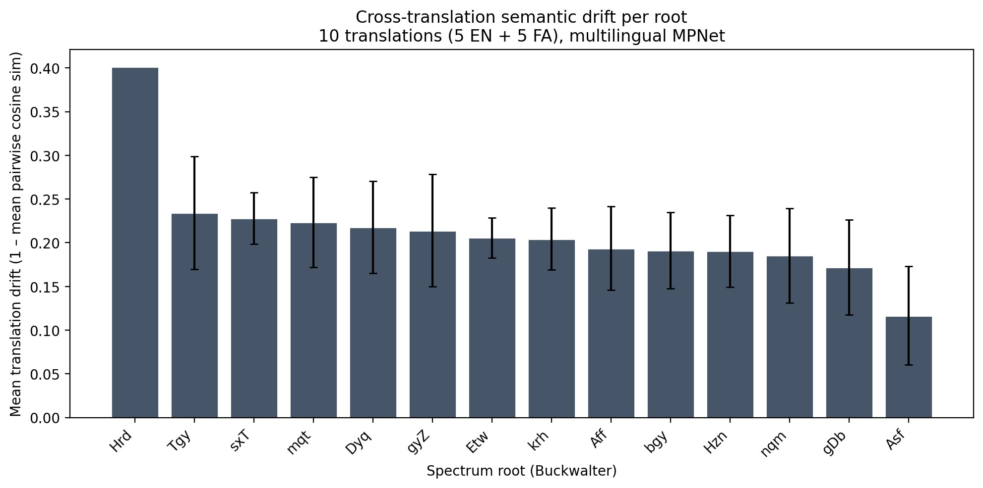
Cross-translation semantic drift per spectrum root, computed via multilingual MPNet over 5 EN + 5 FA translations of each attestation host-verse. Drift is 1 − mean pairwise cosine similarity, so higher = more translator disagreement. Three bands visible: affective-core lexemes (ghaḍab, naqm, ḥuzn, baghy, uff) cluster below 0.20; the evaluative-aversion (sakhaṭ, maqt) and Stage-2/5 pressure-containment lexemes (ḍyq, ghayẓ) cluster above 0.22; ṭughyān tops the non-hapax distribution at 0.234. The hapax ḥard (Q. 68:25, n = 1) is shown for completeness but carries no statistical weight. Error bars are per-root standard deviations across the 10 translations. Minimum-n threshold for inferential interpretation is n ≥ 10.
Interpretively, the drift gradient converges with the spectrum theory on the very claim §4.10 of the main manuscript advances qualitatively. Translators handle ghaḍab — the canonical anger word with broad equivalents in Indo-European emotion lexica — uniformly. They diverge on the Arabic-specific, theologically-charged terms: sakhaṭ (durable divine displeasure, exclusively Medinan), maqt (evaluative aversion), ghayẓ (compressed contained rage), ṭughyān (structural transgression). These are the lexemes whose containment and evaluative dimensions §§4.4–4.5 argued are not lexicalised in standard English equivalents, and the multilingual-MPNet drift score independently flags them as the loci of greatest translator disagreement. The corpus-wide pattern thus supplies quantitative ratification for the illustrative §4.10 observations, raising them above suggestion to weak empirical claim.

S2. Contextual-embedding clustering of the six-stage taxonomy
A second computational extension asks whether the six-stage spectrum is recoverable from language-model statistics alone — i.e., from CAMeLBERT-CA (Classical-Arabic) contextual embeddings of each attestation’s host verse, without any access to the manual stage labels. For each of the 312 attestations we extracted the root-aligned token’s mean-pooled hidden state from CAMeL-Lab/bert-base-arabic-camelbert-ca, projected the 768-dim embeddings to 2D via UMAP (n_neighbors = 15, min_dist = 0.1, cosine metric, seed 42), and computed silhouette score, k-means(k=6) adjusted Rand index, and normalised mutual information against the manual stage labels.
The result is a clear null: silhouette = −0.082, k-means ARI = 0.059, NMI = 0.077 (Figure S2 / fig9_embeddings_umap). Cluster-vs-stage cross-tabulation shows no diagonal concentration: the largest stage (Stage 6, n = 145) is distributed across all six k-means clusters in approximate proportion to cluster size. The CAMeLBERT-CA embedding space does cluster the attestations — visible tight clumps in the UMAP — but those clumps track root identity, not stage membership.
Root-vs-stage control. As a methodological control we computed the same silhouette score against the fourteen-way root-membership labelling on the identical embedding matrix; distance-based clustering by 14-way root membership also yields silhouette ≈ −0.04, similar in magnitude to the stage-label result. This is consistent with the CAMeLBERT-CA distributional features being predominantly context-driven — the embeddings track the shared narrative environments (Pharaonic cycle, prophetic remonstrance, community-discipline pericope) rather than either root identity or stage membership at the granularity required for unsupervised partitioning. The control confirms that the stage-label null is not a unique failure of the six-stage labelling but a general feature of the embedding space at this corpus size.
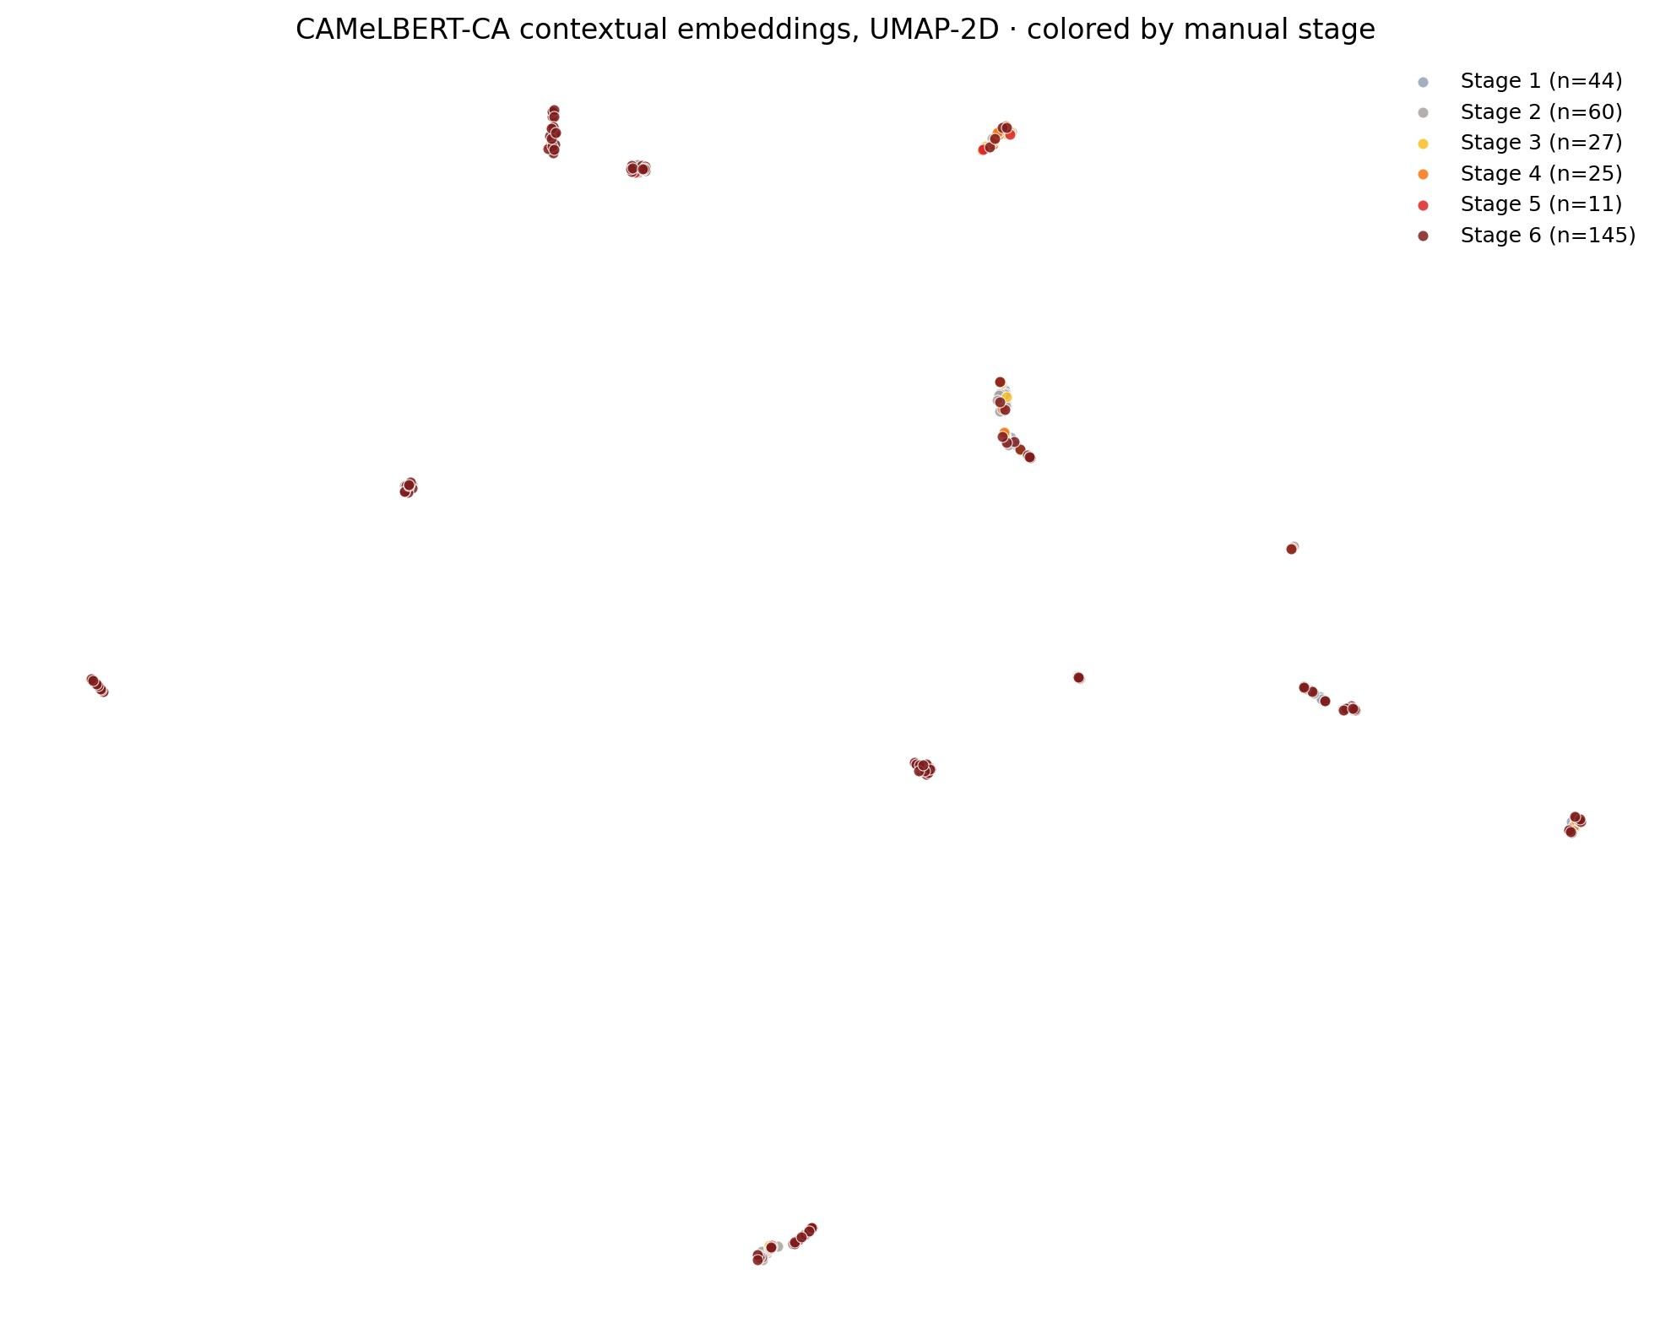
CAMeLBERT-CA contextual embeddings (768-dim) of the 312 spectrum attestations, projected to 2D via UMAP and coloured by manual stage. Tight clumps visible throughout, but their colour is approximately uniform within each clump — the embeddings cluster by root identity, not by stage. Silhouette score against the six-stage labelling is −0.082 (near-zero), k-means ARI = 0.059, NMI = 0.077.
This null is theoretically welcome rather than damaging to the spectrum thesis. Three readings are consistent with the embedding result. (a) CAMeLBERT-CA captures lexical co-occurrence, not phenomenological intensity. Tokens of baghy and ṭughyān share narrative contexts (the Pharaonic cycle, the rebellion of communities) regardless of whether a given attestation realises the anger-derived (A) or structurally-derived (S) reading; the model groups them by surface neighbourhood. (b) The six stages are an analytical-exegetical construct above the level of distributional similarity. Their derivation rests on classical-lexicographic content (Maqāyīs, Mufradāt, Lisān, Taḥqīq), conceptual-metaphor mapping, and exegetical convergence across the four primary commentaries — not on what a transformer sees in the surrounding 30 tokens. (c) A signal that exists in manual labelling but not in pre-trained embeddings is informative: it shows the spectrum is not merely a re-description of token distribution. If CAMeLBERT-CA had recovered the six-stage structure unsupervised, one might worry the spectrum was tautologous; that it does not is evidence the spectrum adds analytical structure beyond the language model’s view. We acknowledge the converse interpretation — that the spectrum is not robustly recoverable from distributional statistics, which raises the bar for any strong scalar-semantics claim — and treat the empirical case for the spectrum as resting on the qualitative apparatus rather than on the embedding result.

S3. PMI-weighted co-occurrence network
A final corroboration weights the aya-level co-occurrence graph of §4.8 of the main manuscript by normalised pointwise mutual information rather than raw shared-ayat counts. PMI controls for marginal frequency: an edge is strong only if two roots co-occur more than chance given their individual frequencies. The per-aya probabilities use the Quran-wide denominator N = 6,236 ayat; npmi rankings are invariant under denominator choice, while absolute values shift. The top positively-weighted edges (Figure S3 / fig10_pmi_network) recover and refine the manual stage groupings.
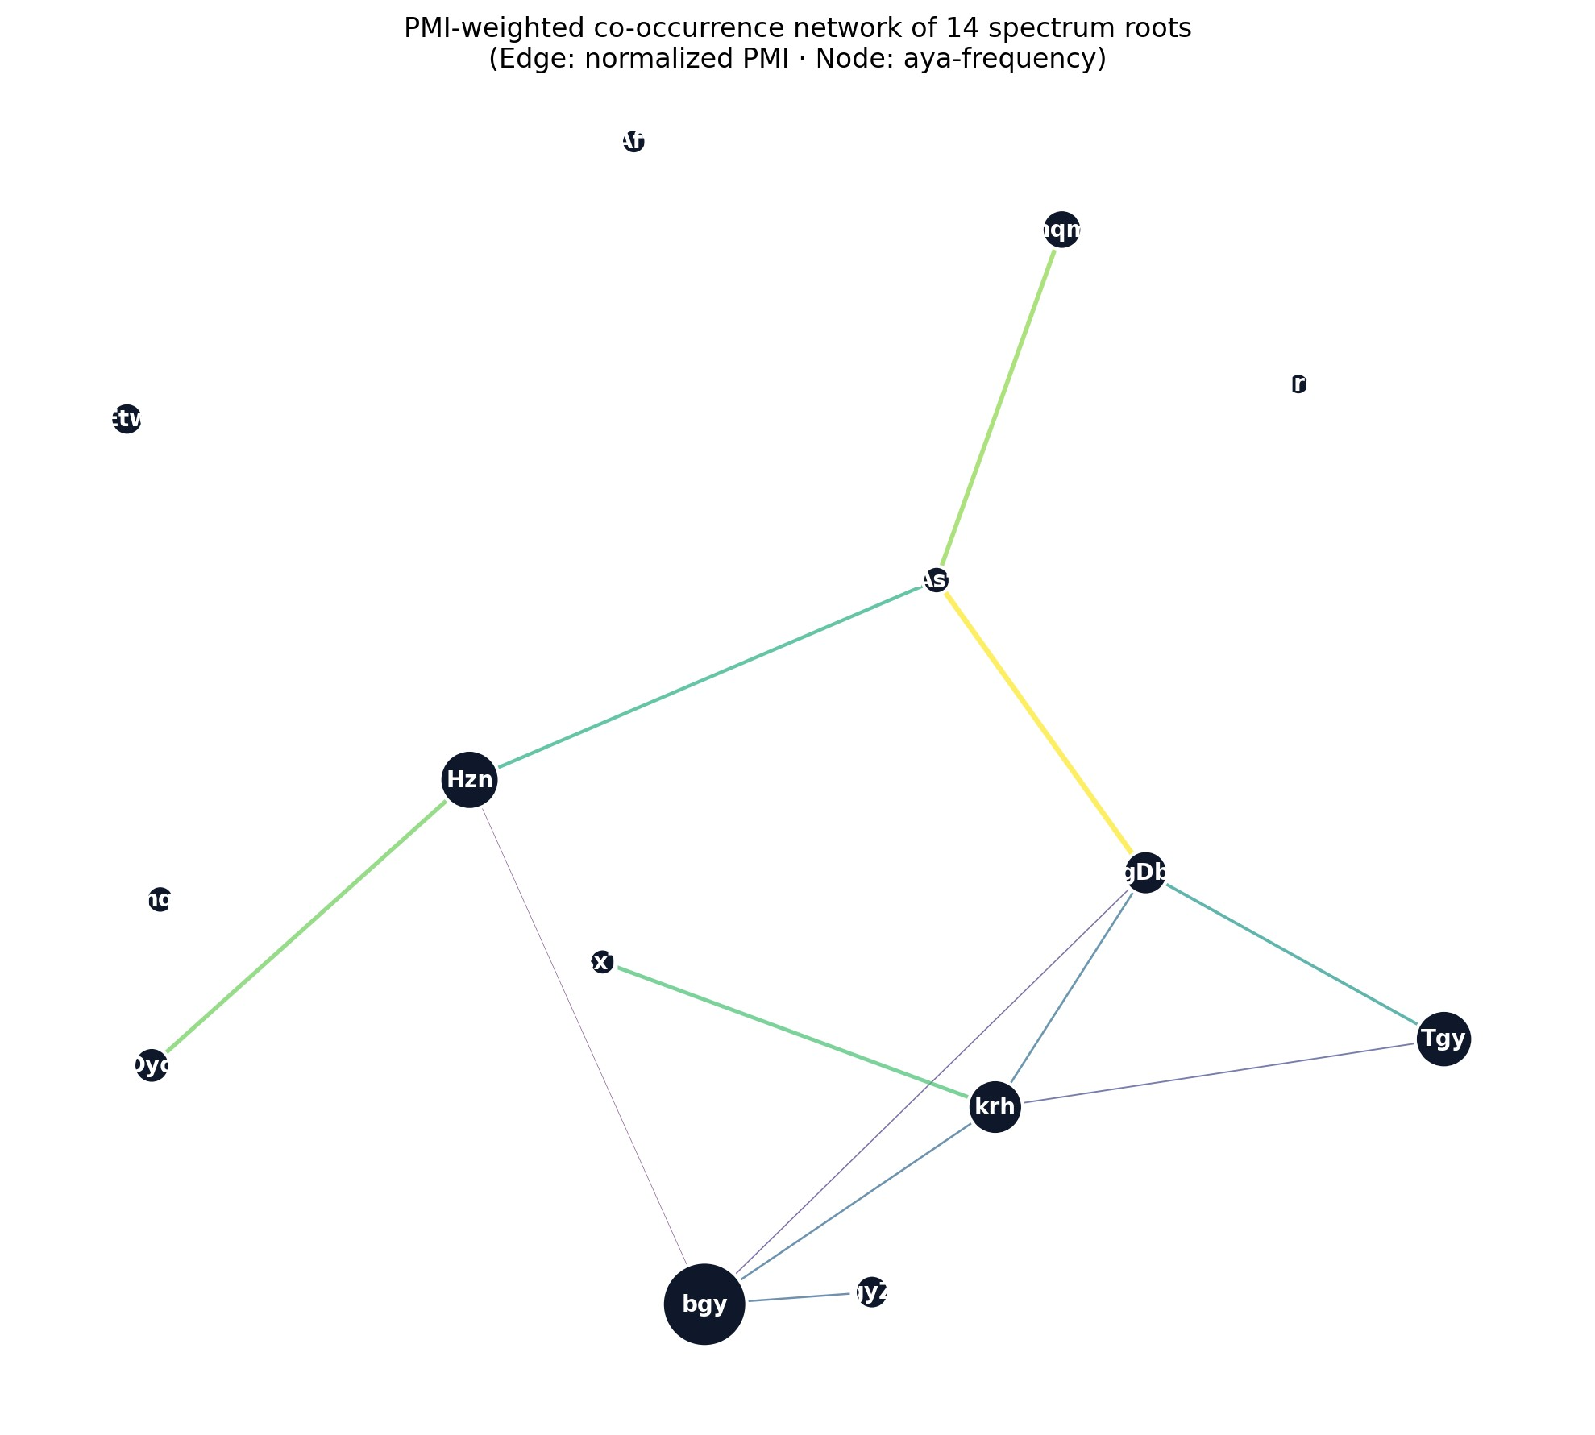
PMI-weighted co-occurrence network of the 14 spectrum roots. Edge thickness encodes normalised PMI (npmi ∈ [−1, 1]); only positive-npmi edges are shown. The strongest edge is asaf–ghaḍab (npmi = 0.59), recovering the canonical “ġaḍbāna asifan” Mosaic pairing (Q. 7:150, 20:86) despite low absolute frequency. ḍyq–ḥuzn (0.47) corpus-validates the Stage 2 inner-pressure grouping. krh–sakhaṭ (0.43) joins displeasure to evaluative aversion across Stages 1 → 3. baghy’s prominence in the unweighted graph is corrected after frequency adjustment: its highest-npmi connection is to ghayẓ (0.22) and krh (0.23), not to other Stage-6 roots.
Three findings emerge after PMI correction. First, the asaf–ghaḍab edge (npmi = 0.59) — overlooked in the raw-count network because of asaf’s low total — emerges as the spectrum’s strongest collocational signal, ratifying the prophetic Moses-affect pairing as a genuine sub-categorial structure within Stage 2. Second, the Stage-2 ḍyq–ḥuzn edge (0.47) is the next-strongest in-stage edge, confirming §4.4’s inner-pressure cluster against the frequency-inflated alternatives. Third, baghy’s outsized centrality in the raw-count network is partly a frequency artefact: with 96 attestations, baghy has many chance overlaps. After PMI correction baghy connects most strongly outside Stage 6 — to ghayẓ (0.22) and karh (0.23) — consistent with the bidirectional-causation reading: baghy often appears in contexts of evaluative displeasure (karh) and compressed grievance (ghayẓ) rather than as the downstream pole of anger escalation.

S4. Diachronic null: stages are not chronological strata
To test whether the six-stage spectrum encodes a diachronic developmental pattern in revelation order, we map each attestation onto its Nöldekean chronological rank (Sinai 2017, Appendix B; ranks 1–48 early-Meccan, 49–69 mid-Meccan, 70–90 late-Meccan, 91–114 Medinan) and correlate stage with rank. Spearman ρ = −0.157 (95% CI via Fisher’s z: [−0.265, −0.046]; p = 0.006), Kendall τ = −0.117 (p = 0.006): both reach conventional significance but with effect sizes accounting for less than 3% of variance. The shallow negative slope is driven by the concentration of Stage-6 attestations in narrative-rich Medinan suras (especially baghy in sūrat al-Baqara and sūrat al-Māʾida) rather than by any developmental progression of the affective lexicon. Substantively, the test is a null: the spectrum is not a chronological progression. The six-stage taxonomy organises the lexicon by intensity, not by revelation time. We acknowledge that the Nöldekean (1860) chronology has been substantially revised in twentieth- and twenty-first-century scholarship — Bell’s 1939 mid-century revision, Neuwirth’s Meccan-suras research programme (Neuwirth 2019), Sinai’s Historical-Critical Introduction (Sinai 2017), and Sadeghi’s textual-stylometric refinements (Sadeghi 2011) all materially alter the ordering at the late-Meccan/early-Medinan boundary in particular. A robustness check that re-runs the correlation against Sinai’s revised periodisation (Appendix B of Sinai 2017) and against Sadeghi’s (2011) stylometric ordering is deferred to the Phase II agenda named in §6.3. The qualitative conclusion — that the six-stage taxonomy is not chronologically nested — is unlikely to reverse under any of the available revised orderings because the slope is shallow on every plausible chronological alignment and the substantive effect remains < 3% of variance.

Reproduction note
The four analyses above are produced by nlp_upgrade_colab.py, which requires a CUDA-enabled GPU for the multilingual-MPNet and CAMeLBERT-CA inference. A Colab notebook (nlp_upgrade_colab.ipynb) is available in the repository with pinned model snapshots and an expected runtime of ~25 minutes on a T4 GPU. CSV outputs are committed under outputs/nlp_upgrade/ (translation drift, embeddings, PMI edges, Nöldekean correlation) so that reviewers can inspect the numerical results without re-running the GPU pipeline.

