Finance App
Iteration #2 Plan
Revision History
Author | Date | Description
Ali Alsagri | 11/12/2014 | Phase-2: Integrating Customer information

Objectives
The purpose of this iteration is to work with the customer information, providing him to add account details, modify details, request sales representative to get best quotes from the vendors. At the end of this iteration, stakeholders should be able to:
- Create, Login and manage their account

Use Cases
The following use cases are involved in this iteration:
- UC4: Create account screen
- UC5: Customer login
- UC6: Manage account

Task Schedule

Task | Effort |  | Completion Date |  | Owner | Status
Task | Est. | Actual | Est. | Actual | Owner | Status
Create Database Schema | 5 | 7 | 11/03/2014 | 11/04/2014 |  | Finished
Create ASP.Net Account Form | 7 | 10 | 11/05/2014 | 11/12/2014 |  | Started
Process Account Form |  |  | 11/12/2014 |  |  | Started
Create ASP.Net Account management |  |  |  |  |  | Not Started

Screenshots

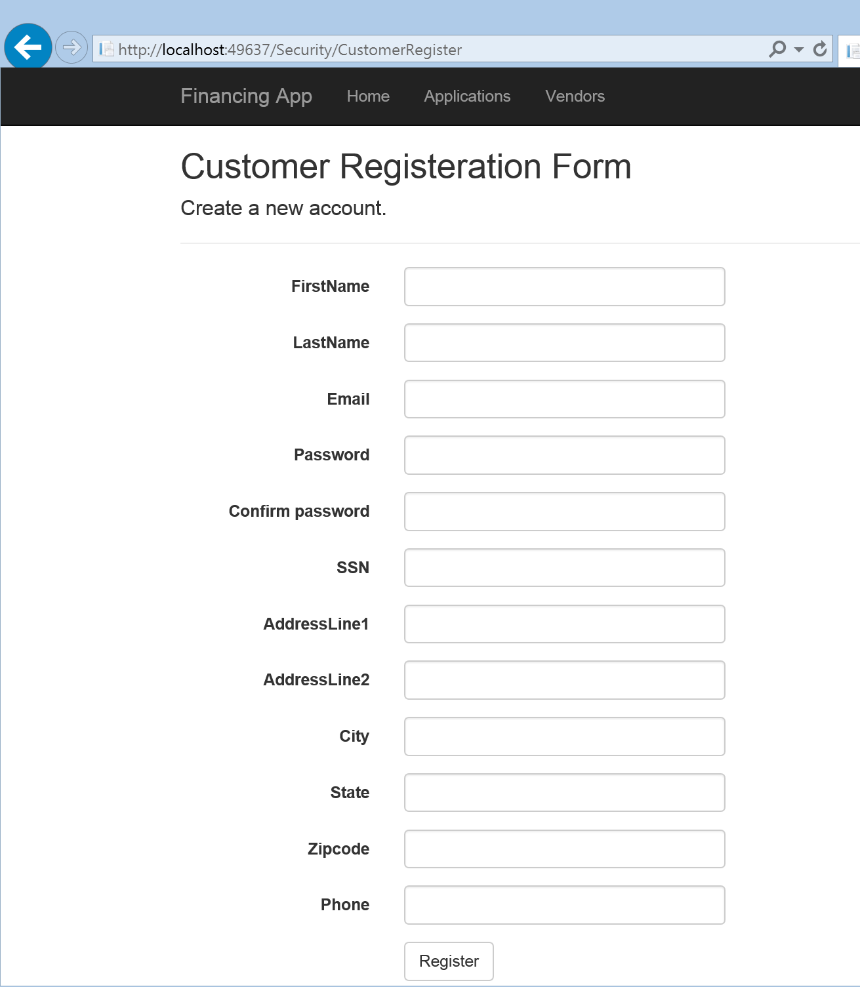

Customer registration form

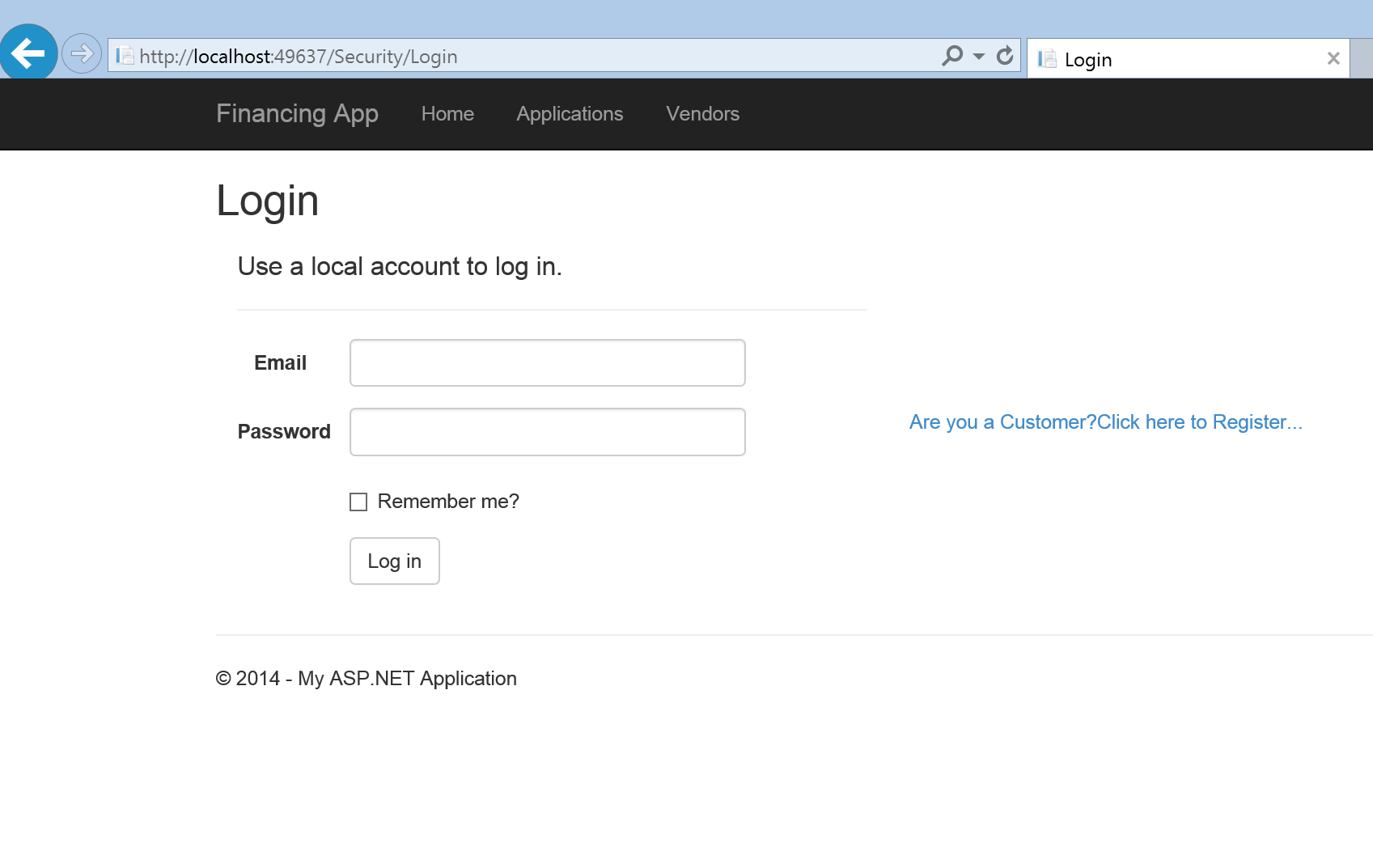
Customer login

