Finance App
Iteration #3 Plan
Revision History
Author | Date | Description
Ali Alsagri | 11/25/2014 | Phase-3: Creating the Application form

Objectives
The purpose of this iteration is to create an application form filled by sales representative.

- Design the Database required to store the application details
- Fill the application with the details provided by the customer and submit to the vendor.

Use Cases
The following use cases are involved in this iteration:
- UC4: Design and create the database tables for application form
- UC5: Create a Application form
- UC5: Submit the information to a vendor

Task Schedule

Task | Effort |  | Completion Date |  | Owner | Status
Task | Est. | Actual | Est. | Actual | Owner | Status
Create Database Schema |  |  |  |  |  | Started
Create ASP.Net interface to communicate with database |  |  |  |  |  | Started
Create UI form to enter application details |  |  |  |  |  | Started
Implementing submission of vendor details |  |  |  |  |  | Not Started

Screenshots
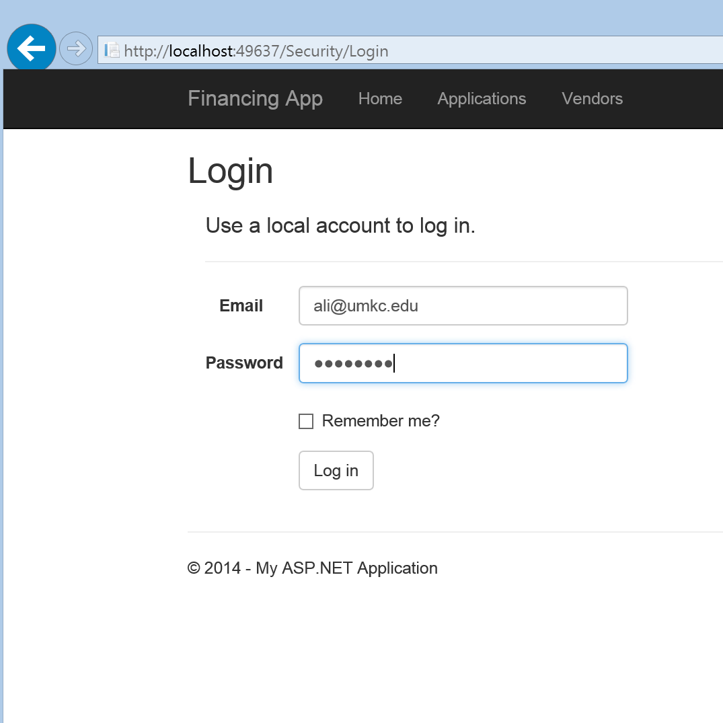
Sales representative login

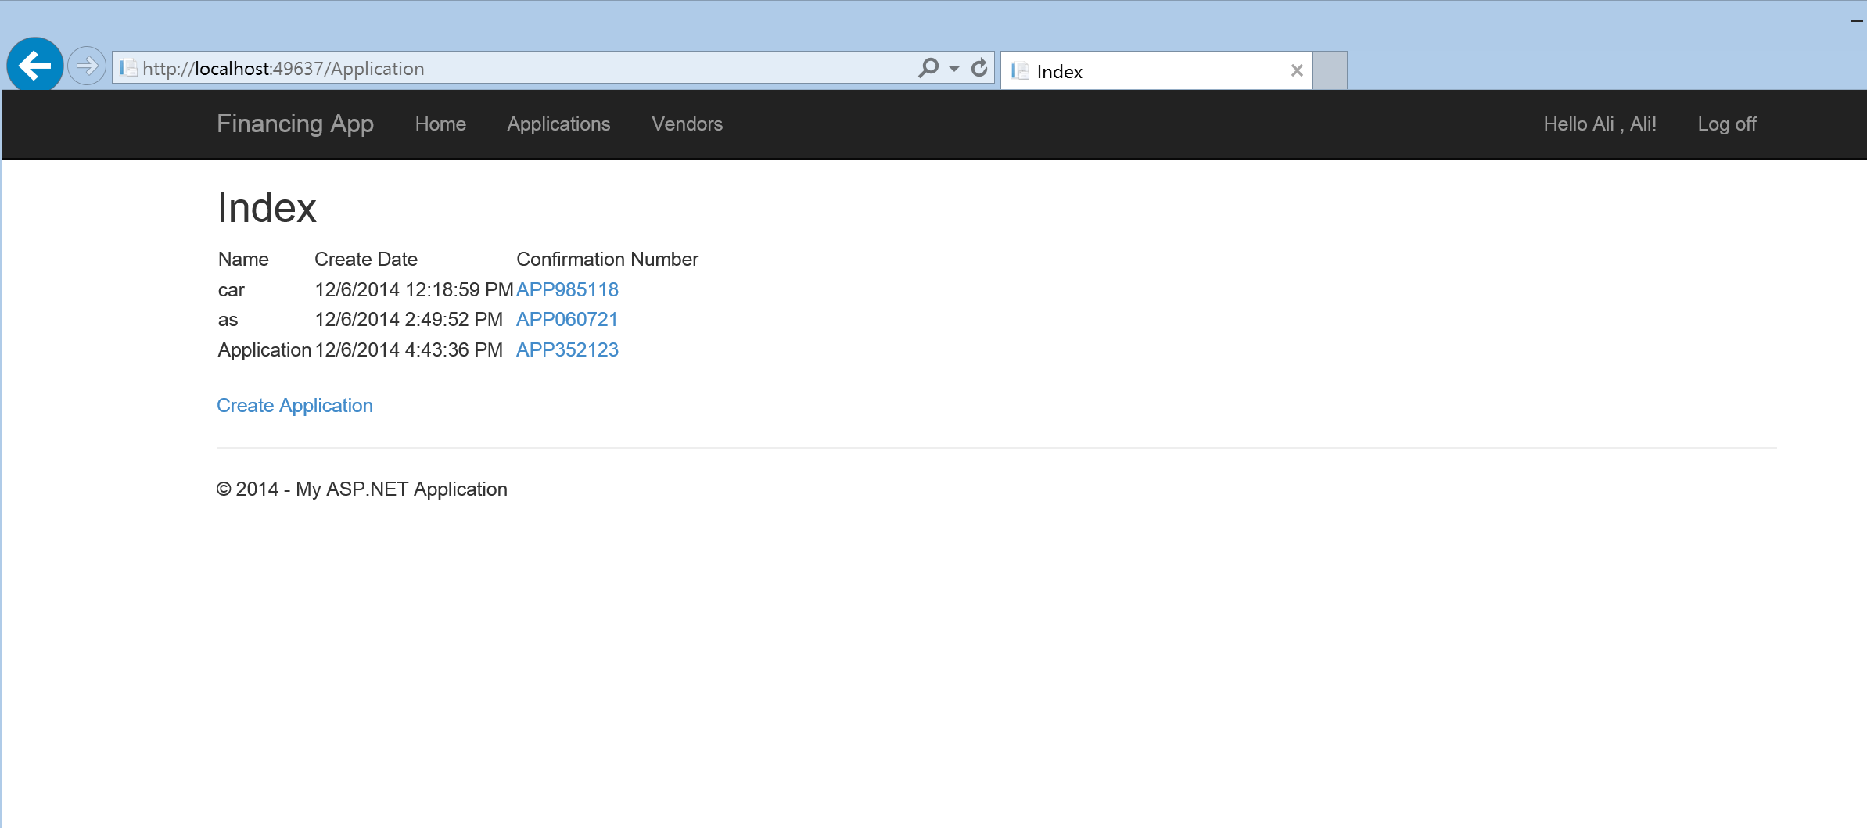
Existing applications list

