Finance App

Iteration #1 Plan

Revision History

|  |  |  |
| --- | --- | --- |
| **Author** | **Date** | **Description** |
| Ali Alsagri | 11/2/2014 | Initial Release |

## Objectives

The purpose of this iteration is to create a working skeleton of the system. The system is divided into three components namely User Interface, Middle-ware(ASP.NET), and a database to store information.

There are three different types of stakeholders - vendors, sales representatives and customers. At the end of this iteration, each individual stakeholder can:

* Create an account
* Login into it successfully

## Use Cases

The following use cases are involved in this iteration:

* UC2: Add vendor details.
* UC3: Create sales representative account

## Task Schedule

|  |  |  |  |  |  |  |
| --- | --- | --- | --- | --- | --- | --- |
| Task | Effort | | Completion Date | | Owner | **Status** |
| **Est.** | **Actual** | **Est.** | **Actual** |
| Create Database Schema | 5 | 7 | 11/3/2014 | 11/04/2014 |  | Finished |
| Create ASP.Net sales representative Account Form | 7 | 10 | 11/05/2014 |  |  | Started |
| Create ASP.NET customer account form | 5 |  |  |  |  | Not Started |
| Form to enter Vendor details | 6 |  |  |  |  | Not Started |

## System Architecture

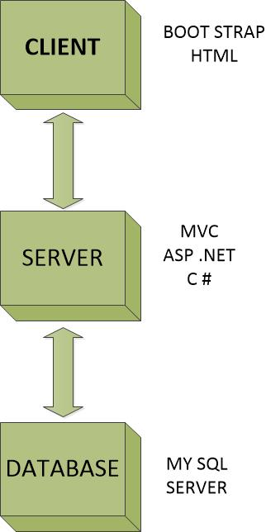

## Screenshots

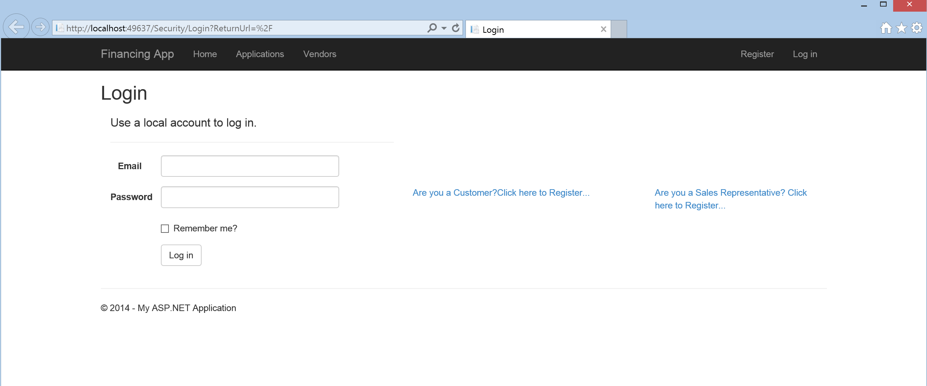

Login screen

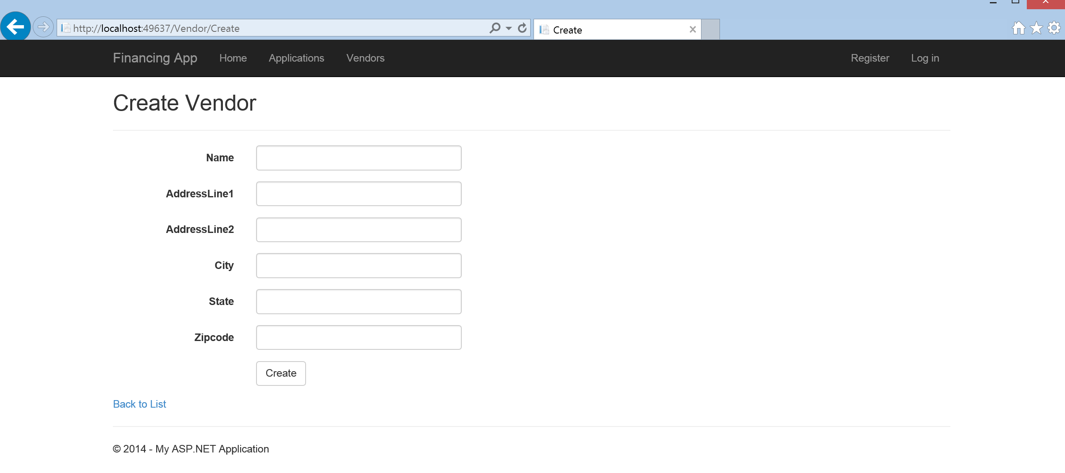

Vendor form

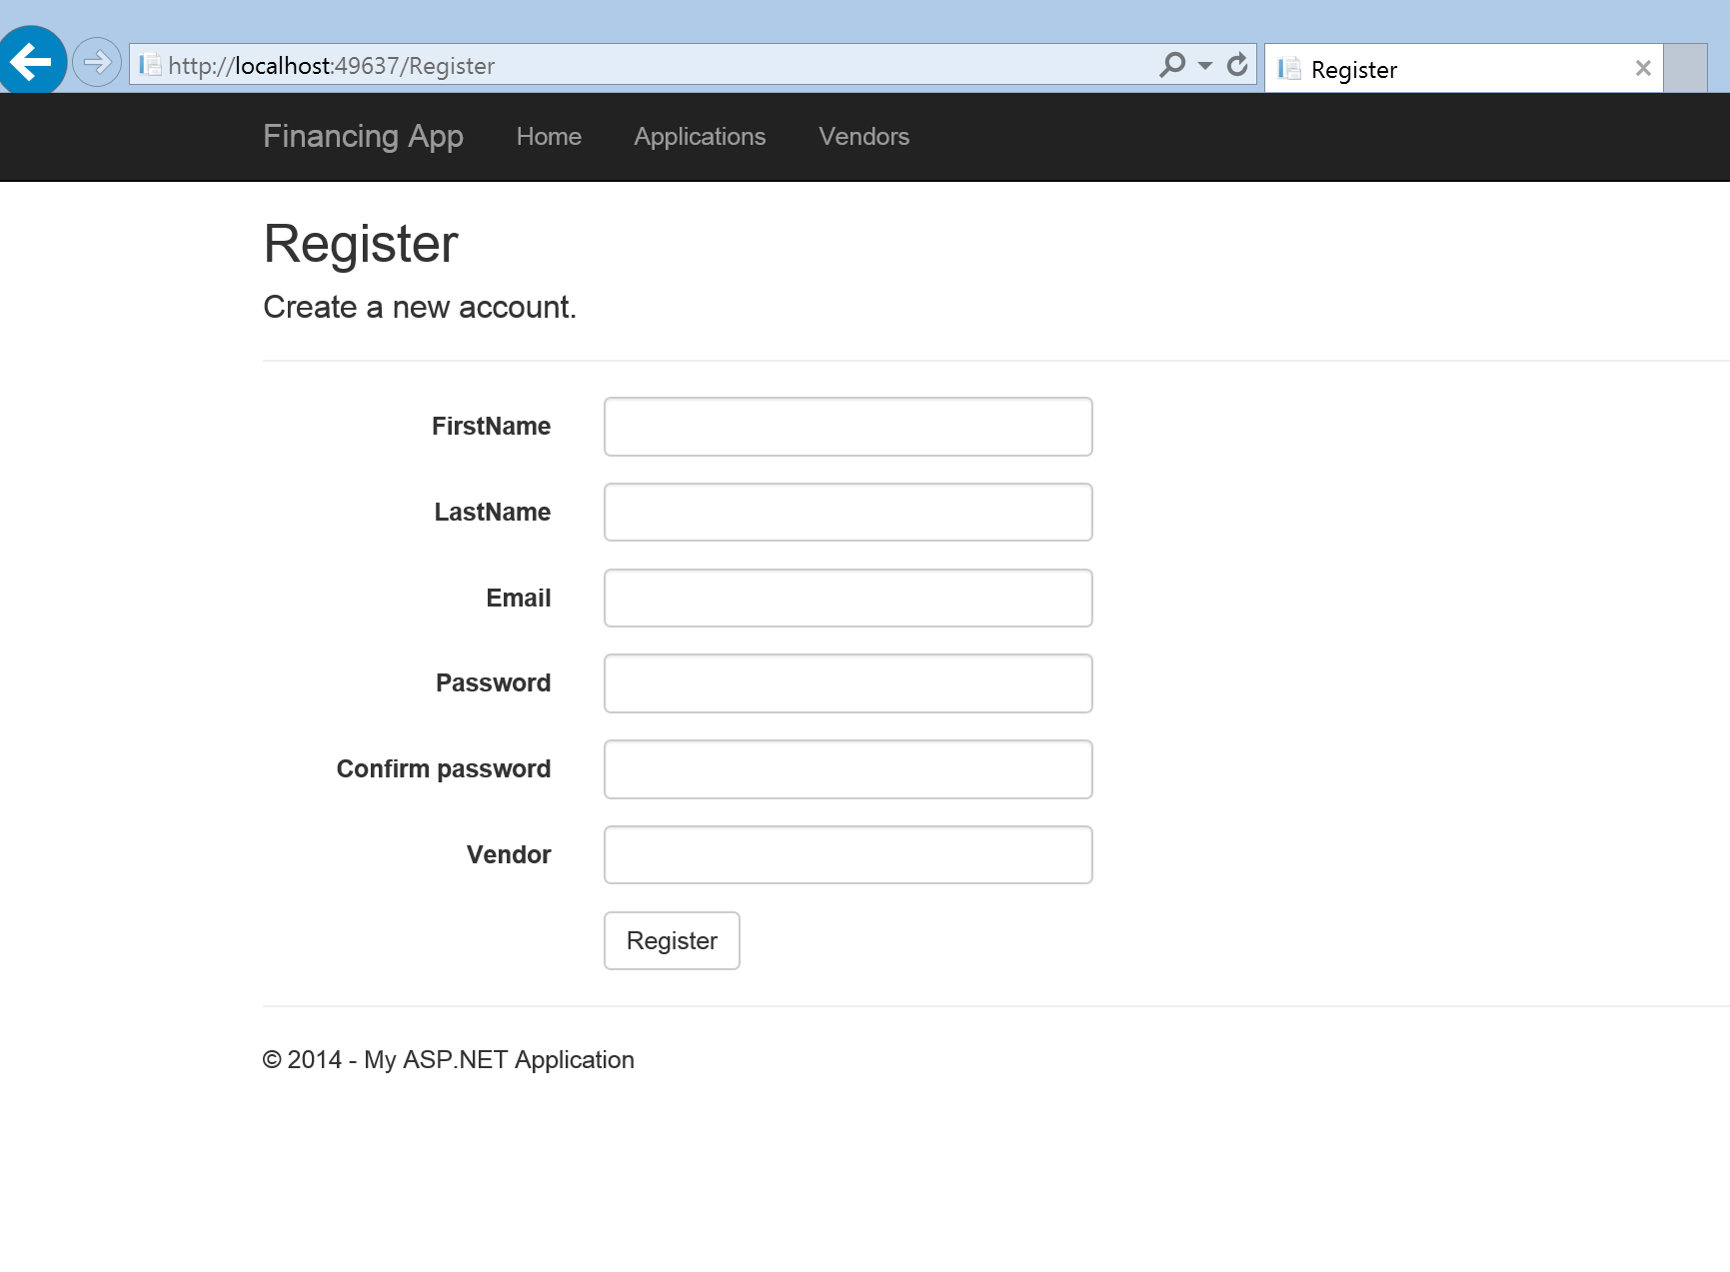

Sales representative registration form