Finance App

Iteration #4 Plan

Revision History

|  |  |  |
| --- | --- | --- |
| **Author** | **Date** | **Description** |
| Ali Alsagri | 12/03/2014 | Phase-4: Implementation |

## Objectives

The purpose of this iteration is to integrate frontend with the database to update the application details.

## Use Cases

The following use cases are involved in this iteration:

* UC4: Updating database with application table and adding its relation with other tables.
* UC5: Implementing logic to receive the data from application and updating into database.

## Task Schedule

|  |  |  |  |  |  |  |
| --- | --- | --- | --- | --- | --- | --- |
| Task | Effort | | Completion Date | | Owner | **Status** |
| **Est.** | **Actual** | **Est.** | **Actual** |
| Update Database Schema with application table |  |  |  |  |  | finished |
| Login in ASP.NET to receive data from UI and update in database |  |  |  |  |  | Started |

## Screenshots

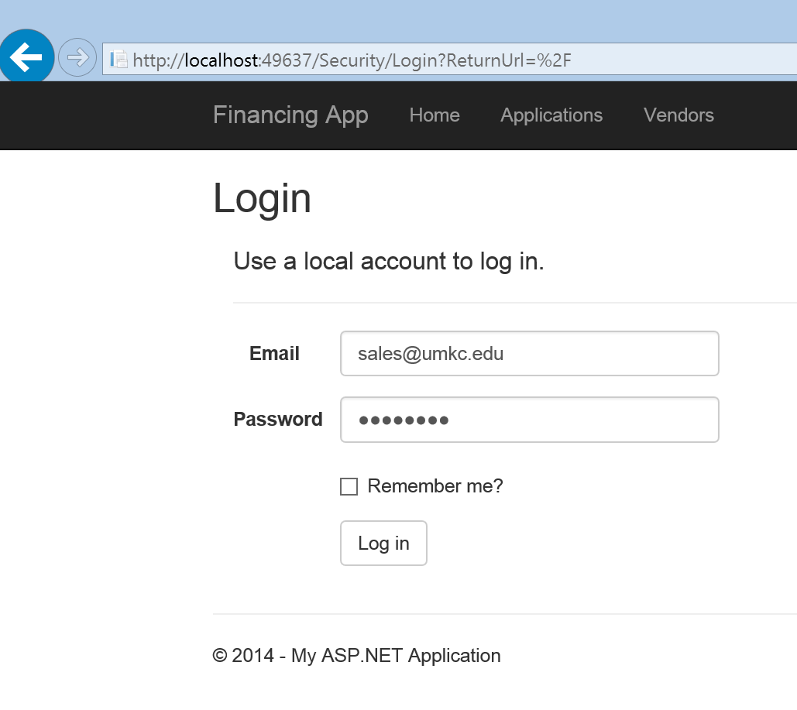

Sales representative login

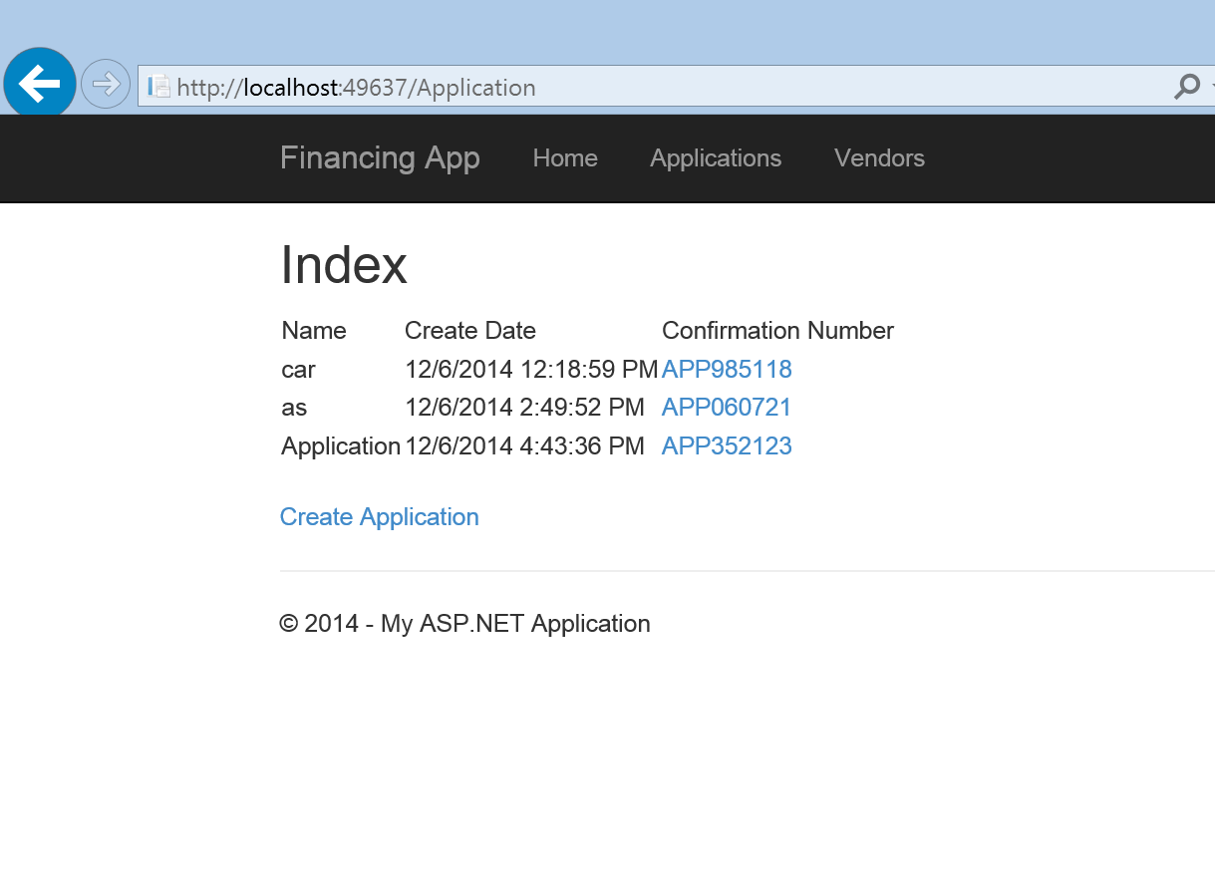

Recent applications submitted

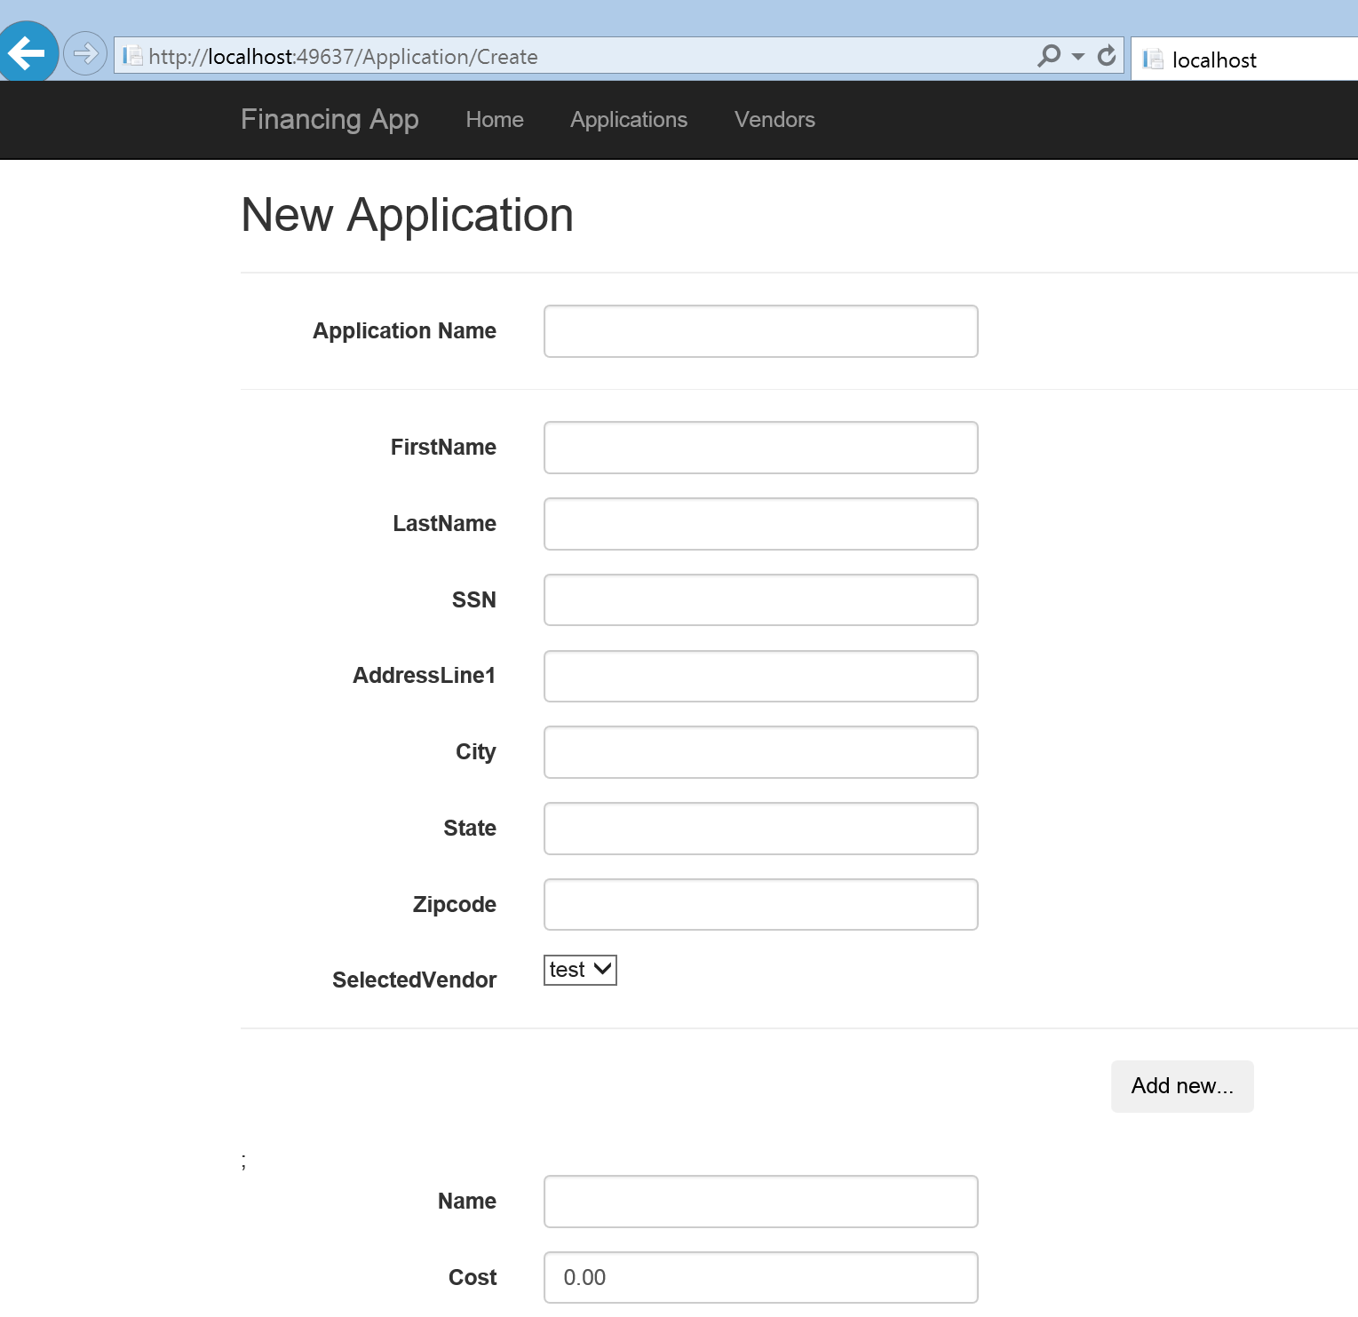

Application form