PROJECT HUB FYP
(PROJECT SHARING & MANAGEMENT SYSTEM)

BY
Student Name

Session

DEPARTMENT COMPUTER SCIENCE
GOVERNMENT COLLEGE NO. 1
DERA ISMAIL KHAN
PAKISTAN

PROJECT HUB FYP
(PROJECT SHARING & MANAGEMENT SYSTEM)

For the partial fulfillment of the requirement for the degree of
BS Computer Science

By:
Student Name
Roll No CS
Student Name
Roll No CS
Session:

DEPARTMENT COMPUTER SCIENCE
GOVERNMENT COLLEGE NO. 1
DERA ISMAIL KHAN
PAKISTAN

IN THE NAME OF ALLAH THE MOST BENIFICIENT
THE MOST MERCIFUL

APPROVAL CERTIFICATE

We, the Supervisory Committee, hereby certify that the contents and form of dissertation submitted by Student Name and Student Name, BS Computer Science were checked and found satisfactory and hereby recommended that it should be processed for the award of degree of Bachelor of studies BS in Computer Science.
Supervisory Committee
Name Signature
__________________________ Supervisor _________________
__________________________ External Examiner _________________
__________________________ Head of Department _________________
__________________________ Principal _________________

DEDICATED TO

THE HOLY PROPHET MUHAMMAD (PBUH),
MY DEAR PARENTS & TEACHERS

Student Declaration

We, Student Name do hereby state that my BS thesis titled Project Hub, is my own work and has not been submitted previously by me for taking any degree from Government College No.1, Dera Ismail Khan or anywhere else in the country/world.

Name of Student Signature_____________ Date___________
Name of Student Signature_____________ Date___________
Name of Supervisor Signature_____________ Date___________

ACKNOWLEDGEMENT

Countless gratitude to Allah Subhana WA Ta’alah, Who has all the supreme powers and who is the only supportive in all ups and downs of life. All praise goes to Him who gave us courage, understanding and devotion to complete this project.
We express our gratitude to our very kind supervisor (supervisor Name) whose earnest support helped us to complete our project successfully. Without his guidance and help it was not possible to complete this web system.
Furthermore we would like to thank all our respected teachers for their ethical support to our efforts, and their guidance and help, where ever it was required.
Last but not least our immense thanks goes to our parents, brothers and sisters for bearing us during development, raising hand in prayer for us and giving their consistent moral support.
Student Name
&
Student Name

PROJECT HUB FYP
ABSTRACT

In the current educational ecosystem, showcasing final year projects (FYPs) and connecting student developers with peers, evaluators, and the community relies heavily on traditional, manual exhibition formats. This approach restricts visibility, limits collaboration, and makes it difficult to maintain a long-term, accessible repository of student innovations.
Project Hub is a centralized, web-based platform designed to overcome these limitations by providing a digital showcase for student projects. It enables students to easily submit their work, integrating seamlessly with GitHub to pull live project metrics and language statistics. The system features an admin panel allowing authorized personnel (such as HODs or project coordinators) to review, approve, or reject submissions, ensuring quality and relevance.
By transitioning to an online repository, Project Hub enhances the accessibility of academic projects, reduces the reliance on physical exhibitions, and preserves the intellectual contributions of students in a centralized, easily navigable database. It provides sorting and filtering capabilities, making it simpler for users to discover projects across different categories. The system utilizes modern web technologies, ensuring robust performance and real-time interactions.
Ultimately, this thesis explores the development lifecycle, system architecture, and real-world implications of deploying a centralized project repository in an educational institution. It addresses the challenges of traditional management and proposes a highly scalable, secure, and user-centric alternative.

Chapter 1: Introduction

1.1 Overview
Every academic institution generates a significant amount of intellectual property through student projects. Final Year Projects (FYPs) in particular represent the culmination of a student's learning and practical application of their degree. However, these projects often remain unseen beyond the evaluation phase due to the lack of an effective showcase platform. Project Hub is a comprehensive web application designed specifically to host, manage, and showcase student projects.
This system streamlines the submission process, allows for strict administrative oversight, and presents the approved projects in a professional, dynamic interface. The system includes features such as live GitHub statistics integration, advanced filtering by category, real-time data synchronization using Firebase, and a structured admin panel for project approval. Project Hub represents a paradigm shift from physical records to a digital-first approach for academic showcases.

1.2 Background Introduction
Traditionally, academic projects are evaluated locally. Their documentation is either stored physically in the department's library or kept in fragmented digital folders across various hard drives. This makes tracking, accessing, and showcasing these projects a tedious, inefficient endeavor.
The main objective of the proposed system is to centralize this process through a unified online platform. By automating the submission and evaluation workflow, the system significantly decreases paperwork, enables easier record maintenance, and provides a public-facing portfolio of student capabilities. In an era where digital presence is paramount, relying on archaic storage methods deprives students of opportunities to showcase their skills to potential employers and collaborators.

1.3 Motivation
The motivation behind Project Hub stems from the desire to give students the visibility they rightfully deserve for their hard work. In the modern era, having a verifiable, digital presence is crucial for budding software developers and engineers. By providing a platform that automatically integrates with GitHub to display real-world metrics, Project Hub bridges the gap between academic requirements and professional portfolios.
Furthermore, institutions face logistical nightmares organizing physical exhibitions. A digital alternative not only saves time and resources but also provides an easy, maintained, and systematic environment for both students to submit and higher panels to review and approve projects.

1.4 Problem Definition
Currently, there is no centralized repository within the institution that effectively showcases student projects. When students graduate, their work often becomes inaccessible to future batches who might want to learn from or build upon it.
The core problem is the lack of a system that connects student work with a wider audience, leading to a loss of valuable educational resources, reduced recognition for students, and inefficiencies in administrative tracking. This disjointed approach limits interdisciplinary collaboration and prevents the institution from proudly displaying its collective technological achievements.

1.5 Current Systems
In the current ecosystem, projects are typically submitted via email, physical media (like USB drives or CDs), or isolated institutional portals that are designed solely for grading purposes. These systems fundamentally lack public-facing portfolios, integration with modern version control systems like GitHub, and interactive filtering mechanisms for exploring different types of projects based on user interests.

1.6 The Problems with Current System
The existing approach suffers from several critical flaws:
- It is incredibly difficult for students to share their work with external entities such as potential employers or industry collaborators.
- It is highly time-consuming for the administration to manually compile project details for annual exhibitions or departmental reviews.
- The lack of a centralized, secure database leads to data loss, corruption of physical media, and makes it nearly impossible to track the evolution of projects over different academic years.
- There is no standardized formatting, making it difficult to compare or categorize projects effectively.

1.7 Goals and Objectives
Project Hub is designed to be a convenient, responsive, and robust solution to these problems. The primary goals and objectives include:
- To provide a centralized, highly accessible web-based platform for continuous project submission and showcasing.
- To implement an automated, multi-tiered approval workflow via a secure admin panel.
- To integrate dynamic data fetching from GitHub to provide real-time project statistics, ensuring the data is always up-to-date without manual intervention.
- To enhance UI/UX with smooth transitions, modern design principles, and category-based filtering for an engaging and intuitive user experience.
- To ensure data integrity and security by utilizing modern cloud databases and authentication mechanisms.

Chapter 2: Proposed System

2.1 Proposed System Overview
In the proposed system, the entire lifecycle of a project exhibition—from submission to approval to public display—is handled through a seamless online platform. Data loss is minimized as all information is maintained in a centralized, cloud-hosted database (Firebase Firestore). The system utilizes a modern technology stack, ensuring fast load times, high availability, and a responsive design that adapts perfectly to both desktop and mobile devices. Real-time updates and interactive filtering make it a flexible and user-friendly solution for the entire institution.

2.2 Module Description
After careful analysis of the requirements and constraints, the system has been architected into distinct, decoupled modules to ensure maintainability and scalability:
- Admin Module: Responsible for oversight, moderation, and system management.
- User/Student Module: Responsible for data input, browsing, and interaction.

2.2.1 Admin Module
The Admin module handles all critical administrative tasks. It provides a secure dashboard accessible only to authenticated personnel (e.g., Head of Department, Project Coordinators). From this dashboard, admins can review all pending project submissions. They can inspect the details, verify the provided repository links, and then choose to either accept or reject the submission. This moderation layer is crucial for ensuring that only appropriate, complete, and high-quality projects are displayed on the public platform.

2.2.2 User/Student Module
The User module is the public-facing aspect of the system. It allows students to submit their project details through an intuitive form, including the project title, detailed description, category classification, and GitHub repository links. Once a project is approved by an admin, users (including guests, peers, and recruiters) can browse the approved projects. They can filter them by category, search by keywords, and view detailed metrics such as language usage graphs dynamically generated from GitHub APIs.

Chapter 3: System Requirements & Technologies
The successful deployment of Project Hub requires specific hardware and software components, as well as the utilization of modern web development technologies. This chapter details the technical foundation of the system.

3.1 Web Development Technologies

3.1.1 HTML5
Hypertext Markup Language 5 (HTML5) is the latest evolution of the standard that defines HTML. It provides the core structure and semantic meaning to the Project Hub application. HTML5 introduces new elements, attributes, and behaviors, as well as a larger set of technologies that allows the building of more diverse and powerful Web sites and applications.

3.1.2 CSS3
Cascading Style Sheets (CSS3) is used for describing the presentation of a document written in HTML. Project Hub utilizes modern CSS3 features extensively. This includes CSS Flexbox and CSS Grid for complex, responsive layouts, media queries for mobile optimization, rounded corners, drop shadows, and complex transitions and animations to create a visually appealing, dynamic aesthetic.

3.1.3 JavaScript (ES6+)
JavaScript is the programming language of the Web. In Project Hub, modern JavaScript (ES6 and beyond) is the backbone of the application's interactivity. It is used to handle dynamic Document Object Model (DOM) manipulation, making the page interactive without requiring full page reloads. JavaScript is also heavily utilized to fetch data asynchronously from external APIs (such as GitHub) using the Fetch API, manage state, and handle asynchronous database operations using Promises and async/await syntax.

3.2 Cloud Infrastructure & Backend

3.2.1 Firebase Firestore
Firebase is a platform developed by Google for creating mobile and web applications. Project Hub utilizes Firebase Firestore as its primary database. Firestore is a flexible, scalable NoSQL cloud database designed to store and sync data for client- and server-side development. It keeps data in sync across client apps through realtime listeners and offers offline support for mobile and web so responsive apps can be built that work regardless of network latency or Internet connectivity.

3.2.2 Firebase Authentication
To secure the Admin panel, the system utilizes Firebase Authentication. This service provides backend services, easy-to-use SDKs, and ready-made UI libraries to authenticate users to the app. It supports authentication using passwords, phone numbers, popular federated identity providers like Google, Facebook and Twitter, and more. For Project Hub, it ensures that only verified institutional administrators can access the moderation tools.

3.3 External APIs

3.3.1 GitHub REST API
To provide real-world context to academic projects, Project Hub integrates deeply with the GitHub REST API. By querying this API with the repository links provided by students, the system dynamically fetches real-time statistics. This includes the primary languages used in the repository, calculating the percentage of each language, and rendering this data graphically on the frontend. This ensures the project details page always reflects the current state of the codebase.

3.4 Hardware Requirements

3.4.1 Client Side Requirements
Because Project Hub is a web-based application, the client-side hardware requirements are minimal. Any device capable of running a modern web browser can access the system.
- Processor: Any modern processor (Intel Core i3 equivalent or higher recommended).
- RAM: 2 GB minimum (4 GB recommended for smooth API rendering).
- Internet connection: Required for API fetching and database communication.

3.4.2 Server Side Requirements
As Project Hub utilizes Firebase (a Backend-as-a-Service), there are no dedicated hardware requirements for the institution to maintain. Google Cloud handles the dynamic scaling, storage, and processing power required by the database and authentication services.

3.5 Software Requirements
The development and access of the system require specific software tools:
- Code Editor: Visual Studio Code, Sublime Text, or similar IDE.
- Web Browser: Google Chrome, Mozilla Firefox, Microsoft Edge, or Safari (updated to the latest versions for full ES6 and CSS3 support).
- Version Control: Git (for managing the application's source code).

Chapter 4: Methodology

4.1 Software Development Life Cycle (SDLC)
The methodology adopted for Project Hub follows an Iterative Prototype model. This approach allows for the continuous refinement of the system based on immediate feedback. The SDLC involved stages of system analysis, design, rapid prototyping, development, and rigorous testing.

4.2 Requirement Analysis
In the analysis phase, the limitations of traditional, physical project exhibitions were evaluated thoroughly. Interviews and discussions with both students and faculty members highlighted the need for a digital alternative. Specific bottlenecks, such as the manual approval process and the difficulty in accessing past projects, were identified as critical areas for automation.

4.3 System Design
The proposed system was designed with a decoupled architecture in mind. The frontend (client) operates independently from the backend (Firebase), communicating entirely through asynchronous network requests. This allows for a highly responsive user interface.

4.4 Implementation Strategy
The new system was implemented using vanilla web technologies (HTML, CSS, JS) to ensure maximum compatibility and performance without the overhead of heavy frameworks for the initial prototype. The Firebase SDK was integrated to handle all database operations and authentication logic directly from the client side, significantly reducing the complexity of maintaining a custom backend server.

4.5 Module Implementation Details

4.5.1 Admin Interface Implementation
The admin panel was implemented with security as the primary focus. Upon successful authentication via Firebase, a session is established. The dashboard queries the Firestore database specifically for documents where the 'status' field is set to 'pending'. The admin is presented with a list of these projects. When the admin clicks 'Approve', a fast database update operation modifies the status to 'approved', which instantly makes the project available on the public feed via Firestore's real-time listeners.

4.5.2 User Interface Implementation
The public-facing module relies heavily on dynamic DOM manipulation. When a user visits the homepage, a query is sent to Firestore to retrieve all 'approved' projects. These projects are dynamically rendered as interactive cards. The filtering system uses JavaScript to show or hide these cards based on the selected category pill, avoiding full page reloads and providing a seamless browsing experience. When a project card is clicked, the system extracts the GitHub URL, parses the repository owner and name, and executes a fetch request to the GitHub API to retrieve language statistics, which are then rendered into a visual bar.

Chapter 5: System Modeling and Diagrams
Visualizing the system through various diagrams helps in understanding the flow of data, the interactions between different entities, and the overall structural logic of Project Hub.

5.1 Data Flow Diagrams (DFD)
A Data Flow Diagram (DFD) maps out the flow of information for any process or system. It uses defined symbols like rectangles, circles and arrows, plus short text labels, to show data inputs, outputs, storage points and the routes between each destination.

5.1.1 Level 0 DFD (Context Diagram)
The Level 0 DFD represents the entire system as a single process. It shows the system's interactions with external entities.
- External Entities: User/Student, Admin.
- Processes: The Project Hub System.
- Data Flow: Students submit project data. The System provides project data back to Students/Users for viewing. Admins receive pending project data. Admins send approval/rejection commands to the System.
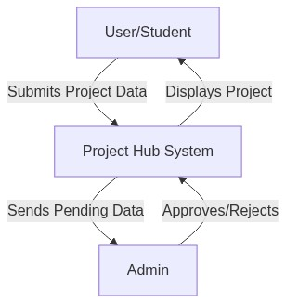
Figure 5.1: Level 0 DFD

5.1.2 Level 1 DFD
The Level 1 DFD breaks down the main process into sub-processes, providing more detail.
- Processes: Form Submission Processing, Admin Verification, Public Display Fetching, External API Integration.
- Data Stores: Firestore Database (Projects Table, Users Table).
- Flow: Submission data goes into the database as pending. The Admin Verification process reads pending data and updates the status. The Public Display process reads approved data and displays it. The External API process fetches data from GitHub based on the database records.
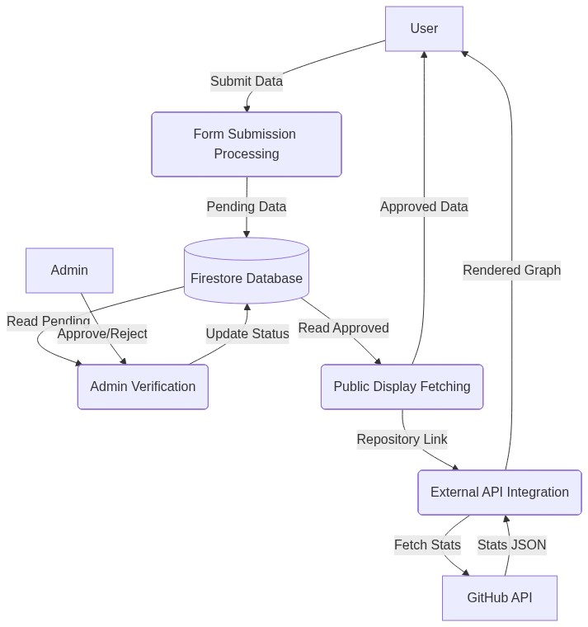
Figure 5.2: Level 1 DFD

5.2 Sequence Diagram
A sequence diagram shows object interactions arranged in time sequence. It depicts the objects and classes involved in the scenario and the sequence of messages exchanged between the objects needed to carry out the functionality.
In the context of Project Hub, a sequence diagram illustrates the step-by-step process of a student submitting a project, the data being saved to Firestore, the admin retrieving the pending list, the admin approving it, and finally, a user viewing the dynamically loaded project page.
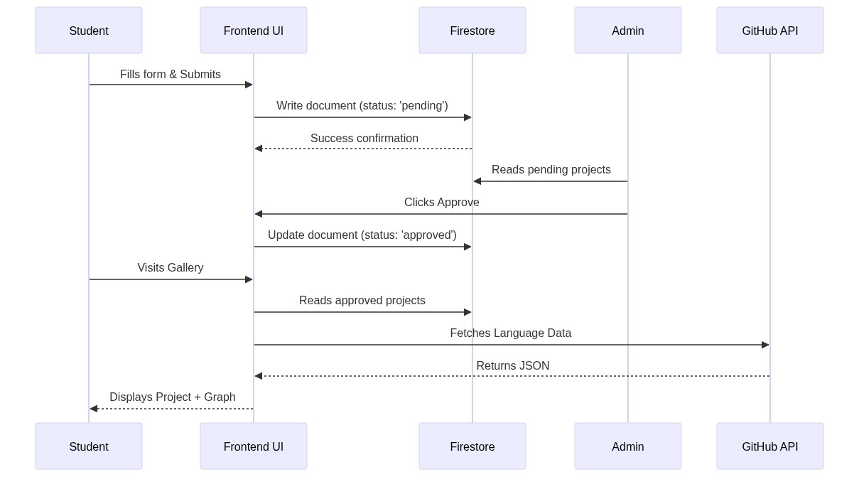
Figure 5.3: Sequence Diagram

5.3 Activity Diagram
Activity diagrams are graphical representations of workflows of stepwise activities and actions with support for choice, iteration and concurrency.

5.3.1 Activity Diagram for Student
The student's activity starts by visiting the submission page, filling out the form, validating the inputs (like checking if the GitHub URL is valid), and submitting. If validation fails, the flow returns to the form. If successful, the data is transmitted to the database and a success message is shown.
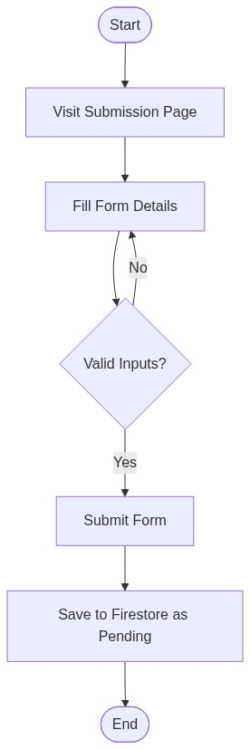
Figure 5.4: Activity Diagram for Student

5.3.2 Activity Diagram for Admin
The admin's activity starts with logging into the secure portal. Upon successful login, they navigate to the dashboard. They select a pending project, review the contents, and make a decision branch: Approve or Reject. The corresponding database action is executed, and the UI updates.
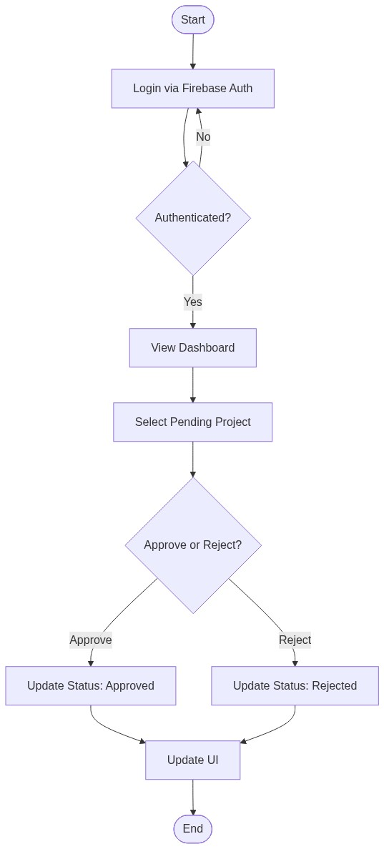
Figure 5.5: Activity Diagram for Admin

Chapter 6: System Architecture and Database Design
This chapter details the high-level architecture of the Project Hub application and the structure of the underlying database that supports it.

6.1 System Architecture Diagram
The architecture of Project Hub is based on a modern Serverless Client-Server model utilizing a Backend-as-a-Service (BaaS).
The Client Side (Frontend) is a Single Page Application (SPA) or multi-page static site built with HTML/CSS/JS. It handles all user interface rendering, form validation, and animations. The client interacts directly with Firebase Services via secure SDKs. There is no traditional middleware server handling requests; instead, the logic is distributed between the client application and Firebase cloud functions/rules.
Additionally, the architecture integrates Third-Party APIs. The client side executes asynchronous network requests directly to the GitHub REST API to fetch auxiliary data, bypassing the primary database entirely for this specific feature to ensure real-time accuracy and reduce database load.
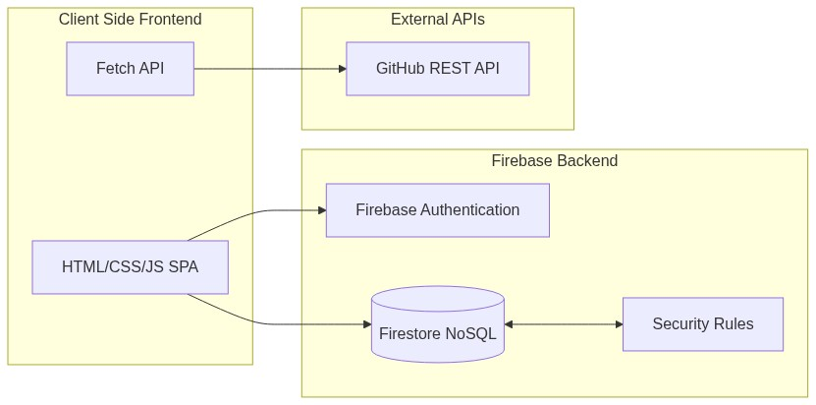
Figure 6.1: System Architecture Diagram

6.2 Database Design (NoSQL)
Unlike traditional relational databases (SQL), Firebase Firestore is a NoSQL, document-oriented database. Data is stored in Documents, which are organized into Collections. This allows for a highly flexible and scalable schema.

6.2.1 Collection: Projects
This is the primary collection in the database. Each document within this collection represents a single project submission.
Document Schema (Example):
- id (String, Auto-generated): Unique identifier.
- title (String): The title of the project.
- description (String): Detailed explanation.
- category (String): The category (e.g., Web App, AI, Mobile).
- githubLink (String): URL to the source code.
- students (Array of Strings): Names of the contributors.
- status (String): Current state ('pending', 'approved', 'rejected').
- timestamp (Timestamp): Time of submission for sorting.
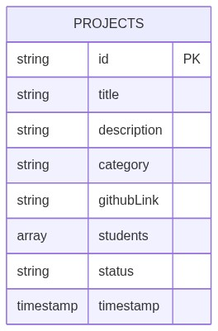
Figure 6.2: Projects Collection Schema

6.2.2 Collection: Admins / Users
While Firebase Authentication handles the actual credentials and security, a supplementary 'users' collection can store additional metadata about the admins.
Document Schema (Example):
- uid (String): Matches the Firebase Auth UID.
- role (String): e.g., 'admin', 'superadmin'.
- email (String): Admin's contact email.
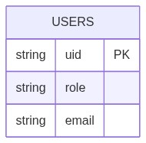
Figure 6.3: Users Collection Schema

6.3 Security Rules
Because the client interacts directly with the database, security is enforced at the database level using Firestore Security Rules. These rules dictate that anyone can 'write' a new document to the Projects collection (for submission), and anyone can 'read' documents where status == 'approved'. However, only authenticated users with a specific Admin UID can 'read' pending documents or 'update' the status of any document. This ensures the integrity of the approval process.

Chapter 7: Implementation Results and Testing
This chapter presents the actual implementation results, the user interfaces developed, and the testing methodologies employed to ensure the system operates reliably.

7.1 Testing Methodologies
Testing is a critical phase in the SDLC. For Project Hub, multiple testing strategies were utilized to ensure robustness.
- Unit Testing: Individual functions, such as the URL parsing logic for GitHub links, were tested in isolation.
- Integration Testing: The interaction between the frontend forms and the Firebase backend was rigorously tested to ensure data is saved and retrieved accurately.
- UI/UX Testing: The responsive design was tested across multiple devices (desktops, tablets, mobile phones) and browsers to ensure layout consistency.

7.2 Test Cases and Results

7.2.1 Form Submission Test
Objective: Verify that a student can submit a project and it defaults to a 'pending' state.
Action: Filled the submission form with valid data and clicked submit.
Result: Successful. The UI showed a success message, and the Firebase console confirmed the creation of a new document with the 'status' field correctly set to 'pending'.

7.2.2 Admin Authentication Test
Objective: Ensure unauthorized users cannot access the admin dashboard.
Action: Attempted to navigate to the admin page without logging in. Attempted to log in with incorrect credentials.
Result: Successful. Unauthenticated access redirects to the login page. Incorrect credentials return a 'Bad Credentials' error.

7.2.3 Admin Verification Test
Objective: Verify that an admin can approve a project and it becomes publicly visible.
Action: Logged in as admin, clicked 'Approve' on a pending project, and navigated to the public gallery.
Result: Successful. The project status updated in Firestore, and the project immediately appeared on the main gallery without requiring a page refresh, thanks to real-time listeners.

7.2.4 Dynamic Data Fetching Test (GitHub API)
Objective: Verify the system correctly fetches and visualizes language usage from GitHub.
Action: Opened a project details page linked to a valid multi-language GitHub repository.
Result: Successful. The system successfully executed the API call, parsed the JSON response, calculated the percentages, and rendered a color-coded language bar accurately reflecting the repository's state.

7.3 Interface Screenshots
The following sections showcase the developed user interfaces for both the public and administrative modules.

7.3.1 Public Project Gallery
This is the main landing page where approved projects are displayed as cards. It features the category filter pills at the top.
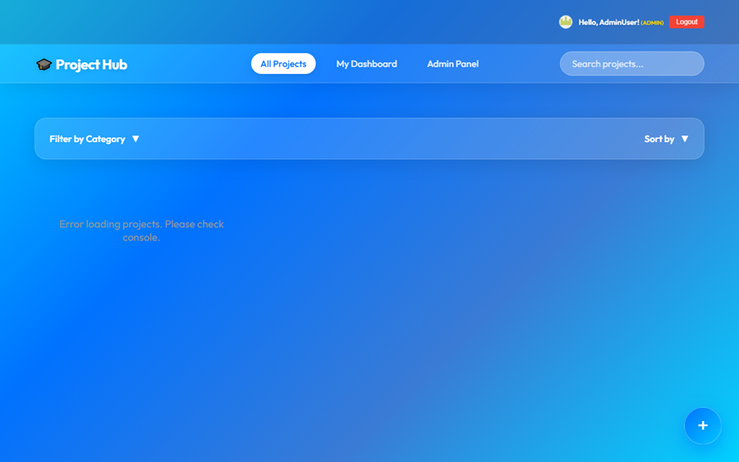
Figure 7.1: Main Project Gallery Interface

7.3.2 Project Submission Form
The interface where students input their project details.
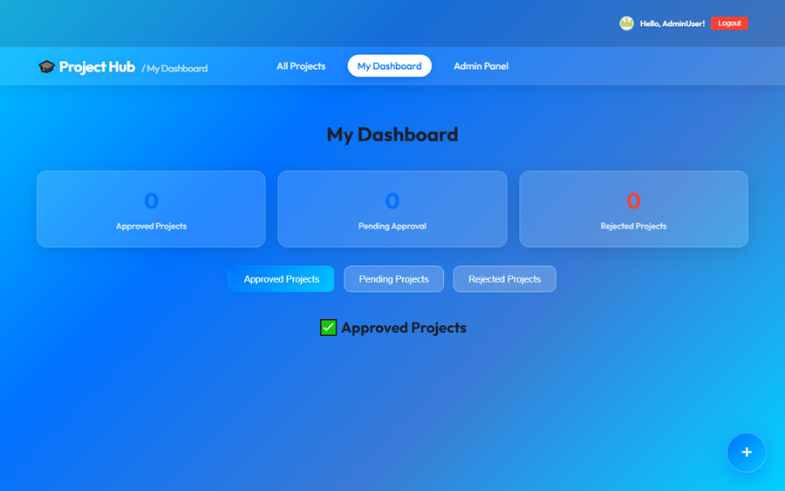
Figure 7.2: Project Submission Form

7.3.3 Admin Dashboard
The secure panel showing the queue of pending projects with Accept/Reject controls.
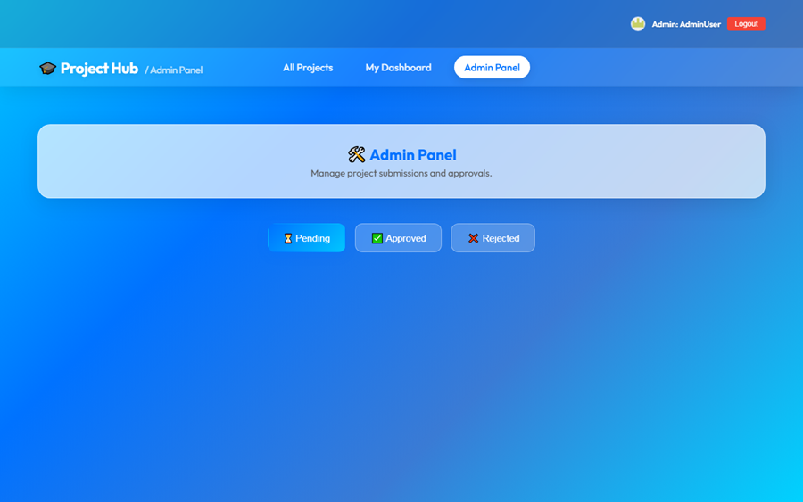
Figure 7.3: Admin Dashboard Interface

7.3.4 Project Details & Language Graph
The detailed view of a single project, highlighting the dynamically generated GitHub language statistics bar.
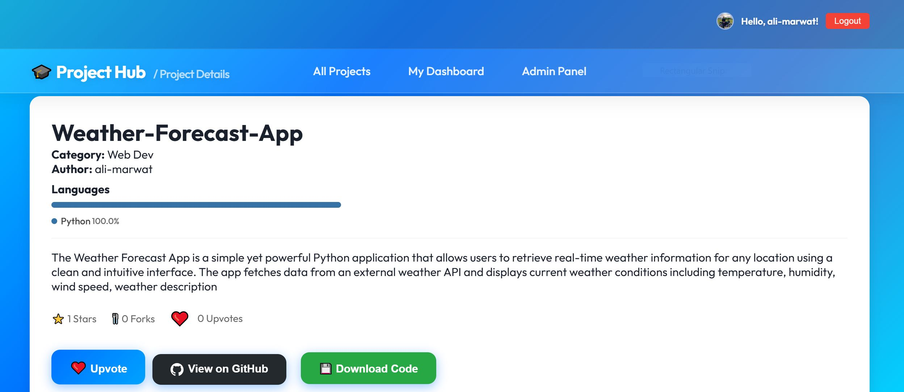
Figure 7.4: Project Details Page with GitHub Integration

Chapter 8: Conclusion and Future Scope

8.1 Conclusion
Project Hub successfully modernizes the way academic projects are showcased and managed within the institution. By replacing manual paperwork and fragmented digital storage with a centralized, dynamic web application, the system provides immense value to both the student body and the administration.
The platform bridges the gap between academic projects and professional portfolios by integrating real-world metrics like GitHub repository data. The implementation of an automated approval workflow ensures quality control while significantly reducing the administrative burden. The utilization of modern technologies like Firebase ensures that the system is scalable, secure, and operates in real-time. Project Hub stands as a robust solution to the problem of intellectual property visibility in academic settings.

8.2 Limitations
While highly functional, the current system has minor limitations. The reliance on the GitHub REST API means that if the API rate limit is exceeded (for unauthenticated requests), the language graph feature may temporarily fail. Additionally, the system currently only supports URL links for project assets, rather than direct file hosting for large video demonstrations or executables due to storage constraints.

8.3 Future Enhancements
To further improve the utility and reach of Project Hub, several enhancements can be considered for future iterations:
- Evaluation & Grading Module: Integrating a rubric-based grading system directly into the admin panel for faculty to grade FYPs digitally.
- Comment and Rating System: Allowing authenticated peers or guest evaluators to leave constructive feedback and rate projects.
- Extended Platform Support: Adding API integrations for other version control platforms like GitLab or Bitbucket.
- Advanced Analytics: Providing a dashboard for the administration to see aggregate statistics, such as the most popular technologies used across all projects in a given academic year.
- Student Profiles: Expanding the system to allow students to have dedicated portfolio pages that aggregate all projects they have contributed to during their academic tenure.

