PROJECT HUB FYP
(PROJECT SHARING & MANAGEMENT SYSTEM)

BY
Student Name

Session

PROJECT HUB FYP
ABSTRACT
In the current educational ecosystem, showcasing final year projects (FYPs) and connecting student developers with peers, evaluators, and the community relies heavily on traditional, manual exhibition formats. This approach restricts visibility, limits collaboration, and makes it difficult to maintain a long-term, accessible repository of student innovations.
Project Hub is a centralized, web-based platform designed to overcome these limitations by providing a digital showcase for student projects. It enables students to easily submit their work, integrating seamlessly with GitHub to pull live project metrics and language statistics. The system features an admin panel allowing authorized personnel (such as HODs or project coordinators) to review, approve, or reject submissions, ensuring quality and relevance.
By transitioning to an online repository, Project Hub enhances the accessibility of academic projects, reduces the reliance on physical exhibitions, and preserves the intellectual contributions of students in a centralized, easily navigable database. It provides sorting and filtering capabilities, making it simpler for users to discover projects across different categories. The system utilizes modern web technologies, ensuring robust performance and real-time interactions.

Chapter 1: Introduction

1.1 Overview
Every academic institution generates a significant amount of intellectual property through student projects. Final Year Projects (FYPs) in particular represent the culmination of a student's learning and practical application of their degree. However, these projects often remain unseen beyond the evaluation phase due to the lack of an effective showcase platform. Project Hub is a comprehensive web application designed specifically to host, manage, and showcase student projects.

1.2 Background Introduction
Traditionally, academic projects are evaluated locally. Their documentation is either stored physically in the department's library or kept in fragmented digital folders across various hard drives. This makes tracking, accessing, and showcasing these projects a tedious, inefficient endeavor.

1.3 Motivation
The motivation behind Project Hub stems from the desire to give students the visibility they rightfully deserve for their hard work. In the modern era, having a verifiable, digital presence is crucial for budding software developers and engineers.

1.4 Goals and Objectives
- To provide a centralized, highly accessible web-based platform for continuous project submission and showcasing.
- To implement an automated, multi-tiered approval workflow via a secure admin panel.
- To integrate dynamic data fetching from GitHub to provide real-time project statistics.

Chapter 2: Proposed System

2.1 Proposed System Overview
In the proposed system, the entire lifecycle of a project exhibition—from submission to approval to public display—is handled through a seamless online platform.

2.2 Module Description
The Admin module handles all critical administrative tasks. It provides a secure dashboard accessible only to authenticated personnel. The User module allows students to submit their project details through an intuitive form.

Chapter 3: System Requirements & Technologies

3.1 Web Development Technologies
HTML5, CSS3, and ES6+ JavaScript form the core frontend technologies.

3.2 Cloud Infrastructure & Backend
Firebase Firestore is utilized as a flexible, scalable NoSQL cloud database designed to store and sync data for client- and server-side development. Firebase Authentication ensures secure access.

Chapter 4: Methodology
The methodology adopted for Project Hub follows an Iterative Prototype model. This approach allows for the continuous refinement of the system based on immediate feedback.

Chapter 5: System Modeling and Diagrams

5.1 Data Flow Diagrams (DFD)
A Data Flow Diagram (DFD) maps out the flow of information for any process or system.
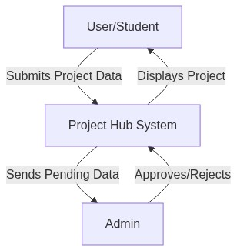
Figure 5.1: Level 0 DFD
The Level 1 DFD breaks down the main process into sub-processes.
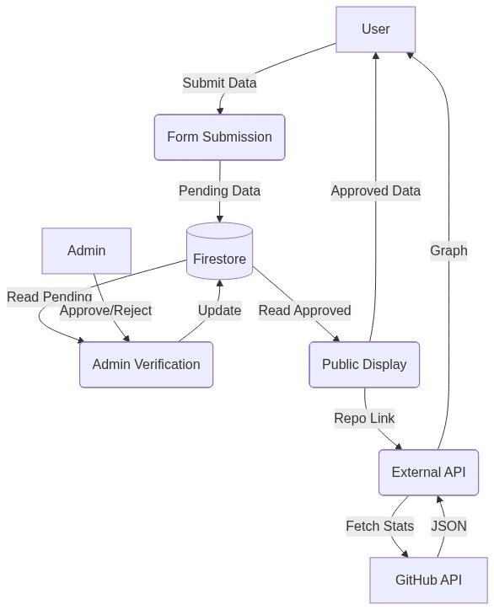
Figure 5.2: Level 1 DFD

5.2 Sequence Diagram
A sequence diagram shows object interactions arranged in time sequence.
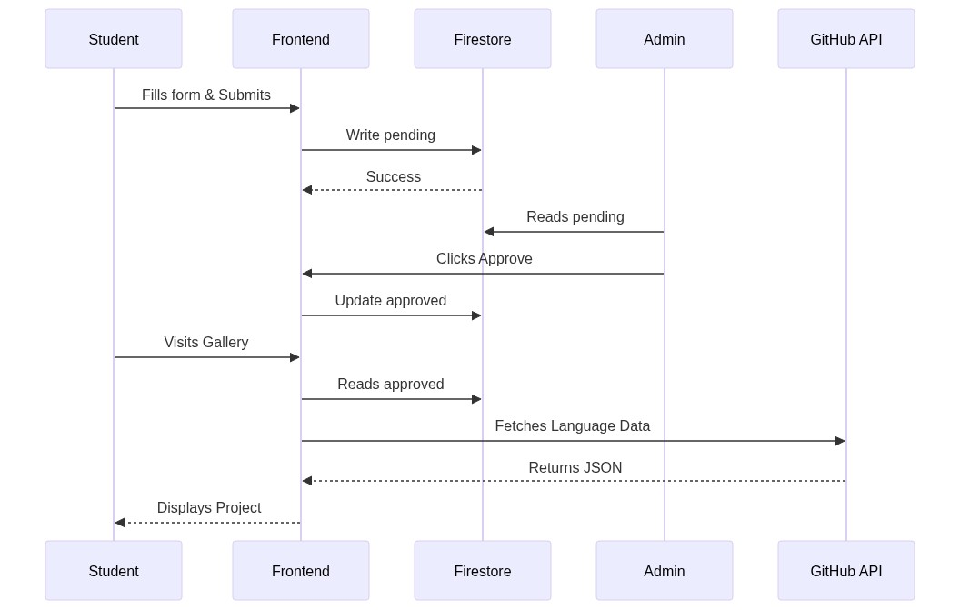
Figure 5.3: Sequence Diagram

5.3 Activity Diagrams
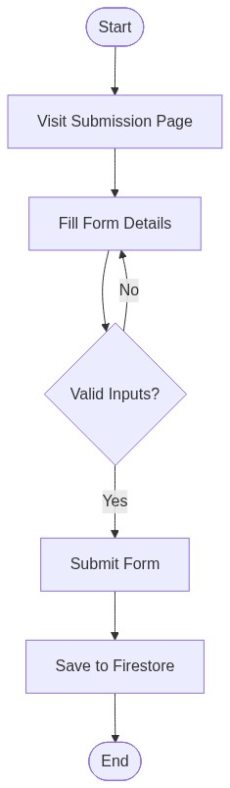
Figure 5.4: Activity Diagram for Student
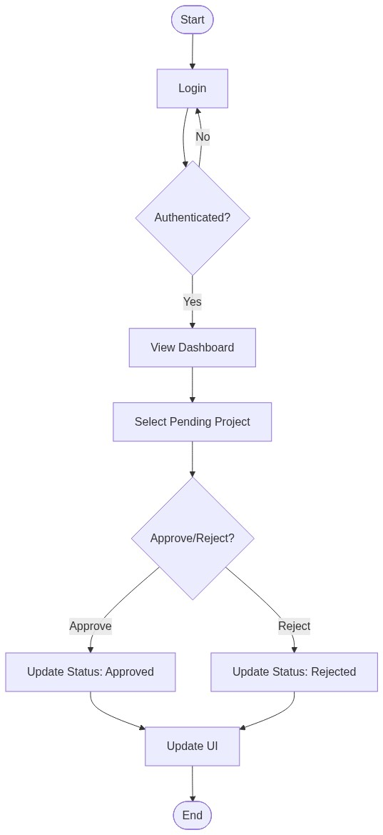
Figure 5.5: Activity Diagram for Admin

Chapter 6: System Architecture and Database Design

6.1 System Architecture Diagram
The architecture of Project Hub is based on a modern Serverless Client-Server model utilizing a Backend-as-a-Service (BaaS).
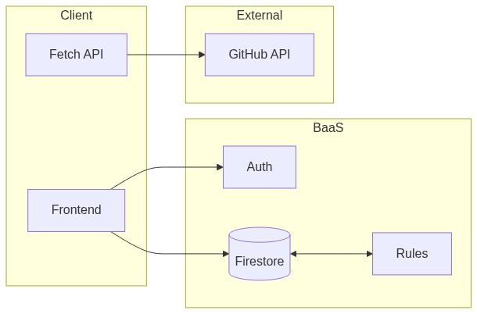
Figure 6.1: System Architecture Diagram

6.2 Database Design (NoSQL)
Unlike traditional relational databases (SQL), Firebase Firestore is a NoSQL, document-oriented database.
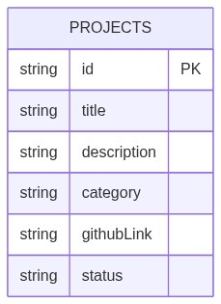
Figure 6.2: Projects Collection Schema
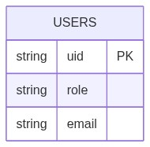
Figure 6.3: Users Collection Schema

6.3 Security Rules
Because the client interacts directly with the database, security is enforced at the database level using Firestore Security Rules. These rules dictate that anyone can 'write' a new document to the Projects collection (for submission), and anyone can 'read' documents where status == 'approved'. However, only authenticated users with a specific Admin UID can 'read' pending documents or 'update' the status of any document. This ensures the integrity of the approval process.

Chapter 7: Implementation Results and Testing

7.1 Interface Screenshots
The main landing page where approved projects are displayed as cards. It features the category filter pills at the top.
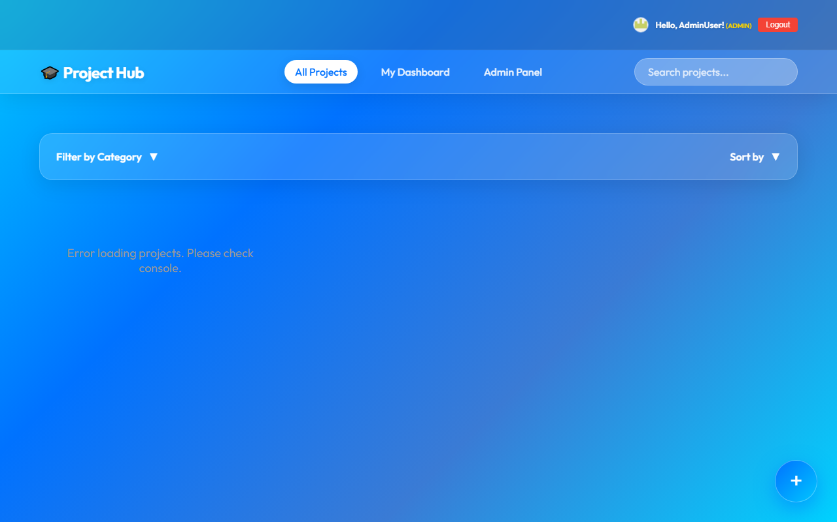
Figure 7.1: Main Project Gallery Interface
The interface where students input their project details.
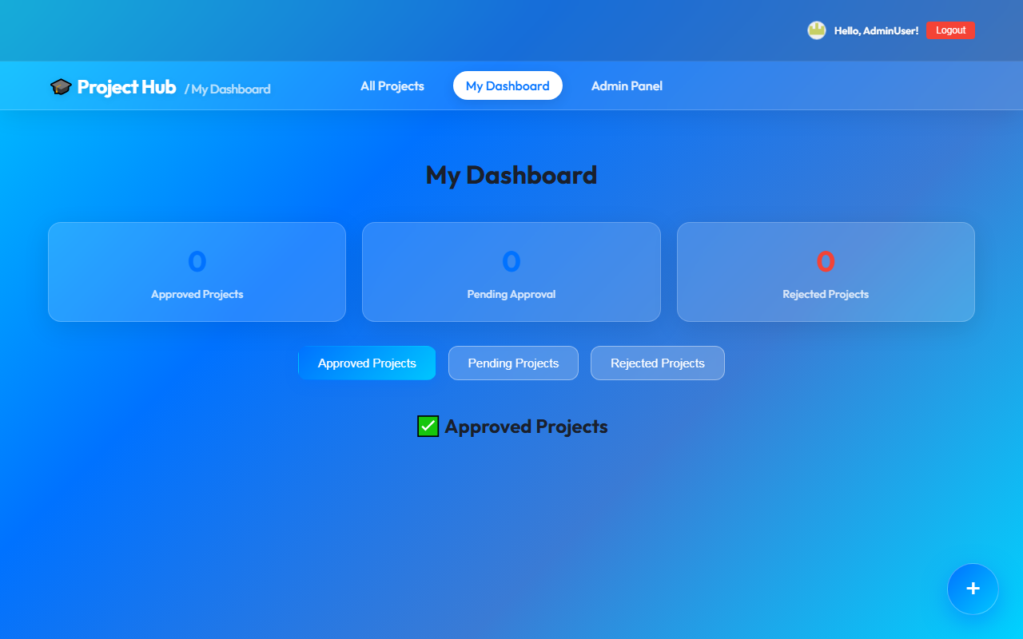
Figure 7.2: Project Submission Form
The secure panel showing the queue of pending projects with Accept/Reject controls.
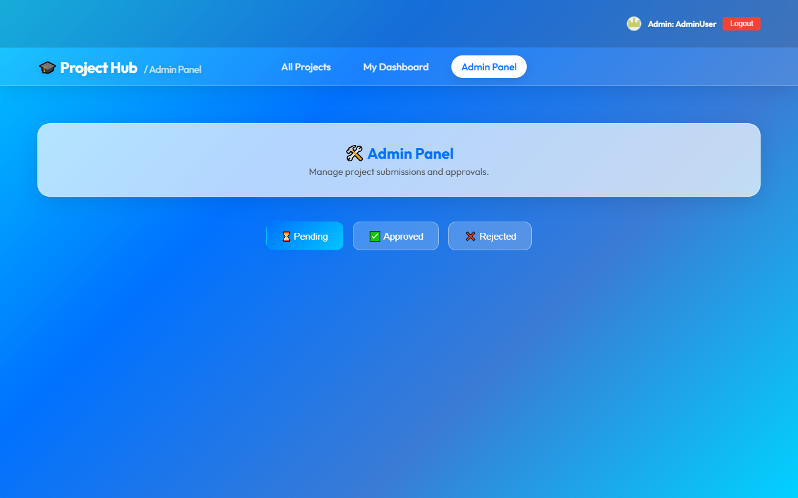
Figure 7.3: Admin Dashboard Interface

Chapter 8: Conclusion and Future Scope
Project Hub successfully modernizes the way academic projects are showcased and managed within the institution. By replacing manual paperwork and fragmented digital storage with a centralized, dynamic web application, the system provides immense value to both the student body and the administration. The platform bridges the gap between academic projects and professional portfolios by integrating real-world metrics like GitHub repository data. The implementation of an automated approval workflow ensures quality control while significantly reducing the administrative burden.

