

12/24/2022

Ali AL Moussawi:1120057 ; Mostafa Jaloul:1120004

**Instructor: Dr. Ali Komati**

Machine Learning Project

Music Genre Classification

Project Idea:

**Music Genre Classification** Automatically classify different musical genres. In our project we are going to develop a machine learning project to automatically classify different musical genres from audio files. We will classify these audio files using their low-level features of frequency and time domain.

For this project we will a dataset of audio (10 types or classes) having similar size and similar frequency range. GTZAN genre classification dataset is the most recommended dataset for the music genre classification project, and it was collected for this task only.

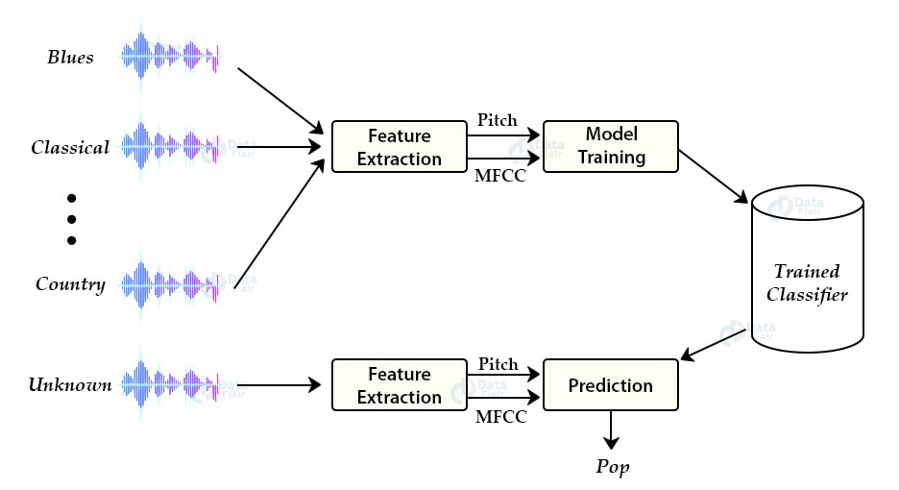

pitch, in music, position of a single sound in the complete range of sound. The MFCC feature extraction technique basically includes windowing the signal, applying the DFT, taking the log of the magnitude, and then warping the frequencies on a Mel scale, followed by applying the inverse DCT. Of course, we have models to do feature extractions…

Also, we will try to classify music **using different algorithms** (knn, Logistic Regression… ). Moreover, **we will try to make a web page** using flask that takes music as input and send it to the model to make prediction using the deployed model and return the result.

Surely, we will use python to develop the project, also anaconda to manage environments, and we will try to get pretrained models, understand them use them. (Hugging face, SKlearn package).

Conclusion:

In a Nutshell, our machine learning project aim is to classify music to a specific genre (class) between 10 different classes. Also, we will have many pretrained models to make the classification. Moreover, we will do a webpage using Flask that take music as input and send it for processing and render the result the web page.

Thank you