**Testing: Delivery Drone Simulator version 1  
Hassaan Ali Khoso, Ali Rehan and Hassan Ghazi**

**Version description:**This is version 1 of the drone delivery simulator, made in accordance with flowchart 1.

The program is designed to make deliveries to three locations A, B and C. It will observe the battery percentage and weather conditions and then take off for delivery only if it is sunny and the battery percentage is greater than 30%. Otherwise it will ask the user to recharge the drone if battery is less than 30% or to retry later if the weather is insufficient.

**Source Code:  
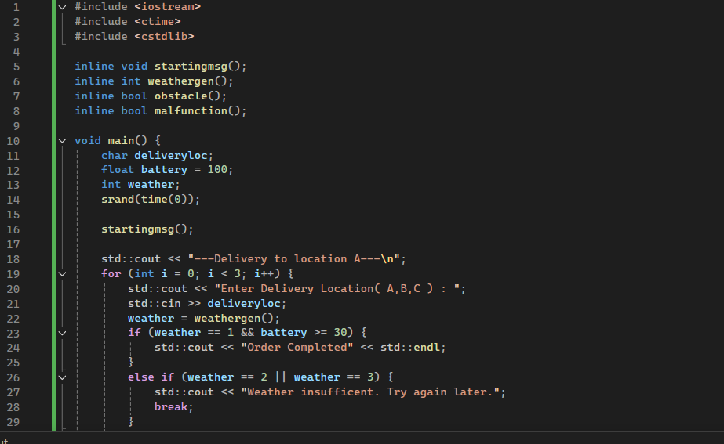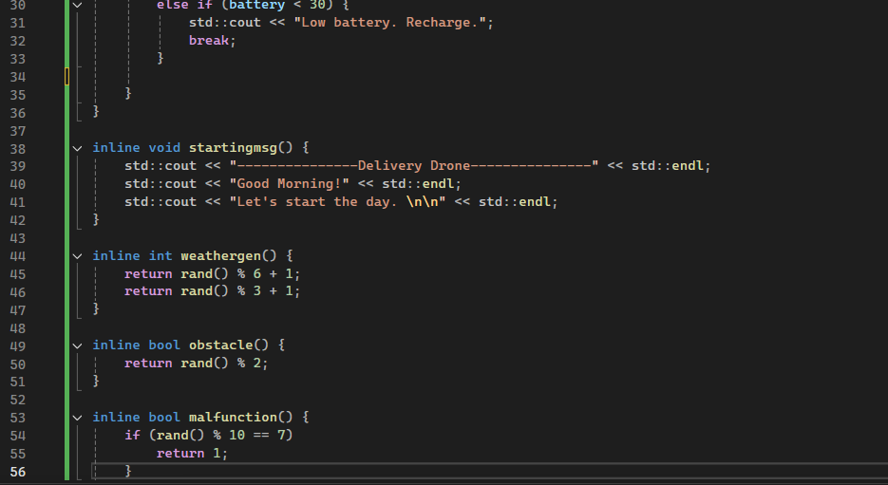**

**Test 1:**Input delivery location: A  
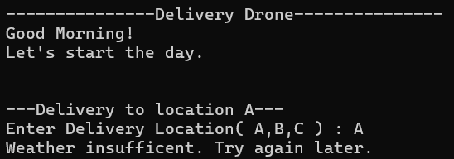

The test was successful. It first printed ‘Delivery to location A’ and then it checked if weather was sufficient. The weather generated randomly was insufficient therefore the program asked us to try again later.

**Test 2:**Input delivery location: B, C and A  
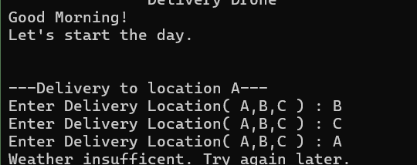  
The program gives no output when B is entered as delivery location, instead it asks for the next delivery location and no output is received again. The third delivery location is asked and C is entered, this time the program responds and tells us to try again later due to insufficient weather.

**Test 3:**

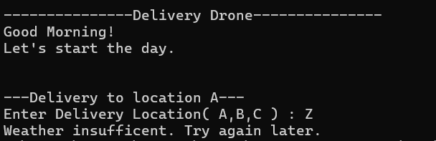Input delivery location: Z

In this test a location Z different to the given options is inputted. The program still runs and gives the insufficient weather message.

**Test 4:**Input delivery locations: Z, X and Y  
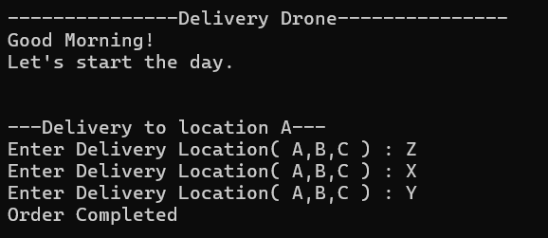

The program outputs ‘Delivery to location A’ and takes input for location. The program takes three delivery location inputs in succession without giving an output, similar to what happened in test 2. It makes the delivery for the 3rd location and outputs ‘Order Completed’

**Errors:**The tests above reveal the following errors in the program:  
**Logical Errors:**  
1. The Program works for any delivery location, It should only work for the 3 locations given.

2. The Program doesn’t always respond after taking a delivery location input, it may immediately ask for the next delivery location.

3. ‘Delivery to location A’ is always printed at the start of the program, regardless of the delivery location.

4. The battery of the drone never decreases.

5. Battery never decreases.

**Syntax Errors:**1. Extra '{' after malfunction function's definition (Fixed).

**Other Logical Errors (revealed by observing code):**1. Unused functions (bool malfunction and bool obstacle).

2. Unreachable code and two returns for a function (the second return in weathergen function).

3. Weather range mismatch (rand() % 6 + 1 produces numbers 1-6 but the code only checks for numbers 1-3.