Testing: Delivery Drone Simulator version 1
Hassaan Ali Khoso, Ali Rehan and Hassan Ghazi
Version description:
This is version 2 of the delivery drone simulator made in accordance with flowchart 2.
The program is designed to deliver utensils to three different locations. The number of deliveries will be decided by the user, they can end operations for the day after any number of deliveries. The program will ask the time at the start and before every delivery, it will ask the delivery location and load of the package. Before every delivery it will check:
- Battery percentage
- Weather conditions
The program will respond to the user based on these inputs:
- If the battery is greater than or equal to 40%, the delivery will be executed, else it will recharge the battery.
- If the weather is sunny or windy, the delivery will be executed and if it is rainy, the drone will wait for clear weather before delivering (it will check after every hour)
Other features of the program include:
- Extra battery and time consumption for packages heavier than 10 kgs, the drone also recharges its battery during a delay.
- Detection of Invalid inputs, if the user enters an invalid input, the program will ask them again.
- Battery consumption counter
- The drone has a charging time at 6pm, It terminates all operations at 6pm
Source code: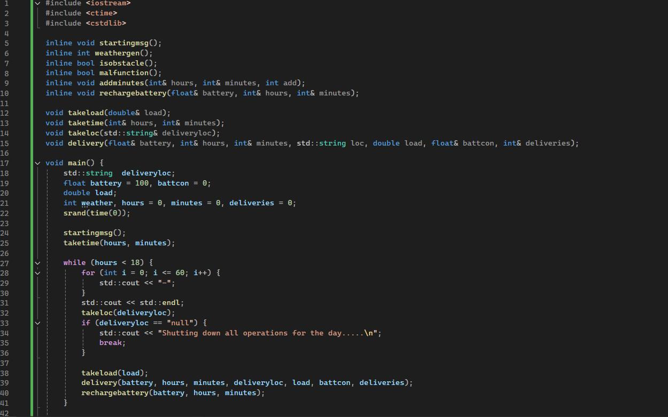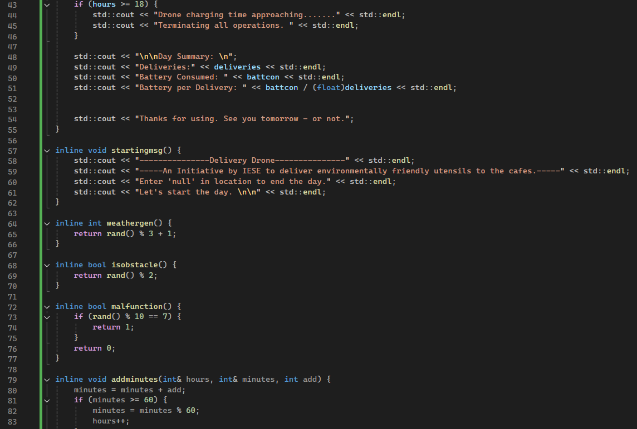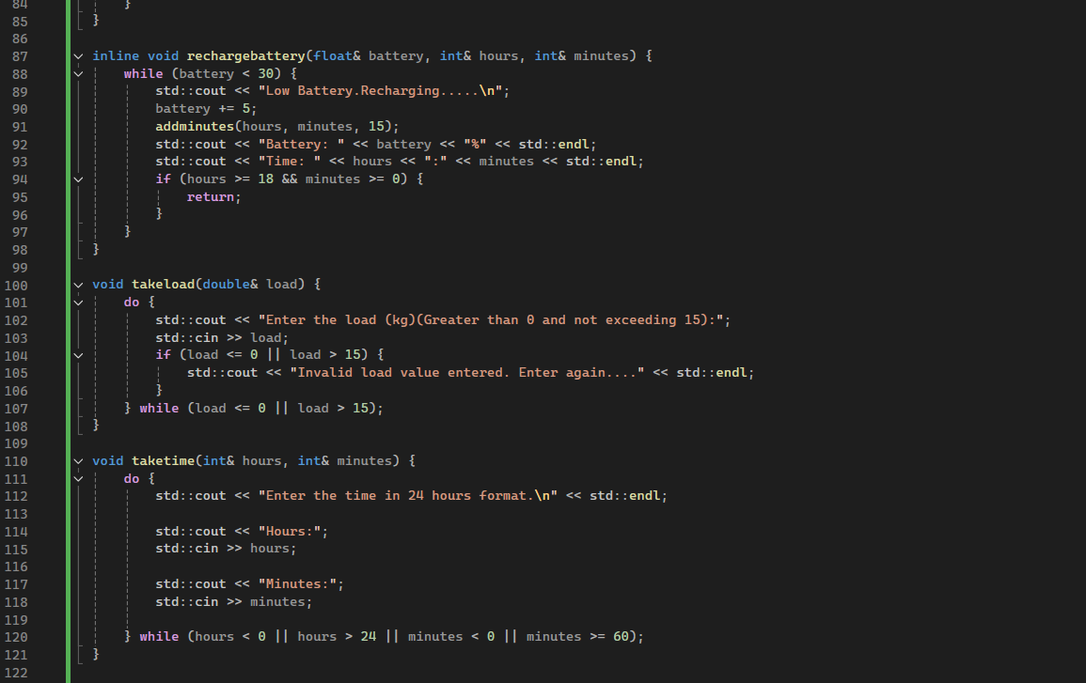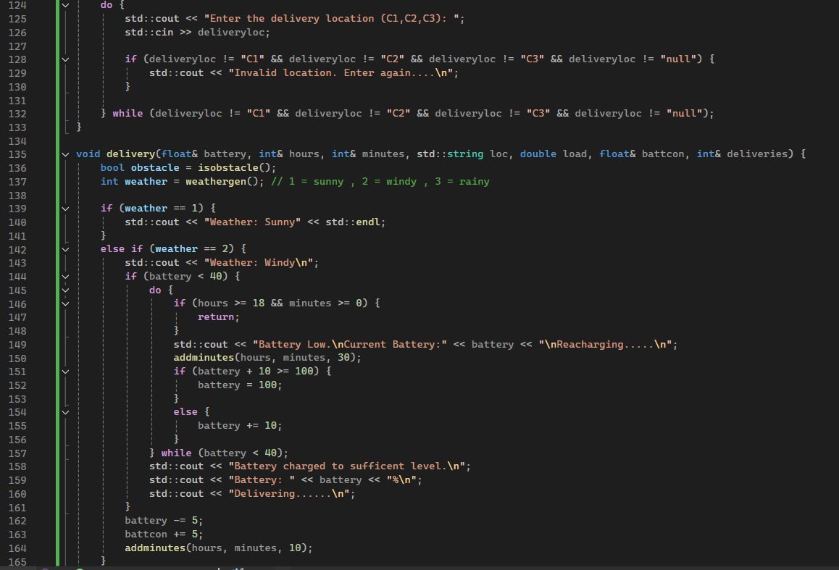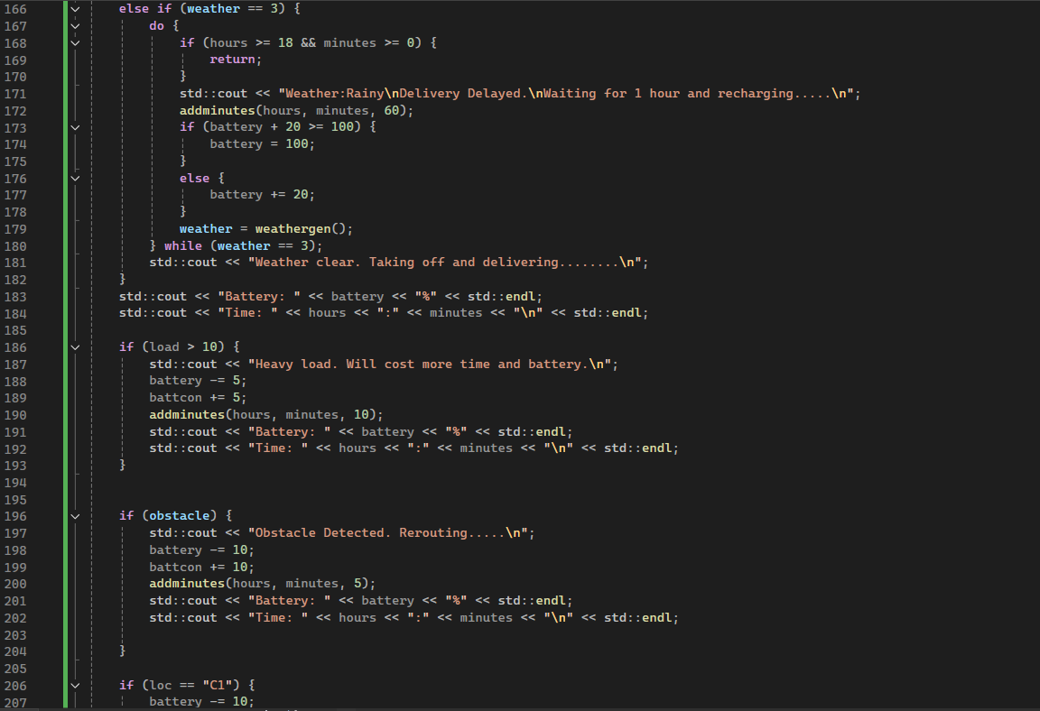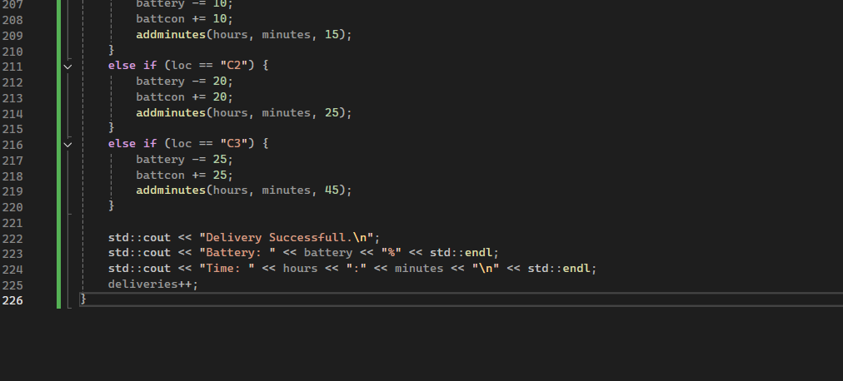

Test 1 (Normal Inputs):
Inputs:
Time: 11:20
Delivery Location: C1
Load: 2kg
In this test the weather randomly generated to be rainy. The drone waited for an hour to check again. The weather had cleared and the drone took off. The drone then encountered and obstacle and rerouted. Then it finally delivered the package successfully. The time and battery consumption was adjusted according to these conditions.
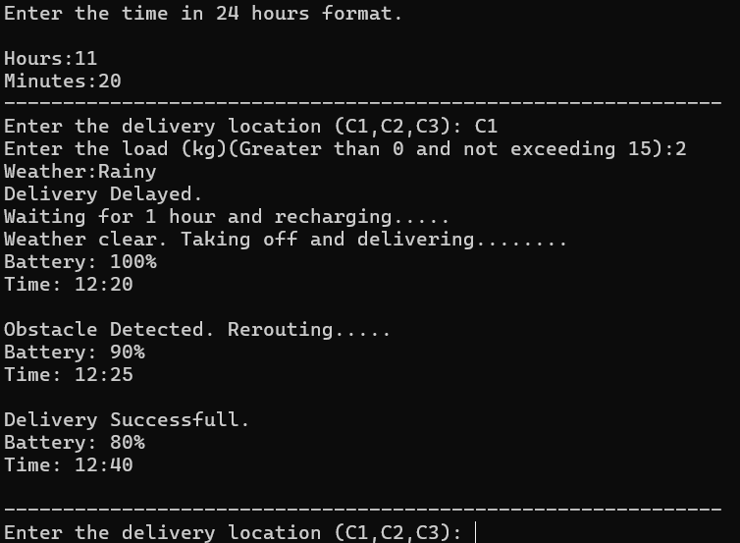
Test 2 (Invalid location):
Inputs
Time: 4:30
Delivery Location: C4, Library
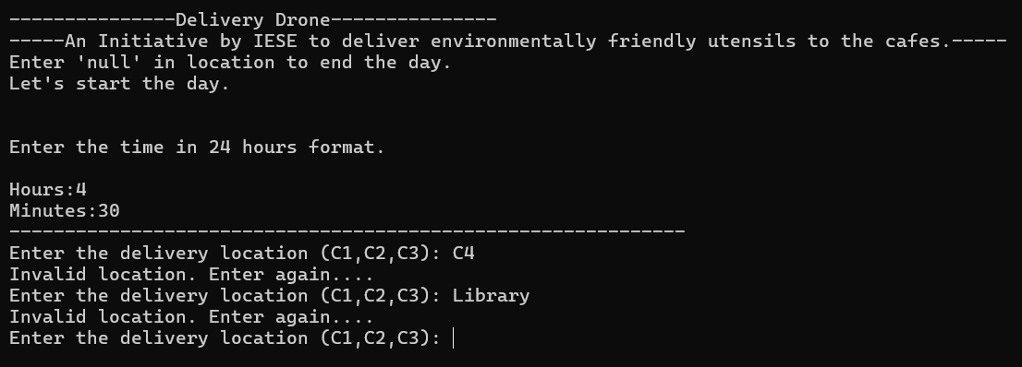
As demonstrated, the program does not take Invalid inputs.
Test 3 (Multiple deliveries):
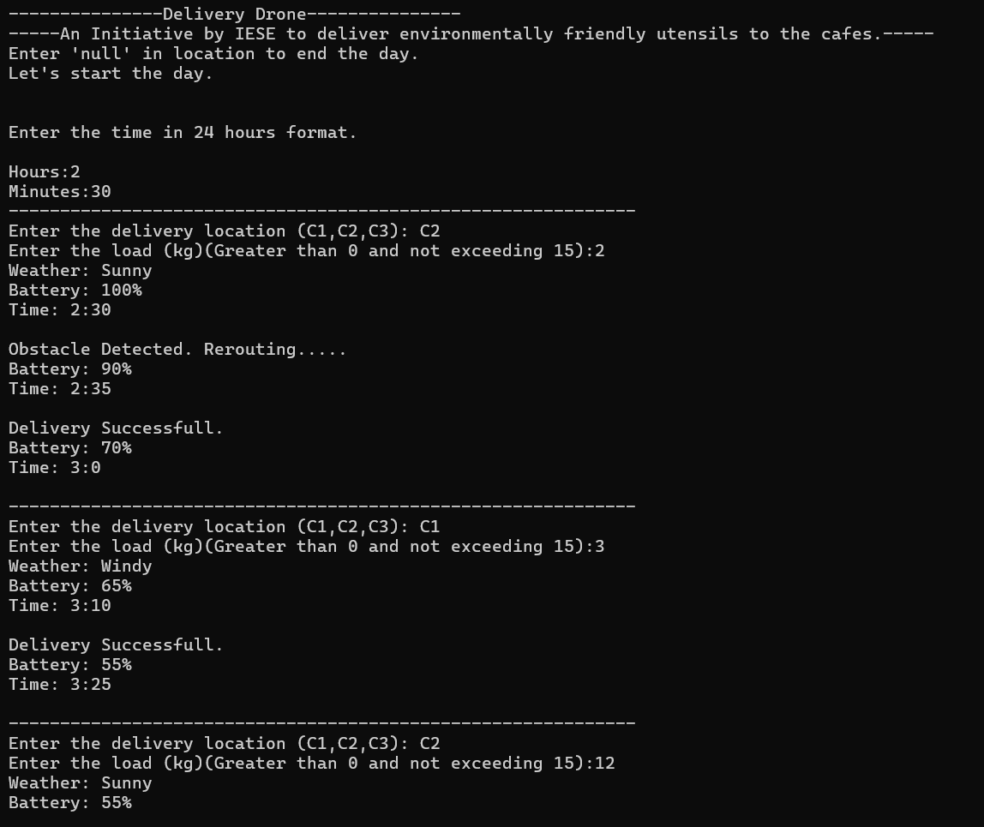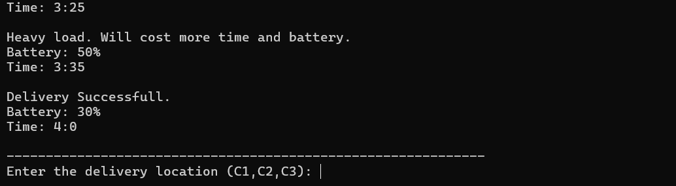
In this test the drone made three deliveries and after that it is ready to make more.

Test 4 (Recharging time):
In this test we will set the time near to the recharging time.
Inputs
Time : 17:45
Delivery Location : C3
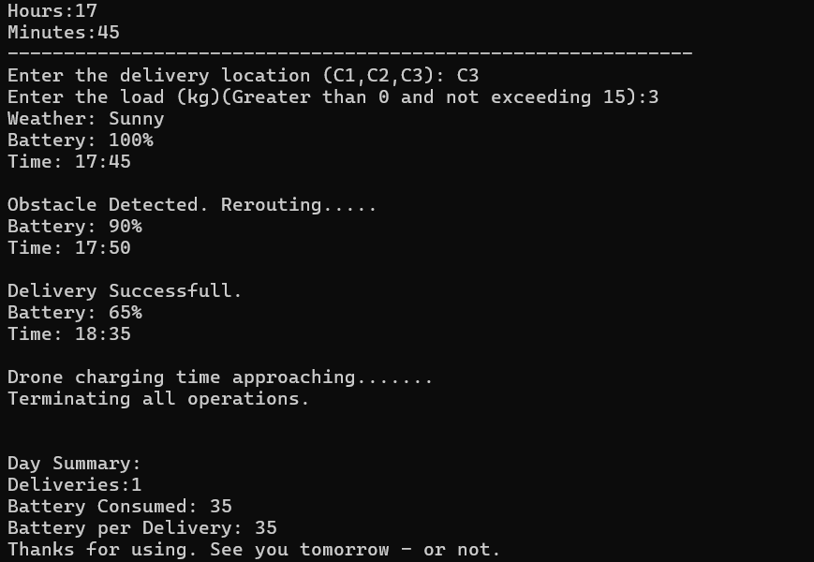

Test 5 (Battery recharge during delay)
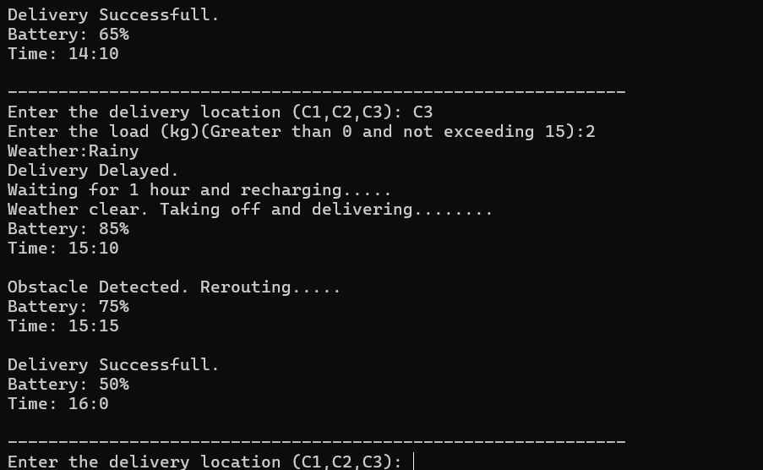
As demonstrated, the drone will recharge its battery during a delay.

