**Presentation topic: Restful API**

**Agenda:**

* Web services introduction
* Restful API introduction – Consuming Restful API’s
* Retrieve a remote URL in PHP
* Demo : using google map API’s and Instagram API

**Web service:**

Webpage are based on HTML and they are formatted in the shape that is readable for humans.

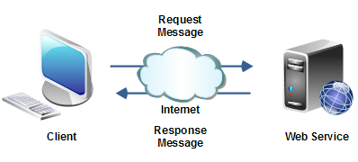

Web services are for consumption of other application and they return XML/JSON

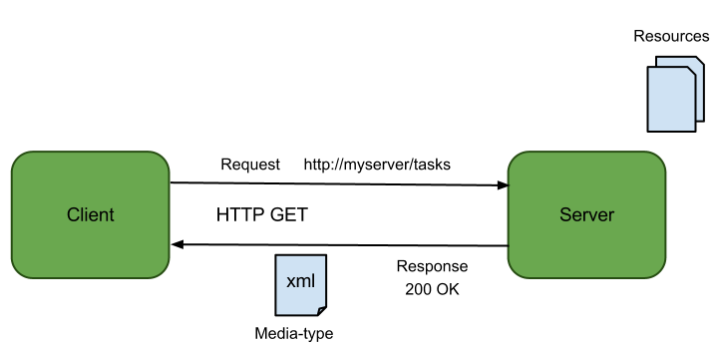

Two type of web service:

1. SOAP web services (transport layer : SOAP protocol) - complex conventions
2. Restful web services (transport layer :on HTTP mostly) - architectural style – recommendation

**API: application programming interface**

It allows one piece of software to talk to another there are different kind of API’s out there and when people talk about API such as twitter, Facebook, … they mean Restful API

**Restful API: Representational State Transfer**

[**http://code.tutsplus.com/tutorials/a-beginners-guide-to-http-and-rest--net-16340**](http://code.tutsplus.com/tutorials/a-beginners-guide-to-http-and-rest--net-16340)

Architectural style - It works similar the way webpage works. Client ask for data

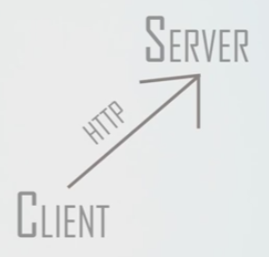

Facebook Graph API:

https://www.facebook.com/youtube

<https://graph.facebook.com/youtube>

<https://graph.facebook.com/youtube?fields=id,name,likes>

SOAP sample: O365 WSDL : <https://disco.crm.dynamics.com/XRMServices/2011/Discovery.svc>

REST is a straightforward style of web APIs in which you make requests to a URL using HTTP methods, such as GET and POST. The URL and body, often in JSON or XML, describe the resource you want to manipulate and the method tells the server what action it should take.

The one downside to REST is there’s no standard schema for data that’s passed in or returned. Every site is free to use what it feels is the best (In SOAP service definition is WSDL). Though this is not a problem for small services, if not designed properly, this can cause complexity when a service grows.

**Common Methods:**

* GET
* POST
* PUT: http://restcookbook.com/HTTP%20Methods/put-vs-post/
* DELETE

**HTTP status code:**

* 200 : success
* 201 created
* 400 bad request
* 401 unauthorized
* 404 not found
* 405 method not allowed
* 500 server error

***Retrieve a remote URL in PHP*** *(there are many ways)   
1.Standard file functions  
2.cURL functions  
3.HTTP_Request2 class from PEAR  
4.pecl_http extension …*

**cURL:**

* cURL is a command line library that allows you to connect and communicate with many different types of server with different types of protocols.
* cURL is a library that lets you make HTTP requests in PHP
* cURL is a way you can hit a URL from your code to get a html response from it.
* <http://php.net/manual/en/book.curl.php>

**How to enable cURL:** (in windows)

1. In php.ini uncomment “extension=php_curl.dll”
2. copy libeay32.dll and ssleay32.dll into your windows folder in c drive (downloaded from openssl)
3. restart the web server

**Serialization and json** : <http://stackoverflow.com/questions/11817950/what-is-data-serialization>

<https://www.youtube.com/watch?v=z7tgc1-k_Gk>

**Demo Time :**

**Mashing up API’s: Using google map API’s and Instagram API**

Google Map API:

<http://maps.googleapis.com/maps/api/geocode/json>

<http://maps.googleapis.com/maps/api/geocode/json?address=vancouver&sensor=false>

let’s mash API’s :

Instagram Media search endpoint

<https://instagram.com/developer/>

go to:

<https://instagram.com/developer/api-console/>

Question?

 <https://github.com/ali-sharifi/php>