ORDER LETTER
LABEL READER — ANDROID SCANNER & ANALYTICAL DASHBOARD
Final Scope, Delivery Requirements & Acceptance Checklist
Customer | Outfit
Developer / Supplier | Ali Vakilzadeh
Project | Label Reader — Offline-first Android scanning application + analytical dashboard
Reference Proposal | Revised Project Proposal — Prototype Phase, Version 2.0, August 2026

Dear Mr. Vakilzadeh,
Outfit hereby confirms its intention to order the development and delivery of the Label Reader project based on the referenced proposal and the requirements stated in this Order Letter. The checklist below shall be used as the basis for final delivery and acceptance of the project.

1. Project Scope
The solution shall consist of two integrated components:
- Android Label Reader application for photographing, storing, processing, reviewing, and exporting apparel records.
- Analytical Dashboard for importing, searching, reviewing, enriching, pricing, grouping, and exporting apparel records.
The solution shall be designed around the actual warehouse workflow described in the proposal, including offline-first scanning, delayed AI processing, human review, daily data transfer, and centralized dashboard analysis.

2. Functional Requirements — Acceptance Checklist
☐ Android application captures and stores photos per physical item.
☐ Scanning works offline and data is safely stored until processing/export. A network interruption must not cause already captured scans to be lost.
☐ AI extracts the agreed apparel information and allows user correction.
☐ Extract, at minimum, code, Sub-category, Gender, Season, Netto, Brutto, Pieces, Brand, Country, Size, Original price, Color, Material, package code and care information where available.
☐ Stamp each record with operator/device information and scan date/time
☐ Each physical item can be individually identified and matched to its registered data.
☐ Similar/repeated items can be grouped under one Article Number while preserving item-level identity.
☐ Information can be copied efficiently to repeated/similar items.
☐ The system should provide duplicate/near-duplicate warnings where the same or nearly identical item appears to have been scanned more than once.
☐ Dashboard imports, searches, filters, and exports all scanned data.
☐ Original product photos remain accessible.
☐ High-quality catalog/product images suitable for online-shop use can be generated and reviewed.
☐ Price offers are generated using data available about similar equipment and products in Outfit Data and the market. (Offered price and price available in the data)

3. Data Quality & Reliability — Acceptance Checklist
☐ No critical data loss during offline scanning, restart, processing, or export.
☐ Duplicate/shared files are not imported more than once.
☐ Missing or uncertain information can be identified and corrected.
☐ The complete workflow is tested using real Outfit samples before final acceptance.

4. Handover & Technical Requirements — Acceptance Checklist
☐ Full source code of the Android application and dashboard is delivered.
☐ Required technical documentation is delivered.
☐ Database structure and system architecture documentation are delivered.
☐ Installation, configuration, deployment, and maintenance information is delivered.
☐ Outfit can maintain, modify, and further develop the system independently or through another developer.

5. Commercial & Delivery Conditions
The referenced proposal states a one-time development cost of USD 4,000: USD 2,500 for the scanner application and USD 1,500 for the analytical dashboard, with recurring third-party AI/hosting costs handled separately as described in the proposal.
The proposal describes a three-week delivery plan, including the Android application during weeks 1–2 and the analytical dashboard during week 3. Feedback from real warehouse testing during the project is to be incorporated within the agreed project scope.
Any additional cost or material scope change must be presented to Outfit in writing, with the reason, estimated development effort, and price, and must receive Outfit's written approval before implementation.

6. Final Acceptance Procedure
☐ Developer demonstrates the completed system using Outfit's agreed test samples and real workflow scenarios.
☐ Outfit verifies every applicable checklist item.
☐ Any failed or incomplete item is recorded as a pending correction and does not count as final acceptance.
☐ All agreed corrections are completed and re-tested.
☐ Source code, documentation, accounts/credentials under Outfit's control, and other agreed deliverables are handed over.
☐ Final acceptance is confirmed by Outfit in writing after all applicable checklist items have been completed.

7. Customer Ownership, Data & Delivery Requirements
The following requirements are an integral part of this Order Letter and shall be considered contractual requirements of the project. The image below forms part of this clause and records the specific requirements regarding ownership, source code, data, third-party services, recurring costs, documentation, and maintainability.
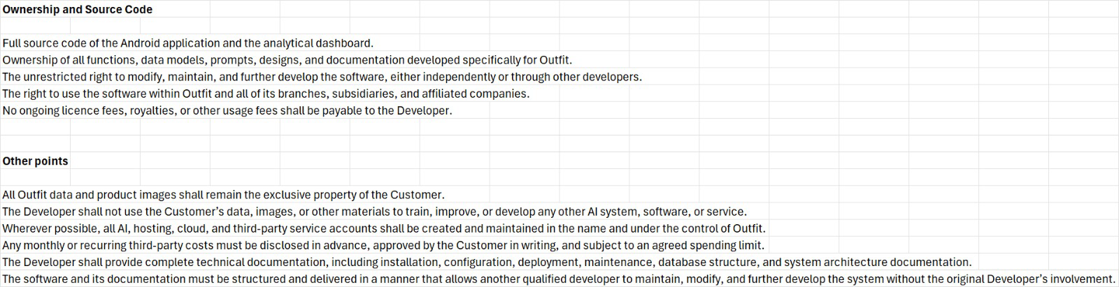
In case of any inconsistency between the referenced proposal and this Order Letter, the requirements expressly stated in this Order Letter shall govern the delivery and final acceptance of the project.

8. Final Sign-Off
By signing below, the parties confirm that the project has been reviewed against the agreed scope and that the checklist has been completed, subject to any written exceptions expressly listed below.
Customer | Outfit
Authorized Representative | ____________________________
Signature | ____________________________
Date | ____________________________
Developer | Ali Vakilzadeh ____________________________

Exceptions / Pending Items (if any):
________________________________________________________________________________
________________________________________________________________________________
________________________________________________________________________________

