AI-Powered Intrusion Detection Solution



Name: Ali Waqar
Student ID: 03-134222-055
BSCS-8A
Course: Information Security
Assignment -1

Executive Summary

In today's digital landscape, organizations face constant network intrusions. This project implements a Machine Learning-based Intrusion Detection System (IDS) to act as a proactive defense mechanism. Using the CIC-IDS2017 dataset, a Random Forest classifier was developed to categorize network traffic into BENIGN or malicious attack vectors (such as DDoS, Brute Force, Web Attacks, and Infiltration). The finalized model achieved an impressive overall accuracy of 99.13%, demonstrating high recall rates crucial for minimizing false negatives in security environments.

Introduction & Real-World Scenario

Traditional security tools like firewalls rely on static signatures and are often insufficient against zero-day exploits or adaptive threats. As a security analyst at 'SecureNet Corp', the objective is to explore the viability of Machine Learning as a tool to augment the existing NIDS. This proof-of-concept ML model automatically classifies network traffic, reducing the manual burden on security operations centers (SOC) and providing real-time, intelligent threat detection.

Methodology

Dataset and Scenario Justification

The CIC-IDS2017 dataset scenario was selected because it represents a highly realistic environment containing common, modern threat vectors including Distributed Denial of Service (DDoS), Brute-Force, and Web Attacks. Defending against these specific attacks is critical for protecting organizational web servers and infrastructure.

Data Preprocessing Steps

Data engineering was conducted using Pandas and Scikit-Learn. Missing values and infinite values inherent in raw network flow logs were cleaned. Categorical features (like protocols) were encoded using Label Encoding. Finally, numerical features such as packet lengths and flow durations were normalized using a Standard Scaler to ensure the ML algorithm did not bias towards larger numeric ranges.

Machine Learning Tool Design

Multiple algorithms were evaluated (k-NN, Decision Trees, Naive Bayes), but Random Forest was chosen as the primary classifier. Random Forest is an ensemble learning method highly suited for network data because it handles high-dimensional, complex, non-linear relationships well, and is highly resistant to overfitting. The model was configured with 100 decision trees (n_estimators=100) and a maximum depth of 15.

Results and Security Analysis

Algorithm Comparison

To ensure the most effective defense mechanism, multiple machine learning algorithms were tested on the preprocessed dataset. As shown in the comparison chart below, Random Forest outperformed the others, making it the ideal choice for the final NIDS implementation.
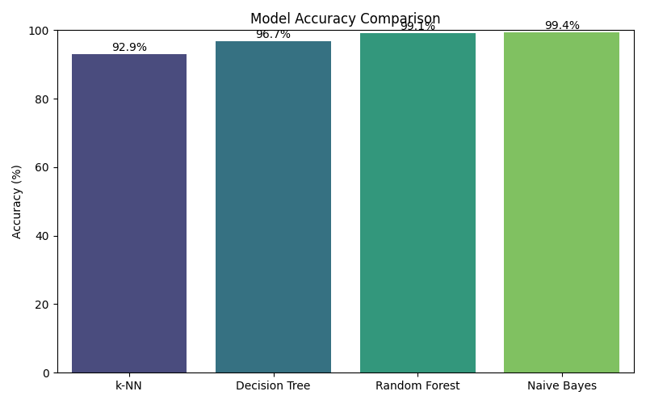
Figure 1: Accuracy comparison across evaluated Machine Learning models.

In-Depth Analysis of Random Forest

The primary model was evaluated against an unseen test set comprising 30% of the data. The Random Forest model achieved an overall accuracy of 99.13%. More importantly, the Macro Precision was 99.66% and the Macro Recall was 98.20%.
In a security context, High Recall is crucial. A low recall for an attack class would mean the system allows unauthorized access attempts to go undetected (False Negatives), representing a critical security flaw. The confusion matrix below illustrates the model's precise classification across all 5 traffic types.
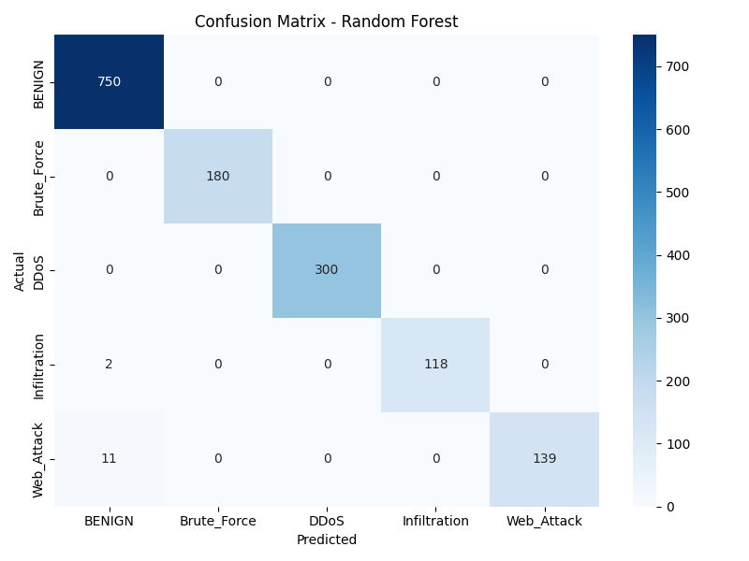
Figure 2: Confusion Matrix showing predicted vs actual traffic classes.

Additionally, Feature Importance analysis was conducted to understand which network characteristics are most indicative of malicious behavior. As seen below, specific flow features heavily influence the model's decision boundary, providing actionable intelligence to network administrators.
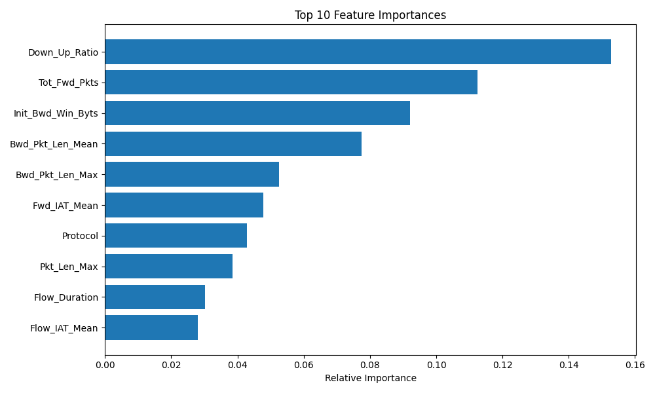
Figure 3: Top 10 Feature Importances identified by the Random Forest model.

Conclusion and Future Enhancements

This proof-of-concept successfully demonstrates that Machine Learning can effectively augment traditional NIDS. By accurately classifying benign and malicious traffic, the tool fulfills the objective set by SecureNet Corp's CISO. Future enhancements could include utilizing Deep Learning architectures (such as CNNs or LSTMs) for sequential packet analysis, and implementing real-time data streaming pipelines using tools like Apache Kafka to process live network taps.

References

1. Sharafaldin, I., Lashkari, A. H., & Ghorbani, A. A. (2018). Toward Generating a New Intrusion Detection Dataset and Intrusion Traffic Characterization. CIC-IDS-2017.
2. Scikit-learn: Machine Learning in Python, Pedregosa et al., JMLR 12, pp. 2825-2830, 2011.

6. Code Repository

GitHub Profile: https://github.com/ali-waqar22
Repository Link: https://github.com/ali-waqar22/IDS-ML-Solution

