DBS Project
University Management system
Fizza Atif, Ali Zafar Awan, Hassan Malik, Khadija Mughees

TASK 01-A
Introduction and Initial Analysis

For this project we chose to implement a University Management System for a university based in Pakistan. The university offers undergraduate degree programmes across eight academic departments including Computer Science, Electrical Engineering, Business Administration, Mathematics, Physics, Civil Engineering, Biotechnology and Mass Communication.
This university management system caters to hundreds of students and employs faculty members across all departments.
This database will serve as a centralized platform that brings all university operations together and will help maintain student records, course management, attendance, grades, fee processing,etc.

The daily transactions this database will support will be:
- Student Registration: When a new student is admitted, their complete personal profile including name, contact information, address, assigned department, degree programme, and section is recorded in the system.
- Student Enrollment: At the start of each semester, students are enrolled into specific course sections. The system records this enrollment and tracks the student's final grade at the end of the semester.
- Attendance Recording: Every time a class takes place, the faculty member marks each student as Present, Absent, or Late. The system stores this against the student's enrollment, building a complete attendance history.
- Grade Submission: At the end of each semester, faculty members submit final grades for every student in their sections. These grades are stored and made accessible to students and administration immediately.
- Fee Generation: When a student enrolls for a semester, the system automatically generates a fee record detailing the total amount due for that student.
- Fee payment processing: When a student makes a payment, the system records the amount paid, the date, and the payment method, and automatically updates the payment status to Paid, Partial, Pending, or Overdue.

List of entities:
- Student
- Faculty
- Department
- Degree
- Course
- Section
- Enrollment
- Attendance
- Fees
- Fee Payment
- Semester

This database design is set up as a relational database, which has many advantages for our university management system. A relational database helps keep data consistent because all information is stored in one place and linked together, meaning there is no risk of the same student appearing with different details across different records. Furthermore, the relational model helps with scalability and easy reporting, administration can instantly generate reports on students, faculty, attendance, and fees without having to manually search through records. The database also enforces rules automatically, for example ensuring that a student cannot be enrolled in a course that does not exist, which reduces the risk of human error significantly.
However, there are some disadvantages to this as well. The initial setup cost of a relational database can be very high, as it requires time, technical expertise, and financial investment upfront. Furthermore, training is also required to ensure that staff and faculty can use the system effectively, which takes additional time and resources. Finally, the database requires ongoing maintenance and IT support to remain secure and up to date, which adds to the long term operational cost of the system.

Task 01-B
ERD & Normalisation to 3NF

UNF: Unnormalized Form

- Student
- Student_ID [PK]
- Section_ID [PK], [FK]
- Name
- Batch
- DOB
- Gender
- Address
- Phone
- Email
- Degree_ID [FK]
- Department_ID [FK]
- Section_Name
- Capacity
- Staff_ID [FK]
- Course_ID [FK]
- Semester_ID [FK]
- Enrollment_Date
- Final_Grade
- Course
- Course_ID [PK]
- Section_ID [PK]
- Course_Name
- Credit_Hours
- Department_ID [FK]
- Section_Name
- Capacity
- Staff_ID [FK]
- Semester_ID [FK]
- Faculty
- Faculty_ID [PK]
- Department_ID [PK], [FK]
- Name
- Job_Title
- DOB
- Gender
- Address
- Phone
- Email
- Department_Name
- HOD_ID [FK]
- Degree
i. Degree_ID [PK]
ii. Department_ID [PK], [FK]
iii. Degree_Name
iv. Duration
v. Department_Name
vi. HOD_ID [FK]
- Fee
- Payment_ID [PK]
- Student_ID [PK]
- Total_Amount_Due
- Amount_Paid
- Payment_Date
- Payment_Method
- Payment_Status
- Semester_ID [FK]
- First_Name
- Last_Name
- Email
- Degree_ID [FK]
- Attendance
- Attendance_ID [PK]
- Enrollment_ID [PK], [FK]
- Date
- Status
- Enrollment_Date
- Final_Grade
- Student_ID [FK]
- Section_ID [FK]

1NF: First Normal Form

- Student
- Student_ID [PK]
- Section_ID [PK], [FK]
- First_Name
- Last_Name
- Batch
- DOB
- Gender
- House_No
- Street_Lane
- Sector_Block
- Area_Town
- City
- Province
- Country
- Postal_Code
- Phone
- Email
- Degree_ID [FK]
- Department_ID [FK]
- Section_Name
- Capacity
- Staff_ID [FK]
- Course_ID [FK]
- Semester_ID [FK]
- Enrollment_Date
- Final_Grade
- Course
- Course_ID [PK]
- Section_ID [PK]
- Course_Name
- Credit_Hours
- Department_ID [FK]
- Section_Name
- Capacity
- Staff_ID [FK]
- Semester_ID [FK]
- Faculty
- Faculty_ID [PK]
- Department_ID [PK], [FK]
- First_Name
- Last_Name
- Job_Title
- DOB
- Gender
- House_No
- Street_Lane
- Sector_Block
- Area_Town
- City
- Province
- Country
- Postal_Code
- Phone
- Email
- Department_Name
- HOD_ID [FK]
- Degree
i. Degree_ID [PK]
ii. Department_ID [PK], [FK]
iii. Degree_Name
iv. Duration
v. Department_Name
vi. HOD_ID [FK]
- Fee
- Payment_ID [PK]
- Student_ID [PK]
- Total_Amount_Due
- Amount_Paid
- Payment_Date
- Payment_Method
- Payment_Status
- Semester_ID [FK]
- First_Name
- Last_Name
- Email
- Degree_ID [FK]
- Attendance
- Attendance_ID [PK]
- Enrollment_ID [PK], [FK]
- Date
- Status
- Enrollment_Date
- Final_Grade
- Student_ID [FK]
- Section_ID [FK]

2NF: Second Normal Form

- Student
- Student_ID [PK]
- First_Name
- Last_Name
- Batch
- DOB
- Gender
- House_No
- Street_Lane
- Sector_Block
- Area_Town
- City
- Province
- Country
- Postal_Code
- Phone
- Email
- Department_ID [FK]
- Department_Name
- Degree_ID [FK]
- Degree_Name
- Duration
- Faculty
- Faculty_ID [PK]
- First_Name
- Last_Name
- Job_Title
- DOB
- Gender
- House_No
- Street_Lane
- Sector_Block
- Area_Town
- City
- Province
- Country
- Postal_Code
- Phone
- Email
- Department_ID [FK]
- Department_Name
- Department
- Department_ID [PK]
- Department_Name
- HOD_ID [FK]
- Degree
- Degree_ID [PK]
- Degree_Name
- Duration
- Department_ID [FK]
- Department_Name
- Section
- Section_ID [PK]
- Section_Name
- Capacity
- Staff_ID [FK]
- Course_ID [FK]
- Course_Name
- Credit_Hours
- Semester_ID [FK]
- Semester_Name
- Start_Date
- End_Date
- Sem_Status
- Enrollment
- Enrollment_ID [PK]
- Enrollment_Date
- Final_Grade
- Student_ID [FK]
- Section_ID [FK]
- Section_Name
- Course_Name
- Fee_Payment
- Payment_ID [PK]
- Total_Amount_Due
- Amount_Paid
- Payment_Date
- Payment_Method
- Payment_Status
- Student_ID [FK]
- Student_Name
- Student_Email
- Semester_ID [FK]
- Semester_Name
- Fees
- Fee_ID [PK]
- Fee_Type
- Amount
- Degree_ID [FK]
- Degree_Name
- Attendance
- Attendance_ID [PK]
- Date
- Status
- Enrollment_ID [FK]
- Enrollment_Date
- Final_Grade

Problems Encounter during the ERD and Normalization process

Problem 1:
Resolving the Circular Dependency between Department and Faculty (HOD). The Department table references a HOD_ID from Faculty while Faculty also references a Department_ID from Department. This created a circular dependency issue where neither record could be inserted first without violating foreign key constraints.

Solution:
We resolved this by making the HOD_ID in the Department table NULL and applying an ON DELETE SET NULL constraint. This allows a Department record to be created first without assigning a HOD immediately. Faculty members can then be added under that department and the HOD can be assigned later through an update. This fixes the circular dependency without messing up referential integrity.

3NF & ERD

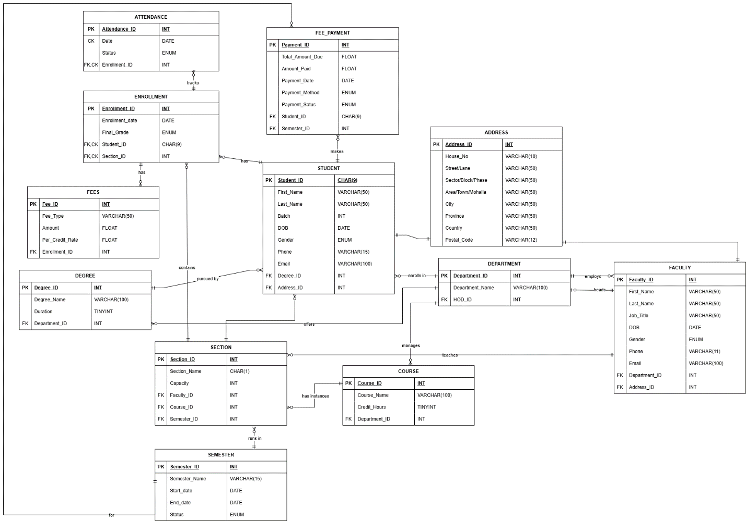

TASK 01-C
Data Dictionary

STUDENT
Sr. | Attribute | Key | Data Type | Constraints
01 | Student_ID | PK | CHAR(9) | PRIMARY KEY
02 | First_Name |  | VARCHAR(50) | NOT NULL
03 | Last_Name |  | VARCHAR(50) | NOT NULL
04 | Batch |  | INT | NOT NULL
05 | DOB |  | DATE | NOT NULL
06 | Gender |  | ENUM | NOT NULL, ENUM ('M','F','O')
07 | Phone |  | VARCHAR(15) | NOT NULL,
08 | Email |  | VARCHAR(100) | NOT NULL, UNIQUE, CHECK (Email LIKE '%@%.%')
09 | Degree_ID | FK | INT | NOT NULL
10 | Address_ID | FK | INT | NOT NULL

ADDRESS
Sr. | Attribute | Key | Data Type | Constraints
01 | Address_ID | PK | INT | PRIMARY KEY, AUTO_INCREMENT
02 | House_No |  | VARCHAR(10)
03 | Street/Lane |  | VARCHAR(50)
04 | Sector/Block/Phase |  | VARCHAR(50)
05 | Area/Town/Mohalla |  | VARCHAR(50) | NOT NULL
06 | City |  | VARCHAR(50) | NOT NULL
07 | Province |  | VARCHAR(50) | NOT NULL
08 | Country |  | VARCHAR(50) | NOT NULL, DEFAULT 'Pakistan'.
09 | Postal_Code |  | VARCHAR(12) | NOT NULL

DEPARTMENT
Sr. | Attribute | Key | Data Type | Constraints
01 | Department_ID | PK | INT | PRIMARY KEY, AUTO_INCREMENT
02 | Department_Name |  | VARCHAR(100) | NOT NULL, UNIQUE
03 | HOD_ID | FK | INT | ON DELETE SET NULL

DEGREE
Sr. | Attribute | Key | Data Type | Constraints
01 | Degree_ID | PK | INT | PRIMARY KEY, AUTO_INCREMENT
02 | Degree_Name |  | VARCHAR(100) | NOT NULL, UNIQUE
03 | Duration |  | TINYINT | NOT NULL, CHECK (Duration BETWEEN 1 AND 6)
04 | Department_ID | FK | INT | NOT NULL

FACULTY
Sr. | Attribute | Key | Data Type | Constraints
01 | Faculty_ID | PK | INT | PRIMARY KEY, AUTO_INCREMENT
02 | First_Name |  | VARCHAR(50) | NOT NULL
03 | Last_Name |  | VARCHAR(50) | NOT NULL
04 | Job_Title |  | VARCHAR(50) | NOT NULL
05 | DOB |  | DATE | NOT NULL
06 | Gender |  | CHAR(1) | NOT NULL, ENUM ('M','F','O')
07 | Phone |  | VARCHAR(15) | NOT NULL,
08 | Email |  | VARCHAR(100) | NOT NULL, UNIQUE, CHECK (Email LIKE '%@%.%')
09 | Department_ID | FK | INT | NOT NULL

COURSE
Sr. | Attribute | Key | Data Type | Constraints
01 | Course_ID | PK | INT | PRIMARY KEY, AUTO_INCREMENT
02 | Course_Name |  | VARCHAR(100) | NOT NULL, UNIQUE
03 | Credit_Hours |  | TINYINT | NOT NULL, CHECK (Credit_Hours BETWEEN 1 AND 5)
04 | Department_ID | FK | INT | NOT NULL

SECTION
Sr. | Attribute | Key | Data Type | Constraints
01 | Section_ID | PK | INT | PRIMARY KEY, AUTO_INCREMENT
02 | Section_Name |  | CHAR(1) | NOT NULL
03 | Capacity |  | INT | NOT NULL, DEFAULT 30  CHECK (Capacity BETWEEN 1 AND 100)
04 | Faculty_ID | FK | INT | NOT NULL
05 | Course_ID | FK | INT | NOT NULL
06 | Semester_ID | FK | INT | NOT NULL

SEMESTER
Sr. | Attribute | Key | Data Type | Constraints
01 | Semester_ID | PK | INT | PRIMARY KEY, AUTO_INCREMENT
02 | Semester_Name |  | VARCHAR(50) | NOT NULL, UNIQUE
03 | Start_date |  | DATE | NOT NULL
04 | End_date |  | DATE | NOT NULL
05 | Status |  | ENUM | NOT NULL, DEFAULT 'Upcoming', ENUM('Upcoming','Active','Completed')

ENROLLMENT
Sr. | Attribute | Key | Data Type | Constraints
01 | Enrollment_ID | PK | INT | PRIMARY KEY, AUTO_INCREMENT
02 | Enrollment_date |  | DATE | NOT NULL, DEFAULT (CURDATE())
03 | Final_Grade |  | ENUM | ENUM ('A+', 'A','A-','B+','B','B-','C+','C','C-','D','F','W')
04 | Student_ID | FK,  CK | CHAR(9) | NOT NULL, ON DELETE CASCADE
05 | Section_ID | FK,  CK | INT | NOT NULL

ATTENDANCE
Sr. | Attribute | Key | Data Type | Constraints
01 | Attendance_ID | PK | INT | PRIMARY KEY, AUTO_INCREMENT
02 | Date | CK | DATE | NOT NULL
03 | Status |  | ENUM | NOT NULL, DEFAULT 'A', ENUM ('P','A','L')
04 | Enrollment_ID | FK,  CK | INT | NOT NULL, ON DELETE CASCADE

FEES
Sr. | Attribute | Key | Data Type | Constraints
01 | Fee_ID | PK | INT | PRIMARY KEY, AUTO_INCREMENT
02 | Fee_Type |  | VARCHAR(50) | NOT NULL
03 | Amount |  | FLOAT | NOT NULL, CHECK (Amount > 0)
04 | Per_Credit_Rate |  | FLOAT | NOT NULL, CHECK (Amount > 0)
05 | Enrollment_ID | FK | INT | NOT NULL

FEE PAYMENT
Sr. | Attribute | Key | Data Type | Constraints
01 | Payment_ID | PK | INT | PRIMARY KEY, AUTO_INCREMENT
02 | Total_Amount_Due |  | FLOAT | NOT NULL, CHECK (Total_Amount_Due >= 0)
03 | Amount_Paid |  | FLOAT | NOT NULL, DEFAULT 0, CHECK (Amount_Paid >= 0), CHECK (Amount_Paid <= Total_Amount_Due)
04 | Payment_Date |  | DATE
05 | Payment_Method |  | ENUM | ENUM ('Cash','Bank Transfer','Online','Cheque')
06 | Payment_Status |  | ENUM | NOT NULL, DEFAULT 'Pending', ENUM ('Paid','Partial','Pending','Overdue'))
07 | Student_ID | FK | CHAR(9) | NOT NULL
08 | Semester_ID | FK | INT | NOT NULL

TASK 02-A
Create Tables in MySQL

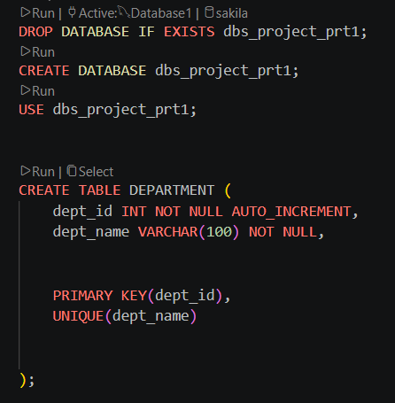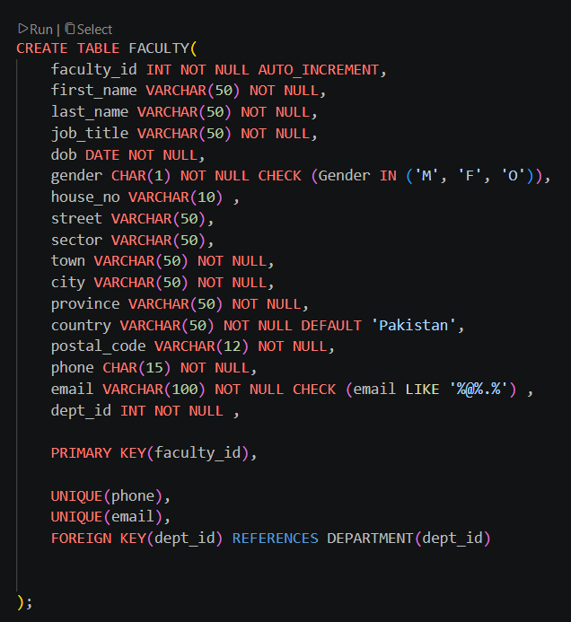
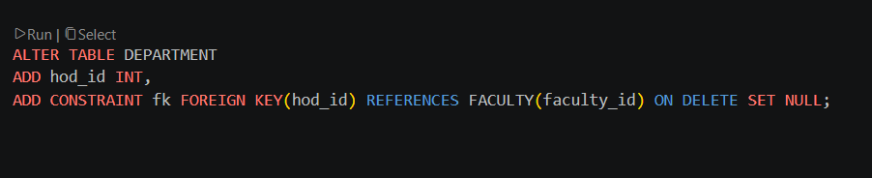

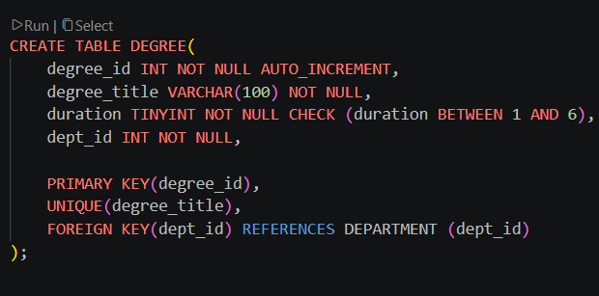
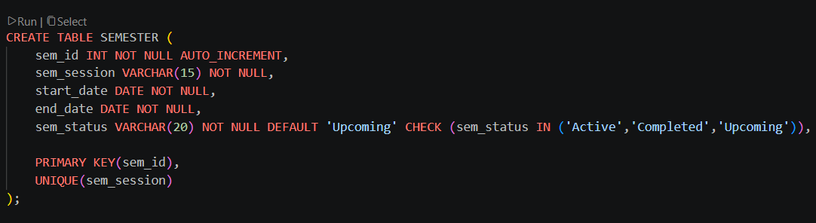
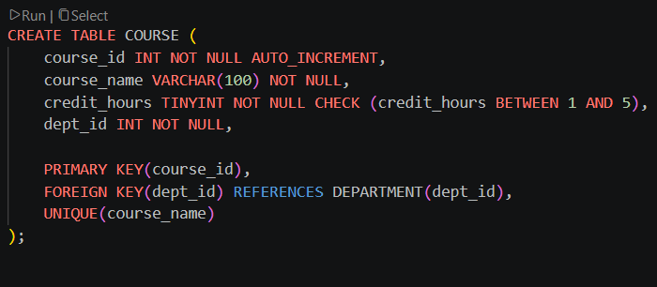
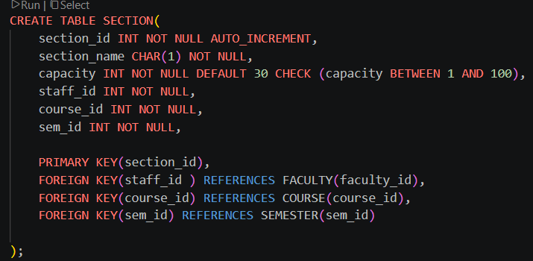
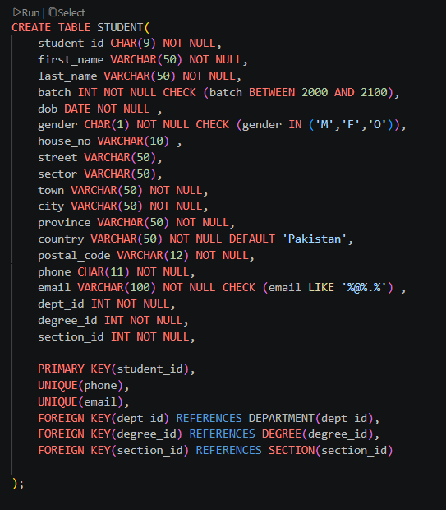
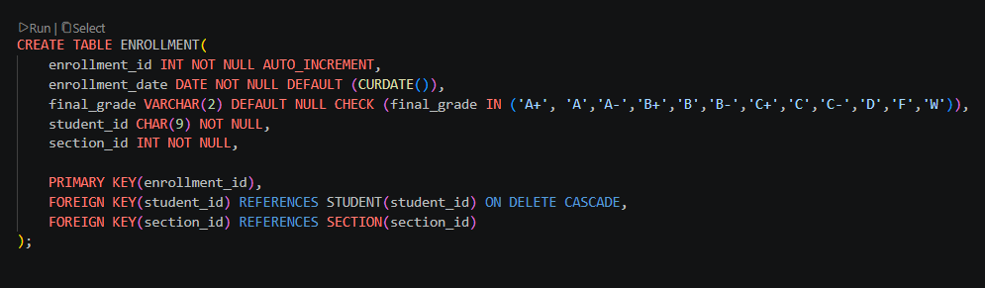
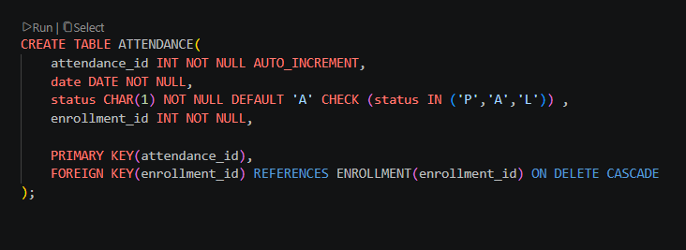
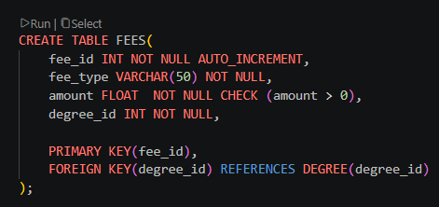
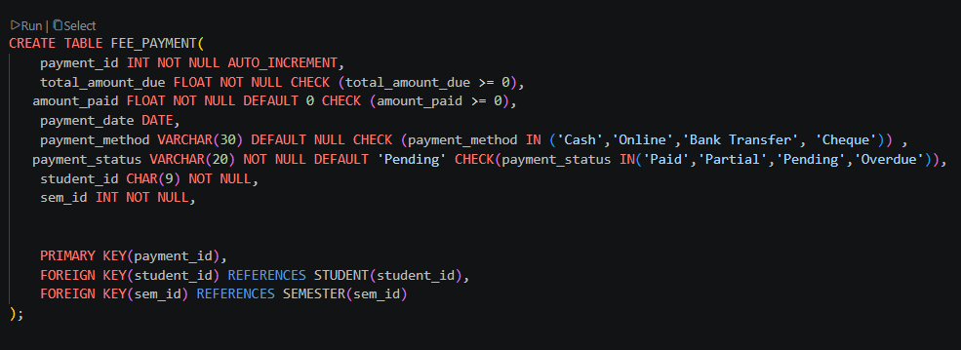

TASK 02-B
Sample Data

We used Claude Sonnet 4.6 by Anthropic to generate our data. This model was specifically chosen as it is capable of following complex structured instructions and has a large enough context window to hold our entire schema in memory while generating rows. It is also a model that we trusted to adhere to the different constraints and produce a consistent and diverse data set that helped generate interesting results for our queries.
We wanted a large dataset that would represent a realistic university management
database and thus gave the model instructions to create INSERT statements that would reflect the data of 500 students.
Our data set includes 8 departments, 48 faculty members, 16 degrees, 8 semesters, 30 different courses, 120 sections, 500 students, 1,251 enrollments, 3,767 attendance records, 48 fee definitions, and 500 fee payment records. Our entire data set consists of a total of 6,296 rows.
These numbers helped us create diversity. For example, with student gender distribution we have 55% male, 49% female, and 6% other. Furthermore, each batch has 100 students, perfectly spread across 5 years (2020-2024).
All these factors combined helped create a dataset that met the requirements of the project and allowed us to write meaningful queries that produced interesting and varied results.

TASK 02-C
SQL Queries
QUERY 1:

This query ranks departments according to their average GPAs and student count. This query aims to deal with the data from the Admin perspective, analysing which departments are underperforming academically and how large they are.
Query:
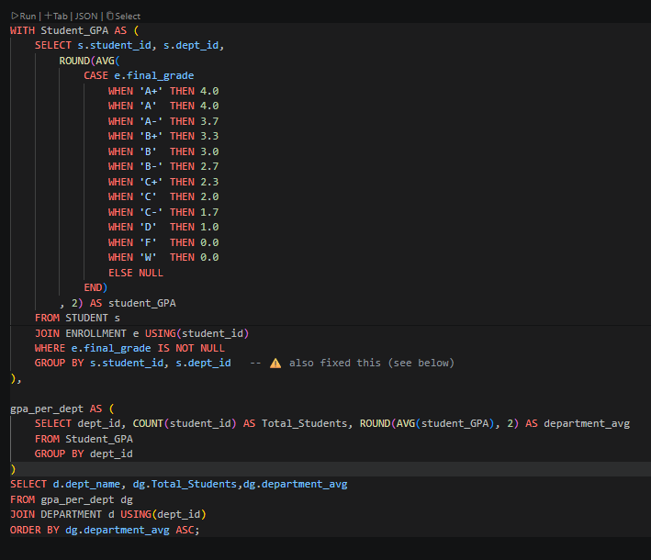
This query uses 2 CTEs. First converts letter grades to GPAs for each student in and the second calculates average GPA and total students per department. The main query displays the final ranking ordered lowest to highest.

Results:
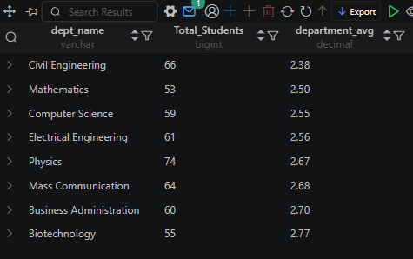

QUERY 2:

This query calculates the teaching load for each faculty member by counting how many sections they are teaching and how many students are enrolled across all their sections.
This query helps us see if the teaching load is being distributed fairly across the faculty in the department.

Query:
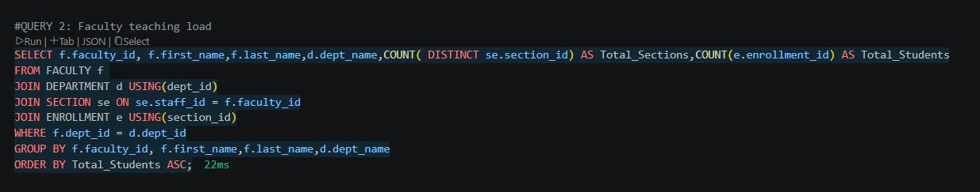
Here we have employed multiple different joins to get data across different tables in our schema. We have also used the aggregate function of COUNT to help us count the sections and the students for each faculty member.

Results:

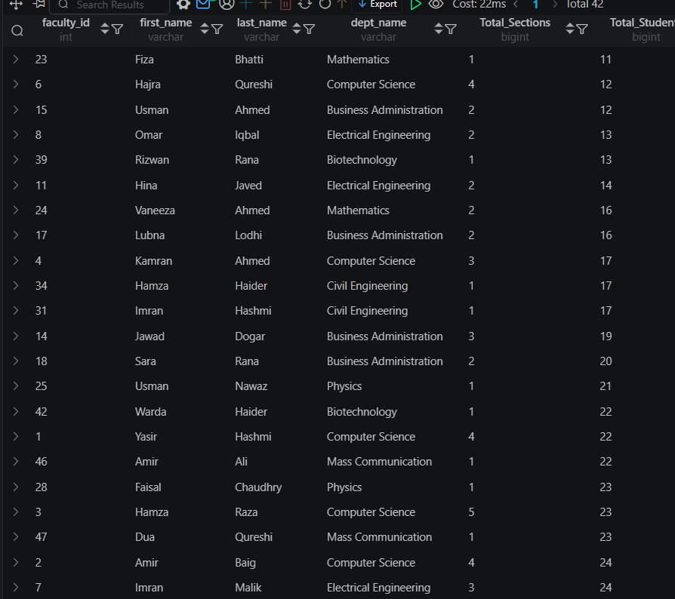

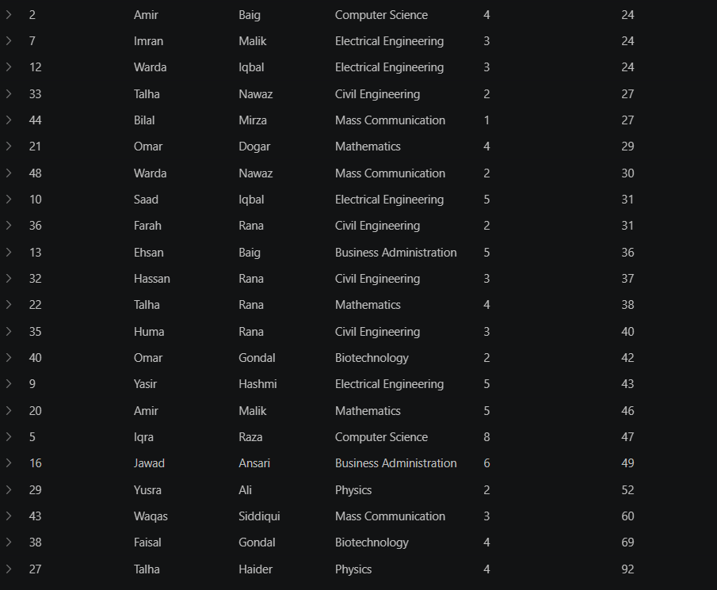

QUERY 3:

This query displays the attendance absence rate per course with faculty name. The aim for this query is to see which courses and which faculty are seeing the most amount of absences.

Query:
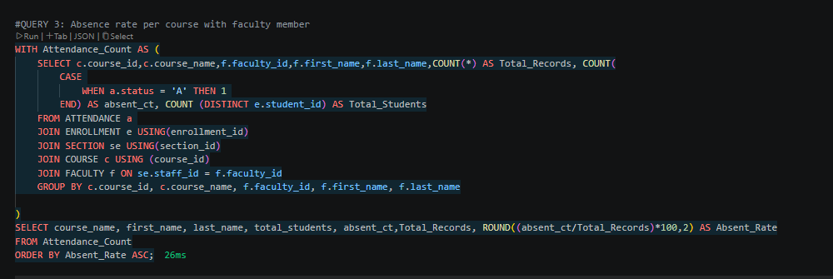
This query also uses a CTE to count the number of absent students per course per faculty member, then the main query calculates the absence rate as a percentage and displays it in ascending order.

Results:
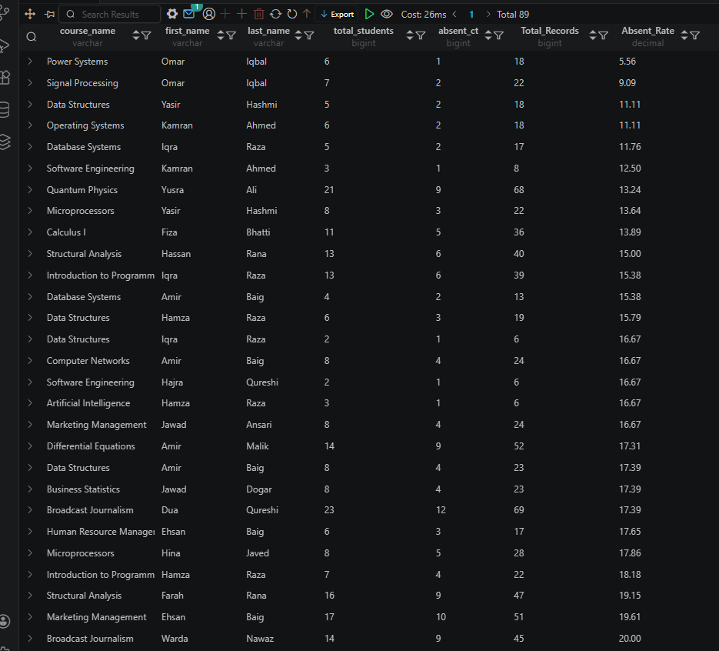

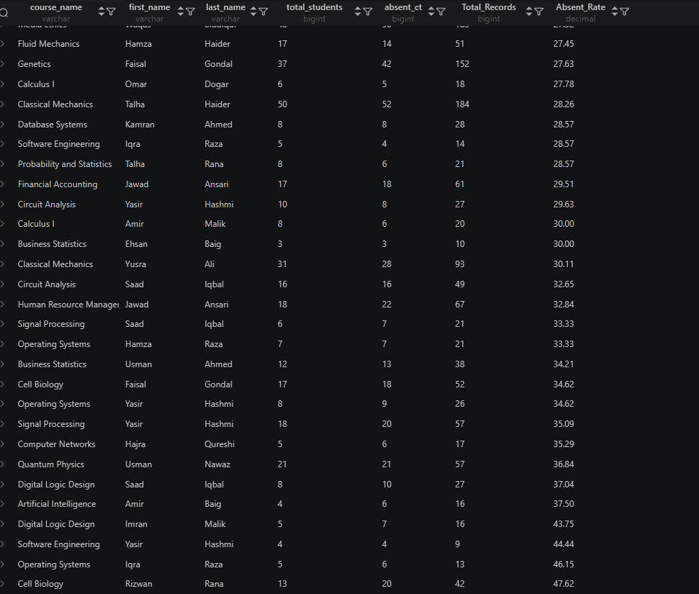

QUERY 4:

This query marks all the pending payments as overdue if the semester is over for that student.
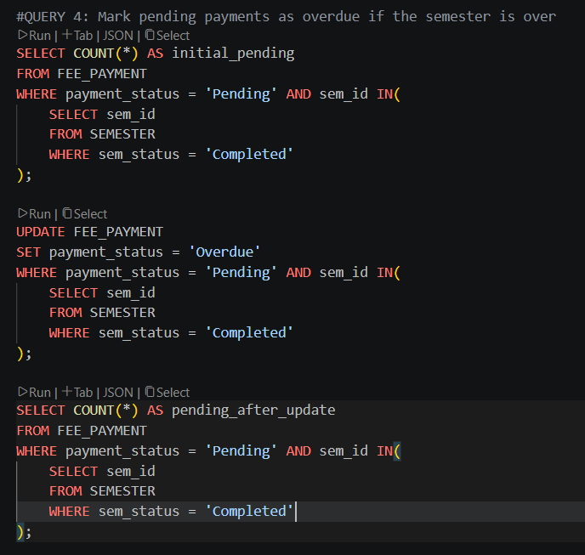
Here we have used two different SELECT statements to help see the difference after updating the tables.

Initial:

After UPDATE:


QUERY 5:

This query deletes the attendance records for the students who have withdrawn form a course.
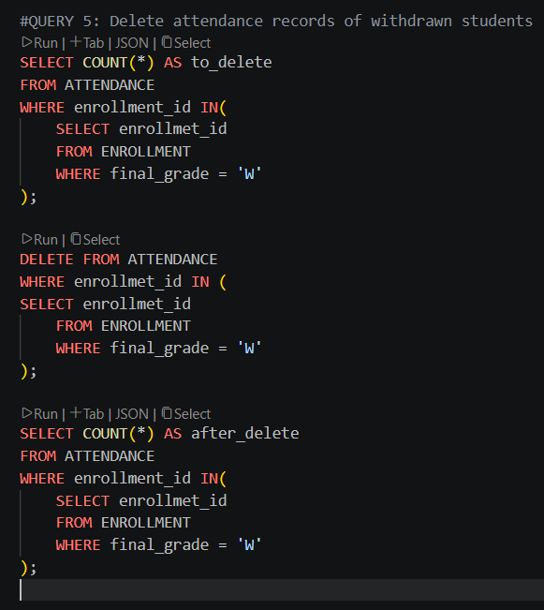

Before:

After DELETE:


TASK 02-D
Transactions

TRANSACTION 1:

This transaction aims to represent a fee payment process for a student.

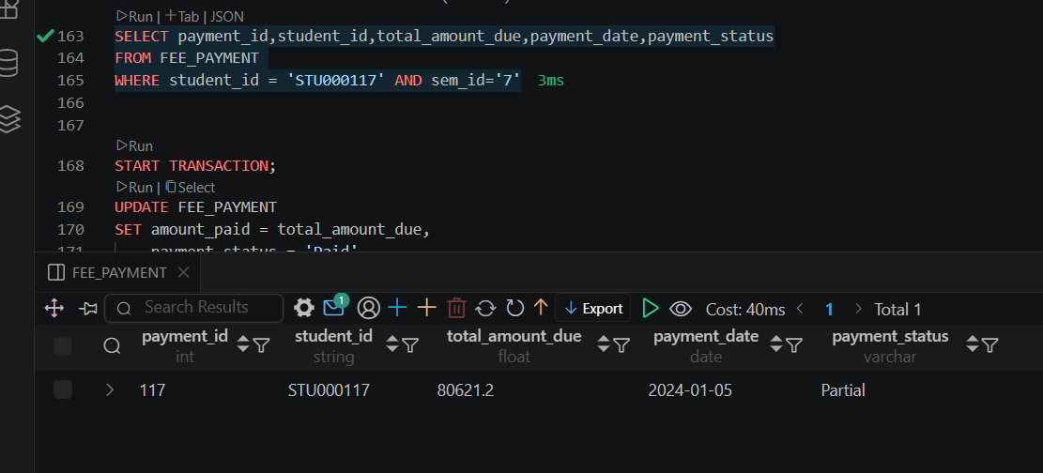

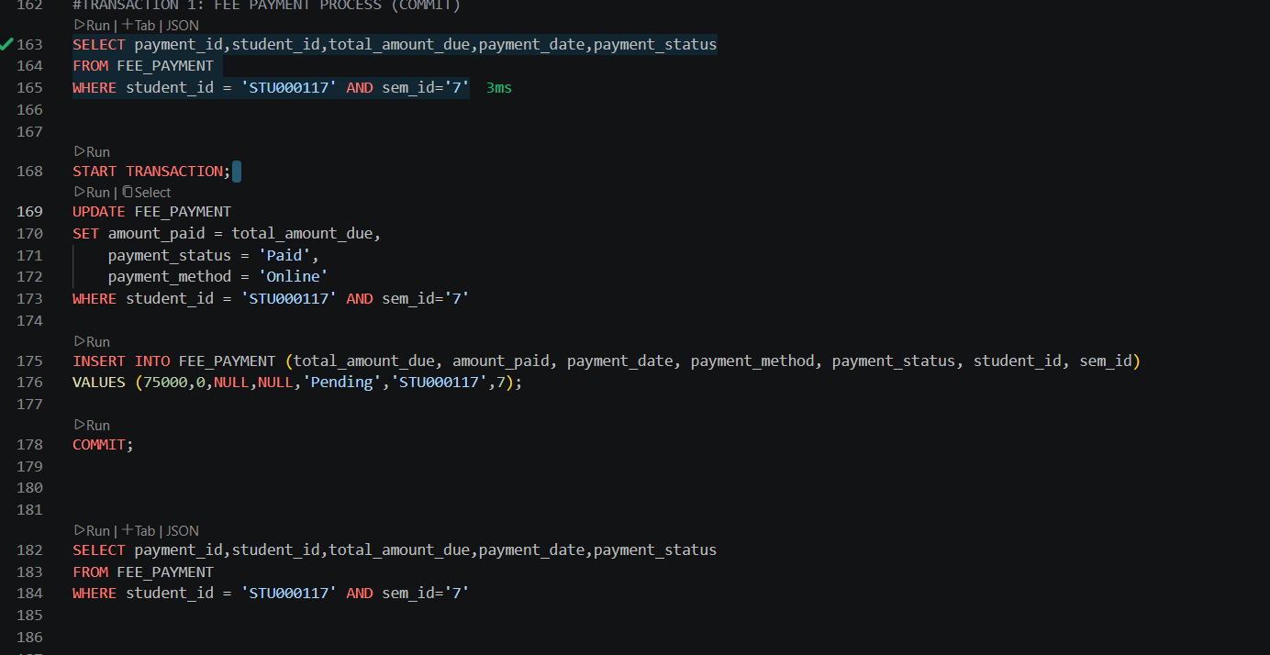

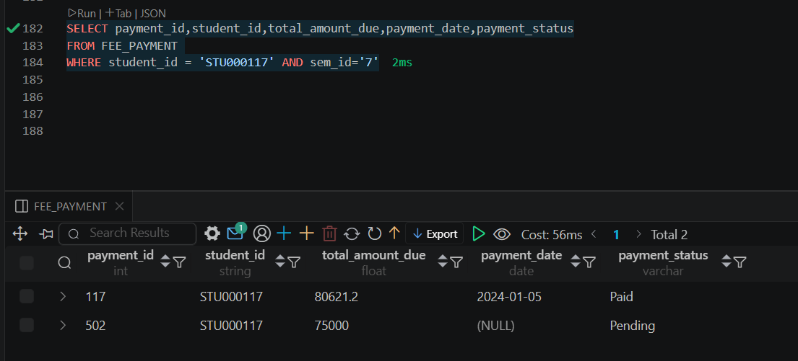

TRANSACTION 2:
In this transaction first the grade of a student is accidentally updated and then we use ROLLBACK to undo that transaction.
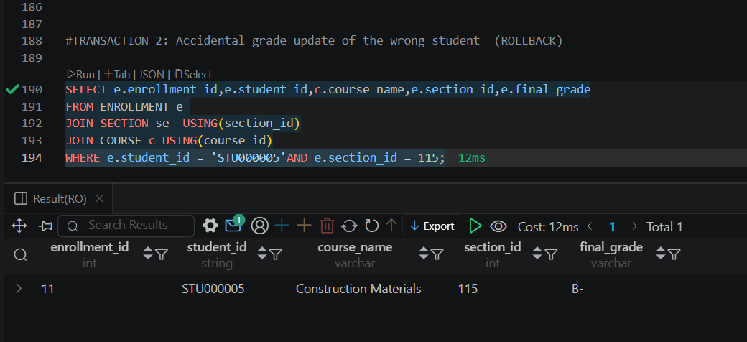
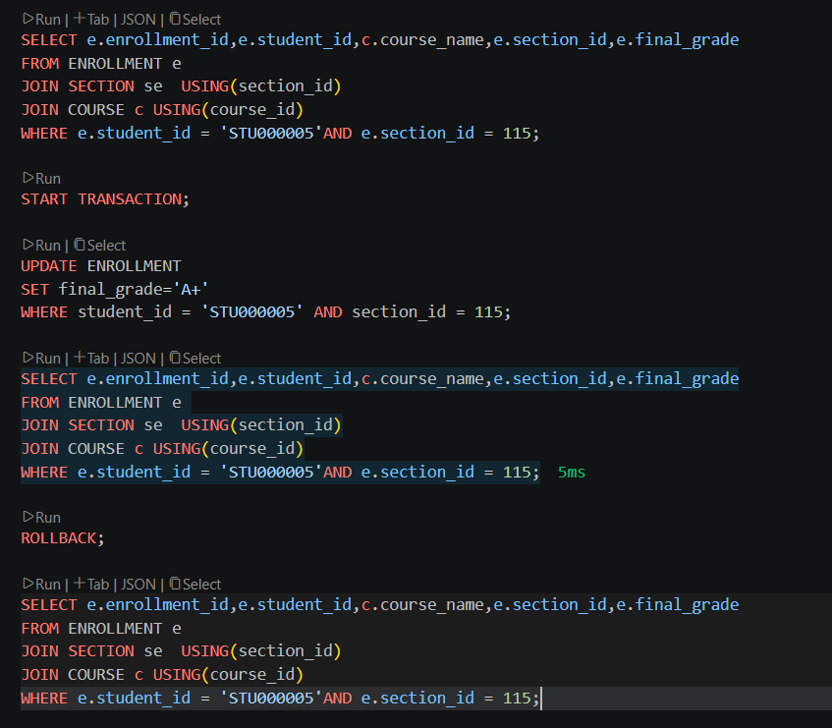
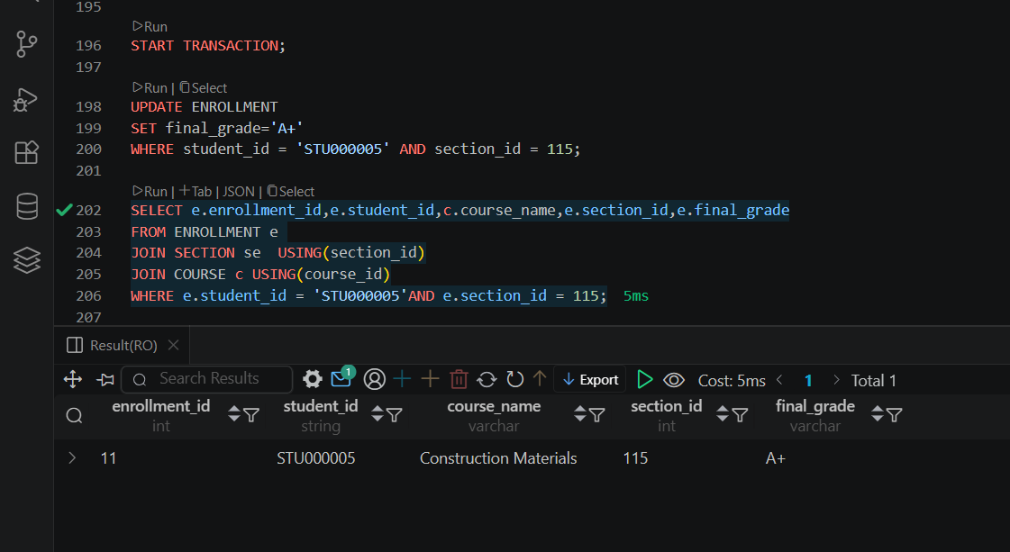
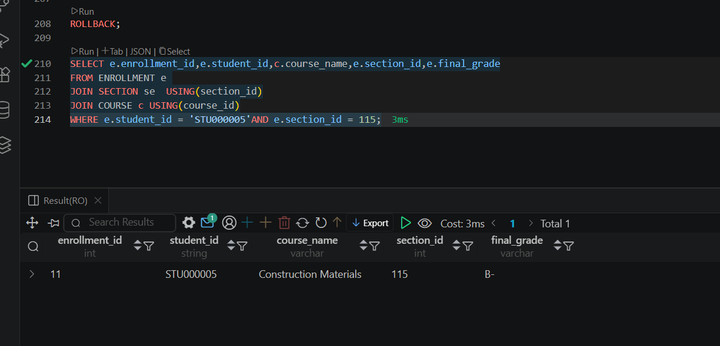

Why atomicity matters specifically for our organization:

For our University Management System, atomicity is important as most administrative processes involve multiple steps to execute successfully. For example, when enrolling a student we need to make sure that a fee record is generated for that student, they are added to a section, and an attendance record is also created for them. If any of these steps fail, the enrollment will be incomplete and the database will be left in an inconsistent state.

TASK 02-E
Role-Based Access Control

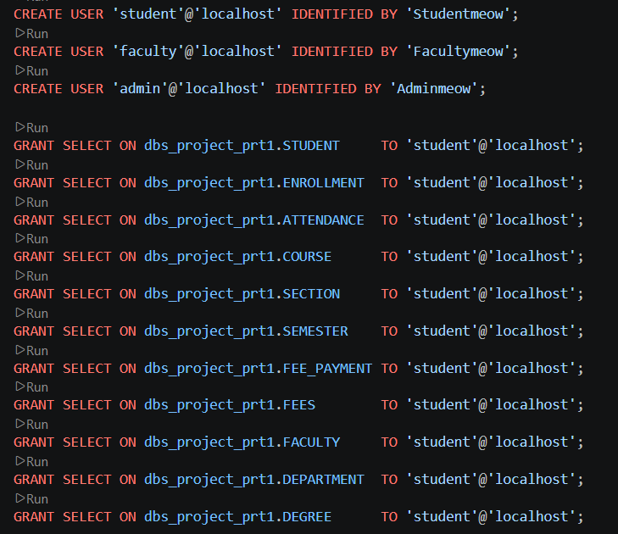
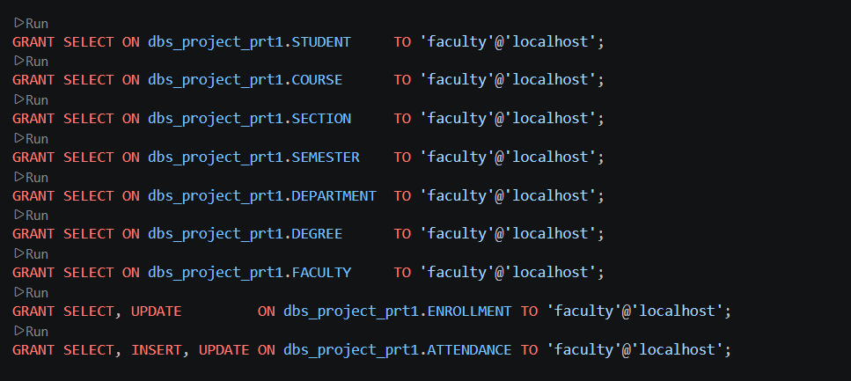
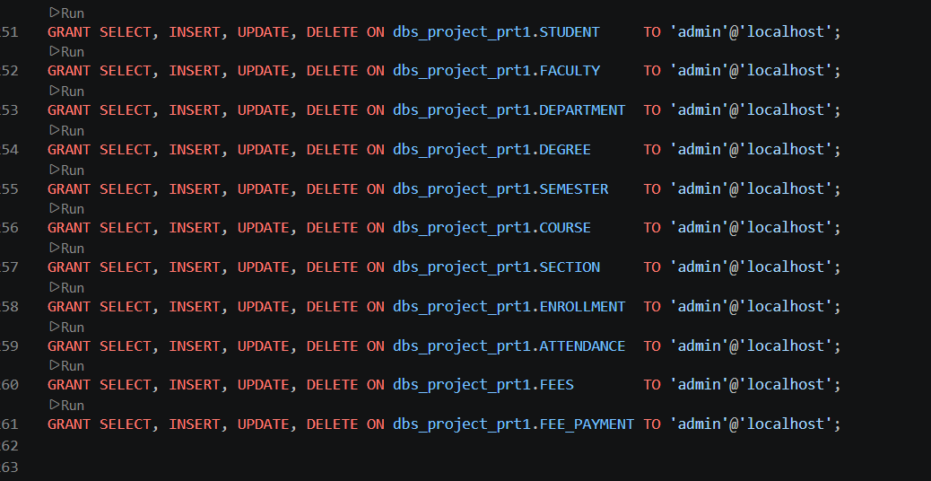
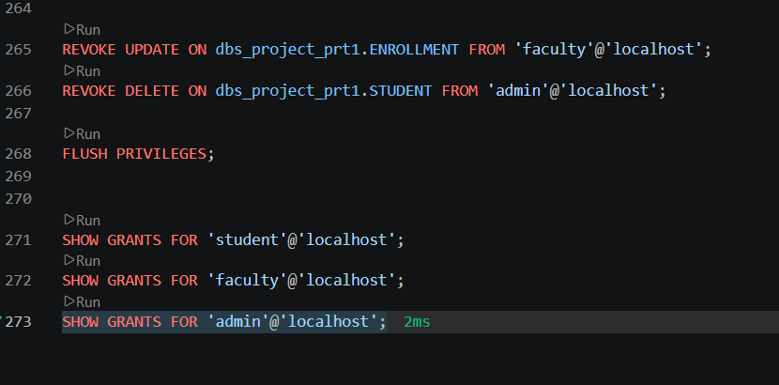

Access Denial:
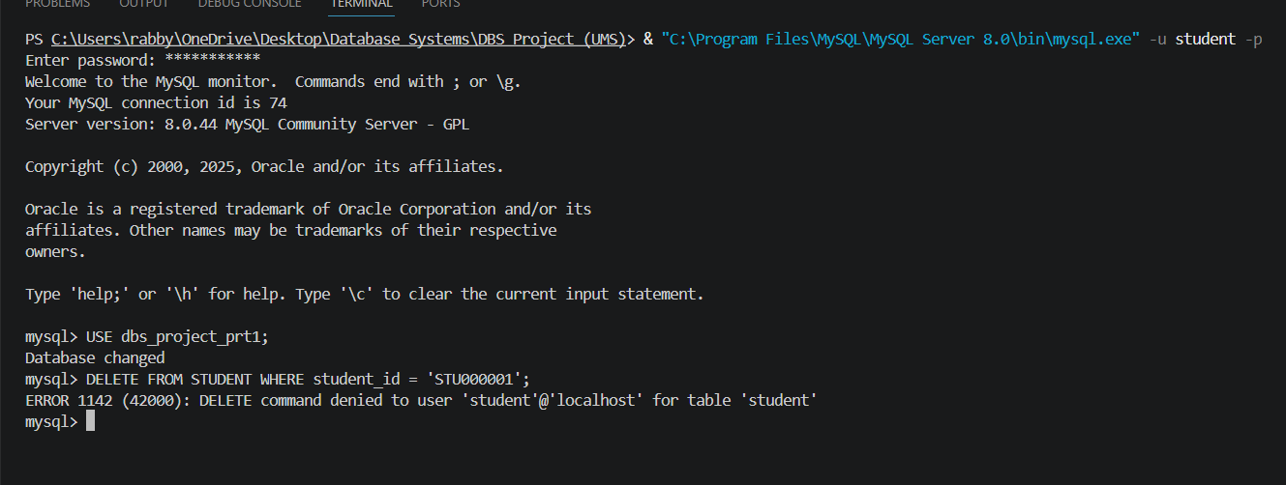

We created three different roles for our role-based access control. Admin, Student, and Faculty.
Students are granted read-only access across all relevant tables so they can view their grades, attendance, etc. They are not granted INSERT, UPDATE, or DELETE privileges as all these modifications require admin approval and should be carried out by the admin.
Faculty are granted SELECT access privileges across all academic tables and are granted INSERT and UPDATE on the Attendance table so they can maintain an attendance record and Enrollment so they can enter final grades.
Admins are granted full access privileges across all tables as they are responsible for managing the entire university database. However, they are not granted to delete on the student table since permanently removing a student is an action that requires formal institutional approval process rather than benign executable by a single admin user.

TASK 03
Web Application Front End

Home Page:

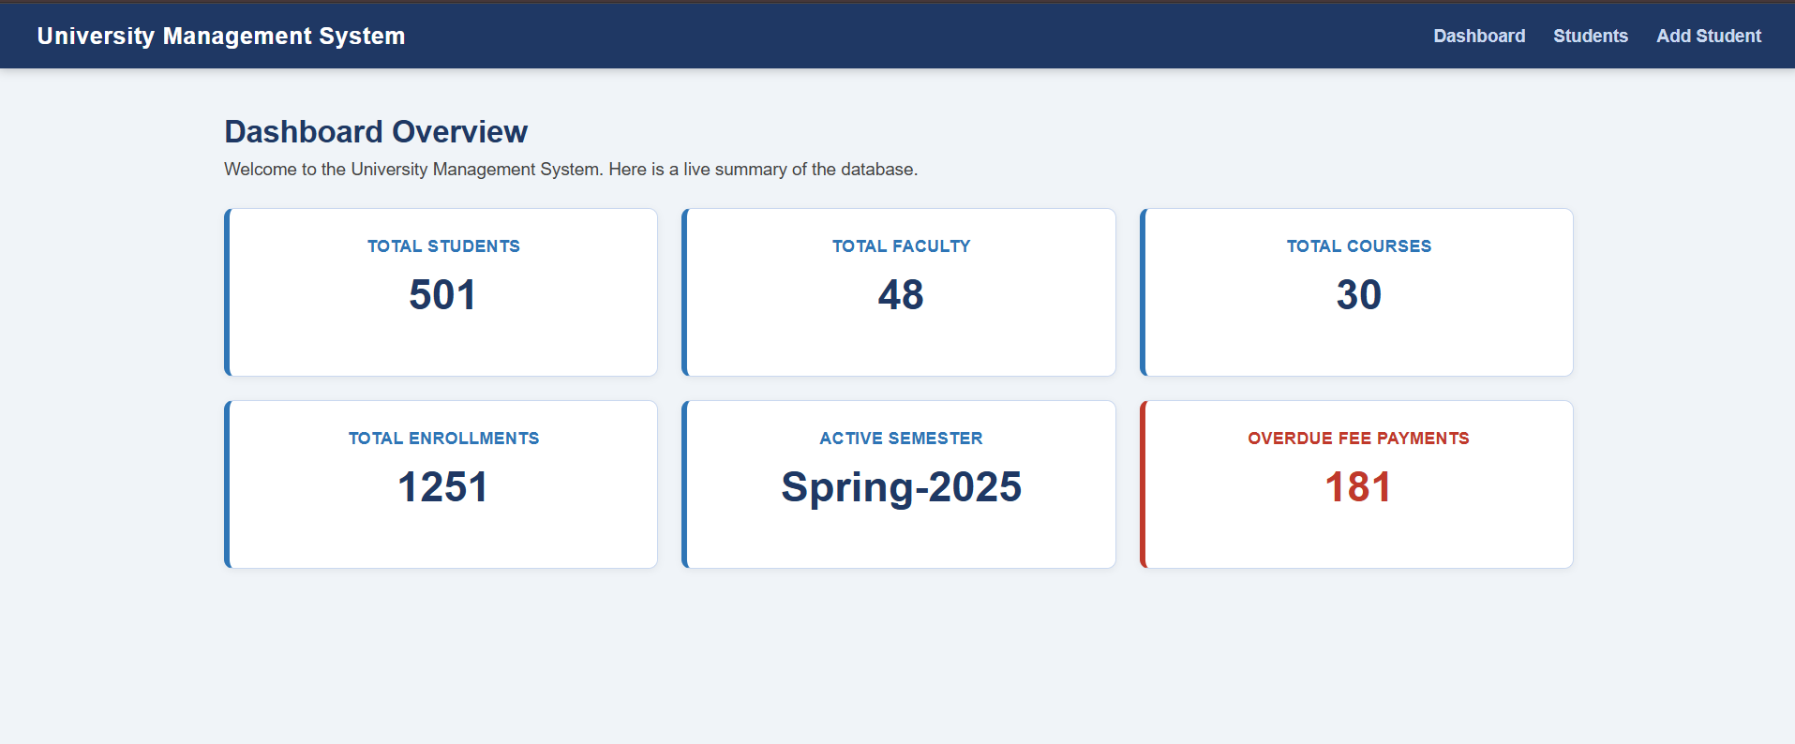

Student Records:

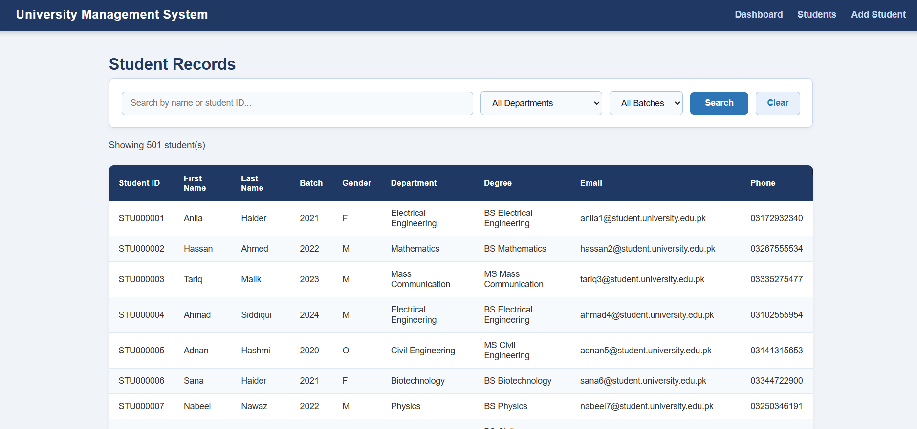

Searching:

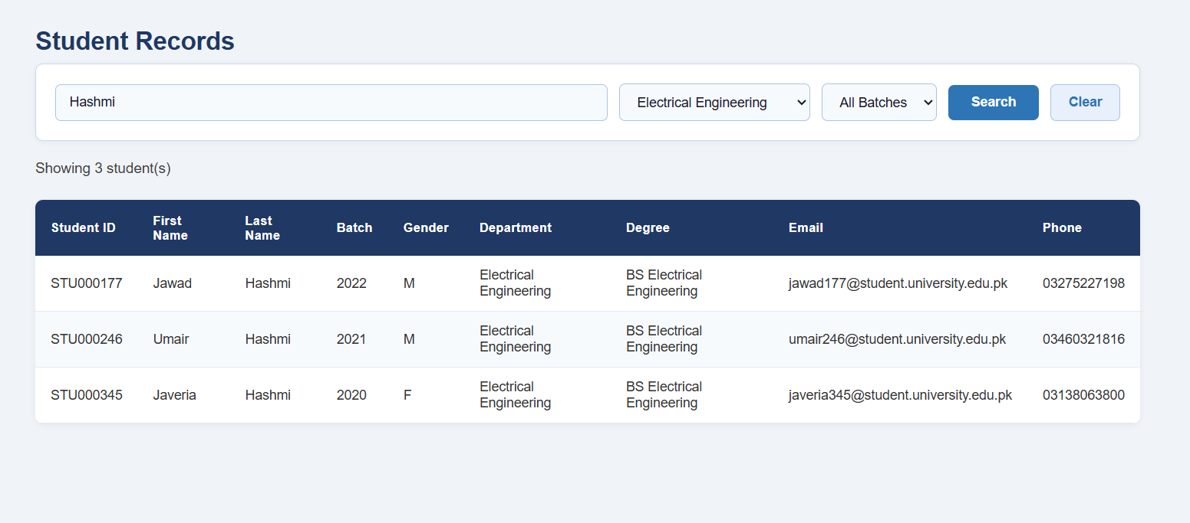

Adding a new student:
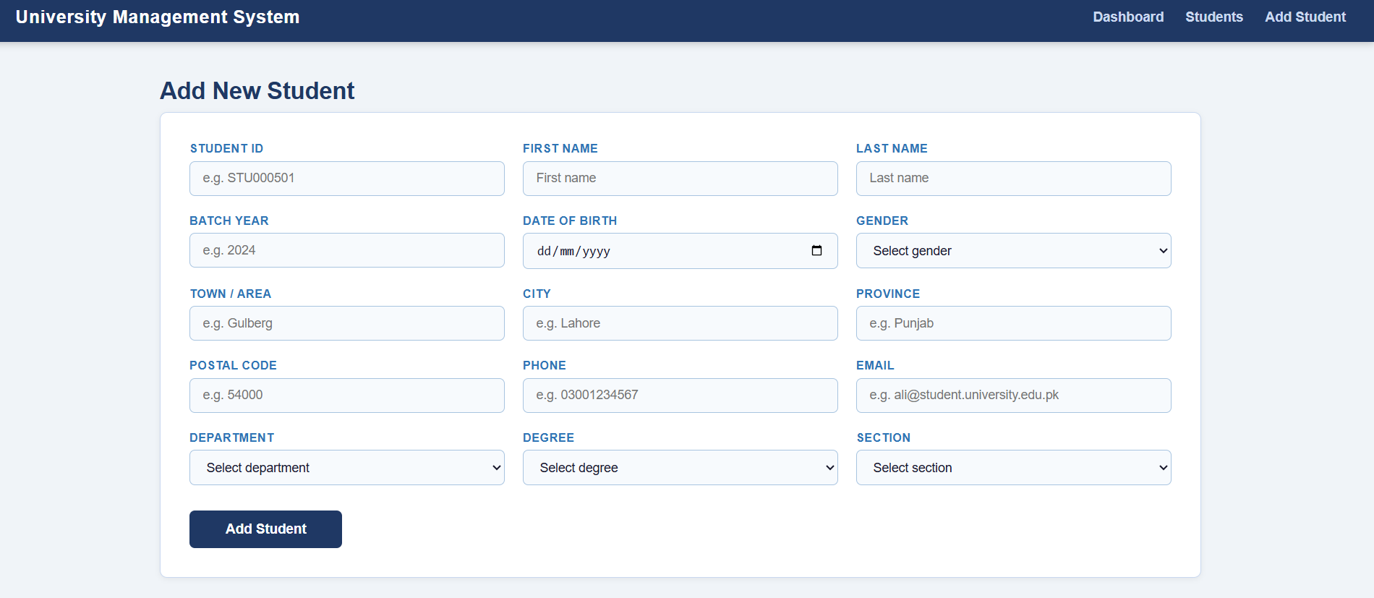
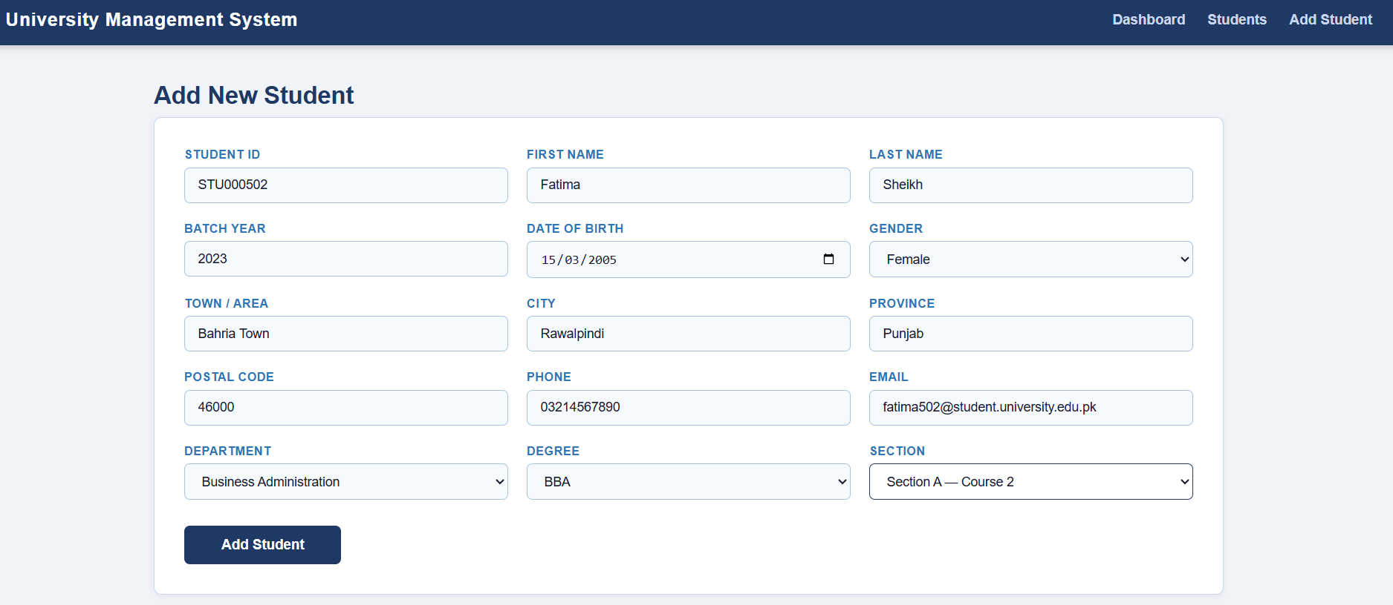


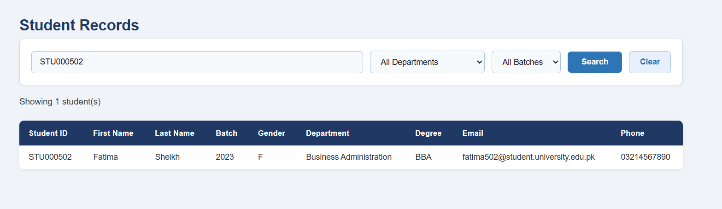

Faculty:

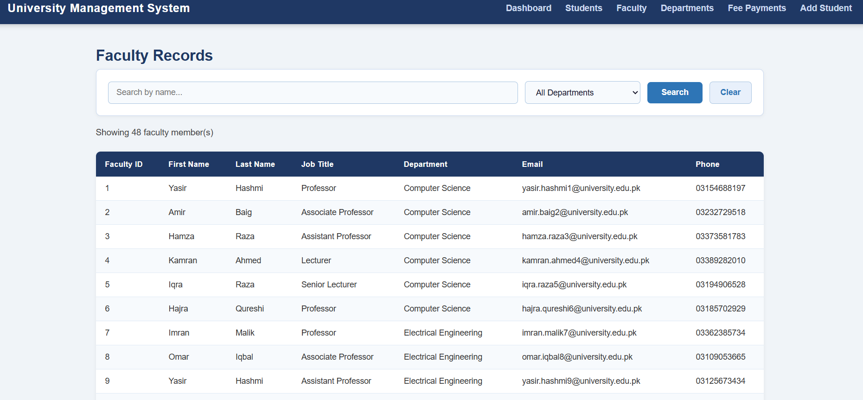

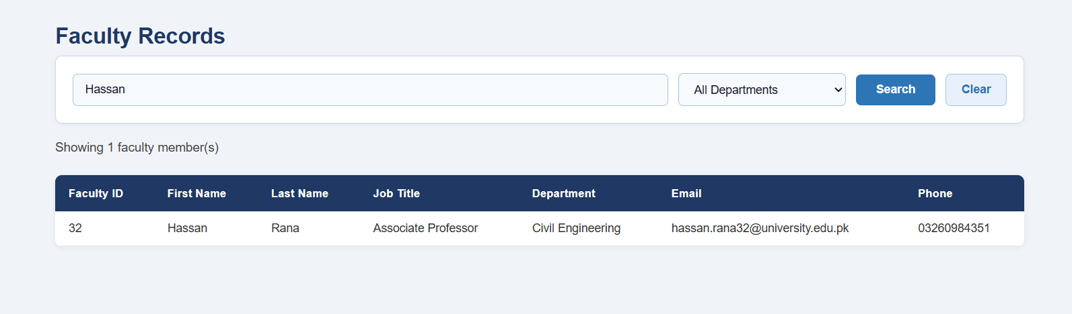

Departments:

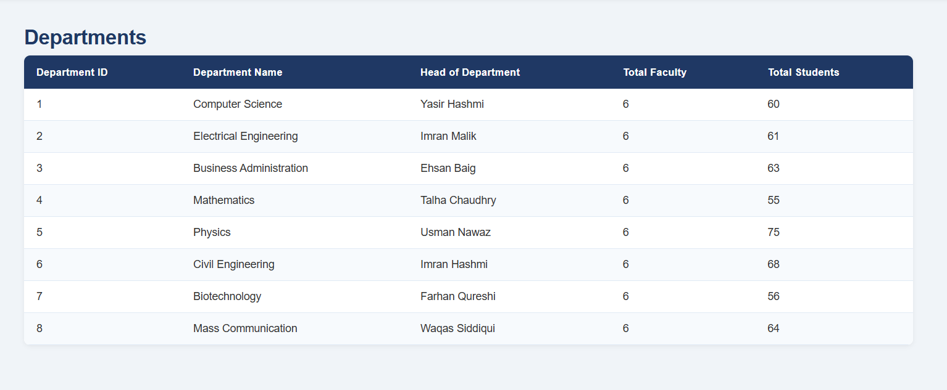
Fee Payment:

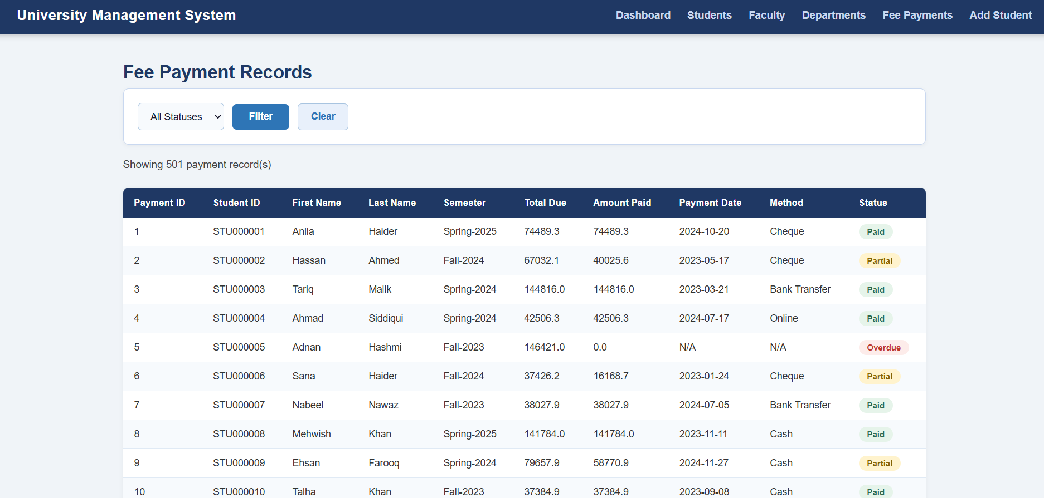

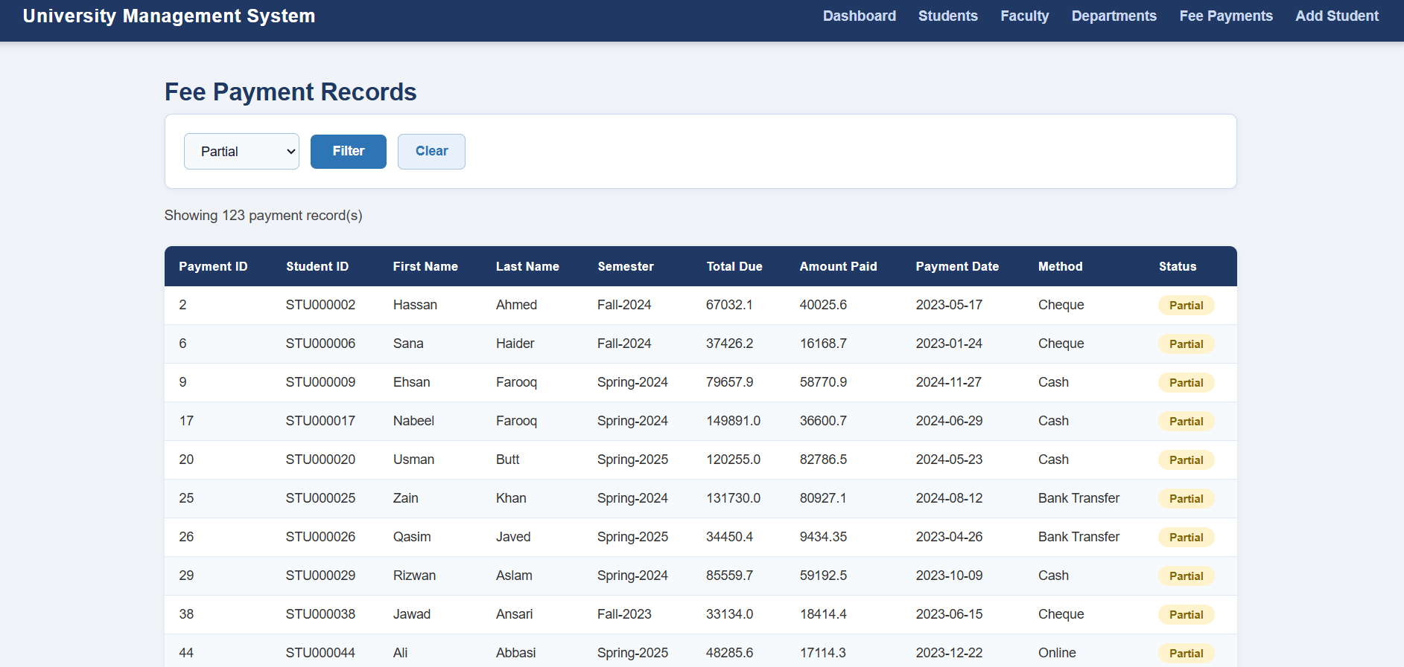

The front end of this application is built using HTML and CSS and is served through a Python Flask web server. Flask acts as the middleman between the browser and the MySQL database when a user navigates to a page, Flask receives the request, queries the database using the mysql-connector-python library, and passes the results to the HTML templates which then display the data in the browser. The three pages each interact with the database differently the dashboard runs COUNT queries across multiple tables to display summary statistics, the students page runs a dynamic SELECT query with optional filters for name, department, and batch, and the add student form submits a POST request which Flask processes and inserts into the STUDENT table using a parameterised INSERT query.
In terms of limitations and challenges, the first major issue we encountered was that the VS Code integrated terminal (PowerShell) was unable to recognise Python and Flask commands due to a script execution policy restriction on the system. This meant we could not run the Flask server through VS Code directly and instead had to use the Windows Command Prompt as a workaround, navigating to the project folder manually each time. The second significant issue was that the HTML template files were not rendering in the browser despite the Flask server running successfully and returning a 200 status code. The pages were displayed as completely blank because the original HTML files contained hidden characters or formatting issues introduced during copy-pasting that prevented Flask's Jinja2 templating engine from parsing the files correctly. This was diagnosed by testing a minimal stripped-down version of the HTML and gradually rebuilding the templates until they rendered correctly. Despite these challenges, all three pages were successfully implemented and connected to the live MySQL database.

