DATABASE PROJECT: UNIVERSITY MANAGEMENT SYSTEM
PROJECT PART 2 - NL2SQL CHATBOT ON KAGGLE

Group Members:
- Ali Zafar Awan
- Hassan Malik
- Khadija Mughees
- Fizza Atif

Hugging Face Model: defog/sqlcoder-7b-2
We used it as our main text-to-SQL model. It’s a 7B model trained specially for SQL generation. It depends heavily on correct schema input. Since our whole project was based on querying a university database, using a model built specifically for SQL tasks made the most sense.

TASK 2
Evaluation: Capabilities & Shortcomings

Query 1: Single table + WHERE clause

Natural Language Input: Show me all the courses being offered in the computer science department.

Output:
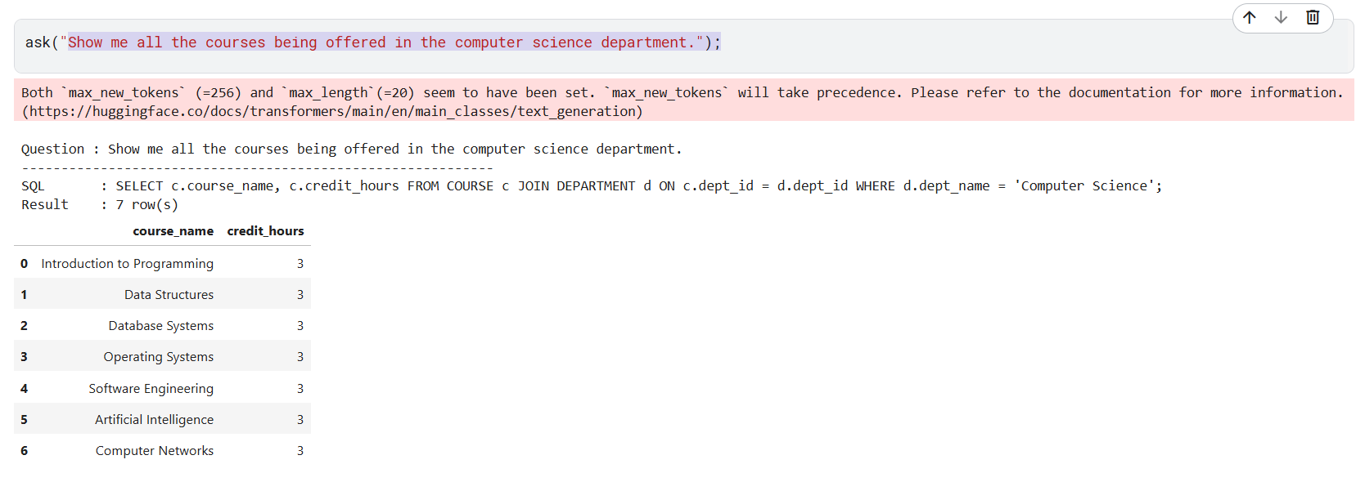

Query 2: Aggregation (AVG)

Natural Language Input: What is the average capacity across all sections in the SECTION table?

Output:
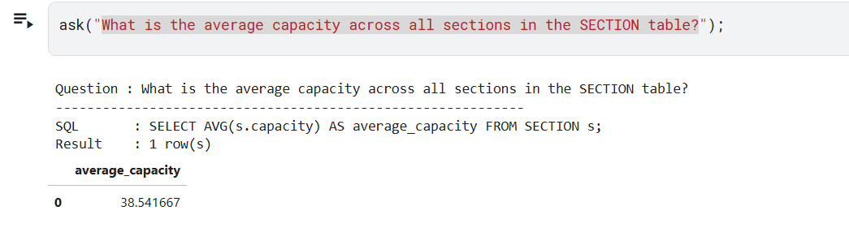

Query 3: Sorting (ORDER BY)

Natural Language Input: Show me all the courses in descending order by the number of students enrolled in that course.

Output:
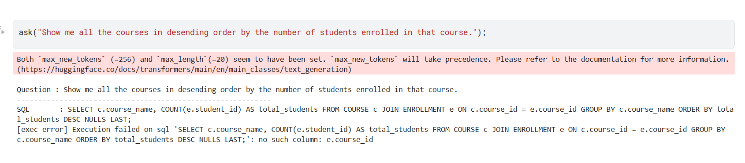

Error Report:
Schema hallucination: The AI assumed that the ENROLLMENT table would contain a course_id because courses and enrollments are commonly linked together. Instead of checking the actual database relationships, it made an incorrect shortcut and generated the wrong join.
Multi-hop reasoning: The AI struggled to understand the relationship between the tables. Instead of following the correct path (COURSE → SECTION → ENROLLMENT), it assumed there was a direct link between COURSE and ENROLLMENT.
After:
Fixed Prompt: Show me all the courses in descending order by the number of students enrolled in that course. (HINT: Join COURSE to SECTION, and SECTION to ENROLLMENT)
Output:
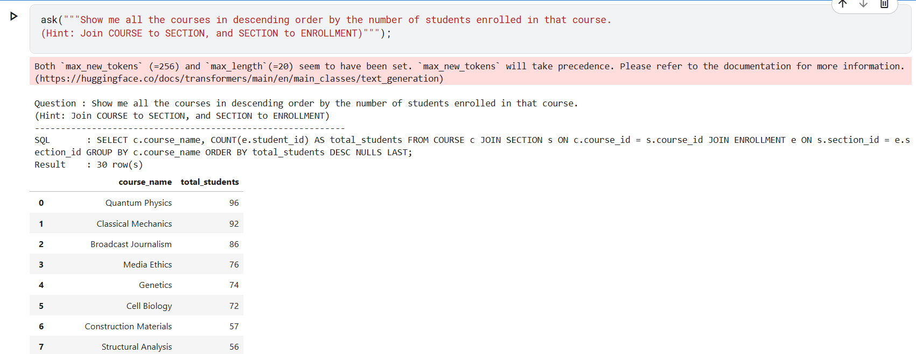

Query 4: Multi-table Join (2 tables - STUDENT → ADDRESS )

Natural Language Input: List out all the students that live in the city Lahore.

Output:
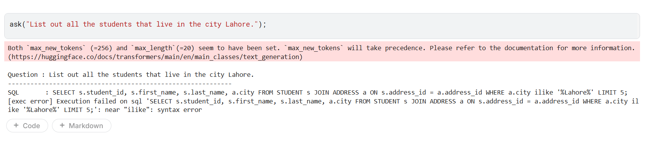
Error Report:
Domain-specific vocabulary: The AI generated ILIKE because it was trained mostly on PostgreSQL syntax, where ILIKE is commonly used for case-insensitive searches. Since our project uses SQLite, the query failed because SQLite does not recognise ILIKE.

After:
Fix: Add an automatic replacement in the ask() function so any generated ILIKE is converted to LIKE before execution: sql = sql.replace(" ilike ", " LIKE ").replace(" ILIKE ", " LIKE ")

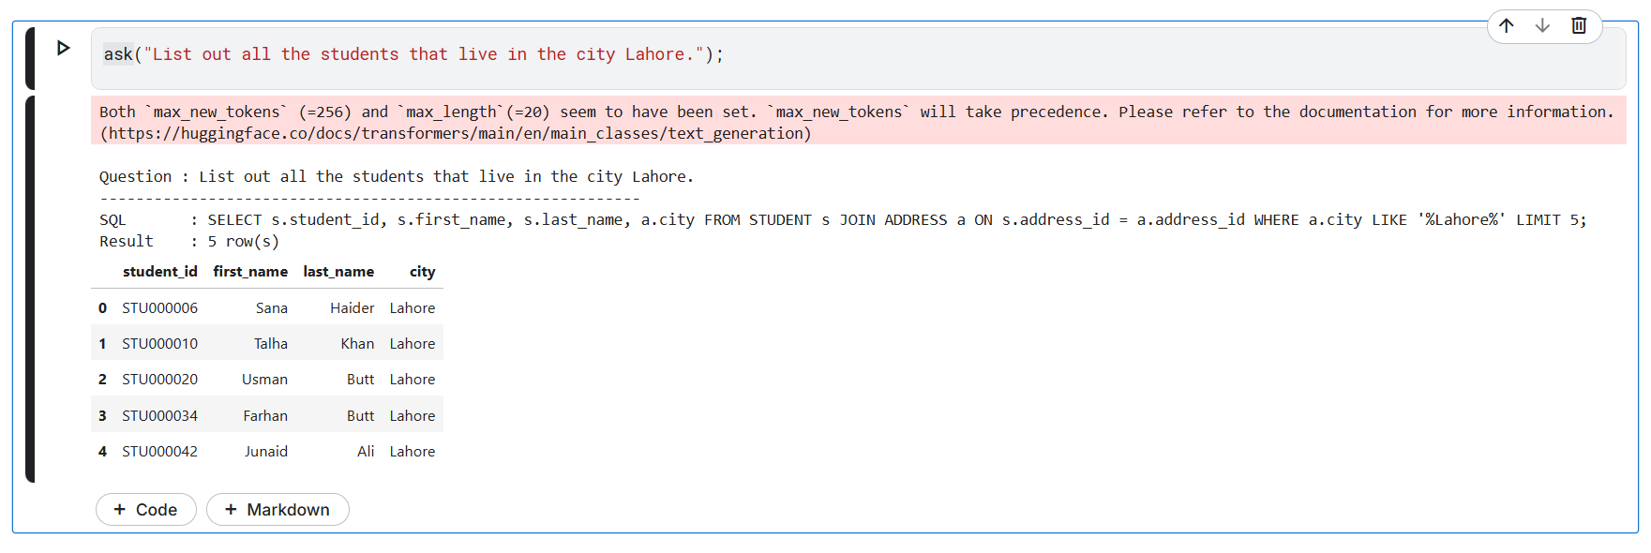

Query 5: Multi-table Join (3 tables - ATTENDANCE → ENROLLMENT → STUDENT )

Natural Language Input: Show me which students were marked Absent, along with the date of thier absence.

Output:
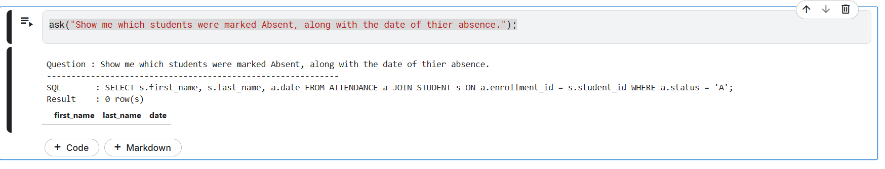

Error Report:

Schema hallucination: The AI joined the wrong columns together. It tried to match enrollment_id with student_id, even though they store completely different types of data. Since the values do not correspond, the query returned no results.

After:
Fixed Prompt: Show me which students were marked status 'A', along with the date of their absence. (Hint: Join ATTENDANCE to ENROLLMENT using enrollment_id, and then ENROLLMENT to STUDENT using student_id)

Output:
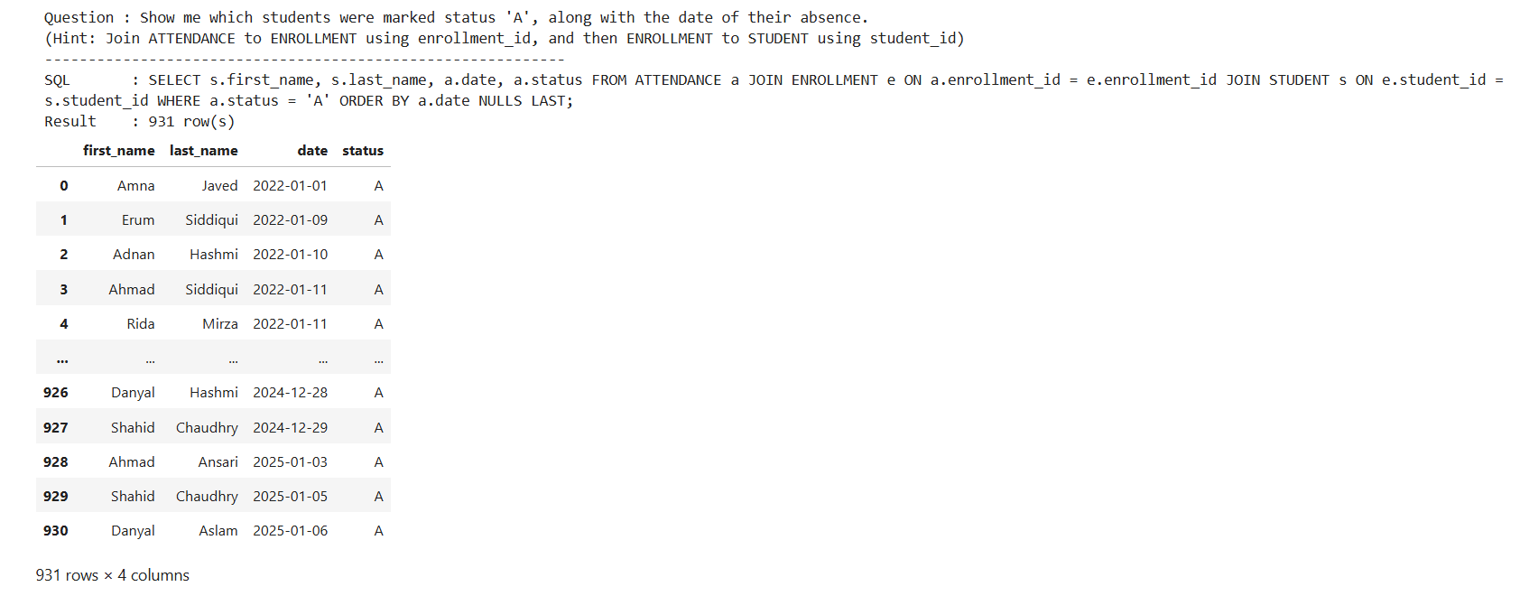

Query 6: Filtering with AND/OR logic

Natural Language Input: Find faculty members that are over the age of 50 and teach in the computer science department.

Output:
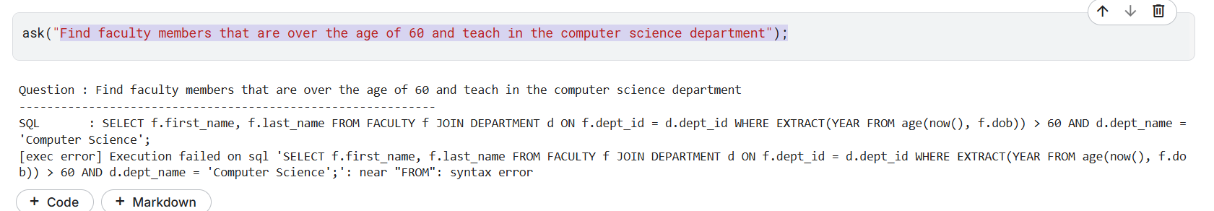

Error Report:
Date/time reasoning : The model used PostgreSQL-style date functions like EXTRACT() and age(), but SQLite doesn’t support them. So when it tried to calculate age from DOB, the query failed because it was using the wrong date format rules for that database.
After:
Fixed Prompt: Find faculty members that are over the age of 60 and teach in the computer science department. (Hint: In SQLite, calculate age using: (strftime('%Y', 'now') - strftime('%Y', dob)
Output:
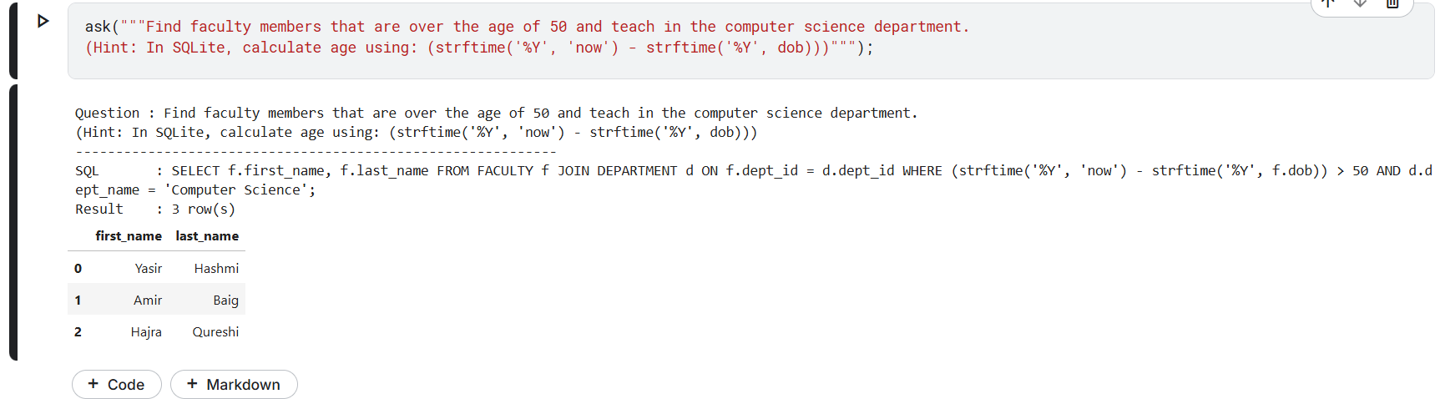

Query 7: Maps to a query I wrote manually in Part 1 Task 2c

Natural Language Input: Show the faculty ID, first name, last name, and department name for each faculty member. Include the total number of unique sections they teach and the total number of students enrolled in their sections. Sort the results by the total number of students in ascending order.
Output:
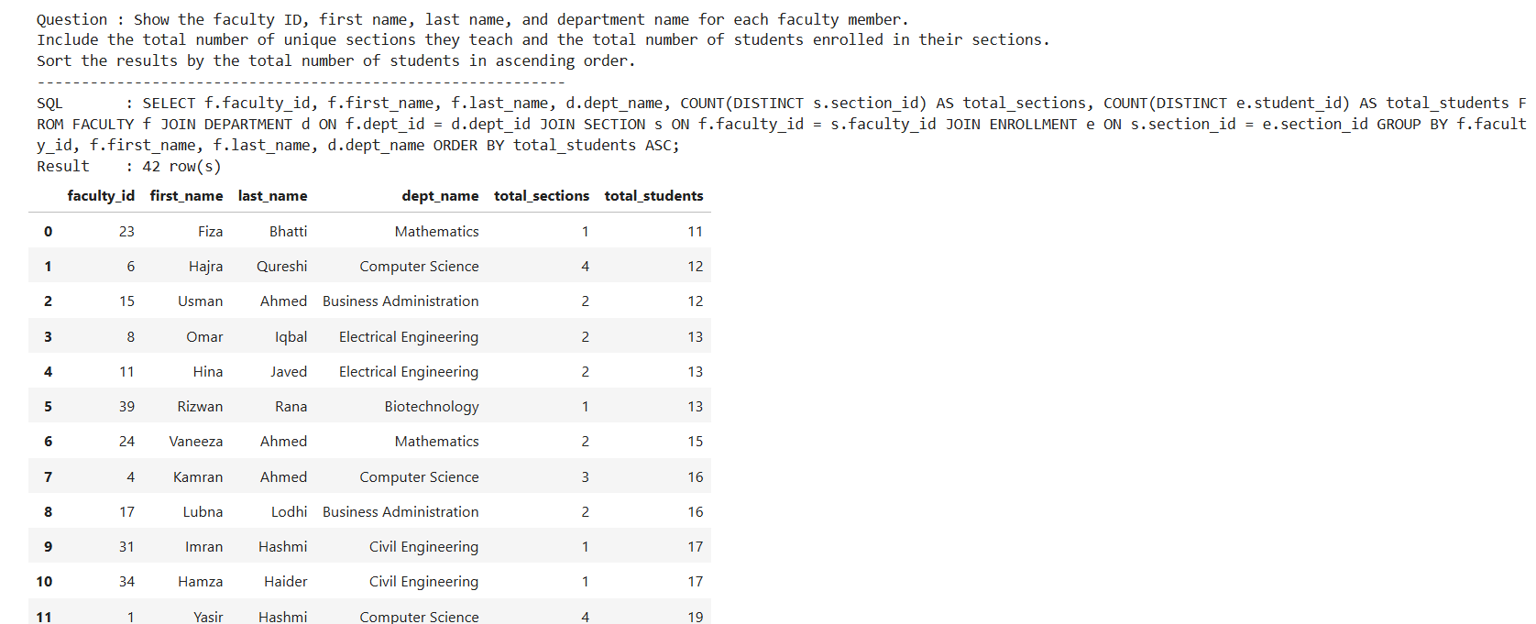

Part1 task 2c query:
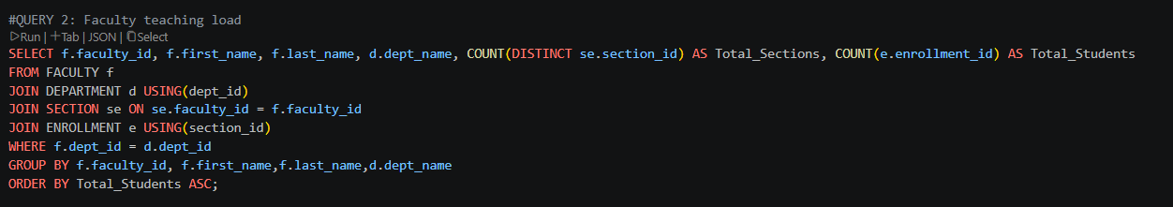Part1 task 2c result:
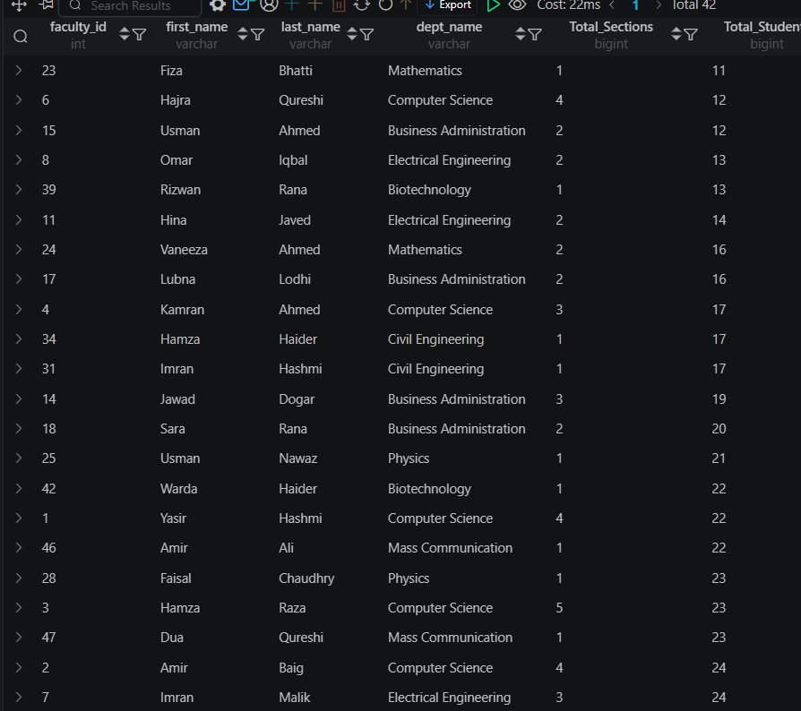
Error Report:
Aggregation + Filter Error: The AI messed up while counting students and sections, so a few student totals came out wrong.
Multi-hop Reasoning Error: The query joins multiple tables together, and the AI loses track of some relationships between them.
Schema hallucination: The AI started guessing and added rows/results that weren’t actually in the SQL output.
Ordering Inconsistency: Since some totals were wrong already, the final sorting order also got messed up.

Query 8: Single table + WHERE clause

Natural Language Input: Show me the students that paid their fees using Online Payment method

Output:
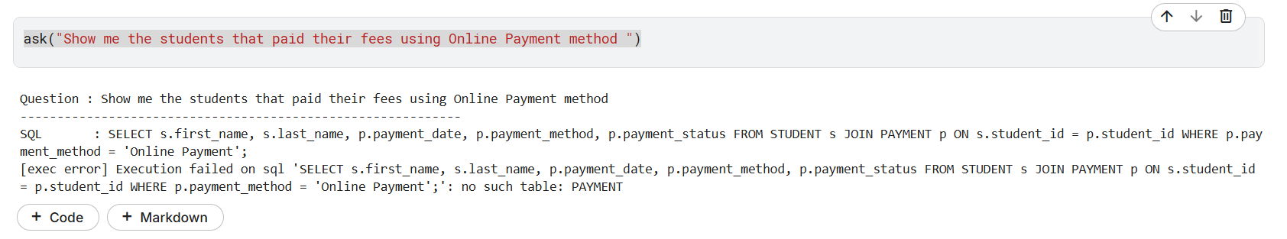
Error Report:
Schema hallucination: The AI referenced a table name that was close in meaning but incorrect (PAYMENT instead of FEE_PAYMENT).
After:
Fixed Prompt: Show me the first and last names of students who paid their fees using the 'Online' payment method. (Hint: use fee_payment and student tables)
Output:
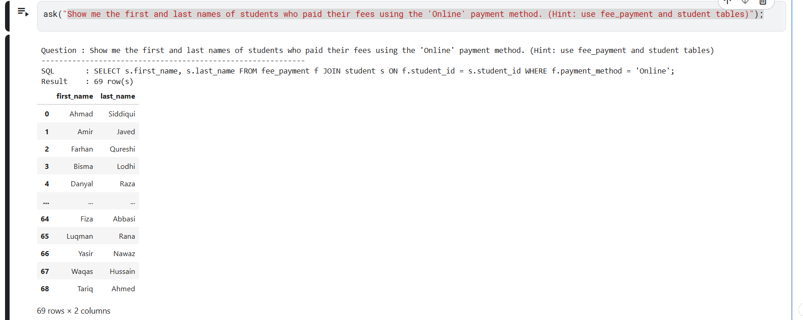

Query 9: Aggregation (Count, Max)

Natural Language Input: which department offers the most courses?

Output:
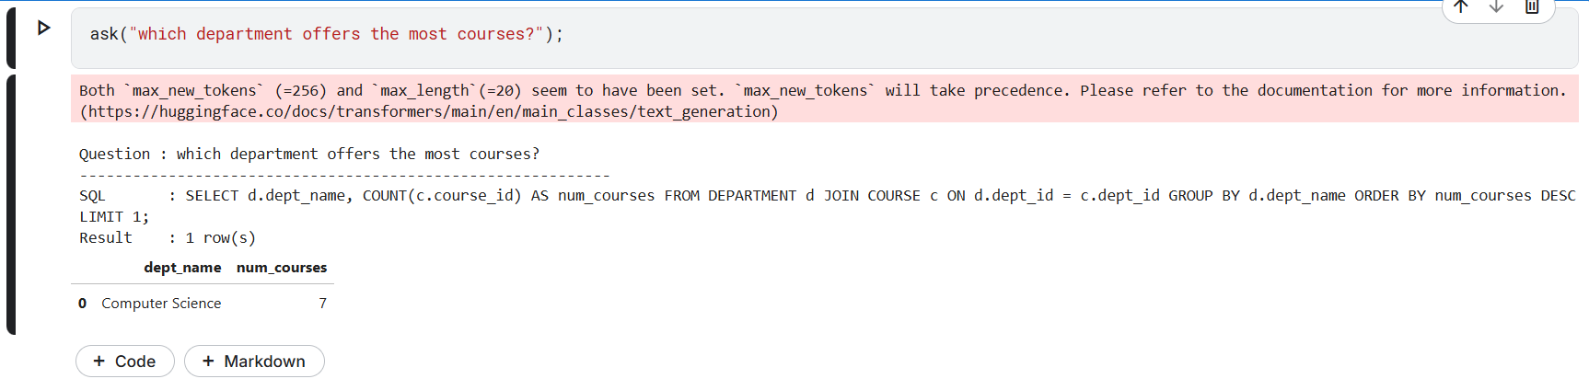

Query 10: Domain-specific Vocabulary

Natural Language Input: Show me all students who are on academic probation.

Output:
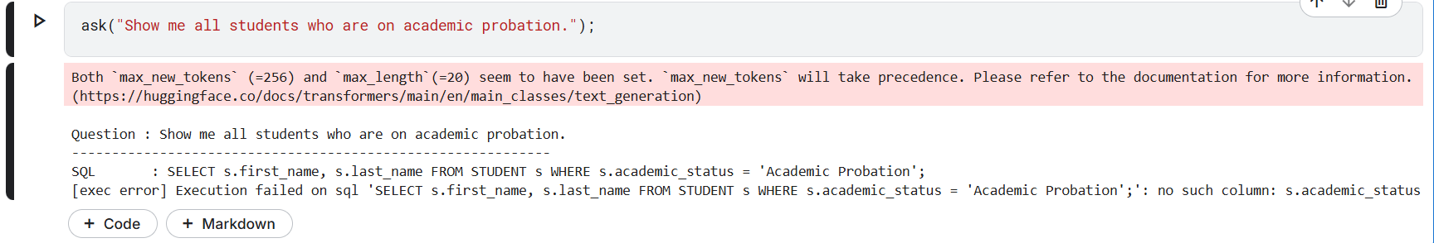

Error Report:

The model saw the term “academic probation” and wrongly assumed your database had a column called academic_status. Instead of checking the real schema, it hallucinated a matching field and queried it, causing the error: no such column: s.academic_status.
After:
Fixed Prompt: Show me all students who are on academic probation. Hint: A student is on probation if their final_grade in any enrollment is 'F'. Use the ENROLLMENT table.
Output:
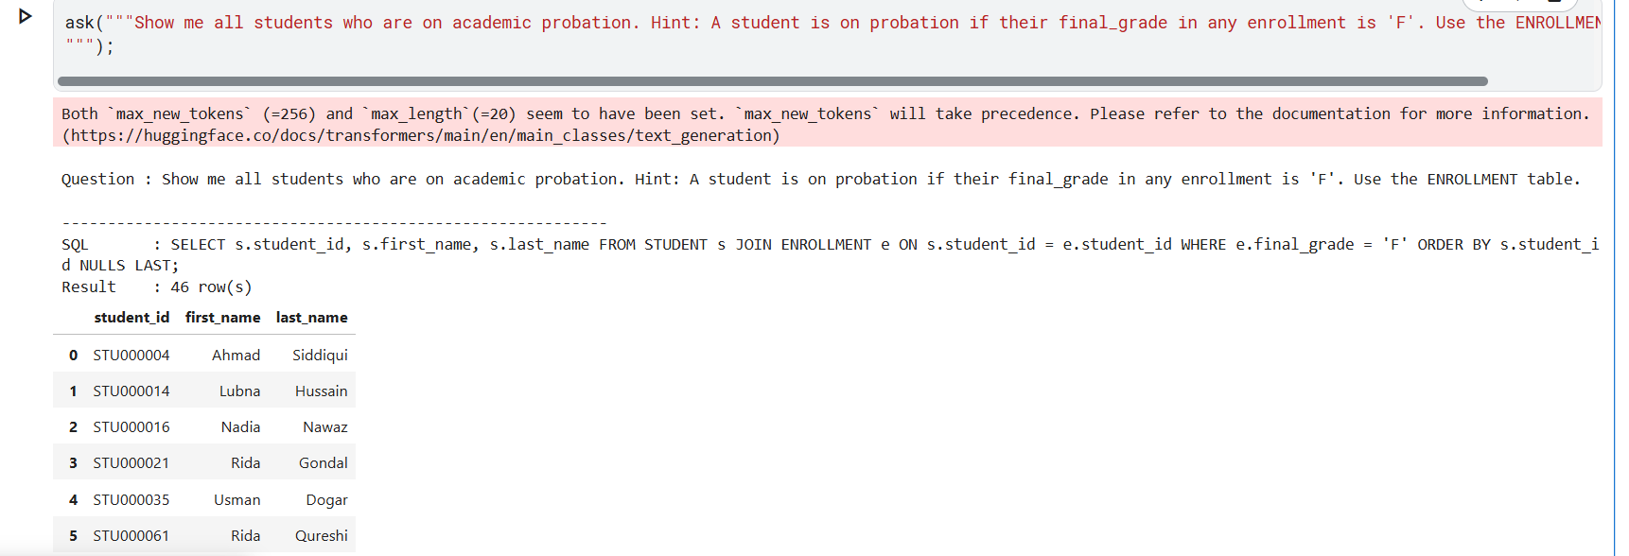

Query 11: Negation

Natural Language Input: Show me all faculty members who have not been assigned as HOD of any department.

Output:
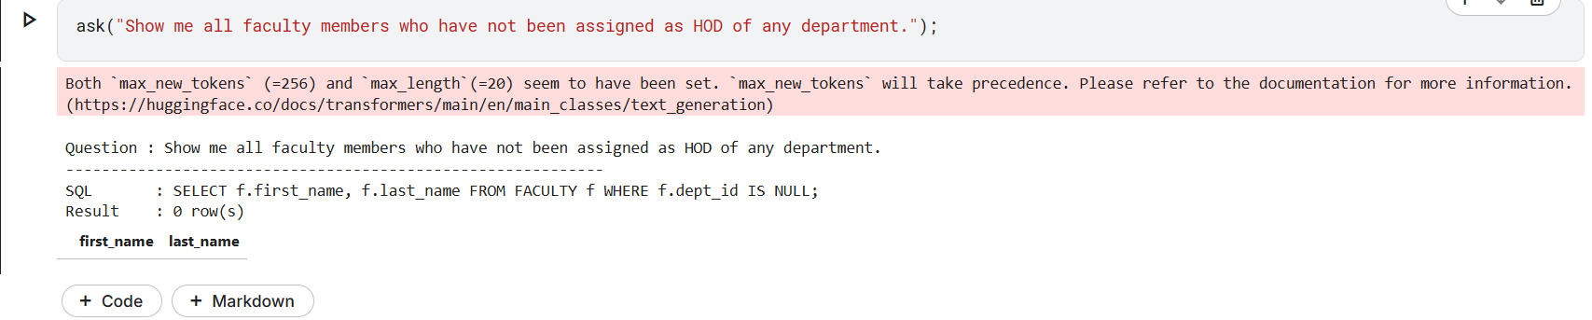

Error Report:

First, it searched for HOD info in the wrong table. The HOD is stored in DEPARTMENT.hod_id, not FACULTY.dept_id. Second, it used the wrong logic. Checking NULL dept_id finds faculty with no department, not faculty who are not HODs.

Query 12: Ambiguous Phrasing Failures

Natural Language Input: Show me a few students who have low attendance.

Output:
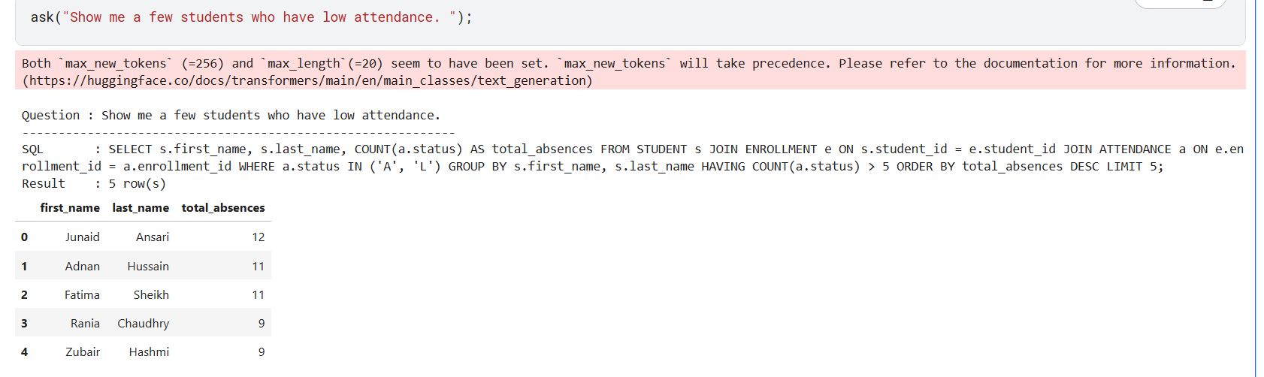

Error Report:

The query executed successfully but made hidden assumptions on its own. It treated “a few” as LIMIT 5 and defined “low attendance” as more than 5 combined A and L absences, even though the user never specified these conditions. Another person asking the same question could easily expect different results.

Bonus A
Ollama Integration

DuckDB Model - What went wrong?
At first we used DuckDB nsql on Ollama. Since it was made for SQL, it looked like the obvious choice. But the issue was that it is trained for DuckDB syntax, not SQLite/MySQL. That messed up a lot of queries. We kept fixing prompts, adding hints, but it still ignored them.
Why we switched to Mistral?
It’s a general model that fits easily within Kaggle’s free GPU limit and works much better. Instead of sticking to one SQL syntax, it mostly writes in ANSI SQL, which works well with SQLite.
What is ANSI SQL?
ANSI SQL is basically the standard version of SQL. It’s the common set of rules almost every database follows.
Comparing Mistral (Ollama) Against the Hugging Face Baseline
Prompt 1: Show me all the courses being offered in the computer science department.
Hugging Face Result:

Ollama Result:
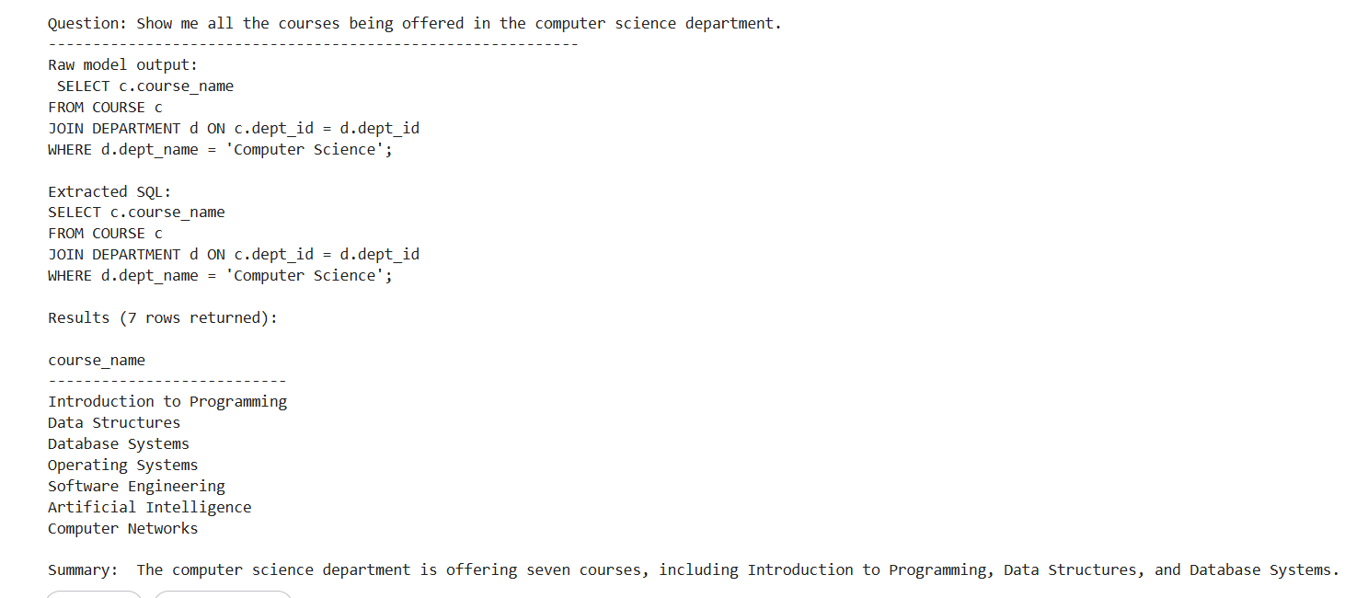
Which is better and why?
Hugging Face does better here since it gives a more complete SQL query and shows both course names and credit hours in a table. Mistral still works, but it only returns course names, so some useful details are missing.

Prompt 2: List out all the students that live in the city Lahore.
Hugging Face Result:


Ollama Result:
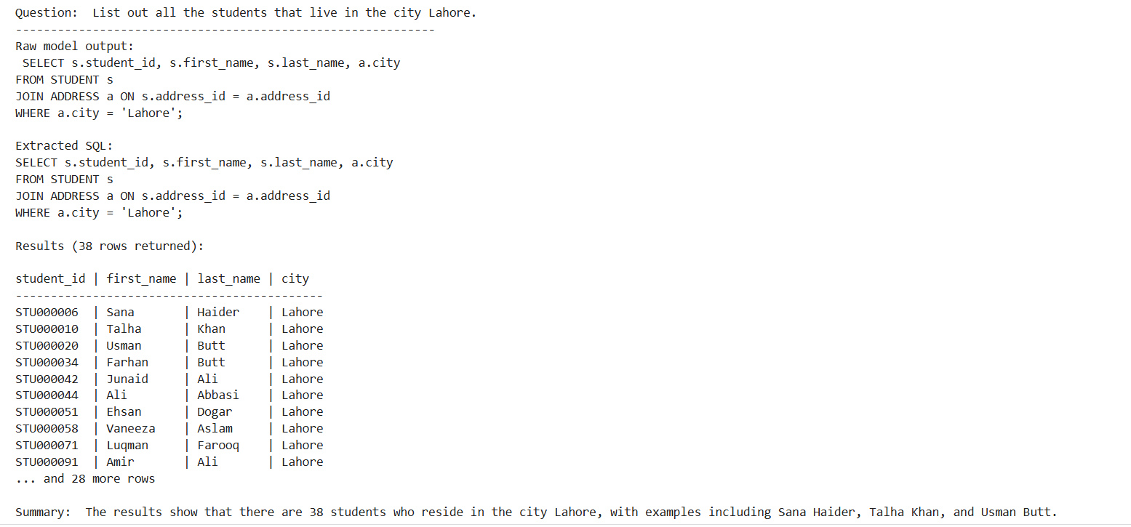
Which is better and why?
Mistral is better here because it returns all 38 students from Lahore, so you actually get the full list like the question asks. Hugging Face only shows 5 results because of a LIMIT 5, which doesn’t really fit the “list all” request. Mistral uses city = 'Lahore' for exact matches, while Hugging Face uses LIKE '%Lahore%', which can also include partial matches.

Prompt 3: Show me all the courses being offered in the computer science department.
Hugging Face Result:
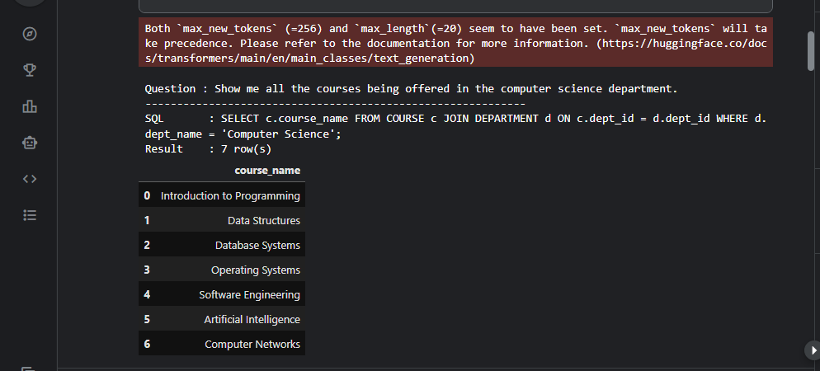

Ollama Result:


Which is better and why?
It’s a tie as both return the same 7 courses with the same logic.

Prompt 4: Find faculty members that are over the age of 50 and teach in the computer science department.
Hugging Face Result: 

Ollama Result:
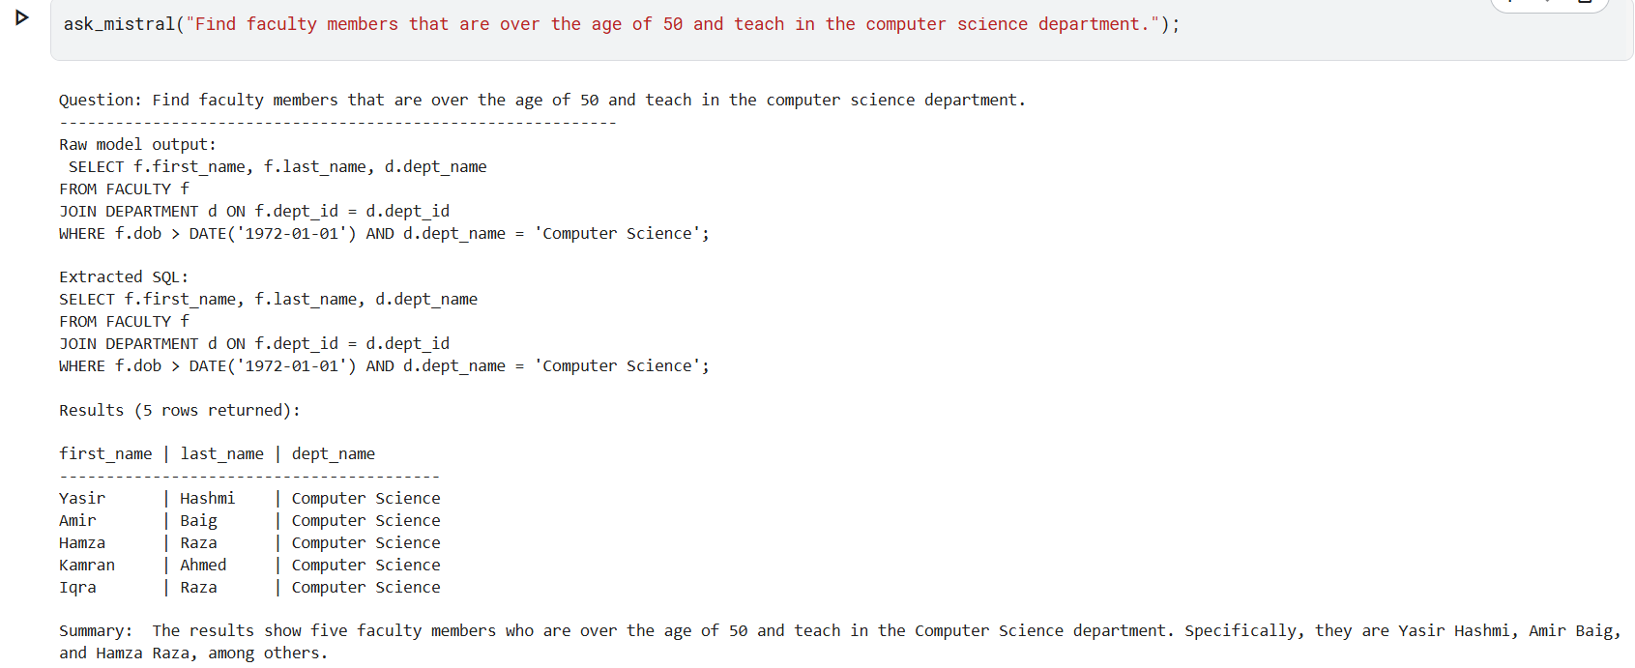
Which is better and why?
Hugging Face is better here because it uses the correct age calculation and returns the right 3 faculty members who are over 50. Mistral uses dob > DATE('1972-01-01'), so the query gives incorrect results even though the output looks fine.
Prompt 5: Show the faculty ID, first name, last name, and department name for each faculty member. Include the total number of unique sections they teach and the total number of students enrolled in their sections. Sort the results by the total number of students in ascending order.
Hugging Face Result:

Ollama Result:
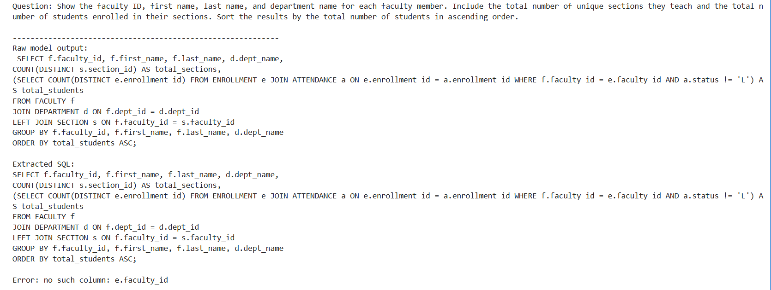

Error 1: Mistral basically took a shortcut that doesn’t exist. It connected FACULTY directly to ENROLLMENT using e.faculty_id, but that column isn’t even in the ENROLLMENT table. The proper link should be: FACULTY → SECTION → ENROLLMENT.

Fixed Prompt:
Show the faculty ID, first name, last name, and department name for each faculty member. Include the total number of unique sections they teach and the total number of students enrolled in their sections. Sort the results by the total number of students in ascending order. Hint: Join FACULTY to DEPARTMENT using dept_id, then JOIN FACULTY to SECTION using staff_id as the join key, then JOIN SECTION to ENROLLMENT using section_id. Do not join FACULTY directly to ENROLLMENT - there is no faculty_id column in ENROLLMENT.

Result:
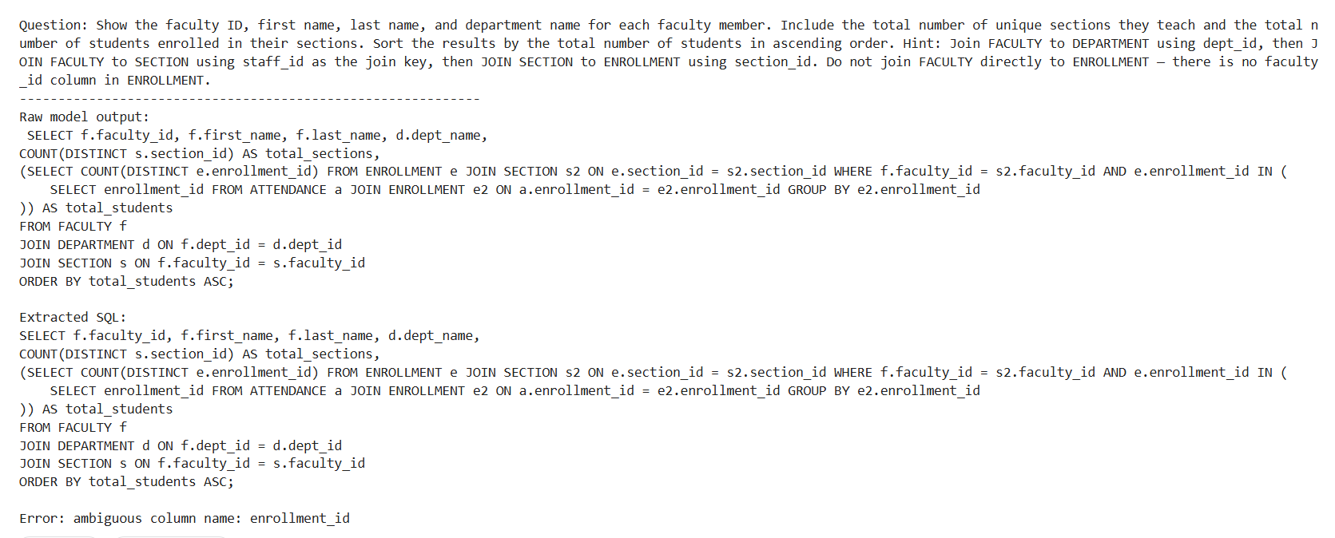

Error 2: Even after being given a detailed hint, Mistral repeated the same mistake by using the made-up s2.faculty_id column and also reused the alias e for two tables, which ended up confusing SQLite completely.

Fixed Prompt: Show the faculty ID, first name, last name, and department name for each faculty member. Include the total number of unique sections they teach and the total number of students enrolled in their sections. Sort the results by the total number of students in ascending order. Use only simple JOINs, do not use subqueries. Join FACULTY to DEPARTMENT using dept_id. Join FACULTY to SECTION using f.faculty_id = s.faculty_id. Join SECTION to ENROLLMENT using s.section_id = e.section_id. Group by faculty_id, first_name, last_name and dept_name. Use COUNT(DISTINCT s.section_id) for total sections and COUNT(DISTINCT e.enrollment_id) for total students.

Result:
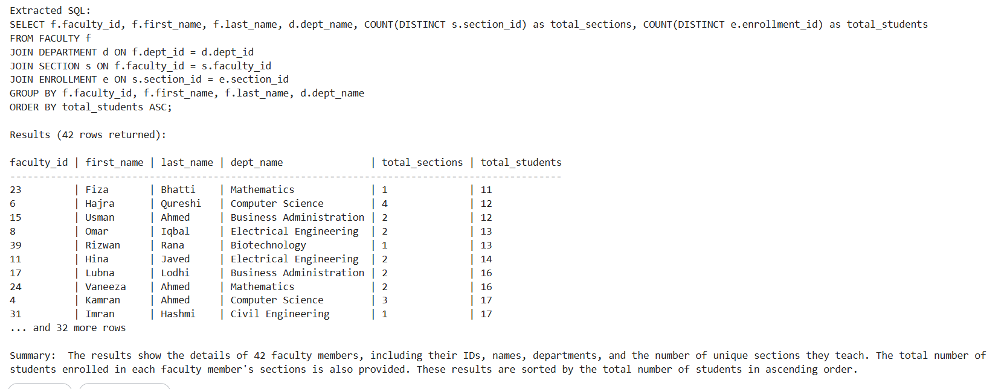

What was the fix? The model was told exactly which joins to use, which columns to group by, and which COUNT expressions to apply.

Which is better and why?
Hugging face is better here because it handles the complex multi-table query better. Mistral, on the other hand, kept hallucinating columns and failed twice before getting it right.

Prompt 6: Show me all students who are on academic probation. Hint: A student is on probation if their final_grade in any enrollment is 'F'. Use the ENROLLMENT table.
Hugging Face Result:


Ollama Result:
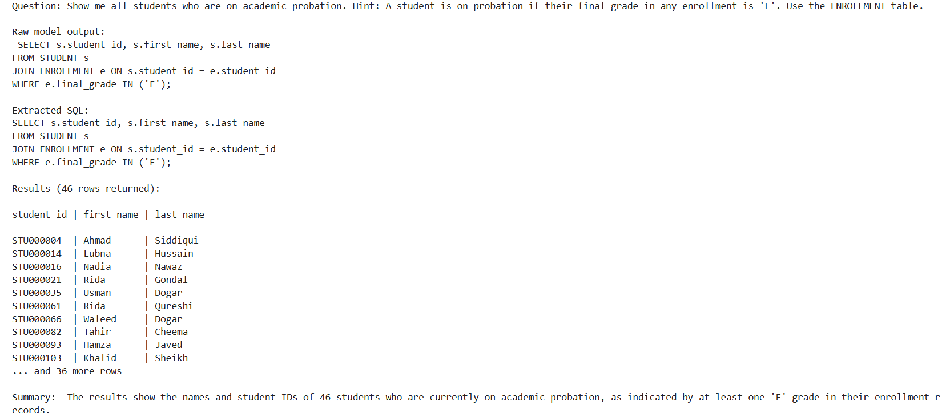

Which is better and why?
It’s a tie as both models used the same query logic and returned the exact same 46 rows.

Bonus B
Prompt Engineering Fixes

We have implemented this bonus throughout Task 2. We made sure that whenever an error was generated, that we understood that error and worked towards finding a solution, most of the time through prompt engineering fixes.
Primarily, our prompt engineering fixes fell into three categories. The first one and the most obvious was question rephrasing. We gave the model explicit hints to try to get it on the right track, this technique was used in queries 3,5,6,8, and 10 where we added join paths, domain definitions, and SQLite-specific function hints directly into the question. The second approach we employed was post-processing SQL fixes, this was used in query 4 where we automatically replaced ILIKE with LIKE in the ask function before execution to handle PostgreSQL dialect output. The third was domain vocabulary clarification which we use in query 10 where we defined academic probation explicitly in the prompt since the model had no schema column to reference.

Bonus C
Interactive Chat Interface
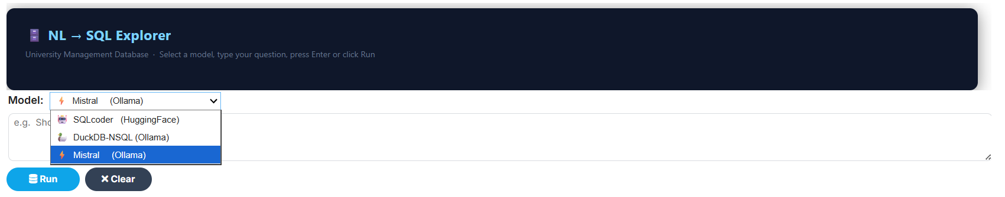
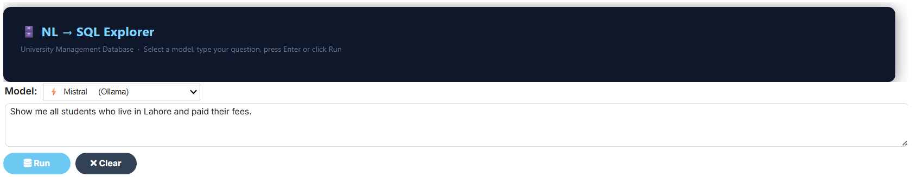
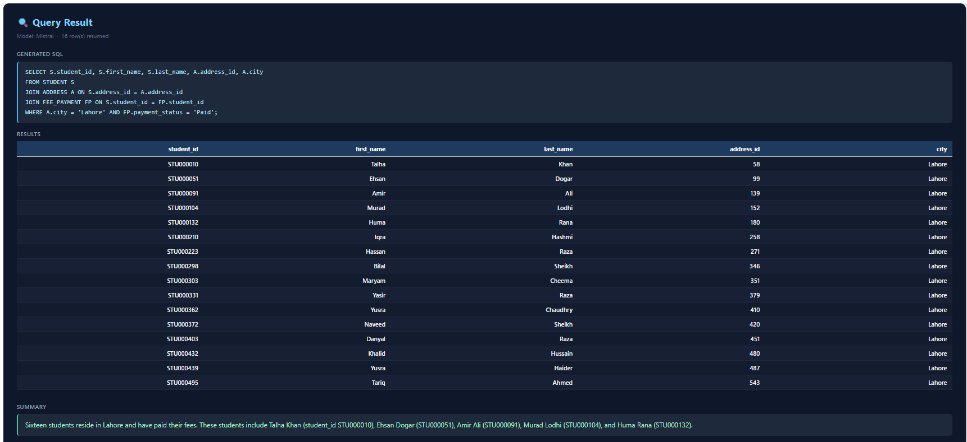

Task 03
Written Report & Reflection

3a: Technical Report
- System Architecture:
The pipeline consists of three main parts: a SQLite database, the LangChain framework and a Hugging Face language model.
The SQLite database holds all the university data across twelve tables (ADDRESS, DEPARTMENT, FACULTY, DEGREE, SEMESTER, COURSE, SECTION, STUDENT, ENROLLMENT, ATTENDANCE, FEES and FEE_PAYMENT). The database was built in Part 1 and is loaded here as a SQLite file.
The Hugging Face model reads the formatted prompt and generates the SQL query as output. The model we used is defog/sqlcoder-7b-2, which is fine-tuned specifically for SQL generation.
LangChain acts as the bridge between the model and the database. It takes the user's question, formats it into a prompt that includes the schema, sends it to the language model and then reads through the response to find and extract the SQL query. The specific chain used is create_sql_query_chain, which was designed exactly for this kind of task.
The CUSTOM_TABLE_INFO dictionary is a key design choice. Instead of letting LangChain auto-generate table descriptions from raw schema, we wrote our own short descriptions for each table. These descriptions explain what the table stores, which columns matter, what the primary key is and how it connects to other tables. This makes it much easier for the model to understand the schema and build correct joins.
Once the model returns a SQL query, the system runs it directly against the SQLite database using Python's sqlite3 library. The results are shown as a table using pandas, and then the same language model is asked to write a short plain-English summary of what the results mean.
- Model Selection:
The model chosen was defog/sqlcoder-7b-2, a 7-billion parameter model fine-tuned specifically for SQL generation by Defog AI. It was picked because it is trained on text-to-SQL tasks across many different schemas which means it already understands SQL syntax and handles joins much better than a general-purpose model of the same size. It depends heavily on correct schema input. Since our whole project was based on querying a university database, using a model built specifically for SQL tasks made the most sense.
For the bonus section, duckdb-nsql via Ollama was also tested. It is a smaller 3B model that runs fully locally without a Hugging Face token. It is quicker to set up but noticeably weaker on joins and nested queries that mess up a lot of queries. So we shifted to Mistral via Ollama. It’s a general model that fits easily within Kaggle’s free GPU limit and works much better. Instead of sticking to one SQL syntax, it mostly writes in ANSI SQL, which works well with SQLite.

- CUSTOM_TABLE_INFO Design:
By default, LangChain shows the model a raw CREATE TABLE statement and a few sample rows. That gives the model column names and data types but it does not explain what the data actually means.
For example, the ATTENDANCE table has a column called status that stores values like 'P' and 'A'. Without a description, the model might guess the wrong values or not realise that 'A' means absent. Our description for ATTENDANCE explicitly states this.
For tables with foreign keys, we always mentioned the relationship. for example, 'hod_id links to FACULTY.faculty_id'. This helps the model build the correct JOIN condition rather than guessing column names.
We also noted non-obvious formatting in the descriptions. For example, the STUDENT table uses a student_id formatted like STU000001. Without mentioning this, the model tends to treat it like a number.
The overall impact of writing these descriptions was noticeable. Queries that involved multiple joins or specific column values worked much better once the descriptions were in place.
- Results Summary:

Query Category | Outcome | Notes
Total student count (simple COUNT) | Correct | Single-table aggregation and no JOIN required
Courses in CS department | Correct | Simple two-table JOIN
Average section capacity | Correct | AVG aggregation on single table
Courses by enrolment count (no hint) | Wrong | Model attempted direct COURSE to ENROLLMENT join and missing SECTION bridge
Courses by enrolment count (with hint) | Correct | Explicit join path hint resolved the three-table chain
Students in Lahore | Correct | JOIN via ADDRESS table and city filter
Absent students with dates (word 'Absent') | Wrong | Model generated WHERE status = 'Absent' instead of 'A'
Absent students (status='A' with hint) | Correct | Explicit ENUM value in question resolved the predicate
Faculty over 50 in CS (no hint) | Wrong | Model used standard SQL date arithmetic; SQLite's strftime needed
Faculty over 50 in CS (with strftime hint) | Correct | SQLite-specific function hint corrected the date predicate
Faculty teaching load summary (complex) | Correct | Five-table JOIN with COUNT DISTINCT; model handled correctly
Students who paid via 'Online Payment' (vague) | Wrong | Ambiguous literal; model used wrong column or value
Students who paid via 'Online' (with hint) | Correct | Precise table and value hint resolved the ambiguity
Department with most courses | Correct | GROUP BY with ORDER BY + LIMIT 1
Attendance % and 75% policy classification | Correct | CASE-WHEN logic and subquery
Faculty not in Lahore | Correct | NOT condition on joined ADDRESS.city
Students with low attendance (vague) | Partial | Returned results but definition of 'low' was arbitrary

Overall, the model succeeded on roughly 60-70% of questions without hints. With well-written hints, that number went up to around 90%. The remaining failures were mostly on queries that required understanding concepts not directly visible in the schema.

- Limitations:
i. Conceptual gap between language and schema:
The model only understands what is clearly stored in the database. If someone asks “students at risk of failing,” the database doesn’t know what “at risk” means unless a rule like marks < 50% is already defined. So, the model understands the words but the database only has raw data. This creates a gap that cannot be fully fixed just by better prompts.
ii. Different SQL variations:
SQL is slightly different in each database system like MySQL, SQLite and PostgreSQL. They use different syntax for things like dates, text search and limits because of this, the model may sometimes generate queries in the wrong format. It can’t always know which database is being used unless clearly told and even then it may still make mistakes.

3b: Reflection

What surprised me most was how much the system depended on column names to understand a question. I thought it would use the descriptions we wrote but most of the time it just matched words from the question with column names in the schema. When the words were similar, the query worked well. When they were different, like asking about “probation” when the column was named final_grade, it often gave wrong results.
Our Part 1 design choices mattered more than I expected. We normalised the database a lot, which is good in real systems, but it made things harder here. For example, a simple question like “Show absent students with their names” needed multiple joins between tables. Sometimes the system stopped early and missed a table. If we had kept some data in one table (less normalised), it would have been much easier to answer such questions even if it’s not the best design practice.
Column names also played a big role. Some names were short or unclear, like sem_session instead of semester_name. These were harder to match with natural questions. Clear and complete names worked much better.
If I redesigned the database for easier question answering, I would use longer, clearer column names. I would also add ready-made views, like one that already shows attendance percentage, so less calculation is needed and instead of short codes like “P” and “A”, I would store full words like “Present” and “Absent”.
Another important thing is how people ask questions. Different users use different words for the same idea. One person might say “failed,” another might say “low marks,” and someone else might say “at risk.” If the database and column names don’t match these common ways of speaking, it becomes harder to get correct results. So, designing a database is not just about technical rules, it should also consider how real people think and ask questions.

