NETWORK PROTOCOL CONFIGURATION & SECURITY LAB
Submitted By:
Your Name: MOHAMMED ALI HUSSAIN
Course:
CCNA (Diploma in Cyber Security)
Institute:
Indian Cyber Security Solutions
Academic Year:
2026

1. INTRODUCTION
Computer networks are essential for communication, resource sharing, and secure data transfer in modern organizations. This project focuses on configuring multiple networking and security protocols in a simulated enterprise LAN environment using Cisco Packet Tracer.
The project demonstrates practical implementation of network communication, server services, remote administration, network segmentation, and switch security.

2. OBJECTIVE
The objective of this project is:
- To design an enterprise LAN topology.
- To configure networking protocols.
- To implement server-based services.
- To secure switch access.
- To verify communication between devices.

3. TOOLS USED
Software Used:
- Cisco Packet Tracer
Hardware Components:
- Cisco 2960 Switches
- PCs
- Server

4. NETWORK TOPOLOGY
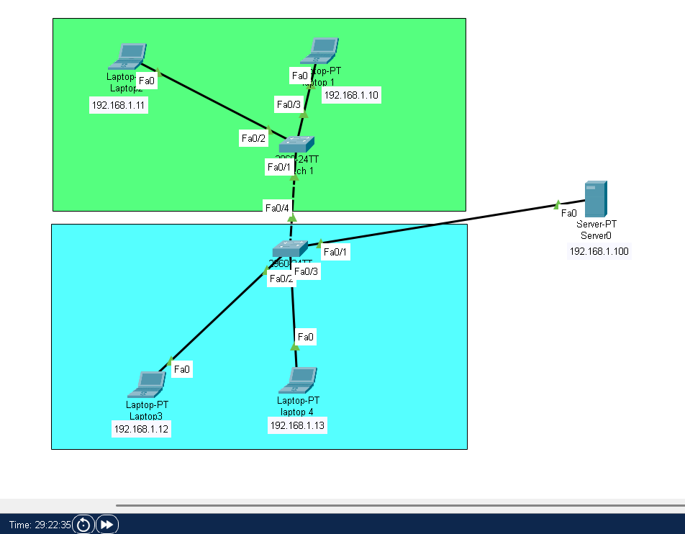

5. PROTOCOL CONFIGURATION
5.1 Address Resolution Protocol (ARP)
Purpose:
ARP is used to map IP addresses to MAC addresses within a local network.
Configuration:
ARP entries were generated automatically during communication between hosts.
Verification:
The command arp -a was used on PC1.
Result:
ARP table successfully displayed MAC address mappings.
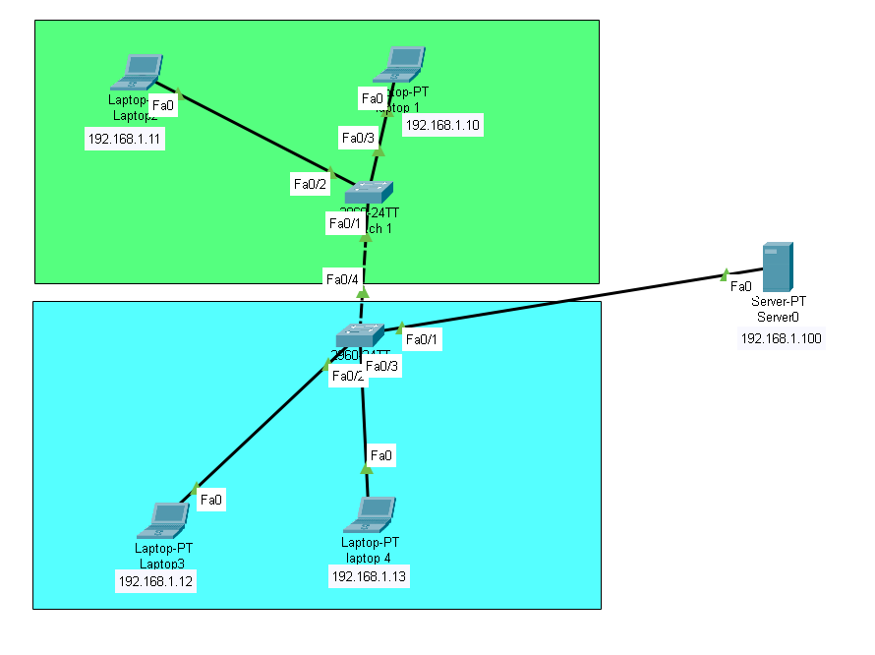

5.2 Internet Control Message Protocol (ICMP)
Purpose:
ICMP is used for connectivity testing.
Configuration:
Ping requests were sent from PC1 to other devices.
Verification:
Ping command used successfully.
Result:
All devices responded successfully.
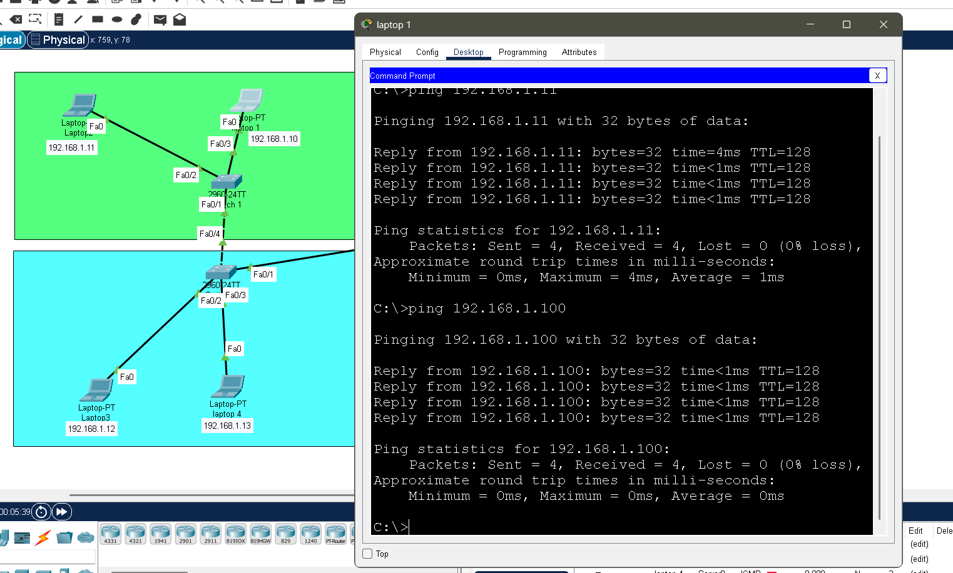

5.3 Dynamic Host Configuration Protocol (DHCP)
Purpose:
DHCP automatically assigns IP addresses to client devices.
Configuration:
DHCP service was enabled on the server.
Verification:
PC4 received an IP address dynamically.
Result:
DHCP service worked successfully.
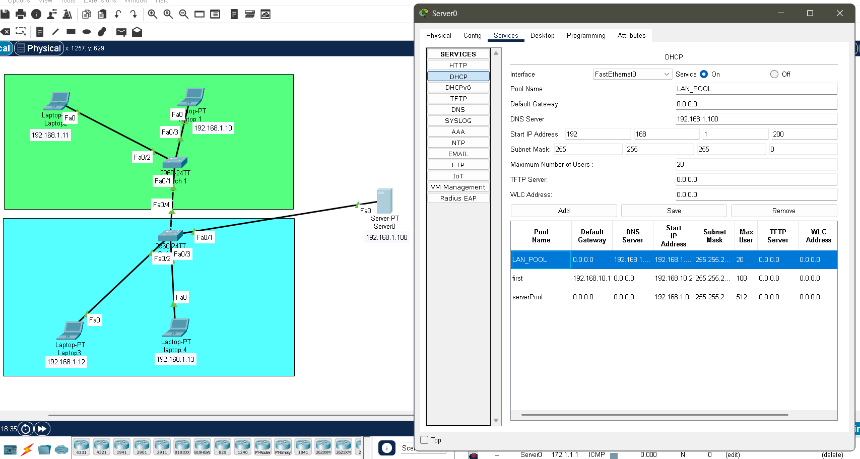

5.4 Domain Name System (DNS)
Purpose:
DNS converts domain names into IP addresses.
Configuration:
Domain company.local was mapped to server IP.
Verification:
The domain opened successfully in browser.
Result:
DNS resolution successful.
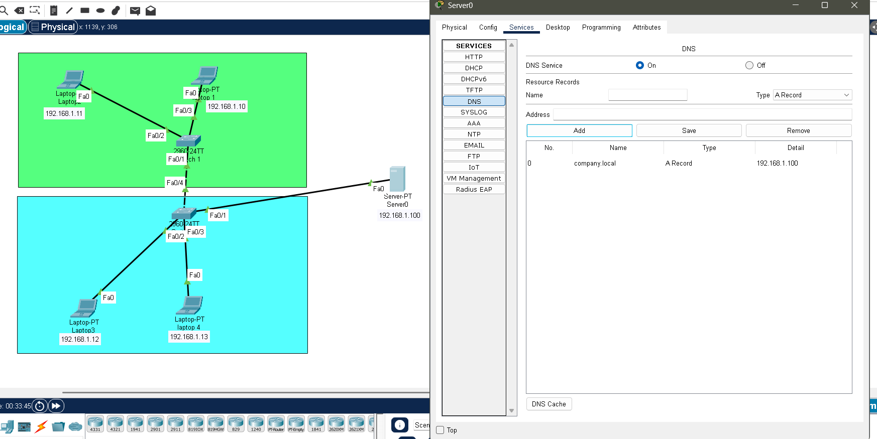

5.5 Hypertext Transfer Protocol (HTTP)
Purpose:
HTTP provides web communication.
Configuration:
HTTP service enabled on server.
Verification:
Custom webpage opened on client browser.
Result:
HTTP service working successfully.
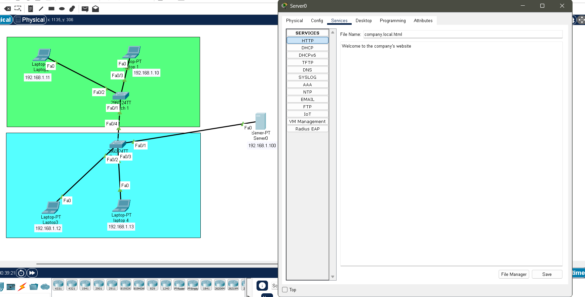

5.6 Hypertext Transfer Protocol Secure (HTTPS)
Purpose:
HTTPS provides secure web communication.
Configuration:
HTTPS service enabled on server.
Verification:
Secure webpage accessed successfully.
Result:
HTTPS service working successfully.
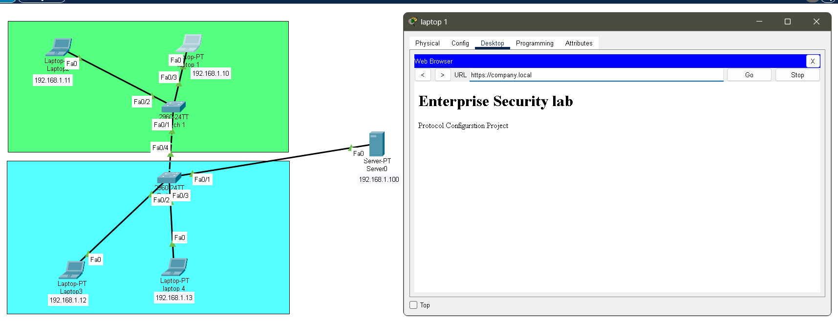

5.7 File Transfer Protocol (FTP)
Purpose:
FTP enables file transfer between client and server.
Configuration:
FTP user account created on server.
Verification:
FTP login performed successfully.
Result:
FTP service working successfully.
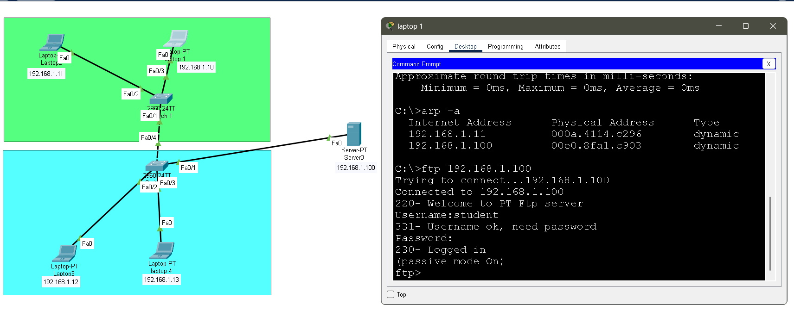

5.8 Secure Shell (SSH)
Purpose:
SSH enables secure remote device administration.
Configuration:
SSH version 2 configured on switch.
Verification:
show ip ssh command confirmed SSH enabled.
Result:
SSH configured successfully.
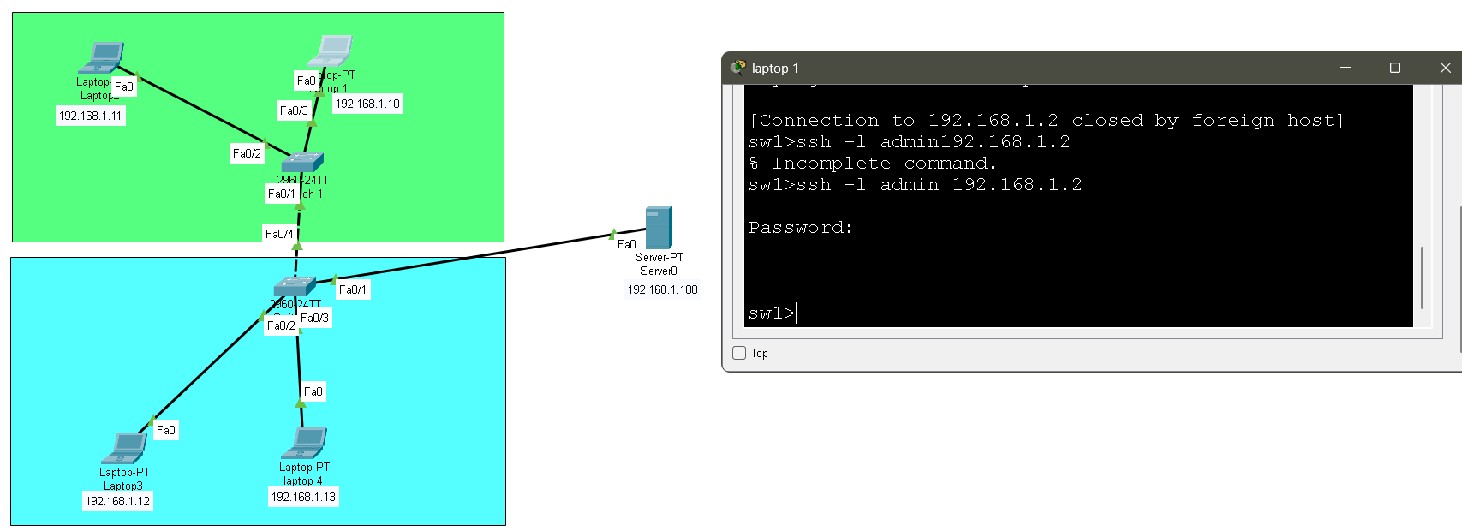

5.9 Telnet
Purpose:
Telnet provides remote command-line access.
Configuration:
VTY lines configured on switch.
Verification:
Telnet login performed successfully.
Result:
Telnet configured successfully.
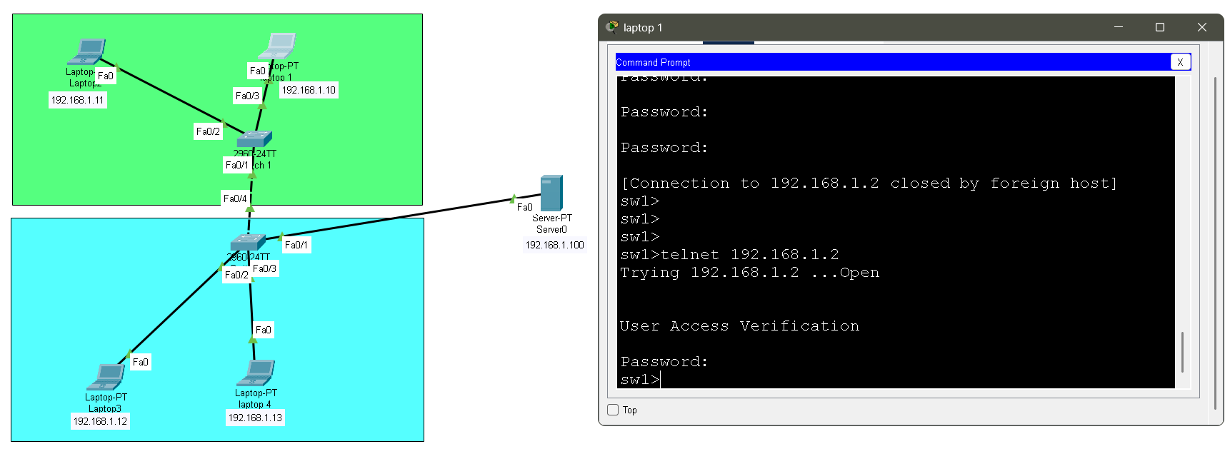

5.10 Virtual Local Area Network (VLAN)
Purpose:
VLAN logically separates users into different networks.
Configuration:
VLAN 10 and VLAN 20 created.
Verification:
show vlan brief command used.
Result:
VLANs configured successfully.
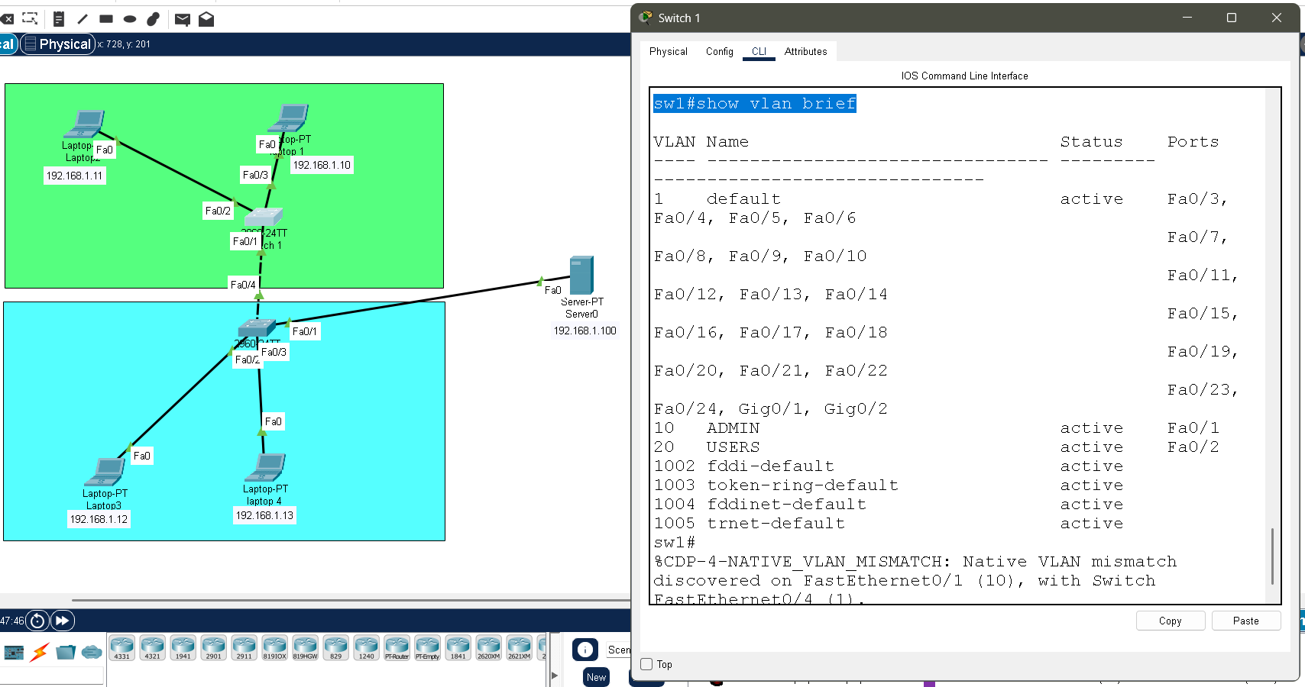

5.11 Spanning Tree Protocol (STP)
Purpose:
STP prevents switching loops.
Configuration:
Default STP verified on switch.
Verification:
show spanning-tree
Result:
STP running successfully.
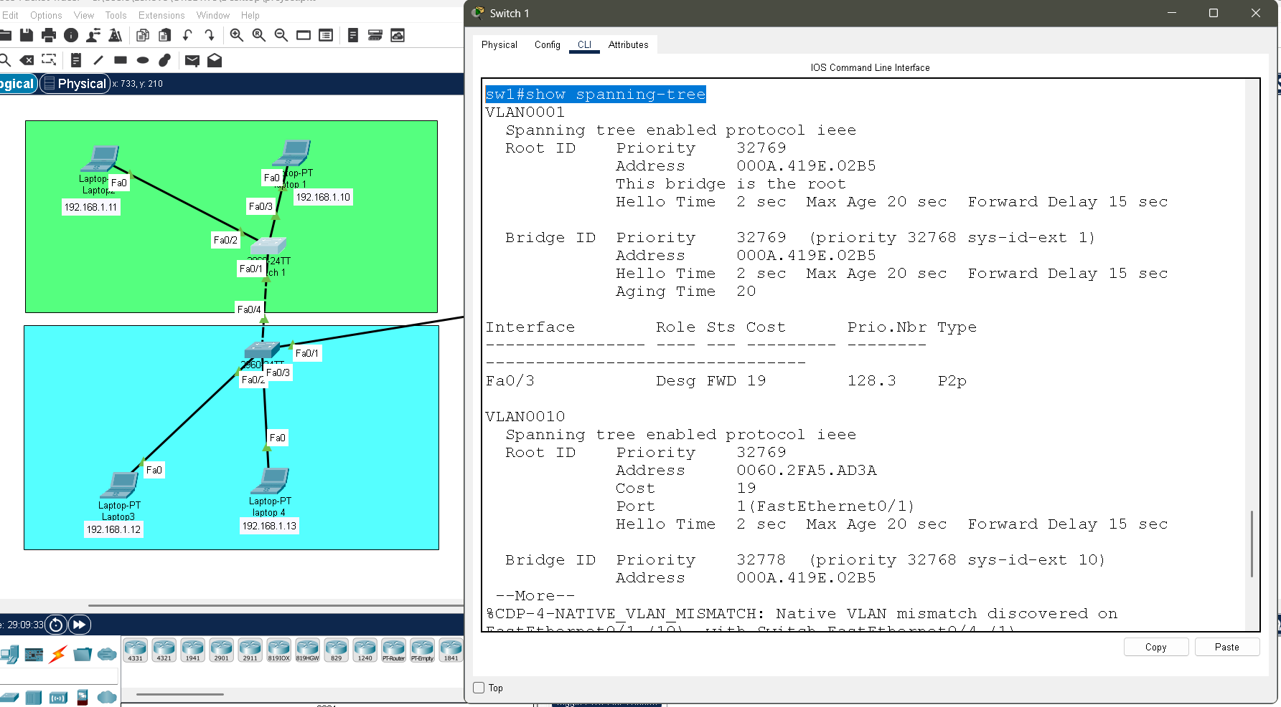

5.12 Port Security
Purpose:
Port security restricts unauthorized device access.
Configuration:
Port security enabled on FastEthernet 0/1.
Verification:
show port-security interface fa0/1
Result:
Port security successfully enabled.
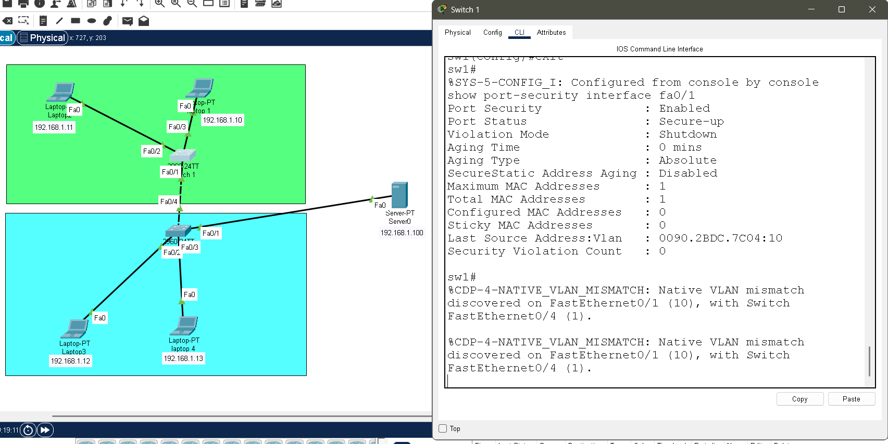

6. CONCLUSION
This project successfully demonstrated the configuration and verification of multiple networking and security protocols in an enterprise LAN environment using Cisco Packet Tracer.
Skills gained during this project include:
- Network design
- Protocol configuration
- Server management
- Remote administration
- Network segmentation
- Switch security
The project enhanced practical knowledge in networking and cybersecurity.

