ASSIGNMENT SUBMISSION COVER SHEET

Student Id: cse24-017

Student names: Gomolemo Meso

Student email: cse24-017@thuto.bac.ac.bw

Cohort: 2025

Assignment title: SCIS OOAD-JAVA_2025

Date of submission: 19 September 2025

Programme of Study: Computer Systems Engineering

Year of Study: Year2

Intellectual property statement

By checking the box below, I certify that this assignment is my own work and is free from plagiarism. I understand that the assignment may be checked for plagiarism by electronic or other means and may be transferred and stored in a database for the purposes of data-matching to help detect plagiarism. The assignment has not previously been submitted for assessment in any other unit or to any other institution. I have read and understood the Botswana Accountancy College plagiarism guidelines policy.

* Agree

Signature……………G.Meso…………. Date…19-09-2025………

REQUIREMENTS ELICITATION

* Functional requirements

Introduction: The Banking System is designed to manage customer accounts and transactions. The core functional requirements, derived from client interviews, are as follows:

* Customer management:
* The system shall allow a new customer to register by providing their first name, surname and address.
* The system shall allow a customer to log in (user authentication).
* Account management:
* The system shall allow a logged-in customer to open a new account. The type of account (Savings, Investment, Cheque) must be specified.
* The system shall enforce account-specific opening rules:
* Investment Account: requires an initial deposit of at least BWP 500.00.
* Cheque Account: requires the customer to provide employment details (company name and address).
* The system shall allow a customer to view all their accounts.
* Transaction management:
* The system shall allow a customer to deposit funds into any of their accounts.
* The system shall allow withdrawals from Investment and Cheque accounts but not from Savings accounts.
* The system shall automatically calculate and pay monthly interest:
* Investment Account: 5% monthly interest.
* Savings Account: 0.05% monthly interest.
* The system shall maintain a transaction history for each account.
* Non-Functional requirements
* Security: customer data and account balances must be secure. Access to the system shall require authentication.
* Usability: the user interface shall be intuitive and easy to navigate for users with basic computer skills.
* Performance: the system should respond to user actions (e.g login, deposit) in under 3 seconds.
* Reliability: the system must be available during banking hours (e.g 8AM to 5PM) with minimal downtime.
* Maintainability: the code shall be well-structured, and banking documented using OOP principles to allow for future updates.

Appendicle of the Interview Record:

1. Do we register a customer?

No, we open an account.

1. Are all the transactions recorded?

Yes, and the date and remaining balance.

1. Should the monthly interest require human approval before finalization, or should they be fully automated?

Yes, it's automated.

1. For opening an account for a customer is it done online?

Yes, it's online for easier access.

Interview Date: 18-September-2025

Time: 08:33am

Attendees: GOMOLEMO MESO(ANALYST), KENTSENAO BASEKI(CLIENT)

SYSYTEM USE CASE DIAGRAM

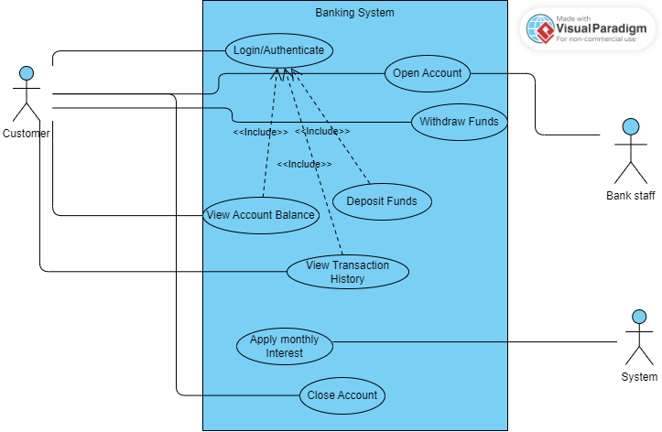

CLASS DIAGRAM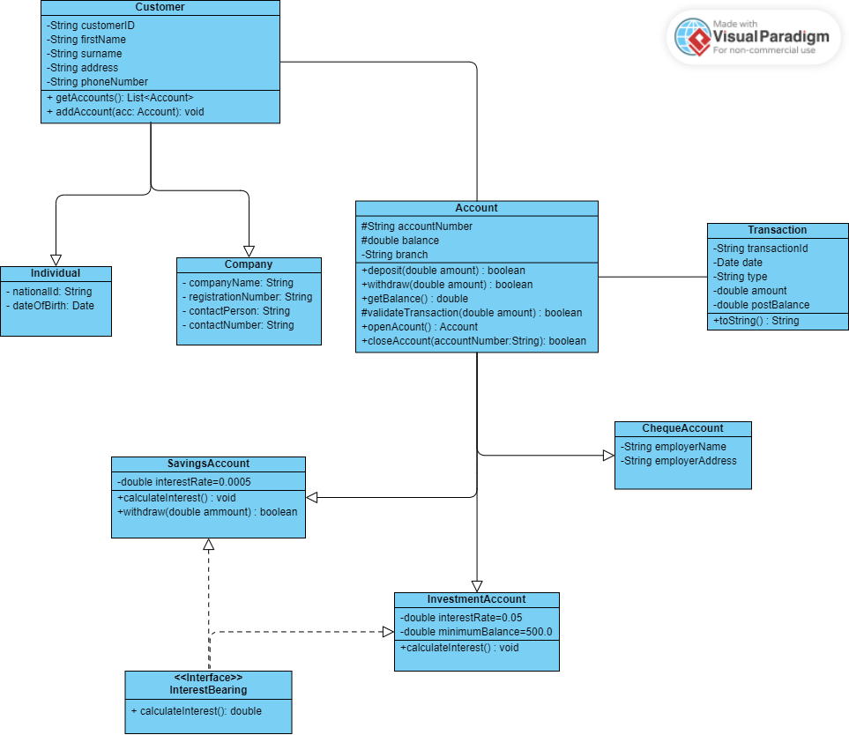

BEHAVIOURAL UML MODELLING

SEQUENCE DIAGRAMS

Login Sequence Diagram

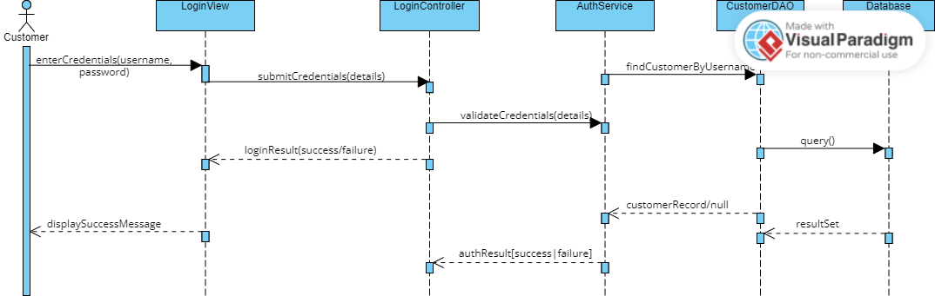

Deposit Sequence Diagram

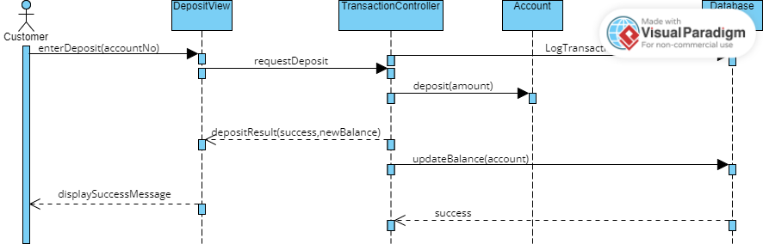

STATE DIAGRAM

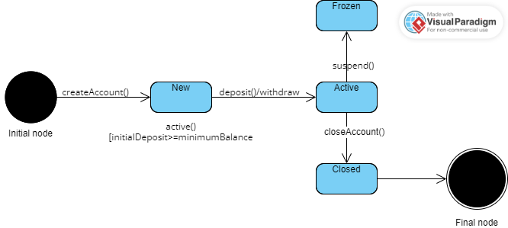

Meeting record appendix

<https://mybac.sharepoint.com/:v:/s/20252026cse202objectorientedanalysisanddevelopmentwithjav/ETK2KNDOJNNCgI3WOcFy_XUB57nHHAzNSlG9JaieWIF_jg?e=zV5bbi>