

E-VOTING SYSTEM

By

Muhammad Basit Farogh (BB-3693)

M. Ghufran Khan (BB-3786)

Umair (BB-3699)

M. Nabeel Khan (BB-3728)

Jawad Ahmed (BB-3727)

A Project

Submitted in partial fulfillment of the

requirements for the degree of Bachelors of Science

to Office of Research, Innovation & Commercialization

(ORIC), Institute of Business &

Technology, Karachi

Karachi,

Pakistan

DECEMBER,

2016

**Acknowledgements**

By the grace of Almighty Allah, we are able to present this proposal on **E-Voting System.**

In completing this graduate project, we have been fortunate to have help, support and encouragement from many people. We would like to acknowledge them for their cooperation.

First, we would like to thank our project supervisor **Zameer Ahmed** for guiding us through each and every step of the process with knowledge and support. Thank you for your advice, guidance and assistance.

We are especially thankful to our parents for praying us, and our siblings providing us help in relevant field and thanking to all our Teachers who taught us till this level.

Furthermore, we would like to thanks our coordinators for their dedication, encouragement and support throughout this project.

**Abstract:**

The implementation of advanced technologies in elections becomes more effectual, beneficial and valuable to eliminate the fraud attempts in voting, to get the accurate voting results and to raise the voter turnout. There are various types of E-Voting System that have introduced and implemented, but they have different vulnerabilities. So this dissertation proposed a new prototype that deals with the design, development and security of a Fingerprint Electronic Voting System based on Android Application. The proposed voting system allows the voter to scan the fingerprint for examining the authentication by matching with the pre-stored fingerprint template in database by using an algorithm. Once the voter completes the verification process, the application automatically allows a voter to cast his vote using friendly graphical user interface design. The vote counting process will be done automatically after the completion of voting time and that makes the voting process efficient, fast, and secure.

**Keyword:**

*Fingerprint; E-voting System; Android Application, graphical user interface; Authentication; Algorithm; verification; Database;*

**Table of Contents**

|  |  |  |
| --- | --- | --- |
| S.NO. | DESCRIPTION | PAGE  NO. |
| 1. | Acknowledgements.……………………………………………. | ii |
| 2. | Abstract…………………………………………………………. | iii |
| 3. | List of Tables…………………………………………………… | vi |
| 4. | List of Figures.…………………………………………………. | vii |
| 5. | Chapter 1: Introduction…………………………………………  1.1. Overview……………………………………………….  1.2. Problem Statement……………………………………..  1.3. Research Objective…………………………………….  1.4. Definition of Terms……………………………………  1.5. Background of the Research…………………………...  1.6. Challenges……………………………………………..  1.7. Proposal Contribution…………………………………  1.8. Proposal Organization………………………………… | 8  8  9  9  10  11  11  12  13 |
| 6. | Chapter 2: Literature Review……………………………………  2.1. Reviews of E-Voting System……………………………  2.2. International Status of E-Voting System………………..  2.3. Summary | 14  14  23  25 |
| 7. | Chapter 3: Methodology…………………………………..  3.1. Overview……………………………………………….  3.2. Research Approach…………………………………….  3.3. Problem Identification…………………………………  3.4. Technical Research…………………………………….  3.4.1. Fingerprint Recognition…………………………..  3.4.2. Fingerprint Classification…………………………  3.5. Project Process Chart…………………………………..  3.6. Software Development Methodology………………….  3.7. System Components……………………………………  3.7.1. Hardware………………………………………….  3.7.2. Software…………………………………………..  3.8. Components Specification……………………………..  3.9. System Design…………………………………………  3.10. System Functionality…………………………………. | 27  27  28  28  29  29  29  32  34  36  36  37  40  41  48 |

|  |  |  |
| --- | --- | --- |
| 8. | Chapter 4: Results…………………………………………  4.1. Overview………………………………………………..  4.2. Simulation and Data Analysis…………………………..  4.3. Securities Analysis………………………………..........  4.4. Comparison of Fingerprint Technology with other Biometric Systems…………………………………………..  4.5. Comparison Chart of Different Voting Systems……….  4.6. World Map of E-Voting System ………………………  4.7. Opinions Regarding E-voting System…………………. | 51  51  51  52  53  54  55  56 |
| 9. | Chapter 5: Discussion, Conclusion & Future Work……………...  5.1. Discussion……………………………………………….  5.2. Conclusion………………………………………………  5.3. Future Work…………………………………………….. | 57  57  58  59 |
| 10. | References……………………………………………………… | 60 |

**List of Tables**

|  |  |  |
| --- | --- | --- |
| S.No. | TABLE(S) | Page  Number |
| 1. | 3.1. Software and Hardware Components Specification | 40 |
| 2. | 4.1. Ratio Percentage of FAR and FRR | 53 |
| 3. | 4.2. Comparison of Different Voting System | 54 |
|  |  |  |
|  |  |  |
|  |  |  |
|  |  |  |
|  |  |  |

**List of Figures**

|  |  |  |
| --- | --- | --- |
| S.No. | FIGURE(S) | Page  Number |
| 1. | 3.1. Steps of Research Report | 28 |
| 2. | 3.2. Types of Fingerprints | 30 |
| 3. | 3.3. Identification Characters | 31 |
| 4. | 3.4. Block Diagram of Minutiae Matching | 31 |
| 5. | 3.5. Image Enhancement through Computation | 32 |
| 6. | 3.6. Project Process Flowchart | 33 |
| 7. | 3.7. RAD Model Diagram | 35 |
| 8. | 3.8. System Design Flowchart | 41 |
| 9. | 3.9. Conceptual Overview Of E-voting System | 42 |
| 10. | 3.10. Database Block Diagram | 43 |
| 11. | 3.11. Fingerprint Algorithm | 43 |
| 12. | 3.12. Integrated system workflow | 44 |
| 13. | 3.13. Layout Design using Adobe Photoshop | 45 |
| 14. | 3.14. Interface Design using XML | 46 |
| 15. | 3.15. Algorithm Functionality Block Diagram | 47 |
| 16. | 3.16. Low Level Block Diagram | 49 |
| 17. | 3.14. High Level Block Diagram | 50 |
| 18. | 4.1. Comparison of E-Voting System among countries | 55 |
| 19. | 4.2. Opinions Regarding E-Voting System | 56 |

**Chapter 1: Introduction**

* 1. Overview:

Pakistan is in a line of developing countries where new technologies are implemented day by day such as Smart CNIC’s, 3G & 4G networks, digital image processing, E-banking etc. and also other technologies implemented in a field of industrial developments , medical & biological sciences and military defense. In 21st century of the world where modernized systems helping in our social and economic life styles but there is still one sector where Pakistan is using its traditional system named as voting. Due to enhancement of technologies many countries are using an E-voting system for their elections known as electronic voting system.

Implementing new technology in a whole election process is very challenging because it requires many years of careful planning detailed structured and lots of trust on the whole entire system. E-voting provides an opportunity for solving the problems of traditional election process such as vote counting, missing stamp, fake voters etc. One common point for introducing this technology is to show the world, the level of internal technological development by a country.

E-voting is a tool for making the whole election process more efficient. Many countries are using this technology for fair elections, time saving and for impartial better results. Unlike the rest of the world Pakistan is still using a traditional paper based voting where each person credentials check manually and after verification it is allowed for giving a vote through ballot paper. E-voting not only provided solutions there is also some challenges and concerns that are moving around this technology and that should be figured out and considered when implementing the E-voting system in a country.

* 1. Problem Statement:

Electronic voting systems are rapidly overlapping the traditional paper-based voting. In traditional voting there are number of factors that make rigging in whole electoral process such as counting of votes, fake voters and involvement of outside sources and also other problems like time consumption, cost budget problems etc. So the purpose of this proposal is to investigate how to model an authentic reliable and upright E-voting system so that a voter is submitted a vote in secure manner while maintaining the time, verification, budget and also the security of the entire system.

* 1. Research Objective:

The expectations, objectives and aims to achieve through the E-voting system are:

* The aim is to develop an efficient and easy prototype of android based E-voting system that provide secure election process and build trust in people regarding this technology and improve voter confidence or experience.
* Prevention of rigging in polling stations during the calculation of results by reducing human interference.
* Reduced the whole budget of election process, such as the amount consumed in production and distribution of election accessories e.g. ballot papers, ballot boxes, voter cards etc.
* Another goal is to help the election management regarding calculation and verification such as fast counting of votes and verification of voters.
  1. Definition of Terms:

1. E- Voting:

E-Voting also known as Electronic Voting, it is basically a voting procedure that allows a voter to cast their vote electronically through different machines and devices in an easy and secure manner. E-voting can eliminate fake votes, speed up the electoral process, increase accessibility and make voting more appropriate for citizens.

1. VVPAT Machines:

VVPAT (Voter Verified Paper Audit Trail) machine also known as VPR (Verified Paper Record) machine used as an electronic voting device. It provides physical evidence of votes that cast in the form of paper receipts. Those receipts are readable by both the voter and machine, and later use for verification and calculation purpose.

1. Biometric Verification:

Biometric Verification is an Identification process used to authenticate a person through its fingerprints and other biological traits such as Human Eye, Voice Recognition, Face recognition etc.

1. NADRA:

NADRA known as National Database and Registration Authority is a government agency works under the interior ministry of Pakistan. It manages data of all citizens of Pakistan and also responsible for issuing NIC’s (National Identity Card) to the national citizens.

* 1. Background of the research:

E-voting is a proactive area of research which is updated year by year by new methodologies, functionalities and new approaches. E-voting can be done through different voting machines like electronic ballot printers, VVPAT machines and internet applications etc. It is first time implemented in 1960’s when punch card systems were introduced. Advance E-voting is implemented in many countries like (Belgium, Brazil, America, India etc.). Many countries even Pakistan is also considering and soon introducing Electronic Voting with the focus of improving many aspects of election process.

In Pakistan the Electronic Voting first time implemented by KPK government along with NADRA in some districts and councils of Peshawar during last year in local bodies election. The KPK government implements an E-voting system based on Biometric (fingerprint) verification, and conducted a successful trial run of the system but this system can only verify the voter through fingerprint and still voting is done through ballot papers. So according to a current situation we are going to develop a Fingerprint E-voting system based on android application with new features and enhancements such as the voting can be done electronically through Tablet device instead of ballot papers, enhance security and also the other features like voters registration, Graphical interface for voters etc. are included in our E-voting application.

* 1. Challenges:

E-voting system have many advantages such as accessibility, simplicity, secure and efficient counting but there are number of challenging problems associated when design, planning and implementing the entire E-voting system. Some of the challenges that we are faced during project are:

Technical challenges: General challenges:

The vote casting device: 1. Undefined goals

* (Viruses or programming errors) 2. Scope changes

Data Security: 3. Lack of engagement

* (Lack of security in Database ) 4. Resource depreciation

Verification & Validation: 5. Lack of time

* (User and device accessibility)

Unauthorized Access, Votes & Result acquire:

* (Inside attacks, fake votes and Result secrecy)

General threats:

* Technical problem
* Human error
  1. Proposal Contribution:
* The research reveals the limitations of existing e-voting system and indicates some technical challenges that are faced by current E-voting system.
* The research deals with the complexities of current E-voting system and proposes a new idea of implementing E-voting system.
* The research examines the multi functionalities of E-voting application and also provides the solutions related to secure the system.
  1. Proposal Organization:

This material is provided to allow the readers to easily find out their areas of interest. Generally this dissertation is organized into five chapters.

Chapter 1 describes the detail overview of E-voting technology with some challenges, background and problem statement. It also proposed the objectives and contribution of this research.

Chapter 2 describes the review of all relevant research that influence on E-voting. It also demonstrates the work done by others on this project. It also provides the short review of methods that we are going to use. Here is also the comparison of all E-voting systems that are implemented and also their vulnerabilities and technical challenges.

Chapter 3 describes the detail work on the project that what methodologies are used to achieve the progress of E-voting system. It demonstrates the overall tools design, planning, implementation and the whole process and its work flow. It also describes the framework, functionalities, challenges, requirements and specifications that are required to implement on this system. Generally this chapter describes the core development of the whole E-voting application.

Chapter 4 describes the results, achievements and clarification of the E-voting system. This chapter basically provides the summary of all the results that we are achieve through the trial or testing of the machine.

Chapter 5 describes the conclusion of the work, short summary of overall research and also the benefits. It also provides some discussion with some future research extension.

**Chapter 2: Literature Review**

2.1. Overview:

Many theories and researches have been proposed to explain the effective working of different E-voting systems, although the literature review covers the wide variety of such theories and researches. These reviews will focus on major themes which emerged repeatedly throughout when implementing the counting and electronic voting projects. These themes are: Making a decision, build the system and implementing a system. Although this section presents these themes in a variety of context, background, related study and comparison. This section will primarily focus on working, problems and enhancement of current technologies in E-voting system.

E-voting system is a proactive area of research and updated year by year by new methodologies, functionalities and new approaches. The engineers and researchers who have done their work in an area of Electronic Voting posting that these voting systems does not fulfill the requirements of public elections, there are still some security problems in it and second the current advanced technologies of these system is still need to be improved. So here are some reviews about researches done by individuals and groups on E-voting systems and also the international status on Electronic voting is described below:

2.1. Reviews On Different E-voting Systems:

This article describes the design, construction and operation of an E-voting machine using a microcontroller. This machine based on two units: voting unit and control unit. A microcontroller requires a code which is written in assembly language. A voting unit is also connected with the control unit. Voting can be done through the Voting unit placed in the polling booth, voter press the button beside the candidate symbol to cast the vote and this vote is saved in the EEPROM of the control unit. The security of data is enforced by produces digital signatures for data files. The election credentials and results which are stored in the EEPROM of the control unit can be easily be checked on the screen of control unit and can also download into a central count system for result tabulation and for other verification purpose. This article also discussed security analysis, proposed different methodologies, solutions and tools. Overall this concept was good but for a practical application it requires more efficiency, usability and feasibility to be further improved. [1]

This research article proposed the multifaceted E-voting system, where voters can cast their votes using a Computer networks, web browsers and mobile phones. The system was based on the three tier architecture: client, server and database. The system interacts between this architecture through application servers which are: GSM modem (GPRS or SMS server), Internet server (Web) and VPN networks (Poll server). These application servers are connected with the database server. The registered voters have a unique number and a voting code. Internet voter (client) cast his vote through URL (web browser) by his unique number and a voting code while SMS voting requires a code and integration of mobile number. Poll site voting also requires a code and fingerprint template for casting the vote. All the votes are stored in database server and counted at a time. The security was based on RSA encryption algorithm, Transport Layer Security (SSL/TLS), cryptographic tunneling and firewalls protocols. The overall system was developed on the .NET framework using Visual C#, Ozeki message server and by using GrFinger scanner device SDK. Web applications were developed using ASP.NET while the database server were designed using MS SQL Server. The problem in this system is that the voter’s identities are linked with the votes which are against the election laws so this system requires improving the voter’s privacy. [2]

This research paper proposed two voting environments one is offline E-voting system using different biometrics with embedded security and the second is online E-voting system. This paper also discussed the polling data security and voter authentication process. In offline E-voting system, verification can be done by different ways such as using Face Recognition, Fingerprint sensing and RFID, which enables the voting machine and allow voters to cast their votes. In online E-voting system, a voter requested for a password through web application by providing his mobile number, and the password is randomly generated and will be automatically send to the voter’s mobile through SMS using GSM. The verification is done by entering that password and voter will be entering to the voting window and cast the vote through web application. The voting data and voter details sent to the database using GSM system with cryptographic technique and RC4 algorithm. The problem in these systems is that the vote counting is very hard because the online votes are saved on servers and offline votes are saved on a voting machine and these votes cannot be merged for calculation at a time. [3]

This proposal describes the enhancement of security for remote electronic voting system based on android application, without compromising the feasibility and usability of the system. It also proposed the different security tools for the system. There are several cryptographic protocols were proposed for security of remote voting system such as Homomorphic Encryption protocol, Blind Signature protocol, Mixed Network (mixnet) protocol and Helios protocol. Authors choose the Helios protocol for the security of remote voting system they also improved the usability and efficiency of Helios protocol by providing features from mixnet protocol, use homomorphic encryption in Helios design and modify Helios scheme and mechanism to protect the vote secrecy, Provide anti-coercion measures and the Zero Knowledge sets technique for the problems like ballot stuffing and credential selling. The paper also proposed the code signing technique for maintains the authentication of the code which is used in the development of an application. At last the android application will implemented with the mobility of improved Helios system and give the secure transmission process for the remote elections. This paper more focuses on secure the system rather than a way of voting. Overall this paper provides the best security measures for remote voting system. [4]

This dissertation proposed the mathematical models for the security and construction of two different electronic voting systems which are based on the two cryptographic techniques which are: verifiable secret sharing system and homomorphic encryption system. The proposed mathematical theories, equations and background for these systems are based on the security issues of these relevant protocols. By comparing these two systems, the voting system based on verifiable secret sharing is more secure than the homomorphic encryptions, both in regard to privacy and structural strength. On the other hand, the voting system based on homomorphic encryptions is more reliable and efficient than the verifiable secret sharing. This paper more focuses on security issues and efficiency issues of these two voting systems rather than a working of a system. Overall this dissertation based on mathematical works for securing of election data and results. [5]

This thesis describes an automated E-voting system. In this system voter credentials will be stored against their fingerprints in the database. In this system voter will first verify his identity through fingerprint and then selected a candidate on a touch screen. All the casted votes are encrypted using DES algorithm. The system is designed using object oriented language JAVA. Three layered network system used for send the votes from client to the main database server. There are three application servers used in this system. One of the servers worked as a dispatcher. The encrypted votes sent from the client system by another application server to the dispatcher and then dispatcher send votes to main database through third application server. All the votes counted automatically in database which takes lesser time. So the result will be more accurate, faster and reliable. This thesis more focuses on secure transmission of election data and votes through different network system. The problem in this system is that the result can easily be manipulated and hacked because of wide use networks system so this system needs more improved encryption schemes for the transmission of data. [6]

This thesis proposed a decentralized electronic voting system application for android devices such as Smart phones and tablets. The term “decentralized” means there is no central server involved in election process. This E-voting system is used when low number of participants involved. CGS97 voting protocol is implemented automatically on each device on the installation of an application. The administrator creates an ad-hoc network with mobile device with the help of an application and the other participants joined this network by scanning the QR code from the administrator device to participate in voting. The administrator creates questions with some specific options which are automatically displayed on participant’s devices due to the ad-hoc network. The participants select their answers and these answers are saved on the administrator device. In order to verifiability and privacy, a voting protocol uses a homomorphic tallying scheme. The application is developed with the help of JAVA language, AllJoyn library used for peer to peer communication between devices, ZXing library used to detect the QR codes, UniCrypt cryptographic library used for encryption and SQLite database used for store the data. This thesis focuses on low participant’s elections such as electing the board of governors etc. Over all it was an efficient use of the mobile device and application. [7]

This article proposed an online E-voting system with security enhancement to minimize attacks with the help of hash function and time stamping algorithm. The system based on six phases which are: registration, authentication, saving, managing, counting and auditing. Overall system infrastructure is based on these components are: voter application, network server, vote storing, counting server and back-end server. The external components include are: E-token known as SMART USB which is a public key, voters will used this token for authentication and also used to execute the election certificate other cryptology method required by online E-voting system. This token also introduces the mobility scheme which allow voter to cast their vote from any place. The other component is certificate authority which is stored in E-token which identifies a voter either it is eligible or not and after verification it allows a voter to cast the vote. The registered voters have their own E-token USB in which the digital certificates are installed known as certificate authority The voter login into voter application with the help of E-token and uses its digital certificate to verify his identity then the voting screen appears and the voter cast his vote. All the votes are encrypted using time stamp and hash function algorithm with the help of E-token. The network server is used to transfer the encrypted vote to the counting server where all the votes are counted and process the election result. This article more focuses on security of the system and also proposed a new idea of online voting which is highly preferable but complicated for the voters. [8]

This dissertation deals with the development and design of an offline Fingerprint based E-voting system. The voter credentials are pre-stored in database with their fingerprints template. The system scans the fingerprint to check the eligibility of voter by the help of MATLAB programming using Gabor algorithm. MySQL is used as a database server. On the completion of fingerprint authentication process, the system allows to cast a vote using graphical user interface. The vote counting will be done on database server that makes process fast, efficient and secure. This dissertation also proposed the problems and solution of different fingerprint verification method. It also helps out in the brief study of mathematical equations used during fingerprint authentication process. This paper more focuses on the methodology and security by various methods and techniques. [9]

This report proposed an optical voting system. This system includes the special software and hardware. The hardware part captures a picture of the ballot card and software part handle the conversion of that picture into binary data. A ballot card is given to the voter; this ballot card contains the candidates name and symbols which are printed in front of each candidate, such as a triangle, stars or uncompleted arrows. The voters choose the candidate by filling in the symbol next to the candidate. After completion of that action the voter put the card inside the vote tabulating machine (like printer). This tabulating device is connected to the computer and has the capability to identify the filling symbols done by voters and according to those filling symbols the computer will saved or record the vote. All the votes are saved and inserted in the system database and finally give the overall results. The problem in this system is that sometimes the machine can not accurately read the ballot card and rejected the vote. [10]

This report proposed an E-voting system that merge two technologies the internet and GSM technology in order to make advance e-mobile voting system where the internet was manage the database and the server of a voting system, while the GSM system provide voter authentication and allow voter to cast vote through mobile. The voting application is pre-defined by the network operators and existed in mobile SIM tool kit option. First the voter have to give some information to verify his eligibility and then it is allowed for a casting a vote through small graphical interface. Then the vote is submitted to the database through internet in a secure manner. The researchers also improve the security and give more flexibility to the voters. The privacy of the voter secure by cryptographic technique using a blind signature protocol so that the voters identity are not linked with the votes. The paper also describes the basic prototype of the GSM electronic voting machine. The problem with this system is that it not allows voters to cast the vote through old mobile models. [11]

This thesis describes an online E-voting system using face recognition. In this system two level of security proposed to prevent from frauds. A voter ID and password used as a first security for login into the system. The credentials entered by the voter is verified by the pre-defined information in database; after verification, voter’s face is captured by a camera source and verified by the database using MATLAB which is the second level of security. After successfully verification of both security levels the voter is allowed to cast a vote. The system is designed using ASP.NET and MySQL database. The systems manage from an IIS server. Eigen face recognition algorithm used for the comparison of faces. The Back-end server is used for vote counting. This paper more focuses on the new design of E-voting system. It also proposed some problems regarding various E-voting systems. The problem in this system is that it has the large ratio of false acceptance rate and the false rejection rate that’s why this system needs more accurate algorithm for the verification of voter’s face. [12]

This report proposed a new idea of E-voting using SMART cards known as SAILAU voting system. There are two terminal used for voting first is voting terminal and second is poll book terminal. In this system the administrator first scans the voter national ID card with the bar code reader to check the eligibility of voter. After verification the ballot SMART card is issue, then the voter go to the voting terminal and insert the card to activate the machine, the machine displayed a ballot screen where the voter selects the candidate through the touch screen. The vote is recorded in the SMART card memory. Then the voter goes to the poll book terminal where the voter inserts the card into the SMART card reader. The machine read the recorded vote and flashes the memory then the card is ready for the next voter. This paper introduce a unique idea of SMART card and it works like an ATM card and it much secure but still complicated for the voter. [13]

This article describes the combination of two systems are: direct optical scanning and paper-based voting. The system based on a touch e-voting machine, barcode printer, scanner, and a ballot box. The voting machine starts by using USB key booting equipment. First the voter verified by the polling officer and after verification the smart card is given to the voter for activates the voting machine. When the machine is activated it displays a ballot screen. After confirmed the vote on a touch screen, a printer prints out a ballot containing two parts, a machine-readable part (QR code) and a human-readable part. Then voter scan the QR code using the scanning unit. The scanning unit is interconnected with a laptop, which automatically stores the vote in a secure USB sticks and the voter also drop down the human-readable ballot paper in a ballot boxes that can be used later for recount purpose. The laptop needs a special tool or software for operating the USB-sticks to check the results. The operating system used for the laptops is LINUX. The system includes a special security such as when a ballot paper is scanned second time the vote will not be registered or stored. This paper more focuses on a new idea of E-voting system which is secure, effective and efficient in working. [14]

So according to overall background study, analysis and experience it is stated that Technology implementation and up-gradation in elections are always challenging and require careful planning. Now we discussed the E-voting experience of various countries which are described below:

2.2. International Status on E-voting System:

This section provides an overview on E-voting experience in various countries. It also proposed the various E-voting systems which are implemented at international level. There are some countries where the E-voting system is implemented are:

* BRAZIL:

In Brazil, the E-voting system was being implemented by the Electoral Court in 1996 when computerized election database was completely introduced. The work done on E-voting project was held by the Aerospace Technical Center (ATC) and the National Institute for Space Research (NISR). The name of first E-voting machine is CEV known as (Collector of Electronic Votes). These Brazilian machines are used for voter authentication, vote casting and calculation. A paper trail was also included in the system and later eliminated due to technical issues with the printers. After advanced research on the system in 2011, biometrics E-voting machines were introduced and start implementing in elections in 2012.

* INDIA:

E-voting machines are used in India since 2002. The current voting machine consists of two units a Balloting Unit and a Control Unit. The poll administrator handles the control unit and voters cast their vote through balloting unit. This E-voting system did not provide paper trail when it was introduced. In order to re-verify the votes the election management decided to introduce a Voter-Verified Paper Audit Trail (VVPAT) system and was used in 2014 general elections in some constituencies. Alongside remote internet voting is also started to be tested in India in 2011 in Gujarat state.

* UNITED KINGDOM (UK):

U.K started electronic voting projects in 2002; and try out various technologies for voting and counting such as remote voting or touch-screen voting machines etc. They test out various system by allow voters to cast their votes using different electronic methods such as IVR technology (voting over the telephone), PC-based systems and mobile devices via SMS service. They also tested KIOSKS voting (devices placed in public places). Although there are still concerns in many projects of E-voting so they try out more secure implications in their projects and implemented soon the electronic voting.

* UNITED STATES OF AMERICA (USA):

Different types of E-voting systems are in used in America, including optical scan systems, DRE voting machines and punch card voting systems. Since 2012, the E-voting systems in use are: DRE machines and optical scans system. Later on these systems also provided a paper audit trail for a verification purpose. Some states also used internet facility for the vote. In Current election process the US election site was also hacked. So from overall scenario the US election government still improved their security and verifiability in the election process and also in researched of new projects of electronic voting.

* PHILIPPINES:

In 2010 the Philippines government implemented optical scan voting system. On testing of machines it is found that 76,000 machines have fault memory cards. The machines also have some software faults and give miscounted votes. After discovering problems, many of the machines are replaced by new machines. But at last the election management was successful in conducting fair elections and continue to use this technology in future elections.

* PAKISTAN:

In Pakistan the E-voting system first time implemented by KPK government along with NADRA in some districts and councils of Peshawar in 2015 in local bodies election. This machine can only verify the voter through biometric print and still voting can be done through ballot papers. Now Election commission of Pakistan is working on two pilot projects one is EVM machine and second is BVM machine and prepared to implement these machines in 2018 general elections in some parts of different provinces.

* ESTONIA:

In Estonia, the company Cybernetica Ltd. was involved in the development of the E-voting system. This system includes the use of electronic signatures and smart cards for casting the vote. They also implemented Internet voting system in 2001 which offers various ways of voter authentication such as ID card number, pin codes, digital ID and mobile number. Remote Internet voting was also implemented and used in national elections in 2005 and onwards, but there are still some securities issues need to be improved.

2.4. Summary:

So according to overall background study, analysis, experience and comparison it is stated that Technology implementation and up-gradation in elections are always challenging and require careful consideration and planning. This study proposed that E-voting provides an opportunity for solving some traditional problems but also introduces new concerns. This study also discusses some typical features and technological solutions of E-voting and provides an overview of the weaknesses and strengths of this technology. At last this technology still need to be improved to enhance the efficiency and usability of the elections.

**Chapter 3: Methodology**

3.1. Overview:

This chapter describes the detail work on the project that what methodologies are used to achieve the progress of E-voting system. This section describes the framework, functionalities, challenges, requirements and specifications that are required to implement on this system. This chapter also demonstrates the overall tools, design, planning, implementation and the whole process and its work flow. Generally this chapter describes the core development of the whole E-voting application.

The above chapter presented the variety of methods and technologies that are used to design the different E-voting systems. These systems can be used in universities, organizations and also in countries. Many researches have been done to upgrade the efficiency and eliminate the errors of these systems that may occur during the election process. The developers and researchers have faced some challenges, shortages, limitations and troubles during these projects which accommodate us in creating such a system that widely covers to overcome on these problems.

3.2. Research Approach:

The research goes through different steps in order to complete the project (E-voting system). The research will be divided into four steps which are shown in the figure below:

FIGURE: 3.1. Steps of Research Approach

3.3. Problem Identification:

Different E-voting systems have introduced to enhance the election process. These systems are regularly analyzed and examined for correctness and security. A variety of researches have specified that all or most of the E-voting system getting used are faulted and not done their task properly. From this point of view our most significant task is to develop an easy and efficient prototype of E-voting system based on android application with enhanced security and protection of the system. This can be attained by upgrade the different measures such as security actions and verification methods and also by avoiding mistakes done by others in their systems or machines.

3.4. Technical Research:

The technical research is a core process related to E-voting system components such as the programming language, user interface, fingerprint algorithms and fingerprint classifications etc. Fingerprint is an emerging technology many researchers and developers came up with different algorithms for the fingerprint matching and identification process. There are the some important factors to consider for achieve the implementation and desire goal of the fingerprint based E-voting application. So here are some technical research and classification are as follows:

3.4.1. Fingerprint Recognition:

Biometrics consider as a vital component used as a personal authentication and identification. Biometric identification can be done by the fingerprint recognition, eye recognition and face recognition and also by speech characteristics. One of the most major biometric processes is the usage of fingerprint. Fingerprint recognition known as the electronic method of verifying or identifying fingerprint images. It is a very complex issue, because of difference in unique impressions in the same finger. Therefore the fingerprint matching is a big problem. There are two approaches used in fingerprint recognition systems are: verification mode and identification mode. There are some techniques used to make the identification and verification process faster. These techniques called fingerprint indexing and classification technique.

3.4.2. Fingerprint Classification:

The fingerprints are categorized into three classes upon their visual patterns are: arches, loops and whorls. Each class is split into smaller classes. The first type is known as loop fingerprint, it also has two types, ulnar loop and radial Loop. Arch is the second type of fingerprint, it is subdivided into two types tented arch and plain arch. The third type of fingerprint name as whorl this type divided into central pocket whorl and plain whorl. These figures below show the different types of fingerprints:



**Plain whorl**

**Delta**

**Radial Loop (right thumb)**

Loop opens toward left or the

radial bone.

**Tented Arches**

Similar to the plain arch, but

has a spike in the center.

**Ulnar Loop (right thumb)**

Loop opens toward right or

the ulna bone.

**Plain Arch**

Ridges enter on one side and

exit on other side.

**Central Pocket whorl**





FIGURE: 3.2. Types of Fingerprints

The lines on a finger are known as ridges. The characteristic of ridges which belongs to a fingerprint are recognized as minutiae, the minutiae are basically bifurcation, dot and ridge ending. Bifurcation can identify when a ridge split into two different ridges. The ridge break point called as the ridge ending. While the small ridge is known as dot (or island). In identification process these three types of features are very essential because the algorithms which are making comparisons are based on these features. These figures below show the different types of fingerprint features or minutiae.



**Ridge Ending**

**Bifurcation**

**Dot (or Island)**

FIGURE: 3.3. Identification Character

Generally the process by which the fingerprint is determined is known as minutiae matching technique. The extraction of minutiae features requires a multiple processes which are shown below:

**Orientation**

**Field**

**Ridge**

**Estimate**

**Binarization**

**Minutiae**

**Matching**

**Minutiae**

**Filtering**

**Thinning**

FIGURE: 3.4. Block Diagram of Minutiae Method

Here are the images below shows the fingerprint at initial process and after computation process.



**Binarization Image**

**Input Image**

FIGURE: 3.5. Image Enhancement through Computation

3.5. Project Process Chart:

The flow chart has been used to simplify the understanding. The flowchart basically a diagram consists of symbols to show the flow of the whole project process. All the steps should be executed in order to attain the final result of the project. The below chart shows the project process:

System Testing

Start

System Designing

Software Research

Hardware Research

Software Development

Assemble Hardware

Testing

Troubleshooting

Verification & Validation

End

NO

YES

FIGURE: 3.6 Project Process Flowchart

3.6. Software Development Methodology:

In software engineering, a software development process is a division of work into phases that containing activities, with better management and planning. The phases includes the pre-define activities that are completed by a team to developed or maintain the application. Common software models include are: waterfall model, iterative and incremental model, prototyping model, spiral model, V-model, rapid application development model, extreme programming model and different types of agile methodology.

3.6.1. Software Model:

The software model, which is used in the development of an android based E-voting application, is a RAD model (Rapid Application Development). This model is used because of rapid prototyping. The detail about the RAD model and its phases are defined below:

3.6.2. RAD Model:

Rapid Application Development is a technique that speeds up the development process and produces the functional system. RAD model is a complete methodology consists of four phases which uses a CASE tool for prototyping and combine high-level development tools and techniques in development. The RAD process allows to analyzing the model early as possible and recommending changes to meet the requirements of the system. RAD is mostly used to reduce the development time and cost and also used to increase the productivity of an application or software.

3.6.3. RAD Phases:

The RAD model based on four phases which are:

FIGURE: 3.7. RAD Model Diagram

3.6.3.1. Requirement Planning:

This phase combines the elements of system analysis, system planning and system requirements. This phase known as concept definition stage and determines the system scope. This phase also briefly define the system components which is used in the development of an application or software.

3.6.3.2. User Design:

This Phase interacts with the prototypes and models that represent the entire systems environment and processes. This phase uses CASE tools and JAD techniques to translate needs into model. This phase is a continuous interactive operation and recognized as a functional design stage. Generally this phase is used to build a design and working model of critical system components.

3.6.3.3. Construction:

Construction phase starts when the process of developing the system model and designing the interface is completed. This phase focuses on application development tasks and also known as the development stage. This phase also allows to suggest improvements or changes that are developed. This phase generally based on coding unit, system testing and integration testing.

3.6.3.4. Cutover:

This phase resembles as implementation phase or deployment stage consists on over all testing, data flow conversions, user training and also the implementation of an application system. Compare with other methods and models the whole process is compressed and as a result: the system is developed, delivered and placed in working environment.

3.7. System Components:

There are many types of components are used in making a prototype model of different electronic voting systems. This prototype is the result of the software and hardware integration. The prototype also shows the architecture, elements and components of the system. In order to design and develop an E-voting system, an extensive research must be completed to find the suitable hardware and software that is capable to meet the system requirements and also be well organized and integrated. There are some technical requirements which have to be considered during developing an application and also when integrating an application with the hardware. In order to make the report more informative and elaborated the detailed hardware and software components are described below:

3.7.1. Hardware:

The hardware components which are going to be used in the development of the system are select according to the requirements to get better result. These components are:

3.7.1.1. Fingerprint Scan Device (SecuGen Hamster Plus):

SecuGen Hamster Plus device can be used for identification, authentication and verification functions that certify the fingerprints to act as a digital password. SecuGen is a versatile fingerprint reader, with Smart Capture and Auto-On features. It also includes the encryption of fingerprint template. Hamster scanner is built with the advanced optical sensor using Surface Enhanced Irregular Reflection (SEIR) fingerprint technology. Auto-On feature is an Automatic Finger Placement Detection technology that scans the finger as it touches the sensor. Smart Capture feature maintain the quality of fingerprint scanning of difficult fingers. It supports different operating systems such as windows 7 and above, Windows Server 2012, 2008 R2, Linux, Java and android 3.1 and above.

3.7.1.2. Tablet PC:

Another core device going to be used in this project is Tablet PC. This tablet PC must have high specifications in order to handle the application functionality and operations efficiently. To work combine with the fingerprint scanner tablet must have an android version 3.1 known as HoneyComb and above and also have the feature of USB hosting for connect the USB cable devices like fingerprint scanner directly to the tablet. The Samsung Galaxy Tab 4with 10.1 inch screen (1280 x 800 resolution) display, running at 1.2GHz processor and 2 GB of RAM and based on Android version 4.4 KitKat going to be used in this project.

3.7.2. Software:

An Android Application based, E-voting system’s hardware is useless without integration and implementation of software in it, So Different types of software are used to operate or develop the E-voting application are:

3.7.2.1. Android Studio:

Android Studio is an official I.D.E (Integrated Development Environment) for Android apps development which is based on JetBrains’ IntelliJ IDEA software. It was introduced on May 2013 at the Google I/O conference. Availability of android studio is free under the Apache License 2.0. Android studio offers more features like developer tools, powerful code editor, testing tools and frameworks etc. which enhance the productivity in the development of an Android application. It is available for Mac OS X, Windowsand Linux and also replaced Eclipse Android Development Tool (ADT) which is used in early stages for android apps development. The official supportive programming language for android studio is JAVA. The current android studio version 2.2.2 is used in this project for the development of an android application.

3.7.2.2. SDK (Software Development Kit):

Fingerprint scanner SDK is advanced feature minutiae-based fingerprint recognition kit that allows developers to add fingerprint verification functionality into different applications. Each scanner device has different SDK’s based on different operating system. Android SDK of SecuGen hamster plus device is used in this project. SDK functionality allows reading fingerprints from scanners and performing fingerprint verification. SDK containsfingerprint authentication algorithm for fingerprint Matching and for Fingerprint feature Extractor. The main purpose of SDK is to integrate the scanning device with the tablet and with application. Generally the SDK is the most important software component for the project.

3.7.2.3. Adobe Photoshop:

Adobe Photoshop is a raster image maker and graphics editor developed by Adobe Systems for Windows and Mac OS. It is currently a licensed software. It can compose and edit raster images in multiple layers and supports alpha compositing masks tools and various color models. Adobe Photoshop has a wide support for graphic file formats such as PSD, PSB, JPEG and PNG etc. In addition to raster graphics, it has many abilities to render text, make 3D graphics or videos and vector graphics etc. The Photoshop version 7.0 is used in the project for making GUI designs such as splash screens, login boxes, background interface etc. It is also the important component because the graphical images help to communicate easily with the application.

3.7.2.4. SQLite Database:

SQLite is a free source database that stores data in a text file on a device. Android comes in with built-in implementation of SQLite database. SQLite supports various relational database features. The file format is android.database.sqlite that contains the classes to manage the database information. It is widely deployed database engine and used by different browsers, embedded systems (such as mobile phones, tablets etc.) and operating systems. SQLite has also bindings to different programming languages. The several version of SQLite database depends on the android versions. The SQLite database is used in the project to store the different data and the main purpose to choose this database is because of compatibility and easy handling of information.

3.7.2.5. JAVA Programming Language:

Java Programming Language is an official language for Android apps Development. Java is a computer programming language that is class-based, concurrent and object-oriented developed by James Gosling in 1995 at Sun Microsystems and now owned by Oracle. Java was originally called OAK. As of 2016, Java is one of the most famous programming languages and in particularly use for client-server applications. The language derives from syntax of C++ and C. The latest version is Java 8 and it is also known as a high-level language. JAVA language is especially used in this project because it is efficient and provides more feasibility in the development of an application.

3.8. Components Specification:

All the components specification is describe in this section. So here is the specification chart of hardware and software used in development of E-voting system is as follow:

|  |  |  |
| --- | --- | --- |
|  |  | **Specifications** |
| Hardware | Tablet PC | Android Version is 4.4KitKat, 2GB RAM |
| Fingerprint Scan Device | Secugen Hamster Plus |
| Software | IDE | Android Studio V.2.2.2 |
| Database | SQLite |
| Fingerprint scan Device Integration Kit | Android SecuGenSoftware Development kit (SDK) |
| Layout Designing | Adobe Photoshop 7.0 |

TABLE: 3.1. Software and Hardware Components Specification

3.9. System Design:

The system designing process starts when the research has been completed about the components that will be used in the development of an application to achieve the task. The design of the E-voting system contain hardware which is the fingerprint scan device and tablet that going to operate the voting application and software will control or manage the verification, identification and the voting process. All the components of the system have to be integrated well together to achieve the task. The JAVA programming language is used in order to build an entire application. The figure below shows the process of system designing:

Research and Study

Planning

Programming

Testing

Troubleshooting

NO

YES

Finalize and Complete

FIGURE: 3.8. System Design Flowchart

System designing is divided into two parts which are system architecture and system development. Architecture part shows the conceptual overview of the main parts of the system while the development part shows the functional overview of the system. Both parts are briefly describes below:

3.9.1. System Architecture:

In the system architecture section, block diagrams are created to show the main parts of the E-voting system which also give a conceptual overview of the main software components that is used in designing the application. This section also includes the flow chart to show the flow of integrated system and also gives an overview on application interface design and layout.

3.9.1.1. Conceptual Overview of System:

The system consists of Control and ballot units. The control unit is designed using the JAVA language and executed by the fingerprint scanner and Android tablet. The other unit called ballot unit consists of Graphical pages that allows administrator to activate the voting process and also allow voters to give the vote by choose the political symbol (candidate) by touch sensing screen and all the information is stored in database.

**Power Supply**

**Android Device**

**Android Application**

**Voter Registration**

**Voter Verification**

**Voting Page**

True

False

Warning

**Database**

FIGURE: 3.9. Conceptual Overview Of E-voting System

3.9.1.2. Software Architecture:

Different software’s are used in this project in order to build the E-voting system based on android application. The block diagrams of the main software components show the software’s technical processes:

3.9.1.2.1. Database Block Diagram:

The database for the E-voting system is developed using SQLite. The database process is shown below in the form of block diagram:

**Data Input**

**Loading Data**

**Encoding Data**

**Sending Data**

**Data Storing**

FIGURE: 3.10. Database Block Diagram

3.9.1.2.2. Fingerprint Algorithm Block Diagram:

The algorithm for the fingerprint scanning and verification is pre-defined in the SDK (software development kit) of fingerprint scanner and is based on android JAVA code. The system read the fingerprint with accuracy and performs some steps by using algorithm. These are the some steps done by the algorithm are:

**Fingerprint Scanning**

**Image Processing**

**Image Intensify**

**Feature Extraction**

**Matching**

FIGURE: 3.11. Fingerprint Algorithm

3.9.1.3. Integrated System:

An Integrated system’s work flow is shown in the figure below:

User Interface

Voter Registration

Voter Verification

Database

No Match Found

Duplicate Found

Match

Found

Wait for user, to vote

Database

FIGURE: 3.12. Integrated System Workflow

3.9.1.4. GUI Design and Layout:

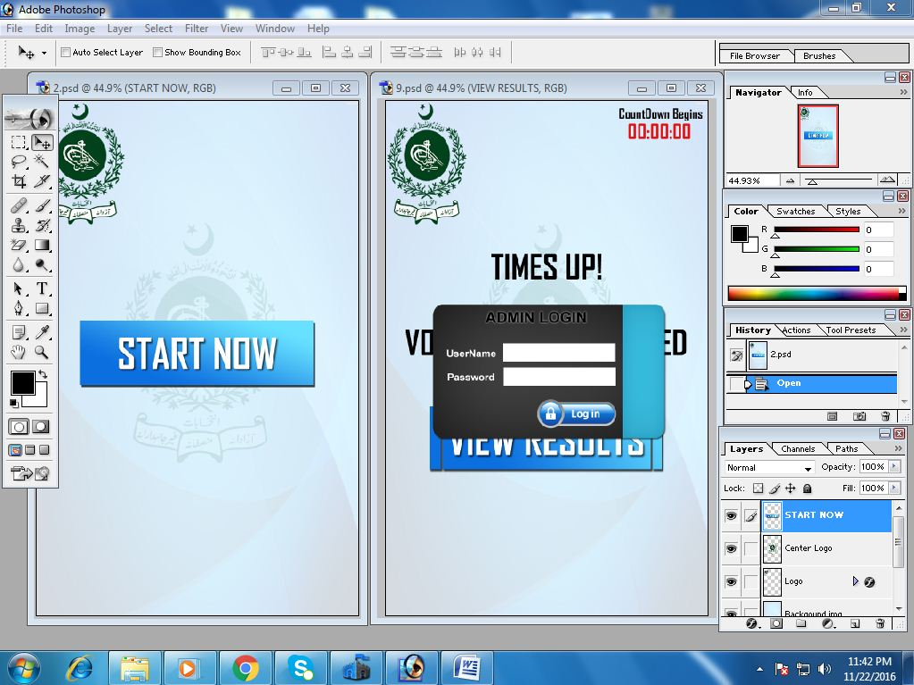The graphical user interface (GUI) provide friendly front-end environment to make the voting process easier for the voter. The Android framework gives the flexibility for managing and declaring application's interface. Using an Adobe Photoshop the GUI can be designed easily by the use of dragging and clicking different images such as splash screens, customized buttons, login box etc. The file will be stored as (.psd) format file.

FIGURE: 3.13. Layout Design using Adobe Photoshop

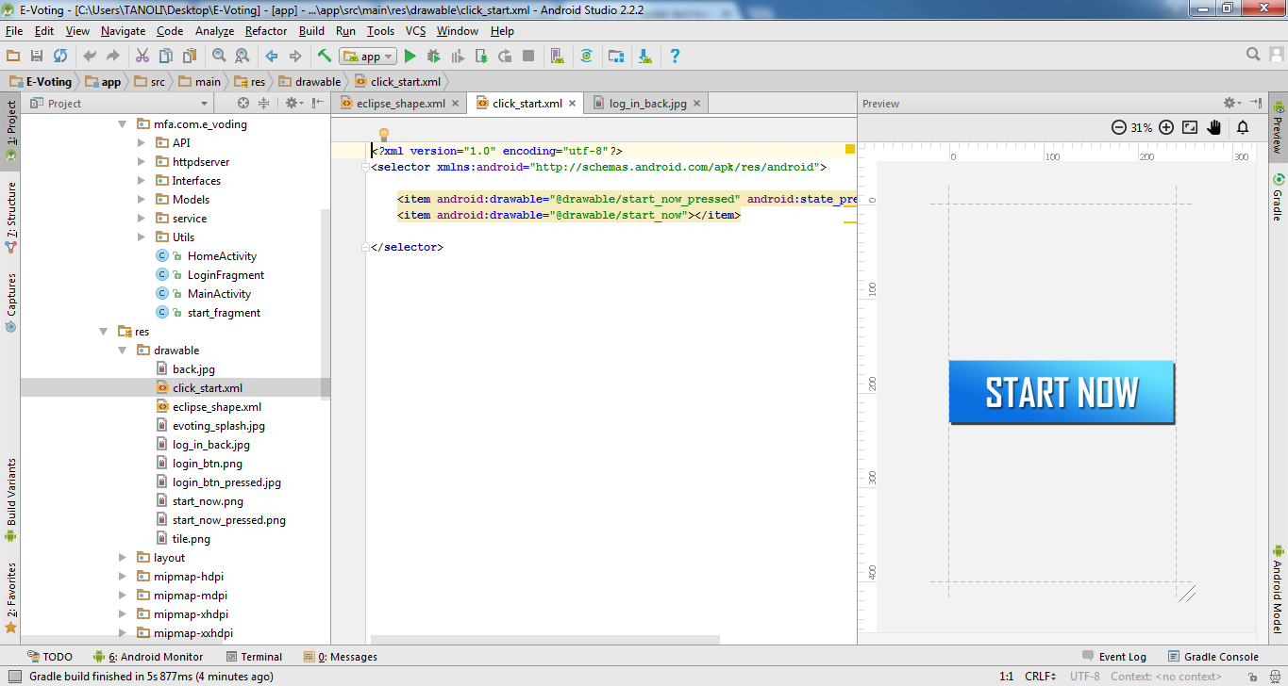Then the Layout is declared in XML including the screen elements with their properties and then the code is added that modify the objects and state of the screen. Declaration of layout in XML makes the better and easier visualization the structure of UI (User interface). The figure below shows XML code of making a user interface

FIGURE: 3.14. Interface Design using XML

3.9.2. System Development:

System development is the collaboration of devices and tools used with the Software and hardware modules. The elaboration of these tools from the functional point of view is explained below:

3.9.2.1. Tablet PC:

A Tablet PC is considered as one of the main device of the system. A Tablet PC works as an interface between the application and the user and execute the program functions to allow the voters to cast their votes.

3.9.2.2. Fingerprint Scanner& SDK:

Fingerprint scanner is also one of the main devices of the system. It is used for verification or authentication of a voter, with the help of SDK it is integrated with the application.

3.9.2.3. Algorithm Functionality:

An algorithm is very essential because it actually authenticate the voters fingerprint. This algorithm includes image processing, enhancement and feature extraction. The matching process starts by scanning the fingerprint of the voter then the algorithm intensify the image and extract the image characteristics. These characteristics then converted into fingerprint template and then the template will be match from the same template which is stored in a database. The block diagram below show the detail algorithm functional process:

**Fingerprint Scanning**

**Image Processing**

**Image Intensify**

**Create Template**

**Feature Extract**

**Fingerprint Scanning**

**Image Processing**

**Image Intensify**

**Feature Extract**

**Matching**

**Database**

**Verification**

**Registration**

FIGURE: 3.15. Algorithm Functionality Block Diagram

3.9.2.4. Database:

The database is one of the core parts of the system which is used to contain all the data regarding voter such as (name, number, fingerprint template or code etc.). It is also used to verify the voter fingerprint either the voter is eligible or not. It also contains the overall voting results.

The above system designing section describes the conceptual and functional overview of components, now the below section describes the overall system functionality by block diagram.

3.10. System Functionality:

System functionality diagrams demonstrate how the data operate by an application that flows through the different processes. It also shows the two levels of data flow block diagram of voting system.

3.10.1. Overview:

The voting system contains a fingerprint scanner, and Tablet as a user interface. There are two modes of authentication one is for the administrator that handles the registration panel and activate the voting process by login through his ID and password and second mode controls the process of verifying the eligibility of the voter by taking the fingerprint template and matches or compares it with the database’s fingerprints template; if the system found similar template in the database then the voter is eligible to cast the vote, if it is not found then the system will show a message or prompt on the screen and all the votes will be stored in the database. At the end of the voting process the election result can be checked through result panel. The below diagrams shows the functional overview of the whole system:

3.10.1.1. Low level Diagram:

**User Interface**

**Vote**

**Feature Extractor**

**Feature Matcher**

**Database**

Yes

No

**Warning**

**Feature Extractor**

FIGURE: 3.16. System Functionality Block Diagram

3.10.1.2. High Level Diagram:

**Android Application**

Admin Panel

Voting Panel

Registration Panel

Start Panel

Thumb Scanning

Thumb Scanning

Create Template

Database

Successfully Registered

No Match Found

Duplicate Match Found

Verified

Voting Page

Candidate Select

No

Yes

Database

Vote Casted

FIGURE: 3.17. System Functionality Block Diagram

**Chapter 4: Results**

4.1. Overview:

This chapter describes the simulation, achievements and clarification of the E-voting system. This chapter basically provides the charts and tables of all the results that we are achieve through the trial or testing of the System. In last it also overview the comparison chart, security analysis and the people’s overview about this system and technology.

In previous chapter we design the system according to the requirements and also complete the development phase. Now we start the simulation process of the system that how it works and what capabilities are included in the system. So the whole simulation and data analysis process is described below:

4.2. Simulation and Data Analysis:

This section describes the whole work flow of the system. The working process of the system is described below:

The whole above figures defines the overall working of the system. Now the security analysis and testing phase comes to check either the each panel or function successfully done their work or not. So here we describe the security analysis and testing phase of the system.

4.3. Securities Analysis:

There are some security challenges which we considered and try to overcome on these challenges in the application are shown below:

4.3.1. Privacy:

In this security analysis, the votes should not be linked to any voter. It means voter’s identities are remain unknown.

4.3.2. Eligibility:

In this analysis, the system only allows the eligible or registered voters to cast their vote. It means if the voter is registered in his constituency so he is able to cast the vote.

4.3.3. Uniqueness:

In this analysis, the voting application should be restricted to those voters who already casted their votes. It means if the voter cast his vote for the first time then he is not able to cast vote twice.

4.3.4. Vote Integrity:

In this security analysis, System should be well programmed and cannot altered or tempered the vote. It means system accurately get the voter’s choice and count the vote in his candidate results.

4.3.5. Verifiability:

In this analysis, system must ensure that all the votes are counted correctly. It means election management or other political parties can later verify the counted result or votes.

4.3.6. Robustness:

In this analysis, the system should be able to manage the disruption. It means if there is involvement of outside sources or trying to manipulate voting results, system should be able to recover the original results.

We successfully overcome on the above security challenges of the application. So we conduct the testing phase of the whole system to confirm the working process of the system.

4.4. Comparison of Fingerprint Technology with other Biometric Systems:

Fingerprint is considered the most accurate technology with other biometric systems because it has the very less false acceptance rate (FAR) and also very less False rejection rate (FRR).

The short definitions of FAR and FRR is described below:

FAR: The ratio of a biometric system which mistakenly accept the unauthorized user.

FRR: The ratio of a biometric system which mistakenly reject the authorized user.

|  |  |  |
| --- | --- | --- |
| Biometric Systems | False Accept Rate (FAR) | False Reject Rate (FRR) |
| Fingerprint | 0.22% | 0.22% |
| Face | 15% | 2% |
| Voice | 10-25% | 2-6% |

TABLE: 4.1. Ratio Percentage of FAR and FRR

So from the above table we can say that the fingerprint method for the E-voting system is the more accurate and secure method and technology for the election process.

4.5. Comparison Chart of Different voting system:

|  |  |  |  |  |  |  |
| --- | --- | --- | --- | --- | --- | --- |
| Electoral Issues | Internet  Voting | DRE without  VVPAT | DRE with VVPAT | PCOS | E- Ballot Printers | Our E-Voting System |
| Fast counting and tabulation | Yes | Yes | Yes | Neutral | Neutral | Yes |
| Management of complicated electoral systems | Neutral | Neutral | Yes | Yes | No | Yes |
| Increased convenience for voters | Yes | Neutral | Neutral | No | Neutral | Yes |
| Prevention of Fraud in polling station | Neutral | No | Yes | Neutral | Yes | Yes |
| Cost Savings | Neutral | No | No | No | No | Yes |
| Lack of transparency | No | Yes | Neutral | Neutral | Neutral | No |
| Avoidance of spoilt ballot papers | Yes | No | No | Yes | Neutral | Yes |
| Meaningful recount | No | No | Yes | Yes | No | Yes |
| Greater accessibility | Neutral | Neutral | Neutral | No | Neutral | Yes |
| Risk of manipulation by outsiders | Yes | Neutral | Neutral | Neutral | Neutral | No |
| Secrecy of the vote | No | Neutral | Neutral | Neutral | Neutral | Yes |

Here we compare our E-voting system with different voting system in the consideration of different electoral issues. The comparison chart shows the working status of different E-voting System:

**Status:**

Good

Normal

Bad

TABLE: 4.2. Comparison of Different Voting System

4.6. World Map of E-voting System:

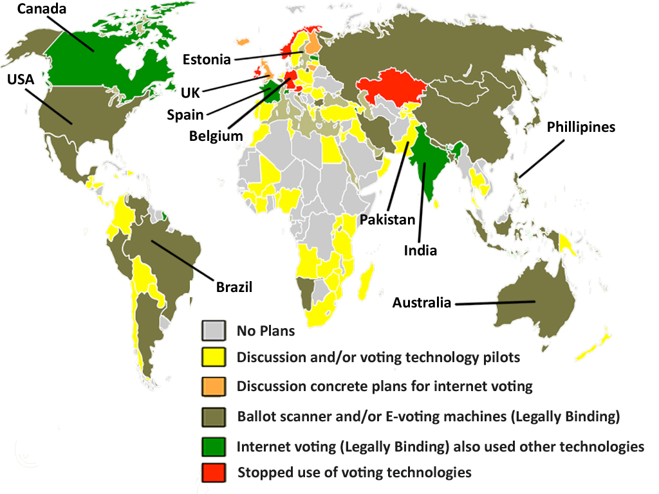

FIGURE: 4.1. Comparison of E-Voting System among countries

4.6. Peoples Perspective about Voting System:

FIGURE: 4.2. Comparison of E-Voting System among countries

**Chapter 5: Discussion, Conclusion & Future Work**

This section describes the conclusion of the work with benefits. It also provides some discussion with some future research extension. Here are some paragraphs which shows over all aspects of the research are as follows:

5.1. Discussion:

It is compulsory to see the errors and benefits of each system, but the most important concern is the correctness of the necessary requirements. In second chapter we examine the different problems of the electronic voting system, and proposed a new idea of E-voting which is offline and based on android application that widely covers to overcome on problems and also increase the rate or speed of the election process. Now instantly the discussion is: Why would an offline system is the better solution for the common issues?

Different countries have already converted from paper voting to computerized voting or Electronic voting. Different measures, techniques and technology were introduced to increase or raise the voter turnout, and decrease the number of fake and fraud attempts. The proposed offline android based voting system will deliver an error free and secure election system with an effective design. The use of a Tablet device and thumb scanner as a voting machine is a solution for many problems like speed of election process, Ballot paper elimination and counting accuracy etc. In the introduction chapter we discussed that democracy needs people to come and show their determination and in Pakistan only 55% people are casted their votes in 2013. So, the main intension of this research is to overcome on these problems faced by the voter during the elections and proposed a design that would solve these problems.

In the methodology chapter we also discussed that after requirements analysis it is important to explore which system is a solution of traditional election process. According to the survey reports Pakistan has a large number of illiterate people that still didn’t know how to read and write their own names. So the main scope of this project is to develop a system which is easy for both the literate and illiterate people in addition the polling staff also needs to be trained with new E-voting system to help voters in the voting process.

In future we also upgrade our technology to the online voting which helps the voter to vote from any locality, anywhere in the city or even out of the country. This discussion above gives a brief overview of a research which helps the out-field people to easily understand the project.

5.2. Conclusion:

In correlation to the research all of the objectives and goals of the voting areas has been achieved positively. On the research of various voting systems we analyzed the security risk that could harm the integrity and confidentiality of the voting process. The result of our study proposed that the fingerprint is recognized as the popular biometric methods, for that intention the main motive of this research is to developing a secure and efficient fingerprint E-voting system based on android application that contains GUI designed. In these research exercises, we conceive a testing methodology, improved new tools for the security analysis and suggest a new idea of the voting system. This E-voting system has the ability to reduce fraud attempts and eliminate errors in votes counting. In addition to its scalability this system can handle various techniques and provide enhanced efficiency and reliability for the elections. This fingerprint E-voting system which is based on android application is evaluated and implemented successfully. The final result of the voting system was amazingly computable and significant with other voting system.

5.3. Future Work:

Improvements are necessary to be done in order to make a system more efficient and reliable. So we are planned to move this system to an online Cloud based ERP System. This online system will allow voters to cast their votes by various electronic ways through their mobile phones, home PC’s, Net‐cafes and Kiosks machines which helps the voter to vote from any locality, anywhere in the city or even out of the country through his secret ID and password. Every system will be connected through internet to the main server which will allow many people to perform voting at the same time. In online voting all the voting results throughout the country can be calculated in Central Count System at a time and displayed on Election Management Sites.

**References:**

[1] Okediran O. O.*et al*, “A Framework For A Multifaceted Electronic Voting System,” *International Journal of Applied Science and Technology*. , Vol. 1 No.4. , July2011,pp. 135-142.

[2] D.Paul and S.Kumar Ray, “A Preview On Microcontroller Based Electronic VotingMachine,” *International Journal of Information and Electronics Engineering*. , Vol. 3 No. 2. , March 2013, pp. 185-190, DOI: 10.7763/IJIEE.2013.V3.295 185.

[3] Alaguvel.R. *et al*, “Biometrics Using Electronic Voting System With Embedded Security,” *International Journal of Advanced Research in Computer Engineering & Technology*. , Vol. 2, Issue 3. , March 2013, pp. 1065-1072, ISSN: 2278 – 1323.

[4] Pedro. *et al*, “Remote Electronic Voting Studying And Improving Helios,” M.S. thesis, Dept. Informatics Eng., Minho Univ., Braga, Portugal, December 2012.

[5] Rune *et al*, “Electronic Voting Systems,” M.S. thesis, Dept. Math. Sci., Norwegian Univ., Trondheim, Norway, October 2006.

[6] M.M. Rahman *et al*, “Electronic Voting System,” B.S thesis, Dept. Comput. Eng., BRAC Univ., Dhaka, Bangladesh, Jan 2007.

[7] J.Ritter, “Decentralized E-Voting On Android Devices Using Homomorphic Tallying,” M.S. thesis, Dept. Appl. Sci. & Inform. Tech., Bern Univ., Biel, Switzerland, February 2014.

[8] I. Mahmud *et al*, “A Realistic Secure On-Line E-Voting System*,*” *International Journal of Engineering Research and Applications*. , Vol. 2, Issue 5. , October 2012, pp. 425-429, ISSN: 2248-9622.

[9] H.Imad Mohammed, “Fingerprint Base Electronic Voting System,” BEng (Hons). Thesis, Dept. Comput. Eng., Asia Pacific Univ., Kuala Lumpur, Malaysia, June 2012, DOI :10.13140/2.1.1108.4481.

[10] Douglas W. Jones, “On Optical Mark-Sense Scanning,” in *Towards Trustworthy Elections*, 1st ed., Iowa Univ., U.S.A: Springer Berlin Heidelberg, 2010, pp. 175-190.

[11] G. B. Shelly and H. J. Rosenblatt, “Systems analysis and design”.in*Requirements Modeling,* Boston, Mass.,U.S.A: Thomson Course Technology, 2010, pp. 142-143. ISBN:0324597665.

[12] Y. Feng*et al*, “An Electronic Voting System Using GSM Mobile Technology,” Dept. Math. Royal Holloway Univ., London, England, Tech. Rep. RHUL–MA–2006–5, June 2006.

[13] B.Arun *et al*, “Online Voting System Using Face Recognition,” B.E Inform. Tech. Thesis, Dept. Inform. Tech. ,SRM Univ., Chennai, India, Apr 2007.

[14] Douglas W. Jones, “Kazakhstan: The Sailau E-voting System,” in *Direct Democracy: Progress and Pitfalls of Election Technology*, Washington D.C, U.S.A: I.E.F.S, Sep 2010, pp. 74-95.

C. González, “The New Belgian E-Voting System,”EVOL2 / eVoting Legal Lab, Spain, rep. DER2010-16741, Jan 2012, pp. 199-211.

P.Wolf*et al*, *Introducing electronic voting: essential considerations*. Stockholm, Sweden: International Institute for Democracy and Electoral Assistance, 2011, ISBN: 978-91-86565-21-3.

V. Pran and P. Merloe, *Monitoring electronic technologies in electoral processes: an NDI guide for political parties and civic organizations*. ,Washington D.C, U.S.A: National Democratic Institute for International Affairs, 2007, ISBN: 978-1-880134-36-8.

C. B. McCormack, *Democracy Rebooted: the Future of Technology in Elections Report*., Washington D.C, U.S.A: Atlantic Council of the United States, 2016, ISBN: 978-1-61977-958-7.

B.Goldsmith and H.Ruthrauff, *Implementing and Overseeing Electronic Voting and Counting Technologies*., Washington D.C, U.S.A: International Foundation for Electoral Systems, N.D.I and United States Agency for International Development, 2013.

*Electronic voting– challenges and opportunities*, The Norwegian Ministry of Local Governmentand Regional Development, Norway, 2006.

Caarls and Susanne, *E-voting handbook: key steps in the implementation of e-enabled elections*. , Strasbourg, France: Council of Europe Pub., 2010.