Fitness Club handling system

**Software Requirements Specification**

Version 1.0



**Group Id: F210272FD6 (BC180406440)**

**Supervisor Name : Aysha Zahid**

**Revision History**

|  |  |  |  |
| --- | --- | --- | --- |
| **Date (dd/mm/yyyy)** | **Version** | **Description** | **Author** |
| 2/jan/2022 | 1.0 | In this project we are developing the web application which will overcome these difficulties which people has to face when getting admission in health club. We are developing the “Fitness Club Handling System” which will handle the automate gym and fitness admission process. As we know admission process is difficult on their desired time and selecting a trainer is also difficult in the physical local club.  This Fitness Club System will provide the online admission process which make it easy for the user to get admission and view the club packages, book the desired slot, online payments, search the best trainer, view club packages and booked the desired slot, hire a trainer and get the diet chart and mark attendance everything is online through this platform of the fitness club. | **BC180406440** |
|  |  |  |  |
|  |  |  |  |
|  |  |  |  |

**Table of Contents**

1. Scope (of the project)
2. Functional Requirements Non Functional requirements
3. Use Case Diagram
4. Usage Scenarios
5. Adopted Methodology
6. Work Plan (Use MS Project to create Schedule/Work Plan)

**SRS Document**

**Scope of Project:**

**Introduction:**

Being healthy is a blessing and for healthy mind and body exercise is very important because exercise is one of the important things for healthy body. But in our busy routine, now a days we find it difficult to get the time for exercise and difficult to find the best trainer specially and managing the schedule according our time and to find the fitness club. Where it is hard to get admission in health fitness club where slots are full.

In this project we are developing the web application which will overcome these difficulties which people has to face when getting admission in health club. We are developing the “Fitness Club Handling System” which will handle the automate gym and fitness admission process. As we know admission process is difficult on their desired time and selecting a trainer is also difficult in the physical local club.

This Fitness Club System will provide the online admission process which make it easy for the user to get admission and view the club packages, book the desired slot, online payments, search the best trainer, view club packages and booked the desired slot, hire a trainer and get the diet chart and mark attendance everything is online through this platform of the fitness club.

Being healthy is the first thing to be kept in mind because most of the time our attitude

depends on how we feel. It is hard to get admission in health club when slots are full. This

project aims to automate gym and fitness admission process as the admission process in

gyms and selecting a trainer is difficult. Sometimes it is difficult to get a desired slot timing.

This health club management system will help to overcome such problems by booking the

desired slot online and pay fees by electronic money transfer.

In this fitness club system, there is 3 entities namely, Admin, Member, and Trainer. Admin

can login using credentials. Admin can manage packages by adding cost, discount and

deleting old packages. Admin can manage member details by adding, updating and deleting.

Admin can view the package details of an individual member. Admin can also view the

member’s attendance taken by the trainer.

Members can login using credentials. They can view their profile and list of trainers. They

can also view the package and payment details. Members can give feedback on their

trainers. They can make payments via card details. A trainer can log in using credentials. A

trainer can set their profile. A trainer can take member’s attendance daily.

**Purpose:**

The purpose of the system is to develop the easy approach system for the fitness or gym club where people can easily get the information of the fitness club from online website platform and even make it easy for the trainer and admin to manage the club and its activities and user registration process. The main purpose is to handle the club activities easily in the efficient way specially through online platform which make it easy approach for the user and even for trainer and admin to get the information easily and handle it.

**Scope:**

This system has a scope because it can be used in the market place by the people who have fitness club business and the owner of the club can grow their business. The system is developed in English which will be easily understood by the people.

**Functional and non Functional Requirements:**

**Functional Requirements:**

**Admin**

* Admin can login into system.
* Admin can delete/ edit information of member and trainer
* Admin can keep the track of members and trainer attendance
* Admin can make and update packages
* View individual member package detail

**Member**

* Member can create account
* Member can log in into the system
* View and Edit Account information
* Can view package and payment details
* View list of trainers
* Search for trainer by name
* Can select trainer
* View Schedules
* Select schedule
* Rate trainers
* View members ratings
* Can make payments online

**Trainer**

* Create an account
* Log in into the system
* View and Edit Account information
* Select or reject students
* Can share schedule
* Can take members attendance
* View attendance
* Add the services
* Edit the services
* Can share diet charts for each student
* Add diet chart
* View ratings
* View/Print schedules

**Non-Functional Requirements:**

1. **Performance**: website is designed and developed in such a way that it does not utilize many resources.
2. **Secure:** website provide secure and safe system of registration, login and online payment.
3. **Friendly interface:** website has a friendly interface which is simple and easy to use. The user can easily use it.
4. **Maintainability:** the website is maintained properly from time to time.
5. **Portability:** the website can be easily viewed in any browser.
6. **Flexibility:** the website keeps on updating the data according to the transaction that takes place.
7. **Timeless:** the website performs all the operations with very less time of consumption.
8. **Reliability:** the website developed in such a way that it is able to meet all needs and expectations of the user.
9. **Fault Tolerance:** the website is developed in such a way that it is able to recover from any failure.
10. **Availability:** the website available all the time.

**Use Case Diagram(s):**

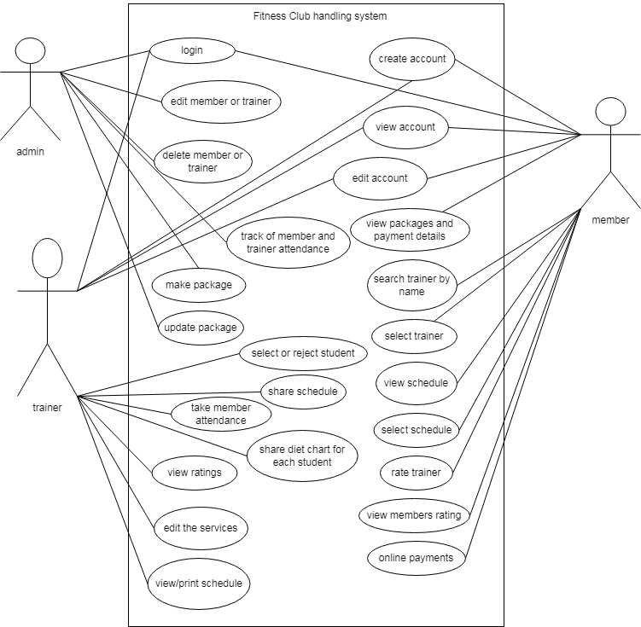

**Usage Scenarios:**

**Usage scenarios 1:**

|  |  |  |  |
| --- | --- | --- | --- |
| Use case title | Create account | | |
| Abbreviated title | CA | | |
| Use case ID | 1 | | |
| Actors | member, trainer | | |
| Description | In this use case the actor can create its account in the website application by selection the register option and filling the registration form. | | |
| Pre-conditions | Internet connection should be available and user opens the website. | | |
| Task sequence | | | Exceptions |
| 1. The user can create its account by selecting register option  2. After selecting register option the registration form will appear in which user have to fill all its details like name, email, gender etc.  3. After submitting the form the user account will be created. | | | 1. The system opens the registration form.  2. The system verifies all the user registration form details and if form information is not correct it shows the notification invalid information.  3. If the form registration information is correct the system will save all the user detail in the database and create a user account. |
| Post condition | | User has successfully registered in the website and user account has been created. | |
| Author | | Bc180406440 | |

**Usage scenarios 2:**

|  |  |  |  |
| --- | --- | --- | --- |
| Use case title | login | | |
| Abbreviated title | LN | | |
| Use case ID | 2 | | |
| Actors | member, trainer, admin | | |
| Description | In this use case the actor can login in its account which he has created in the website by selecting login option. | | |
| Pre-conditions | Internet connection should be available and user opens the website. | | |
| Task sequence | | | Exceptions |
| 1. The user can login in its account by selecting login option.  2. After selecting login option the login form will appear in which user have to fill it’s create account details to login.  3. When user submits the login form then user will login in its account. | | | 1. The system opens the login form.  2. The system will verify the user login filling form details from the database and check all user details from the database.  3. The system check if user login details exist in the database and is valid the system login the user in its account if detail is invalid it show notification that show invalid account. |
| Post condition | | The user has successfully login in its account. | |
| Author | | Bc180406440 | |

**Usage scenarios 3:**

|  |  |  |  |
| --- | --- | --- | --- |
| Use case title | View account | | |
| Abbreviated title | VA | | |
| Use case ID | 3 | | |
| Actors | member, trainer | | |
| Description | In this use case the user after login in the account can view its account details. | | |
| Pre-conditions | the user must login in its account | | |
| Task sequence | | | Exceptions |
| 1. The user can view its account information by selecting view account option.  2. The form will disappear that shows all the user account information.  . | | | 1. The system gets all the user account information from the database and show it. |
| Post condition | | User has successfully view its account. | |
| Author | | Bc180406440 | |

**Usage scenarios 4:**

|  |  |  |  |
| --- | --- | --- | --- |
| Use case title | edit account | | |
| Abbreviated title | EA | | |
| Use case ID | 4 | | |
| Actors | member, trainer | | |
| Description | In this use case the user after login in the account can edit its account information. | | |
| Pre-conditions | the user must login in its account | | |
| Task sequence | | | Exceptions |
| 1. The user can edit its account information by selecting edit account option.  2. The form will disappear that shows all the saved information of the user account.  3. the user can edit the new information in the form after submitting the form the new information of the user account information save | | | 1. The system gets all the user account information from the database and show it.  2. After submitting the form the system will save the new edited information of the account in the database. |
| Post condition | | User has successfully edited its account. | |
| Author | | Bc180406440 | |

**Usage scenarios 5:**

|  |  |  |  |
| --- | --- | --- | --- |
| Use case title | View packages and payment details | | |
| Abbreviated title | VPPD | | |
| Use case ID | 5 | | |
| Actors | member | | |
| Description | In this use case the member can view all the packages detail and its payment details. | | |
| Pre-conditions | the user must open the website | | |
| Task sequence | | | Exceptions |
| 1. The user can view all the packages detail with its payment detail like package name, detail, price etc. and also payment detail option by selecting view package option on the homepage | | | 1. The system gets all the packages information from the database that is saved in it and shows it. |
| Post condition | | The member has successfully view the packages and their payment details on the website. | |
| Author | | Bc180406440 | |

**Usage scenarios 6:**

|  |  |  |  |
| --- | --- | --- | --- |
| Use case title | Search trainer by name | | |
| Abbreviated title | STBN | | |
| Use case ID | 6 | | |
| Actors | member | | |
| Description | In this use case the member can search the trainer by their name and can view their profile. | | |
| Pre-conditions | the user must open the website | | |
| Task sequence | | | Exceptions |
| 1. The user can search the trainer by entering the trainer name in the search option.  2. After searching the user can view all the trainers related to the search name query. | | | 1. The system gets all the trainer information in the list from the database that is related to user search name query and shows it only if data exist in the database otherwise it shows no record found. |
| Post condition | | The member has successfully search the trainer by name | |
| Author | | Bc180406440 | |

**Usage scenarios 7:**

|  |  |  |  |
| --- | --- | --- | --- |
| Use case title | Select trainer | | |
| Abbreviated title | ST | | |
| Use case ID | 7 | | |
| Actors | member | | |
| Description | In this use case the member can select any trainer from the website. | | |
| Pre-conditions | the user must open the website | | |
| Task sequence | | | Exceptions |
| 1. The trainers detail page will open it include personal detail, services detail and experience details of all the trainers.  2. The user can view all the trainer profile with their detail and user can select any trainer according to its choice and trainer will be selected. | | | 1. The system gets all the trainer information from the database and shows it.  2. The system will save the user selected trainer request in the database. |
| Post condition | | The memeber has successfully selected the trainer. | |
| Author | | Bc180406440 | |

**Usage scenarios 8:**

|  |  |  |  |
| --- | --- | --- | --- |
| Use case title | View schedules | | |
| Abbreviated title | VS | | |
| Use case ID | 8 | | |
| Actors | member | | |
| Description | In this use case the member can view all the schedules detail. | | |
| Pre-conditions | the user must open the website | | |
| Task sequence | | | Exceptions |
| 1. The user can view all the schedule detail like schedule timing, schedule days etc. By selecting view schedules option.  2. The schedule page will open that show all the schedules information. | | | 1. The system gets all the schedule information from the database that is saved in it and shows it. |
| Post condition | | The member has successfully view the schedule details on the website. | |
| Author | | Bc180406440 | |

**Usage scenarios 9:**

|  |  |  |  |
| --- | --- | --- | --- |
| Use case title | Select schedule | | |
| Abbreviated title | SS | | |
| Use case ID | 9 | | |
| Actors | member | | |
| Description | In this use case the member can select the schedule of the training by selecting the select schedule option. | | |
| Pre-conditions | the user must open the website and login in its account | | |
| Task sequence | | | Exceptions |
| 1. When user select the schedule option The schedule detail page will open it include the schedule information like day, time etc.  2. The user can select any schedule according to its desire by selecting the option select schedule. | | | 1. The system gets all the schedule information from the database and shows it in the schedule page.  2. When user select the option select schedule the system will save the selected schedule details of the user in the database. If any error occurs while saving the detail the system show the error message and it also show error if user select any wrong option. |
| Post condition | | The member has successfully selected the desired schedule from the website. | |
| Author | | Bc180406440 | |

**Usage scenarios 10:**

|  |  |  |  |
| --- | --- | --- | --- |
| Use case title | Rate trainer | | |
| Abbreviated title | RT | | |
| Use case ID | 10 | | |
| Actors | member | | |
| Description | In this use case the member can rate the selected trainer by selecting the option rate trainer. | | |
| Pre-conditions | the user must open the website and login in its account | | |
| Task sequence | | | Exceptions |
| 1. When user can rate the selected trainer by selecting the rate trainer.  2. trainer rating form will open and member can fill its rating detail and select the button save rating. | | | 1. The system fetches the selected trainer detail of the member from the database and shows it.  2. The system will save the member rating details in the database and if any error occurs the system shows the notification. |
| Post condition | | The member has successfully rate its selected trainer in the website. | |
| Author | | Bc180406440 | |

**Usage scenarios 11:**

|  |  |  |  |
| --- | --- | --- | --- |
| Use case title | Online payments | | |
| Abbreviated title | OP | | |
| Use case ID | 11 | | |
| Actors | member | | |
| Description | In this use case the member can pay the package price online through online transaction. | | |
| Pre-conditions | user must open the website and login in its account and selected the package. | | |
| Task sequence | | | Exceptions |
| 1. Member login in its account.  2. member select the package  3. After selecting the package select the package fee payment mode.  4. The payment detail form will open and member fills its account details and checks out and confirms the payment. | | | 1. System fetches the package details from the database and shows it.  2. System saves the member online payment details in the database and it shows error if any payment detail is incorrect. |
| Post condition | | The member has successfully made the online payment of the selected package | |
| Author | | Bc180406440 | |

**Usage scenarios 12:**

|  |  |  |  |
| --- | --- | --- | --- |
| Use case title | Select or reject student | | |
| Abbreviated title | SRS | | |
| Use case ID | 12 | | |
| Actors | trainer | | |
| Description | Trainer can select or reject the member request of the selected trainer. | | |
| Pre-conditions | Member login in its account and select the option of show requests. | | |
| Task sequence | | | Exceptions |
| 1. Member login in its account.  2. Member selects the option requests.  3. The list of request shows.  4. Member can view any request of the member.  5. After viewing the request of the member the trainer can select or reject the member request by selecting the option. | | | 1. System fetches all the trainer requests of the member from the database and shows it.  2. System saves the trainer requests response of the member in the database or it show message if any error or requests response did not save. |
| Post condition | | The trainer has successfully select or reject the member request | |
| Author | | Bc180406440 | |

**Usage scenarios 13:**

|  |  |  |  |
| --- | --- | --- | --- |
| Use case title | Share schedule | | |
| Abbreviated title | SSH | | |
| Use case ID | 13 | | |
| Actors | trainer | | |
| Description | Trainer can create the schedule and can share it with the member | | |
| Pre-conditions | Trainer login in its account. | | |
| Task sequence | | | Exceptions |
| . 1. Trainer can create the schedule by selecting the option create schedule.  2. The schedule form open the trainer fill the schedule details and select the save button.  3. After saving Trainer can view the list of schedule by selecting the option show schedule.  4. Trainer can select any schedule from the list and can share the schedule to any member by selecting the share option. | | | 1. System opens the schedule form.  2. The system saves the schedule detail in the database and show message if any error occurs.  3. The system fetches all the schedules form the database and shows it.  4. system share the schedule to the member. |
| Post condition | | The trainer has successfully shared the schedule. | |
| Author | | Bc180406440 | |

**Usage scenarios 14:**

|  |  |  |  |
| --- | --- | --- | --- |
| Use case title | Take member attendance | | |
| Abbreviated title | TMA | | |
| Use case ID | 14 | | |
| Actors | trainer | | |
| Description | Trainer can take the attendance of the selected member. | | |
| Pre-conditions | Trainer login in its account. | | |
| Task sequence | | | Exceptions |
| 1. The trainer selects the option view selected member by selecting the view selected member.  2. The list of the trainer selected member will open and trainer can select any member from the list to mark the attendance of member by selecting the option mark attendance.  3. The mark attendance form will open the trainer take the attendance of the selected member and select the option save attendance. | | | 1. System fetches the trainer selected member details from the database and shows it.  2. The system save the attendance detail of the member in the database or it show message if any error occurs. |
| Post condition | | The trainer has successfully take the attendance of the member | |
| Author | | Bc180406440 | |

**Usage scenarios 15:**

|  |  |  |  |
| --- | --- | --- | --- |
| Use case title | Share diet chart | | |
| Abbreviated title | SDC | | |
| Use case ID | 15 | | |
| Actors | trainer | | |
| Description | Trainer can create the diet chart plan for the member and can share it with the member | | |
| Pre-conditions | Trainer login in its account. | | |
| Task sequence | | | Exceptions |
| . 1. Trainer can create the diet chart by selecting the option create diet chart.  2. The diet chart form open the trainer fill the diet chart details and select the save button.  3. After saving the diet chart Trainer can view the list of diet chart by selecting the option show diet chart.  4. Trainer can select any diet chart from the list and can share the diet chart to any member by selecting the share option. | | | 1. System opens the diet chart form.  2. The system saves the diet chart detail in the database and show message if any error occurs.  3. The system fetches all the diet charts form the database and shows it.  4. System shares the diet chart to the selected member. |
| Post condition | | The trainer has successfully shared the diet chart. | |
| Author | | Bc180406440 | |

**Usage scenarios 15:**

|  |  |  |  |
| --- | --- | --- | --- |
| Use case title | Edit the services | | |
| Abbreviated title | ES | | |
| Use case ID | 15 | | |
| Actors | trainer | | |
| Description | Trainer can edit its added services from its account | | |
| Pre-conditions | Trainer login in its account. | | |
| Task sequence | | | Exceptions |
| 1. Trainer select the option add services option.  2. Add service fill open the trainer fill the service detail in the form and save the services by selecting the option save services.  3. Trainer can view its services by selecting the option view services. The trainer services list will display.  4. Trainer can select any of its service from the list and can edit it by selecting the option edit service.  5.the edit service form will open the trainer fill the updated detail of the service and save it by selecting the option save edit service. | | | 1. System saves the services detail of trainer in the database and show error message if any error occurs.  2. System fetches all the services of the trainer from the database and shows it.  3. system save the updated details of the service form in the database or show error message if any error occurs. |
| Post condition | | The trainer has successfully edit his service. | |
| Author | | Bc180406440 | |

**Adopted Methodology**

Introduction:

Project planning is a discipline for stating how to complete a project within a certain timeframe, usually with defined stages, and with designated resources.

Methodology:

A methodology is a model, which is used for the design, planning, implementation and achievement of their project objectives. There are different methodologies to benefit different projects.

**Available Methodology:**



**The waterfall model:**

The waterfall model is a linear sequential process model used in software development processes. In waterfall model, each phase must be completed before starting the next phase. It is an earliest SDLC approach used for software development. Waterfall model works in a linear sequential flow.

Linear sequential flow means that any phase begins only if the previous phase is completed. In waterfall model phases do not overlap.

In waterfall model approach the whole process of software development is divided into separate phases. The outcome of one phase acts as the input for the next phase sequentially. The sequential phases in waterfall model are:

* **Requirement gathering and analysis:** all the requirements of the system are captured in this phase and requirements documented in a requirement specification document.
* **System design:** the requirements which are documented from the first phase are studied and the design according to the requirements is prepared in this phase. The system design helps in specifying hardware and system requirements.
* **Implementation:** the source code is developed in this phase by using logic and requirements designated in the previous stages.The system is first developed in small programs called units which are integrated in the next phase. Each unit is developed and tested for its functionality.
* **Integration and testing:** all theunits developed in the implementation phase are integrated into a system after testing of each unit. Entire system is tested for any faults and failures.
* **Deployment of system**: the functional and non-functional testing is done. Now the product is ready to release into the market.
* **Maintenance:** if there are some issues comes up in the client environment. In this phase we fix those issues and also enhance the product for better versions or improvement. Maintenance is done to deliver the client changes in the environment.

All the phases of waterfall model flowing steadily downwards like a waterfall. The next phase is started only after completed the previous phase. Phases are not overlap in this model.

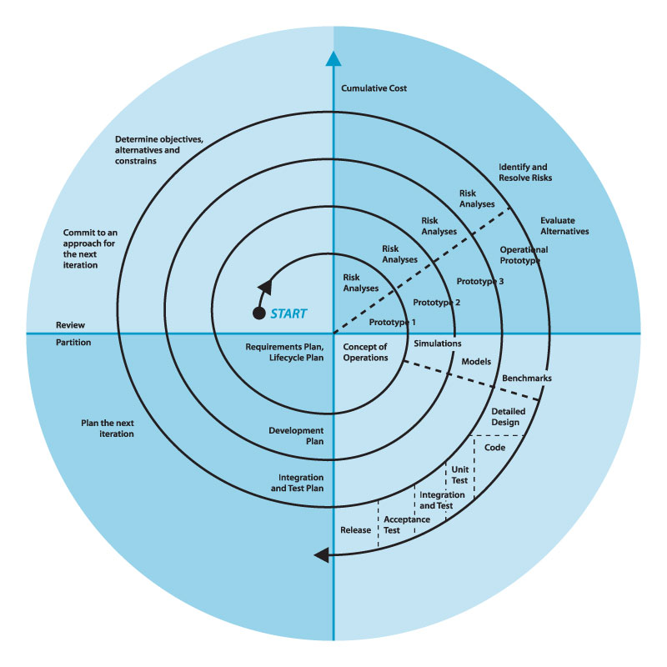

**The spiral model:**

The spiral model is the iterative development model. It is the combination of iterative and model with waterfall model. In this model there is coil having many cycles or loops. Each spiral cycle is a stage in the development process. This model is used for large projects which involve continuous enhancements. There are specific activities that done in one iteration (spiral) where the output is a small prototype. It allows the software to be rolled out and refined in each phase of the spiral with the ability to build prototype in each stage. It has four main phases: planning, risk analysis, engineering and evaluation. Same activities are repeated for all spirals until the entire software is built.

A prototype is created at the beginning of each phase as a risk management technique. This model has the ability to manage unknown risks. The four phases of spiral model are explained below:

* **Planning:** this phase includes requirement gathering and analysis. Based on the requirements, objectives are defined and different alternate solutions are proposed. This phase is the baseline for the entire project and the remaining three phase build upon what was determined in the planning phase.
* **Risk Analysis:** in this phase developers try to find which other approaches can be implemented in order to fulfill the identified constraints. The risks associated with every alternative are analyzed. A prototype is produced at the end of this phase.
* **Engineering:** in this phase the product is developed and verified. The software also produced in engineering stage and tested at the end of the phase.
* **Evaluation:** in this phase customer evaluate the output of the project before continues to the next spiral of the project.

**Chosen Methodology:**

It is a method used for development of project. I have adopted the VU Process Model which is the combination of Waterfall methodology and Spiral methodology. VU Process Model will combine the benefits of Waterfall and Spiral methodologies.

**Reasons for chosen Methodology:**

The main idea to choose is to get the benefits of both these models.

* It is sequential model with backward repetition.
* In vu process model we will be work in phases to complete the given project.
* All the activities are performed in a sequence in VU Process Model.
* Maximize the quality of system and minimize the disadvantages and risk.
* System is more responsive to user requirements.
* Cost and schedule are more accurate.
* It is good to use vu process model which gives the nature of both methodology to complete the project successfully.

**Work Plan (Use MS Project to create Schedule/Work Plan)**

