Flambe Controller Spec
Revision 40
Table of Contents
1. Specification 3
1.1 Connection Overview 3
1.2 States 3
1.3 State Machine 4
1.4 Input PWM Signal 5
Timings 5
Hysteresis 5
No Signal Handling 5
1.5 Output PWM Signal 5
2 Reference 6
2.1 Arduino Pro Micro Pin Out 6
2.2 Arduino IDE Setup 7
Permissions 7
Dependencies 7
Target Board 7
Serial Monitor 7
3. Testing 8
3.1 Direct Connection Test 8
3.2 Input Test 9
3.3 Output Test 10
3.4 Pass-through Test 11

1. Specification

1.1 Connection Overview
Figure 1: Hardware Overview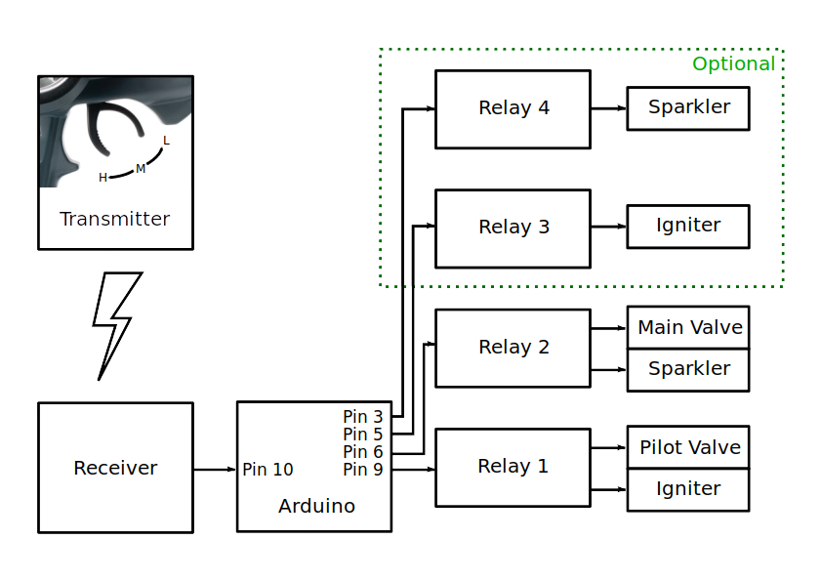

1.2 States

System Logical States
State | Relay 1 / Pilot Valve (Igniter) | Relay 2 / Main Valve (Sparkler) | Relay 3 / Igniter | Relay 4 / Sparkler
Off | Off | Off | Off | Off
Idle | On | Off | On | Off
On | On | On | On | On
Table 1: Logical States

1.3 State Machine
Figure 2: State Diagram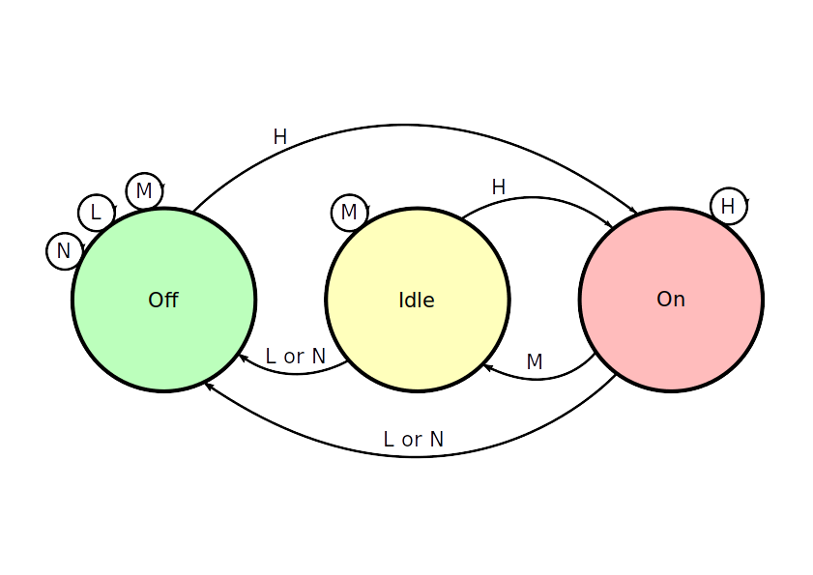

State Transition Table
Controller Input |  | Current → Next State
Name | Code | Off... | Idle... | On...
Low | L | Off | Off | Off
Medium | M | Off | Idle | Idle
High | H | On | On | On
No Signal | N | Off | Off | Off
Table 2: State Transitions

1.4 Input PWM Signal

Timings
The Arduino detects the input signal based on timing the period between the rising and falling edge of the input PWM signal:
Input Signal Timings
Lower Bound (microseconds) | Upper Bound (microseconds) | Signal
0 | 500 | NoSignal
500 | 1300 | Low
1300 | 1700 | Medium
1700 | 2500 | High
2500 | ∞ | NoSignal
Table 3: PWM Timings

Hysteresis
In order to prevent the input signal from rapidly changing when the input in near to a boundary, hysteresis is performed. The input signal length must be more than 100 microseconds outside the current input band in order for the input to change. This value can be changed by editing the HYSTERESIS definition in the sketch. Hysteresis is not applied when the current signal is NoSignal.

No Signal Handling
The Arduino watchdog timer is enabled to activate after 500 milliseconds. The rising edge interrupt resets the watchdog timer. Consequently if no signal at all is present, the Arduino will reset after 500ms. This value can be changed by editing the TIMEOUT definition in the sketch. After resetting, the Arduino initializes all outputs to Off.
If the input signal is present but the timing falls in the NoSignal ranges, the state machine switches to Off state immediately.

1.5 Output PWM Signal
Is handled by the Arduino Servo library.

2 Reference

2.1 Arduino Pro Micro Pin Out
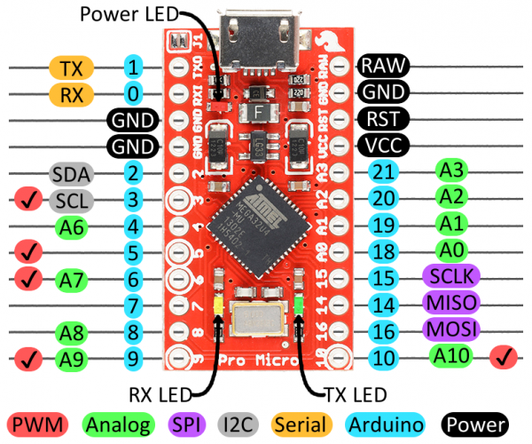Figure 3: Arduino Pro Micro Pinout

2.2 Arduino IDE Setup

Permissions
Ensure you have added your user to the dialout group:
sudo gpasswd -a <user> dialout
Note: In order to activate the new group you must start a new login session.

Dependencies
To install required dependencies, click Tools → Library Manager. Search for the dependency and then click Install.
Note: If the Library Manager option is not present, it means your IDE version is too old.
The following dependencies are required:
1. PinChangeInterrupt
2. Servo *

Dependencies marked * should be installed by default with the Arduino IDE.

Target Board
Use Tools → Board → Arduino Leonardo as the target board type. This is a 5V board based on Atmega32U4, with the same logical pin mapping as Pro Micro.

Serial Monitor
The serial monitor is opened by clicking Tools → Serial Monitor. In older versions of the IDE, uploading a sketch will close the serial monitor.
Whenever the Arduino resets, the serial monitor will lose some of the first messages. This is because the USB device disconnects and reconnects, and the IDE must reopen it. This may cause the initial “Reset” message to be lost.

3. Testing

3.1 Direct Connection Test
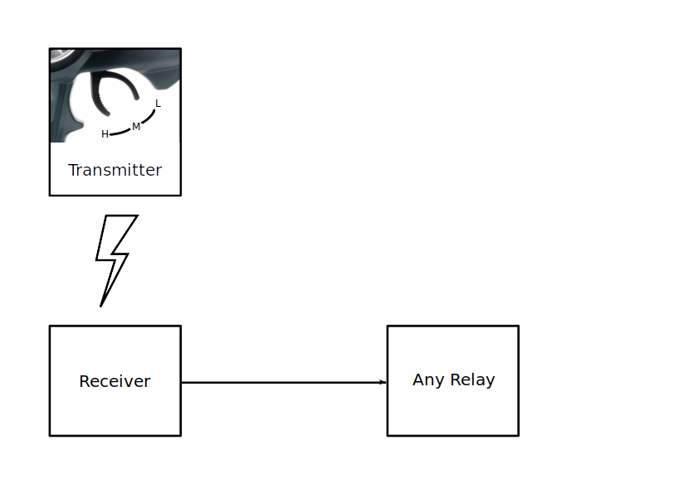Figure 4: Direct Connection Setup
1. Connect Any relay directly to the output of the RC receiver.
2. Verify that moving the transmitter to ‘H’ turns on the relay.
3. Verify that moving the transmitter to ‘L’ turns off the relay.

3.2 Input Test
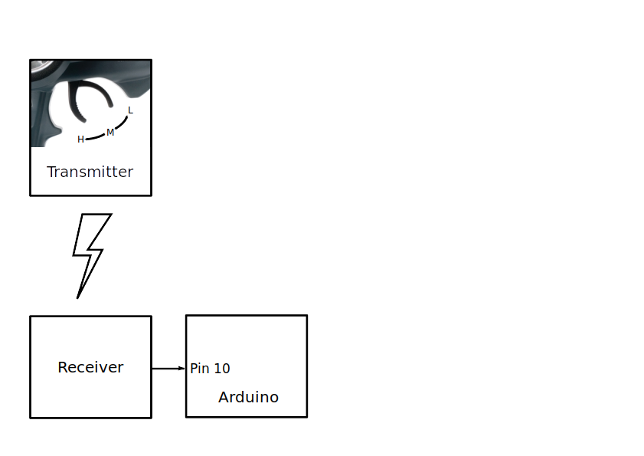Figure 5: Input Test Setup
1. Program passthrough sketch to the Arduino.
2. Connect the RC receiver to pin 10 of the Arduino.
3 Open the Arduino Serial Monitor.
4. Verify that moving the transmitter trigger to ‘H’ causes the Arduino to output ‘Input: High’.
5. Verify that moving the transmitter trigger to ‘M’ causes the Arduino to output ‘Input: Medium’.
6. Verify that moving the transmitter trigger to ‘L’ causes the Arduino to output ‘Input: Low’.
7. Disconnect the receiver and verify that the Arduino outputs “Reset” and/or “Input: NoSignal” repeatedly.

3.3 Output Test
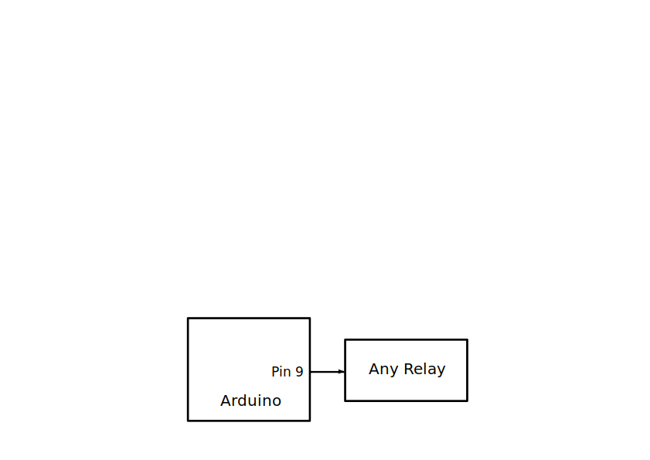Figure 6: Output Test Setup
1. Program File → Examples → Servo → Sweep to the Arduino
2. Connect any relay to the Arduino pin 9.
3. Verify that the relay turns on and off approximately every 2.7 seconds. (2.7s on, 2.7s off.)

3.4 Pass-through Test
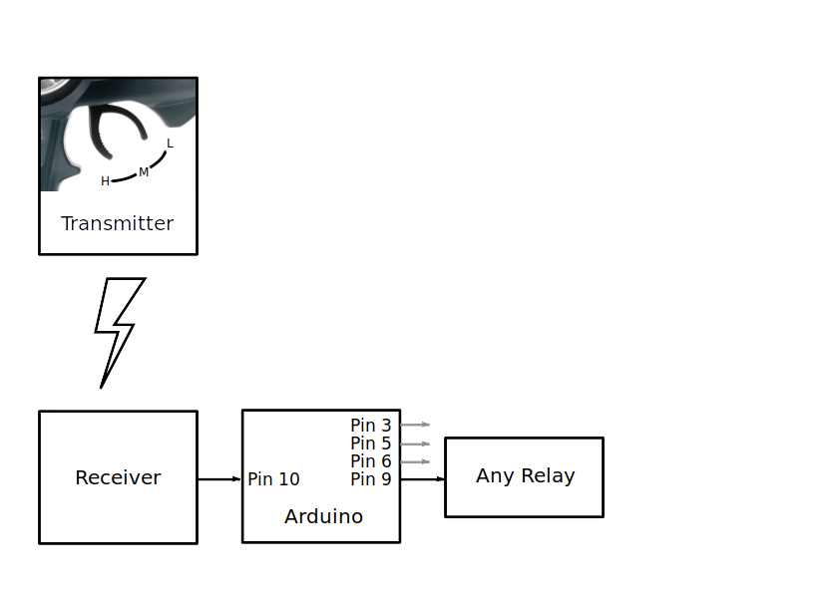Figure 7: Pass-Through Test Setup
1. Program passthrough sketch to the Arduino.
2. Connect the RC receiver to pin 10 of the Arduino.
3. Connect any relay to pin 9 of the Arduino.
4. Verify that moving the transmitter trigger to ‘H’ causes the relay to turn on.
5. Verify that moving the transmitter trigger to ‘L’ causes the relay to turn off.
6. Move the relay to Arduino pin 3 and repeat steps 4 and 5.
7. Move the relay to Arduino pin 5 and repeat steps 4 and 5.
8. Move the relay to Arduino pin 6 and repeat steps 4 and 5.

