Change The Connection String

To change the Database name or server name just put your connection string in the right place in **Web.Config file** like in the picture

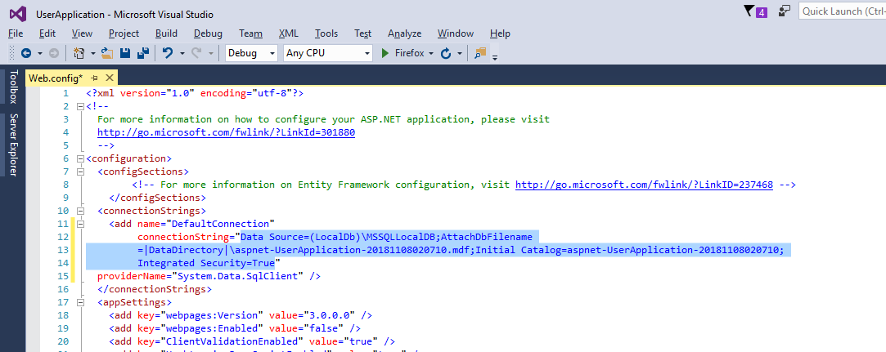

Change The Email Confirmation Info

Just Change in **Controllers/AccountController/Register** => the black with your email address ,the red with your confirmation text, the blue with your stmp info and the green with your password

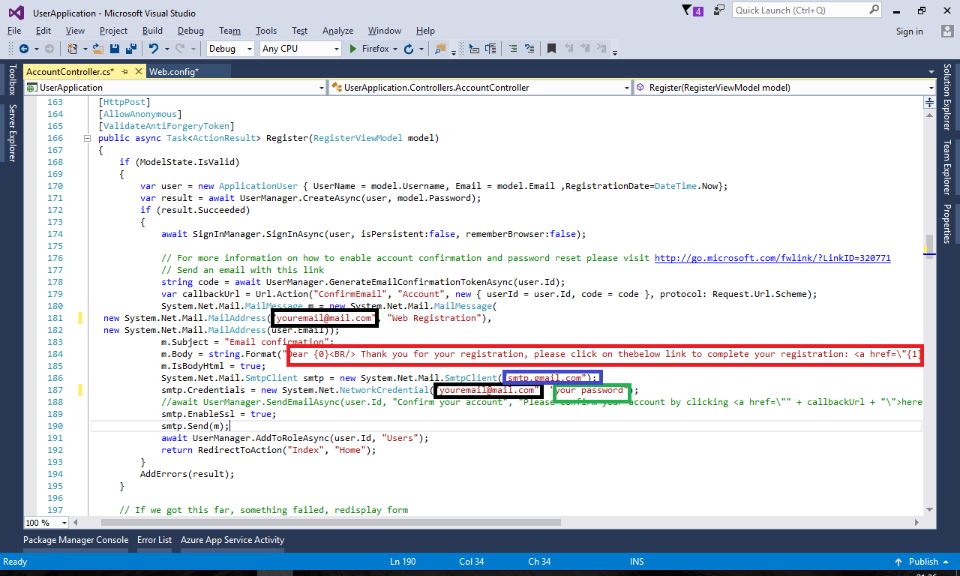

Change The Default User and Roles

In **Starup.cs** you will found a method called CreatDefaultUsersAndRoles contains the info of default user and roles:

Change **the red** with the name of admin role, **the green** with username of the admin user and **the yellow** with his password and **the blue** with his email address

Change **the orange** with the users name role

