|  |
| --- |
|  |

AMS Coursework 1

Fire extinguishing agent

Ali Azam | BSC Computer Science | 1528624

# Introduction

The report will discuss the strategy used for implementation, challenges faced, learning curves, experimentation and combination of multiple agents. The report will mainly cover the following parts:

1. Extended Agent
   1. Description and Justification of the design
   2. Description of the experiments conducted
   3. Results of the experiments
2. Design Choice to increase efficiency
   1. Description and justification of the design choice
   2. Results of experimentation
3. Improvements
4. Advantages and Disadvantages to reactive agent approach

# Extended Agent

**Description and Justification of the design:**

The extended agent still uses the subsumption architecture and extends it to add more features such as extinguishing fire and refueling when needed. The agent design is as follows:

Check whether the agent has detected any fire using the detect-fire sensor and if it has then check whether it has water to extinguish the fire, and if has the water then extinguish it otherwise move to the base to refuel.

Then the agent checks whether its at the base already and it needs water, if it needs water then it refuels otherwise it will just move randomly because of the last if statement.

If it needs water and not at the base then it starts moving towards the base and once it gets to the base, it will refuel because of the earlier if statement.

The only obstacles it can now detect is the other units and hence it avoids them (the reason that it wont detect any fires is because of the order of the logic as first of all it checks whether it has detected fire and either puts it out if it has water otherwise moves towards the base to get more water.)

Lastly, its an if statement which will always be true which will make the agent randomly explore the forest, now it can be argued that have-water instead of true maybe a better design choice, however I believe that there is no need to use have-water when the agent is using need-water because they eventually mean the same thing. If an agent needs water then have water must be false and vice versa.

The design of the agent is deliberately made to be simple as its easy to understand and the focus was to have a flow in the behavior of the agent, that’s one of the reasons that every if statement picks up from where the last one last, for example, if the agent detected fire but didn’t have water then the agent will move towards the base and that’s where the next if statement picks up (if at-base) and will refuel it.

There are some precautionary checks just to be sure as it’s a good programming practice to do so, such as checking it needs a refueling before doing so.

It was also later found out that “and” could be used instead of nested if statements which may have made the program simpler, however it has no effect on the efficiency, hence nested if statements were used instead. (Also because I could not find documentation for “and” and saw that in tutorials there were using nested if statements, hence followed the convention)

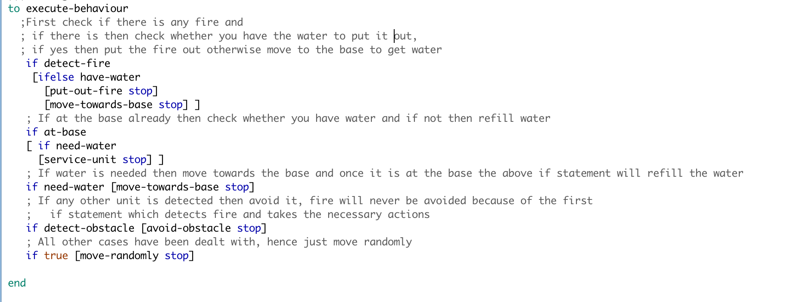

Figure 1 showing the code for fire extinguishing agent

**Description of the experiments conducted:**

There were several tests conducted to evaluate the performance of the extended model and the experiments are as follows (Initial-water was set to 25 in all cases):

**Experiment: 1:** Fire-unit-nums: 1 Tree-num: 400 Number-of-fires:40

This experiment focused on testing what happens if there is only one unit to extinguish the fire as the worst case scenario and to test whether it refuels when it runs out of water and general performance in terms of how randomly moving around will distinguish fires. The reason 400 trees were selected is because the agent will have a better chance of finding the trees on fire if there are a lot of them. (10% of them were on fire).

**Experiment: 2:** Fire-unit-nums: 1 Tree-num: 100 Number-of-fires:40

This experiment was similar to the experiment 1 but number of trees were set to 100 which was the minimum it could go and the reason for this was to see how the agent performs when the environment/trees are very sparse and it was found that one agent could only save 10 trees on average with these parameters as the trees were far away from each other and also the agent did not detect the that two neighboring trees were on fire hence it should have put out both but it moved randomly instead.

**Experiment: 3:** Fire-unit-nums: 40 Tree-num: 400 Number-of-fires:40

This experiment set the maximum of everything to see how the agents behave in terms of coordination and whether they will be able to put out all the fire together as they all had 25 units of water each and trees were quite close to one another, the result of this experiment was that dead trees were an average of 5 and in some cases even 0, hence an average was used.

**Experiment: 4:** Fire-unit-nums: 40 Tree-num: 400 Number-of-fires:1

This experiment was used to test what happens if the fires start out with 1 as its often the case with the real world that the fire starts with 1 tree and then goes wild. This was tested with all 40 agents to see whether they can control it before it goes wild and becomes uncontrollable, this was kept in mind that 40 agents may not all be present at hence experiment 5 was carried out to support this.

**Experiment: 5:** Fire-unit-nums: 10 Tree-num: 400 Number-of-fires:1

This experiment was carried out to see whether if the fire starts out with only one fire and there are 10 agents deployed in the forest for precautionary measures will be able to handle it as it happens in reality that at the start very few agents(humans) try to extinguish the fire even with limited resources and they often result is saving the forest. In this experiment the extended agent model performed well as the average number of dead trees were 10 and in most cases the agent was able to control the fire earlier on and dead trees were reduced to minimum.

**Results:**

The results are an average of running the simulation 10 times to get a better estimate rather than running it a single time. (The individual results are shown below)

|  |  |  |  |  |
| --- | --- | --- | --- | --- |
|  | Saved trees | Dead Trees | Unaffected Trees | Analyses |
| Experiment 1 | **30.9** | **218.9** | **150.2** | For one agent in the whole forest and 40 fires to begin with, it is good that it can save almost 31 trees as roughly 60% trees caught and almost 10% were saved with just one agent. Although the number of dead trees are significant, it cannot be blamed to the agent as there was only one and there were 40 fires. The conclusion drawn from this is that the agent works really well as alone it saves 10% of burning trees on an average. |
| Experiment 2 | **8** | **50.2** | **41.8** | This time around the trees were quite sparse because there were only 100 trees and 40 of them were on fire, the agent did quite well with saving 8% of trees with almost 60% on fire. This shows that perhaps 8 agents are enough for a forest of 100 trees as one can eliminate 8% of the total fire on average (based on simulation) |
| Experiment 3 | **192** | **8.5** | **199.5** | Best case scenario based on maximum values allowed in the simulation. With all 40 agents on the field, they did a pretty good job by eliminating more than 90% of the fire and with an average of only 8.5 dead trees. It has to be taken into account that the agents were moving random and were not aware of where the fire was to just head there and eliminate it. Almost half of the forest caught fire and about 95% were controlled by the agents. This shows that with minimalistic damage, the forest can be saved with 40 agents. |
| Experiment 4 | **6.2** | **0.6** | **393.2** | In this scenario, the fire started with one tree and there were all 40 units there to save it, as it can be seen the average dead trees was less than 1 when atleast 7 trees were on fire from 400. This shows that with 40 agents, even if a fire starts with one tree, can be controlled before it spreads through the forest and most of the forest remains safe. |
| Experiment 5 | **3.2** | **6.7** | **390.1** | In this scenario, there were only 10 units to extinguish fire instead of 40 as from experiment 4 and this would seem more realistic as 10 units can be deployed in each forest and as it can be seen with the results, most of the forest remains safe from fire and only 10 trees caught fire from which 30% were saved with the minimum resources available, however this shows that even with putting out fire on limited trees prevented the fire going wild all over the forest. |

**The Individual experiment data is shown on the next page**

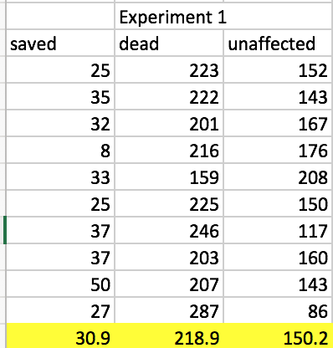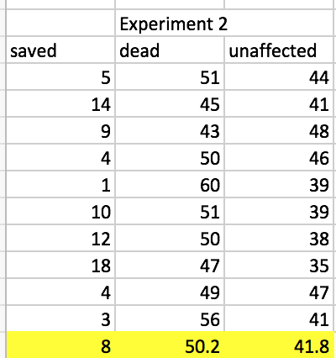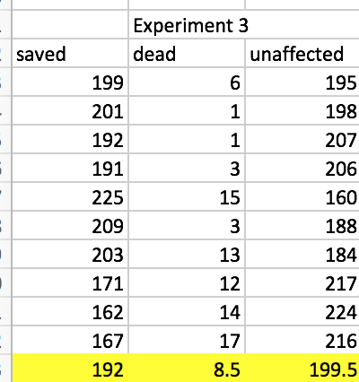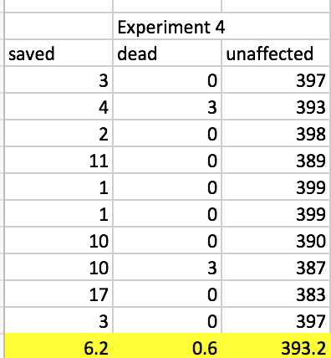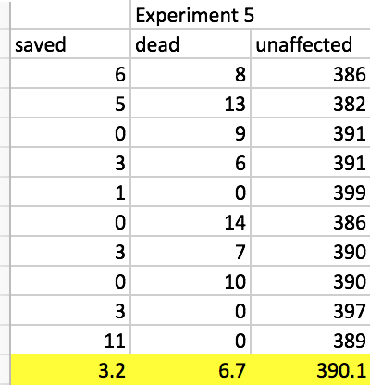

# Design Choice to increase Efficiency

**Design Choice:**

The design choice when tested with the set of experiments was not quite accurate as the more units of water loaded onto the agent made it slower and it was not able to reach further from the base and hence the number of dead trees increased. Below are the set of experiments conducted to test the wise choice.

**Experiment: 6:** Fire-unit-nums: 40 Tree-num: 400 Number-of-fires:40

Initial-water: 50

This experiment was carried out to see whether the wise decision of refueling maximum number of units hold or not and the results are discussed below in detail, however the initial-water was set to 50 as it was the maximum possible and all other parameters were set to their maximum as the focus was to see how much initial-water affects the dead trees. This should be kept in mind that the more the water, the slower the unit gets and hence it wont be able to reach the corners in time to save the trees with carrying max number of water units.

**Experiment: 7:** Fire-unit-nums: 40 Tree-num: 400 Number-of-fires:40

Intital-water:25

This experiment was carried out to check whether halving the maximum number of units result in fewer dead trees. As the agents are now carrying half the weight, they should be able to reach the corners with still having some water. The purpose of this experiment was to check how the agents will behave with having half water supplies with respect to maximum capacity.

**Experiment: 8:** Fire-unit-nums: 40 Tree-num: 400 Number-of-fires:40

Intital-water:10

This experiment was carried out to check how the agent behaves when it has only 10 units of water as opposed to earlier experiment with 25 water units. The number of fires and number of units were deliberately made to be the same to have a fairer comparison. The results of the experiment are shown below:

**Results:**

|  |  |  |  |  |
| --- | --- | --- | --- | --- |
|  | Saved trees | Dead Trees | Unaffected Trees | Analyses |
| Experiment 6 | **140.4** | **72.4** | **187.2** | The theory was put to test in this experiment as it was tested to refuel to maximum capacity every time an agent runs out of fuel. The results show that the number of dead trees were extremely high because the speed of the units got so slow that they could not reach the end trees in time to put out the fire. The agents were only able to extinguish about 60% of the fire and the rest led to dead trees. |
| Experiment 7 | **200.3** | **7.5** | **192.2** | In this experiment, the initial-water was halved and the results were astonishing, the average number of dead trees dropped from 72.4 to 7.5. This is a huge decrease and it shows that our initial choice was not accurate as the more units of water the agents carried, the more the dead trees were. |
| Experiment 8 | **200.4** | **0** | **199.6** | Lastly, the initial-water was even reduced to 10 and the results were unbelievable as in the 10 runs, the number of dead trees were 0, to check this theory even further, some tests were done unrecorded and results were the same, the number of dead trees remained to be 0 in all of the tests performs. This concludes that 10 is perhaps the magic number for forest fire case and this also proves the initial choice was wrong as the more units of water the agents carry, the slower they get and hence there is an incredible amount of increase in number of dead trees. |

The individual test results are shown below:

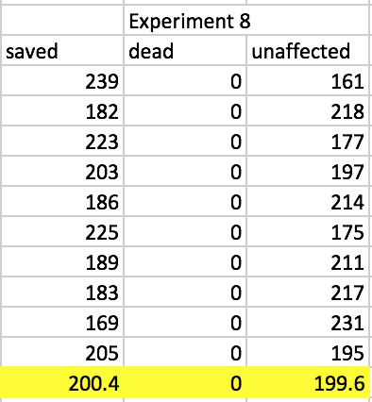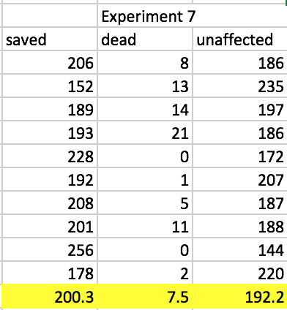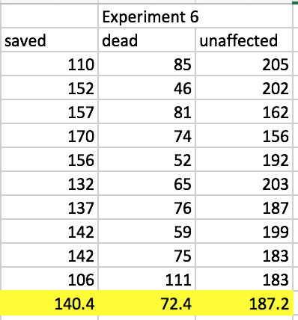

# 

# Improvements

There are a number of improvements which can be suggested to the current system as in the current system, the agents just move randomly which is not efficient as it may work sometimes and may not work at all at other points. Below are the detailed points of improvements with their justifications of proposal:

1. **Neighbor trees** – If a tree is on fire then the agent should check its neighboring trees for any traces of fire because its very likely that if one tree is on fire then its neighbor may also be on fire and if that is the case then agent checking for that will increase efficiency by eliminating fire which comes in the form of cluster and stop the fire early on as one cluster of trees on fire will not affect the others.
2. **Multi-agent communication** – agents should help each other in terms of communication, right now the agents move randomly without any knowledgebase whatsoever, even if one agent has seen fire and did not have enough water to extinguish it, it does not let other agents know that there is a fire at these coordinates so maybe some other agent around could put it out, this is very similar to how the police coordinates when someone is running away and nearest police car reacts accordingly, this will still be using the subsumption architecture but will help to increase the efficiency as if one agent cant eliminate the fire then rest will have a goal to reach and they will mostly reach and extinguish the fire before the agent which reported it comes back and this way they can all delegate the work and efficiency will be increased rapidly as they are no longer moving around randomly but they rather have a goal to reach.
3. **Water lending between agents** – One of the other improvements which could be suggested is the water lending between agents as for a scenario where one agent just came fully refueled, and its close by agents are running out of water, instead of other agent going back to base to get more water, the agent with full water can lend half of its water to the other agent and they can extinguish more fires together and this will help to increase efficiency as by giving half of the water away, the agents speed is doubled and with two agents instead of one, they can now extinguish more fires then one could alone.

# Advantages and Disadvantages

There are many advantages of the reactive agent approach in the forest fire problem as the forest fire happen all of a sudden and it needs reactive agents to handle the fire immediately, it cannot be proactive because no one can tell when a fire will start hence there are several benefits of reactive agent approach. For example the reactive agent will extinguish fire as soon as it detects it but if its not around then it will not help.

Lets take a look into some disadvantages of the reactive approach first:

One of the disadvantages of the reactive approach is that it does not care about the bigger picture, it will only take out the fire it detects first rather than how proactive approach can generate an effective plan to reduce the number of dead trees based on trees on fire and then give agents only the number of water units required by them to eliminate the fire and this way some of the agents can remain idle at the base and be dispatched with a plan once a fire is known, this will be more like an ambulance rescue service which is highly effective.

There are advantages and disadvantages to the reactive approach and in my opinion, the hybrid of both proactive and reactive approach will solve the problem in the best manner possible, however evaluating reactive approach based on the forest fire problem, It works reasonably well as experiments confirm.