**How to setup OtomaX into English**

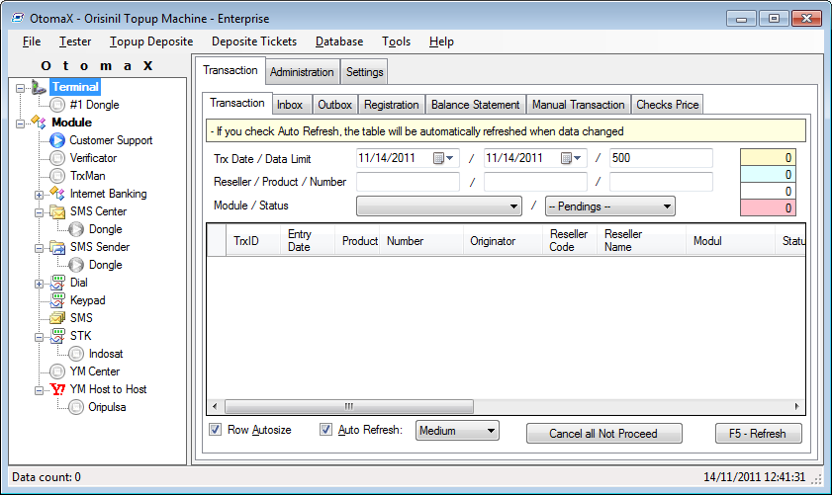

Steps:

1. Download language file at <http://orisinil.com/otomax/download>

File name: otomax.lang. It is an xml file, so you can edit it with a standard text editor like notepad or notepad++. Extract the file to the folder you install/extract OtomaX, ex: D:\OtomaX. You may need to restart OtomaX.

This setup requires OtomaX version 2.8 or later.

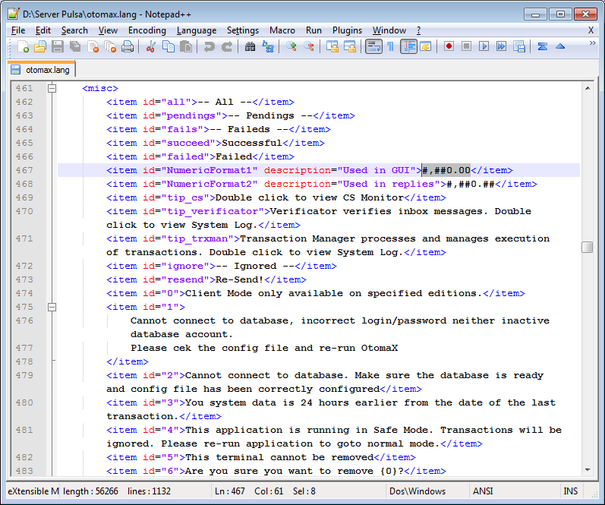

1. Change data type of some fields on OtomaX database. You can use Microsoft SQL Server Management Studio to do that. You must login with an administrator privilege to change data type.

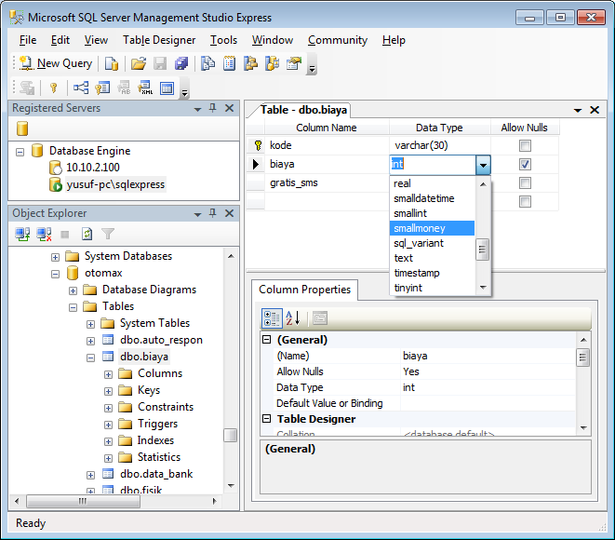

Here is the list of fields to be changed: (table.field: data type)

* Biaya.biaya: smallmoney
* Komisi.jumlah: smallmoney
* Level.selisih_harga: smallmoney
* Mutasi.jumlah: money
* Mutasi.saldo_akhir: money
* Parsing.harga_beli: smallmoney
* Produk.harga_jual: smallmoney
* Produk.harga_beli: smallmoney
* Produk_level.harga: smallmoney
* Reseller.saldo: money
* Reseller.saldo_minimal: money
* Sms_sender.biaya: smallmoney
* Tiket_deposit.jumlah: money
* Transaksi.harga: smallmoney
* Transaksi.harga_beli: smallmoney
* Transaksi.saldo_awal: smallmoney

Maximum value of **smallmoney** is 214,748.3647 (two hundred and fourteen thousand…). You may use **money** to replace **smallmoney**, but it will use more spaces (twice) on the database.