* Name:                   Faiqa Akhtar.
* Institute :               Afro-asian.
* Department :         Dpt.
* Semester :             8th.
* Session :               2016-2021.
* Assignment:         clinical medicine 2.
* Topic:                    stroke & its types.
* Submitted to:        mam fatima
* Submission date:  30-07-2020.

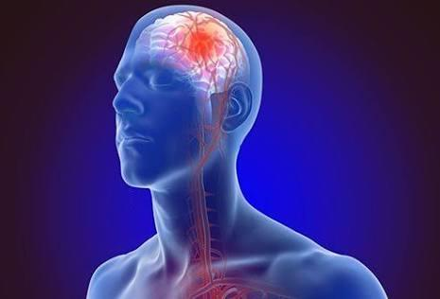

Stroke.

***Overview*** :

* .A **stroke** occurs when the blood supply to part of your brain is interrupted or reduced, preventing brain tissue from getting oxygen and nutrients.
* Brain cells begin to die in minutes.
* A **stroke** is a medical emergency, and prompt treatment is crucial.
* Early action can reduce brain damage and other complications.

Types:

* There are three different types of stroke; ischaemic strokes, haemorrhagic strokes and transient ischemic attacks.
* An [ischaemic stroke](https://www.stroke.org.uk/what-is-stroke/types-of-stroke/ischaemic-stroke) is caused by a blockage cutting off the blood supply to the brain. This is the most common type of stroke.
* A [haemorrhagic stroke](https://www.stroke.org.uk/what-is-stroke/types-of-stroke/haemorrhagic-stroke) is caused by a bleeding in or around the brain.
* A [transient ischaemic attack or TIA](https://www.stroke.org.uk/what-is-stroke/types-of-stroke/transient-ischaemic-attack) is also known as a mini-stroke. It is the same as a stroke, except that the symptoms only last for a short amount of time. This is because the blockage that stops the blood getting to your brain is temporary.

### **Causes:**

* As we age, our arteries become harder and narrower and more likely to become blocked.
* However, certain medical conditions and lifestyle factors can speed up this process and increase your risk of having a stroke.

[signs of a stroke](https://www.healthline.com/health/stroke/stroke-warning-signs)

* Paralysis
* numbness or weakness in the arm, face, and leg, especially on one side of the body
* trouble speaking or understanding speech
* confusion
* slurring speech
* vision problems, such as trouble seeing in one or both eyes with vision blackened or blurred, or double vision
* trouble walking
* loss of balance or coordination
* dizziness
* severe, sudden headache with an unknown cause