Handling more data

Handling higher concurrency levels

Handling higher interaction rates

if you are building a website, your clients would navigate from page to page every 15 to 120 seconds. If you are building a multiplayer mobile game, however, you may need to exchange messages multiple times per second.

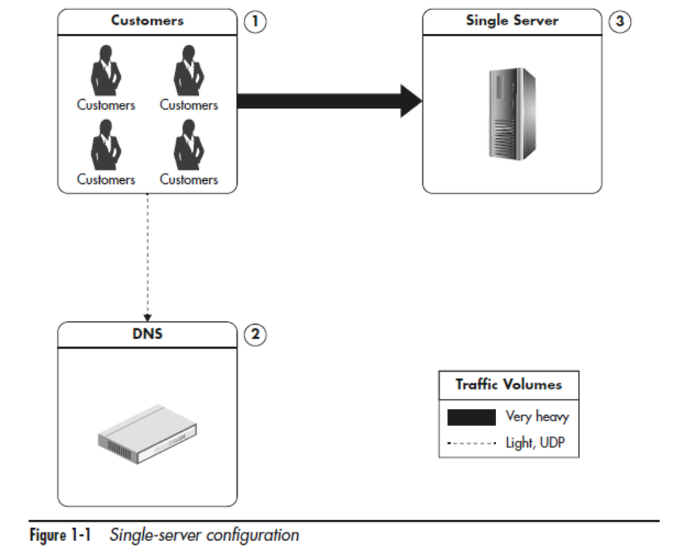
Shared Host has NOT administration privileges
Virtual Private Server (VPS) has administration privileges
Making the Server Stronger: Scaling Vertically
- Adding more I/O capacity by adding more hard drives in Redundant Array of Independent Disks (RAID) arrays. I/O throughput and disk saturation are the main bottlenecks in database servers
- Improving I/O access times by switching to solid-state drives (SSDs).
- Reducing I/O operations by increasing RAM.
- Improving network throughput by upgrading network interfaces or installing additional ones
- Switching to servers with more processors or more virtual cores

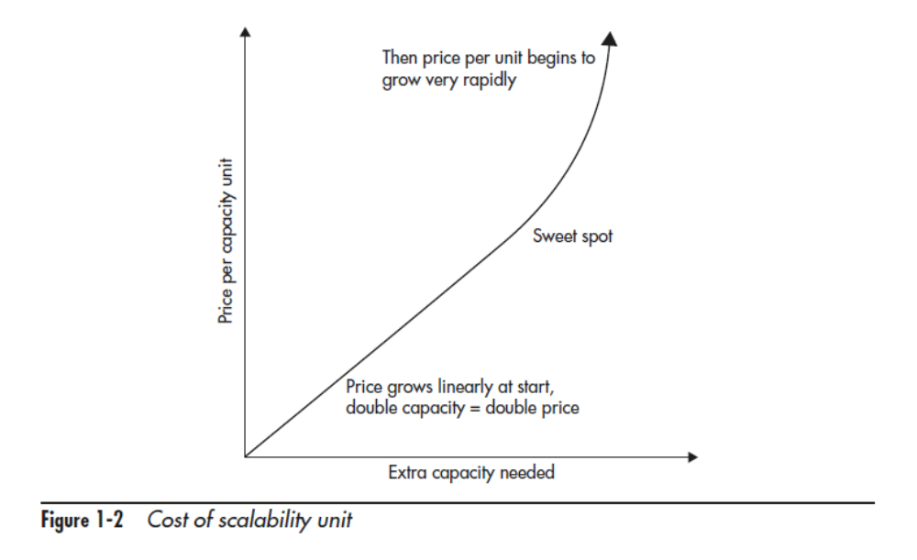

Isolation of Services
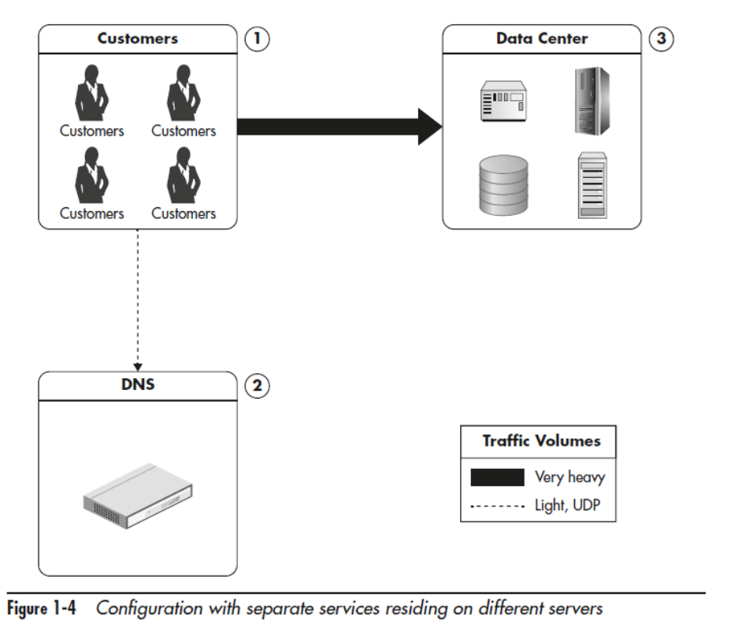

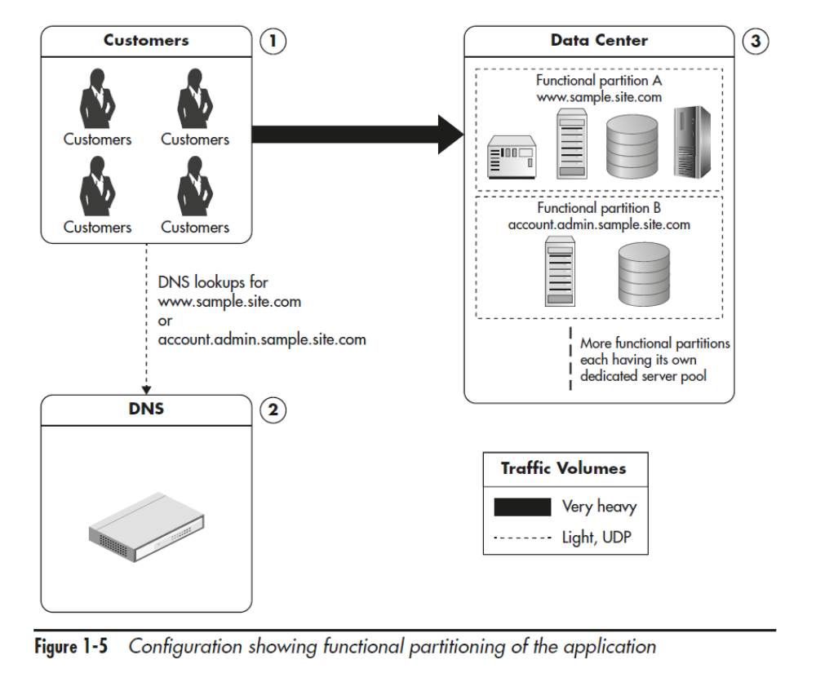

Content Delivery Network: Scalability for Static Content
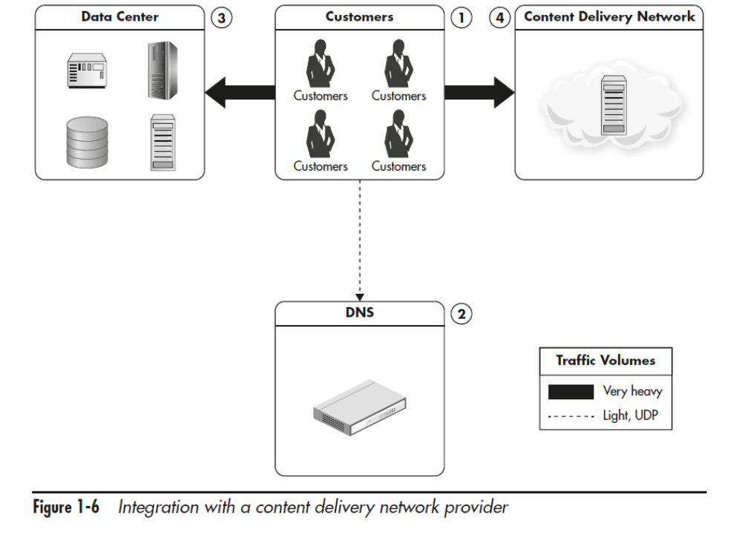

Distributing the Traffic: Horizontal Scalability
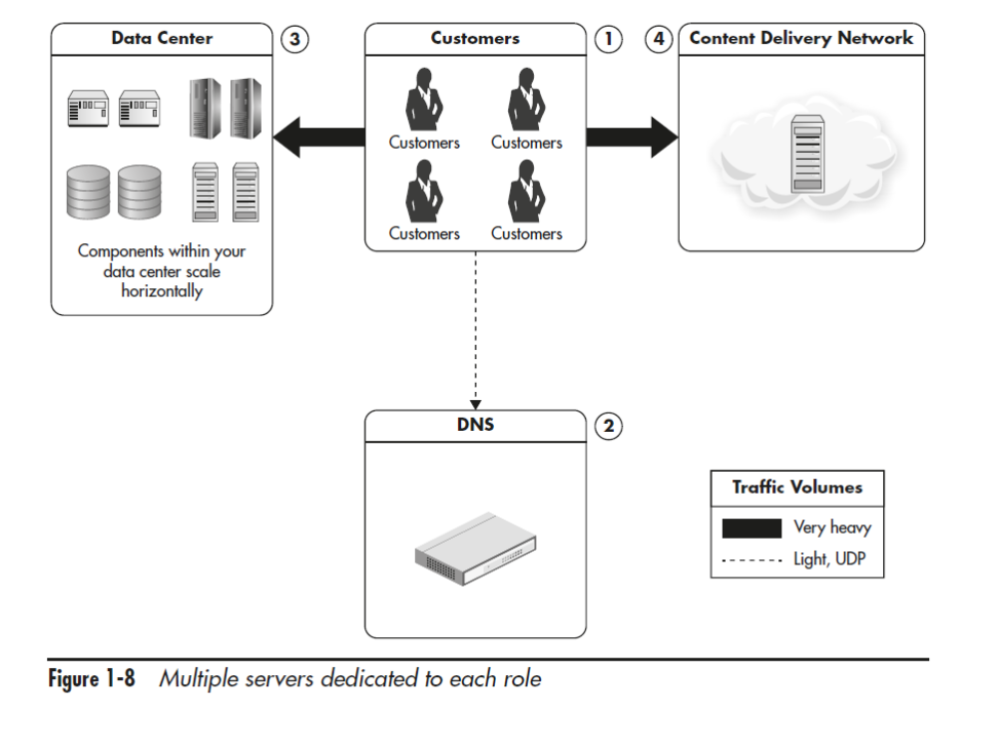
Round-Robin DNS servers to distribute traffic

GeoDNS is a DNS service that allows domain names to be resolved to IP addresses based on the location of the customer
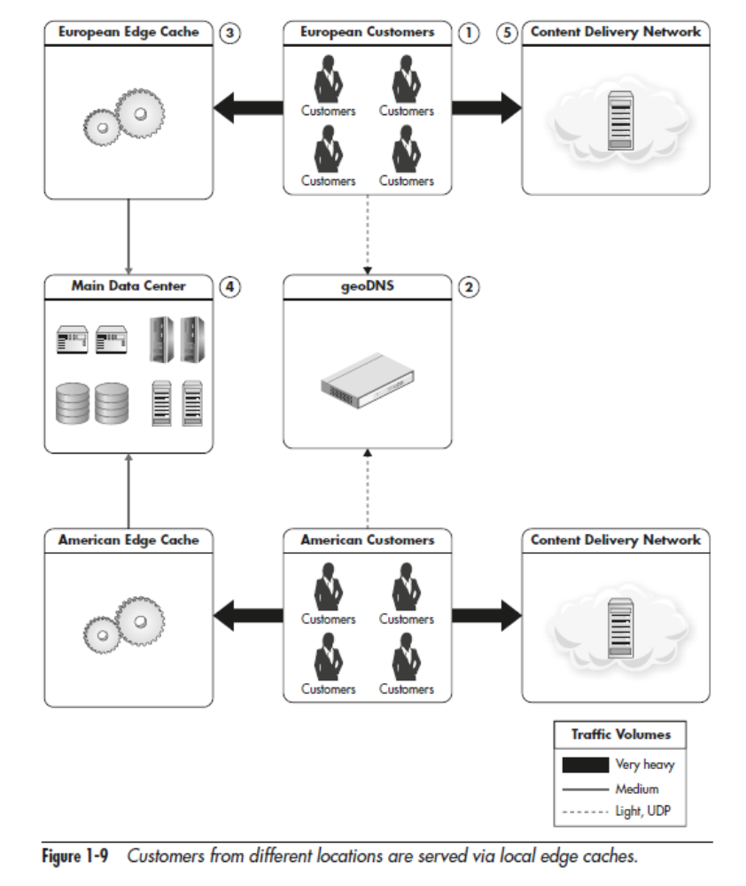

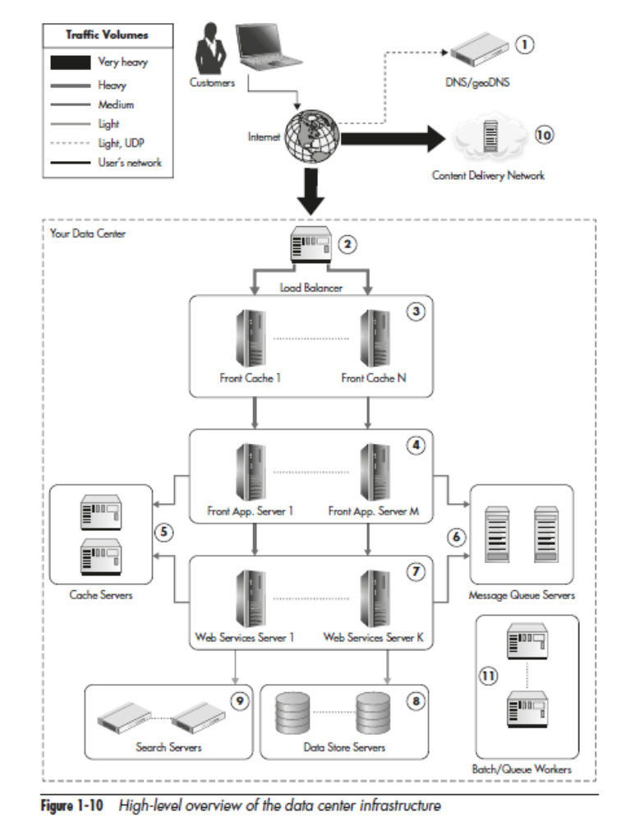

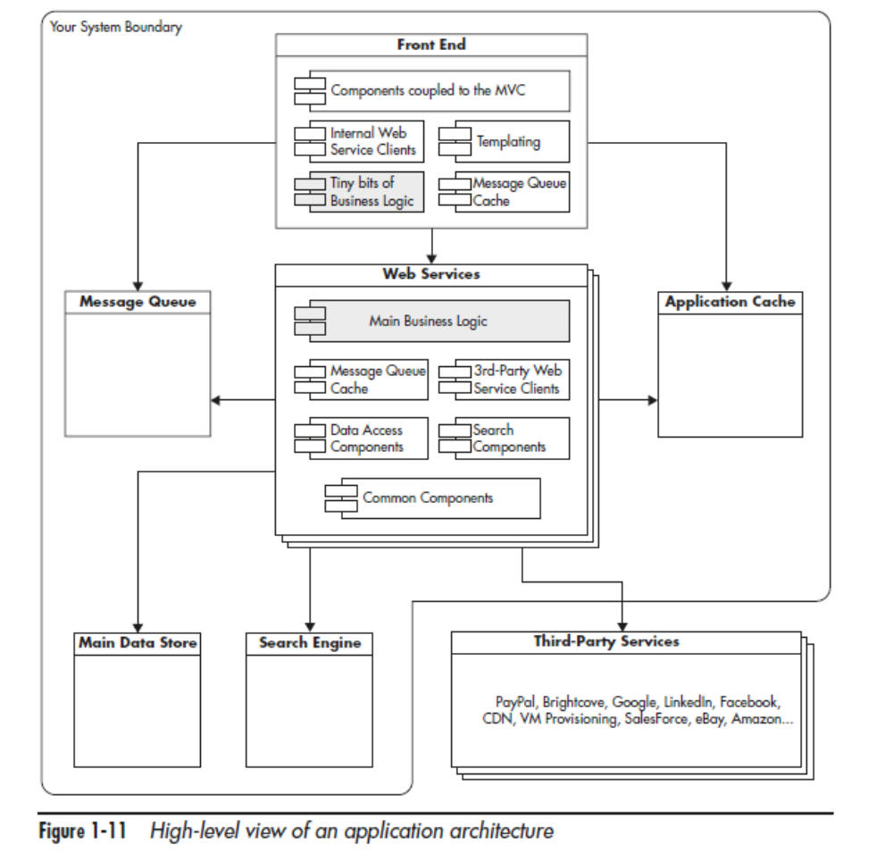

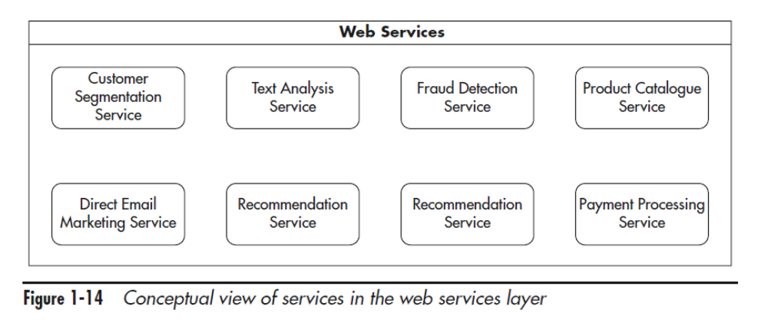
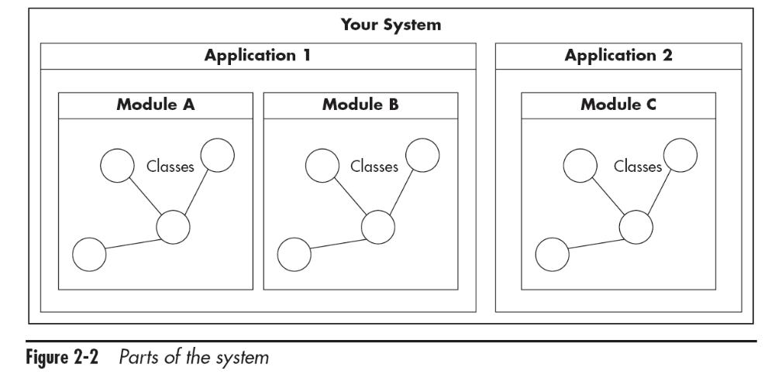
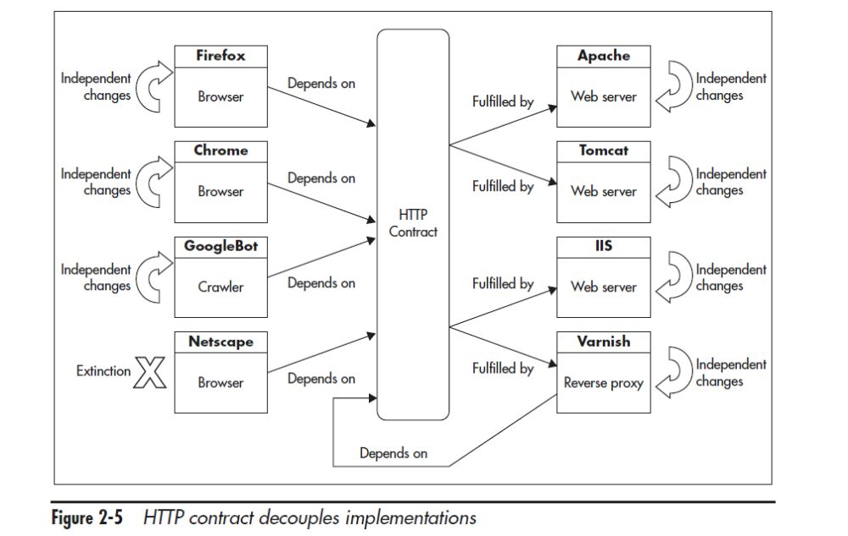

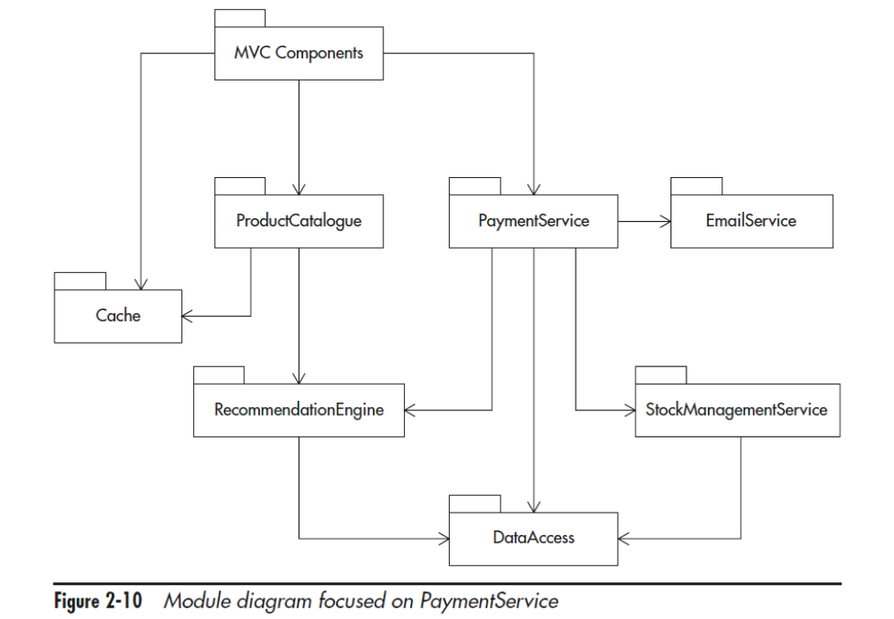

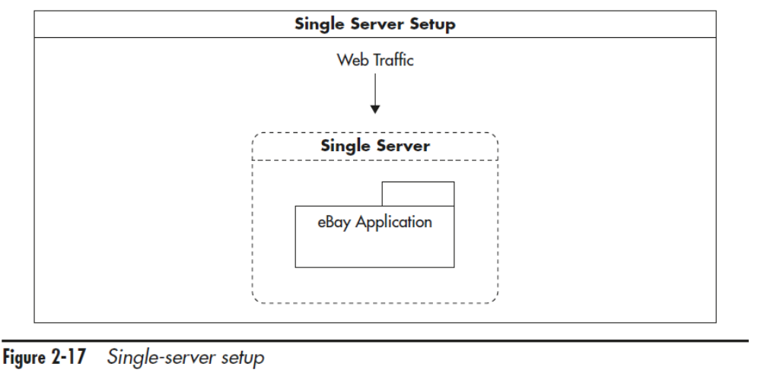

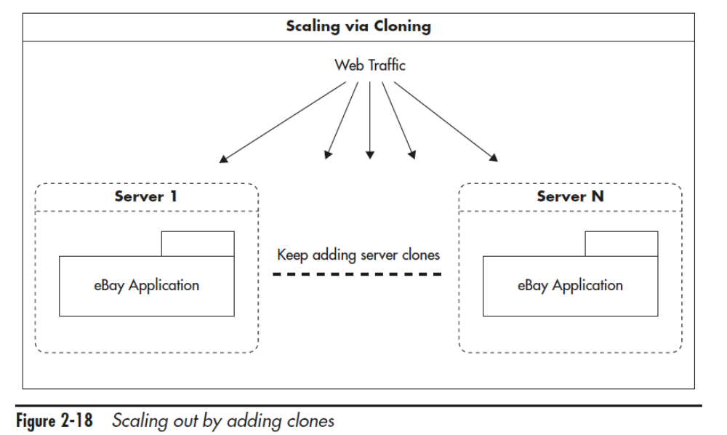
Stateless Services

Scaling by adding clones is the easiest and cheapest technique to implement in your web layer.

Functional Partitioning
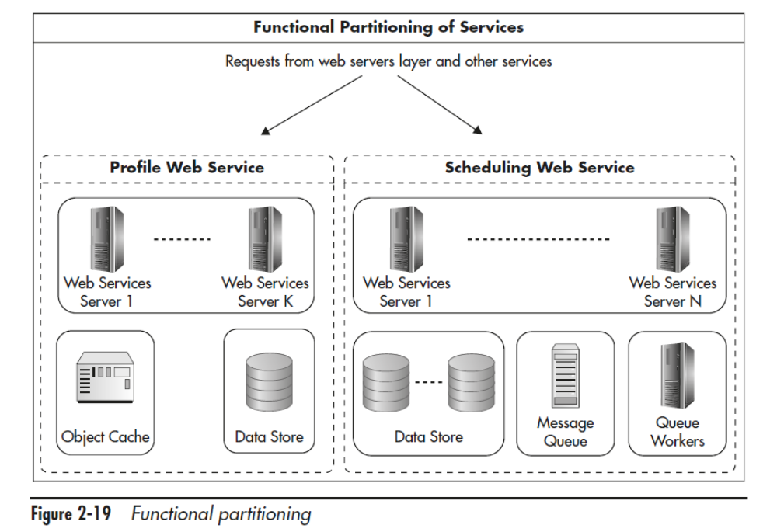

Data Partitioning

Not sharing state means there is no data synchronization, no need for locking, and that failures can be isolated because nodes do not depend on one another.

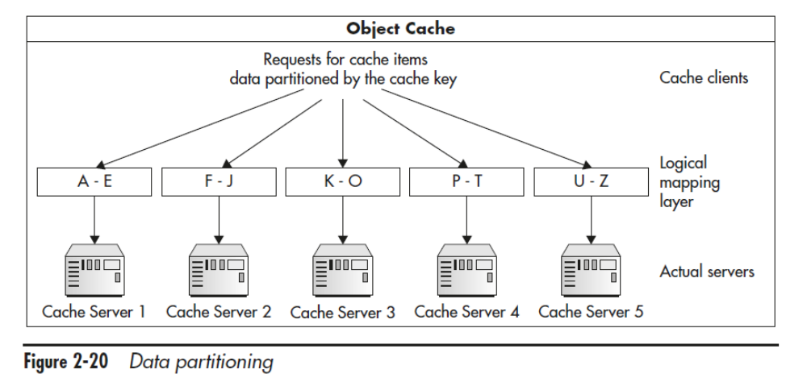

Design for Self-Healing
When designing for high availability, you need to hope for the best but prepare for the worst, always thinking about what else can fail and in what order.

Building the Front-End Layer
Front-end applications built with scale in mind are mostly stateless
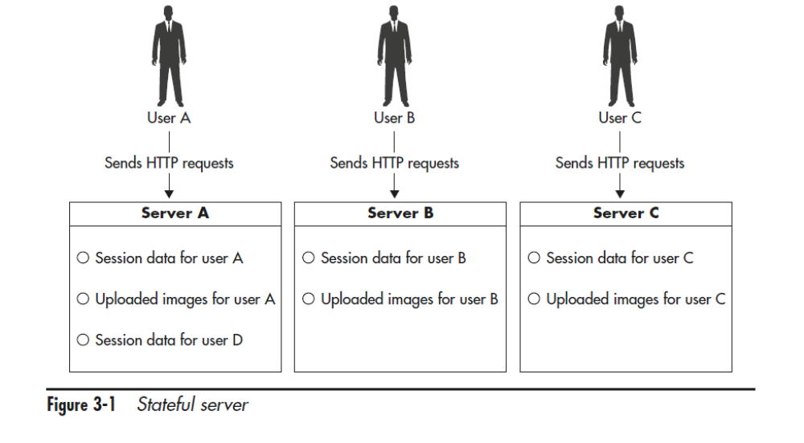
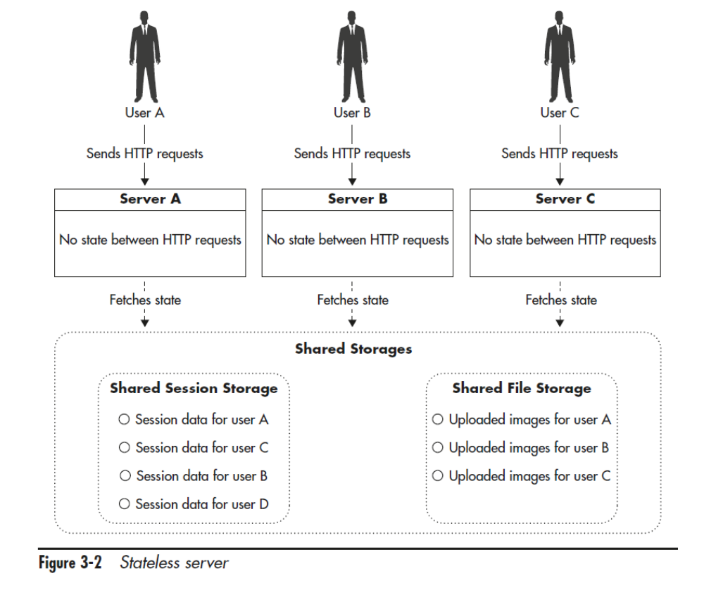

- Store session state in cookies
- Delegate the session storage to an external data store
- Use a load balancer that supports sticky sessions

Managing Files

- User-generated content being uploaded to your servers
- Files generated by your system that need to be downloaded by the user

By setting a long expiration policy on public files, you will allow CDN to cache them effectively forever

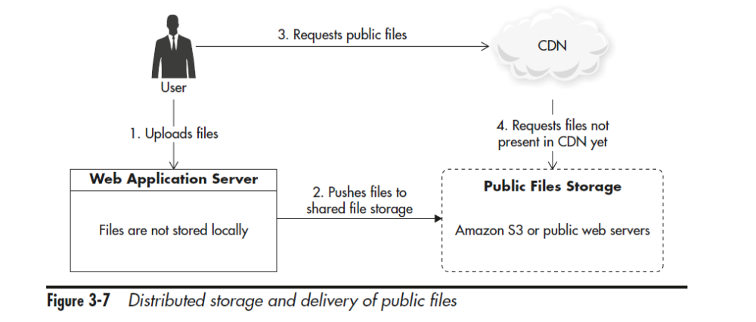
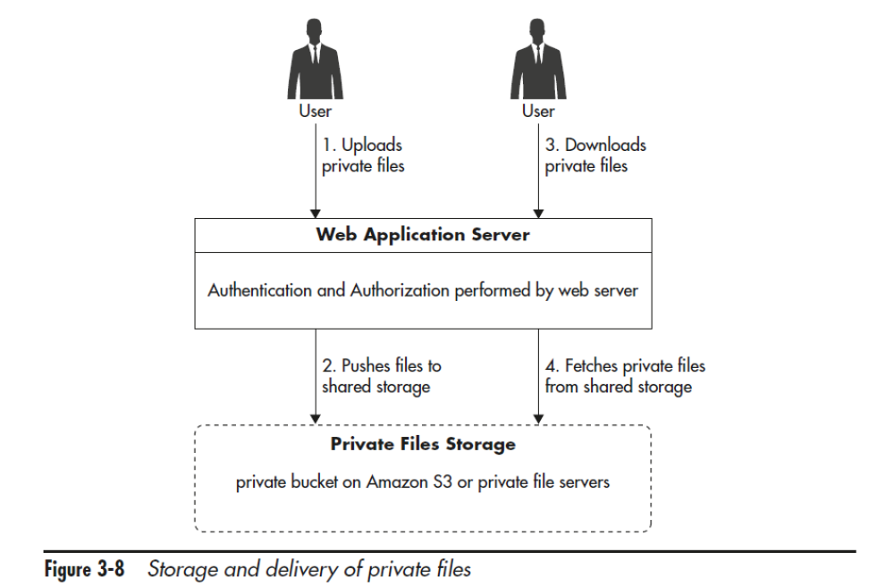

Weighted random server selection

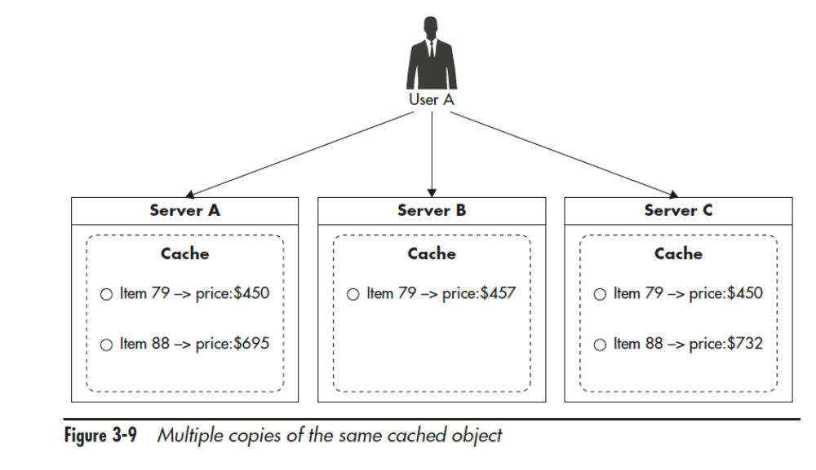
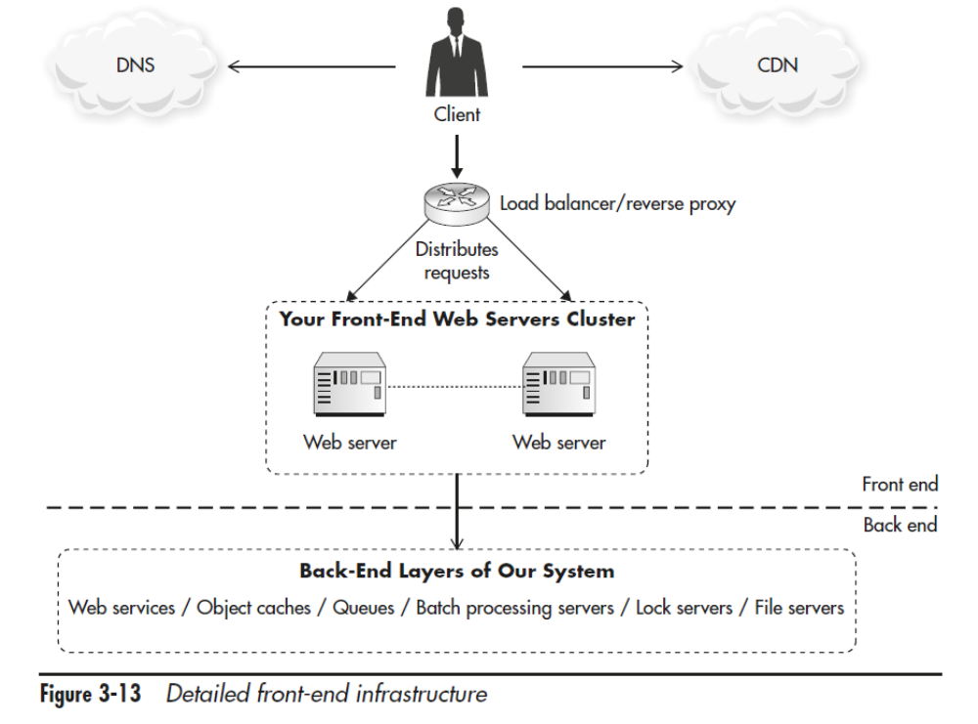

DNS

If your startup grows much larger, you can also use latency-based routing of Route 53 to direct your clients to the “closest” data center.
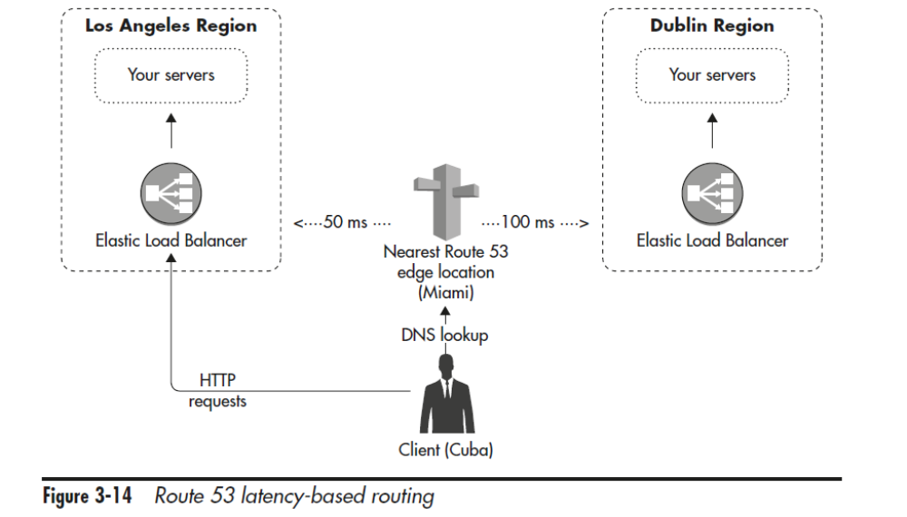

easydns.com, dnsmadeeasy.com, dnsimple.com, and dyn.com

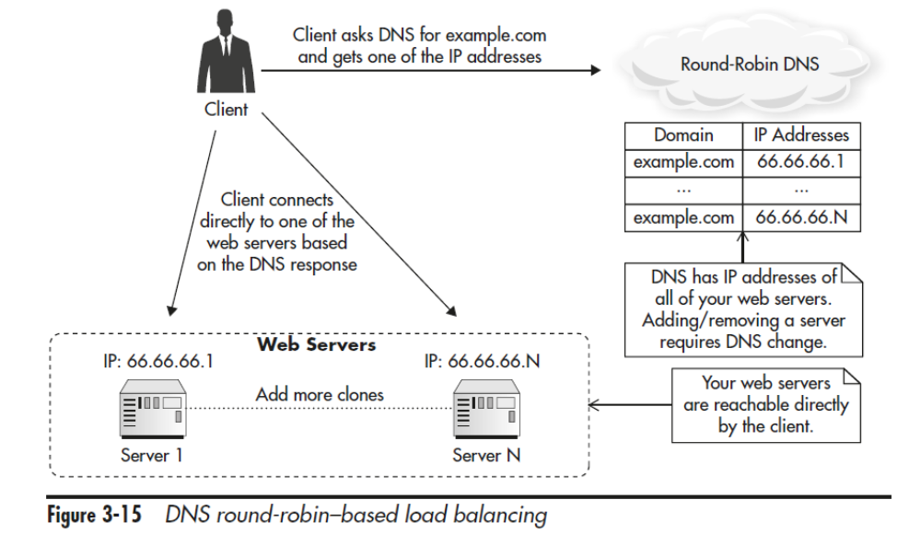
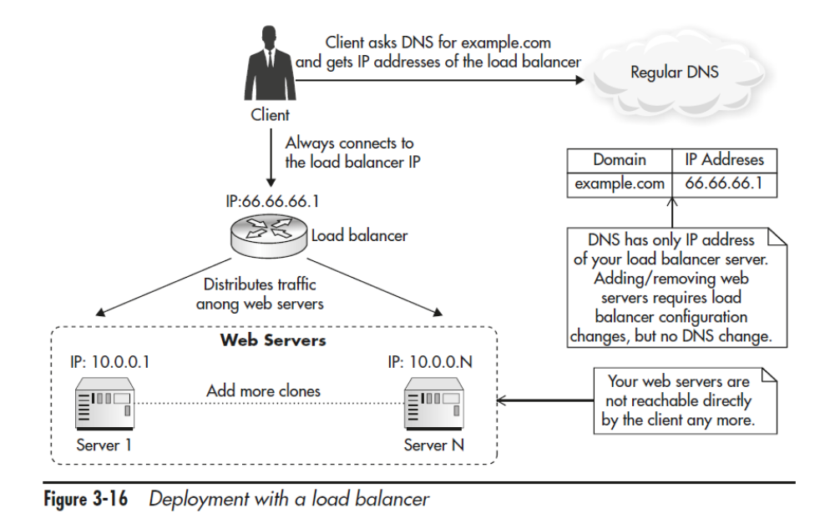

- Hidden server maintenance
- Seamlessly increase capacity
- Efficient failure management
- Automated scaling
- Effective resource management

Load Balancer as a Hosted Service

Self-Managed Software-Based Load Balancer

reverse proxy like Nginx or a specialized open-source load balancer product like HAProxy
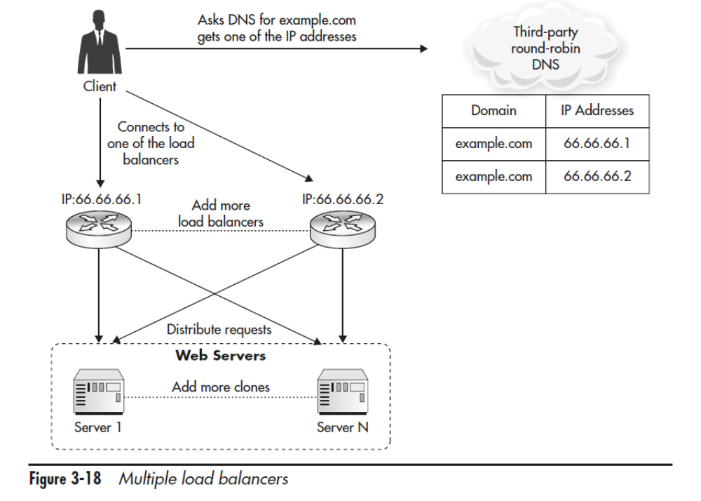

Hardware Load Balancer

CDN and reserve proxy servers
shared object cache like Redis or Memcached
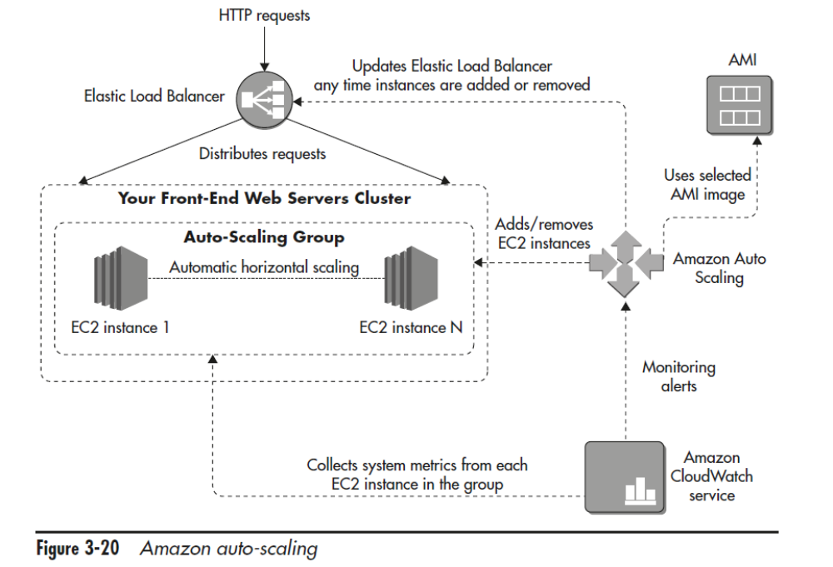

Designing Web Services

Web Services as an Alternative Presentation Layer
API-First Approach
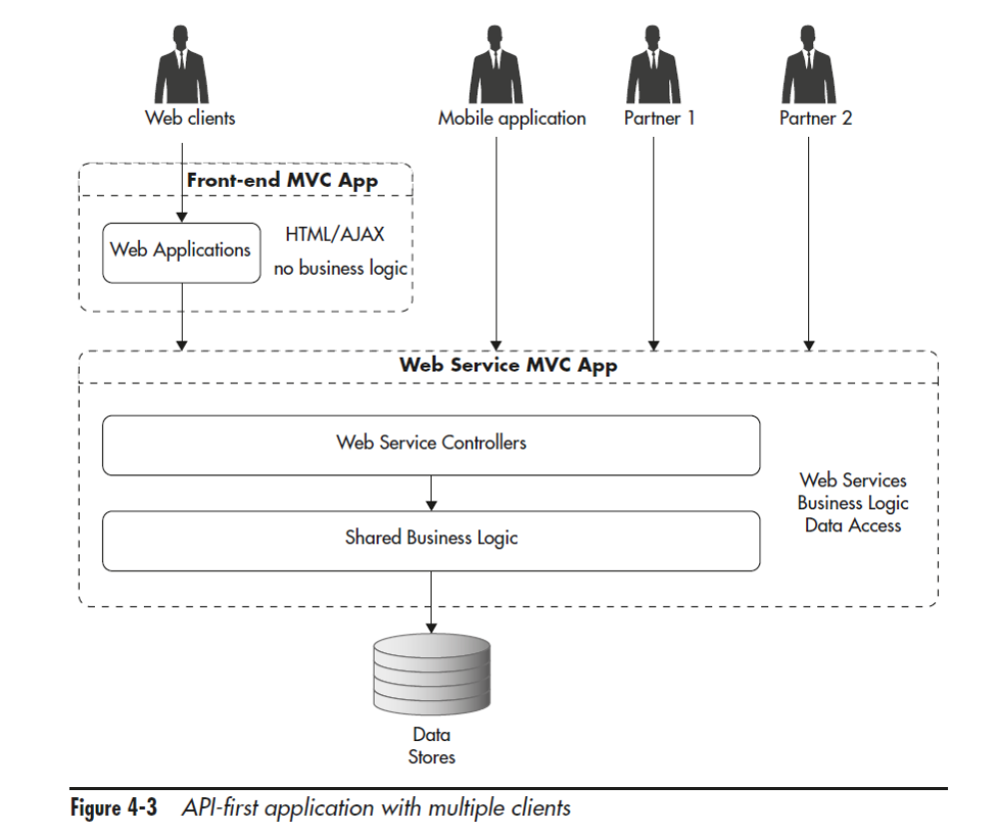

Types of Web Services

Function-Centric Services
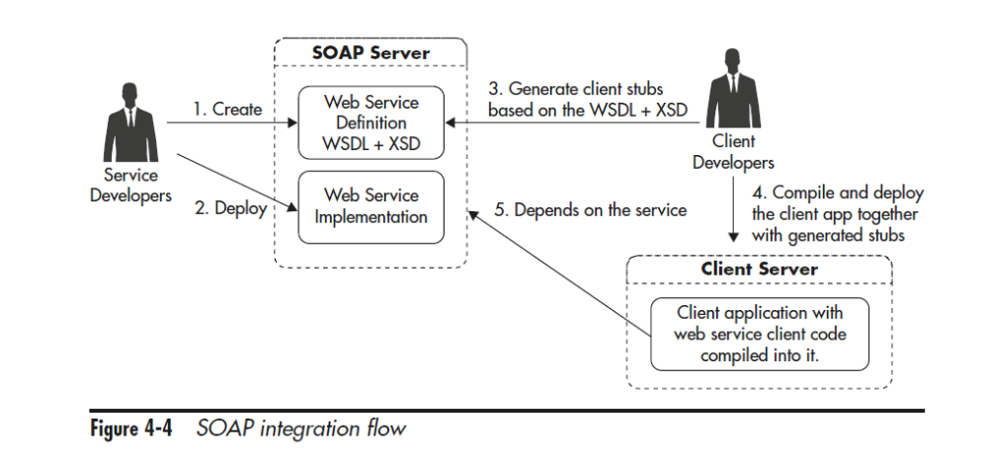

Resource-Centric Services

Scaling REST Web Services

Keeping Service Machines Stateless
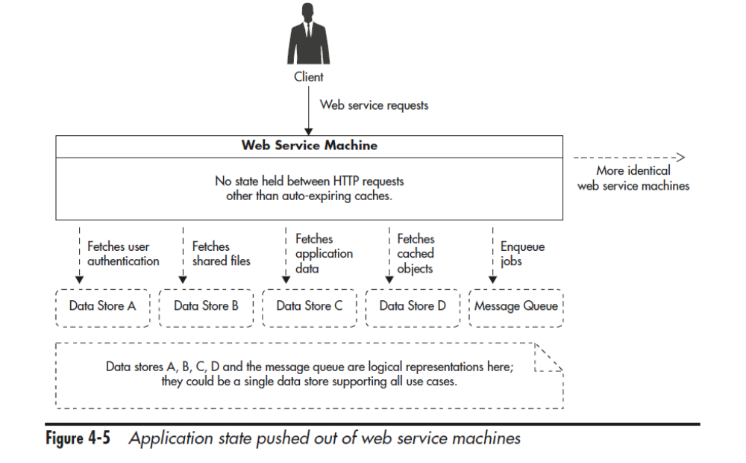

Caching Service Responses
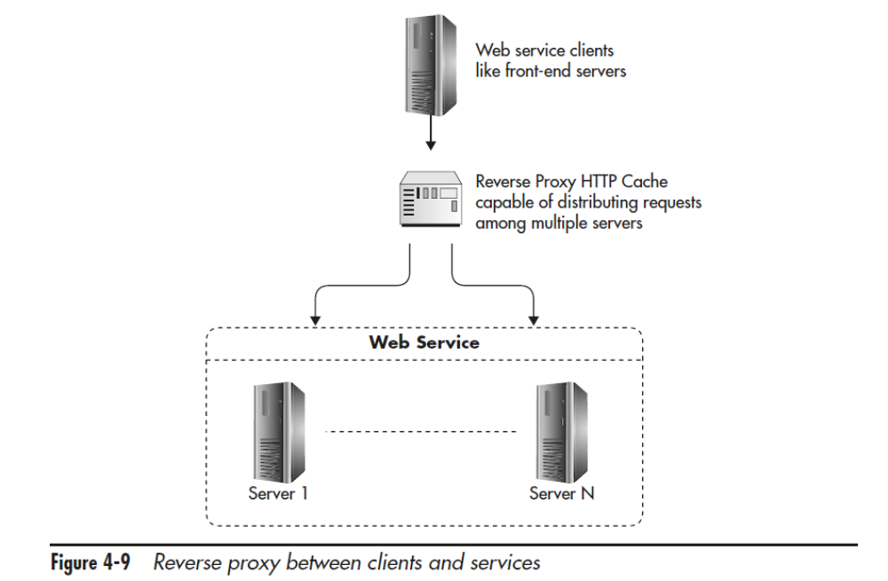
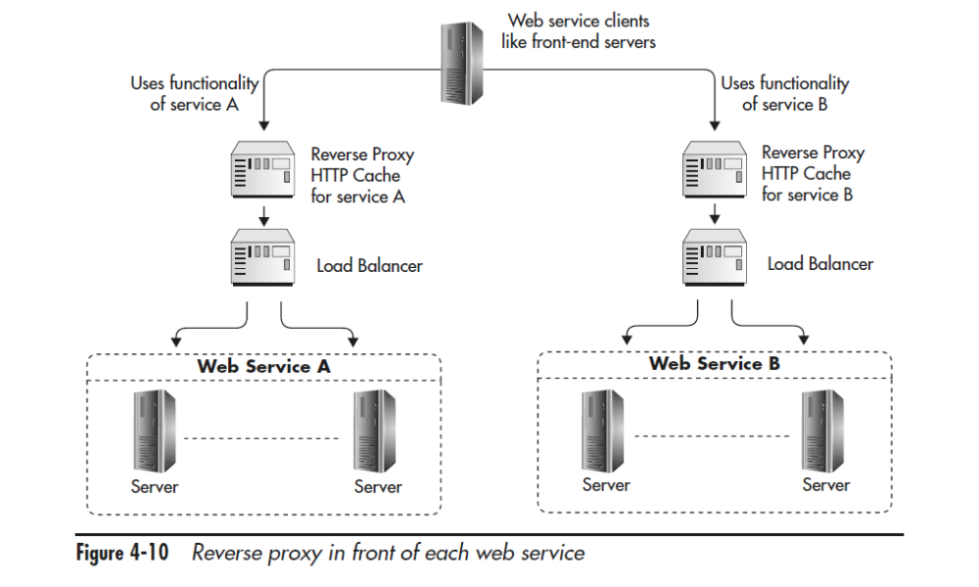

Functional Partitioning
P150

